Slewing Drive Controller Board Manual
AS5600 + Arduino Nano + Arduino UNO + MCP2515 / MCP2551 CAN
KiCad project: Slewing_Drive.kicad_sch
Author: Pharos
Rev. 0.2 (firmware-aware)

1. Overview
This document describes the operation, wiring, firmware, and usage of the Slewing_Drive circuit designed in KiCad. The board measures the rotation angle of a user-operated handle with an AS5600 magnetic encoder, conditions the data through two Arduino boards, and forwards real-time servo motion commands to a Kinco servo drive over a CAN bus using CANopen Profile Position mode.
The system accepts two parallel inputs: handle angle from the local sensor board, and host commands from a PC over USB serial. The main controller (Arduino UNO) fuses both inputs according to the active mode and emits the final servo control frames on the CAN bus.

1.1 Why two MCUs?
The system is split between an Arduino Nano (handle board) and an Arduino UNO (main controller) because the two modules were developed independently and then integrated. The handle side was developed to validate AS5600 sampling, multi-turn counting, and safe-range clamping; the main side was developed to validate the CANopen servo control logic. The two modules were finally combined with a single inter-board UART link.
This split was useful during development, but for production and long-term maintenance the design should be migrated to a single MCU. A future revision should consolidate the two boards into one MCU with richer pin / flash / interrupt resources (for example an STM32) in order to (a) reduce part count, (b) eliminate inter-board UART signal-integrity concerns, and (c) tightly synchronize the handle and servo control loops.

2. System Block Diagram

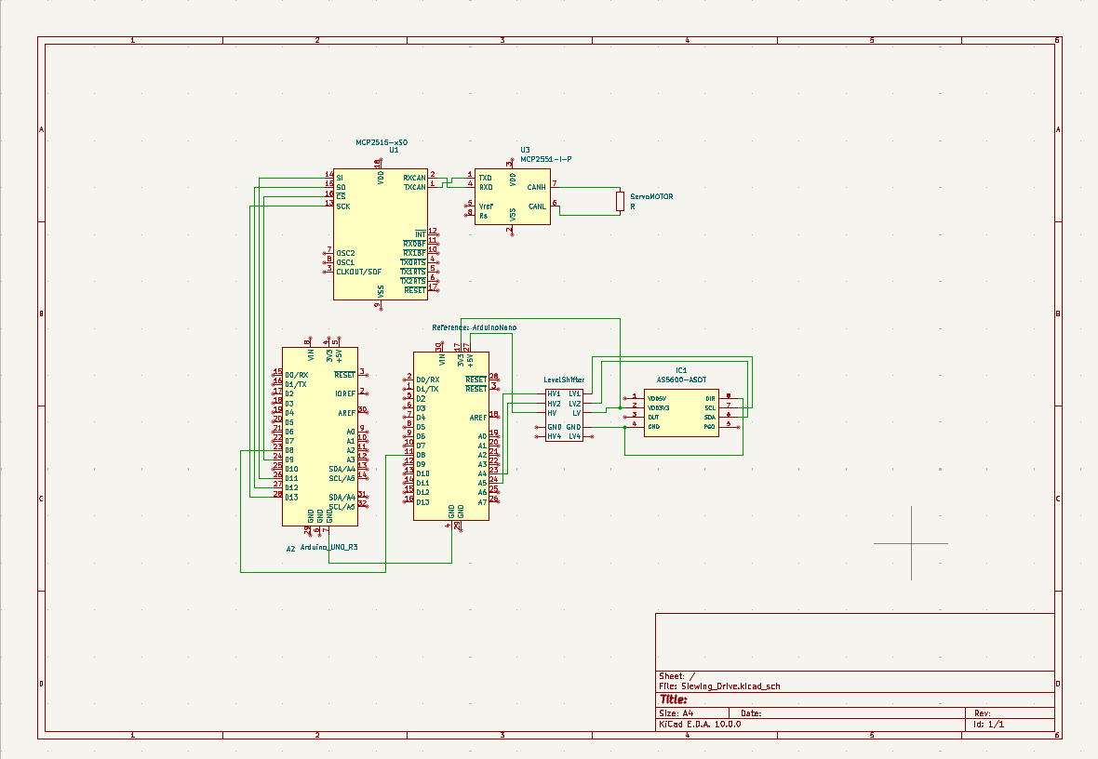
The figure below summarizes the entire signal path.
+--------------+ I2C +--------------+ I2C +--------------+ UART +--------------+
| AS5600 |-------->| Level |------>| Arduino |-------->| Arduino |
| (Encoder) | 3.3V | Shifter U2 | 5V | Nano (A1) | D8->D8 | UNO R3 (A2) |
+--------------+ +--------------+ +--------------+ 57600 +------+-------+
| SPI
v
+---------------------------+
| MCP2515 CAN ctrl (U1) |
| CS=D9, INT=D2, 16 MHz |
+-------------+-------------+
| TXCAN/RXCAN
v
+------------+ +----------------------+
PC --USB---| UNO (A2) |<------------->| MCP2551 (U3) + |
+------------+ 250 kbps | 120 ohm term -> BUS |
+----------------------+

The core data flows can be summarized as follows.
- Handle angle: AS5600 -> level shifter -> Arduino Nano -> Arduino UNO (Nano D8 -> UNO D8, 57600 bps).
- Host command: PC -> USB serial 115200 bps -> Arduino UNO.
- Servo command: Arduino UNO -> MCP2515 (SPI, CS=D9) -> MCP2551 -> CAN 250 kbps -> Kinco drive.

3. Bill of Materials
Ref. | Part | Role | Notes
IC1 | AS5600-ASOT | 12-bit magnetic rotary encoder (handle angle) | I2C interface, 3.3 V
U2 | Logic level converter (4ch) | Bidirectional 3.3 V <-> 5 V translator | Protects I2C lines between AS5600 and Nano
A1 | Arduino Nano (handle board) | AS5600 sampling, filtering, handle command Tx | AS5600 -> Nano (I2C); Nano D8 -> UNO D8 (UART)
A2 | Arduino UNO R3 (main controller) | Parses PC commands and emits servo commands on CAN | USB serial <-> PC; SPI <-> MCP2515; D8 <- Nano
U1 | MCP2515 | SPI-to-CAN controller | 16 MHz crystal (per firmware)
U3 | MCP2551-I/P | High-speed CAN transceiver (CAN_H / CAN_L) | Physical layer for the CAN bus
R1 | 120 ohm | CAN bus termination resistor | Between CAN_H and CAN_L

4. Theory of Operation

4.1 AS5600 (handle angle measurement)
The AS5600 is a contactless magnetic rotary encoder that reports the full 0 to 360 degree range with 12-bit resolution (4096 counts per revolution). A diametrically magnetized magnet is mounted on the handle shaft, and the IC reports the absolute angle through Hall sensing. The IC is used in I2C mode at 3.3 V, with the 4-channel level shifter U2 translating the SCL and SDA lines to the 5 V Nano.

4.2 Arduino Nano (handle board)
The Nano polls the AS5600 raw angle, detects 0 <-> 4095 boundary crossings, and updates a multi-turn counter (turnCount) to construct an absolute tick value (absTick). On power-up the firmware averages the first 10 readings to define the current handle position as the center (zeroAbsTick = 0).
The valid travel is hard-clamped to +/- 2 turns (MAX_TICKS = +/- 8192). Only 90 % of that range (SAFE_TICKS = MAX_TICKS * 0.9) is used as the actual control span. relTick is normalized to the -1.0 to +1.0 range (norm) and then quantized to a 16-bit signed integer cmd in -1000 to +1000.
Each sample is sent as the one-line message "S<value>\n" (for example S0, S-523, S1000) on SoftwareSerial (D8, 57600 bps) at roughly 50 Hz (20 ms loop).

4.3 Arduino UNO (main controller)
The UNO fuses two input streams:
- USB serial 115200 bps: parses mode, set-point, and motion commands from the PC.
- SoftwareSerial 57600 bps on D8: receives the real-time handle cmd value (-1000 to +1000) from the Nano.
- Control logic: depending on the mode it applies (1) PC-driven SDO commands, (2) direct handle tracking, or (3) both at once.
- CAN transmit: encodes the resulting servo command as a CANopen frame and pushes it to the MCP2515 over SPI.
In handle mode, every loop the firmware computes pos = steer_cmd * 2000 and writes it to 0x607A so the Kinco drive updates its target position. When USE_PDO_FOR_HANDLE is false (default), each update is sent as an SDO write; when true, RPDO1 (COB-ID 0x200 + NODE_ID) is mapped to 0x607A and used instead.

4.4 MCP2515 + MCP2551 (CAN link)
The MCP2515 is connected to the UNO over SPI (CS=D9, INT=D2) and clocked by a 16 MHz external crystal. The firmware initializes the controller at CAN_250KBPS with MCP_16MHz and switches to MCP_NORMAL mode. The MCP2551 converts the digital TXCAN/RXCAN lines to the differential CAN_H / CAN_L bus to the Kinco drive, with R1 (120 ohm) providing termination at this end of the bus.

5. Pin Maps

5.1 AS5600 <-> U2 <-> Arduino Nano
AS5600 pin | Signal | Nano pin (I2C) | Notes
VDD3V3 / VDD5V | Power | 3V3 / 5V | Use only one rail (3.3 V recommended)
GND | Ground | GND | All grounds must be common
SCL | I2C clock | A5 (SCL) | Through U2 channel 1 (LV1 <-> HV1)
SDA | I2C data | A4 (SDA) | Through U2 channel 2 (LV2 <-> HV2)
DIR | Direction select | GND or VCC | Firmware uses AS5600_CLOCK_WISE
OUT / PGO | Analog out / programming | Not used | NC in I2C mode

5.2 Inter-board UART link (Nano <-> UNO)
Role | Nano pin | UNO pin | Notes
Inter-board TX/RX | D8 (TX, SW Serial) | D8 (RX, SW Serial) | Nano D8 -> UNO D8 (one-way)
Inter-board dummy pin | D9 (dummy RX) | D7 (dummy TX) | Required only to instantiate SoftwareSerial
Baud rate | 57600 bps | 57600 bps | linkSerial.begin(57600) on both sides
Ground | GND | GND | Common ground required

5.3 Arduino UNO <-> MCP2515 (SPI)
MCP2515 pin | Signal | Arduino UNO pin | Notes
VDD / VSS | Power / Ground | 5V / GND | Use 0.1 uF decoupling capacitor
SI (MOSI) | SPI data in | D11 (MOSI) | -
SO (MISO) | SPI data out | D12 (MISO) | -
SCK | SPI clock | D13 (SCK) | -
CS | Chip select | D9 (PIN_CS) | Hardcoded as PIN_CS = 9
INT | Receive interrupt | D2 (PIN_INT) | Hardcoded as PIN_INT = 2
OSC1 / OSC2 | Crystal | - | 16 MHz, two 22 pF caps (MCP_16MHz)
TXCAN / RXCAN | CAN digital signals | U3 (MCP2551) | Wired straight to MCP2551 TXD/RXD

5.4 MCP2551 (CAN transceiver)
MCP2551 pin | Signal | Connection | Notes
TXD / RXD | Digital TX/RX | MCP2515 TXCAN / RXCAN | -
VDD / VSS | Power / Ground | 5V / GND | -
CANH / CANL | Differential CAN bus | Kinco servo drive | Place 120 ohm R1 across the pair
Rs | Slope control | GND (high-speed mode) | -
Vref | Reference voltage | Not used | -

6. Data Flow Summary
Step | Source | Destination | Protocol / signal
1 | AS5600 (IC1) | Arduino Nano (A1) | I2C (SCL/SDA) through level shifter U2
2 | Arduino Nano (A1) | Arduino UNO (A2) | SoftwareSerial 57600 bps - Nano D8 -> UNO D8 (common GND)
3 | Host PC | Arduino UNO (A2) | USB serial 115200 bps - mode / motion commands
4 | Arduino UNO (A2) | MCP2515 (U1) | SPI (CS=D9, INT=D2, SCK/MISO/MOSI)
5 | MCP2515 (U1) | MCP2551 (U3) | TXCAN / RXCAN digital signals (250 kbps)
6 | MCP2551 (U3) | Kinco servo drive | Differential CAN_H / CAN_L with 120 ohm termination

7. Firmware Specification

7.1 Handle board (Arduino Nano)
- Libraries: Wire, AS5600, SoftwareSerial.
- USB serial (debug): 115200 bps. Prints raw, angle, norm, cmd.
- Inter-board link: SoftwareSerial(RX=D9 dummy, TX=D8) at 57600 bps.
- AS5600 setup: setDirection(AS5600_CLOCK_WISE); on boot, average 10 raw readings to derive raw0 and store as zeroAbsTick.
- Travel range: TICKS_PER_REV = 4096, MAX_TURNS_EACH_SIDE = 2 -> MAX_TICKS = +/- 8192, SAFE_RATIO = 0.9 -> SAFE_TICKS = +/- 7372.
- Output protocol: "S<int16>\n" (for example S0, S-1000, S1000), about 50 Hz.

7.2 Main board (Arduino UNO)
- Libraries: SPI, mcp2515_can, SoftwareSerial.
- MCP2515: PIN_CS = 9, PIN_INT = 2, FIXED_BAUD = CAN_250KBPS, FIXED_CLK = MCP_16MHz, MCP_NORMAL after init.
- Handle link: SoftwareSerial(RX=D8, TX=D7 dummy) at 57600 bps. Parses lines starting with 'S' and clamps to +/- 2,500,000.
- Handle mode loop: pos = steer_cmd * 2000, then write to 0x607A every loop.
- Host serial: 115200 bps, line-based parser terminated by '\n'.
- Default mode: MODE_SDO_CMD. Type '2' to switch to MODE_HANDLE.

7.3 Serial commands (UNO <-> PC)
Command | Argument | Description
en | - | Enable sequence: Profile Position mode + 0x6081 (profile_speed) + 0x6040 = 0x103F
rst | - | Fault reset (0x6040 = 0x0086)
abs | <pos> | Absolute target position (in increments) via SDO write to 0x607A
rel | <delta> | Relative move from current target by <delta> increments
spd | <rpm> | Sets 0x6081 from rpm (DEC_PER_RPM = 1000 / 0.06)
1 | - | MODE_SDO_CMD: PC drives the system via abs/rel/spd
2 | - | MODE_HANDLE: handle value is streamed as target position
3 | - | MODE_BOTH_DEBUG: SDO commands and handle stream both active
h / help | - | Print help text on the USB serial console

7.4 CANopen objects used (Kinco drive)
Object | Value / structure | Purpose
0x6040 Controlword | 0x0086 / 0x103F | Fault reset / Enable + new set-point (Profile Position)
0x6060 Mode of Operation | 1 | Profile Position Mode
0x6081 Profile Speed | u32 (DEC) | Top speed (rpm to DEC; 1 rpm ~ 16667 DEC)
0x607A Target Position | i32 (inc) | Absolute target position. Updated every loop in handle mode.
RPDO1 (optional) | COB-ID 0x200 + NODE_ID | Mapped through 0x1400 / 0x1600. Used only when USE_PDO_FOR_HANDLE = true.
SDO Tx COB-ID | 0x600 + NODE_ID | NODE_ID = 1 -> 0x601
CAN bit rate | 250 kbps | FIXED_BAUD = CAN_250KBPS
MCP2515 clock | 16 MHz | FIXED_CLK = MCP_16MHz

8. Operating Procedure
- Wiring check: UNO and Nano connected via D8 to D8 with common ground; MCP2515 CS=D9, INT=D2; MCP2551 CAN_H/L wired to the drive; 120 ohm termination present.
- Apply power: 5 V (USB or external). Verify the AS5600 sees a stable 3.3 V rail.
- Flash the Nano firmware. Confirm the serial console prints "AS5600 Connect: 1" and the initial raw0 value.
- Flash the UNO firmware. Confirm the host serial (115200 bps) prints the "=== Kinco FD1x5 ..." banner.
- Enable the drive: type 'en' on the host serial (applies Profile Position mode + profile_speed + Controlword 0x103F).
- Basic motion test: try 'abs 10000' to confirm SDO absolute motion.
- Switch to handle mode: type '2' to enter MODE_HANDLE. Turn the handle and observe the servo following in real time.
- Tune speed: use 'spd 200' (or any rpm) to update 0x6081.

9. Troubleshooting
- "[EN] FAIL" printed on host serial - check CAN termination and wiring, confirm NODE_ID matches the Kinco drive ID, and verify drive power.
- Turning the handle has no effect on the servo - confirm the controller is in MODE_HANDLE (type '2') and that the [HANDLE] targetPos values change in the serial log as the handle is rotated.
- Nano-to-UNO link drops - verify direct D8 to D8 wiring, common ground, baud 57600 on both ends, and that the Nano prints "AS5600 Connect: 1" at boot.
- AS5600 saturates at one travel limit - check magnet alignment / field strength and confirm SAFE_TICKS clamping is the intended behavior.
- Servo moves too slowly or too fast - retune with 'spd <rpm>'. Note that DEC_PER_RPM = 1000 / 0.06 ~ 16667.
- CAN error counters rising - check for missing or duplicate 120 ohm terminations, confirm MCP2515 crystal is 16 MHz (FIXED_CLK = MCP_16MHz), and confirm the bit rate (250 kbps) matches the drive.

10. Safety and Cautions
- Handle motion is fed directly to the servo as a real-time command. Keep personnel and obstacles clear during power-on and initial commissioning.
- Immediately after 'en', Controlword 0x103F and profile_speed are applied, so the motor may respond instantly. Be cautious with the magnitude of subsequent 'abs' / 'rel' commands.
- The AS5600 is ESD-sensitive. Handle the board in an ESD-safe environment.
- Use shielded twisted-pair cable for the CAN bus and place 120 ohm termination only at the two physical end nodes.
- A missing or floating ground reference between boards can cause communication errors and may damage the ICs.

11. Future Improvements
- Single-MCU integration: move AS5600 sampling and CAN transmission into one MCU (for example STM32) to reduce part count and eliminate the inter-board UART link.
- Improved real-time behavior: replace SoftwareSerial with hardware UART or timer interrupts to synchronize the handle and servo control loops.
- Stabilize PDO usage: set USE_PDO_FOR_HANDLE = true once RPDO1 timing is verified, to reduce bus load compared with per-loop SDO writes.
- Fail-safe behavior: when the handle link drops, automatically stop or hold the last safe position.

12. Appendix - KiCad Project Information
- Schematic file: Slewing_Drive.kicad_sch
- Page size: A4, 1 of 1.
- Symbols used: Arduino UNO R3, Arduino Nano, MCP2515, MCP2551, AS5600, 4-channel logic level converter.
When laying out the PCB, route CAN_H and CAN_L as a length-matched differential pair, keep them clear of digital traces, and provide a continuous ground reference under the CAN section.

