***Emirhan TAZE***

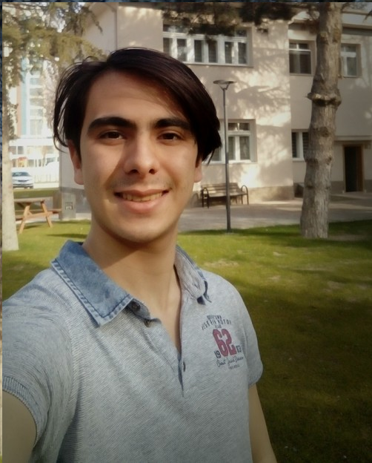

Çünür mah. Toki evl. C-2 blok no:15 Merkez/Isparta  
+90 544 551 25 42  
[emtiyltezkry@gmail.com](mailto:emtiyltezkry@gmail.com)

[emirhan.taze@agu.edu.tr](mailto:emirhan.taze@agu.edu.tr)

<https://www.linkedin.com/in/emirhan-taze-07a3b115b/>

*I am saphomore electrical and electronics student at Abdullah Gül University. In the last 2 years we studied on more than 6 projects including small ones. With these projects, I’m very experienced with Lego Mindstorms EV3 robots, analog filters, modulation technics, analog to digital convertion, digital filter and processing. Starting from 2nd year I started to study Undergraduate project about smart nanophotonics with Asst. Prof. Talha Erdem. Besides the university lessons, I’ve learned c#, python programming languages.*

Education:

High School: Özel Öbek Boğaziçi Anadolu Lisesi

Graduation: June 2017

University: Abdullah Gül University

Department: Electrical and Electronics Engineering (English)

Status: 2nd Year Student

GPA: 3.19

Relevant Skills:

|  |  |
| --- | --- |
| * Electrical engineering * Analytical thinking * English | * Electronics engineering * Programming skills (python, MATLAB, c#, java, Lego EV3, JavaScript, Html, CSS) * Teamwork skills |

Project History (Some of the projects don’t have documentation and small thus I didn’t list them):

1st Year Projects:

* **Electrical & Electronics Engineering 1st Year Integrated Project | Color Matcher Robot**
* **Electrical & Electronics Engineering 1st Year Art of Computing Project | Field Tiredness Map (FTM) Project**
* **Electrical & Electronics Engineering 1st Year Integrated Project | Border Surveillance Systems**

Link: <https://tetrahedronx.blogspot.com/2018/12/department-of-electrical-electronics.html>

* **Electrical & Electronics 1st Year Capsule | Frequency Modulation Radio Receiver**

Link: <https://tetrahedronx.blogspot.com/2019/02/aircraft-band-receiver.html>

<https://drive.google.com/file/d/1JJZZJwIHqUghkMW-uIAPdWs_0F8PeHlP/view>

2nd Year Projects:

* **Motion Game Controller Project | Signal Acquisition & Processing by MATLAB, Arduino**
* **Electrocardiography (ECG) System and Signal Analysis Software Development Project**
* **Electrocardiography (ECG) System & Signal Analysis & Processing Project**

Link: <https://drive.google.com/file/d/1U5BW7PS8FqVfCZWKofFu8CufspmlY_Zc/view>