Development​ ​Assignment​ ​1

Developer Tools

Web Technologies MSIS517L

Date: 09/29/2017

1. **Design Diagram:**

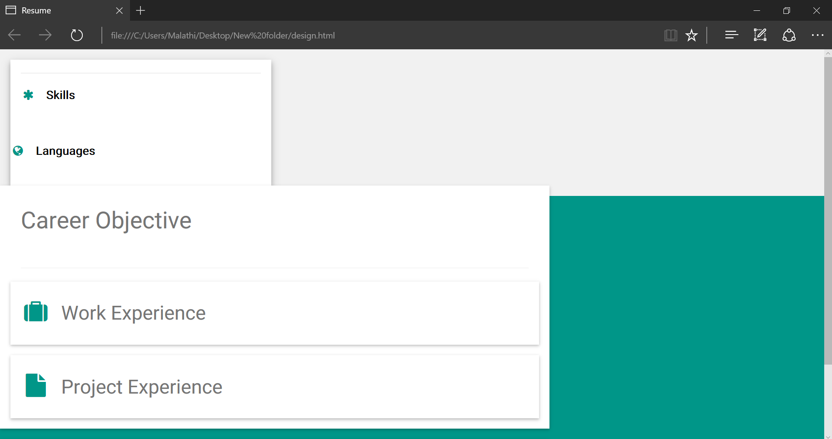

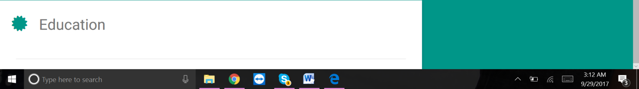

**2) Content Outline:**

* Career Objective
* Work Experience
* Skills
* Languages
* Project experience
* Education

**4) Screenshot of website:**

