Mainactivity.java

import android.support.v7.app.AppCompatActivity;  
import android.os.Bundle;  
import android.view.View;  
import android.widget.AdapterView;  
import android.widget.ArrayAdapter;  
import android.widget.ListView;  
import android.widget.Toast;  
  
public class MainActivity extends AppCompatActivity {  
  
 @Override  
 protected void onCreate(Bundle savedInstanceState) {  
 super.onCreate(savedInstanceState);  
 setContentView(R.layout.*activity_main*);  
 ListView listViewAnimals = (ListView) findViewById(R.id.*listView*);  
 final ArrayAdapter<CharSequence> adapterAnimals = ArrayAdapter.*createFromResource*(this,  
 R.array.*animalsArray*,  
 android.R.layout.*simple_list_item_1*);  
 listViewAnimals.setAdapter(adapterAnimals);  
  
 listViewAnimals.setOnItemClickListener(new AdapterView.OnItemClickListener() {  
 @Override  
 public void onItemClick(AdapterView<?> parent, View view, int position, long id) {  
 String message = getString(R.string.*toastMessage*) + adapterAnimals.getItem(position);  
 Toast.*makeText*(getApplicationContext(),  
 message,  
 Toast.*LENGTH_SHORT*).show();  
 }  
 });  
 }  
}

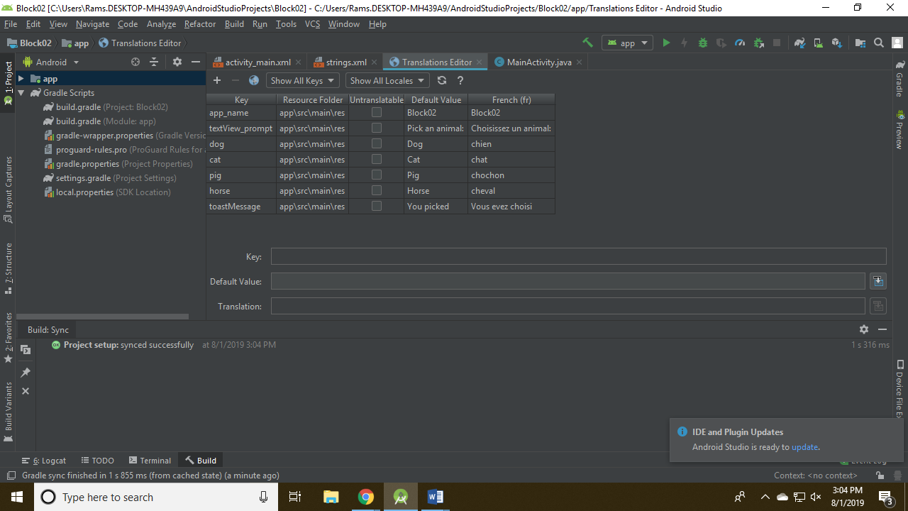

Strings.xml

<resources>  
 <string name="app_name">Block02</string>  
 <string name="textView_prompt">Pick an animal:</string>  
 <string name="dog">Dog</string>  
 <string name="cat">Cat</string>  
 <string name="pig">Pig</string>  
 <string name="horse">Horse</string>  
 <string name="toastMessage">You picked</string>  
 <string-array name="animalsArray">  
 <item>@string/dog</item>  
 <item>@string/cat</item>  
 <item>@string/pig</item>  
 <item>@string/horse</item>  
 </string-array>  
  
</resources>