F7 motor parts receipt

-------------------------------------------------------------------------------

A Introduction to Computing Project
Presented to the
Faculty of the College of Information Technology
Cagayan de Oro College
Cagayan de Oro City

-------------------------------------------------------------------------------

In Partial Fulfillment
of the Requirements for the Degree
Bachelor of Science in Information Technology

-------------------------------------------------------------------------------

NAME OF RESEARCHER

Ayudtod, Ryan B.
Cabezas, Rusty O.
Gamboa, Chris Gian Levi
Gumadlas, Harold
Loquias, Sam Milby
Pelimiano, Jhon Michael C.
Salapang, Mariel S.

APRIL, 2026

1.1 Introduction
Today’s world has become dependent on modern technologies to operate and support their customers’ needs. Technology continues to evolve and has a major impact on how businesses run. More than ever before, small business owners are using computer-based systems to assist with efficiency and cut down on labor. It has been stated by Yuwono et al. (2024) that through an organization’s use of Information Technologies (IT), they can increase the efficiency of their internal workings and be able to produce more products. A similar point was made by Ramadhani et al. (2025), who pointed out that Digital Point-of-Sale Systems greatly assist in automating the transaction process as well as cutting back on the amount of human error. With many motor part businesses having to make multiple purchases or deal with numerous customers throughout each day, it would be beneficial for them to have a receipt management system available. The motor part business of F7 Motor Parts, located at Ramon Chavez Street, Cogon, Cagayan de Oro City, Misamis Oriental, Philippines, currently writes receipts manually. Using this method of creating receipts could result in longer wait times when making transactions and miscalculations. As the volume of business increases, so will the necessity to create a system that will allow for faster, accurate, and easier processes. Therefore, the goal of F7 Motor Parts Receipt Pro is to create a receipt system that is easy to use and reliable for the purpose of supporting its business operations.

Manual transaction systems can produce many issues with operations. As Mistri (2025) described, one issue is the tendency for manual systems to experience errors by humans as well as less than optimal data handling. In addition, at F7 Motor Parts, all receipts are created by hand and also totaled manually, thereby increasing the likelihood of incorrect calculations on receipts. This will likely result in an increase in inaccuracies on receipts. The other challenge is the length of time needed to complete each transaction; particularly during periods of high volume demand when staff spend a significant amount of time calculating totals and creating receipts. Therefore, this creates a longer wait period for customers. In addition, Shehzadi (2025) mentioned that manual systems also provide a hindrance in managing and tracking past transaction information. This includes loss or misplacement of receipts from prior transactions. Further still, Madamidola et al. (2024) stated that the lack of electronic systems impacts operational productivity and record management. These examples illustrate why there is a need for a computerized receipt system.
This research is based on developing F7 Motor Parts Receipt Pro. It will be a console-based receipt application for F7 Motor Parts located at Raagas, Bonbon, Cagayan de Oro City. The application's goal is to simplify receipt creation as well as total calculations by automatically creating receipts with accurate totals. As stated in Ramadhani et al. (2025) as well as Zhang et al. (2021), using technology to create a digital system increases the operational efficiency of an auto parts business. Additionally, Ramadhani et al. (2025) states that reducing the number of transactions that are done manually with a computerized system will increase customer satisfaction and decrease human error. Therefore, by utilizing this new system, F7 Motor Parts can provide improved services through better quality, less errors in each transaction, and greater customer satisfaction.

1.2 Statement of the Problem
General Problem
F7 Motor Parts experiences difficulties in processing sales manually, which leads to slow transactions, inaccurate calculations, and inefficient tracking of customer purchases.
Specific Problem
- Manual Calculation Errors
Employees calculate totals by hand, which may result in mistakes in pricing or quantities during sales.
- Time-Consuming Transaction Process
Writing receipts manually and calculating totals slows down service, especially when customers buy multiple products.
- Limited Access to Transaction Records
Manual receipts can be misplaced, making it hard to review past sales during manual operations.

1.3 General Objectives
To develop a console-based receipt system for F7 Motor Parts that automates calculations, speeds up transactions, and stores sales temporarily for review during system runtime.
1.4 Specific Objectives
- To implement a login and sign-up system for cashiers
- To allow selection and editing of motor parts in a virtual cart
- To calculate totals and subtotals accurately to prevent manual errors
- To provide a cash payment system with change calculation
- To generate receipts with date and time
- To temporarily store and view transaction records during system runtime

Scope & Limitation
1.5 Scope
The proposed F7 Motor Parts Receipt Pro is a simple console-based system that supports basic sales operations. The system includes:
- Login and Sign-Up: Cashiers can create accounts and access the system.
- Customer Input: Enter customer names for each transaction.
- Product Selection and Cart Management: Select motor parts, add quantities, edit, or remove items.
- Receipt Generation: Automatically calculates subtotals and totals.
- Cash Payment Handling: Accept cash payments and calculate change.
- Transaction Records: Temporarily stores transactions for review during runtime.
- Menu Navigation and Error Handling: Simple interface with prompts and input validation

1.6 Limitation
The system is console-based and only temporarily stores transaction records, meaning all data is lost when the program exits. It does not support permanent storage, multi-user access, database integration, online connectivity, inventory tracking, or advanced features like receipt printing or search. The system is designed primarily for small-scale demonstration purposes and real-time sales management during program execution.
.
1.7 System Requirements
Hardware Requirements
- Processor: 1 GHz or higher CPU.
- RAM: 512 MB or higher.
- Storage: 50 MB free space
- Input: Keyboard for commands.
- Output: Console/terminal display and Monitor.
- Network: None required.
Software Requirements
- OS: Windows
- Language: Java.
- IDE: Visual Studio Code
- • JDK 8 or higher
- • Java Runtime Environment

Cashier Functional Requirements
- Login / Sign-Up: Cashier can create an account and log in to access the system.
- Enter Customer Name: Input the customer’s name for each transaction.
- Select Products: View available motor parts and choose items to add to the cart.
- Manage Cart: Add, edit, or remove items from the cart as needed.
- Checkout / Payment: Calculate total, accept cash payment, and compute change.
- Generate Receipt: Display receipt with customer name, cashier, items, prices, quantities, total, date, and time.
- View Transaction History: Temporarily view past transactions stored during program execution.
- Navigate Menu: Select actions via numeric options displayed in the console.

Non-Functional
- Usability: Clear prompts and menu navigation, easy to follow for cashiers.
- Reliability: Input validation to prevent invalid menu choices, negative quantities, or empty entries.
- Security: Basic login authentication to restrict access to cashiers.
- Performance: Fast in-memory operations with immediate calculation of totals and change.

1.8 Flowchart
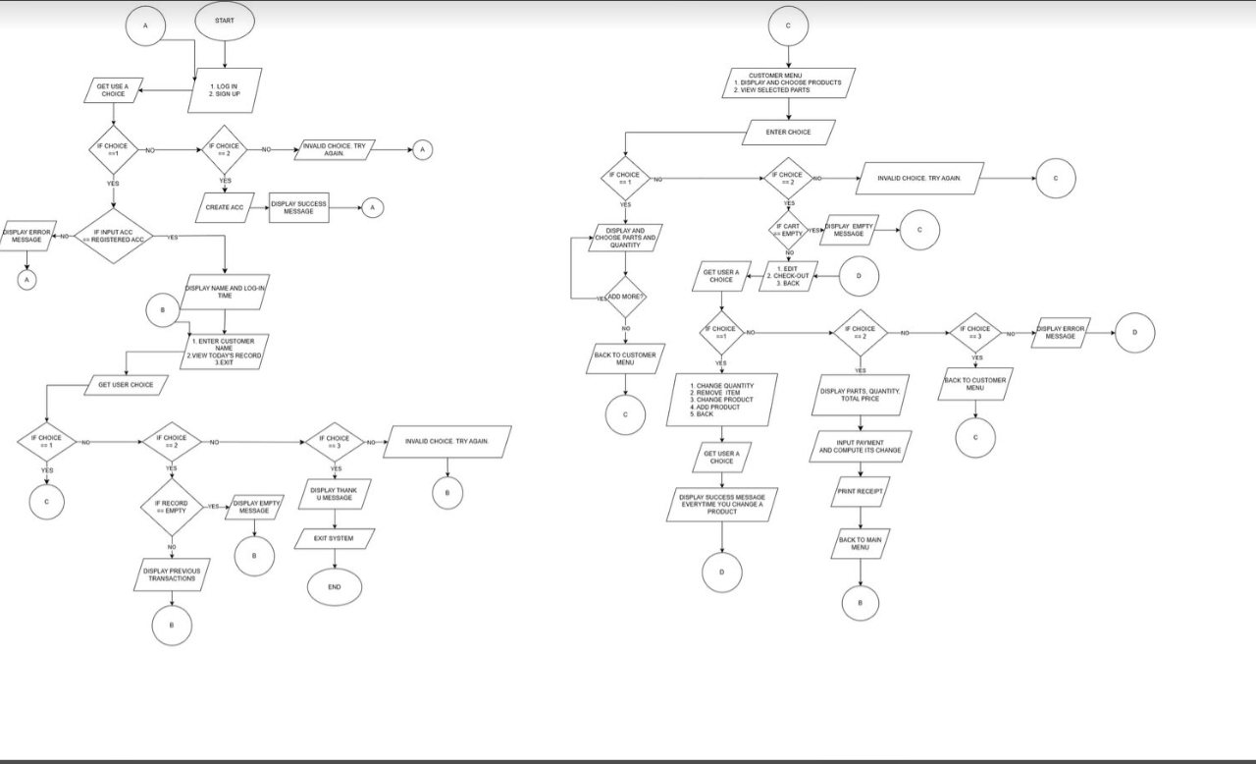

1.9 Code Snippet
