OS2023_Lab9_2019043890_LeeChangMin

1.After running ./createTest.x – create a New Thread

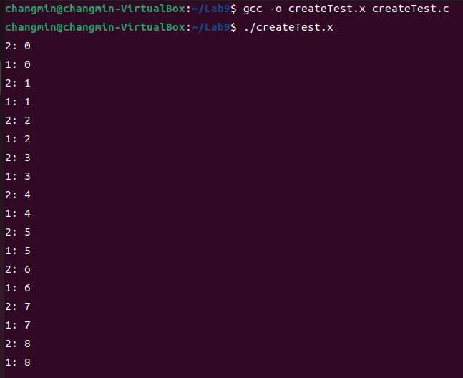

2. After running ./joinTest.x – Joining a Thread

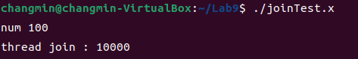

3. After running ./DetachTest.x – Detaching a Thread

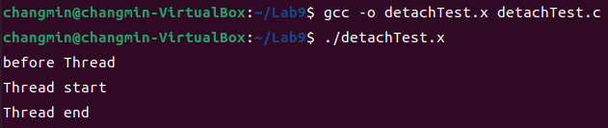

4. After running ./exitTest.x – Exiting a Thread

