OSLab10

2019043890 Lee ChangMin 이창민

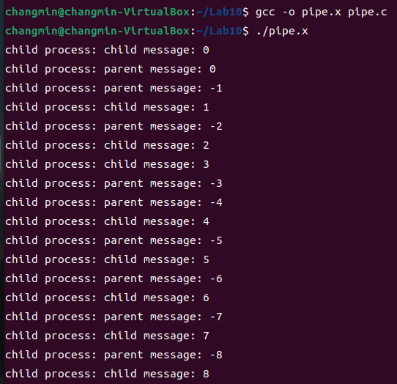

Two processes are created, each process sends message to other process.

Then each reads and prints its message.

Sender is sending a message, receiver receives it.

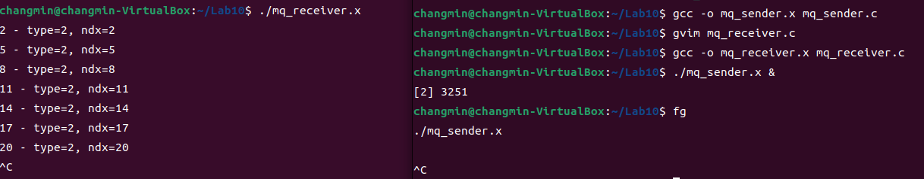

Message queue sender is sending a message.

Message queue receiver prints a message

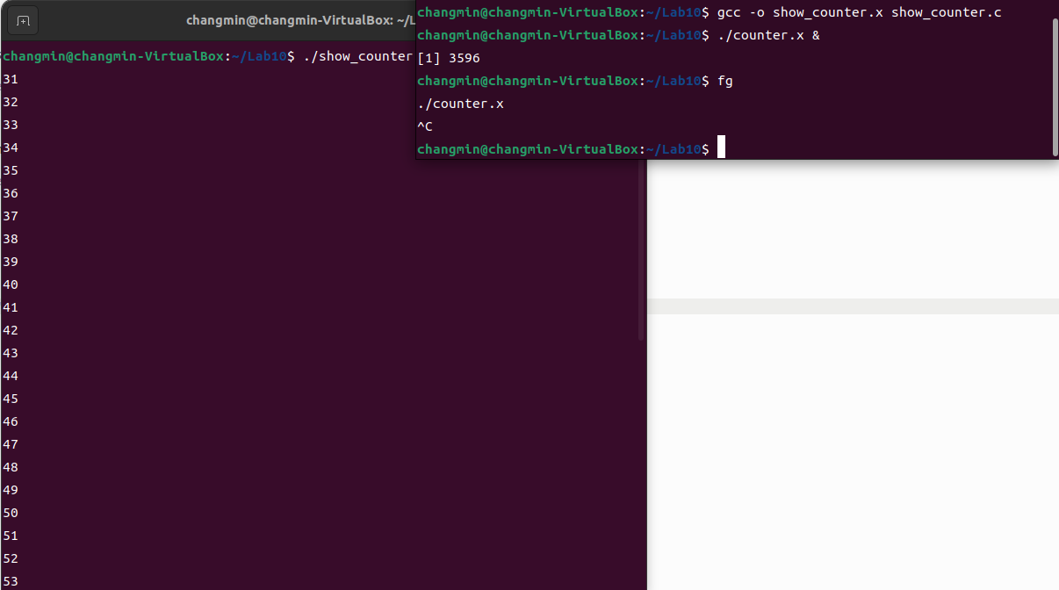

Counter is shared memory sender. Show_counter receives it.