**CA-3**

**CAP276: Data Communication and Networking – Laboratory**

**Note:**

1. **Odd roll number students of to perform Set A and Even roll number to perform Set B**
2. **Put the resultant Packet tracer file in my private lpulive account.**

**Dr. Avinash Bhagat: 11002**

**Given the network scenario**

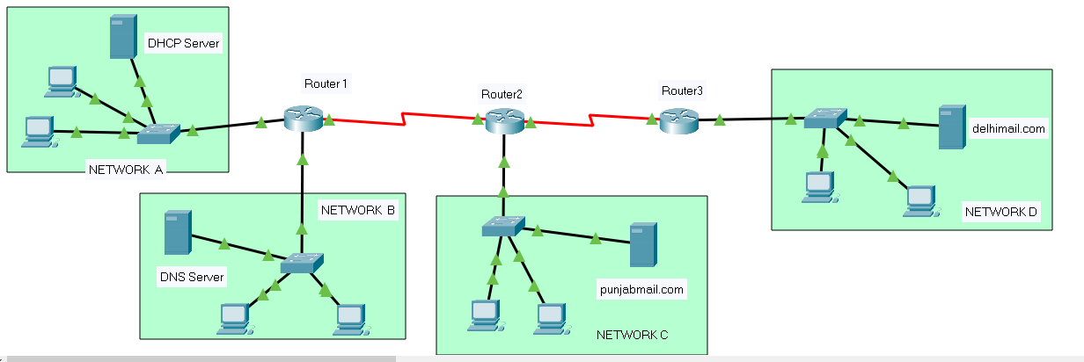

**SET-A**

Connect following three networks with following server in each network:

**Network Server**

A: 200.23.26.0 /24 DHCP Server

B: 191.220.0.0 /16 DNS Server

C: 207.45.65.0 /24 punjabmail server

D: 192.168.10.0/24 delhimail server

create at least two users for each email domain and demonstrate the e-mail communication between the users of different domains.

**SET-B**

Connect following three networks with following server in each network:

**Network Server**

A: 202.203.26.0 /24 DHCP Server

B: 191.219.0.0 /16 DNS Server

C: 107.45.65.0 /8 punjabmail server

D: 192.168.40.0/24 delhimail server

create at least two users for each email domain and demonstrate the e-mail communication between the users of different domains.