Forward-Secure Lattice-Based Encryption for IoT with ML-Enhanced Trust Scoring and Federated Learning

MAJOR PROJECT REPORT
Submitted in partial fulfillment for the award of the degree of
BACHELOR OF TECHNOLOGY
(Department of Computer Science and Engineering)

Submitted to
INDIAN INSTITUTE OF INFORMATION TECHNOLOGY
BHOPAL (M.P.)
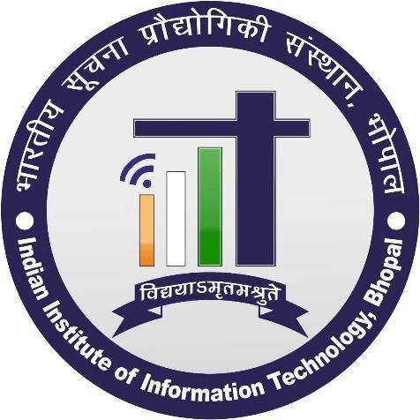
Submitted by
Jatin Rathore (23U02072)
Sathwik Krishna Kunapareddy (23U02145)
Mukund Mahakalkar (23U02045)
Jasvant Singh Dhaked (23U02054)

Under the supervision of
Dr. Saurabh Jain
Assistant Professor
Computer Science and Engineering
IIIT Bhopal

INDIAN INSTITUTE OF INFORMATION TECHNOLOGY
BHOPAL (M.P.)

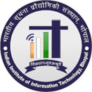

CERTIFICATE

This is to certify that the work embodied in this report entitled "Forward-Secure Lattice-Based Encryption for IoT with ML-Enhanced Trust Scoring and Federated Learning" has been satisfactorily completed by Jatin Rathore (23U02072), Sathwik Krishna Kunapareddy (23U02145), Mukund Mahakalkar (23U02045), and Jasvant Singh Dhaked (23U02054). It is a bona fide piece of work carried out under the guidance of Dr. Saurabh Jain in the Department of Computer Science and Engineering, Indian Institute of Information Technology, Bhopal, in partial fulfilment of the requirements for the award of the degree of Bachelor of Technology.

Date:

Dr. Saurabh Jain
Assistant Professor,
Computer Science and Engineering,
IIIT Bhopal (M.P.)
Dr. Rahul Chaurasia,
Minor Project Coordinator,
Computer Science and Engineering
IIIT Bhopal (M.P.)

INDIAN INSTITUTE OF INFORMATION TECHNOLOGY
BHOPAL (M.P.)
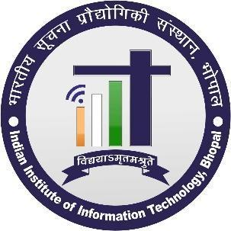

DECLARATION

We hereby declare that this major project report entitled "Forward-Secure Lattice-Based Encryption for IoT with ML-Enhanced Trust Scoring and Federated Learning" is an authentic account of the work carried out by us under the guidance of Dr. Saurabh Jain, Assistant Professor, Department of Computer Science and Engineering, Indian Institute of Information Technology, Bhopal, in partial fulfilment of the requirements for the award of the degree of Bachelor of Technology. The work presented in this report has been carried out by our group and has not been submitted, in whole or in part, to any other institute or organization for the award of any degree or professional diploma.

We further declare that the statements made above are true to the best of our knowledge.

Jatin Rathore (23U02072)
Sathwik Krishna Kunapareddy (23U02145)
Mukund Mahakalkar (23U02045)
Jasvant Singh Dhaked (23U02054)
ACKNOWLEDGEMENT

We, Jatin Rathore, Sathwik Krishna Kunapareddy, Mukund Mahakalkar and Jasvant Singh Dhaked, wish to express our sincere gratitude to all those who supported and guided us throughout the successful completion of our major project entitled "Forward-Secure Lattice-Based Encryption for IoT with ML-Enhanced Trust Scoring and Federated Learning". Their encouragement and assistance have been invaluable throughout this work.

First and foremost, we extend our heartfelt thanks to our esteemed Director, Prof. Ashutosh Kumar Singh, for providing the resources and facilities required to carry out this project. His encouragement and support have contributed greatly to our work.

We are deeply grateful to Dr. Saurabh Jain, our project supervisor, for his constant guidance, valuable suggestions, and thoughtful advice throughout the project. His knowledge and encouragement helped us strengthen the quality of our work and remain focused on its objectives.

We also sincerely thank Dr. Rahul Chaurasia for organizing and overseeing the project process. His assistance in addressing our queries and providing direction supported the smooth progress of the work.

We express our gratitude to all the faculty members of the Department of Computer Science and Engineering for their continued support and encouragement. Their teaching and knowledge have contributed to our technical understanding and helped us complete this project.

We also thank our friends for their support, useful suggestions, and help at various stages of the project. Their encouragement motivated us to continue our work with commitment.

Finally, we express our deepest gratitude to our parents and family members for their love, patience, and constant moral support throughout the project.

We are thankful to everyone who contributed, directly or indirectly, to the successful completion of this project.

Jatin Rathore (23U02072)
Sathwik Krishna Kunapareddy (23U02145)
Mukund Mahakalkar (23U02045)
Jasvant Singh Dhaked (23U02054)

