Forward-Secure Lattice-Based Encryption for IoT with ML-Enhanced Trust Scoring and Federated Learning

MAJOR PROJECT REPORT
Submitted in partial fulfillment for the award of the degree of
BACHELOR OF TECHNOLOGY
(Department of Computer Science and Engineering)

Submitted to
INDIAN INSTITUTE OF INFORMATION TECHNOLOGY
BHOPAL (M.P.)

Submitted by
Jatin Rathore (23U02072)
Sathwik Krishna Kunapareddy (23U02145)
Mukund Mahakalkar (23U02045)
Jasvant Singh Dhaked (23U02054)

Under the supervision of
Dr. Saurabh Jain
Assistant Professor
Computer Science and Engineering
IIIT Bhopal

INDIAN INSTITUTE OF INFORMATION TECHNOLOGY
BHOPAL (M.P.)



CERTIFICATE

This is to certify that the work embodied in this report entitled "Forward-Secure Lattice-Based Encryption for IoT with ML-Enhanced Trust Scoring and Federated Learning" has been satisfactorily completed by Jatin Rathore (23U02072), Sathwik Krishna Kunapareddy (23U02145), Mukund Mahakalkar (23U02045), and Jasvant Singh Dhaked (23U02054). It is a bona fide piece of work carried out under the guidance of Dr. Saurabh Jain in the Department of Computer Science and Engineering, Indian Institute of Information Technology, Bhopal, in partial fulfilment of the requirements for the award of the degree of Bachelor of Technology.

Date:

Dr. Saurabh Jain
Assistant Professor,
Computer Science and Engineering,
IIIT Bhopal (M.P.)
Dr. Rahul Chaurasia,
Minor Project Coordinator,
Computer Science and Engineering
IIIT Bhopal (M.P.)

INDIAN INSTITUTE OF INFORMATION TECHNOLOGY
BHOPAL (M.P.)


DECLARATION

We hereby declare that this major project report entitled "Forward-Secure Lattice-Based Encryption for IoT with ML-Enhanced Trust Scoring and Federated Learning" is an authentic account of the work carried out by us under the guidance of Dr. Saurabh Jain, Assistant Professor, Department of Computer Science and Engineering, Indian Institute of Information Technology, Bhopal, in partial fulfilment of the requirements for the award of the degree of Bachelor of Technology. The work presented in this report has been carried out by our group and has not been submitted, in whole or in part, to any other institute or organization for the award of any degree or professional diploma.

We further declare that the statements made above are true to the best of our knowledge.

Jatin Rathore (23U02072)
Sathwik Krishna Kunapareddy (23U02145)
Mukund Mahakalkar (23U02045)
Jasvant Singh Dhaked (23U02054)

ACKNOWLEDGEMENT

We, Jatin Rathore, Sathwik Krishna Kunapareddy, Mukund Mahakalkar and Jasvant Singh Dhaked, wish to express our sincere gratitude to all those who supported and guided us throughout the successful completion of our major project entitled "Forward-Secure Lattice-Based Encryption for IoT with ML-Enhanced Trust Scoring and Federated Learning". Their encouragement and assistance have been invaluable throughout this work.

First and foremost, we extend our heartfelt thanks to our esteemed Director, Prof. Ashutosh Kumar Singh, for providing the resources and facilities required to carry out this project. His encouragement and support have contributed greatly to our work.

We are deeply grateful to Dr. Saurabh Jain, our project supervisor, for his constant guidance, valuable suggestions, and thoughtful advice throughout the project. His knowledge and encouragement helped us strengthen the quality of our work and remain focused on its objectives.

We also sincerely thank Dr. Rahul Chaurasia for organizing and overseeing the project process. His assistance in addressing our queries and providing direction supported the smooth progress of the work.

We express our gratitude to all the faculty members of the Department of Computer Science and Engineering for their continued support and encouragement. Their teaching and knowledge have contributed to our technical understanding and helped us complete this project.

We also thank our friends for their support, useful suggestions, and help at various stages of the project. Their encouragement motivated us to continue our work with commitment.

Finally, we express our deepest gratitude to our parents and family members for their love, patience, and constant moral support throughout the project.

We are thankful to everyone who contributed, directly or indirectly, to the successful completion of this project.

Jatin Rathore (23U02072)
Sathwik Krishna Kunapareddy (23U02145)
Mukund Mahakalkar (23U02045)
Jasvant Singh Dhaked (23U02054)

AREA OF WORK
The major project focuses on post-quantum secure data sharing for Internet of Things (IoT) environments. It brings together forward-secure lattice-based identity-based encryption (fs-IBE), machine-learning-based trust scoring, and federated learning to strengthen access decisions and support collaborative learning across gateway nodes [18], [38], [43], [44].
The cryptographic component builds on lattice-based constructions related to the Learning with Errors problem [8]. Epoch-based key evolution is used to limit the exposure of earlier data if a current key is compromised, following the forward-secure IBE direction for IoT [1], [18]. The project studies this protection alongside practical constraints such as computation and key management in connected devices.
The trust component examines whether a request is consistent with observed device and user behavior. The updated model uses machine-learning-based anomaly assessment in addition to the existing verification flow, with the aim of identifying patterns that a fixed score may not distinguish. This work is informed by research on IoT anomaly detection and trust management [36], [37], [43], [44]. Post-quantum signatures authenticate federated model updates in the simulation, in line with the ML-DSA standard [45].
The federated-learning component models several gateways that train on local traffic data and send authenticated, encrypted model updates to an aggregation server. The server combines accepted updates using federated averaging, while the simulation also examines rejection of a tampered update. This approach reflects the privacy and coordination challenges discussed in federated learning for IoT security [38]-[42]. The evaluation uses synthetic data and simulated gateway activity; its results assess the implemented workflow rather than claim field performance.
TABLE OF CONTENT
S.no | Title | Page No.
 | Certificate
 | Declaration
 | Acknowledgement
 | Area of Work
 | List of Figures
 | List of Tables
 | Abstract
1 | Introduction
1.1 | The Quantum Threat to IoT
1.2 | Overcoming IoT Limitations with Advanced Cryptography
1.3 | Project Motivation and Scope
2 | Literature Review
2.1 | Identity-Based Encryption and Lattice Cryptography
2.2 | Forward Security and Key Evolution
2.3 | Trust Assessment and Machine-Learning-Based Detection
2.4 | Federated Learning for IoT Security
2.5 | Post-Quantum Authentication and Update Integrity
2.6 | Research Gap
3 | Problem Definition and Objectives
3.1 | Problem Statement
3.2 | Technical Challenges
3.3 | Objectives
4 | Proposed Methodology and Work Description
4.1 | System Architecture Overview
4.2 | Core System Components
4.3 | Step-by-Step System Flow and Work Description
5 | Implementation (Tools and Technology Used)
5.1 | Programming Language and Core Libraries
5.2 | Development and Experimentation Environment
5.3 | Implemented Cryptographic and Learning Components
5.4 | Data and Evaluation Tools
6 | Proposed Algorithm
6.1 | ML-Enhanced Trust Model Training and Scoring
6.2 | Request Verification and Authorization
6.3 | Protected Federated Update and FedAvg
6.4 | Forward-Secure Epoch Update and Decryption
7 | Result Discussion and Analysis
7.1 | Evaluation Setup
7.2 | Static and ML-Enhanced Trust Scoring
7.3 | Held-Out Classifier Performance
7.4 | Federated Learning Results
7.5 | Security Checks and Interpretation
7.6 | Summary of Results
8 | Conclusion and Future Work
 | References
LIST OF FIGURES
Fig | Description | Page no.
Fig. 1 | Proposed Integrated Framework for Forward-Secure IoT Data Sharing and Federated Trust Learning
Fig. 2 | Static and ML-Enhanced Trust Comparison
Fig. 3 | Held-Out Performance Across the Six Models and Ensemble
Fig. 4 | Confusion Matrices for Individual Models and Ensemble
Fig. 5 | Federated Global Model Convergence Across Five Rounds
Fig. 6 | Federated Metrics, Cryptographic Timings, and Gateway Update Outcomes
LIST OF TABLES
Table No | Description | Page no.
Table 1 | Summary of Literature Review
Table 2 | Static and ML-Enhanced Trust Scoring Results
Table 3 | Held-Out Model Performance on 8,000 Test Samples
Table 4 | Global Model Performance Across FedAvg Rounds
Table 5 | Federated Update Cryptographic Timings (Seconds per Round)
Table 6 | Security Checks Recorded in the Federated Simulation

ABSTRACT

This project presents a simulated framework for Internet of Things data sharing that combines forward-secure lattice-based identity-based encryption with machine-learning-based trust scoring and federated learning. The encryption layer follows an epoch-based forward-secure IBE design, with security motivation grounded in lattice problems such as Learning with Errors [8], [18]. The work brings cryptographic protection and request assessment into a common system workflow.

The updated trust-scoring evaluation compared static and machine-learning approaches using 100 legitimate requests and 100 attack requests. In this run, the machine-learning approach detected 80 attacks, while the static method detected 20; both accepted all 100 legitimate requests. The separate held-out evaluation used 40,000 synthetic samples, with 32,000 for training and 8,000 for testing. The combined ensemble reached 95.76% accuracy, 92.51% recall, and an 89.08% F1-score. These experiments address anomaly detection and trust assessment concerns identified in IoT research [36], [37], [43], [44].

The federated-learning simulation involved three honest gateways and one gateway that submitted tampered updates across five FedAvg rounds. Global accuracy increased from 0.8255 in the first round to 0.9345 in the fifth, while the F1-score increased from 0.3590 to 0.8150. The three honest updates were accepted in each round, and the tampered update was rejected in rounds two and four. Federated learning supports collaborative model training without pooling raw gateway data [38]-[42]; in this implementation, updates were encrypted with the lattice-based scheme and authenticated using ML-DSA-65 signatures [18], [45].

The results demonstrate the behavior of the implemented components under the stated synthetic-data and simulation conditions. They provide a basis for examining the interaction of forward-secure encryption, adaptive trust assessment, and federated model aggregation in an IoT setting. Further evaluation with real device traffic and deployment-scale resources would be needed to establish operational performance.

- Introduction

Internet of Things (IoT) deployments bring together sensors, medical monitors, industrial controllers, smart meters, and gateways that collect and exchange information with limited direct supervision. These devices may handle personal, operational, or safety-related data, so the system must protect confidentiality while also checking who is requesting access and whether the request is trustworthy. Conventional public-key infrastructure can be difficult to administer across large populations of constrained devices, and the long service life of some IoT equipment makes the future security of stored and transmitted data a practical concern [2], [6], [7].

1.1 The Quantum Threat to IoT
A sufficiently capable quantum computer would threaten public-key systems whose security depends on factoring or discrete logarithms. Shor's algorithm gives a polynomial-time method for those problems, motivating the transition to post-quantum cryptography [2]. The concern is especially relevant to IoT because data captured now may remain sensitive for years. Lattice-based cryptography is among the approaches being studied for this transition, with Learning with Errors providing a central hardness foundation [8], [21].

Replacing a conventional algorithm does not by itself address key exposure over time. A device that is compromised may reveal the secret key it currently holds, while earlier ciphertexts can remain valuable to an attacker. Forward-secure encryption addresses this problem by evolving secret keys across time periods and restricting the use of a later key for earlier epochs [1]. The project adopts an epoch-based lattice IBE design for IoT, following the forward-secure construction studied by Jin et al. [18].

1.2 Overcoming IoT Limitations with Advanced Cryptography
The project treats IoT security as a combination of related tasks: protecting data, managing changing keys, authenticating requests, and identifying suspicious behavior. Identity-based encryption can simplify recipient addressing by deriving public encryption information from an identity, while lattice-based constructions provide a post-quantum direction for that design [3], [4], [8], [18]. The prototype studies these properties in a unified workflow rather than treating encryption and access assessment as unrelated components.

In the implemented workflow, device data is encrypted for an identity and an epoch, and the corresponding secret key evolves as the system advances. This structure is intended to limit the exposure of prior epochs after a later key compromise. The work examines encryption, decryption, and epoch transitions as part of a software simulation; it does not claim a formal security proof or production-grade cryptographic implementation [1], [18].

Access decisions also require information about the behavior of the entity making a request. The updated trust component evaluates behavioral features with machine-learning models and compares the resulting decisions with a static trust rule. This direction is consistent with research on anomaly detection and trust management in IoT networks [36], [37], [43], [44]. The machine-learning score supplements the system's cryptographic checks; it is not a substitute for identity or signature verification.

The project further models several gateways that train on locally held traffic data and contribute model updates to a shared global model. Federated learning supports this form of collaborative training while keeping the clients' raw training records local, although model updates themselves still require protection and validation [38]-[42]. The implemented simulation uses FedAvg, encrypts updates through the lattice-based communication workflow, and authenticates them with ML-DSA-65 signatures [18], [40], [45].

Because distributed training can be exposed to faulty or malicious participants, the simulation includes a gateway that submits tampered updates. The aggregator verifies update signatures before accepting them, and the experiment records whether honest and tampered submissions are accepted or rejected. This is a focused integrity check; it should not be interpreted as a complete defense against every Byzantine or poisoning strategy described in adversarial machine-learning research [45], [46].

1.3 Project Motivation and Scope
The motivation for this major project is to bring together forward-secure, post-quantum encryption with adaptive trust assessment and privacy-conscious collaborative learning. Existing work addresses lattice-based forward-secure IBE, IoT anomaly detection, and federated intrusion detection, but integrating these elements into one executable workflow raises practical questions about their interaction, update authentication, and measured behavior [18], [36]-[44].

Accordingly, the project implements and evaluates a software prototype with four related objectives: to exercise identity- and epoch-based lattice encryption; to compare static trust scoring with machine-learning-based scoring on synthetic request data; to simulate federated training across multiple gateways with encrypted and signed updates; and to record detection, model-quality, and update-validation outcomes. The scope is limited to the supplied implementation and its synthetic-data experiments. The reported results are therefore evidence about these runs, not guarantees of performance on a live IoT deployment [18], [40], [43]-[45].

- Literature Review

Research on secure data sharing for the Internet of Things spans identity-based encryption, post-quantum cryptography, forward security, behavioral trust assessment, and distributed learning. These strands address different parts of the same operational problem: protecting data over long device lifetimes while deciding whether requests and collaborating gateways should be trusted. This chapter reviews the foundations and relevant developments, then identifies the gap addressed by the present project [18], [36]-[44].

2.1 Identity-Based Encryption and Lattice Cryptography
Shamir introduced identity-based encryption (IBE) in which a user identity can serve as public encryption information, reducing the need to distribute a separate certificate for every recipient [3]. Boneh and Franklin later gave a practical pairing-based IBE construction [4]. These works established an influential approach to key management, although pairing-based systems rely on mathematical problems that are vulnerable to sufficiently capable quantum computers [2], [8].
Lattice-based cryptography offers a post-quantum alternative. Regev formalized the Learning with Errors problem and its connection to worst-case lattice problems [8]. Gentry, Peikert, and Vaikuntanathan developed trapdoor methods that support constructions such as lattice-based IBE, while later work refined the efficiency of lattice trapdoors [9], [12]. Lattice schemes remain demanding for constrained devices because their keys, ciphertexts, and matrix operations can impose significant storage and computation costs [9], [21].
For IoT, the design question is therefore not simply whether a primitive is post-quantum. A practical system must also account for device resources, identity and key management, and the lifetime of protected data. Earlier work on lattice-based access control and revocable IBE addresses parts of this problem, but does not by itself provide the combination of epoch-based forward security and behavior-based query assessment examined here [15], [19], [20].

2.2 Forward Security and Key Evolution
Forward-secure encryption limits the consequences of a later secret-key compromise by preventing a key for a current period from decrypting ciphertexts associated with earlier periods. Canetti, Halevi, and Katz formalized tree-based key evolution for forward-secure public-key encryption [1]. Such designs are relevant to IoT devices that may operate unattended and remain exposed to physical capture over extended periods [6], [18].
Lattice-based forward-secure IBE combines identity-based addressing with key evolution across epochs. Jin et al. describe a lattice-based forward-secure IBE scheme designed for IoT [18]. This work provides the principal cryptographic foundation for the present project. Key evolution, however, addresses past-key exposure; it does not establish whether a correctly authenticated user is making a benign or appropriate request. That distinction motivates a separate trust-assessment layer [18], [43].

2.3 Trust Assessment and Machine-Learning-Based Detection
Encryption protects confidentiality but does not alone determine whether a request should be served. IoT trust-management research considers identity, observed behavior, and access policy as complementary inputs to a decision [43]. Surveys of machine-learning-based trust assessment and IoT anomaly detection describe methods for identifying behavior that departs from a device or user's expected pattern [36], [37], [44].
Static trust rules are straightforward to interpret, but a fixed score may not capture combinations of behavioral signals or changing patterns. Machine-learning models can use features derived from request frequency, epoch consistency, signature history, and other observed behavior to classify or score requests. Their effectiveness depends on representative data, suitable thresholds, and evaluation that distinguishes attack detection from false alarms [36], [37], [44].
The present project evaluates this extension through a comparison between static trust scoring and an ML-enhanced model, and through a separate held-out evaluation of several classifiers and an ensemble. These are distinct experiments on synthetic data, so their metrics should not be combined into a single estimate. The evaluation is intended to demonstrate model behavior within the implemented simulation and should be interpreted with that scope in mind [36], [37], [44].

2.4 Federated Learning for IoT Security
Federated learning allows multiple clients to train a shared model while keeping their local training records at their respective sites. FedAvg aggregates client model updates using a weighted average and established a widely used baseline for collaborative training [40]. Broader surveys describe the privacy, communication, data heterogeneity, and robustness questions that remain open in federated learning [41].
Research has examined federated learning for IoT intrusion detection and anomaly monitoring, including the challenge of training across distributed devices and gateways with different traffic distributions [38], [39], [42]. Keeping raw examples local can reduce direct data centralization, but it does not make model updates intrinsically private or trustworthy. Secure transport, participant authentication, and checks on submitted updates remain important parts of a deployment [41], [42].
In this project, gateways participate in a simulated FedAvg process. Their model updates are encrypted through the lattice-based communication workflow and authenticated with ML-DSA-65 signatures, based on the standardized module-lattice signature scheme [18], [45]. A tampered update is included to examine signature-based rejection. This experiment evaluates update integrity in the implemented workflow; it does not claim comprehensive protection against all poisoning or Byzantine attacks [45], [46].

2.5 Post-Quantum Authentication and Update Integrity
Digital signatures provide evidence that a message or model update was produced by an entity holding the corresponding signing key and that the signed content has not been altered. NIST standardized ML-DSA in FIPS 204, providing a post-quantum signature mechanism based on module lattices [45]. In a distributed-learning system, signature verification can be used to reject modified or unauthenticated submissions, while separate aggregation defenses are needed to address malicious but validly signed updates [45], [46].
2.6 Research Gap
The literature provides foundations for identity-based encryption, lattice-based post-quantum protection, forward-secure key evolution, IoT trust assessment, and federated learning [1], [8], [18], [36]-[45]. These lines of work are often studied separately. The remaining practical question is how these components behave when combined: whether epoch-based encryption, adaptive trust assessment, and authenticated federated updates can operate as one coherent IoT workflow, and what trade-offs appear in a controlled simulation.
This project addresses that question through a prototype that connects lattice-based forward-secure IBE, ML-enhanced trust scoring, and a multi-gateway FedAvg simulation. It compares ML and static trust outcomes, reports a separate held-out classifier evaluation, and records model quality and update acceptance over federated rounds. The experiments use synthetic data and do not constitute a formal security proof or a deployment-scale benchmark. Table 1 summarizes selected contributions and limitations from the literature relevant to these components [18], [36]-[46].

Table 1: Summary of Literature Review
S.No | Article | Journal / Conference | Methodology | Contribution / Limitation
1 | Identity-Based Cryptosystems and Signature Schemes - Shamir [3] | CRYPTO (1984) | Introduces identity as public encryption information | Establishes IBE; practical construction followed later
2 | Identity-Based Encryption from the Weil Pairing - Boneh and Franklin [4] | CRYPTO (2001) | Pairing-based IBE under the BDH assumption | Practical IBE construction; pairing assumptions are not post-quantum
3 | On Lattices, Learning with Errors, and Cryptography - Regev [8] | JACM (2009) | Studies LWE and its connection to worst-case lattice problems | Provides a foundation for lattice cryptography; implementations can be resource-intensive
4 | Trapdoors for Hard Lattices and New Cryptographic Constructions - Gentry et al. [12] | STOC (2008) | Develops lattice trapdoor techniques and sampling methods | Enables lattice-based constructions; key and computation costs remain relevant
5 | Trapdoors for Lattices: Simpler, Tighter, Faster, Smaller - Micciancio and Peikert [9] | EUROCRYPT (2012) | Refines lattice trapdoor generation | Improves efficiency; constrained-device costs still require attention
6 | A Forward-Secure Public-Key Encryption Scheme - Canetti et al. [1] | EUROCRYPT (2003) | Uses tree-based key evolution across time periods | Protects earlier periods after later key exposure; not a lattice construction
7 | Lattice-Based Access Control for IoT - Chen et al. [15] | IEEE TIFS (2019) | Applies lattice methods to IoT access control | Post-quantum direction; does not combine the ML trust and FL workflow studied here
8 | A Lattice-Based Forward-Secure IBE Scheme for IoT - Jin et al. [18] | Information Sciences (2024) | Combines lattice-based IBE with epoch-based forward security | Direct cryptographic foundation for this project; resource and integration questions remain
9 | Efficient Lattice-Based Integrated Revocable IBE - Huang et al. [19] | Scientific Reports (2025) | Uses an integrated revocation approach for lattice IBE | Addresses revocation and key management; behavior-based trust is outside its focus
10 | IoT Anomaly Detection Methods and Applications - Chatterjee and Ahmed [36] | Internet of Things (2022) | Surveys anomaly-detection methods for IoT | Maps detection approaches; performance depends on data and evaluation setting
11 | AI-Based Anomaly Detection in IoT and Sensor Networks - DeMedeiros et al. [37] | Sensors (2023) | Reviews AI-based anomaly detection methods | Identifies methods and challenges; does not prescribe one universal model
12 | Evaluating Federated Learning for IoT Intrusion Detection - Marmol Campos et al. [38] | Computer Networks (2022) | Reviews federated learning for IoT intrusion detection | Highlights distributed-learning potential and open implementation challenges
13 | Federated-Learning-Based Anomaly Detection for IoT Security Attacks - Mothukuri et al. [39] | IEEE IoT Journal (2022) | Studies federated anomaly detection for IoT attacks | Supports decentralized detection; federation and data variation affect results
14 | Communication-Efficient Learning of Deep Networks from Decentralized Data - McMahan et al. [40] | AISTATS (2017) | Introduces FedAvg for aggregating local model updates | Reduces raw-data movement; update integrity and robustness need separate controls
15 | Advances and Open Problems in Federated Learning - Kairouz et al. [41] | Foundations and Trends in ML (2021) | Surveys FL methods, privacy, systems, and robustness | Frames key open problems, including privacy and heterogeneous clients
16 | Federated Learning for IoT Intrusion Detection - Lazzarini et al. [42] | AI (2023) | Reviews FL for intrusion detection in IoT | Relevant to gateway collaboration; deployment constraints remain
17 | A Survey of Trust Management for IoT - Konsta et al. [43] | IEEE Access (2023) | Reviews trust models and management in IoT | Provides trust-management context; models vary by application and evidence
18 | A Survey on Machine Learning for IoT Trust Management - Akli and Chougdali [44] | IEEE GCAIoT (2023) | Reviews ML methods for IoT trust assessment | Motivates adaptive scoring; data quality and interpretability remain concerns
19 | Module-Lattice-Based Digital Signature Standard - NIST [45] | FIPS 204 (2024) | Specifies ML-DSA for digital signatures | Provides standardized post-quantum authentication; does not itself secure aggregation
20 | Machine Learning with Adversaries: Byzantine Tolerant Gradient Descent - Blanchard et al. [46] | NeurIPS (2017) | Studies gradient aggregation under Byzantine participants | Addresses adversarial updates; broader defenses are outside this prototype

3. Problem Definition and Objectives
This chapter states the problem addressed by the project, identifies the technical challenges that shape its implementation, and sets out the objectives used to guide the prototype and its evaluation.
IoT data-sharing systems must protect information over time, make access decisions for individual requests, and support coordinated detection across distributed gateways. These requirements are difficult to satisfy together. Lattice-based forward-secure IBE addresses post-quantum confidentiality and key evolution, while ML-based trust assessment and federated learning introduce additional model-quality, update-integrity, and resource questions [1], [18], [38]-[45].
3.1 Problem Statement
The project addresses the problem of integrating forward-secure lattice-based encryption, behavior-based trust scoring, and collaborative model learning within an IoT data-sharing workflow. Encryption alone does not determine whether a request is suspicious, and an ML trust score alone cannot protect stored data or authenticate an update. Similarly, federated learning can support collaborative detection, but its gateway updates require confidentiality and integrity checks. The implementation therefore examines how these components can work together and what outcomes can be measured in a controlled simulation [18], [36]-[45].
3.2 Technical Challenges
The problem gives rise to several linked technical challenges that inform the design and evaluation of the system:
- Cryptographic key evolution: The encryption workflow must associate ciphertexts with identities and epochs while advancing secret keys over time. The prototype must represent this forward-secure behavior and check that a later key cannot be used to decrypt an earlier-epoch ciphertext in the evaluated scenario [1], [18].
- Trust assessment and data quality: The ML-enhanced trust model must distinguish malicious activity from legitimate variation without treating a synthetic-data score as proof of real-world performance. Static and ML-based decisions therefore need to be evaluated separately, with attention to attack detection, false alarms, and the scope of the training and test data [36], [37], [43], [44].
- Federated update integrity: Gateway updates must be encrypted and authenticated before aggregation. Signature verification can detect altered or unauthenticated updates, but by itself does not prevent a malicious participant from submitting a harmful update signed with a valid key. The current simulation focuses on update authentication and rejection of tampering; broader poisoning defenses remain an open challenge [40], [41], [45], [46].
- Resource and integration costs: Lattice operations, ML inference, signature processing, and repeated model communication all contribute to the system cost. These costs must be recorded in a way that distinguishes the separate evaluation runs and reflects that measured timings depend on the software and hardware environment [9], [18], [41], [42].

3.3 Objectives
The objective of this major project is to implement and study an integrated IoT security prototype with the following goals:
- Implement an identity- and epoch-based lattice forward-secure encryption workflow and examine key evolution using the available simulation [1], [8], [18].
- Incorporate ML-enhanced trust scoring into the request-assessment process and compare its behavior with the static trust baseline using the updated synthetic-data evaluation [36], [37], [43], [44].
- Simulate collaborative model training across multiple gateways using FedAvg, with model updates encrypted through the lattice-based workflow and authenticated using ML-DSA-65 signatures [18], [40], [45].
- Record detection and classification measures, federated-round model quality, update acceptance or rejection, and relevant cryptographic timings, while reporting the limits of the simulated evaluation [38]-[42], [45], [46].
Together, these objectives define a prototype-level investigation of how forward-secure encryption, adaptive trust assessment, and federated learning can be coordinated in an IoT setting. The intended contribution is an implemented and measured workflow; claims about deployment-scale security or performance require further analysis and validation [18], [41], [43]-[46].
4. Proposed Methodology and Work Description
This chapter describes the system architecture and the sequence used to integrate forward-secure lattice encryption, ML-enhanced trust scoring, and federated learning. The prototype is evaluated through software simulations; the workflow is summarized in Fig. 1.
4.1 System Architecture Overview
The system is organized around four cooperating roles: IoT data producers, a trusted coordination layer, gateway clients participating in federated learning, and authorized data consumers. IoT data is encrypted and stored with an identity and epoch context. Requests pass through cryptographic and behavioral checks before data is released. Gateway training remains local, while signed and encrypted model updates are submitted to the federated aggregator [18], [38]-[45].
- Data producers: IoT end devices generate sensor readings and encrypt them for the intended identity and epoch before transmission. Gateways can also train local trust or anomaly models on locally available traffic records; raw training examples remain at the client in the simulated federated workflow [18], [40]-[42].
- Trusted coordination layer: The authority initializes system parameters and manages identity and epoch-related keys. The access gateway coordinates requests, while the trust manager combines the ML-derived assessment with cryptographic verification. Encrypted storage retains ciphertexts for later authorized retrieval [1], [18], [43], [44].
- Federated aggregator: The aggregation server verifies the integrity and authenticity of incoming updates, decrypts accepted updates through the configured lattice-based channel, and combines eligible client contributions using FedAvg. The simulation includes honest clients and a tampered submission to observe acceptance and rejection behavior [40], [41], [45], [46].
Data consumers: Authorized users construct requests for data associated with an identity and epoch. After the request passes signature, trust, and epoch checks, the matching ciphertext is returned for local decryption with the current valid epoch key [1], [18], [43].
4.2 Core System Components
The prototype is implemented as connected software modules. The modules separate lattice parameter and key operations, epoch-based encryption, trust-feature processing, federated client training, aggregation, and result recording. This organization allows each stage to be evaluated while preserving the complete system flow [18], [40], [45].
- Lattice encryption and key evolution: The encryption component provides setup, identity-based key generation, encryption, decryption, and epoch update operations. Ciphertexts are bound to their intended identity and time period. Forward-security checks examine whether a ciphertext from an earlier epoch remains inaccessible after the key advances [1], [8], [18].
- ML trust engine: The trust module extracts behavioral features and evaluates request activity using the trained anomaly-detection models and ensemble. Its output informs an allow-or-block decision alongside the existing cryptographic checks. The evaluation compares this path with a static trust baseline [36], [37], [43], [44].
- Federated client and aggregator: Each simulated gateway trains on its local partition and returns a model update. The update is encrypted for transport and signed with ML-DSA-65; the aggregator verifies the signature before accepting the update for FedAvg [40], [41], [45].
- Encrypted storage and result logger: The storage component holds encrypted records and returns a matching ciphertext only after the request passes the required checks. The logger records trust decisions, model metrics, gateway acceptance, and cryptographic timings for later analysis [18], [38], [39].
4.3 Step-by-Step System Flow and Work Description
The implementation follows the stages below. Figure 1 presents the combined data-sharing and federated-learning paths.

Phase 1: System setup and key initialization
Step 1 - Parameter setup: The authority initializes the lattice parameters and the master and public key material used by the prototype. These parameters establish the encryption context for identities and epochs [8], [18].
Step 2 - Identity and client initialization: IoT devices, authorized consumers, and gateway clients are assigned identities and initialized with the keys or local model state needed for their respective roles [18], [40].
Step 3 - Epoch key distribution: The authorized consumer receives the secret key for the active epoch through the modeled key-generation and distribution process. The key is updated as the system advances between epochs [1], [18].

Phase 2: Data encryption and storage
Step 4 - Encrypted data upload: An IoT producer encrypts its data for the intended identity and current epoch, then sends the ciphertext to storage. The storage layer retains ciphertext rather than the plaintext reading [18].

Phase 3: Request assessment and trust decision
Step 5 - Request construction: A consumer forms a request containing the target data or keyword and the relevant epoch. The request is signed using the configured post-quantum signature mechanism so that its contents can be verified [45].
Step 6 - Feature extraction and verification: The gateway checks request structure, identity, signature validity, and epoch context. It derives behavioral features for the ML trust engine from the request and available activity history [36], [43]-[45].
Step 7 - Trust-based decision: The system combines the ML trust assessment with the cryptographic checks and configured decision rule. Requests that fail signature or epoch validation, or fall below the trust threshold, are rejected; accepted requests proceed to retrieval [36], [43]-[45].

Phase 4: Retrieval and decryption
Step 8 - Ciphertext retrieval: For an accepted request, storage returns the matching identity- and epoch-bound ciphertext. The consumer decrypts it locally using the valid secret key for that epoch [1], [18].
Phase 5: Federated training and aggregation
Step 9 - Local training: Each gateway trains or updates its local model using its own traffic partition. The client retains its raw training records locally and prepares a model update for the aggregation round [40]-[42].
Step 10 - Protected update submission: The gateway encrypts the update through the lattice-based communication workflow and signs the update with ML-DSA-65. The aggregator verifies the signature and rejects an update whose signed content does not verify [18], [45].
Step 11 - Aggregation and distribution: The aggregator combines accepted client updates using FedAvg and returns the global model to participating gateways for the next round. The simulation records model quality and client acceptance by round [40], [41].

Phase 6: Epoch advancement and evaluation
Step 12 - Key update and security checks: At an epoch transition, the key state advances according to the implemented update procedure. The evaluation checks forward-security behavior, signature tampering, ML trust decisions, and federated update handling within the simulated environment [1], [18], [45], [46].
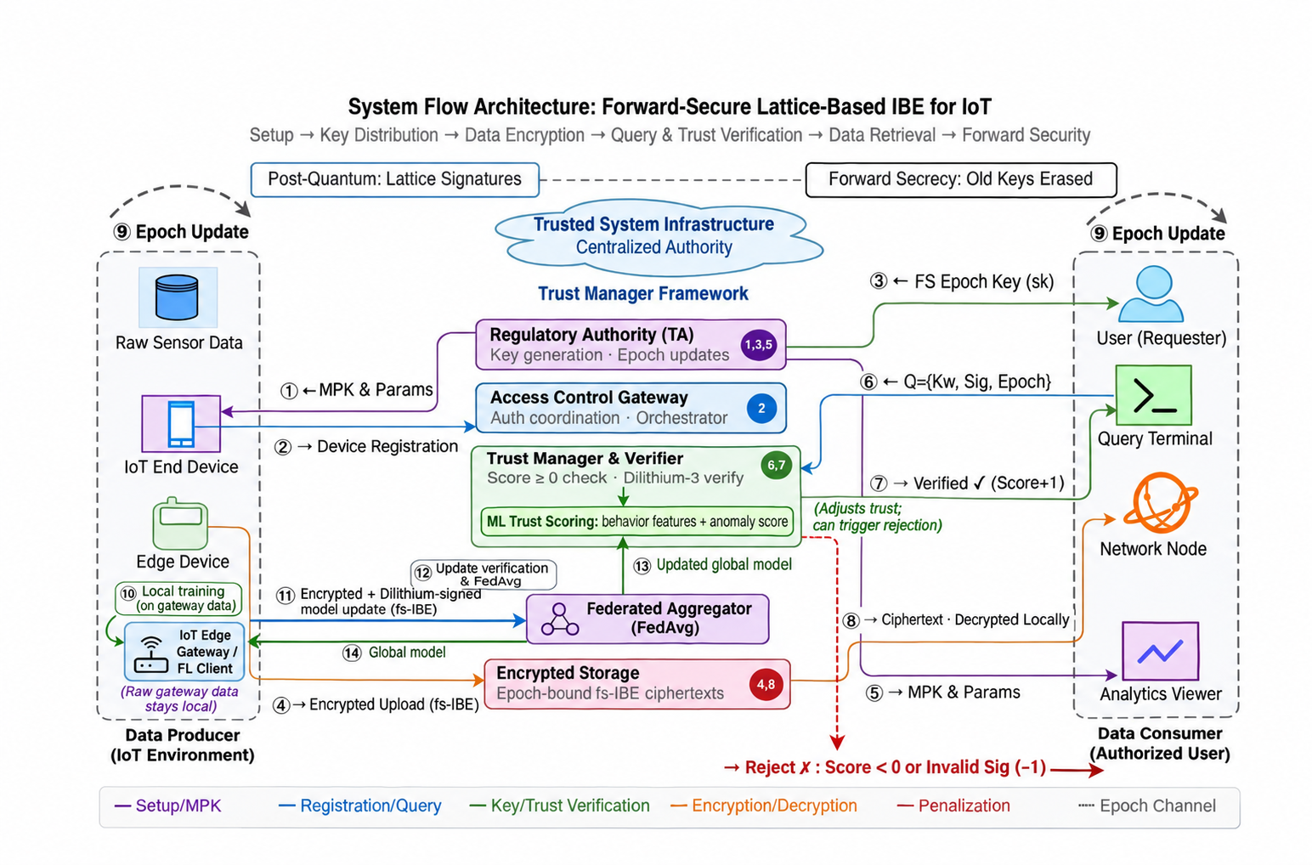
Fig. 1: Proposed Integrated Framework for Forward-Secure IoT Data Sharing and Federated Trust Learning

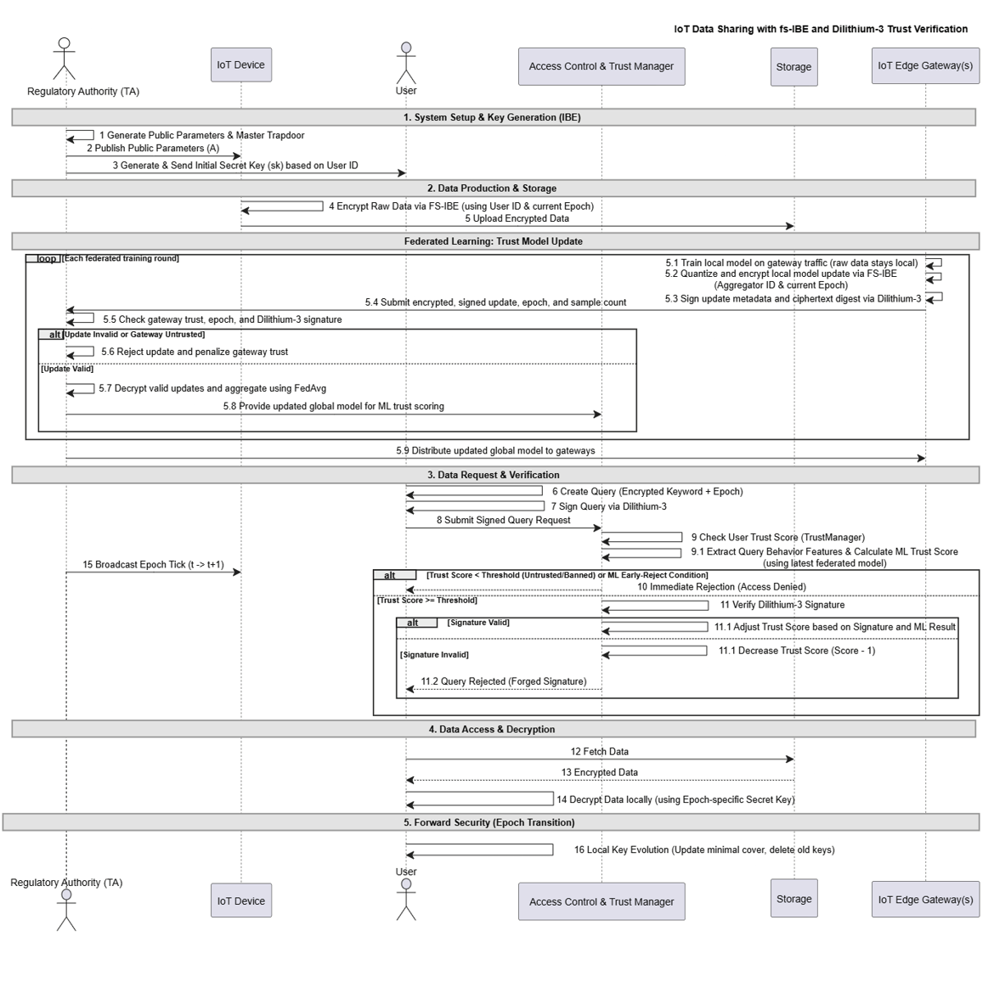
Fig 2:
5. Implementation (Tools and Technology Used)
This chapter describes the software environment, libraries, cryptographic components, machine-learning tools, and development resources used to implement and evaluate the prototype.
5.1 Programming Language and Core Libraries
- Python: The project is implemented in Python. Its scientific-computing and machine-learning ecosystem supports the development of the lattice operations, trust models, federated simulation, and result analysis in one environment.
- NumPy: NumPy arrays and numerical operations are used for lattice parameters, feature matrices, model weights, and federated aggregation. It also supports the generation and manipulation of synthetic experiment data.
- scikit-learn: The ML trust experiments use scikit-learn components, including Isolation Forest, Random Forest, Support Vector Machine, K-Nearest Neighbors, Decision Tree, and Multi-Layer Perceptron models, together with preprocessing, train-test splitting, and classification metrics.
- Python standard libraries: hashlib supports deterministic hashing operations used in the cryptographic prototype. json and csv support configuration, result logging, and export of the simulation metrics.
5.2 Development and Experimentation Environment
- Jupyter Notebook: The updated ML-trust and federated-learning experiments are organized in Jupyter notebooks. The notebook environment supports staged execution, inspection of intermediate results, and recording of model and simulation outputs.
- Supporting scripts and visualizations: Python modules implement the trust engine, attack-data generation, lattice operations, forward-secure key updates, federated clients, and aggregation server. Matplotlib is used to plot model performance and federated convergence. CSV and JSON outputs preserve the results produced by the current runs.
5.3 Implemented Cryptographic and Learning Components
The prototype combines cryptographic operations with behavioral scoring and distributed model training. The components below describe the implementation represented in the project files and updated experiment outputs.
- Lattice-based forward-secure IBE: The encryption modules implement identity- and epoch-associated encryption, decryption, and key evolution using lattice-based operations. The project draws on LWE and trapdoor-based constructions and the forward-secure IBE design for IoT [8], [9], [12], [18].
- Key evolution: The forward-security module manages epoch-specific key state and evaluates decryption across epoch transitions. The simulated security check confirms the behavior of an earlier-epoch ciphertext after advancing the key state; this is an implementation check, not a formal proof of security [1], [18].
- ML-enhanced trust scoring: The updated trust engine uses behavioral features, synthetic attack data, and a combination of supervised and unsupervised models. The static-versus-ML comparison and the held-out six-model evaluation are reported as separate experiments because they use different evaluation procedures [36], [37], [43], [44].
- Federated learning and update authentication: Gateway clients train local models and submit encrypted, signed updates to a FedAvg aggregator. The current simulation uses ML-DSA-65 signatures to verify update integrity and records rejection of tampered submissions [40], [41], [45].
- Trust and result management: The trust and aggregation modules record request decisions, gateway update outcomes, and model metrics. The simulation also includes signature-tampering and epoch-related checks. Its scope is limited to the behaviors exercised by the implemented scenarios [18], [45], [46].
5.4 Data and Evaluation Tools
The ML experiments use a 40,000-sample synthetic dataset. The held-out model evaluation uses an 80:20 split, while the static-versus-ML trust comparison is a separate run over 100 legitimate and 100 attack requests. The federated simulation uses three honest gateways and one gateway that submits tampered updates over five FedAvg rounds. These settings define the reported results and should be considered when interpreting them [36]-[42].
All measured timings depend on the execution environment. The reported model scores and gateway outcomes characterize the specified synthetic data and simulation runs; they are not presented as measurements from a deployed IoT network [38], [41], [42].

6. Proposed Algorithm
The algorithms below describe the principal procedures implemented in the prototype. Each procedure states its inputs, outputs, execution steps, and notation. The descriptions reflect the simulation and do not constitute a formal security proof.
6.1 Algorithm 1: ML-Enhanced Trust Model Training and Scoring
This procedure trains the anomaly-detection models and evaluates the behavioral features of a request. The models and ensemble are assessed using the synthetic dataset [36], [37], [43], [44].
Input: labeled dataset D = (X, y); request feature vector x; decision threshold tau
Output: anomaly label z, confidence c, and trust decision d
Steps:
- Generate or load the labeled training data and divide it into training and held-out subsets.
- Fit a feature scaler using only the training subset and transform the training and held-out features.
- Fit Isolation Forest using normal training samples; fit Random Forest, SVM, KNN, Decision Tree, and MLP using labeled training samples.
- For each held-out sample, obtain supervised predictions and probabilities, the Isolation Forest anomaly prediction, and its anomaly score.
- Combine the model outputs using the configured ensemble rule and record classification metrics on the held-out subset.
- For a new request, transform x with the fitted scaler and compute its anomaly label z and confidence c.
- Apply tau and the configured trust rule to produce d = ALLOW or REJECT; record the result.

Symbol description:
- D: labeled synthetic dataset used for training and evaluation.
- X: feature matrix; y: corresponding labels, where normal and malicious classes are distinguished.
- x: eight-feature request vector, including query frequency, epoch mismatch, signature failure history, inter-query interval, payload deviation, time-of-day encoding, and burst count.
- z: predicted anomaly label; c: model confidence or ensemble score.
- tau: configured decision threshold; d: final trust decision.

6.2 Algorithm 2: Request Verification and Authorization
This procedure combines signature and epoch validation with ML-based trust assessment. Behavioral scoring does not override a failed cryptographic check [18], [43]-[45].
Input: request Q; identity ID; epoch t; signature sig; verification key pk; trained model M; threshold tau
Output: access decision d in {ALLOW, REJECT}
Steps:
- Check that Q contains the required identity, payload, and epoch fields.
- Verify sig over the request payload using pk. If verification fails, set d = REJECT, record the failure, and stop.
- Check that t is valid for the requested ciphertext and the active key state. If the epoch is invalid or expired, reject and stop.
- Extract the request behavior vector x and compute (z, c) = M(x).
- If z indicates anomalous behavior or c violates tau, set d = REJECT; otherwise set d = ALLOW.
- Record d and update the requester history used by subsequent trust assessments.
Symbol description:
- Q: structured data request, including its identity, payload, and target epoch.
- ID: identity associated with the requester; t: requested epoch.
- sig: digital signature over the request; pk: corresponding public verification key.
- M: trained ML trust model; x: extracted behavioral feature vector; z and c: model output label and confidence.
- tau: trust decision threshold; d: authorization result.

6.3 Algorithm 3: Protected Federated Update and FedAvg
Each gateway trains on local records and sends a protected model update. The aggregator verifies the signature and epoch, decrypts accepted updates, and computes a sample-weighted average [18], [40], [41], [45].
Input: gateway packages P = {(ID_k, C_k, sig_k, pk_k, n_k, t_k)}; aggregation epoch t; current global model W
Output: updated global model W and accepted/rejected gateway counts
Steps:
- Initialize the accepted update set A as empty.
- For each package k, verify sig_k over its payload and check t_k = t. Reject and record any invalid signature or epoch mismatch.
- Decrypt each accepted package C_k using the server key bundle for epoch t. Reject the package if decryption fails.
- Reconstruct local model parameters W_k and retain the gateway sample count n_k; add the valid pair (W_k, n_k) to A.
- If A is non-empty, compute W_new = sum_k (n_k / N) W_k, where N is the total sample count among accepted gateways.
- Distribute W_new to participating gateways and record the round metrics and acceptance counts.

Symbol description:
- P: collection of gateway update packages; ID_k: gateway identity.
- C_k: encrypted update; sig_k and pk_k: update signature and verification key.
- t_k: package epoch; n_k: local sample count; W_k: decrypted local model parameters.
- A: accepted updates; N: sum of n_k over A; W_new: sample-weighted global model.

6.4 Algorithm 4: Forward-Secure Epoch Update and Decryption
The key bundle is reduced to the key material required for future epochs. During decryption, the system selects the key associated with the ciphertext epoch [1], [18].
Input: active key bundle B_t; current epoch t; epoch tree T; ciphertext C with epoch t_C
Output: updated key bundle B_(t+1), or decryption result / failure
Steps:
- Set t_next = t + 1. If t_next is outside the configured epoch range, return an empty bundle.
- Compute the minimal cover S of T for epochs beginning at t_next.
- Retain in B_(t+1) only keys needed for S and valid future epochs; discard expired key entries.
- To decrypt C, locate the key associated with t_C in the active bundle. If no matching key exists, return failure.
- Compute the noisy decryption value from C and the selected key, then apply the scheme's threshold rule to recover the plaintext bit.
- Return the plaintext result and retain the updated bundle for subsequent epochs.

Symbol description:
- B_t and B_(t+1): active key bundles before and after an epoch transition.
- t: current epoch; t_next: next epoch; t_C: ciphertext epoch.
- T: binary epoch tree; S: minimal cover of the remaining epochs.
- C: ciphertext; selected key: epoch-specific secret key used for decryption.
- Failure: returned when the bundle contains no key for t_C or decryption cannot be completed.
7. Result Discussion and Analysis
The evaluation is based on the updated ML-trust and federated-learning notebook outputs. The trust comparison, held-out classifier evaluation, and federated experiment are separate runs with different evaluation protocols. Their results are presented separately below; timing values are specific to the execution environment.
7.1 Evaluation Setup
The ML-trust comparison used 100 legitimate requests and 100 attack requests. A separate held-out evaluation used 40,000 synthetic records, divided into 32,000 training and 8,000 test samples. The federated simulation used five FedAvg rounds, three honest gateways, and one gateway that submitted tampered updates in rounds two and four. Table 2 summarizes the trust comparison, while Tables 3 and 4 report the independent classifier and federated results.

7.2 Static and ML-Enhanced Trust Scoring
As shown in Table 2, the ML-enhanced trust method detected 80 of the 100 attack requests, compared with 20 for the static rule. Both methods accepted all 100 legitimate requests in this run, producing no false positives in this sample. The ML method therefore improved attack recall from 20% to 80% and F1 from 33.33% to 88.89%. Its reported mean inference time was 119.56 ms; this timing should be read as environment-dependent.

Table 2: Static and ML-Enhanced Trust Scoring Results
Metric | Static Trust | ML-Enhanced Trust | Interpretation
Accuracy | 60.00% | 90.00% | Higher in this run
Precision | 100.00% | 100.00% | No false alarms in this sample
Recall | 20.00% | 80.00% | 80 vs. 20 attacks detected
F1-score | 33.33% | 88.89% | Improved balance of precision and recall
False positive rate | 0.00% | 0.00% | 100 legitimate requests accepted
Average inference time | Not reported | 119.56 ms | Environment-dependent

Figure 2 visualizes the comparison. The result is encouraging but limited to the defined synthetic test episodes; it does not establish a zero false-positive rate for other traffic or deployments.
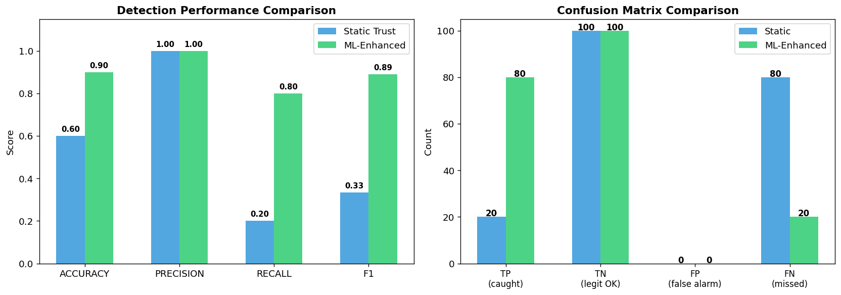
Fig. 3: Static and ML-Enhanced Trust Comparison

7.3 Held-Out Classifier Performance
Table 3 presents the separate held-out evaluation. The Random Forest achieved the highest accuracy at 95.89%, while the combined ensemble recorded 92.51% recall and an 89.08% F1-score. Isolation Forest attained 99.93% recall but lower precision, indicating that its high anomaly detection rate came with more false alarms on this split. Figure 3 compares the model metrics; Figure 4 shows their confusion matrices.
Table 3: Held-Out Model Performance on 8,000 Test Samples
Model | Accuracy | Precision | Recall | F1-score
Isolation Forest | 88.08% | 61.05% | 99.93% | 75.80%
Random Forest | 95.89% | 88.25% | 89.97% | 89.10%
SVM | 95.43% | 86.30% | 89.77% | 88.00%
KNN | 95.13% | 86.91% | 87.02% | 86.97%
Decision Tree | 95.10% | 89.70% | 83.34% | 86.41%
MLP | 95.80% | 86.79% | 91.44% | 89.06%
Combined ensemble | 95.76% | 85.90% | 92.51% | 89.08%
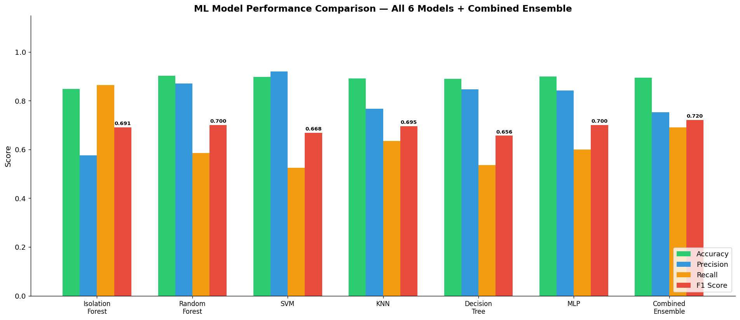
Fig. 4: Held-Out Performance Across the Six Models and Ensemble

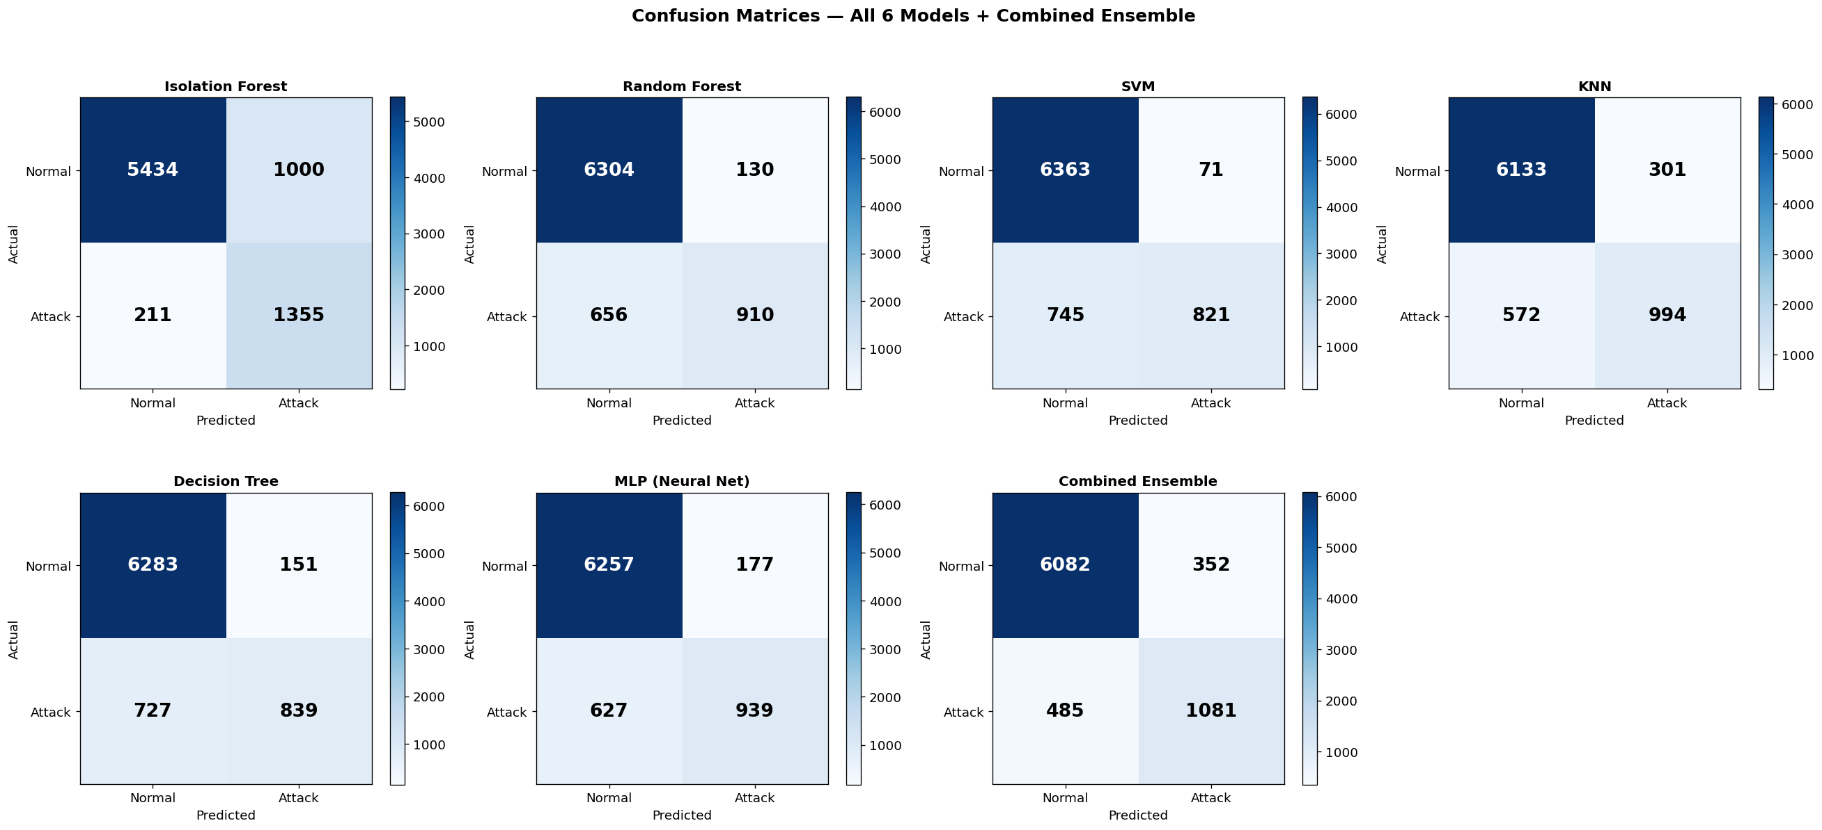
Fig. 5: Confusion Matrices for Individual Models and Ensemble

7.4 Federated Learning Results
Table 4 reports the global model metrics by round. Accuracy increased from 0.8255 in round one to 0.9345 in round five, and F1 increased from 0.3590 to 0.8150. Three honest gateway updates were accepted in every round. The tampered update was rejected in rounds two and four. Figure 5 shows the upward trend across the five rounds; early-round recall remained modest and improved as training progressed.

Table 4: Global Model Performance Across FedAvg Rounds
Round | Accuracy | Precision | Recall | F1-score
1 | 0.8255 | 0.5725 | 0.2615 | 0.3590
2 | 0.8884 | 0.8558 | 0.4843 | 0.6185
3 | 0.9075 | 0.8896 | 0.5766 | 0.6997
4 | 0.9181 | 0.9078 | 0.6254 | 0.7406
5 | 0.9345 | 0.8631 | 0.7719 | 0.8150
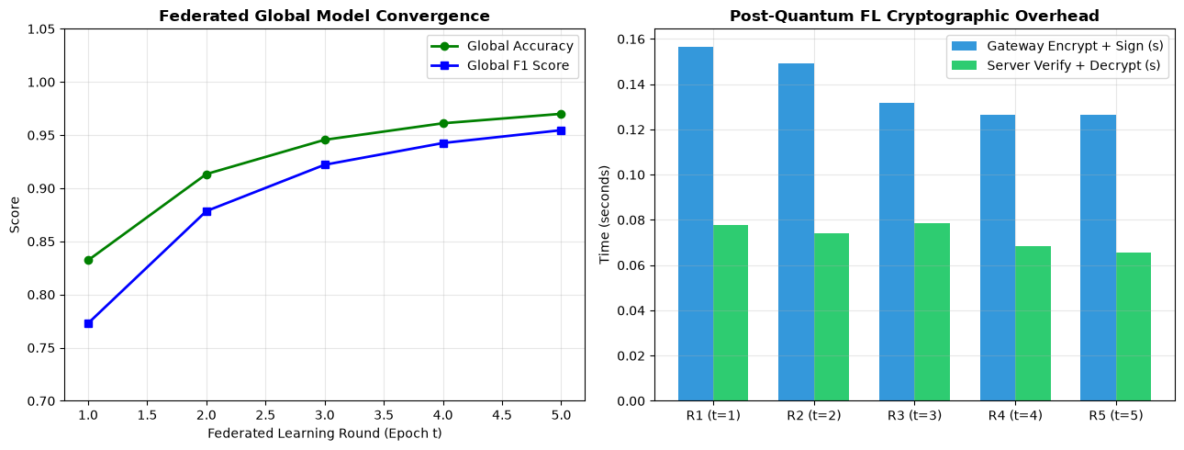
Fig. 6: Federated Global Model Convergence Across Five Rounds

Table 5 gives the per-round cryptographic timings. Client encryption ranged from 0.2044 to 0.2559 seconds. Signing time varied from 0.1990 to 0.7315 seconds; verification took 0.1046 to 0.1438 seconds, and server decryption took 0.0036 to 0.0052 seconds. The observed variation reflects the notebook execution environment and should not be treated as a device-independent benchmark.

Table 5: Federated Update Cryptographic Timings (Seconds per Round)
Round | fs-IBE encryption | ML-DSA-65 signing | ML-DSA-65 verification | fs-IBE decryption
1 | 0.2559 | 0.2633 | 0.1260 | 0.0047
2 | 0.2131 | 0.5217 | 0.1138 | 0.0040
3 | 0.2044 | 0.1990 | 0.1046 | 0.0041
4 | 0.2044 | 0.6659 | 0.1312 | 0.0036
5 | 0.2474 | 0.7315 | 0.1438 | 0.0052
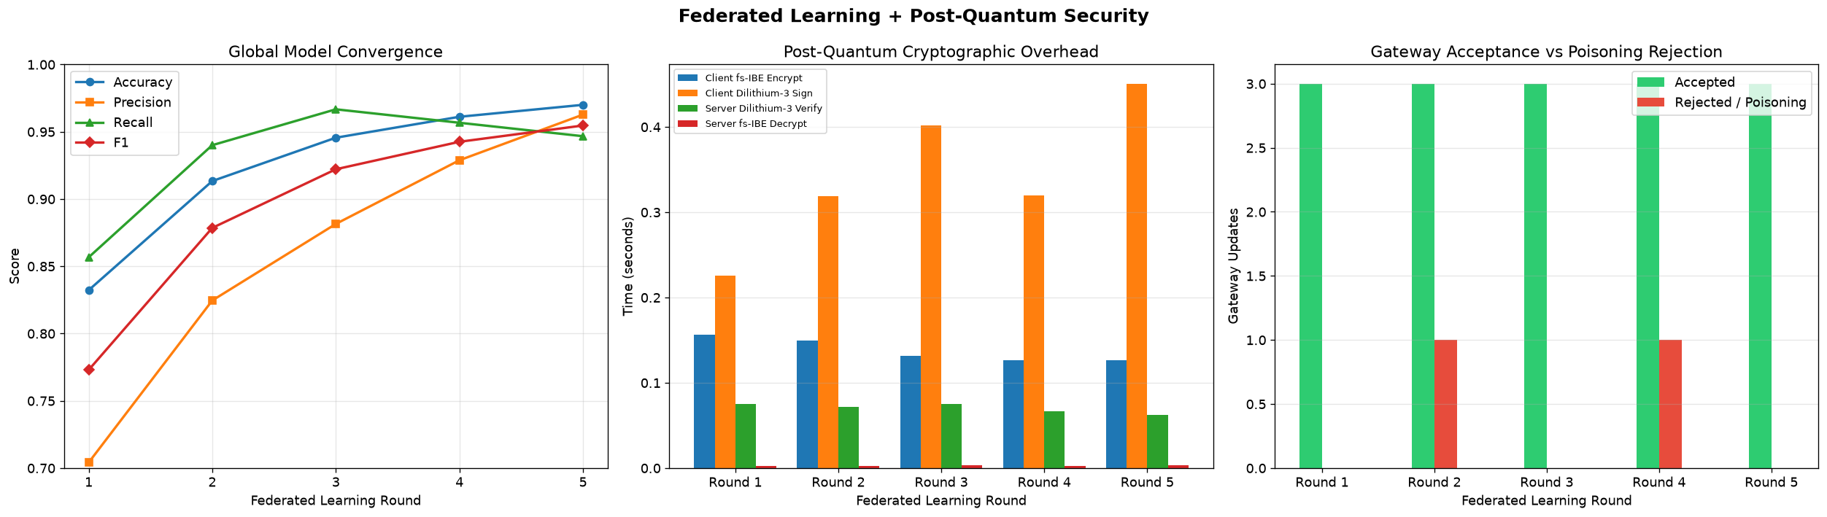
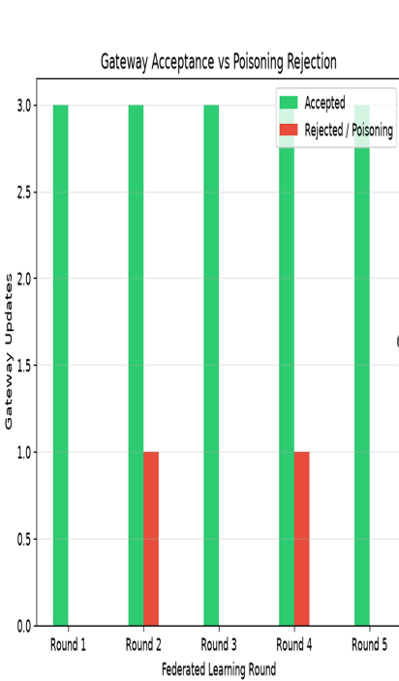
Fig. 7: Federated Metrics, Cryptographic Timings, and Gateway Update Outcomes
7.5 Security Checks and Interpretation
The updated simulation recorded three relevant checks. An epoch-one ciphertext decrypted at epoch one but returned no plaintext after the server advanced to epoch six. A valid gateway update signature verified, while a tampered payload and a modified signature failed verification. The ML-DSA-65 public key, secret key, and signature sizes were 1,952, 4,032, and 3,309 bytes, respectively. These outcomes verify the exercised code paths but do not replace a formal cryptographic analysis or broader adversarial testing.
Table 6: Security Checks Recorded in the Federated Simulation
Check | Observed result | Evidence | Scope
Forward secrecy | Passed | Epoch-1 ciphertext unavailable at epoch 6 | One simulated transition
Valid signature | Accepted | Verification returned true | Valid update package
Tampered payload | Rejected | Verification returned false | Tamper audit
Modified signature | Rejected | Verification returned false | Tamper audit
ML-DSA-65 sizes | Recorded | PK 1,952 B; SK 4,032 B; signature 3,309 B | Implementation output
Taken together, the experiments show improved attack detection in the static-versus-ML comparison and improving global model metrics across the five federated rounds. They also show the expected behavior for the tested signature-tampering and epoch-evolution cases. The main limitations are the use of synthetic data, the small number of simulated gateways, the short training run, and environment-dependent timing. Accordingly, the results support feasibility within the prototype rather than a claim of deployment readiness.

7.6 Summary of Results
Across the separate synthetic-data experiments, ML-enhanced trust detected 80 of 100 attacks compared with 20 for static trust, while both methods accepted all 100 legitimate requests in that run. On a separate 8,000-sample held-out test set, the ensemble achieved 95.76% accuracy, 92.51% recall, and an 89.08% F1-score. In the five-round federated simulation, global accuracy rose from 0.8255 to 0.9345 and F1 from 0.3590 to 0.8150; the three honest gateway updates were accepted in each round and tampered updates were rejected in rounds two and four.
These results support the feasibility of integrating the tested components in the prototype. They remain bounded by the synthetic dataset, small gateway population, short training schedule, and environment-dependent timings; they should not be read as proof of deployment-level performance or comprehensive attack resistance.
8. Conclusion and Future Work
This project developed a software prototype that brings together lattice-based forward-secure identity-based encryption, ML-enhanced trust scoring, and federated learning for an IoT data-sharing setting. The implementation models identity- and epoch-bound ciphertexts, behavioral assessment of requests, and authenticated model updates aggregated across gateways. The design draws on lattice-based forward-secure IBE and established work on IoT trust and federated learning [1], [8], [18], [40], [43]-[45].

The updated experiments show that the ML-enhanced trust method detected more attacks than the static baseline in the 200-request comparison, while accepting all legitimate requests in that run. In a separate held-out classifier evaluation, the ensemble achieved an F1-score of 89.08%. During five simulated federated rounds, the global model improved in accuracy and F1, honest updates were accepted, and tampered submissions were rejected when introduced. The epoch and signature audits also produced the expected outcomes for the scenarios tested. These are simulation results on synthetic data and do not establish performance or security in a deployed network [36]-[46].
Future work should evaluate the trust models with real and diverse IoT traffic, expand the number and heterogeneity of participating gateways, and study model drift over longer training periods. The federated update path should be tested against validly signed poisoning, collusion, and other Byzantine behaviors, and may be strengthened with secure aggregation or differential privacy where appropriate [41], [46]. The cryptographic implementation also requires formal analysis and benchmarking on constrained hardware before deployment claims can be made [8], [18], [45].
References
[1] R. Canetti, S. Halevi, and J. Katz, "A forward-secure public-key encryption scheme," in Proc. EUROCRYPT, 2003, pp. 255-271.
[2] NIST, "Post-Quantum Cryptography Standardization," NIST, 2022. [Online]. Available: https://csrc.nist.gov/projects/post-quantum-cryptography
[3] A. Shamir, "Identity-based cryptosystems and signature schemes," in Proc. CRYPTO, 1984, pp. 47-53.
[4] D. Boneh and M. Franklin, "Identity-based encryption from the Weil pairing," in Proc. CRYPTO, 2001, pp. 213-229.
[5] L. Ducas et al., "CRYSTALS-Dilithium: A lattice-based digital signature scheme," IACR Trans. Cryptogr. Hardw. Embedded. Syst., vol. 2018, no. 1, pp. 238-268, 2018.
[6] R. Roman, J. Zhou, and J. Lopez, "On the features and challenges of security and privacy in distributed internet of things," Comput. Netw., vol. 57, no. 10, pp. 2266-2279, Jul. 2013.
[7] Z. Zhao and G. Ge, "Internet of things security - research on authentication and key establishment," Int. J. Secur. Appl., vol. 7, no. 3, pp. 57-66, May 2013.
[8] O. Regev, "On lattices, learning with errors, random linear codes, and cryptography," J. ACM, vol. 56, no. 6, pp. 1-40, Sep. 2009.
[9] D. Micciancio and C. Peikert, "Trapdoors for lattices: Simpler, tighter, faster, smaller," in Proc. EUROCRYPT, 2012, pp. 700-718.
[10] C. Cocks, "An identity based encryption scheme based on quadratic residues," in Proc. IMA Int. Conf. Crypt. Coding, 2001, pp. 360-363.
[11] B. Waters, "Efficient identity-based encryption without random oracles," in Proc. EUROCRYPT, 2005, pp. 114-127.
[12] C. Gentry, C. Peikert, and V. Vaikuntanathan, "Trapdoors for hard lattices and new cryptographic constructions," in Proc. STOC, 2008, pp. 197-206.
[13] S. Agrawal, D. Boneh, and X. Boyen, "Efficient lattice (H)IBE in the standard model," in Proc. EUROCRYPT, 2010, pp. 553-572.
[14] X. Boyen, Q. Chu, and B. Waters, "Forward-secure signatures with untrusted update," in Proc. CCS, 2006, pp. 191-200.
[15] J. Chen et al., "Lattice-based access control for IoT," IEEE Trans. Inf. Forensics Security, vol. 14, no. 6, pp. 1459-1471, Jun. 2019.
[16] H. Xiong and Z. Qin, "Revocable and scalable certificateless remote authentication protocol with anonymity for wireless body area networks," IEEE Trans. Inf. Forensics Security, vol. 10, no. 7, pp. 1442-1455, Jul. 2015.
[17] B. Waters, "Dual system encryption: Realizing fully secure IBE and HIBE under simple assumptions," in Proc. CRYPTO, 2009, pp. 619-636.
[18] R. Jin, L. Qu, R. Chen, Z. Yang, and Y. Wang, "A lattice-based forward secure IBE scheme for Internet of things," Information Sciences, vol. 660, p. 120083, 2024.
[19] H. Huang, J. Li, S. Bi, and Q. Yuan, "An efficient lattice-based integrated revocable identity-based encryption," Scientific Reports, vol. 15, no. 16729, 2025.
[20] X. Wang et al., "Revocable IBE with En-DKER from lattices: A novel approach for lattice basis delegation," in European Symposium on Research in Computer Security (ESORICS), 2023.
[21] C. Peikert, "A decade of lattice cryptography," Foundations and Trends in Theoretical Computer Science, vol. 10, no. 4, pp. 283-424, 2016.
[22] V. Lyubashevsky, C. Peikert, and O. Regev, "On ideal lattices and learning with errors over rings," in Proc. EUROCRYPT, 2010, pp. 1-23.
[23] D. Boneh, X. Boyen, and E. Goh, “Hierarchical identity-based encryption with constant size ciphertext,” in Proc. EUROCRYPT, 2005, pp. 440–456.
[24] A. Boldyreva, V. Goyal, and V. Kumar, “Identity-based encryption with efficient revocation,” in Proc. ACM CCS, 2008, pp. 417–426.
[25] M. Abdalla, A. Fiat, and M. Naor, “Revocation systems with very small private keys,” in Proc. IEEE Symp. Security and Privacy, 2012, pp. 273–285.
[26] A. Alrawais, A. Alhothaily, C. Hu, and X. Cheng, “Fog computing for the Internet of Things: Security and privacy issues,” IEEE Internet Computing, vol. 21, no. 2, pp. 34–42, 2017.
[27] L. Ducas and D. Micciancio, "Improved short lattice signatures in the standard model," in Proc. CRYPTO, 2014, pp. 335-352.
[28] J. Katz and Y. Lindell, *Introduction to Modern Cryptography*, 2nd ed. Boca Raton, FL, USA: CRC Press, 2014.
[29] S. Gorbunov, V. Vaikuntanathan, and D. Wichs, “Leveled fully homomorphic signatures from standard lattices,” in Proc. STOC, 2015, pp. 469–477.
[30] D. Pointcheval and J. Stern, “Security arguments for digital signatures and blind signatures,” Journal of Cryptology, vol. 13, no. 3, pp. 361–396, 2000.
[31] A. Sahai and B. Waters, “Fuzzy identity-based encryption,” in Proc. EUROCRYPT, 2005, pp. 457–473.
[32] R. Ostrovsky, A. Sahai, and B. Waters, “Attribute-based encryption with non-monotonic access structures,” in Proc. ACM CCS, 2007, pp. 195–203.
[33] S. Goldwasser and S. Micali, “Probabilistic encryption,” Journal of Computer and System Sciences, vol. 28, no. 2, pp. 270–299, 1984.
[34] N. Koblitz and A. Menezes, “The random oracle model: A twenty-year retrospective,” Designs, Codes and Cryptography, vol. 77, no. 2–3, pp. 587–610, 2015.
[35] T. Okamoto and D. Pointcheval, “The gap-problems: A new class of problems for the security of cryptographic schemes,” in Proc. PKC, 2001, pp. 104–118.
[36] A. Chatterjee and B. S. Ahmed, "IoT anomaly detection methods and applications: A survey," Internet of Things, vol. 19, Art. no. 100568, 2022, doi: 10.1016/j.iot.2022.100568.
[37] K. DeMedeiros, A. M. Hendawi, and M. Alvarez, "A survey of AI-based anomaly detection in IoT and sensor networks," Sensors, vol. 23, no. 3, Art. no. 1352, 2023, doi: 10.3390/s23031352.
[38] E. Marmol Campos, P. Fernandez Saura, A. Gonzalez-Vidal, J. L. Hernandez-Ramos, J. Bernal Bernabe, G. Baldini, and A. Skarmeta, "Evaluating federated learning for intrusion detection in Internet of Things: Review and challenges," Computer Networks, vol. 203, Art. no. 108661, 2022, doi: 10.1016/j.comnet.2021.108661.
[39] V. Mothukuri, P. Khare, R. M. Parizi, S. Pouriyeh, A. Dehghantanha, and G. Srivastava, "Federated-learning-based anomaly detection for IoT security attacks," IEEE Internet of Things Journal, vol. 9, no. 4, pp. 2545-2554, 2022, doi: 10.1109/JIOT.2021.3077803.
[40] H. B. McMahan, E. Moore, D. Ramage, S. Hampson, and B. A. y Arcas, "Communication-efficient learning of deep networks from decentralized data," in Proc. 20th Int. Conf. Artificial Intelligence and Statistics, 2017, pp. 1273-1282.
[41] P. Kairouz et al., "Advances and open problems in federated learning," Foundations and Trends in Machine Learning, vol. 14, nos. 1-2, pp. 1-210, 2021, doi: 10.1561/2200000083.
[42] R. Lazzarini, H. Tianfield, and V. Charissis, "Federated learning for IoT intrusion detection," AI, vol. 4, no. 3, pp. 509-530, 2023, doi: 10.3390/ai4030028.
[43] A. M. Konsta, A. Lluch-Lafuente, and N. Dragoni, "A survey of trust management for Internet of Things," IEEE Access, vol. 11, pp. 122175-122204, 2023, doi: 10.1109/ACCESS.2023.3327335.
[44] A. Akli and K. Chougdali, "A survey on machine learning for IoT trust management," in Proc. 2023 IEEE Global Conf. Artificial Intelligence and Internet of Things (GCAIoT), pp. 59-65, 2023, doi: 10.1109/GCAIoT61060.2023.10385118.
[45] National Institute of Standards and Technology, "Module-lattice-based digital signature standard," Federal Information Processing Standards Publication 204, Aug. 2024, doi: 10.6028/NIST.FIPS.204.
[46] P. Blanchard, E. M. El Mhamdi, R. Guerraoui, and J. Stainer, "Machine learning with adversaries: Byzantine tolerant gradient descent," in Advances in Neural Information Processing Systems, vol. 30, 2017.

