ML-Trust Scoring Results (Updated Notebook)
Results aligned with Major_Project_ML_Trust_Scoring_updated.ipynb. The static-versus-ML benchmark evaluated 100 normal queries and 100 attack queries. These are the notebook's current run results; inference timing is environment-dependent.

Static vs. ML-Enhanced Trust Scoring
Metric | Static Trust | ML-Enhanced Trust
Accuracy | 60.00% | 90.00%
Precision | 100.00% | 100.00%
Recall | 20.00% | 80.00%
F1-score | 33.33% | 88.89%
False positive rate | 0.00% | 0.00%
True positives (attacks caught) | 20 | 80
False positives (false alarms) | 0 | 0
True negatives (legitimate accepted) | 100 | 100
False negatives (attacks missed) | 80 | 20
ML-enhanced trust caught 80 of 100 attacks, compared with 20 for static trust, while both accepted all 100 legitimate queries in this run. Average ML inference time: 119.56 ms.

Six-Model Training/Test Performance
Model | Accuracy | Precision | Recall | F1-score
Isolation Forest | 88.08% | 61.05% | 99.93% | 75.80%
Random Forest | 95.89% | 88.25% | 89.97% | 89.10%
SVM | 95.43% | 86.30% | 89.77% | 88.00%
KNN | 95.13% | 86.91% | 87.02% | 86.97%
Decision Tree | 95.10% | 89.70% | 83.34% | 86.41%
MLP | 95.80% | 86.79% | 91.44% | 89.06%
Combined ensemble | 95.76% | 85.90% | 92.51% | 89.08%
Separate held-out test split: 32,000 training samples and 8,000 test samples.

Scenario Demonstrations
Scenario | Anomaly detected | Confidence | Trust score | Decision
Normal IoT sensor | No | 0.8808 | 0.4464 | Allow
Flood attack | Yes | 0.9988 | 0.7631 | Block
Replay attack | Yes | 0.9552 | 0.6479 | Block
Epoch manipulation | Yes | 0.9873 | 0.6277 | Block
Sybil attack | Yes | 0.9962 | 0.7586 | Block
Each row is one hand-specified example, not a per-attack statistical recall estimate.

Evaluation scope
The static-versus-ML comparison and six-model held-out test table are separate evaluations and should not be conflated. Prior literature-comparison figures and cross-layer latency or CPU-saving claims are omitted because the updated notebook run does not produce them.

Notebook Figures
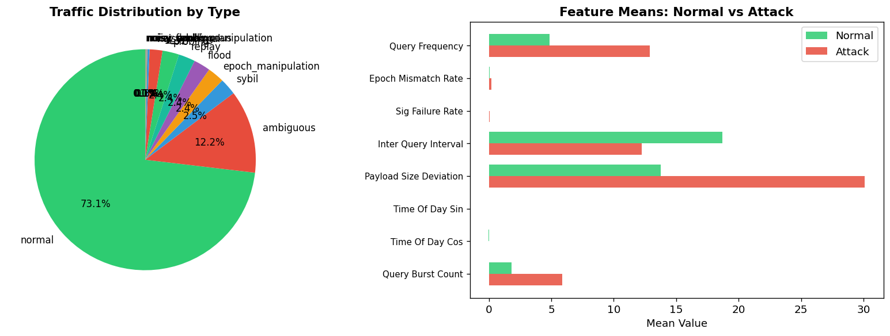
Figure: Synthetic traffic and label distribution
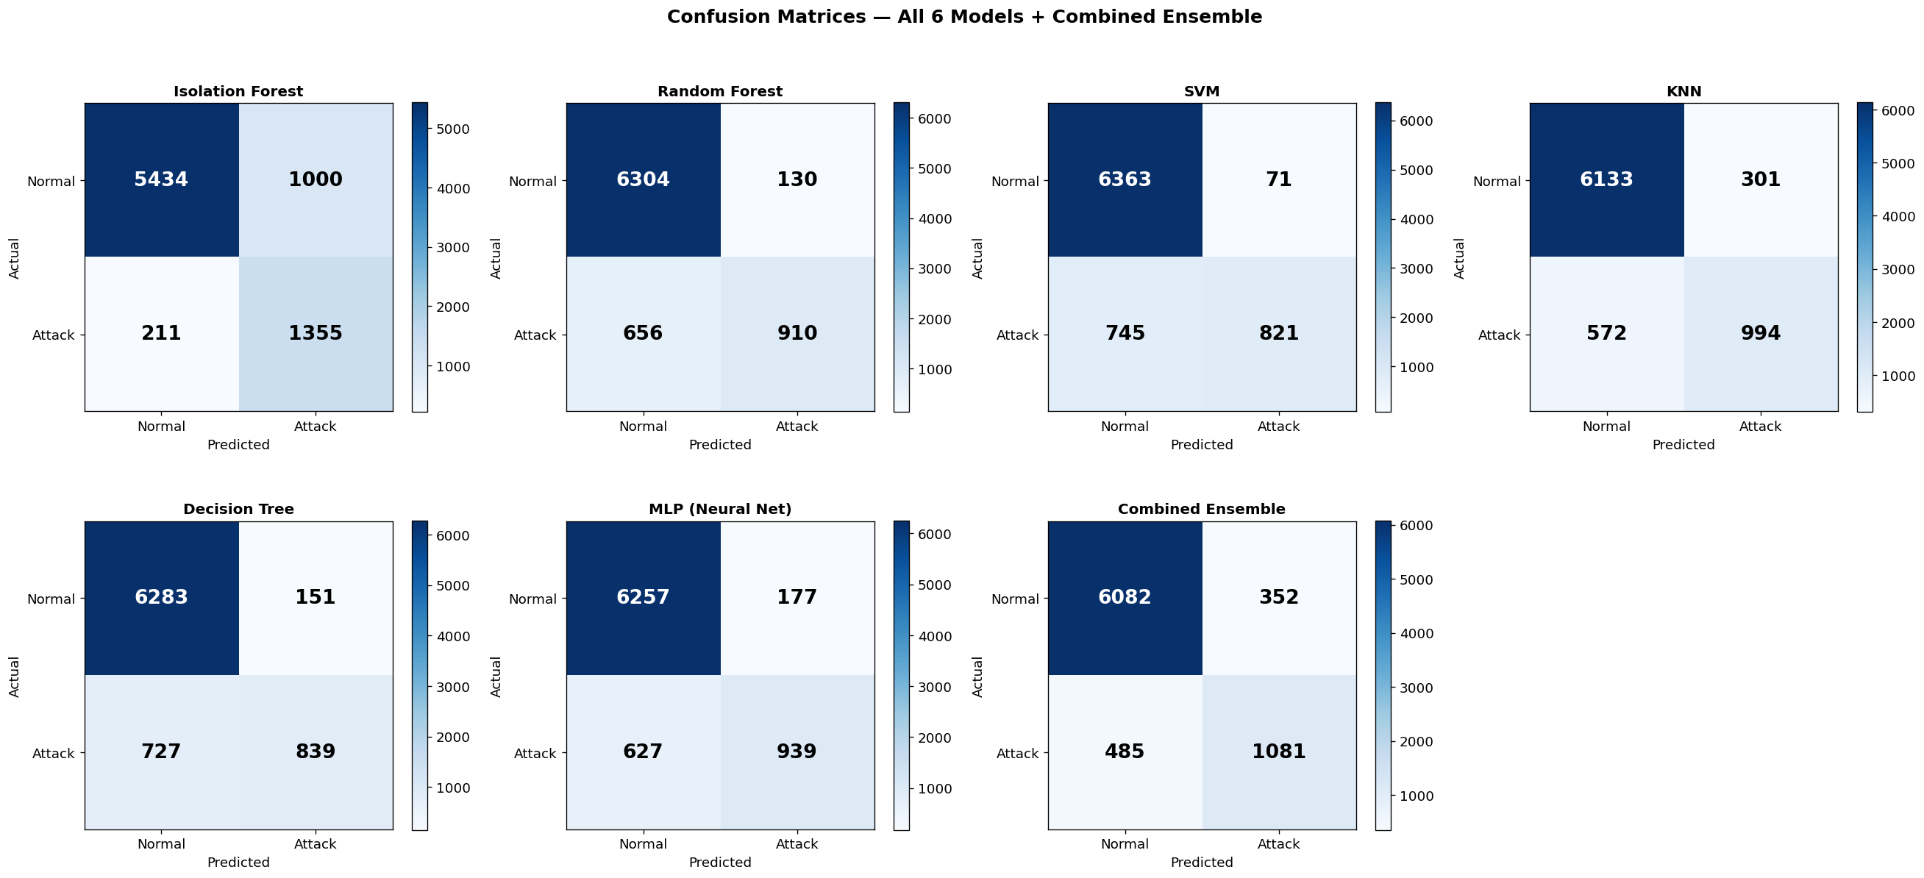
Figure: Confusion matrices for individual models and ensemble
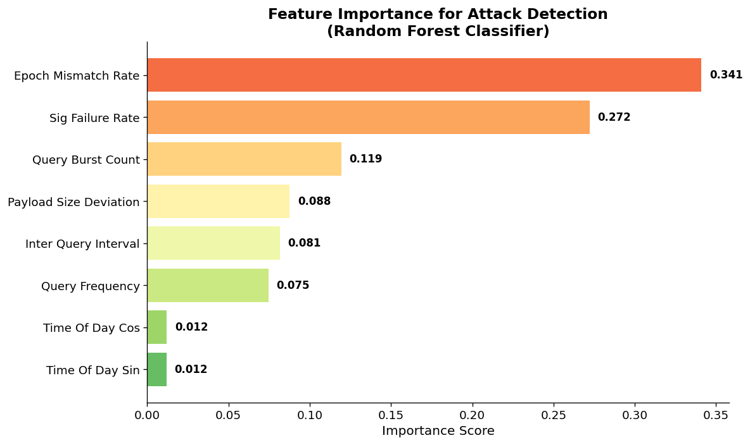
Figure: Random Forest feature importance
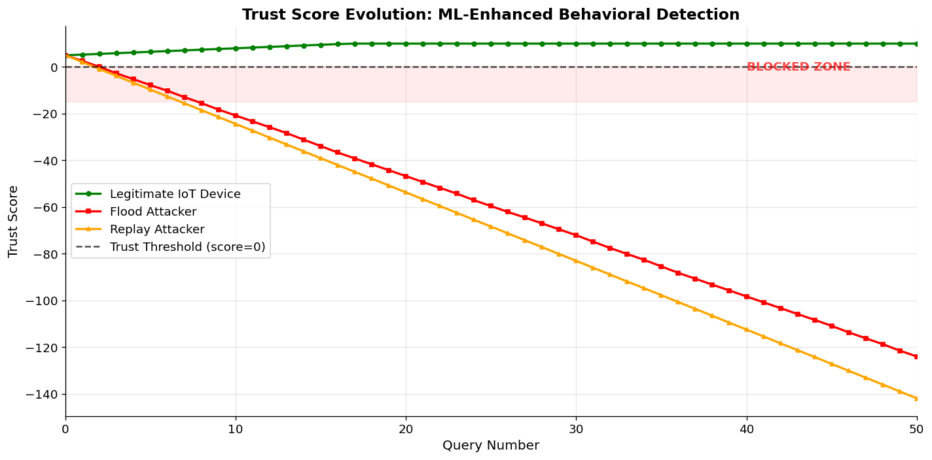
Figure: Trust score trajectories across simulated behaviors
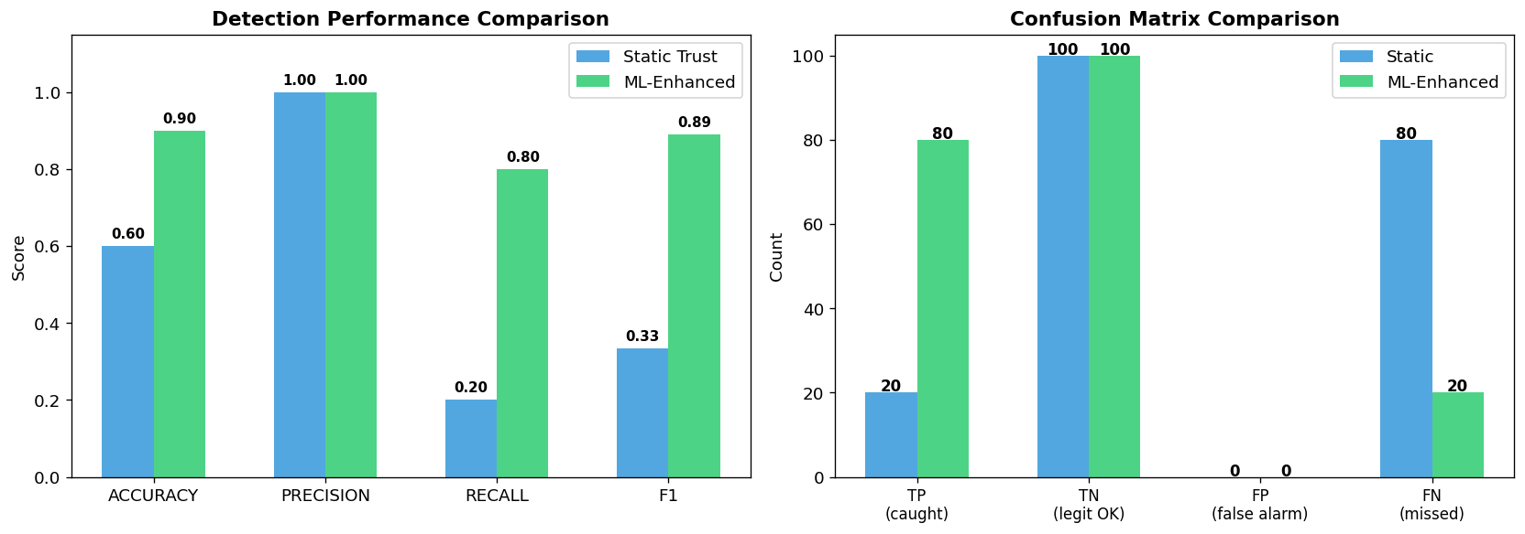
Figure: Static versus ML-enhanced trust comparison
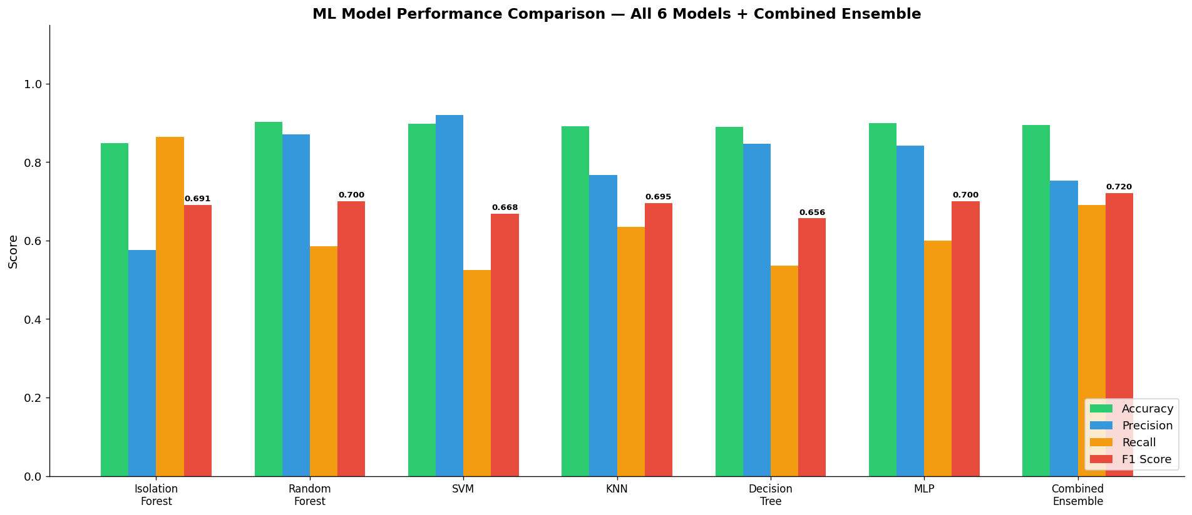
Figure: Held-out performance across the six models and combined ensemble

