Federated Learning Results (Updated Notebook)
Results follow the telemetry displayed in Major_Project_ML_Trust_Scoring_updated.ipynb. The simulation ran five FedAvg rounds on the current 40,000-row dataset with three honest gateways. A malicious gateway submitted tampered signatures in rounds 2 and 4. Timings depend on the execution environment.

Round-by-Round Global Model Metrics
Round | Epoch | Accuracy | Precision | Recall | F1 | Honest Accepted | Rejected
1 | 1 | 0.8255 | 0.5725 | 0.2615 | 0.3590 | 3 | 0
2 | 2 | 0.8884 | 0.8558 | 0.4843 | 0.6185 | 3 | 1
3 | 3 | 0.9075 | 0.8896 | 0.5766 | 0.6997 | 3 | 0
4 | 4 | 0.9181 | 0.9078 | 0.6254 | 0.7406 | 3 | 1
5 | 5 | 0.9345 | 0.8631 | 0.7719 | 0.8150 | 3 | 0
Accuracy increased from 0.8255 in round 1 to 0.9345 in round 5; F1 increased from 0.3590 to 0.8150. Three honest updates were accepted in every round, and the tampered update was rejected in rounds 2 and 4.

Post-Quantum Cryptographic Timings (seconds)
Round | Client fs-IBE Encrypt | Client ML-DSA-65 Sign | Server ML-DSA-65 Verify | Server fs-IBE Decrypt
1 | 0.2559 | 0.2633 | 0.1260 | 0.0047
2 | 0.2131 | 0.5217 | 0.1138 | 0.0040
3 | 0.2044 | 0.1990 | 0.1046 | 0.0041
4 | 0.2044 | 0.6659 | 0.1312 | 0.0036
5 | 0.2474 | 0.7315 | 0.1438 | 0.0052

Security Checks
- Forward secrecy verified: the epoch-1 ciphertext decrypted at epoch 1 and returned None with the epoch-6 key bundle after five epoch advances.
- Signature checks: the valid gateway update verified; the tampered payload and modified signature both failed verification.
- ML-DSA-65 sizes: public key 1,952 bytes; secret key 4,032 bytes; signature 3,309 bytes.
FL_Results_Report.csv contains the round telemetry, and fl_simulation_results.json contains the telemetry and security audit outcomes.

Federated Learning Figures
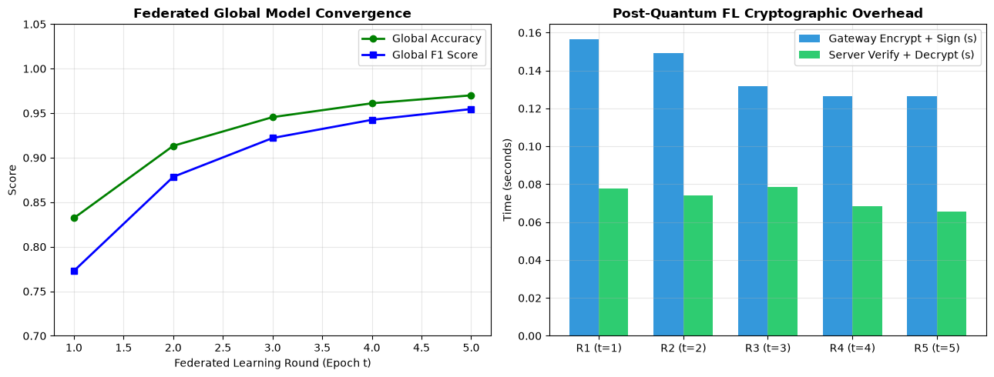
Figure: Federated global model convergence across rounds
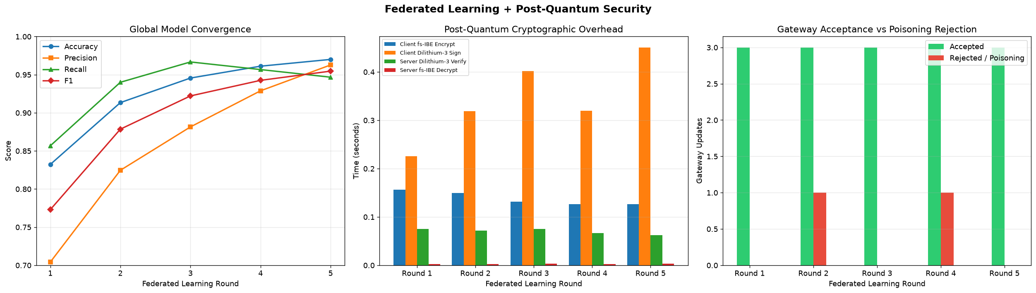
Figure: Federated metrics, cryptographic timings, and gateway acceptance/rejection

