Algonquin College
After you provided your high level architecture, the CIO has some further questions regarding whether or not cloud services may be beneficial for AC. He has noted that the college is near capacity and the BI expansion will require the purchase of new hardware or the use of cloud services.

Assignment – Part 2
- Completing A
  - I am successful setting up my Microsoft Azure student account for the email chmstimoteo@gmail.com.
  - Set up a Resource Group named CST2210-maci0193. I’ve set the location to be Canada East.
    - Set up the following resources.
      - SQL Server (not on a virtual machine) – called sqlserver-maci0193
      - Azure Cosmos DB – could not be set due to pricing policy
      - PHP Empty Microsoftb App – called phpewa-maci0193
      - API App – called restapi-maci0193
      - Virtual Machine: Windows Server 2016 Datacenter – could not be set due to pricing policy and licensing
      - Virtual Machine: Ubuntu Server (Canonical) 16.04 LTS – could not be set due to pricing policy

Submission requirements:

Dashboard

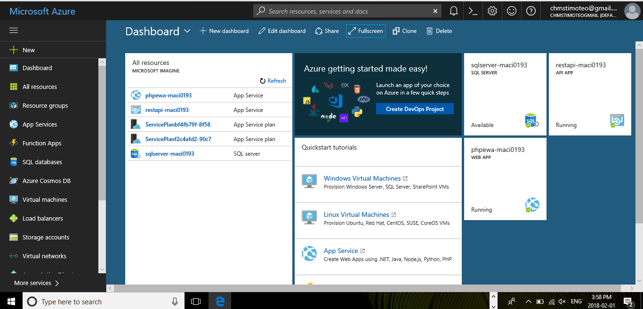

List the items that you could not set up with the information requested above.
        - Azure Cosmos DB – On Azure Cosmos DB, you only pay for reserved throughput provisioned and data stored in containers (collection of documents or a table or a graph). Reserved throughput, billed as Request Units (RU) per second or RU/s), allows you to read from or write data into containers. Each container is billed on an hourly basis for throughput provisioned in units of 100 RU/second, with a minimum of 400 RU/second, and data stored (in GBs). Unlimited containers have a minimum of 100 RU/s per partition.

UNIT | Price (CAD)
SSD Storage (per GB) | $0.3344 GB/month
400 Reserved RUs/second (minimum) | $0.0428/hour
Each 100 Reserved Rus/second | $0.0107/hour

Monthly price estimates are based on 730 hours per month.

        - Virtual Machine: Windows Server 2016 Datacenter – Microsoft is transitioning from processor-based licensing to core-based licensing with Windows Server 2016 Datacenter and Standard editions.

Windows Server 2016 Edition | Ideal for | Licensing Model | CAL requirements | Pricing (US$)
Datacenter | Highly virtualized and software-defined datacenter environments | Core based | Windows Server CAL | $6,155
Standard | Low density or non-virtualized environments | Core based | Windows Server CAL | $882
Essentials | Small businesses with up to 25 users and 50 devices | Specialty servers (server license) | NO CAL required | $501

CALs are required for every user or device accessing the server.
Datacenter and Standard edition pricing is for 16 core licenses.

        - Virtual Machine: Ubuntu Server (Canonical) 16.04 LTS – All current generation Virtual Machines include load balancing and auto-scaling, for free. For optimal performance, Microsoft recommends pairing your Virtual Machines with Managed Disks. Standard egress charges apply.

Payment Option | Ideal for | Costing Range
Pay as you | Users who prefer the low cost and flexibility of Azure Virtual Machines.  Applications with short-term, spiky, or unpredictable workloads that cannot be interrupted.  Applications being developed or tested on Azure Virtual Machines for the first time. | B1S, 1 vCPU, 1 GiB RAM - Starting from $0.014/hour  F2 v2, 2 vCPU, 4 GiB RAM - Starting from $0.104/hour  D2 v3, 2 vCPU, 8 GiB RAM -Starting from $0.117/hour  E2 v3, 2 vCPU, 16 GiB RAM, Starting from $0.162/hour
Reserved Virtual Machine Instances | Applications with steady-state usage.  Customers who want budget predictability  Customers who can commit to using a Virtual Machine over a one or three-year term to reduce computing costs. | 3 years reserved  B1S, 1 vCPU, 1 GiB RAM, Starting from $0.006/hour  F2 v2, 2 vCPU, 4 GiB RAM, Starting from $0.038/hour  D2 v3, 2 vCPU, 8 GiB RAM, Starting from $0.046/hour  E2 v3, 2 vCPU, 16 GiB RAM, Starting from $0.061/hour
Reserved Virtual Machine Instances |  | 1 year reserved  B1S, 1 vCPU, 1 GiB RAM, Starting from $0.008/hour  F2 v2, 2 vCPU, 4 GiB RAM, Starting from $0.061/hour  D2 v3, 2 vCPU, 8 GiB RAM, Starting from $0.071/hour  E2 v3, 2 vCPU, 16 GiB RAM, Starting from $0.096/hour

Linux support

Support for certain Linux virtual machine images in the Azure Marketplace is available from the publisher. In some cases, it’s provided by the publisher for free. In other cases, Microsoft charge by the minute for the right to receive support. The total charge for running a Linux virtual machine is the support rate (if applicable) plus the Linux compute rate. Microsoft does not provide support for Linux images in the Azure Marketplace.
Free trial, MSDN, BizSpark, and Microsoft Partner Network member benefits (monetary credits) don’t apply to publisher provided Linux support, which is billed separately.

Canonical Ubuntu Server Linux images

Customers who deploy virtual machines from Canonical Ubuntu Server Linux images available in the Azure Marketplace are entitled to receive patching from Canonical for those virtual machines at no additional charge over the compute rates.

IP address options

Every Azure Cloud service containing one or more Azure Virtual Machines is automatically assigned a free dynamic virtual IP (VIP) address. For an additional charge, you can also get:
- Instance-level public IP addresses—A dynamic public IP address (PIP) that is assigned to a virtual machine for direct access.
- Reserved IP addresses—A public IP address that can be reserved for your subscription, which can be used as a VIP address for any cloud service in the region.
- Load-balanced IP addresses—Additional load-balanced VIP addresses that can be assigned to an Azure Cloud Service containing one or more Azure Virtual Machines.

Support & SLA

Microsoft provide technical support for all Azure services released to General Availability, including Azure Cosmos DB, through Azure Support, starting at $35.27/month. Billing and subscription management support is provided at no cost.
SLA—Microsoft guarantee at least 99.99% of the time Microsoft will successfully process requests to perform operations against Azure Cosmos DB Resources. To learn more about our SLA, please visit the SLA page.

References

https://azure.microsoft.com/en-us/pricing/

