Resultados Guardados:

1 Execução Padrão: Execução com a base de dados “replace missing” e convertida de “Numeric” para “Nominal”.

=== Run information ===

Scheme: weka.associations.Apriori -N 10 -T 0 -C 0.9 -D 0.05 -U 1.0 -M 0.1 -S -1.0 -c -1
Relation: adult-weka.filters.unsupervised.attribute.NumericToNominal-Rfirst-last
Instances: 32561
Attributes: 15
age
workclass
fnlwgt
education
education-num
marital-status
occupation
relationship
race
sex
capital-gain
capital-loss
hours-per-week
native-country
class
=== Associator model (full training set) ===

Apriori
=======

Minimum support: 0.7 (22793 instances)
Minimum metric <confidence>: 0.9
Number of cycles performed: 6

Generated sets of large itemsets:

Size of set of large itemsets L(1): 5

Size of set of large itemsets L(2): 8

Size of set of large itemsets L(3): 5

Best rules found:

1. class=<=50K 24720 ==> capital-loss=0 23974 conf:(0.97)
2. capital-gain=0 class=<=50K 23685 ==> capital-loss=0 22939 conf:(0.97)
3. class=<=50K 24720 ==> capital-gain=0 23685 conf:(0.96)
4. capital-loss=0 class=<=50K 23974 ==> capital-gain=0 22939 conf:(0.96)
5. native-country=United-States 29170 ==> capital-loss=0 27791 conf:(0.95)
6. race=White 27816 ==> capital-loss=0 26470 conf:(0.95)

8. capital-gain=0 29849 ==> capital-loss=0 28330 conf:(0.95)

=== Run information ===

Scheme: weka.associations.Apriori -N 10 -T 0 -C 0.9 -D 0.05 -U 1.0 -M 0.1 -S -1.0 -c -1
Relation: adult-weka.filters.unsupervised.attribute.ReplaceMissingValues-weka.filters.unsupervised.attribute.NumericToNominal-Rfirst-last
Instances: 32561
Attributes: 15
age
workclass
fnlwgt
education
education-num
marital-status
occupation
relationship
race
sex
capital-gain
capital-loss
hours-per-week
native-country
class
=== Associator model (full training set) ===

Apriori
=======

Minimum support: 0.75 (24421 instances)
Minimum metric <confidence>: 0.9
Number of cycles performed: 5

Generated sets of large itemsets:

Size of set of large itemsets L(1): 6

Size of set of large itemsets L(2): 6

Size of set of large itemsets L(3): 2

Best rules found:

1. native-country=United-States 29753 ==> capital-loss=0 28338 conf:(0.95)
2. race=White 27816 ==> capital-loss=0 26470 conf:(0.95)
4. capital-gain=0 29849 ==> capital-loss=0 28330 conf:(0.95)
6. race=White 27816 ==> native-country=United-States 26007 conf:(0.93)
7. race=White capital-loss=0 26470 ==> native-country=United-States 24713 conf:(0.93)
8. native-country=United-States 29753 ==> capital-gain=0 27228 conf:(0.92)
9. race=White 27816 ==> capital-gain=0 25407 conf:(0.91)
10. capital-loss=0 31042 ==> native-country=United-States 28338 conf:(0.91)

=== Run information ===

Scheme: weka.associations.Apriori -N 10 -T 0 -C 0.9 -D 0.05 -U 1.0 -M 0.1 -S -1.0 -c -1
Relation: adult-weka.filters.unsupervised.attribute.NumericToNominal-Rfirst-last-weka.filters.unsupervised.attribute.ReplaceMissingValues
Instances: 32561
Attributes: 15
age
workclass
fnlwgt
education
education-num
marital-status
occupation
relationship
race
sex
capital-gain
capital-loss
hours-per-week
native-country
class
=== Associator model (full training set) ===

Apriori
=======

Minimum support: 0.75 (24421 instances)
Minimum metric <confidence>: 0.9
Number of cycles performed: 5

Generated sets of large itemsets:

Size of set of large itemsets L(1): 6

Size of set of large itemsets L(2): 6

Size of set of large itemsets L(3): 2

Best rules found:

1. native-country=United-States 29753 ==> capital-loss=0 28338 conf:(0.95)
2. race=White 27816 ==> capital-loss=0 26470 conf:(0.95)
4. capital-gain=0 29849 ==> capital-loss=0 28330 conf:(0.95)
6. race=White 27816 ==> native-country=United-States 26007 conf:(0.93)
7. race=White capital-loss=0 26470 ==> native-country=United-States 24713 conf:(0.93)
8. native-country=United-States 29753 ==> capital-gain=0 27228 conf:(0.92)
9. race=White 27816 ==> capital-gain=0 25407 conf:(0.91)
10. capital-loss=0 31042 ==> native-country=United-States 28338 conf:(0.91)

=== Run information ===

Scheme: weka.associations.Apriori -N 10 -T 0 -C 0.9 -D 0.05 -U 1.0 -M 0.1 -S -1.0 -c -1
Relation: adult-weka.filters.unsupervised.attribute.ReplaceMissingValues-weka.filters.unsupervised.attribute.NumericToNominal-Rfirst-last
Instances: 32561
Attributes: 15
age
workclass
fnlwgt
education
education-num
marital-status
occupation
relationship
race
sex
capital-gain
capital-loss
hours-per-week
native-country
class
=== Associator model (full training set) ===

Apriori
=======

Minimum support: 0.75 (24421 instances)
Minimum metric <confidence>: 0.9
Number of cycles performed: 5

Generated sets of large itemsets:

Size of set of large itemsets L(1): 6

Size of set of large itemsets L(2): 6

Size of set of large itemsets L(3): 2

Best rules found:

1. native-country=United-States 29753 ==> capital-loss=0 28338 conf:(0.95)
2. race=White 27816 ==> capital-loss=0 26470 conf:(0.95)
4. capital-gain=0 29849 ==> capital-loss=0 28330 conf:(0.95)
6. race=White 27816 ==> native-country=United-States 26007 conf:(0.93)
7. race=White capital-loss=0 26470 ==> native-country=United-States 24713 conf:(0.93)
8. native-country=United-States 29753 ==> capital-gain=0 27228 conf:(0.92)
9. race=White 27816 ==> capital-gain=0 25407 conf:(0.91)
10. capital-loss=0 31042 ==> native-country=United-States 28338 conf:(0.91)

=== Run information ===

Scheme: weka.associations.Apriori -N 10 -T 0 -C 0.9 -D 0.05 -U 1.0 -M 0.1 -S -1.0 -c -1
Relation: adult-weka.filters.unsupervised.attribute.NumericToNominal-Rfirst-last
Instances: 32561
Attributes: 15
age
workclass
fnlwgt
education
education-num
marital-status
occupation
relationship
race
sex
capital-gain
capital-loss
hours-per-week
native-country
class
=== Associator model (full training set) ===

Apriori
=======

Minimum support: 0.7 (22793 instances)
Minimum metric <confidence>: 0.9
Number of cycles performed: 6

Generated sets of large itemsets:

Size of set of large itemsets L(1): 5

Size of set of large itemsets L(2): 8

Size of set of large itemsets L(3): 5

Best rules found:

1. class=<=50K 24720 ==> capital-loss=0 23974 conf:(0.97)
2. capital-gain=0 class=<=50K 23685 ==> capital-loss=0 22939 conf:(0.97)
3. class=<=50K 24720 ==> capital-gain=0 23685 conf:(0.96)
4. capital-loss=0 class=<=50K 23974 ==> capital-gain=0 22939 conf:(0.96)
5. native-country=United-States 29170 ==> capital-loss=0 27791 conf:(0.95)
6. race=White 27816 ==> capital-loss=0 26470 conf:(0.95)
8. capital-gain=0 29849 ==> capital-loss=0 28330 conf:(0.95)

=== Run information ===

Scheme: weka.associations.Apriori -I -N 5 -T 0 -C 0.9 -D 0.1 -U 1.0 -M 0.1 -S -1.0 -V -c -1
Relation: adult-weka.filters.unsupervised.attribute.NumericToNominal-Rfirst-last-weka.filters.unsupervised.attribute.ReplaceMissingValues
Instances: 32561
Attributes: 15
age
workclass
fnlwgt
education
education-num
marital-status
occupation
relationship
race
sex
capital-gain
capital-loss
hours-per-week
native-country
class
=== Associator model (full training set) ===

Apriori
=======

Minimum support: 0.8 (26049 instances)
Minimum metric <confidence>: 0.9
Number of cycles performed: 2

Generated sets of large itemsets:

Size of set of large itemsets L(1): 4

Large Itemsets L(1):
race=White 27816
capital-gain=0 29849
capital-loss=0 31042
native-country=United-States 29753

Size of set of large itemsets L(2): 4

Large Itemsets L(2):
race=White capital-loss=0 26470
capital-gain=0 capital-loss=0 28330
capital-gain=0 native-country=United-States 27228
capital-loss=0 native-country=United-States 28338

Best rules found:

1. native-country=United-States 29753 ==> capital-loss=0 28338 conf:(0.95)
2. race=White 27816 ==> capital-loss=0 26470 conf:(0.95)
3. capital-gain=0 29849 ==> capital-loss=0 28330 conf:(0.95)
4. native-country=United-States 29753 ==> capital-gain=0 27228 conf:(0.92)
5. capital-loss=0 31042 ==> native-country=United-States 28338 conf:(0.91)

2 Execução de Prova das regras encontradas: Execução com a base de dados com atributos selecionados.

=== Run information ===

Scheme: weka.associations.Apriori -N 10 -T 0 -C 0.9 -D 0.05 -U 1.0 -M 0.1 -S -1.0 -c -1
Relation: adult-weka.filters.unsupervised.attribute.ReplaceMissingValues-weka.filters.supervised.attribute.AttributeSelection-Eweka.attributeSelection.CfsSubsetEval-Sweka.attributeSelection.BestFirst -D 1 -N 5-weka.filters.unsupervised.attribute.NumericToNominal-Rfirst-last
Instances: 32561
Attributes: 6
education-num
marital-status
relationship
capital-gain
capital-loss
class
=== Associator model (full training set) ===

Apriori
=======

Minimum support: 0.35 (11396 instances)
Minimum metric <confidence>: 0.9
Number of cycles performed: 13

Generated sets of large itemsets:

Size of set of large itemsets L(1): 5

Size of set of large itemsets L(2): 8

Size of set of large itemsets L(3): 4

Best rules found:

4. class=<=50K 24720 ==> capital-loss=0 23974 conf:(0.97)
5. capital-gain=0 class=<=50K 23685 ==> capital-loss=0 22939 conf:(0.97)
6. class=<=50K 24720 ==> capital-gain=0 23685 conf:(0.96)
7. capital-loss=0 class=<=50K 23974 ==> capital-gain=0 22939 conf:(0.96)
8. capital-gain=0 29849 ==> capital-loss=0 28330 conf:(0.95)

=== Run information ===

Scheme: weka.associations.Apriori -N 10 -T 0 -C 0.9 -D 0.05 -U 1.0 -M 0.1 -S -1.0 -c -1
Relation: adult-weka.filters.unsupervised.attribute.ReplaceMissingValues-weka.filters.unsupervised.attribute.Remove-V-R5-6,8,11-12,15-weka.filters.unsupervised.attribute.Reorder-Rfirst-last-weka.filters.unsupervised.attribute.NumericToNominal-Rfirst-last
Instances: 32561
Attributes: 6
education-num
marital-status
relationship
capital-gain
capital-loss
class
=== Associator model (full training set) ===

Apriori
=======

Minimum support: 0.35 (11396 instances)
Minimum metric <confidence>: 0.9
Number of cycles performed: 13

Generated sets of large itemsets:

Size of set of large itemsets L(1): 5

Size of set of large itemsets L(2): 8

Size of set of large itemsets L(3): 4

Best rules found:

4. class=<=50K 24720 ==> capital-loss=0 23974 conf:(0.97)
5. capital-gain=0 class=<=50K 23685 ==> capital-loss=0 22939 conf:(0.97)
6. class=<=50K 24720 ==> capital-gain=0 23685 conf:(0.96)
7. capital-loss=0 class=<=50K 23974 ==> capital-gain=0 22939 conf:(0.96)
8. capital-gain=0 29849 ==> capital-loss=0 28330 conf:(0.95)

=== Run information ===

Scheme: weka.associations.Apriori -N 10 -T 0 -C 0.9 -D 0.05 -U 1.0 -M 0.1 -S -1.0 -c -1
Relation: adult-weka.filters.unsupervised.attribute.Remove-V-R5-6,8,11-12,15-weka.filters.unsupervised.attribute.ReplaceMissingValues-weka.filters.unsupervised.attribute.NumericToNominal-Rfirst-last
Instances: 32561
Attributes: 6
education-num
marital-status
relationship
capital-gain
capital-loss
class
=== Associator model (full training set) ===

Apriori
=======

Minimum support: 0.35 (11396 instances)
Minimum metric <confidence>: 0.9
Number of cycles performed: 13

Generated sets of large itemsets:

Size of set of large itemsets L(1): 5

Size of set of large itemsets L(2): 8

Size of set of large itemsets L(3): 4

Best rules found:

4. class=<=50K 24720 ==> capital-loss=0 23974 conf:(0.97)
5. capital-gain=0 class=<=50K 23685 ==> capital-loss=0 22939 conf:(0.97)
6. class=<=50K 24720 ==> capital-gain=0 23685 conf:(0.96)
7. capital-loss=0 class=<=50K 23974 ==> capital-gain=0 22939 conf:(0.96)
8. capital-gain=0 29849 ==> capital-loss=0 28330 conf:(0.95)

=== Run information ===

Scheme: weka.associations.Apriori -N 10 -T 0 -C 0.9 -D 0.05 -U 1.0 -M 0.1 -S -1.0 -c -1
Relation: adult-weka.filters.unsupervised.attribute.ReplaceMissingValues-weka.filters.unsupervised.attribute.Remove-V-R1-2,4,6-15-weka.filters.unsupervised.attribute.NumericToNominal-Rfirst-last
Instances: 32561
Attributes: 13
age
workclass
education
marital-status
occupation
relationship
race
sex
capital-gain
capital-loss
hours-per-week
native-country
class
=== Associator model (full training set) ===

Apriori
=======

Minimum support: 0.75 (24421 instances)
Minimum metric <confidence>: 0.9
Number of cycles performed: 5

Generated sets of large itemsets:

Size of set of large itemsets L(1): 6

Size of set of large itemsets L(2): 6

Size of set of large itemsets L(3): 2

Best rules found:

1. native-country=United-States 29753 ==> capital-loss=0 28338 conf:(0.95)
2. race=White 27816 ==> capital-loss=0 26470 conf:(0.95)
3. race=White native-country=United-States 26007 ==> capital-loss=0 24713 conf:(0.95)
4. capital-gain=0 29849 ==> capital-loss=0 28330 conf:(0.95)
5. capital-gain=0 native-country=United-States 27228 ==> capital-loss=0 25813 conf:(0.95)
6. race=White 27816 ==> native-country=United-States 26007 conf:(0.93)
7. race=White capital-loss=0 26470 ==> native-country=United-States 24713 conf:(0.93)
8. native-country=United-States 29753 ==> capital-gain=0 27228 conf:(0.92)
9. race=White 27816 ==> capital-gain=0 25407 conf:(0.91)
10. capital-loss=0 31042 ==> native-country=United-States 28338 conf:(0.91)

=== Run information ===

Scheme: weka.associations.Apriori -N 10 -T 0 -C 0.9 -D 0.05 -U 1.0 -M 0.1 -S -1.0 -c -1
Relation: adult-weka.filters.unsupervised.attribute.Remove-V-R5-6,8,11-13,15-weka.filters.unsupervised.attribute.NumericToNominal-Rfirst-last
Instances: 32561
Attributes: 7
education-num
marital-status
relationship
capital-gain
capital-loss
hours-per-week
class
=== Associator model (full training set) ===

Apriori
=======

Minimum support: 0.4 (13024 instances)
Minimum metric <confidence>: 0.9
Number of cycles performed: 12

Generated sets of large itemsets:

Size of set of large itemsets L(1): 6

Size of set of large itemsets L(2): 8

Size of set of large itemsets L(3): 2

Best rules found:

2. class=<=50K 24720 ==> capital-loss=0 23974 conf:(0.97)
3. capital-gain=0 class=<=50K 23685 ==> capital-loss=0 22939 conf:(0.97)
4. class=<=50K 24720 ==> capital-gain=0 23685 conf:(0.96)
5. capital-loss=0 class=<=50K 23974 ==> capital-gain=0 22939 conf:(0.96)
7. capital-gain=0 hours-per-week=40 14096 ==> capital-loss=0 13438 conf:(0.95)
8. capital-gain=0 29849 ==> capital-loss=0 28330 conf:(0.95)
10. class=<=50K 24720 ==> capital-gain=0 capital-loss=0 22939 conf:(0.93)

3 Clusterização dos Conjuntos: Tentativa de formar grupos que melhor possam representar a distribuição numérica após o filtro para Nominal.

=== Run information ===

Scheme: weka.clusterers.SimpleKMeans -N 4 -A "weka.core.ManhattanDistance -R first-last" -I 500 -O -S 10
Relation: adult-weka.filters.unsupervised.attribute.ReplaceMissingValues
Instances: 32561
Attributes: 15
age
workclass
fnlwgt
education
education-num
marital-status
occupation
relationship
race
sex
capital-gain
capital-loss
hours-per-week
native-country
class
Test mode: evaluate on training data

=== Model and evaluation on training set ===

kMeans
======

Number of iterations: 5
Sum of within cluster distances: 98041.55859913059
Missing values globally replaced with mean/mode

Cluster centroids:
Cluster#
Attribute Full Data 0 1 2 3
(32561) (7777) (7845) (8296) (8643)
============================================================================================================================
age 37 23 43 40 41
workclass Private Private Private Private Private
fnlwgt 178356 185575 176185 176634 176897
education HS-grad Some-college HS-grad HS-grad Bachelors
education-num 10 10 9 9 13
marital-status Married-civ-spouse Never-married Married-civ-spouse Divorced Married-civ-spouse
occupation Prof-specialty Other-service Craft-repair Adm-clerical Prof-specialty
relationship Husband Own-child Husband Not-in-family Husband
race White White White White White
sex Male Male Male Female Male
capital-gain 0 0 0 0 0
capital-loss 0 0 0 0 0
hours-per-week 40 40 40 40 40
native-country United-States United-States United-States United-States United-States
class <=50K <=50K >50K <=50K <=50K

Clustered Instances

0 7777 ( 24%)
1 7845 ( 24%)
2 8296 ( 25%)
3 8643 ( 27%)

=== Run information ===

Scheme: weka.clusterers.SimpleKMeans -N 6 -A "weka.core.ManhattanDistance -R first-last" -I 500 -O -S 10
Relation: adult-weka.filters.unsupervised.attribute.ReplaceMissingValues
Instances: 32561
Attributes: 15
age
workclass
fnlwgt
education
education-num
marital-status
occupation
relationship
race
sex
capital-gain
capital-loss
hours-per-week
native-country
class
Test mode: evaluate on training data

=== Model and evaluation on training set ===

kMeans
======

Number of iterations: 8
Sum of within cluster distances: 93569.18413516758
Missing values globally replaced with mean/mode

Cluster centroids:
Cluster#
Attribute Full Data 0 1 2 3 4 5
(32561) (6488) (7214) (5106) (8067) (1848) (3838)
==================================================================================================================================================================
age 37 23 43 45 41 38 31
workclass Private Private Private Private Private Private Private
fnlwgt 178356 185541 176185.5 174497 177647 173871 183612
education HS-grad Some-college HS-grad HS-grad Bachelors HS-grad HS-grad
education-num 10 10 9 9 13 9 9
marital-status Married-civ-spouse Never-married Married-civ-spouse Divorced Married-civ-spouse Married-civ-spouse Never-married
occupation Prof-specialty Other-service Craft-repair Adm-clerical Prof-specialty Sales Craft-repair
relationship Husband Own-child Husband Not-in-family Husband Wife Unmarried
race White White White White White White White
sex Male Male Male Female Male Female Female
capital-gain 0 0 0 0 0 0 0
capital-loss 0 0 0 0 0 0 0
hours-per-week 40 40 40 40 40 40 40
native-country United-States United-States United-States United-States United-States United-States United-States
class <=50K <=50K >50K <=50K <=50K <=50K <=50K

Clustered Instances

0 6488 ( 20%)
1 7214 ( 22%)
2 5106 ( 16%)
3 8067 ( 25%)
4 1848 ( 6%)
5 3838 ( 12%)

=== Run information ===

Scheme: weka.clusterers.SimpleKMeans -N 4 -A "weka.core.ManhattanDistance -R first-last" -I 500 -O -S 3
Relation: adult-weka.filters.unsupervised.attribute.ReplaceMissingValues
Instances: 32561
Attributes: 15
age
workclass
fnlwgt
education
education-num
marital-status
occupation
relationship
race
sex
capital-gain
capital-loss
hours-per-week
native-country
class
Test mode: evaluate on training data

=== Model and evaluation on training set ===

kMeans
======

Number of iterations: 8
Sum of within cluster distances: 94835.85095078297
Missing values globally replaced with mean/mode

Cluster centroids:
Cluster#
Attribute Full Data 0 1 2 3
(32561) (8730) (7202) (6564) (10065)
============================================================================================================================
age 37 36 43 23 42
workclass Private Private Private Private Private
fnlwgt 178356 179135.5 176128 183786.5 176689
education HS-grad HS-grad Bachelors Some-college HS-grad
education-num 10 9 13 10 9
marital-status Married-civ-spouse Never-married Married-civ-spouse Never-married Married-civ-spouse
occupation Prof-specialty Adm-clerical Prof-specialty Other-service Craft-repair
relationship Husband Not-in-family Husband Own-child Husband
race White White White White White
sex Male Female Male Female Male
capital-gain 0 0 0 0 0
capital-loss 0 0 0 0 0
hours-per-week 40 40 40 40 40
native-country United-States United-States United-States United-States United-States
class <=50K <=50K >50K <=50K <=50K

Clustered Instances

0 8730 ( 27%)
1 7202 ( 22%)
2 6564 ( 20%)
3 10065 ( 31%)

=== Run information ===

Scheme: weka.clusterers.SimpleKMeans -M -N 4 -A "weka.core.ManhattanDistance -R first-last" -I 500 -O -S 10
Relation: adult
Instances: 32561
Attributes: 15
age
workclass
fnlwgt
education
education-num
marital-status
occupation
relationship
race
sex
capital-gain
capital-loss
hours-per-week
native-country
class
Test mode: evaluate on training data

=== Model and evaluation on training set ===

kMeans
======

Number of iterations: 6
Sum of within cluster distances: 100953.44221306295

Cluster centroids:
Cluster#
Attribute Full Data 0 1 2 3
(32561) (7917) (8039) (8350) (8255)
============================================================================================================================
age 37 24 43 40 41
workclass Private Private Private Private Private
fnlwgt 178356 185554 176118 176851 176724
education HS-grad Some-college HS-grad HS-grad Bachelors
education-num 10 10 9 9 13
marital-status Married-civ-spouse Never-married Married-civ-spouse Divorced Married-civ-spouse
occupation Prof-specialty Other-service Craft-repair Adm-clerical Prof-specialty
relationship Husband Own-child Husband Not-in-family Husband
race White White White White White
sex Male Male Male Female Male
capital-gain 0 0 0 0 0
capital-loss 0 0 0 0 0
hours-per-week 40 40 40 40 40
native-country United-States United-States United-States United-States United-States
class <=50K <=50K >50K <=50K <=50K

Clustered Instances

0 7917 ( 24%)
1 8039 ( 25%)
2 8350 ( 26%)
3 8255 ( 25%)

4 Análise Gráfica: Visualização dos grupos clusterizados, o seu valor numérico associado com o objetivo de comprovar as regras de associação.

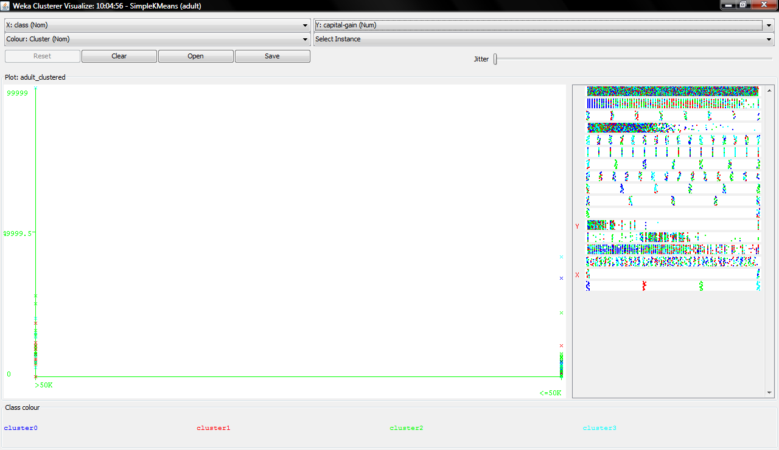
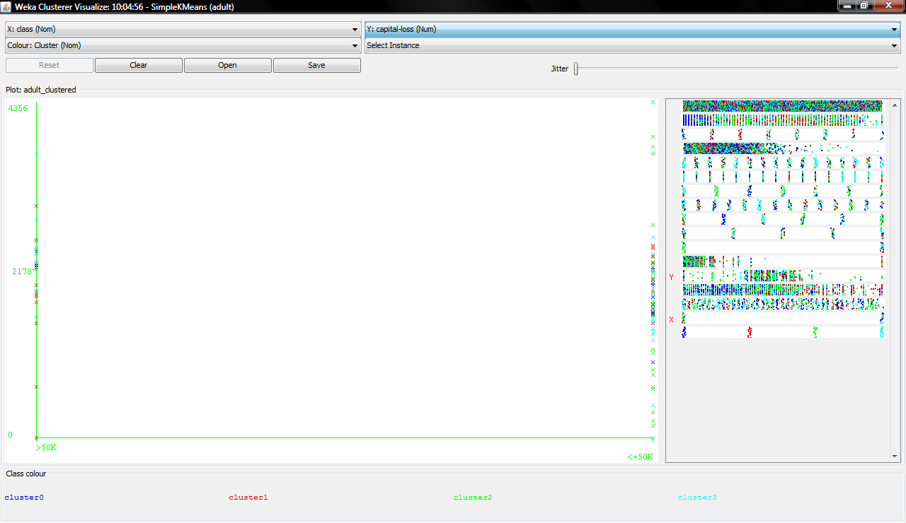

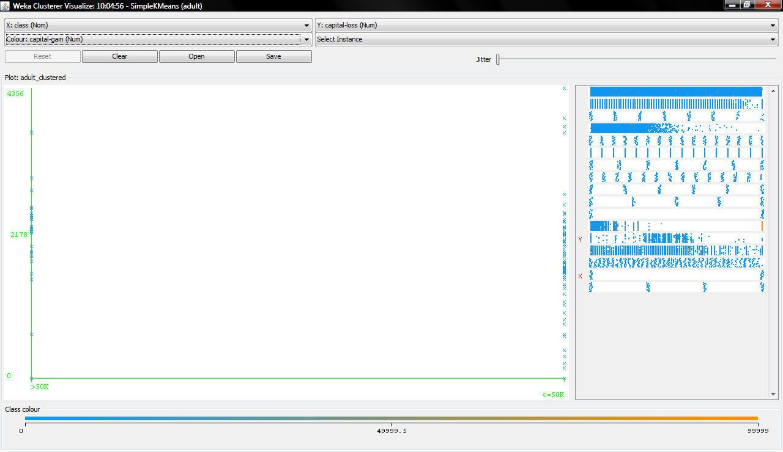

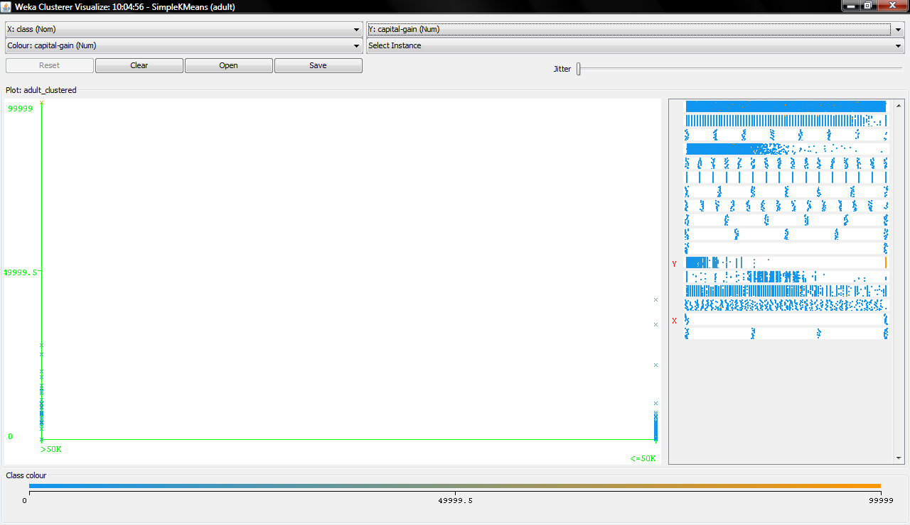

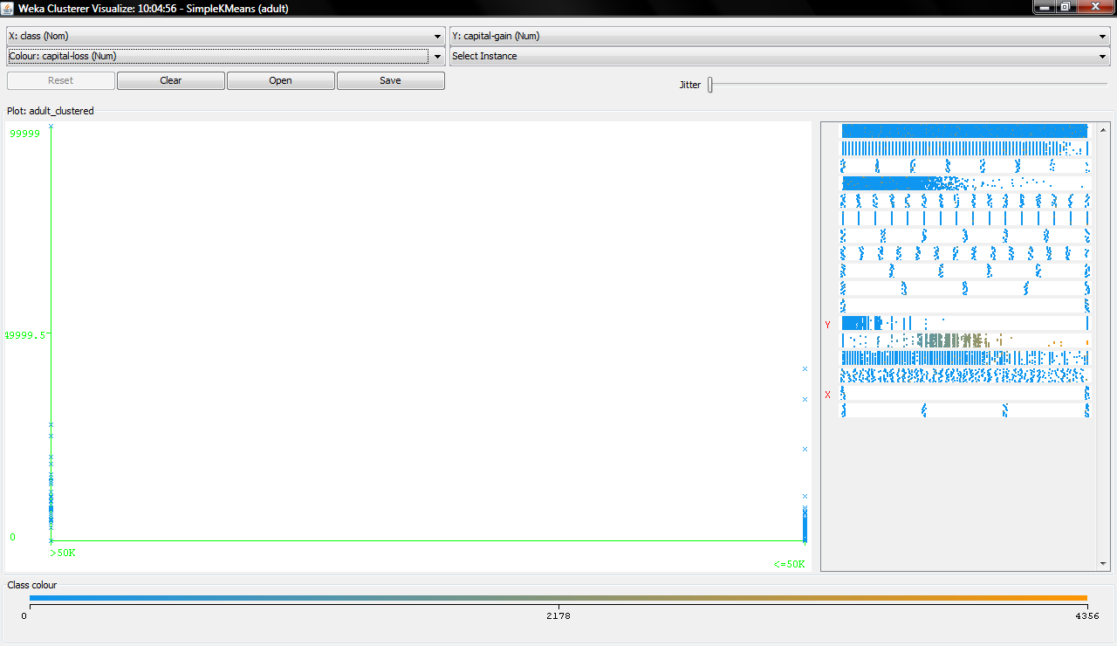

5 Outras Observações:

