 | Ushape Data Warehousing Project  Data Design Document  Version 1.0

National University of Computer and Emerging Sciences (NUCES-FAST), Lahore

Group ID

DW_F18_Group01

Project Team

Submission Date

Revision History
Date | Version | Description | Author
October 1, 2018 | 1.0 | Revision of the whole document, identified discrepancy in the E.R. diagram.
October 3, 2018 | 1.0 | Finalized E.R. Diagram and review of the Target system along with the dimensional system.
October 9, 2018 | 1.0 | Finalized document and review carried out.

Job Log

Job Performed | Performed By | Job Description | Time Taken
E.R. diagrams. | Isbah  Izaan  Tahreem | Involved transfer of E.R. diagrams from paper into Erwin, identify and fill holes. | 7 days
Introduction, scope,  requirements and Integrated Target database Design and Data dictionaries | Isbah | Combine all the E.R. models into one target system. | 3 day
Order Tracking Module module dimensional design and pictorial diagrams | Izaan  Tahreem | Design dimensional model of Order Tracking System | 1 day
Accounts module dimensional modeling  ER diagrams revision and Data dictionary | Isbah | Design dimensional model Accounts Management system module. | 1 day
Sales module dimensional modeling + logical dimensional models | Izaan | Design dimensional model of Sales Information system module | 1 day
Finalizing Document | Tahreem | Finalized document and revisions | 3 day

Table of Contents

1. Introduction 1
1.1. Purpose 1
1.2. Scope 1
1.3. References 2
2. Project Overview 3
2.1. Project Description 3
2.2. Goals 3
2.3 .Scope 3
2.4 .High Level User Requirements 4
2.3. Source Design 5
2.3.1 Sales information system 5
2.3.2 Order Tracking System 13
2.3.3 Accounts Management System 20
3. Data Marts Design 25
3.1. Data Mart 1 – Sales Information System 25
3.1.1. Logical Model 25
3.1.2. Physical Model 30
3.1.3. Data Dictionary 31
3.2. Data Mart 2 – Accounts Management System 41
3.2.1. Logical Model 41
3.2.2. Physical Model 45
3.2.3. Data Dictionary 46
3.3. Data Mart 3 – Order Tracking System 55
3.3.1. Logical Model 55
3.3.2. Physical Model 61
3.3.3. Data Dictionary 61

Data Design Document

Introduction

Purpose

The purpose of writing this document is to give a detailed view of the project (Ushape Data ware house). How are the things defined in the project and their association with each other. Also, the document gives a deep insight into the design of the project, having focus on its implementation. The audience for this document can be users using the data warehouse and all those developers, building the data warehouses on the same lines. We hope, this would give them, useful information and steps, to carry out things. This document provides all the tiny details of data warehousing creation such as normalized design of the data warehouse, dimensional design of the data warehouse.
This document is not only helpful for the users of the data warehouse because it provides necessary implementation and design information but it is equally helpful for the Software designers for further maintenance of the software.

Scope

The design of the Ushape data warehouse will allow users (executives) of Ushape shopping mall cooperation to more easily and efficiently monitor the business activities like sales, Orders including Shipments, Accounts and find needed information faster. Our product aims to improve the user's business efficiency through a well defined and easy-to-navigate data warehouse.
This document covers much of the design ideas and main implementation features of the Ushape data warehouse. Section 1.0 provides an introduction of the project, Section 2.0 provides a Project Overview while In Section 3.0 a high level Plan for the project including Target ER model design and the Target Dimensional Data Marts Designs.
There are basically three major OLTP systems involved in the product development and they are:

- SIS (Sales information System)
- AMS ( Accounts Management System)
- OTS (Order Tracking System)

So all the Strategic information or BI will be done by getting the information from these systems and the Resulting Data ware house will include the corresponding three Data marts of the data ware house.

This document is aimed to provide necessary information for the users and the developers to guide them for future use or maintenance respectively. This document is aimed to provide the executives a Q&A reference. We have tried to make it clear and understandable containing all needed information. Some very minor information may be not discussed in the document, otherwise it should be considered as a complete design specification document for Ushape data warehouse.

Definitions, Acronyms and Abbreviations

UShape Online shopping mall
Q&A An abbreviation for "Question and Answer."
SRS Software Requirements Specification
GUI (Graphical User Interface) - a visually based application that serves to provide an interactive medium between the user and the application.
E-R Entity-Relationship
SIS Sales information System
AMS Accounts Management System
OTS Order Tracking System
ETL Extraction, Transformation, Loading (of data for Data warehouse)
DW Abbreviation of Data Warehouse
SRS Software Requirements Specification
SDS Software Design Specifications
GUI (Graphical User Interface) - a visually based application that serves to provide an Interactive medium between the user and the application.
OLTP Online Transaction Processing Systems (Operational Systems)
BI business Intelligence

References

Data Warehousing Fundamentals, Paulraj Ponniah
Building the Data Warehouse, W. H. Inmon

Project Overview

2.1. Project Description

This project deals with Ushape Shopping Mall-- UShape's online shopping mall features a directory of Pakistan's best online shopping destinations - all in one place and categorized for your shopping convenience. It features online shopping malls, online music stores, movie stores, and also allows you to do online bill payments, create online shopping carts at stores. You can pay online by choosing UShape as the online payment service on the merchant's store and then using our Internet payment gateway.
These business processes are handled via a SIM (Sales information System) and Accounts Management System (AMS) and OTS (Order Tracking System). The management wants to build a data warehouse based on these three source systems for the purpose of better business understanding and increasing business profit as well as improving their online shopping services for their valuable customers.

2.2. Goals

The goals of the project are categorized as following:
• Build a data warehouse Build a small data warehouse for UShape Online Stores that integrates the given three systems SIS system AMS and OTS systems being used by the corporation and helps them in analyzing the business.
• The system must provide data in such a form, which is readily available for the analysis purpose.
• The system must be optimized for complex queries.
• Getting a clear picture of requirements and that will ultimately lead to a better data warehouse design.

.Scope

The scope of the target system mainly covers following business processes.
• Sales and profitability given by products and customers.
• Quality of service provided to customers.
• Efficiency of shipment and order tracking process.
• Efficient analysis of customers Account Management process.

. High Level User Requirements

The required system is a data warehouse system, which is used for business
Analysis purposes. The major analysis needs of the customer are as following:

- Which are the most profitable products
- Who are the most profitable customers
- What are the demands of their most profitable customers
- In which regions, the service is not very effective
- What is account information for a customer for given month
- How much revenue is generated in one year
- How many orders are miss tract
- How many orders are miss tract by given months
- In which state sale is maximum for a product
- In which zip area of a particular city, Customers are unsatisfied.
- In which city Shipment is delayed.
- In which city sale Products is maximum
- For which region or area Customers Shipment is delayed
- Which products are demanded less in a particular city.
- In which country Ushape has least number of customers
- To which organization least no. of individual customers associated

2.3. Source Design

2.3.1 Sales information system
Data Model:

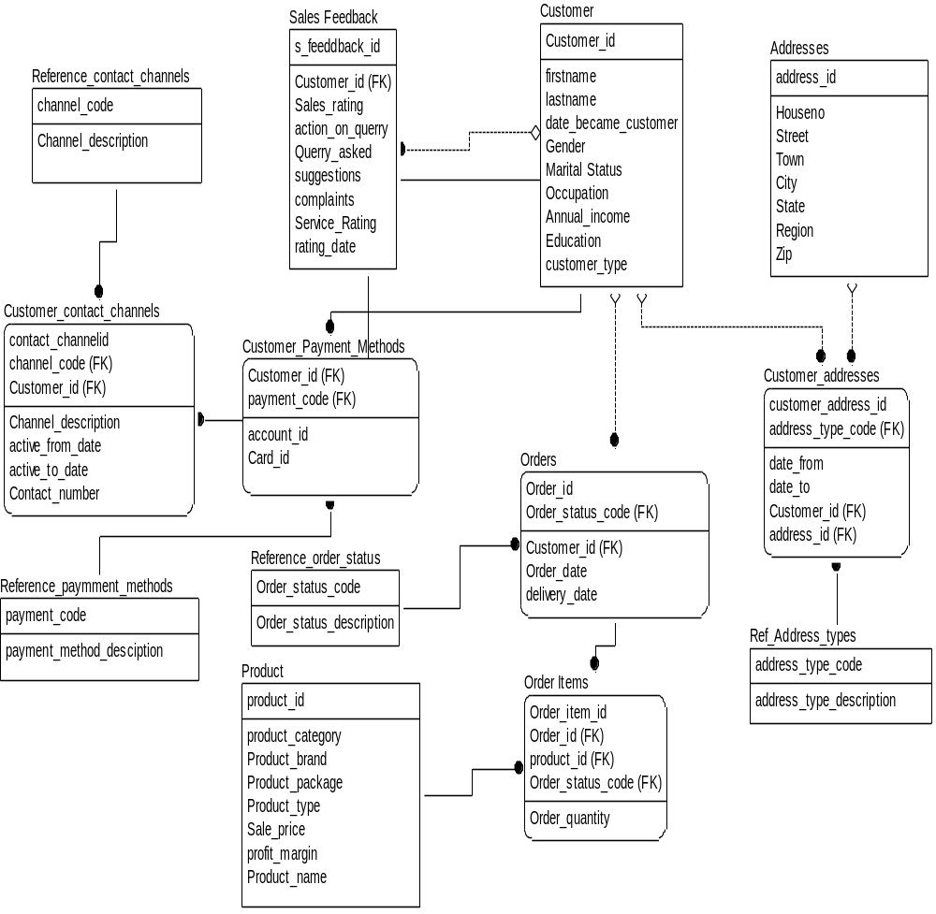

Data Dictionary:

Sale Information System:

Customer:

Table name | Customer | Database name | SaleInformation System
Description | This will provide information regarding customers.
Attributes | Customer _id, firstname, lastname, Gender, Date_became_customer, Marital Status, Occupation, Annual_income, Education, Customer_type
Primary keys | Customer _id
Foreign keys | -

Attribute Name | Description | Data type | Domain Constraint
Customer _id | It is the unique customer ssn or id | DECIMAL(10) | PK
Firstname | It will tell the first name of the customer. | CHAR(18) | -
Lastname | It will tell the last name of the customer. | CHAR(18) | -
Gender | It will tell the gender of the customer. | CHAR(6) | -
Date_became_customer | It will tell the date of becoming the customer. | DATE | -
Marital Status | It will tell the marital status of the customer. | CHAR(18) | -
Occupation | It will tell occupation of the customer. | CHAR(18) | -
Annual_income | It will tell the annual income of the customer. | FLOAT | -
Education | It will tell the education level of the customer. | CHAR(18) | -
Customer_type | Customer type corporate or residential | CHAR(18) | -

Addresses:

Table name | Addresses | Database name | Sales Information System
Description | This will provide information regarding addresses.
Attributes | adderess_id, Houseno, Street, Town, City, State, Region, Zip
Primary keys | adderess_id
Foreign keys | -

Attribute Name | Description | Data type | Domain Constraint
adderess_id | It will uniquely store the addresses. | DECIMAL(10) | PK
Houseno | provides the information regarding house no of customer | CHAR(18) | -
Street | provides the information regarding street address of customer | CHAR(18) | -
Town | provides the information regarding town name | CHAR(18) | -
City | provides the information regarding city name | CHAR(18) | -
State | provides the information regarding state name | CHAR(18) | -
Region | provides the information regarding region name | CHAR(18) | -
Zip | provides the information regarding zip code | DECIMAL(6) | -

Customer_addresses
Table name | Customer_addresses | Database name | Sales Information System
Description | This will provide information regarding customer addresses.
Attributes | Customer_address_id, address_type_code, Date_from, Date_to, Customer_id, Address_id
Primary keys | Customer_address_id,
Foreign keys | address_type_code, Customer_id, Address_id

Attribute Name | Description | Data type | Domain Constraint
Customer_address_id | Tells the unique address of the customers. | CHAR(18) | PK
address_type_code | Tells the unique address of the customers. | CHAR(18) | FK
Date_from | It is the date from which the customer is having some address. | DATE | -
Date_to | It is the date at which the customer left some address. | DATE | -
Customer_id | It is the unique customer sent or id | DECIMAL(10) | FK
Address_id | It is address id of customer | DECIMAL(10) | -

Ref_address_types:

Table name | Ref_Address_types | Database name | Sales Information System
Description | This will provide information regarding reference address types.
Attributes | Address_type_description
Primary keys | Address_type_code ,Address_type_code
Foreign keys | -

Attribute Name | Description | Data type | Domain Constraint
Address_type_code | Tells the type code of the address. | CHAR(18) | PK
Address_type_description | provides the information regarding billing or delivery address | CHAR(18) | FK

Orders:
Table name | Orders | Database name | Sales Information System
Description | This will provide information regarding the orders placed by customers.
Attributes | Order_id,Order_status_code Customer_id, Order_date, Deliver_date
Primary keys | Order_id,
Foreign keys | Order_status_code, Customer_id

Attribute Name | Description | Data type | Domain Constraint
Order_id | It will tell the unique order id of the orders. | DECIMAL(10) | PK
Order_status_code | It will uniqely tells the status code of each order. | CHAR(18) | FK
Customer_id | It is the unique customer ssn or id | DECIMAL(10) | FK
Order_date | provides the information regarding date of order placed | DATE | -
Deliver_date | provides the information regarding date of delivery | DATE | -

Attribute Name | Description | Data type | Domain Constraint
Order_status_code | It will uniqely tells the status code of each reference order. | CHAR(18) | PK
Order_status_description | provides the information regarding order status description weather pending or delivered | CHAR(18) | -

Table name | Reference_order_status | Database name | Sales Information System
Description | This will provide information regarding the reference order status.
Attributes | Order_status_code, Order_status_description
Primary keys | Order_status_code
Foreign keys | -

Order_items:

Table name | Order items | Database name | Sales Information System
Description | This will provide information regarding ordered items.
Attributes | Order_item_id, Order_id, Product_id, Order_status_code, Order_quantity
Primary keys | Order_item_id
Foreign keys | Order_id, Product_id, Order_status_code

Attribute Name | Description | Data type | Domain Constraint
Order_item_id | Tells the unique id of ordered item. | CHAR(18) | PK
Order_id | It will tell the unique order id of the customers. | DECIMAL(10) | FK
Product_id | product id of each product | DECIMAL(10) | FK
Order_status_code | It will uniqely tells the status code of each order. | CHAR(18) | FK
Order_quantity | provides the information regarding quanity or no of order placed | CHAR(18) | -

Table name | Product | Database name | Sales Information System
Description | This will provide information regarding products.
Attributes | Product_id, Product_category, Product_brand, Product_package, Product_type, Sale_price, Profit_margin, Product_name
Primary keys | Product_id
Foreign keys | -

Attribute Name | Description | Data type | Domain Constraint
Product_id | provides the information regarding product id of each product | DECIMAL(10) | PK
Product_category | provides the information regarding category of product | CHAR(18) | -
Product_brand | provides the information regarding brand name of product | CHAR(18) | -
Product_package | provides the information regarding package name of product | CHAR(18) | -
Product_type | provides the information regarding product type of product | CHAR(18) | -
Sale_price | provides the information regarding sale price of product | FLOAT | -
Profit_margin | provides the information regarding profit margin of product | FLOAT | -
Product_name | provides the information regarding name of product | CHAR(18)

Table name | Sales Feedback | Database name | Sales Information System
Description | This will provide information sales feedback.
Attributes | S_feedback_id, Sales_rating, Action_on_query, Query_asked, suggestions, complaints, Service_rating, Rating_date
Primary keys | s_feedback_id
Foreign keys | Customer_id

Attribute Name | Description | Data type | Domain Constraint
s_feedback_id | Uniquely tells the feedback id of the sales feedback. | CHAR(18) | PK
Customer_id | It is the unique customer ssn or id | DECIMAL(10) | FK
Sales_rating | Sales rating could be 0,1,2,3,4,5 5 is the best rating | DECIMAL(1) | -
Action_on_query | It keeps the action performed on query | CHAR(18) | -
Query_asked | Any query asked by user | CHAR(18) | -
suggestions | Any suggestions given during feedback | CHAR(18) | -
complaints | Any complaints given by customer | CHAR(18) | -
Service_rating | Service rating given by the customer during feedback | DECIMAL(1) | -
Rating_date | It is the date of the feedback taken | DATE | -

Table name | Customer_payment_methods | Database name | Sales Information System
Description | This will provide information regarding customer payment methods.
Attributes | Payment_code ,Customer_id, Account_id, Card_id
Primary keys | Payment_code
Foreign keys | Customer_id

Customer_id | It is the unique customer ssn or id | DECIMAL(10) | PK
Payment_code | It is the fk of payment code entitiy | CHAR(18) | FK
Account_id | It is the accound id of the cutomer | LARGE BINARY | -
Card_id | provides the information regarding card no of customer | LARGE BINARY | -

Customer_contact_channels:
Table name | Customer_contact_channels | Database name | Sales Information System
Description | This will provide information regarding customer contact channels.
Attributes | Contact_channelid,Channel_code,Customer_id,Channel_description, Active_from_date, Active_to_date, Contact_number
Primary keys | Contact_channelid
Foreign keys | Customer_id,Channel_code

Attribute Name | Description | Data type | Domain Constraint
Contact_channelid |  | DECIMAL(10) | PK
Channel_code | channel code is the channel primary key | CHAR(18) | FK
Customer_id | It is the unique customer ssn or id | DECIMAL(10) | FK
Channel_description | channel disc by email or mobile no | CHAR(18) | -
Active_from_date | provides the information regarding activation date | DATE | -
Active_to_date | provides the information regarding expiry date of activation | DATE | -
Contact_number | provides the information regarding contact no of channel | CHAR(18) | -

Reference_payment_mathods:

Table name | Reference_payment_methods | Database name | Sales information system
Description | This will provide information regarding reference payment methods
Attributes | Payment_code ,Payment_method_description,
Primary keys | Payment_code
Foreign keys | -

Attribute Name | Description | Data type | Domain Constraint
Payment_code |  | CHAR(18) | PK
Payment_method_description | This will provide information regarding payment method by weather by cheque or by card or by cash |  | -

Reference_contact_channels:
Table name | Reference_contact_channels | Database name | Sales information system
Description | This will provide information regarding reference contact channels.
Attributes | Channel_code, Channel_description
Primary keys | Channel_code
Foreign keys | -

Attribute Name | Description | Data type | Domain Constraint
Channel_code | channel code is the channel primary key | CHAR(18) | PK
Channel_description | Tells the channel description eg email address of the customer |  | FK

2.3.2 Order Tracking System
Data Model:
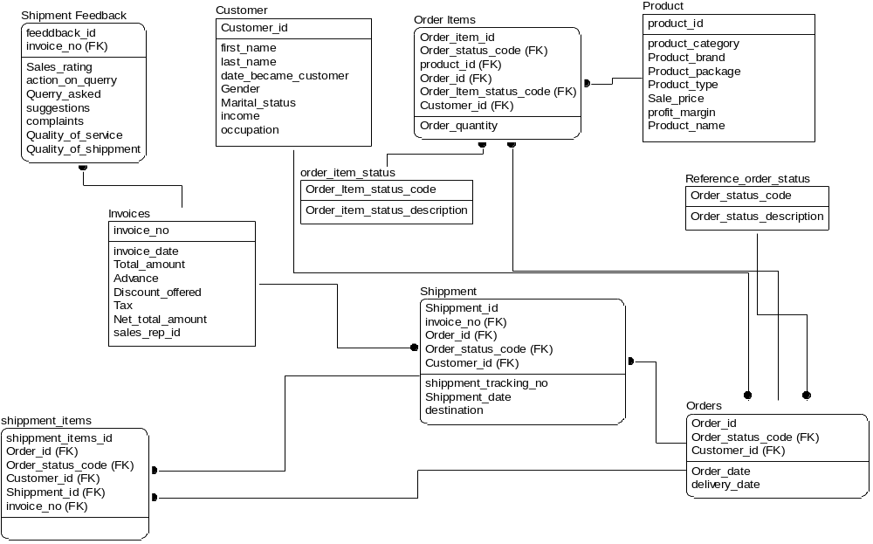

Data Dictionary:
Customer:

Table name | Customer | Database name | SaleInformation System
Description | This will provide information regarding customers.
Attributes | Customer _id, firstname, lastname, Gender, Date_became_customer, Marital Status, Occupation, Annual_income, Education, Customer_type
Primary keys | Customer _id
Foreign keys | -

Attribute Name | Description | Data type | Domain Constraint
Customer _id | It is the unique customer ssn or id | DECIMAL(10) | PK
Firstname | It will tell the first name of the customer. | CHAR(18) | -
Lastname | It will tell the last name of the customer. | CHAR(18) | -
Gender | It will tell the gender of the customer. | CHAR(6) | -
Date_became_customer | It will tell the date of becoming the customer. | DATE | -
Marital Status | It will tell the marital status of the customer. | CHAR(18) | -
Occupation | It will tell occupation of the customer. | CHAR(18) | -
Annual_income | It will tell the annual income of the customer. | FLOAT | -
Product:

Table name | Product | Database name | Order Tracking System
Description | This will provide information regarding products.
Attributes | Product_id, Product_category, Product_brand, Product_package, Product_type, Sale_price, Profit_margin, Product_name
Primary keys | Product_id
Foreign keys | -

Attribute Name | Description | Data type | Domain Constraint
Product_id | product id of each product | DECIMAL(10) | PK
Product_category | category of product | CHAR(18) | -
Product_brand | brand name of product | CHAR(18) | -
Product_package | package name of product | CHAR(18) | -
Product_type | product type of product | CHAR(18) | -
Sale_price | sale price of product | FLOAT | -
Profit_margin | profit margin of product | FLOAT | -
Product_name | name of product | CHAR(18)
Orders:

Table name | Orders | Database name | Order tracking System
Description | This will provide information regarding the orders placed by customers.
Attributes | Order_id,Order_status_code ,Customer_id,order_date,deliver_date
Primary keys | Order_id,
Foreign keys | Order_status_code, Customer_id

Attribute Name | Description | Data type | Domain Constraint
Order_id | It will tell the unique order id of the customers. | DECIMAL(10) | PK
Order_status_code | It will uniqely tells the status code of each order. | CHAR(18) | FK
Customer_id | It is the unique customer ssn or id | DECIMAL(10) | FK
Order_date | provides the information regarding date of order placed | DATE | -
Deliver_date | provides the information regarding date of delivery | DATE | -

Order_items:

Table name | Order items | Database name | Order Tracking System
Description | This will provide information regarding ordered items.
Attributes | Order_item_id,Order_id,Product_id,Order_status_code, Order_quantity,order_item_statuscode,customerid
Primary keys | Order_item_id
Foreign keys | Order_id, Product_id, Order_status_code, order_item_statuscode, customer_id

Attribute Name | Description | Data type | Domain Constraint
Order_item_id | Tells the unique id of ordered item. | CHAR(18) | PK
Order_id | It will tell the unique order id of the . | DECIMAL(10) | FK
Product_id | product id of each product | DECIMAL(10) | FK
Order_status_code | It will uniqely tells the status code of each order. | CHAR(18) | FK
Order_quantity | This will provide information regarding quantity or no of order placed | CHAR(18) | -
Customer_id | It is the unique customer ssn or id | DECIMAL(10) | FK
order_item_statuscode | Tells the status code of order each item. | CHAR(18) | FK
Reference_order_status:
Table name | Reference_order_status | Database name | Order tracking System
Description | This will provide information regarding the reference order status.
Attributes | Order_status_code, Order_status_description
Primary keys | Order_status_code
Foreign keys | -

Attribute Name | Description | Data type | Domain Constraint
Order_status_code | It will uniqely tells the status code of each order. | CHAR(18) | PK
Order_status_description | provides the information regarding order status description e.g pending or delivered | CHAR(18) | -
Order_item_status:
Table name | Order_item_status | Database name | Order tracking System
Description | This will provide information regarding order item status.
Attributes | Order_status_code, Order_status_description
Primary keys | Order_status_code
Foreign keys | -

Attribute name | Description | Data type | Domain Constraint
Order_status_code |  | CHAR(18) | PK
Order_status_description |  | CHAR(18) | FK
Shipment:
Table name | Shipment | Database name | Order tracking System
Description | This will provide information regarding shipment
Attributes | Shipment_id, Invoice_no, Order_id, Order_status_code , Customer_id, Shipment_tracking_no, Shipment_date, destination, Arrival_date, Arrival_time, Shipment_time, Shipping_expenses, mode, distance
Primary keys | Shipment_id
Foreign keys | Customer_id, Invoice_no, Order_id, Order_status_code

Attribute name | Description | Data type | Domain Constraint
Shipment_id |  | DECIMAL(10) | PK
Invoice_no | Invoice number of the shipment | DECIMAL(10) | FK
Order_id | It will tell the unique order id of the customers. | DECIMAL(10) | FK
Order_status_code | It will uniqely tells the status code of each order. | CHAR(18) | FK
Customer_id | It is the unique customer ssn or id | DECIMAL(10) | FK
Shipment_tracking_no | Tells the shipment tracking number. | CHAR(18) | -
Shipment_date |  | DATE | -
destination | Tells the destination of shipment. | CHAR(18) | -
Arrival_date | Tells the arrival date of the shipment. | DATE | -
Arrival_time | Tells the arrival time of the shipment. | TIME | -
Shipment_time | Tells the shipment time. | TIME() | -
Shipping_expenses | Tells the shipment expenses. | FLOAT | -
mode |  | CHAR(18) | -
distance | Provides the information regarding distance. | CHAR(18) | -

Invoice:

Table name | Invoice | Database name | Order tracking System
Description | This will provide information regarding invoices.
Attributes | Invoice_no, Invoice_date, Total_amount, Invoice_date, Total_amount, advance, Discount_offered, tax, Net_total_amount, Sales_rep_id
Primary keys | Invoice_no
Foreign keys | -

Attribute Name | Description | Data type | Domain Constraint
Invoice_no | Invoice number of the shipment | DECIMAL(10) | PK
Invoice_date | Invoice date | DATE | FK
Total_amount | Total amount paid | FLOAT | -
advance | Advance paid | FLOAT | -
Discount_offered | Provides the information regarding discount offered. | FLOAT | -
Tax | Provides the information regarding tax. | FLOAT | -
Net_total_amount | Net total amount paid | FLOAT | -
Sales_rep_id | Sales rep id | CHAR(18)

Shipment Feedback:

Table name | Shipment Feedback | Database name | Order tracking system
Description | This will provide information regarding shipment feedback.
Attributes | Feedback_id, Invoice_no, Sales_rating, Action_on_query, Query_asked, complaints, Quality_of_service, Quality_of_shipment
Primary keys | Feedback_id
Foreign keys | -

Attribute Name | Description | Data type | Domain Constraint
Feedback_id | It is the unique feedback id of the shipment feedback. | CHAR(18) | PK
Invoice_no |  | Invoice_no | FK
Sales_rating | provides the information regarding complaints | DECIMAL(1) | -
Action_on_query |  | CHAR(18) | -
Query_asked | Provides the information regarding asked query. | CHAR(18) | -
Suggestions, | provides the information regarding suggestions. | CHAR(18) | -
complaints | provides the information regarding complaints . | CHAR(18) | -
Quality_of_service | provides the information regarding quality of service. | DECIMAL(1) | -
Quality_of_shipment | provides the information regarding quality of shipment | CHAR(18) | -
Shipment_items:

Table name | Shipment_items | Database name | Order tracking System
Description | This will provide information regarding shipment items.
Attributes | Shipment_items_id, Order_id, Order_status_code, Customer_id, Shipment_id, Shipment_id
Primary keys | Shipment_items_id,
Foreign keys | Order_id, Order_status_code, Customer_id, Shipment_id, Shipment_id

Attribute Name | Description | Data type | Domain Constraint
Shipment_items_id |  | CHAR(18) | PK
Order_id | It will tell the unique order id of the customers. | DECIMAL(10) | FK
Order_status_code | It will uniqely tells the status code of each order. | CHAR(18) | FK
Customer_id | It is the unique customer ssn or id | DECIMAL(10) | FK
Shipment_id |  | DECIMAL(10) | FK
Invoice_no | Invoice number of the shipment | DECIMAL(10) | FK

2.3.3 Accounts Management System
Data Model:
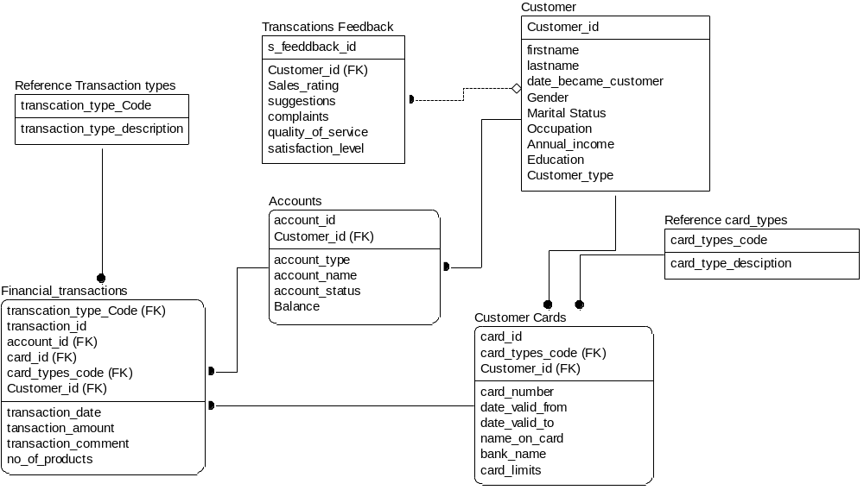

Data Dictionary:

Customer:

Table name | Customer | Database name | Account Management System
Description | This will provide information regarding customers.
Attributes | Customer _id, firstname, lastname, Gender, Date_became_customer, Marital Status, Occupation, Annual_income, Education, Customer_type
Primary keys | Customer _id
Foreign keys | -

Attribute Name | Description | Data type | Domain Constraint
Customer _id | It is the unique customer ssn or id | DECIMAL(10) | PK
firstname | It will tell the first name of the customer. | CHAR(18) | -
lastname | It will tell the last name of the customer. | CHAR(18) | -
Gender | It will tell the gender of the customer. | CHAR(6) | -
Date_became_customer | It will tell the date of becoming the customer. | DATE | -
Marital Status | It will tell the marital status of the customer. | CHAR(18) | -
Occupation | It will tell occupation of the customer. | CHAR(18) | -
Annual_income | It will tell the annual income of the customer. | FLOAT | -
Education | It will tell the education level of the customer. | CHAR(18) | -
Customer_type | Customer type corporate or residential | CHAR(18) | -

Accounts:

Table name | Accounts | Database name | Account Management System
Description | This will provide information regarding customer accounts.
Attributes | account_id, Customer _id, account_type, account_name, account_status, Balance
Primary keys | account_id
Foreign keys | Customer _id

Attribute Name | Description | Data type | Domain Constraint
account _id | It will tell the unique account numbers of the customers. | DECIMAL(10) | PK
Customer _id | It is the unique customer ssn or id | DECIMAL(10) | FK
account_type | It will tell the account type of the customer. | CHAR(18) | -
account_name | It will tell the account name of the customer. | CHAR(18) | -
account_status | It will tell the account status of the customer. | CHAR(18) | -
Balance | It will tell the balance of the customer. | FLOAT | -

Transactions Feedback

Table name | Transactions Feedback | Database name | Account Management System
Description | This will provide information regarding transactions feedback.
Attributes | s_feedback_id,Customer _id, Sales_rating,,suggestions,complaints, quality_of_service, satisfaction_level
Primary keys | s_feedback_id
Foreign keys | Customer _id

Attribute Name | Description | Data type | Domain Constraint
s_feedback_id | It will uniqely tells the feedback id of the transaction feedback. | CHAR(18) | PK
Customer _id | It is the unique customer ssn or id | DECIMAL(10) | FK
Sales_rating | It will tell the sales rating. | DECIMAL(1) | -
suggestions | It will tell the suggestions given by the customer. | CHAR(18) | -
complaints | It will tell the complaints given by the customer. | CHAR(18) | -
quality_of_service | It will tell the qulaity of service provided to the customers. | CHAR(18) | -
Satisfaction_level | It will tell the satisfaction level of the customer. | DECIMAL(1) | -

Customer Cards:
Table name | Customer Cards | Database name | Account Management System
Description | This will provide information regarding customer cards.
Attributes | Card_id, Customer_id,card_types_code, card_number, date_valid_from, date_valid_to, name_on_card, bank_name, card_limits
Primary keys | Card_id
Foreign keys | Customer _id,,card_types_code

Attribute Name | Description | Data type | Domain Constraint
card_id | It will tell the unique card id of the customers. | DECIMAL(14) | PK
card_types_code | It will tell the card type code of the customer card. | CHAR(18) | FK
Customer _id | It is the unique customer ssn or id | DECIMAL(10) | FK
card_number | It will tell the card number of the customer. | DECIMAL(10) | -
date_valid_from | It will tell the date from which the card was valid. | DATE | -
date_valid_to | It will tell the date at which the card will expire | DATE | -
name_on_card | It will tell the name of the card. | CHAR(18) | -
bank_name | It will tell the bank name on the card. | CHAR(18) | -
card_limits | It will tell the card limit of the card. | CHAR(18) | -
Financial_transactions:
Table name | Financial_transactions | Database name | Account Management System
Description | This will provide information regarding financial transactions.
Attributes | transaction_type_code,transaction_id,account_id,card_id,card_types_code, Customer_id,transaction_date,transaction_amount,transaction_comment, no_of_products
Primary keys | transaction_id,
Foreign keys | transaction_type_code, account_id, card_id, card_types_code, Customer_id

Attribute Name | Description | Data type | Domain Constraint
transaction_type_code | It will uniquely tells the type code of each transaction. | CHAR(18) | PK
transaction_id | It will tell the unique transaction id of each financial transaction. | CHAR(18) | FK
account_id | It will tell the unique account numbers of the customers. |  | FK
card_id | It will tell the unique account numbers of the customers. | DECIMAL(14) | FK
card_types_code | It will tell the card type code of the customer card. | CHAR(18) | FK
Customer_id | It is the unique customer ssn or id | DECIMAL(10) | FK
transaction_date | It will tell the date at which the transaction was made. | DATE | -
transaction_amount | It will tell transaction amount | CHAR(18) | -
transaction_comment | It will tell transaction comment. | CHAR(18) | -
no_of_products | It will tell no of products against each transaction. | INTEGER | -
Reference Transaction Types:
Table name | Reference Transaction Types | Database name | Account Management System
Description | This will provide information regarding reference transaction types.
Attributes | transaction_type_code, transaction_type_description
Primary keys | transaction_type_code
Foreign keys | -

Attribute Name | Description | Data type | Domain Constraint
transaction_type_code, | It will uniquely tells the type code of each transaction. | CHAR(18) | PK
transaction_type_description | It will tell the description about the transaction type. | CHAR(18) | -

Reference card_types:
Table name | Reference card_types | Database name | Account Management System
Description | This will provide information regarding reference card types.
Attributes | card_types_code, card_type_description
Primary keys | card_types_code
Foreign keys | -

Data Marts Design

Data Mart 1 – Sales Information System

Logical Model

Time Dimension

Attribute Name | Description | Sample Values
Day  Week  Month  Quarter  Year | It keeps the value of a particular day  It keeps the value of a particular week  It keeps the value of a particular month  It keeps the value of a particular Quarter  It keeps the value of a particular Year | Saturday  Week1  June  Second Quarter  2007
A

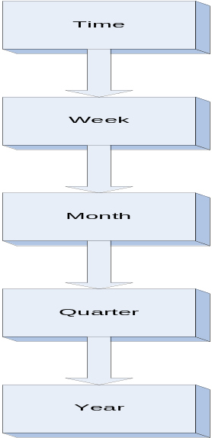

Region Dimension

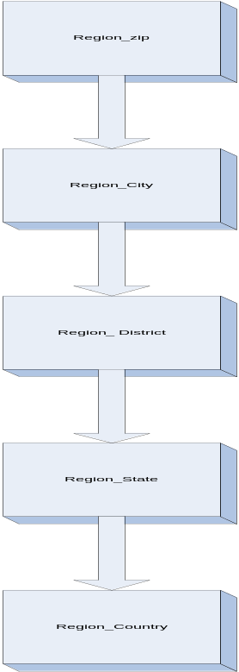
Attribute Name | Description | Sample Values
Zip  City  District  State  Country | It stores the zip code of an area  It stores the city name  It stores the district name  It stores the state name  It stores the country name | 54000  Sialkot  Lahore  Punjab  Pakistan
A

Customer dimension
Attribute Name | Description | Sample Values
First name | Customer first name | Hassan, Muhammad
Last name | Customer Last name | Zia, Umair
Date_became customer | When the customer did his first purchase. | 12-08-2007
Gender | Male/Female | M/F
Martial status | Single, Married | S/M
Annual _income | The income that the customer earns in one year. | Rs.200000, Rs.500000
Occupation | This will record the information related Job, Profession. | Engineer, Doctor
Education | This will record the information related Academics of customer. | Master, Graduate,etc
Customer type | It stores the customer type either corporate or invidulal | Corporate ,individual
Zip | The zip of the customer. | 02214, 05252
City | The city of the customer. | Lahore, Karachi
District | The District of the customer. | Lahore, Karachi
State | The state of the customer. | Punjab, Sind
Country | The country of the customer. | Pakistan.

Order dimension

Attribute Name | Description | Sample Values
Order_id | Order id number | 45454
Order_date | Date of order placement | 12-02-2007
Delivery_date | Date of order Delivery | 25-02-2007
Order_status_discriptioon | Whether the order has been delivered or not | Delivered
Customer_id | Customer id who place the order | 252552

Product dimension

Attribute Name | Description | Sample Values
Product_id | Product id number | 757
Product_name | Name of the product | Lux soap
Product_brand | Brand name of the product | LUX
Product_category | Category of the product | SOAP
Product_package | Project package of the product | Combo1
Product_type | It stores the product type of the product | food
Sale_price | Sale price of the product | R.52
Profit_margin | Profit margin | Rs.7

Order item dimension

Attribute Name | Description | Sample Values
Order_item_id | Order item id number | 45454
Order_Quantity | Date of order placement | 12-02-2007
Product_id | Product id number | 757
Customer_id | Customer id who place the order | 252552

Sales feedback dimension

Attribute Name | Description | Sample Values
S_feedback_id | Feedback id number | 78
Sales_rating | How good the sale is going. Rang 1-5. 1(mini),5(max) | 3
Service_rating | It stores the overall service ratings of the sales department | 1
Rating_date | Date of feedback placement | 24-06-2007
Customer_id | Customer id who place the feedback | 252552

Sales Fact
Fact Name | Description | Default Aggregation rule
Product_quantity_count | It measures the product quanity sold count | One way aggregate
Product_magin_count | It measures the product profit margin count | One way aggregate

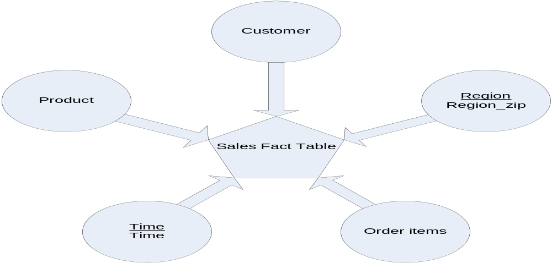

Sales Feedback Fact Table:
Fact Name | Description | Default Aggregation rule
Sales_rating_count | It measures the sales rating | One way aggregate
Service_rating_count | It measures the service rating | One way Aggregate

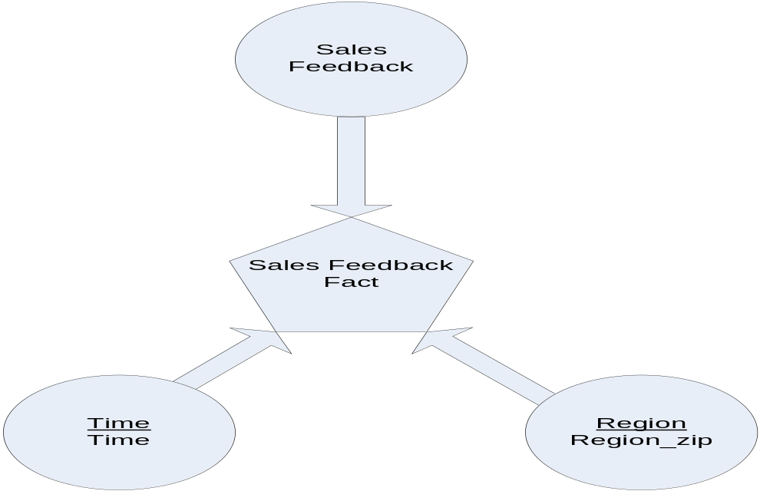

Sales Aggragate Fact Table:
Fact Name | Description | Default Aggregation rule
Product_quantity_count | It measures the product quanity count | Two way aggregate
Product_magin_count | It measures the product profit margin count | Two way aggregate

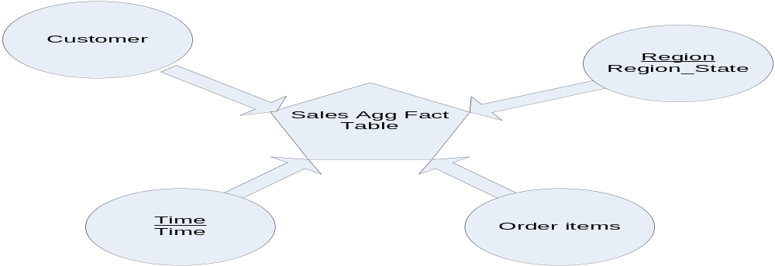

Physical Model

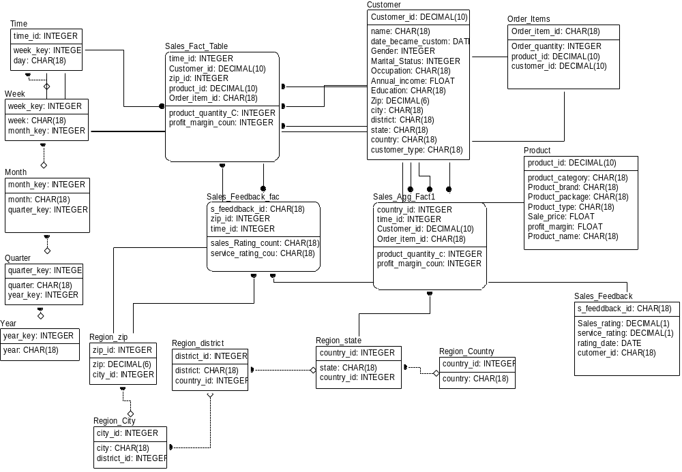

Data Dictionary
Dimension name | Customer | Model name | Sales DM
Description | It will keep the customer personal information.
Attributes | Customer_id,Firstname,Lastname,Date_became_customer,Gender,Marital_status, Occupation,Annual_income,Education,Customer_type,zip,city,district,state, country, customer_type
Primary keys | Customer_id
Foreign keys | None
Associated Fact Tables | , sales_Agg_Fact1, sales_Fact_table
Time Dimension Table

Dimension name | Time | Model name | Sales DM
Description | Record time
Attributes | Time_id, week_key
Primary keys | Time_id
Foreign keys | Week_key
Associated Fact Tables | , sales_fact_table , sales_feedback_fact, sales_agg_fact1,
Week Dimension Table
Dimension name | Week | Model name | Sales DM
Description | Record time in week format
Attributes | Week_key, ,month_key
Primary keys | Week_key
Foreign keys | Month_key
Associated Fact Tables

Month Dimension Table
Dimension name | Month | Model name | Sales DM
Description | Record time in month format
Attributes | Month, quarter_key, ,month_key
Primary keys | Month_key
Foreign keys | quarter_key
Associated Fact Tables

Quarter Dimension Table

Dimension name | Quarter | Model name | Sales DM
Description | Record time in quarter format
Attributes | Quarter, quarter_key, year_key
Primary keys | quarter_key
Foreign keys | Year_key
Associated Fact Tables

Dimension name | Year | Model name | Sales DM
Description | Record time in year format
Attributes | Year_key , year
Primary keys | Year_key
Foreign keys
Associated Fact Tables

Order item Dimension Table

Dimension name | Order_item | Model name | Sales DM
Description
Attributes | Order_item_id, order_quantity, product_id, customer_id
Primary keys | Order_item_id
Foreign keys
Associated Fact Tables | sales agg fact1, sales fact table

Product Dimension Table

Dimension name | Product | Model name | Sales DM
Description | This table will keep the information about product.
Attributes | Product_id, Product_name, Product_category, Product_brand, Product_package, Product_type, sale_price, profit_margin
Primary keys | Product_id
Foreign keys
Associated Fact Tables | Sales fact table

Sales feedback Dimension Table

Dimension name | Sales feedback | Model name | Sales DM
Description | This table will keep the feed back from the customer about sale services.
Attributes | s_feedback_id , sales_rating, service_rating, rating_dat, customer_id
Primary keys | s_feedback_id
Foreign keys
Associated Fact Tables | Sales feedback fact

Region zip Dimension Table
Dimension name | Regin_zip | Model name | Sales DM
Description | Zip wise record
Attributes | zip_id, zip, city_id
Primary keys | Zip_id
Foreign keys | City_id
Associated Fact Tables | Sales feedback fact , Sales fact table,

Region city Dimension Table

Dimension name | Region_city | Model name | Sales DM
Description | City wise record
Attributes | City_id, city, district_id
Primary keys | City_id
Foreign keys | district_id
Associated Fact Tables

Region district Dimension Table

Dimension name | Region_district | Model name | Sales DM
Description | District wise record
Attributes | District_id, district, state_id
Primary keys | District_id
Foreign keys | state_id
Associated Fact Tables

Region state Dimension Table

Dimension name | Region_state | Model name | Sales DM
Description | State wise record
Attributes | State_id, state, country_id
Primary keys | State_id
Foreign keys | country_id
Associated Fact Tables | Sales agg fact1

Region country Dimension Table
Dimension name | Region_country | Model name | Sales DM
Description | Country wise record
Attributes | Country_id, country
Primary keys | Country_id
Foreign keys
Associated Fact Tables

Attribute(s) of "Customer" Dimension
Name | Description | Data Type | (Domain Constraints )Is PK | Is FK
Customer_id | primary key of customer | decimal(10) | Yes | No
name | name of the customer | char(18) | No | No
date_became_customer | date of becoming a customer | date | No | No
Gender | gender information | integer | No | No
Marital Status | marital status information | iinteger | No | No
Occupation | occupation information | char(18) | No | No
Annual_income | annual income of the customer | float | No | No
Education | education of the customer | char(18) | No | No
Zip | zip no of the csutomer | decimal(6) | No | No
city | city of the customer | char(18) | No | No
district | district of the customer | char(18) | No | No
state | state of the customer | char(18) | No | No
country | country of the customer | char(18) | No | No
customer_type | cystomer type corporate or individual | char(18) | No | No

Attribute(s) of "Month" Dimension
Name | Description | Data Type | (Domain Constraints )Is PK | Is FK
month_key | month foriegn key | integer | Yes | No
month | month information | char(18) | No | No
quarter_key | foegin key of quarter | integer | No | Yes

Attribute(s) of "Order Items" Dimesnion
Name | Description | Data Type | (Domain Constraints )Is PK | Is FK
Order_item_id | primary key of order items | char(18) | Yes | No
Order_quantity | order quanity | integer | No | No
product_id | product id | decimal(10) | No | No
customer_id | customer id of the customer | decimal(10) | No | No

Attribute(s) of "Product" Dimension
Name | Description | Data Type | (Domain Constraints )Is PK | Is FK
product_id | foregin key of product dimension | decimal(10) | Yes | No
product_category | category of product | char(18) | No | No
Product_brand | brand of product | char(18) | No | No
Product_package | package info of product | char(18) | No | No
Product_type | product type | char(18) | No | No
Sale_price | sale price of product | float | No | No
profit_margin | profit margin of product | float | No | No
Product_name | name of product | char(18) | No | No

Attribute(s) of "Quarter" Dimension
Name | Description | Data Type | (Domain Constraints )Is PK | Is FK
quarter_key | quarter primary key | integer | Yes | No
quarter | quarter information | char(18) | No | No
year_key | foregin key of year | integer | No | Yes

Attribute(s) of "Region City" Dimension
Name | Description | Data Type | (Domain Constraints )Is PK | Is FK
city_id | primary key of city | integer | Yes | No
city | city info | char(18) | No | No
district_id | foregin key of district | integer | No | Yes

Attribute(s) of "Region_Country" Dimension
Name | Description | Data Type | (Domain Constraints )Is PK | Is FK
country_id | primary key of contry | integer | Yes | No
country | country info | char(18) | No | No

Attribute(s) of "Region_district" Dimension
Name | Description | Data Type | (Domain Constraints )Is PK | Is FK
district_id | primary key of district | integer | Yes | No
district | district info | char(18) | No | No
state_id | foregin key of state_id | integer | No | Yes

Attribute(s) of "Region_state" Dimension
Name | Description | Data Type | (Domain Constraints )Is PK | Is FK
state_id | primary key of state_id | integer | Yes | No
state | state info | char(18) | No | No
country_id | foregin key of customer id | integer | No | Yes

Attribute(s) of "Region_zip" Dimension
Name | Description | Data Type | (Domain Constraints )Is PK | Is FK
zip_id | primary key of zip | integer | Yes | No
zip | zip code | decimal(6) | No | No
city_id | foregin key of city_id | integer | No | Yes

Attribute(s) of "Time" Dimension
Name | Description | Data Type | (Domain Constraints )Is PK | Is FK
time_id | time id key of the time dimesion | integer | Yes | No
week_key | foregin key of week | integer | No | Yes
day | day information | character(18) | No | No

Attribute(s) of "Week" Dimension
Name | Description | Data Type | (Domain Constraints )Is PK | Is FK
week_key | foregin key of week |  | Yes | No
week | stores week information | char [18] | No | No
month_key | foregin key of month | integer | No | Yes

Attribute(s) of "Year" Dimension
Name | Description | Data Type | (Domain Constraints )Is PK | Is FK
year_key | year primary key | integer | Yes | No
year | stores year information | char(18) | No | No

Fact Tables:
Sales Fact table

Fact Table name | Sales Fact Table | Model name | Sales DM
Description | It calculates the sales Related facts like product quanity or product profits margins
Attributes | time_id,zip_id,customer_id,product_id,order_item_id, Product_quantity_count, Profit_margin_count
Primary keys
Foreign keys | time_id,zip_id,customer_id,product_id,order_item_id
Facts / Measures | Product_quantity_count, Profit_margin_count
Associated  Dimensions | Time, Redion_Zip, Product, Customer, Order_item

Sales agg Fact table

Fact Table name | Sales agg Fact Table | Model name | Sales DM
Description | It calculates the sales Related facts like product quanity or product profits margins
Attributes | time_id,state_id,customer_id,order_item_id, Product_quantity_count, Profit_margin_count
Primary keys
Foreign keys | time_id,state_id,customer_id,order_item_id
Facts / Measures | Product_quantity_count, Profit_margin_count
Associated  Dimensions | Time, Redion_state, Customer, Order_item

Sales feedback Fact table
Fact Table name | Sales feedback Fact Table | Model name | Sales DM
Description | Its measures the feedback on sales and related topics
Attributes | time_id, zip_id, s_feeedback_id, Sales_rating_count, service_rating_count
Primary keys
Foreign keys | time_id, zip_id, s_feeedback_id
Facts / Measures | Sales_rating_count, service_rating_count
Associated  Dimensions | Time, Redion_zip, s_feedback_id

Attribute(s) of "Sales Agg Fact1"
Name | Description | Data Type | (Domain Constraints )Is PK | Is FK
state_id | foregin key of region dimension | integer | Yes | Yes
time_id | time id key of the time dimesion | integer | Yes | Yes
Customer_id | foregin key of customer | decimal(10) | Yes | Yes
Order_item_id | foregin key of orders_item dimension | char(18) | Yes | Yes
product_quantity_count | keeps the count of product quanitity | integer | No | No
profit_margin_count | keeps the count of profit margin | integer | No | No

Attribute(s) of "Sales Feedback"
Name | Description | Data Type | (Domain Constraints )Is PK | Is FK
s_feeddback_id | primary key of sales feedback dimension | char(18) | Yes | No
Sales_rating | sales rating | decimal(1) | No | No
service_rating | rating of services quality | decimal(1) | No | No
rating_date | date of rating | date | No | No
cutomer_id | customer id of the customer giving feedbacck | char(18) | No | No

Attribute(s) of "Sales_Feedback fact"
Name | Description | Data Type | (Domain Constraints )Is PK | Is FK
s_feeddback_id | foregin key of feedback dimension | char(18) | Yes | Yes
zip_id | foregin key of zip dimension | integer | Yes | Yes
time_id | time id key of the time dimesion | integer | Yes | Yes
sales_Rating_count | keeps the couting of sales rating | integer | No | No
service_rating_count | keeps the couting of service ratings | integer | No | No

Attribute(s) of "Sales Fact Table"
Name | Description | Data Type | (Domain Constraints )Is PK | Is FK
time_id | time id key of the time dimesion | integer | Yes | Yes
Customer_id | foregin key of customer dimension | decimal(10) | Yes | Yes
zip_id | foregin key of region dimension | integer | Yes | Yes
product_id | foreign key of product dimension | decimal(10) | Yes | Yes
Order_item_id | foregin key of Orde_items dimension | char(18) | Yes | Yes
product_quantity_Count | keeps product quantity count | integer | No | No
profit_margin_count | keeps profit margin count | integer | No | No

Data Mart 2 – Accounts Management System

Logical Model

Time Dimension
Attribute Name | Description | Sample Values
Day  Week  Month  Quarter  Year | It keeps the value of a particular day  It keeps the value of a particular week  It keeps the value of a particular month  It keeps the value of a particular Quarter  It keeps the value of a particular Year | Saturday  Week1  June  Second Quarter  2007

Customer dimension
Attribute Name | Description | Sample Values
First name | Customer first name | Hassan, Muhammad
Last name | Customer Last name | Zia, Umair
Date_became customer | When the customer did his first purchase. | 12-08-2007
Gender | Male/Female | M/F
Martial status | Single, Married | S/M
Annual _income | The income that the customer earns in one year. | Rs.200000, Rs.500000
Occupation | This will record the information related Job, Profession. | Engineer, Doctor
Education | This will record the information related Academics of customer. | Master, Graduate,etc
Customer type
Zip | The zip of the customer. | 02214, 05252
City | The city of the customer. | Lahore, Karachi
District | The District of the customer. | Lahore, Karachi
State | The state of the customer. | Punjab, Sind
Country | The country of the customer. | Pakistan.
A
Pictorial repre

Customer Card dimension

Attribute Name | Description | Sample Values
Card id | The id number of the customer card. | 1224214212
Card number | The serial number of the customer card. | 255212
Date_valid_from | The date when card’s validity starts. | 12-05-2007
Date_valid_to | The date when card’s validity ends. | 11-05-2008
Name_on_card | The card display name. | Hassan,Ali
Bank_name | The name of the Bank who issues card | MCB, HBL
Card_limits | How much cash can be used at once | Rs.10000,Rs.50000
Card_type_Des | Depit, credit | Credit,depit
Customer_id | Id of the customer | 2020202

To

Transaction feedback dimension

Attribute Name | Description | Sample Values
S_feedback_id
Suggestion | Suggestions from customer to improve service
Complaints | Complaints from customers about service
Quality_of_service | Excellent, good or poor | Excellent
Satisfaction_level | Level from 1-5.5 for max and 1 for mini | 1,2,3,4,5
Customer_id | Customer id to recognize which customer give the feedback | 1221121212

Accounts dimension

Attribute Name | Description | Sample Values
Account_id | Id of the account | 124587
Account_type
Account_name
Account_status | Active/De-active | A/D
Balance | Amount of cash in the account | Rs.20000000
Customer_id | Customer id to keep track whose information is this | 12457845

Financial transaction dimension

Attribute Name | Description | Sample Values
Transaction_id | Transaction id number | 154
Transaction_date | Date of transaction. | 24-08-2007
Transaction_amount | The amount of transaction. | Rs.2000
Transaction_type_discription
Account_id | Account id number from where transaction is done | 52025
Card_id | Card id number from where payment is made | 5555555

Accounts Fact
Fact Name | Description | Default Aggregation rule
Balance | Revenue generated by Sales | One way aggregate
Transaction_amount | The total amount of transaction | One way aggregate
Debit_amount | debit amount | One way aggregate
Credit_amount | Credit amount | One way aggregate

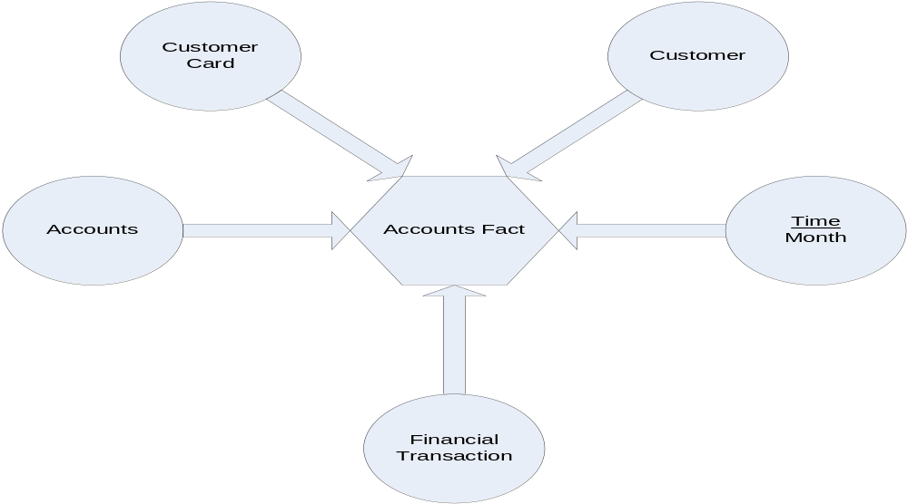

Accounts Feedback Fact Table:
Fact Name | Description | Default Aggregation rule
Quality_of_service | How overall people rated our transaction service. | One way aggregate
Satisfaction_level | What is the overall satisfaction level | One way aggregate

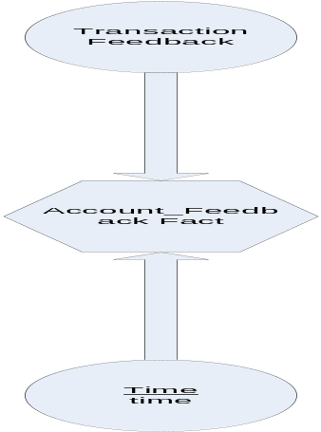

Accounts Aggragate Fact Table:

Fact Name | Description | Default Aggregation rule
Revenue | Revenue generated by Sales | two way aggregate

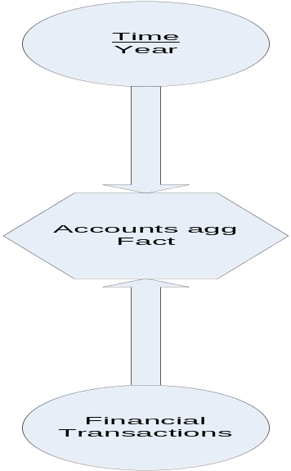

Physical Model

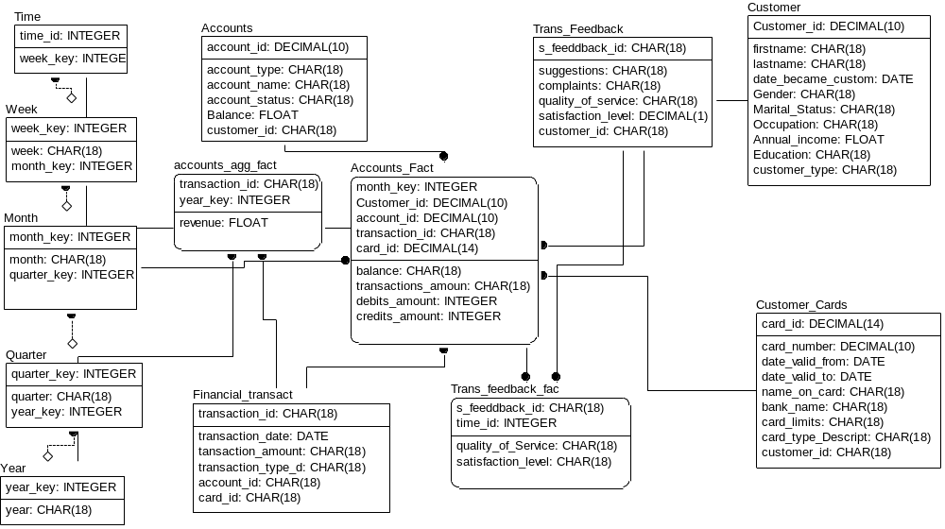

Data Dictionary

Accounts Dimension Table
Dimension name | Accounts | Model name | Accounts DM
Description | It will keep the record of customer accounts information.
Attributes | Account_id, account_type,account_name,account_status,Balance,customer_id
Primary keys | Accounts_id
Foreign keys | Customer_id
Associated Fact Tables | Accounts Fact,

Customer Dimension Table

Dimension name | Customer | Model name | Accounts DM
Description | It will keep the customer personal information.
Attributes | Customer_id,Firstname,Lastname,Date_became_customer,Gender,Marital_status, Occupation,Annual_income,Education,Customer_type,zip,city,district,state, country, customer_type
Primary keys | Customer_id
Foreign keys | None
Associated Fact Tables | Accounts Fact table,

Transactions_Feedback Dimension Table

Dimension name | Transactions_Feedback | Model name | Accounts DM
Description | It will record feed back about transactions done by customer.
Attributes | S_feedback_id, suggestions, complaints, quality_of_service, satisfaction_level, customer_id
Primary keys | S_feedback_id
Foreign keys | Customer_id
Associated Fact Tables | Trans_feedback fact

Customer Cards Dimension Table

e descript
Dimension name | Customer Cards | Model name | Accounts DM
Description | It will keep record of customer’s card information.
Attributes | Card_id, card_number, date_valid_from,date_valid_to,name_on_card,bank_name, card_limits,card_type_discription, customer_id
Primary keys | S_feedback_id
Foreign keys | Customer_id
Associated Fact Tables | Accounts Fact

Time Dimension Table

ion for t
Dimension name | Time | Model name | Accounts DM
Description | Record time
Attributes | Time_id, week_key
Primary keys | Time_id
Foreign keys | Week_key
Associated Fact Tables | Trans_feedback fact

Week Dimension Table

he dimens
Dimension name | Week | Model name | Accounts DM
Description | Record time in week format
Attributes | Week_key, ,month_key
Primary keys | Week_key
Foreign keys | Month_key
Associated Fact Tables

Month Dimension Table

Dimension name | Month | Model name | Accounts DM
Description | Record time in month format
Attributes | Month, quarter_key, ,month_key
Primary keys | Month_key
Foreign keys | quarter_key
Associated Fact Tables | Accounts fact

Quarter Dimension Table

Dimension name | Quarter | Model name | Accounts DM
Description | Record time in quarter format
Attributes | Quarter, quarter_key, year_key
Primary keys | quarter_key
Foreign keys | Year_key
Associated Fact Tables

Year Dimension Table

Dimension name | Year | Model name | Accounts DM
Description | Record time in year format
Attributes | Year_key , year
Primary keys | Year_key
Foreign keys
Associated Fact Tables

Financial transactions Dimension Table

Dimension name | Financial_transactions | Model name | Account DM
Description | This table will keep the record of customers’ financial transactions.
Attributes | Transaction_id,transaction_date,transaction_amount,transaction_type_description, account_id, card_id
Primary keys | Transaction_id
Foreign keys
Associated Fact Tables | Accounts fact, accounts agg fact.

Attribute(s) of "Customer" Dimension
Name | Description | Data Type | (Domain Constraints )Is PK | Is FK
Customer_id | primary key of customer | decimal(10) | Yes | No
name | name of the customer | char(18) | No | No
date_became_customer | date of becoming a customer | date | No | No
Gender | gender information | integer | No | No
Marital Status | marital status information | iinteger | No | No
Occupation | occupation information | char(18) | No | No
Annual_income | annual income of the customer | float | No | No
Education | education of the customer | char(18) | No | No
Zip | zip no of the csutomer | decimal(6) | No | No
city | city of the customer | char(18) | No | No
district | district of the customer | char(18) | No | No
state | state of the customer | char(18) | No | No
country | country of the customer | char(18) | No | No
customer_type | cystomer type corporate or individual | char(18) | No | No

Attribute(s) of "Month" Dimension
Name | Description | Data Type | (Domain Constraints )Is PK | Is FK
month_key | month foriegn key | integer | Yes | No
month | month information | char(18) | No | No
quarter_key | foegin key of quarter | integer | No | Yes

Attribute(s) of "Time" Dimension
Name | Description | Data Type | (Domain Constraints )Is PK | Is FK
time_id | time id key of the time dimesion | integer | Yes | No
week_key | foregin key of week | integer | No | Yes
day | day information | character(18) | No | No

Attribute(s) of "Week" Dimension
Name | Description | Data Type | (Domain Constraints )Is PK | Is FK
week_key | foregin key of week |  | Yes | No
week | stores week information | char [18] | No | No
month_key | foregin key of month | integer | No | Yes

Attribute(s) of "Year" Dimension
Name | Description | Data Type | (Domain Constraints )Is PK | Is FK
year_key | year primary key | integer | Yes | No
year | stores year information | char(18) | No | No

Attribute(s) of "Quarter" Dimension
Name | Description | Data Type | (Domain Constraints )Is PK | Is FK
quarter_key | quarter primary key | integer | Yes | No
quarter | quarter information | char(18) | No | No
year_key | foregin key of year | integer | No | Yes

Attribute(s) of "Accounts" Dimension
Name | Description | Data Type | (Domain Constraints )Is PK | Is FK
account_id | primary key of account demension | decimal(10) | Yes | No
account_type | account type eg. savings current etc | char(18) | No | No
account_name | name of the account personnel | char(18) | No | No
account_status | status of the account.. freezed or working | char(18) | No | No
Balance | account balance info | float | No | No
customer_id | customer id whose account id is this | char(18) | No | No
Attribute(s) of "Customer Cards" Dimension
Name | Description | Data Type | (Domain Constraints )Is PK | Is FK
card_id | primay key of card dimension | decimal(14) | Yes | No
card_number | number of the card | decimal(10) | No | No
date_valid_from | valid from | date | No | No
date_valid_to | date uptill card is valid | date | No | No
name_on_card | name on the card | char(18) | No | No
bank_name | name of the bank | char(18) | No | No
card_limits | limits applied on the card | float | No | No
card_type_Description | card type desc debt or atm or credit card | char(18) | No | No
customer_id | customer id whose card is this | char(18) | No | No

Attribute(s) of "Financial_transactions" Dimension
Name | Description | Data Type | (Domain Constraints )Is PK | Is FK
transaction_id | primary key | char(18) | Yes | No
transaction_date | date of transaction | date | No | No
tansaction_amount | amount of transactions | float | No | No
transaction_type_description | description of transactions type debit or credit | char(18) | No | No
account_id | primay key of account dimension | char(18) | No | No
card_id | primary key of card dimension | char(18) | No | No

Attribute(s) of "Transcations Feedback" Dimensions
Name | Description | Data Type | (Domain Constraints )Is PK | Is FK
s_feeddback_id | primary key of feedback id | char(18) | Yes | No
suggestions | suggestions | char(18) | No | No
complaints | complaints of the feedback | char(18) | No | No
quality_of_service | quality of service feedback from 0 to 5 | decimal(1) | No | No
satisfaction_level | satisfaction level feedback from 0 to 5 | decimal(1) | No | No
customer_id | customer id or ssn of the customer | char(18) | No | No
Accounts Fact table

Fact Table name | Accounts Fact Table | Model name | Accounts DM
Description | It measures all the facts releated to accounts
Attributes | Month_key,customer_id,account_id,card_id,Transaction_id, Balance, transaction_amount, debit_amount, credit_amount,
Primary keys
Foreign keys | Month_key,customer_id,account_id,card_id,Transaction_id
Facts / Measures | Balance, transaction_amount, debit_amount, credit_amount,
Associated  Dimensions | Month, Customer, customer card, Accounts, Financial Transaction
Transaction feedback Fact table

Fact Table name | Transaction feedback Fact Table | Model name | Accounts DM
Description | It measures the feedbacks related to accounts department
Attributes | Time_id , S_feedback_id, Time, Transaction Feedback
Primary keys
Foreign keys | Time_id , S_feedback_id
Facts / Measures | Quality_of_service , satisfaction_level
Associated  Dimensions | Time, Transaction Feedback
Accounts agg Fact table

Fact Table name | Accounts agg Fact Table | Model name | Accounts DM
Description | It measures the annual revenue generated
Attributes | Transaction_id, Year_key,Revenue
Primary keys
Foreign keys | Transaction_id, Year_key
Facts / Measures | Revenue
Associated  Dimensions | Year, Financial Transaction

Attribute(s) of "accounts agg fact"
Name | Description | Data Type | (Domain Constraints )Is PK | Is FK
transaction_id | foregin key of transactions id | char(18) | Yes | Yes
year_key | foregin key of year dimension | integer | Yes | Yes
revenue | revenue gerneated in a year | float | No | No

Attribute(s) of "Accounts Fact"
Name | Description | Data Type | (Domain Constraints )Is PK | Is FK
month_key | foregin key of month dimension | integer | Yes | Yes
Customer_id | foregin key of customer id | decimal(10) | Yes | Yes
account_id | primary key of account demension | decimal(10) | Yes | Yes
transaction_id | foreign key of transaction id | char(18) | Yes | Yes
card_id | primay key of card dimension | decimal(14) | Yes | Yes
balance | balance of the customer | float | No | No
transactions_amount | transactions amount | float | No | No
debits_amount | amount of debits | float | No | No
credits_amount | amount of credits | float | No | No

Attribute(s) of "Trans_feedback fact"
Name | Description | Data Type | (Domain Constraints )Is PK | Is FK
s_feeddback_id | primary key of feedback id | char(18) | Yes | Yes
time_id | foreign key time id | integer | Yes | Yes
quality_of_Service | quality of serive rating | decimal(1) | No | No
satisfaction_level | satisfaction level rating | decimal(1) | No | No

Data Mart 3 – Order Tracking System

Logical Model

Customer dimension
Attribute Name | Description | Sample Values
First name | Customer first name | Hassan, Muhammad
Last name | Customer Last name | Zia, Umair
Date_became customer | When the customer did his first purchase. | 12-08-2007
Gender | Male/Female | M/F
Martial status | Single, Married | S/M
Annual _income | The income that the customer earns in one year. | Rs.200000, Rs.500000
Occupation | This will record the information related Job, Profession. | Engineer, Doctor
Education | This will record the information related Academics of customer. | Master, Graduate,etc
Customer type | Customer type corporate or individual | Corporate or individual
Zip | The zip of the customer. | 02214, 05252
City | The city of the customer. | Lahore, Karachi
District | The District of the customer. | Lahore, Karachi
State | The state of the customer. | Punjab, Sind
Country | The country of the customer. | Pakistan.

Order dimension

Attribute Name | Description | Sample Values
Order_id | Order id number | 45454
Order_date | Date of order placement | 12-02-2007
Delivery_date | Date of order Delivery | 25-02-2007
Order_status_discriptioon | Whether the order has been delivered or not | Delivered
Customer_id | Customer id who place the order | 252552

Shipment dimension

Attribute Name | Description | Sample Values
Shipment_id | Id number of the shipment | 565656
Shipment_tracking_no | Number to track where the shipment has arrived yet | 585858
Shipment_date | Date of the shipment | 25-05-2007
Arrival_date | Date of the arriving shipment | 25-05-2007
Arrival_time | Time of the arriving shipment | 26-05-2007
Shipment_time | Time of shipment | 12:00 am
Shipping_expenses | The expenses of the shipment | Rs.500

Shipment Feedback dimension

Attribute Name | Description | Sample Values
Feedback_id | Feedback id number | 78
Sales_Rating | How good the sale is going. Rang 1-5. 1(mini),5(max) | 3
Action_on_Query | In case of query asked then what respond is given | Informed
Query_asked | Any query asked by the user | New products ?
Suggestion | Suggestions to improve the quality of shipment | Reduce rates
Complaints | Complaints about shipment | Poor shippment
Quality_of_Service | How the shipment service is performing Excellent, good, poor | Good
Quality_of_shipment | How the shipment service is performing Excellent, good, poor | Good
Customer_id | Customer id who place the feedback | 252552

Time Dimension

Attribute Name | Description | Sample Values
Day  Week  Month  Quarter  Year | It keeps the value of a particular day  It keeps the value of a particular week  It keeps the value of a particular month  It keeps the value of a particular Quarter  It keeps the value of a particular Year | Saturday  Week1  June  Second Quarter  2007

A

Region Dimension
Attribute Name | Description | Sample Values
Zip  City  District  State  Country | It stores the zip code of an area  It stores the city name  It stores the district name  It stores the state name  It stores the country name | 54000  Sialkot  Lahore  Punjab  Pakistan

Shipment Fact
Fact Name | Description | Default Aggregation rule
Order_status | Delivered | One way
Delayed_shipment_count | Count of late delivered orders | One way
Timely_shipment_count | Count of timely delivered orders | One way

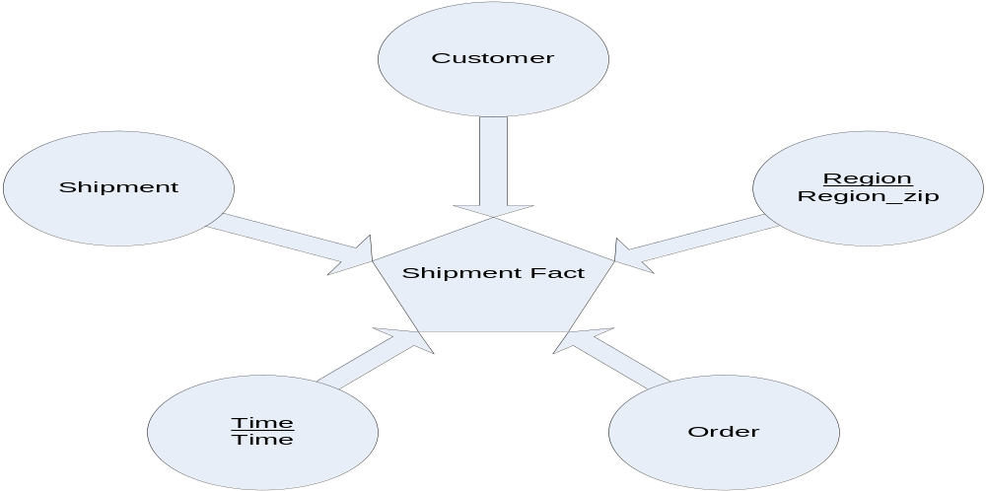

Shippment Feedback Fact Table:
Fact Name | Description | Default Aggregation rule
Quality_of_service | How overall people rated our shipment service. | One way aggregate
Quality_of_shipment | Delayed or timely | One way aggregate

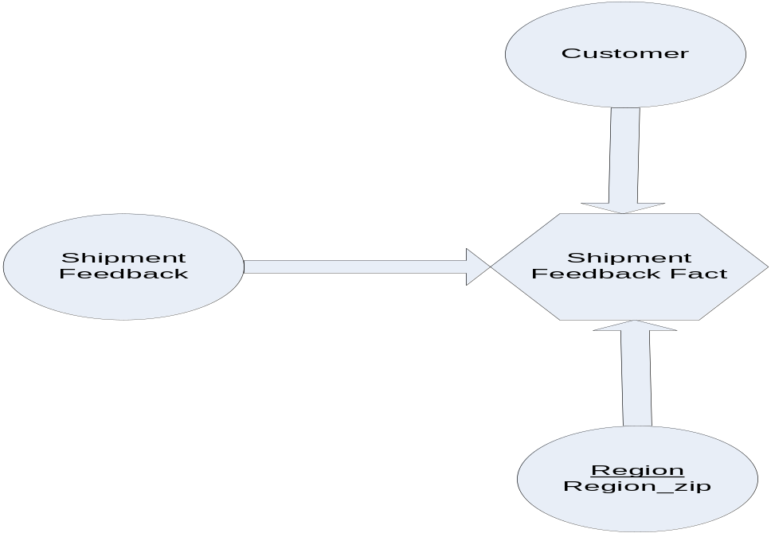

Shipment Aggragate Fact Table:

Fact Name | Description | Default Aggregation rule
Order_status | Delivered | Two way
Delayed_shipment_count | Count of late delivered orders | Two way
Timely_shipment_count | Count of timely delivered orders | Two way

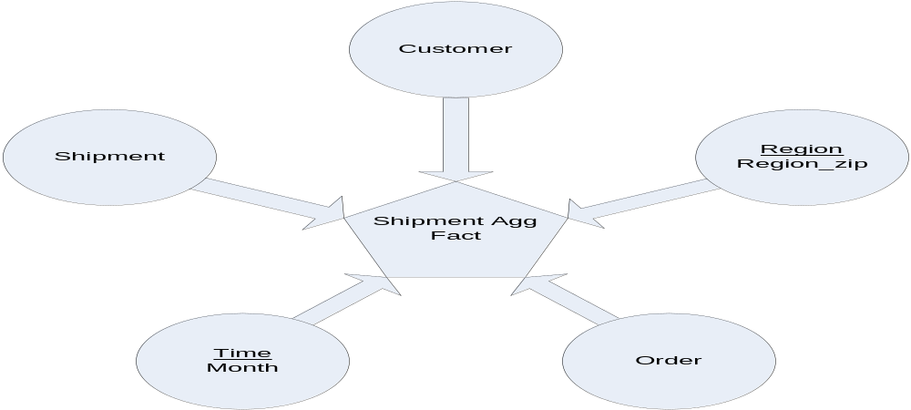

Physical Model

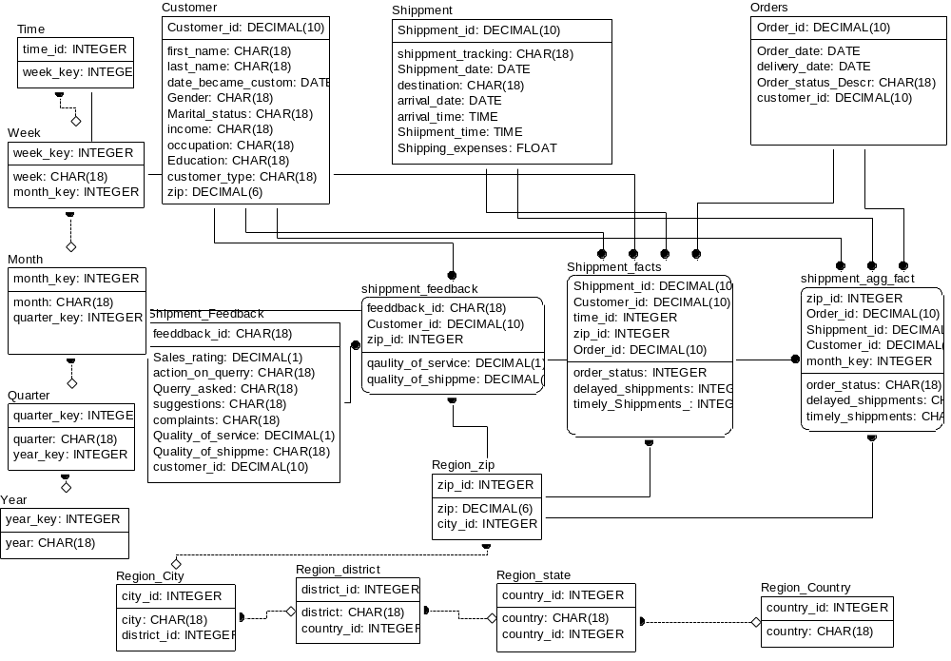

Data Dictionary

Customer Dimension Table

Dimension name | Customer | Model name | OTS DM
Description | It will keep the customer personal information.
Attributes | Customer_id,Firstname,Lastname,Date_became_customer,Gender,Marital_status, Occupation,Annual_income,Education,Customer_type,zip,city,district,state, country, customer_type
Primary keys | Customer_id
Foreign keys | None
Associated Fact Tables | Accounts Fact table, Shippment feedbacks fact, shipment facts, shipment agg fact, sales_Agg_Fact1, sales_Fact_table

Region zip Dimension Table

Dimension name | Regin_zip | Model name | OTS DM
Description | Zip wise record
Attributes | zip_id, zip, city_id
Primary keys | Zip_id
Foreign keys | City_id
Associated Fact Tables | Sales feedback fact , Sales fact table, shipment feedback facts, shipment facts, shipment agg facts

Region city Dimension Table

Dimension name | Region_city | Model name | OTS DM
Description | City wise record
Attributes | City_id, city, district_id
Primary keys | City_id
Foreign keys | district_id
Associated Fact Tables

Region district Dimension Table

Dimension name | Region_district | Model name | OTS DM
Description | District wise record
Attributes | District_id, district, state_id
Primary keys | District_id
Foreign keys | state_id
Associated Fact Tables

Region state Dimension Table

Dimension name | Region_state | Model name | OTS DM
Description | State wise record
Attributes | State_id, state, country_id
Primary keys | State_id
Foreign keys | country_id
Associated Fact Tables | Sales agg fact1

Region country Dimension Table
Dimension name | Region_country | Model name | OTS DM
Description | Country wise record
Attributes | Country_id, country
Primary keys | Country_id
Foreign keys
Associated Fact Tables

Shipment Dimension Table

Dimension name | Shipment | Model name | OTS DM
Description | This table will keep the records related to shipment.
Attributes | Shipment_id,shipment_tracking_no,shipment_date,destination,arrival_date, arrival_time,shipment_time, shipment_expenses
Primary keys | Shipment_id
Foreign keys
Associated Fact Tables | Shipment facts, shipment agg facts

Orders Dimension Table

Dimension name | Order | Model name | OTS DM
Description | This table will keep the records of orders.
Attributes | Order_id,order_date,delivery_date,order_status_description,customer_id
Primary keys | Order_id
Foreign keys
Associated Fact Tables | Shipment facts, shipment agg facts

Shipment feedback Dimension Table
Dimension name | Shipment feedback | Model name | OTS DM
Description | This table will keep the feed back from customers about shipment services.
Attributes | Feedback_id,sales_rating,actions_on_querry,querry_asked,Suggestion,complaints, Quality_of_shipment,customer_id
Primary keys | Feedback_id
Foreign keys
Associated Fact Tables | Shipment feedback fact

Time Dimension Table

Dimension name | Time | Model name | OTS DM
Description | Record time
Attributes | Time_id, week_key
Primary keys | Time_id
Foreign keys | Week_key
Associated Fact Tables | Trans_feedback fact

Week Dimension Table

Dimension name | Week | Model name | OTS DM
Description | Record time in week format
Attributes | Week_key, ,month_key
Primary keys | Week_key
Foreign keys | Month_key
Associated Fact Tables

Month Dimension Table

Dimension name | Month | Model name | OTS DM
Description | Record time in month format
Attributes | Month, quarter_key, ,month_key
Primary keys | Month_key
Foreign keys | quarter_key
Associated Fact Tables

Quarter Dimension Table

Dimension name | Quarter | Model name | OTS DM
Description | Record time in quarter format
Attributes | Quarter, quarter_key, year_key
Primary keys | quarter_key
Foreign keys | Year_key
Associated Fact Tables

Year Dimension Table

Dimension name | Year | Model name | OTS DM
Description | Record time in year format
Attributes | Year_key , year
Primary keys | Year_key
Foreign keys
Associated Fact Tables

Attribute(s) of "Customer" Dimension
Name | Description | Data Type | (Domain Constraints )Is PK | Is FK
Customer_id | primary key of customer | decimal(10) | Yes | No
name | name of the customer | char(18) | No | No
date_became_customer | date of becoming a customer | date | No | No
Gender | gender information | integer | No | No
Marital Status | marital status information | iinteger | No | No
Occupation | occupation information | char(18) | No | No
Annual_income | annual income of the customer | float | No | No
Education | education of the customer | char(18) | No | No
Zip | zip no of the csutomer | decimal(6) | No | No
city | city of the customer | char(18) | No | No
district | district of the customer | char(18) | No | No
state | state of the customer | char(18) | No | No
country | country of the customer | char(18) | No | No
customer_type | cystomer type corporate or individual | char(18) | No | No

Attribute(s) of "Month" Dimension
Name | Description | Data Type | (Domain Constraints )Is PK | Is FK
month_key | month foriegn key | integer | Yes | No
month | month information | char(18) | No | No
quarter_key | foegin key of quarter | integer | No | Yes

Attribute(s) of "Time" Dimension
Name | Description | Data Type | (Domain Constraints )Is PK | Is FK
time_id | time id key of the time dimesion | integer | Yes | No
week_key | foregin key of week | integer | No | Yes
day | day information | character(18) | No | No

Attribute(s) of "Week" Dimension
Name | Description | Data Type | (Domain Constraints )Is PK | Is FK
week_key | foregin key of week |  | Yes | No
week | stores week information | char [18] | No | No
month_key | foregin key of month | integer | No | Yes

Attribute(s) of "Year" Dimension
Name | Description | Data Type | (Domain Constraints )Is PK | Is FK
year_key | year primary key | integer | Yes | No
year | stores year information | char(18) | No | No

Attribute(s) of "Quarter" Dimension
Name | Description | Data Type | (Domain Constraints )Is PK | Is FK
quarter_key | quarter primary key | integer | Yes | No
quarter | quarter information | char(18) | No | No
year_key | foregin key of year | integer | No | Yes

Attribute(s) of "Region City" Dimension
Name | Description | Data Type | (Domain Constraints )Is PK | Is FK
city_id | primary key of city | integer | Yes | No
city | city info | char(18) | No | No
district_id | foregin key of district | integer | No | Yes

Attribute(s) of "Region_Country" Dimension
Name | Description | Data Type | (Domain Constraints )Is PK | Is FK
country_id | primary key of contry | integer | Yes | No
country | country info | char(18) | No | No

Attribute(s) of "Region_district" Dimension
Name | Description | Data Type | (Domain Constraints )Is PK | Is FK
district_id | primary key of district | integer | Yes | No
district | district info | char(18) | No | No
state_id | foregin key of state_id | integer | No | Yes

Attribute(s) of "Region_state" Dimension
Name | Description | Data Type | (Domain Constraints )Is PK | Is FK
state_id | primary key of state_id | integer | Yes | No
state | state info | char(18) | No | No
country_id | foregin key of customer id | integer | No | Yes

Attribute(s) of "Region_zip" Dimension
Name | Description | Data Type | (Domain Constraints )Is PK | Is FK
zip_id | primary key of zip | integer | Yes | No
zip | zip code | decimal(6) | No | No
city_id | foregin key of city_id | integer | No | Yes

Attribute(s) of "Orders" Dimension
Name | Description | Data Type | (Domain Constraints )Is PK | Is FK
Order_id | primary key of orders dimension | decimal(10) | Yes | No
Order_date | order date | date | No | No
delivery_date | delivery date of order | date | No | No
Order_status_Description | status of order delivered or not | char(18) | No | No
customer_id | customer id whose order is to be delivered | decimal(10) | No | No

Attribute(s) of "Shipment Feedback" Dimension
Name | Description | Data Type | (Domain Constraints )Is PK | Is FK
feeddback_id | primary key of feedback dimension | char(18) | Yes | No
Sales_rating | sales rating from 0 to 5 | decimal(1) | No | No
action_on_querry | action performed on querey | char(18) | No | No
Querry_asked | querey asked | char(18) | No | No
suggestions | any suggestions given in the feedback | char(18) | No | No
complaints | complaints given by the customers | char(18) | No | No
Quality_of_service | quality of service rating | decimal(1) | No | No
Quality_of_shippment | quality of shippment ratinhg | decimal(1) | No | No
customer_id | customer id whose order is to be shipped | decimal(10) | No | No

Attribute(s) of "Shippment" Dimension
Name | Description | Data Type | (Domain Constraints )Is PK | Is FK
Shippment_id | shippment id of the shippment dimension | decimal(10) | Yes | No
shippment_tracking_no | it is the shippment tracking no | char(18) | No | No
Shippment_date | it is the shipping date | date | No | No
destination | destination of shippment | char(18) | No | No
arrival_date | arrival date of shippment | date | No | No
arrival_time | arrival time of shippment | time | No | No
Shiipment_time | shipping time | time | No | No
Facts :
Shipment feedback Fact table
Fact Table name | Shipment feedback Fact Table | Model name | OTS DM
Description | It measures the feedback on shipment services
Attributes | Feedback_id, zip_id, customer_id, Quality_of_service ,Quality_of_shipment
Primary keys
Foreign keys | Feedback_id, zip_id, customer_id
Facts / Measures | Quality_of_service ,Quality_of_shipment
Associated  Dimensions | Shipment feedback,Customer,region_zip.
Shipment Fact table

Fact Table name | Shipment Fact Table | Model name | OTS DM
Description | It measures the facts related to shippments
Attributes | Time_id, zip_id, customer_id, order_id, shipment_id, Order_status, Delayed_shipmenmts, timely_shipments_count
Primary keys
Foreign keys | Time_id, zip_id, customer_id, order_id, shipment_id
Facts / Measures | Order_status, Delayed_shipmenmts, timely_shipments_count
Associated  Dimensions | Time, Order, Customer, Region_zip, Shipment.
Shipment agg Fact table

Fact Table name | Shipment agg Fact Table | Model name | OTS DM
Description | It is the shipment agg fact table
Attributes | Month_key, zip_id, customer_id, order_id, shipment_id, Month_key, zip_id, customer_id, order_id, shipment_id
Primary keys
Foreign keys | Month_key, zip_id, customer_id, order_id, shipment_id
Facts / Measures | Order_status, Delayed_ shipments, timely_shipments
Associated  Dimensions | month, Order, Customer, Region_zip, Shipment.

Attribute(s) of "shippment agg facts"
Name | Description | Data Type | (Domain Constraints )Is PK | Is FK
zip_id | foregin key of zip region | integer | Yes | Yes
Order_id | primary key of orders dimension | decimal(10) | Yes | Yes
Shippment_id | shippment id of the shippment dimension | decimal(10) | Yes | Yes
Customer_id | foregin key of cusomer dimension | decimal(10) | Yes | Yes
month_key | foregin key of time dimension month | integer | Yes | Yes
order_status | order status count | integer | No | No
delayed_shippments | delayed shippments count | integer | No | No
timely_shippments | timely shippments count | integer | No | No

Attribute(s) of "Shippment facts"
Name | Description | Data Type | (Domain Constraints )Is PK | Is FK
Shippment_id | shippment id of the shippment dimension | decimal(10) | Yes | Yes
Customer_id | foregin key of customer dimension | decimal(10) | Yes | Yes
time_id | foregin key of time dimension | integer | Yes | Yes
zip_id | zip id of region zip dimension | integer | Yes | Yes
Order_id | primary key of orders dimension | decimal(10) | Yes | Yes
order_status | order status count (delivered or not deliverd count) | integer | No | No
delayed_shippments | delayed shippmetns count | integer | No | No
timely_Shippments_count | timely shippments count | integer | No | No

Attribute(s) of "shippment feedbacks fact"
Name | Description | Data Type | (Domain Constraints )Is PK | Is FK
feeddback_id | primary key of feedback dimension | char(18) | Yes | Yes
Customer_id | foreign key of customer id | decimal(10) | Yes | Yes
zip_id | zip id of region | integer | Yes | Yes
qaulity_of_service | quality of service rating count | integer | No | No

