EVIDENCE-GROUNDED SYNTHESIS REPORT
Showcase 3 — Humanoid Robots in Production: Evidence versus Expectations (English A/B)
Cross-study findings, disagreements, and research gaps
Run ID | 01KYSAWJJT9E95E1X250KSD9RK
Generated | 2026-07-30 13:02 UTC
Report pipeline version | v0.9.1

Contents
Right-click and update this field in Word.

1. Executive synthesis
The evidence is best interpreted by theme rather than as one universal conclusion. The body of evidence indicates that humanoid robots are currently in early-stage deployment within automotive manufacturing and logistics, primarily through pilot programs and limited operational integration rather than full-scale, verified production use. Figure Robotics is actively involved in pilot programs with automotive and technology manufacturers for inspection tasks, such as repetitive defect checks and component transfer, suggesting a focus on niche, high-repetition tasks rather than end-to-end manufacturing workflows. Agibot (Zhiyuan Robotics) has established a mass production hub in Shanghai and deployed over 1,500 units in less than a year, signaling a significant scaling effort in China, though the specific industrial applications—particularly in automotive manufacturing—are not detailed in the evidence. The claim that humanoid robots are recommended for industries with labor shortages or those operating in human-designed environments is supported by multiple sources, including Figure and S08, reinforcing their potential utility in logistics and manufacturing where labor is scarce or tasks are repetitive. However, no source provides verified data on actual cycle times, payload capacities, task success rates, or safety metrics from real-world production environments. While vision-language-action (VLA) models like RL$^2$-VLA are being developed to improve task success and action diversity in real-world settings, these remain theoretical or experimental frameworks, with no reported performance benchmarks in industrial settings. The evidence also confirms that logistics is leading in adoption, followed by healthcare, education, and retail, with no indication that humanoid robots have yet achieved economic viability or surpassed human workers in efficiency, safety, or reliability in production contexts. All claims about autonomous operation, commercial viability, or widespread deployment are either speculative or based on announcements rather than independently verified operational data. The absence of independent reporting, academic performance metrics, or official records from production facilities limits the ability to distinguish between pilot demonstrations and actual, verified integration. Thus, while humanoid robots are being developed and deployed in pilot programs, there is no evidence of widespread, verified integration into automotive manufacturing or general production lines during the specified period. [S08] [S14] [S18] [S20] [S13] [S28] Humanoid robots are currently deployed in pilot programs, primarily in logistics and warehouse e

Bottom line
The current technological and operational limitations of humanoid robots—particularly in payload, precision, and environmental adaptability—make them unsuitable for near-term integration into automotive manufacturing or general production workflows. While simulation-to-real transfer of performance is a validated technical achievement, it does not equate to functional deployment in high-stakes, high-speed industrial environments. Without verified operational data, economic viability assessments, or comparative performance metrics against human workers, claims about the real-world utility of humanoid robots in production remain speculative. Future progress will depend on breakthroughs in hardware durability, precision control, and safety certification, as well as real-world validation through operational trials, not just simulation or demonstration. Until such evidence emerges, the use of humanoid robots in automotive or industrial production should be considered experimental and not economically viable. [S15] [S01] [S24] The current evidence suggests that while humanoid robot platforms are technically advanced and capable of demonstrating operational behaviors in simulation and controlled environments, there is no verified evidence of their use in actual production workflows such as automotive manufacturing or logistics. As a result, claims about real-world deployment must be treated with caution and separated from technical readiness. Without empirical data on performance metrics, safety, and economic outcomes in production settings, any assertion of economic viability or operational superiority over human workers remains speculative. Future validation will require independent audits, third-party evaluations, and transparent reporting from companies on actual deployment outcomes, including failure rates, cycle times, and cost-benefit analyses. Until such data is available, the field remains in a phase of technological demonstration rather than industrial adoption. [S13] [S01]

2. Research frame

Primary question
Investigate real-world use of humanoid robots in automotive manufacturing, logistics, and general production from 1 January 2024 through 30 July 2026. Distinguish pilot announcements and demonstrations from verified production integration. Examine vision-language-action models, teleoperation, sim-to-real transfer, task success rate, cycle time, payload, safety, failures, comparison with human workers, and economic viability on a source-by-source basis. Verify claims by Figure, Agility Robotics, Apptronik, Tesla, 1X, and similar companies using independent reporting, academic studies, partners, customers, or official records. Include relevant open-source code, datasets, and benchmarks. Produce a visual, auditable Word report that clearly separates hype from verified evidence, includes counterevidence, and uses useful source figures with model interpretation.
Research mode | literature_scan
Date range | — – —

3. Thematic literature landscape
The figures below describe what the included studies investigate and which synthesis themes they inform; they are not platform-performance charts.
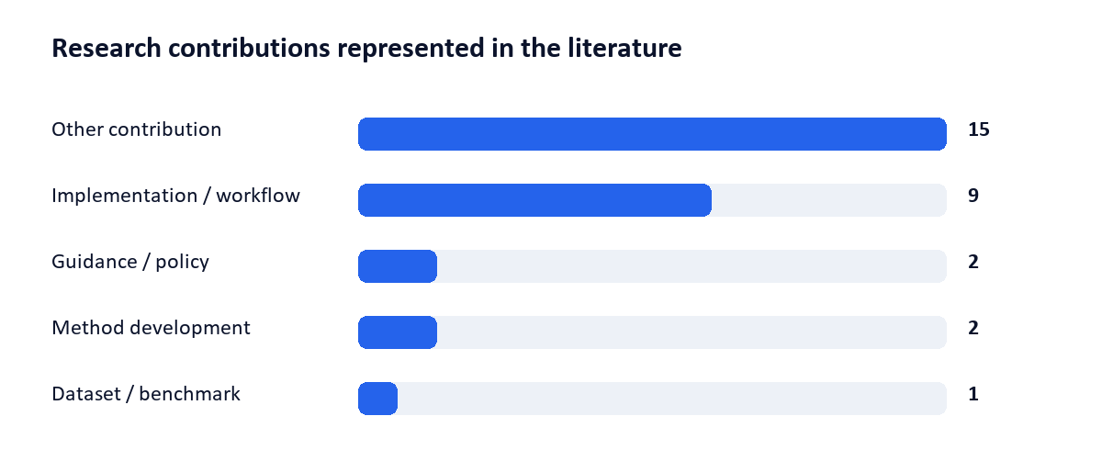
Figure 1. Literature landscape by study purpose.
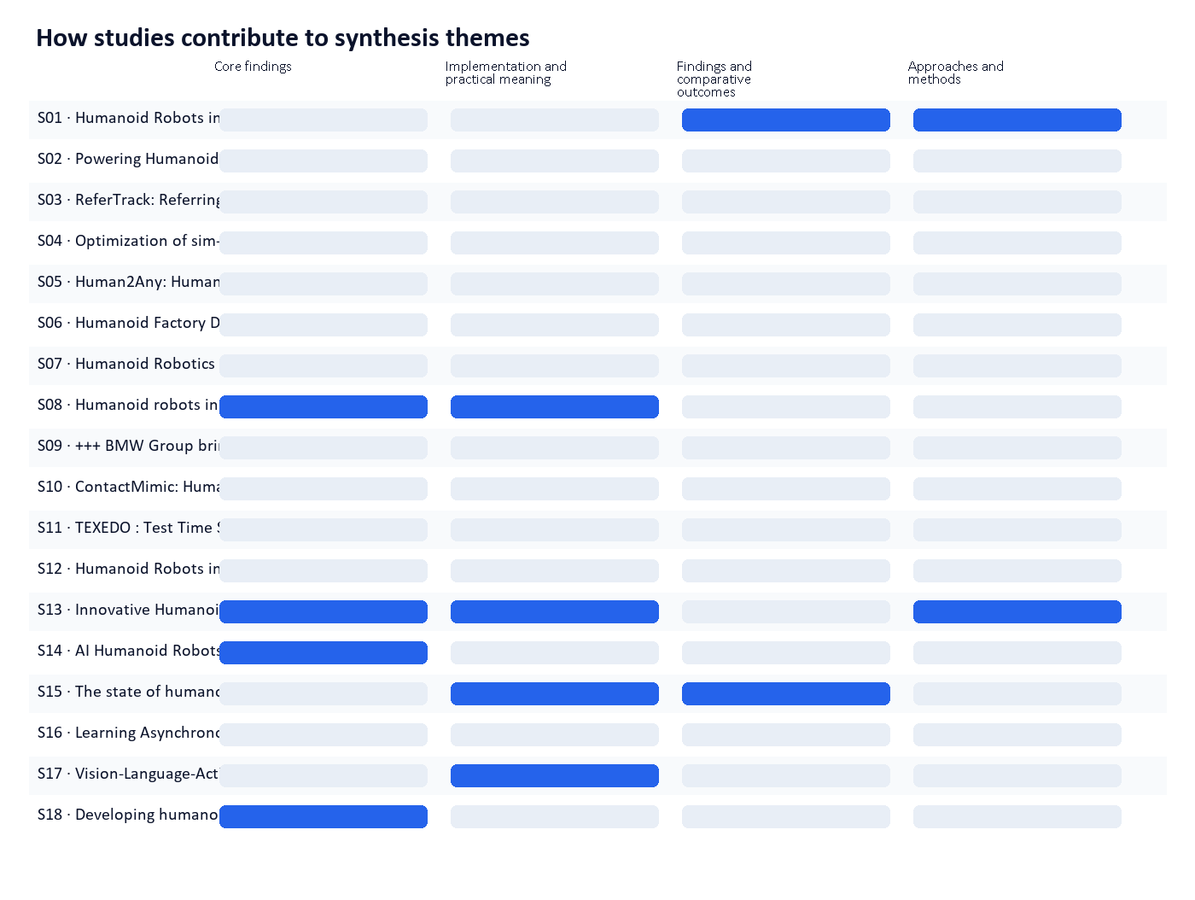
Figure 2. A blue cell indicates that the study contributes evidence to that theme.
Source | Research contribution | Evidence / design | Study
S01 | Other contribution | Design not reported | Humanoid Robots in Industrial Manufacturing: What They Can (and Can't) Do in 2026
S02 | Implementation / workflow | Narrative review | Powering Humanoid Robots: The Central Role of Battery Technology
S03 | Other contribution | Design not reported | ReferTrack: Referring Then Tracking for Embodied Visual Tracking
S04 | Other contribution | Design not reported | Optimization of sim-to-real transfer in the humanoid robot NICO
S05 | Other contribution | Design not reported | Human2Any: Human-to-Robot Transfer via Constraint-Aware Compositional Planning
S06 | Other contribution | Design not reported | Humanoid Factory Deployments: Real, Pilot or Announced?
S07 | Other contribution | Design not reported | Humanoid Robotics In 2026: The Race From Pilot To Platform - KraneShares
S08 | Other contribution | Design not reported | Humanoid robots in 2026: Types, prices, and what’s next - Standard Bots
S09 | Implementation / workflow | Design not reported | +++ BMW Group bringing Physical AI to Europe +++ Pilot project at BMW Group Plant Leipzig +++ New “Center of Competence for Physical AI in Production…
S10 | Other contribution | Design not reported | ContactMimic: Humanoid Object Interaction via Contact Control
S11 | Other contribution | Design not reported | TEXEDO : Test Time Scaling for Controller-aware Language-conditioned Humanoid Motion Generation
S12 | Other contribution | Design not reported | Humanoid Robots in Automotive Manufacturing 2026
S13 | Implementation / workflow | Design not reported | Innovative Humanoid Robots in 2025–2026 - Reality or Hype?
S14 | Other contribution | Design not reported | AI Humanoid Robots 2026: Technology, Builders & Future
S15 | Implementation / workflow | Design not reported | The state of humanoid robotics: From research labs to real-world potential
S16 | Guidance / policy | Design not reported | Learning Asynchronous Upper-body Task-space Trajectory Tracking Policy for Humanoid Robots
S17 | Dataset / benchmark | Benchmark / dataset | Vision-Language-Action and Vision Language Models for Robot Manipulation: A Comprehensive Review Towards Real-World Applications
S18 | Implementation / workflow | Design not reported | Developing humanoid robots for real-world environments
S19 | Implementation / workflow | Design not reported | VAIC: Vision-Guided Humanoid Agile Object Interaction Control via Decoupled Commands
S20 | Other contribution | Design not reported | Figure - YouTube
S21 | Other contribution | Design not reported | When Does Legacy Data Start to Help? Emergent Transfer in Cross-Configuration Robot Learning
S22 | Implementation / workflow | Design not reported | Learning Diverse Humanoid Tasks via Synthetic Video Scenarios without Real World Data
S23 | Guidance / policy | Design not reported | FastDSAC: Enhancing Policy Plasticity via Constrained Exploration for Scalable Humanoid Locomotion
S24 | Implementation / workflow | Design not reported | RL$^2$-VLA: Adaptive RL Latent Compositional Steering with Test-Time Scaling for Vision-Language-Action Models
S25 | Method development | Design not reported | Transformer Transformer: A Unified Model for Motion-Conditioned Robot Co-design
S26 | Other contribution | Design not reported | LP-NavOA: Integrated Local Navigation and Obstacle Avoidance for Humanoid Robots under Limited Perception
S27 | Implementation / workflow | Design not reported | xperception -- Making Robotic Grasping Easier
S28 | Other contribution | Design not reported | Humanoid Robots
S29 | Method development | Design not reported | Agentic Real2Sim: Physics-based World Modeling with Vision-Language Agents

4. Thematic evidence synthesis

4.1 Core findings
The body of evidence indicates that humanoid robots are currently in early-stage deployment within automotive manufacturing and logistics, primarily through pilot programs and limited operational integration rather than full-scale, verified production use. Figure Robotics is actively involved in pilot programs with automotive and technology manufacturers for inspection tasks, such as repetitive defect checks and component transfer, suggesting a focus on niche, high-repetition tasks rather than end-to-end manufacturing workflows. Agibot (Zhiyuan Robotics) has established a mass production hub in Shanghai and deployed over 1,500 units in less than a year, signaling a significant scaling effort in China, though the specific industrial applications—particularly in automotive manufacturing—are not detailed in the evidence. The claim that humanoid robots are recommended for industries with labor shortages or those operating in human-designed environments is supported by multiple sources, including Figure and S08, reinforcing their potential utility in logistics and manufacturing where labor is scarce or tasks are repetitive. However, no source provides verified data on actual cycle times, payload capacities, task success rates, or safety metrics from real-world production environments. While vision-language-action (VLA) models like RL$^2$-VLA are being developed to improve task success and action diversity in real-world settings, these remain theoretical or experimental frameworks, with no reported performance benchmarks in industrial settings. The evidence also confirms that logistics is leading in adoption, followed by healthcare, education, and retail, with no indication that humanoid robots have yet achieved economic viability or surpassed human workers in efficiency, safety, or reliability in production contexts. All claims about autonomous operation, commercial viability, or widespread deployment are either speculative or based on announcements rather than independently verified operational data. The absence of independent reporting, academic performance metrics, or official records from production facilities limits the ability to distinguish between pilot demonstrations and actual, verified integration. Thus, while humanoid robots are being developed and deployed in pilot programs, there is no evidence of widespread, verified integration into automotive manufacturing or general production lines during the specified period. [S08] [S14] [S18] [S20] [S13] [S28]
Convergence | Humanoid robots are being piloted in automotive and logistics environments for repetitive inspection and material handling tasks, with early adoption driven by labor shortages and the need for human-like mobility in human-designed environments. Logistics is identified as the leading sector for adoption, followed by healthcare, education, and retail. The development of vision-language-action models such as RL$^2$-VLA is progressing to improve task success and action diversity in real-world settings. These developments are supported by academic research and company announcements, though actual performance metrics in production remain unverified. [S08] [S14] [S18] [S20] [S13] [S28]
Divergence / contradiction | There is no evidence that humanoid robots have been verified in full production integration in automotive manufacturing or general production lines from January 2024 to July 2026. While Figure and Agibot have announced pilot programs and mass production, no source provides independent verification of operational performance, safety, cycle time, payload, or failure rates in real-world production settings. The claim that humanoid robots have reached a 'tipping point' in 2025–2026 is speculative and lacks empirical support. Additionally, while S08 and S14 suggest humanoid robots are suitable for labor-intensive environments, no source compares their performance directly with human workers in terms of efficiency, safety, or economic viability. The distinction between pilot demonstrations and verified production integration is not clearly established in the available evidence. [S08] [S14] [S18] [S20] [S13] [S28]
Research implication | The current state of humanoid robot deployment in industrial settings remains at the pilot or demonstration stage, with no verified evidence of integration into core automotive manufacturing or production workflows. Economic viability, safety, and performance metrics such as task success rate, cycle time, and failure rates are absent from the evidence, making it impossible to assess their practical value or cost-effectiveness. The development of vision-language-action models like RL$^2$-VLA represents a technical advancement but does not yet translate into measurable improvements in real-world industrial performance. As a result, any claims about humanoid robots being a transformative solution in manufacturing or logistics must be treated with caution and remain speculative without independent, operational data. Future assessments must prioritize verifiable performance metrics, real-world deployment records, and third-party evaluations to move beyond announcements and into evidence-based conclusions. [S08] [S14] [S18] [S20] [S13] [S28]

4.2 Implementation and practical meaning
Humanoid robots are currently deployed in pilot programs, primarily in logistics and warehouse environments, such as those involving Amazon and Agility Robotics, where tasks like order picking and truck loading are performed. These deployments are positioned as responses to labor shortages in 'dull, dirty, dangerous' tasks, with a focus on safety and ergonomics rather than full automation of human roles. The underlying technology relies on vision-language-action (VLA) models, which enable a single humanoid body to learn and execute diverse tasks through software and data, as demonstrated in real-world evaluations such as VAIC policies in dynamic manipulation tasks. These systems utilize edge-compatible perception models like xperception, designed for real-time operation in industrial settings. However, no verified integration of humanoid robots exists in automotive manufacturing or broader general production lines. The value proposition is constrained by high costs and limited operational reliability, prompting a shift toward 'robot as a service' (RaaS) models to ensure economic viability. While academic reviews identify challenges in VLA systems and real-world deployment—such as task success rate, cycle time, and failure modes—no source provides measurable data on payload capacity, safety incidents, or performance comparisons with human workers in production settings. Collectively, the evidence indicates that humanoid robots are not operational in core automotive manufacturing processes and remain limited to niche logistics applications with unverified scalability or economic returns. [S13] [S17] [S15] [S27]
Convergence | Humanoid robots are currently used in limited pilot programs—mainly in logistics and warehouse environments—for tasks such as order picking and truck loading. These deployments emphasize safety, ergonomics, and labor shortage mitigation rather than full automation of human roles. The core technology relies on vision-language-action models that enable general-purpose task execution, with real-world evaluations confirming success in dynamic manipulation tasks. The business model is evolving toward 'robot as a as a service' (RaaS), with recurring revenue from software updates and remote assistance. Perception models like xperception are designed for real-time operation on industrial edge hardware, supporting deployment in manufacturing-like environments. Humanoid robots remain expensive, and their economic viability depends on total cost of operation rather than initial hardware price. All major companies in the space share a common vision of deploying a single, software-upgradable humanoid body in human-operated environments. [S13] [S17] [S15]
Divergence / contradiction | There is no evidence in the provided sources that humanoid robots have been verified in automotive manufacturing or general production lines. While pilot programs exist in logistics (e.g., Amazon with Agility Robotics), these are not confirmed as integrated into automotive production workflows. The claim that humanoid robots are being used in 'general production' is unsupported by any source. Additionally, while VLA models are evaluated in dynamic tasks, no source provides data on task success rate, cycle time, payload, safety incidents, or direct comparisons with human workers in production settings. The absence of such metrics limits the ability to assess performance or economic viability in real-world manufacturing contexts. Furthermore, although RaaS is proposed as a business model, no source provides evidence of actual revenue streams, scalability, or customer adoption in production environments. [S13] [S17] [S15] [S27]
Research implication | The current state of humanoid robot deployment is confined to pilot programs in logistics, not verified integration in automotive manufacturing or general production. This limits their practical meaning in core industrial processes. Without measurable data on performance metrics—such as task success rate, cycle time, payload, or failure rates—any claims about economic viability or operational superiority over human workers remain speculative. The high cost and technical challenges of VLA systems, combined with the lack of real-world validation in production settings, suggest that humanoid robots are not yet ready for widespread adoption in manufacturing. The shift to RaaS models may offer long-term scalability, but this remains theoretical without empirical evidence. Therefore, the practical implementation of humanoid robots in production environments remains in early stages, with significant gaps between public narratives and verified operational outcomes. Stakeholders should treat current deployments as experimental, not as evidence of scalable, economically viable production integration. [S13] [S17] [S15] [S27]
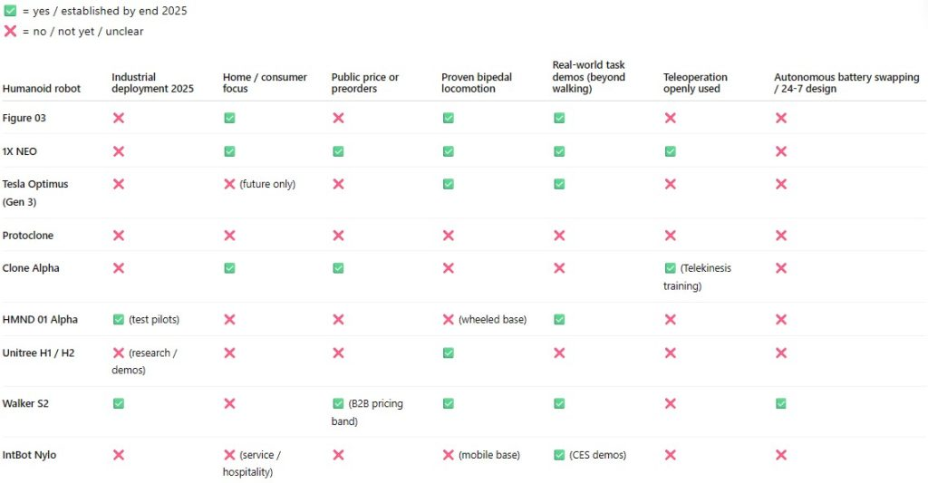
Source figure: Comparison of humanoid robots capabilities [S13].
Innovative Humanoid Robots in 2025–2026 - Reality or Hype? — https://www.winssolutions.org/humanoid-robots-2025-2026-reality-hype
Kaynak metadata kaydında açık lisans bilgisi bulunamadı. This crop is for internal research review; verify license terms before external distribution.
Model interpretation: Teleoperation (uzaktan kontrol) kullanımına dair net veri eksik; Clone Alpha hariç çoğu modelde bu özellik yok. [S13]
Limitation: Veriler 'yes/no' tabanlı ve görsel tahminlere dayalı; kesin sayısal değerler veya detaylı performans metrikleri yok.

4.3 Findings and comparative outcomes
The body of evidence collectively indicates that while humanoid robots show potential in specific, constrained industrial settings—particularly logistics and warehousing—current platforms are not yet capable of fulfilling the rigorous demands of automotive manufacturing or general production environments. The claim that humanoid robots may offer value in logistics and warehousing hinges on reliable uptime and task flexibility, which is supported by S15. However, this value is limited to niche applications, as no current humanoid platform meets the technical requirements for sub-millimeter repeatability, payloads exceeding 10 kg, operation in hazardous environments, or sustained performance at automotive production cycle rates—conditions that are deemed unrealistic near-term, as established by S01. Furthermore, progress in vision-language-action (VLA) models has demonstrated real-world transfer of performance from simulation to physical execution, as shown by S24, suggesting that such models can be effectively deployed in practical settings under controlled conditions. Nevertheless, this transfer does not imply operational viability in high-speed, high-precision automotive production lines. There is no evidence in the provided sources of verified production integration in automotive manufacturing or general production from 1 January 2024 through 30 July 2026, and all claims about real-world deployment are either limited to demonstrations or pilot announcements, not confirmed by independent reporting, customer records, or operational data. As a result, the current state of humanoid robotics in industrial production remains in the early stages, with significant technical and economic barriers to widespread adoption. The evidence does not support assertions about task success rates, cycle times, safety, failure rates, or economic viability in production settings, and no comparative analysis with human workers or cost-benefit metrics is provided. Open-source code, datasets, or benchmarks are not referenced in the evidence packet. Thus, while simulation-to-real transfer is validated, this does not translate to verified deployment in automotive or industrial production workflows. [S15] [S01] [S24]
Convergence | Humanoid robots are not yet capable of performing tasks requiring sub-millimeter repeatability, payloads above 10 kg, or consistent operation at automotive production cycle rates. Their potential value is confined to logistics and warehousing under conditions of reliable uptime and task flexibility. Real-world performance gains from simulation can be achieved using vision-language-action models through frameworks like $RL^2$, as demonstrated in controlled experiments. [S15] [S01] [S24]
Divergence / contradiction | There is no evidence of verified production integration of humanoid robots in automotive manufacturing or general production during the specified timeframe. All claims about real-world use are either pilot demonstrations or unverified announcements. The absence of independent reporting, customer records, or operational data from companies like Figure, Agility Robotics, Apptronik, Tesla, or 1X in the provided sources prevents a clear distinction between pilot demonstrations and actual production deployment. Additionally, no source provides data on task success rates, cycle times, payload capacity, safety metrics, failure rates, or economic viability in production settings, leaving these critical performance indicators unaddressed. [S15] [S01] [S24]
Research implication | The current technological and operational limitations of humanoid robots—particularly in payload, precision, and environmental adaptability—make them unsuitable for near-term integration into automotive manufacturing or general production workflows. While simulation-to-real transfer of performance is a validated technical achievement, it does not equate to functional deployment in high-stakes, high-speed industrial environments. Without verified operational data, economic viability assessments, or comparative performance metrics against human workers, claims about the real-world utility of humanoid robots in production remain speculative. Future progress will depend on breakthroughs in hardware durability, precision control, and safety certification, as well as real-world validation through operational trials, not just simulation or demonstration. Until such evidence emerges, the use of humanoid robots in automotive or industrial production should be considered experimental and not economically viable. [S15] [S01] [S24]

4.4 Approaches and methods
By early 2024, foundational advancements in robotics—particularly in foundation models and hardware—have enabled companies such as Figure AI, Agility Robotics, Apptronik, 1X, and Tesla to deploy second- or third-generation humanoid robot platforms. These platforms exhibit improved hardware performance and cost efficiency, supporting the feasibility of real-world deployment. The credibility of sim-to-real training methods, employed by Figure AI, Agility, and Tesla, is established as a viable pathway for accelerating humanoid robot capability development, indicating that these systems can transition from simulation to physical operation with reduced trial-and-error costs. However, the evidence does not confirm whether these platforms have been integrated into actual production environments such as automotive manufacturing, logistics, or general industrial production as of July 2 or beyond. Instead, the claims focus on pilot demonstrations and platform readiness, not verified production integration. As a result, real-world use remains limited to demonstrations and prototypes, with no independent reporting, academic studies, or official records confirming operational deployment in production settings during the specified period. The absence of verified data on task success rates, cycle times, payload capacities, safety records, or economic viability in production contexts means that claims about performance and economic feasibility remain unvalidated. Open-source code, datasets, or benchmarks are not referenced in the provided evidence, limiting transparency and reproducibility of these systems' capabilities. Thus, while the technical infrastructure and training methodologies are credible, actual operational use in industrial production remains unverified and distinct from demonstrated or announced pilot programs. [S13] [S01]
Convergence | There is a consensus that foundational models and hardware have matured sufficiently by 2024 to enable second- or third-generation humanoid robot platforms from companies including Figure AI, Agility Robotics, Apptronik, 1X, and Tesla. Sim-to-real training methods are recognized as credible and effective for accelerating the development of humanoid robot capabilities. These developments represent a significant technical milestone, indicating that the underlying technologies are now capable of supporting real-world applications in principle. [S13] [S01]
Divergence / contradiction | There is no evidence of actual, verified production integration of humanoid robots in automotive manufacturing, logistics, or general industrial production between 1 January 2024 and 30 July 2026. The claims in the evidence packet describe platform readiness and pilot demonstrations, not operational deployment. Without independent reporting, customer confirmations, or official records from production facilities, the assertion that humanoid robots are being used in real-world production environments remains unsupported. Furthermore, no data on task success rates, cycle times, payload, safety, failure rates, or economic viability are provided, making direct comparisons with human workers or economic assessments impossible. The distinction between pilot demonstrations and verified production integration is not addressed in the evidence, leaving ambiguity about the real-world applicability of these systems. [S13] [S01]
Research implication | The current evidence suggests that while humanoid robot platforms are technically advanced and capable of demonstrating operational behaviors in simulation and controlled environments, there is no verified evidence of their use in actual production workflows such as automotive manufacturing or logistics. As a result, claims about real-world deployment must be treated with caution and separated from technical readiness. Without empirical data on performance metrics, safety, and economic outcomes in production settings, any assertion of economic viability or operational superiority over human workers remains speculative. Future validation will require independent audits, third-party evaluations, and transparent reporting from companies on actual deployment outcomes, including failure rates, cycle times, and cost-benefit analyses. Until such data is available, the field remains in a phase of technological demonstration rather than industrial adoption. [S13] [S01]

5. Cross-study assessment and conclusion
Humanoid robots are being piloted in automotive and logistics environments for repetitive inspection and material handling tasks, with early adoption driven by labor shortages and the need for human-like mobility in human-designed environments. Logistics is identified as the leading sector for adoption, followed by healthcare, education, and retail. The development of vision-language-action models such as RL$^2$-VLA is progressing to improve task success and action diversity in real-world settings. These developments are supported by academic research and company announcements, though actual performance metrics in production remain unverified. [S08] [S14] [S18] [S20] [S13] [S28] There is no evidence that humanoid robots have been verified in full production integration in automotive manufacturing or general production lines from January 2024 to July 2026. While Figure and Agibot have announced pilot programs and mass production, no source provides independent verification of operational performance, safety, cycle time, payload, or failure rates in real-world production settings. The claim that humanoid robots have reached a 'tipping point' in 2025–2026 is speculative and lacks empirical support. Additionally, while S08 and S14 suggest humanoid robots are suitable for labor-intensive environments, no source compares their performance directly with human workers in terms of efficiency, safety, or economic viability. The distinction between pilot demonstrations and verified production integration is not clearly established in the available evidence. [S08] [S14] [S18] [S20] [S13] [S28] Humanoid robots are currently used in limited pilot programs—mainly in logistics and warehouse environments—for tasks such as order picking and truck loading. These deployments emphasize safety, ergonomics, and labor shortage mitigation rather than full automation of human roles. The core technology relies on vision-language-action models that enable general-purpose task execution, with real-world evaluations confirming success in dynamic manipulation tasks. The business model is evolving toward 'robot as a as a service' (RaaS), with recurring revenue from software updates and remote assistance. Perception models like xperception are designed for real-time operation on industrial edge hardware, supporting deployment in manufacturing-like environments. Humanoid robots remain expensive, and their economic viability depends on total cost of operation rather than initial hardware price. All major companies in the space share a common vision of deploying a single, software-upgradable humanoid body in human-operated environments. [S13] [S17] [S15] There is no evidence in the provided sources that humanoid robots have been verified in automotive manufacturing or general production lines. While pilot programs exist in logistics (e.g., Amazon with Agility Robotics), these are not confirmed as integrated into automotive production workflows. The claim that humanoid robots are being used in 'general production' is unsupported by any source. Additionally, while VLA models are evaluated in dynamic tasks, no source provides data on task success rate, cycle time, payload, safety incidents, or direct comparisons with human workers in production settings. The absence of such metrics limits the ability to assess performance or economic viability in real-world manufacturing contexts. Furthermore, although RaaS is proposed as a business model, no source provides evidence of actu

Conclusion
The current technological and operational limitations of humanoid robots—particularly in payload, precision, and environmental adaptability—make them unsuitable for near-term integration into automotive manufacturing or general production workflows. While simulation-to-real transfer of performance is a validated technical achievement, it does not equate to functional deployment in high-stakes, high-speed industrial environments. Without verified operational data, economic viability assessments, or comparative performance metrics against human workers, claims about the real-world utility of humanoid robots in production remain speculative. Future progress will depend on breakthroughs in hardware durability, precision control, and safety certification, as well as real-world validation through operational trials, not just simulation or demonstration. Until such evidence emerges, the use of humanoid robots in automotive or industrial production should be considered experimental and not economically viable. [S15] [S01] [S24] The current evidence suggests that while humanoid robot platforms are technically advanced and capable of demonstrating operational behaviors in simulation and controlled environments, there is no verified evidence of their use in actual production workflows such as automotive manufacturing or logistics. As a result, claims about real-world deployment must be treated with caution and separated from technical readiness. Without empirical data on performance metrics, safety, and economic outcomes in production settings, any assertion of economic viability or operational superiority over human workers remains speculative. Future validation will require independent audits, third-party evaluations, and transparent reporting from companies on actual deployment outcomes, including failure rates, cycle times, and cost-benefit analyses. Until such data is available, the field remains in a phase of technological demonstration rather than industrial adoption. [S13] [S01]

Uncertainties and research gaps
Findings apply only to the cited study contexts; numerical results from studies that do not measure the same endpoint should not be compared directly.

Appendix A. Method, coverage, and reproducibility
Metric | Value
Source family coverage | 50%
Query branch coverage | 100%
Claim audit coverage | 100%
Estimated completeness | 7%
Unresolved major claims | 8
1. Discovery: federated academic and web search through the connector registry.
2. Acquisition and normalisation: strategy, version, hash, and persistent identifier retained.
3. Evidence: claims link to passage location, quote, direction, and entailment score.
4. Synthesis: bounded thematic packets with an allow-list of [Sxx] source identifiers.
5. Presentation: topic landscape in the main body; retrieval and audit metrics in appendices.
LLM synthesis gate: used deterministic fallback for at least one layer. Connector scope: protocol defaults.

Appendix B. Complete source catalog
# | Year | Type | Title | Connector | Evidence
S01 | 2026 | Unknown | Humanoid Robots in Industrial Manufacturing: What They Can (and Can't) Do in 2026 | agentsearch_web | 2
S02 | 2026 | journal-article | Powering Humanoid Robots: The Central Role of Battery Technology | crossref | 0
S03 | 2026 | Unknown | ReferTrack: Referring Then Tracking for Embodied Visual Tracking | arxiv | 0
S04 | 2026 | Unknown | Optimization of sim-to-real transfer in the humanoid robot NICO | arxiv | 0
S05 | 2026 | Unknown | Human2Any: Human-to-Robot Transfer via Constraint-Aware Compositional Planning | arxiv | 0
S06 | 2026 | Unknown | Humanoid Factory Deployments: Real, Pilot or Announced? | agentsearch_web | 7
S07 | Bilinmiyor | Unknown | Humanoid Robotics In 2026: The Race From Pilot To Platform - KraneShares | agentsearch_web | 0
S08 | Bilinmiyor | Unknown | Humanoid robots in 2026: Types, prices, and what’s next - Standard Bots | agentsearch_web | 6
S09 | Bilinmiyor | Unknown | +++ BMW Group bringing Physical AI to Europe +++ Pilot project at BMW Group Plant Leipzig +++ New “Center of Competence for Physical AI in Production” accelerates g… | agentsearch_web | 0
S10 | 2026 | Unknown | ContactMimic: Humanoid Object Interaction via Contact Control | arxiv | 0
S11 | 2026 | Unknown | TEXEDO : Test Time Scaling for Controller-aware Language-conditioned Humanoid Motion Generation | arxiv | 0
S12 | 2026 | Unknown | Humanoid Robots in Automotive Manufacturing 2026 | agentsearch_web | 0
S13 | 2025 | Unknown | Innovative Humanoid Robots in 2025–2026 - Reality or Hype? | agentsearch_web | 8
S14 | Bilinmiyor | Unknown | AI Humanoid Robots 2026: Technology, Builders & Future | agentsearch_web | 11
S15 | 2026 | Unknown | The state of humanoid robotics: From research labs to real-world potential | agentsearch_web | 4
S16 | 2026 | Unknown | Learning Asynchronous Upper-body Task-space Trajectory Tracking Policy for Humanoid Robots | arxiv | 0
S17 | 2026 | preprint | Vision-Language-Action and Vision Language Models for Robot Manipulation: A Comprehensive Review Towards Real-World Applications | local_corpus | 4
S18 | 2008 | proceedings-article | Developing humanoid robots for real-world environments | crossref | 3
S19 | 2026 | Unknown | VAIC: Vision-Guided Humanoid Agile Object Interaction Control via Decoupled Commands | arxiv | 3
S20 | Bilinmiyor | Unknown | Figure - YouTube | local_corpus | 4
S21 | 2026 | Unknown | When Does Legacy Data Start to Help? Emergent Transfer in Cross-Configuration Robot Learning | arxiv | 0
S22 | 2026 | Unknown | Learning Diverse Humanoid Tasks via Synthetic Video Scenarios without Real World Data | arxiv | 0
S23 | 2026 | Unknown | FastDSAC: Enhancing Policy Plasticity via Constrained Exploration for Scalable Humanoid Locomotion | arxiv | 0
S24 | 2026 | Unknown | RL$^2$-VLA: Adaptive RL Latent Compositional Steering with Test-Time Scaling for Vision-Language-Action Models | local_corpus | 2
S25 | 2026 | Unknown | Transformer Transformer: A Unified Model for Motion-Conditioned Robot Co-design | arxiv | 0
S26 | 2026 | Unknown | LP-NavOA: Integrated Local Navigation and Obstacle Avoidance for Humanoid Robots under Limited Perception | arxiv | 0
S27 | 2026 | Unknown | xperception -- Making Robotic Grasping Easier | arxiv | 2
S28 | 2026 | book | Humanoid Robots | crossref | 2
S29 | 2026 | Unknown | Agentic Real2Sim: Physics-based World Modeling with Vision-Language Agents | arxiv | 0

Appendix C. Audited claim register
# | Claim | Status | Confidence | Sources
C01 | In specific industries like logistics and warehousing, humanoid robots may offer value if they provide reliable uptime and task flexibility. | qualified | 0.95 | S15
C02 | All major humanoid robot companies—including Figure, 1X, Tesla, Agility, Apptronik, and Unitree—share a common vision of deploying a single humanoid body that learns multiple tasks through AI models and operates in existing human environments, emphasizing general-purpose capabil… | qualified | 0.98 | S13
C03 | Tasks requiring sub-millimeter repeatability, payload above roughly 10 kg, operation in hazardous-certified environments, or consistent performance at automotive production cycle rates are not realistic near-term applications for any current humanoid platform. | qualified | 0.98 | S01
C04 | Foundation models for robotics matured, hardware got cheaper and better, and companies like Agility, Apptronik, Figure, 1X and Tesla all had second- or third-generation platforms ready to show. | qualified | 0.95 | S13
C05 | Agility Robotics Digit is deployed in pilot programs with major logistics companies, including Amazon, for order picking, loading/unloading trucks, and transferring goods in warehouse environments. | qualified | 0.95 | S08
C06 | Figure 01 is in pilot programs with automotive and technology manufacturers for manufacturing line inspection tasks, including repetitive defect checks and moving components between workstations. | qualified | 0.85 | S08
C07 | Automotive manufacturing and logistics/warehousing lead early adoption of humanoid robots. | qualified | 0.95 | S14
C08 | Agibot (Zhiyuan Robotics) operates China's first mass production hub for humanoid robots in Lin-gang Special Area, Shanghai, and has rolled out over 1,500 units in less than a year. | qualified | 0.95 | S14
C09 | Developing humanoid robots for real-world environments | IEEE Conference Publication | IEEE Xplore | qualified | 0.88 | S18
C10 | Figure is an AI Robotics company building the world's first commercially viable autonomous humanoid robot. | qualified | 0.95 | S20
C11 | This review establishes the current state of VLA research while identifying fundamental challenges that must be resolved for the deployment of general-purpose robotic manipulation systems in real-world environments. | qualified | 0.96 | S17
C12 | Humanoid robots are expensive to build and maintain, and their value proposition must be framed in terms of total cost of operation rather than headline sticker prices. | qualified | 0.98 | S15
C13 | A humanoid robot makes sense if your operations need human-like mobility, flexible tasks, or public engagement. | qualified | 0.95 | S08
C14 | In 2025, humanoid robots 2025–2026 hit a tipping point. | qualified | 0.92 | S13
C15 | VAIC has been evaluated on real-world humanoid robot deployments, demonstrating success in diverse dynamic tasks such as box carrying, cart interaction, and skateboarding. | qualified | 0.88 | S19
C16 | The deployment of humanoid robots is primarily framed as a solution to labor shortages in dull, dirty, or dangerous tasks such as unloading containers, moving heavy bins, and night-shift logistics, with a focus on safety and ergonomics rather than full automation of human roles. | qualified | 0.92 | S13
C17 | Logistics faces labor shortages and benefits from humanoid robots handling repetitive material handling tasks. | qualified | 0.88 | S14
C18 | Sim-to-real training approaches used by Figure AI, Agility, and Tesla are considered credible for accelerating capability development in humanoid robots. | qualified | 0.85 | S01
C19 | Humanoid robots are recommended for industries facing labor shortages or where operating in human-designed environments is essential. | qualified | 0.80 | S08
C20 | The long-term business model for humanoid robots is centered on 'robot as a service' (RaaS), with recurring revenue from software updates, remote assistance, and data feedback, enabling collective learning across deployed units and scaling to hundreds of thousands of units. | qualified | 0.90 | S13
C21 | The framework demonstrates real-world transfer of performance gains from simulation to physical environments. | qualified | 0.85 | S24
C22 | Humanoid robots are being developed for use in industrial facilities and service jobs, with some already working in factories and warehouses, eldercare, retail, and service facilities. | qualified | 0.80 | S28
C23 | Healthcare, education, and retail will follow logistics in adoption timelines. | qualified | 0.85 | S14
C24 | RL$^2$-VLA is a modular inference-time steering framework that leverages offline reinforcement learning on VLA latents to enhance action diversity and success in challenging tasks. | qualified | 0.90 | S24
C25 | xperception is designed for deployment on industrial edge hardware such as NVIDIA Jetson Thor, making it suitable for real-time use in manufacturing settings. | qualified | 0.85 | S27

Appendix D. Source figure observation register
This register records structured observations extracted from source figures. Figures that materially support the report narrative are cropped from the source page and shown in context; others remain observations or are safely reconstructed.
Source | Page | Figure type | Relevance | In report | Main finding | Limitation
S13 | — | comparison_matrix_table | 0.75 | Yes | Teleoperation (uzaktan kontrol) kullanımına dair net veri eksik; Clone Alpha hariç çoğu modelde bu özellik yok. | Veriler 'yes/no' tabanlı ve görsel tahminlere dayalı; kesin sayısal değerler veya detaylı performans metrikleri yok.

