/* Minesweeper GUI + HTML
* Ruijing Li
* Period 3
* 3/26/14
* Time Spent: 1 hour coding GUI, 30 minutes doing html
* Html was pretty easy to do, even by hand with the tag guides. The GUI editor helped a lot in
* making the GUI but also made it harder to customize the GUI with code. It took a while to get
* the colors to work properly, something easier to do in code. However, the GUI editor has
* taken away the stress of layouts, which is much good, such relief.

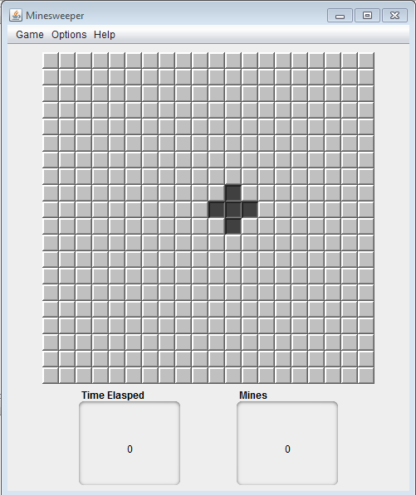

About html code
<html>
<head>
<title>About</title>
</head>
<body>
<center>
<h3>
Minesweeper</h3>
<p>
<i>version 1.0</i>
</p>
<p>
<br />
By Ruijing Li
</p>
</center>
</body>
</html>

How to Play HTML code
<html>
<head>
<title>How To Play</title>
</head>
<body>
<center>
<h4><img src="mines.png" width="41" height="41" border="0" alt="Mines" />How To Play<img src="mines.png" width="41" height="41" border="0" alt="Mines" /></h4>
</center>
<p>
<b>Overview</b>
<br />
Minesweeper is a game of logic and probability. The game begins with a
grid of cells, some of which contains mines. The goal is to reveal all the cells that are safe by clicking on them. A cell is safe if it doesn’t contain a mine. Once the user has revealed all safe cells, the game is won!
</p>
<br />
<h4>Types of Cell</h4>
<p>
<img src="block.png" width="41" height="41" border="0" alt="Cell" />The game begins with unrevealed cells
</p>
<p>
<img src="numblock.png" width="41" height="41" border="0" alt="Numbered Cell" />If you click an unrevealed cell you may uncover a number cell. Number cells range from 1 to 8 and represent the number of neighboring cells containing mines. For example, in the game below, four cells are touching 1 neighboring mine and three cells are touching 2 neighboring mines.
<center><img src="GameEx.png" border="0" alt="Example" /></center>
</p>
<p>
<img src="flagIcon.png" width="41" height="41" border="0" alt="Flag" />If you suspect that a cell contains a mine, you can flag it by right-clicking the cell. In the game shown below, two cells have been correctly flagged as containing mines.
<center><img src="GameExFlag.png" border="0" alt="Example 2" /></center>
</p>
<br />
<h4>Game Interface</h4>
<p>
Under the Game menu, you can choose to start a new game or exit; in the Options menu you can set the total number of mines; in the Help menu you can find this page and the about page.
<center><img src="menu.png" border="0" alt="Menu" /></center>
</p>
<p>
<img src="time.png" width="80" height="80" border="0" alt="Time" />Here you can see how much time has passed since you started the game.
</p>
<p>
<img src="mineNum.png" width="80" height="80" border="0" alt="number" />Here you can see how many mines are left.
</p>
<br />
<br />
<center>
<b>Enjoy your stay and have fun!!!</b>
</center>

</body>
</html>

