**Writeup:**

**Problem Statement:**

As a Full Stack Developer, design and develop a backend administrative portal for the Learners Academy .

**Developer Name: Nikitha**

**Developer Email:** [**cnikitha@teksystems.com**](mailto:cnikitha@teksystems.com)

**SimpliLearn Full Stack Development Course Phase 2**

Github Link:

<https://github.com/chnikitha/Learners-Academy>

Steps:

1)Login Page:

<!DOCTYPE html>

<html>

<head>

<meta charset=*"ISO-8859-1"*>

<title>Learner's Academy</title>

</head>

<body>

<h1 style="Color:*blue*">Learner's Academy</h1><b>Developer Name: Nikitha

&nbsp;&nbsp;Developer Email: cnikitha@teksystems.com

&nbsp;&nbsp;SimpliLearn Full Stack Development Course Phase 2</b>

<h2 style="text-align:*center*; Color:*green*"> Welcome To Your School Login Page!</h2>

<br/>

<br/>

<div style="text-align:*center*;">

<form action=*"Dashboard.jsp"* method=*"post"*>

<table border=*"1"* style="text-align:*center*; margin-left:*auto*;margin-right:*auto*;" >

<tr><td><br/>&nbsp;&nbsp;Please Enter Your Username: <input type=*"text"* name=*"username"* placeholder=*"username"*>&nbsp;&nbsp;<br/><br/>

&nbsp;&nbsp;Please Enter Your Password: <input type=*"password"* name=*"password"* placeholder=*"password"*>&nbsp;&nbsp;<br/><br/></td></tr>

<tr><td><input type=*"submit"* value=*"login"*></td></tr>

</table>

</form>

</div>

<br/>

<br/>

<br/>

<br/>

</body>

</html>

o/p:

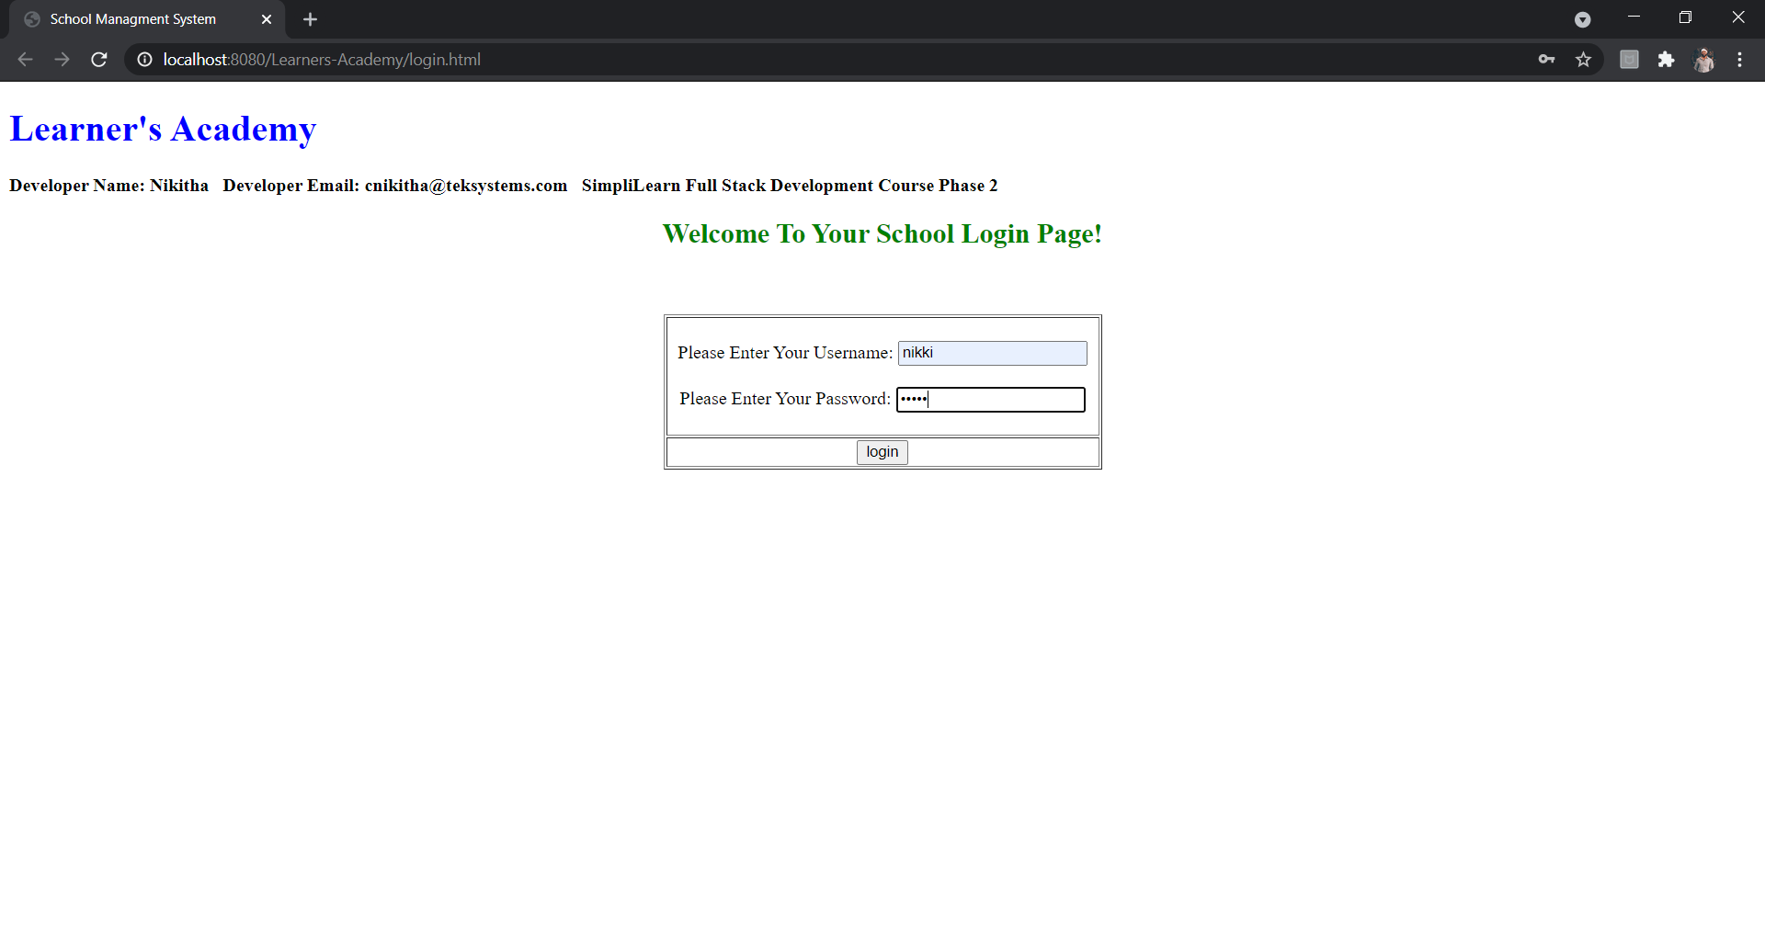

Step:2

Dashboard.jsp

<%@page import=*"javax.servlet.http.HttpSession"*%>

<%@page import=*"java.util.Date"*%>

<%@ page language=*"java"* contentType=*"text/html; charset=ISO-8859-1"*

pageEncoding=*"ISO-8859-1"*%>

<%@page session=*"false"* %>

<!DOCTYPE html>

<html>

<head>

<meta charset=*"ISO-8859-1"*>

<title>Learners Academy</title>

</head>

<body>

<%

HttpSession mySession=request.getSession(**false**);

**if**(mySession==**null**){

out.print("<center><h3>Your session has expired.. Navigating you to home page.....</h3></center>");

response.setHeader("refresh", "5;url='/Learners-Academy'");

}

**else**{

Date createTime = **new** Date(mySession.getCreationTime());

%>

<h1 style="Color:*blue*">Learner's Academy</h1><b style="Color:*blue*">You Logged in at <%=createTime %></b>

<div style="text-align:*center*;">

<h2>Welcome to your Dashboard

</h2>

<table style="text-align:*center*; margin-left:*auto*;">

<tr><td>&nbsp;&nbsp;<a href=*"LogoutController"*>logout</a>&nbsp;&nbsp;</td></tr>

</table>

<br/>

<div style="color:*red*;text-align: *center*; border: *1px outset red*;

background-color: *lightblue*;" >

<%**if**(mySession.getAttribute("exception")!=**null**) {%>

<%=mySession.getAttribute("exception") %>

<%}**if**(mySession.getAttribute("exceptionSys")!=**null**) {%>

System Error <%=mySession.getAttribute("exceptionSys") %>

<%} %>

</div>

<br/>

<table border=*"1"* style="text-align:*center*; margin-left:*auto*;margin-right:*auto*;">

<tr><td>&nbsp;&nbsp;<a href=*"ManageStudent1"*>manage students</a>&nbsp;&nbsp;</td><td> Get a list of all students

<br/>Add New Students

<br/>Update Student Details

<br/>Delete an existing student</td></tr>

<tr><td>&nbsp;&nbsp;<a href=*"ManageClasses1"*>manage classes</a>&nbsp;&nbsp;</td><td> Get a list of all Classes

<br/>Add New Class

<br/>Delete an existing Class

<br/>Generate Class Report</td></tr>

<tr><td>&nbsp;&nbsp;<a href=*"ManageTeacher1"*>manage teachers</a>&nbsp;&nbsp;</td><td> Get a list of all Teachers

<br/>Add New Teachers

<br/>Update Teacher Details

<br/>Delete an existing Teacher</td></tr>

<tr><td>&nbsp;&nbsp;<a href=*"ManageSubject1"*>manage subjects</a>&nbsp;&nbsp;</td><td> Get a list of all Subjects

<br/>Add New Subject

<br/>Update Subject Details, Assign a Teacher, Designate a Class

<br/>Delete an existing Subject</td></tr>

</table>

</div>

<%@include file=*'footer.html'* %>

<%}%>

<%mySession.removeAttribute("exception");

mySession.removeAttribute("exceptionSys");%>

</body>

</html>

o/p:

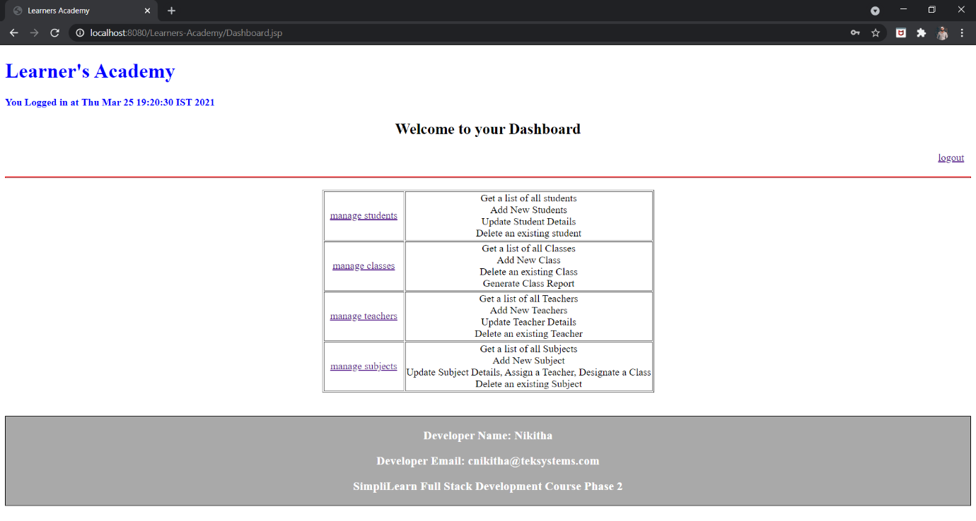

3)Manage Students:

ManageStudent.java

package com.learnersacademy.servlet;

import java.io.IOException;

import java.io.PrintWriter;

import java.util.List;

import javax.servlet.ServletException;

import javax.servlet.http.HttpServlet;

import javax.servlet.http.HttpServletRequest;

import javax.servlet.http.HttpServletResponse;

import javax.servlet.http.HttpSession;

import com.exception.BusinessException;

import com.learnersacademy.bo.LearnersAcadBOImpl;

import com.learnersacademy.model.StudentObj;

public class ManageStudent1 extends HttpServlet {

private static final long serialVersionUID = 1L;

public ManageStudent1() {

super();

// TODO Auto-generated constructor stub

}

protected void doGet(HttpServletRequest request, HttpServletResponse response) throws ServletException, IOException {

response.setContentType("text/html");

HttpSession session=request.getSession(false);

PrintWriter out=response.getWriter();

LearnersAcadBOImpl boObj=new LearnersAcadBOImpl();

if(session!=null) {

try {

List<StudentObj> studentList=boObj.listStudents();

session.setAttribute("studentList", studentList);

response.sendRedirect("viewStudent.jsp");

}catch (BusinessException e) {

session.setAttribute("exception", e.getMessage());

response.sendRedirect( "Dashboard.jsp");}

catch(Exception e1) {

session.setAttribute("exceptionSys", e1.getMessage());

response.sendRedirect( "Dashboard.jsp");

}

}

else {

out.print("<center><h3>Your session has expired.. Navigating you to home page.....</h3></center>");

response.setHeader("refresh", "5;url='/Learners-Academy'");

}

}

/**

* @see HttpServlet#doPost(HttpServletRequest request, HttpServletResponse response)

*/

protected void doPost(HttpServletRequest request, HttpServletResponse response) throws ServletException, IOException {

response.setContentType("text/html");

HttpSession session=request.getSession(false);

PrintWriter out=response.getWriter();

LearnersAcadBOImpl boObj=new LearnersAcadBOImpl();

if(session!=null) {

try {

Integer studentId = Integer.parseInt(request.getParameter("studentId_delete"));

boObj.deleteStudent(studentId);

List<StudentObj> studentList=boObj.listStudents();

session.setAttribute("studentList", studentList);

response.sendRedirect("viewStudent.jsp");

} catch (BusinessException e) {

session.setAttribute("exception", e.getMessage());

response.sendRedirect( "student");}

catch(Exception e1) {

session.setAttribute("exceptionSys", e1.getMessage());

response.sendRedirect( "student");

}

}

else {

out.print("<center><h3>Your session has expired.. Navigating you to home page.....</h3></center>");

response.setHeader("refresh", "5;url='/Learners-Academy'");

} }

}

ManageStudent fetch the data from database with the help of LearnersAacdDAOImpl.java File

Which will redirect it to viewStudents.jsp file

o/p:

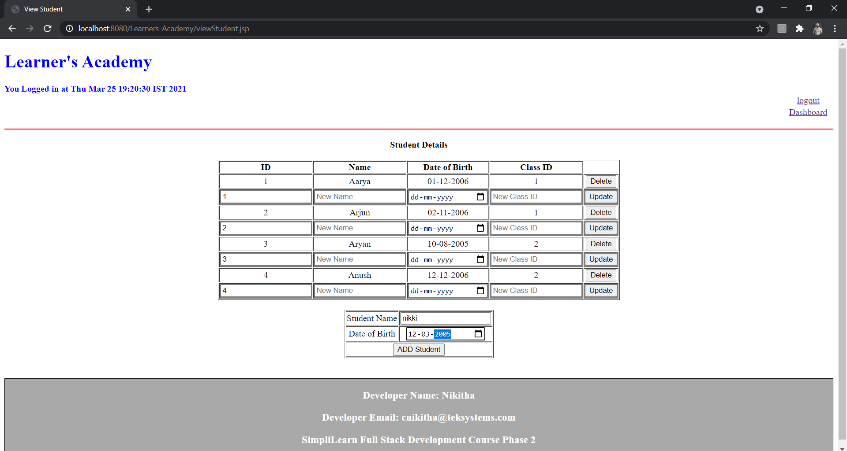

Add Student will redirect it to UpdateStudent1.java file and the data gets updated in the database

Step3:

Manageclasses:

package com.learnersacademy.servlet;

import java.io.IOException;

import java.io.PrintWriter;

import java.util.List;

import javax.servlet.ServletException;

import javax.servlet.http.HttpServlet;

import javax.servlet.http.HttpServletRequest;

import javax.servlet.http.HttpServletResponse;

import javax.servlet.http.HttpSession;

import com.exception.BusinessException;

import com.learnersacademy.bo.LearnersAcadBOImpl;

import com.learnersacademy.model.ClassObj;

public class ManageClasses1 extends HttpServlet {

private static final long serialVersionUID = 1L;

public ManageClasses1() {

super();

// TODO Auto-generated constructor stub

}

protected void doGet(HttpServletRequest request, HttpServletResponse response) throws ServletException, IOException {

response.setContentType("text/html");

HttpSession session=request.getSession(false);

PrintWriter out=response.getWriter();

LearnersAcadBOImpl boObj=new LearnersAcadBOImpl();

if(session!=null) {

try {

List<ClassObj> classList=boObj.listClasses();

session.setAttribute("classList", classList);

response.sendRedirect("viewClass.jsp");

} catch (BusinessException e) {

session.setAttribute("exception", e.getMessage());

response.sendRedirect( "Dashboard.jsp");}

catch(Exception e1) {

session.setAttribute("exceptionSys", e1.getMessage());

response.sendRedirect( "Dashboard.jsp");

}

}

else {

out.print("<center><h3>Your session has expired.. Navigating you to home page.....</h3></center>");

response.setHeader("refresh", "5;url='/Learners-Academy'");

}

}

protected void doPost(HttpServletRequest request, HttpServletResponse response) throws ServletException, IOException {

response.setContentType("text/html");

HttpSession session=request.getSession(false);

PrintWriter out=response.getWriter();

LearnersAcadBOImpl boObj=new LearnersAcadBOImpl();

if(session!=null) {

try {

Integer classId = Integer.parseInt(request.getParameter("classId_delete"));

boObj.deleteClass(classId);

List<ClassObj> classList=boObj.listClasses();

session.setAttribute("classList", classList);

response.sendRedirect("viewClass.jsp");

} catch (BusinessException e) {

session.setAttribute("exception", e.getMessage());

response.sendRedirect( "classes");}

catch(Exception e1) {

session.setAttribute("exceptionSys", e1.getMessage());

response.sendRedirect( "classes");

}

}

else {

out.print("<center><h3>Your session has expired.. Navigating you to home page.....</h3></center>");

response.setHeader("refresh", "5;url='/Learners-Academym'");

}

}

}

Manageclasses fetch the data from database with the help of LearnersAacdDAOImpl.java File

Which will redirect it to viewclasses.jsp file

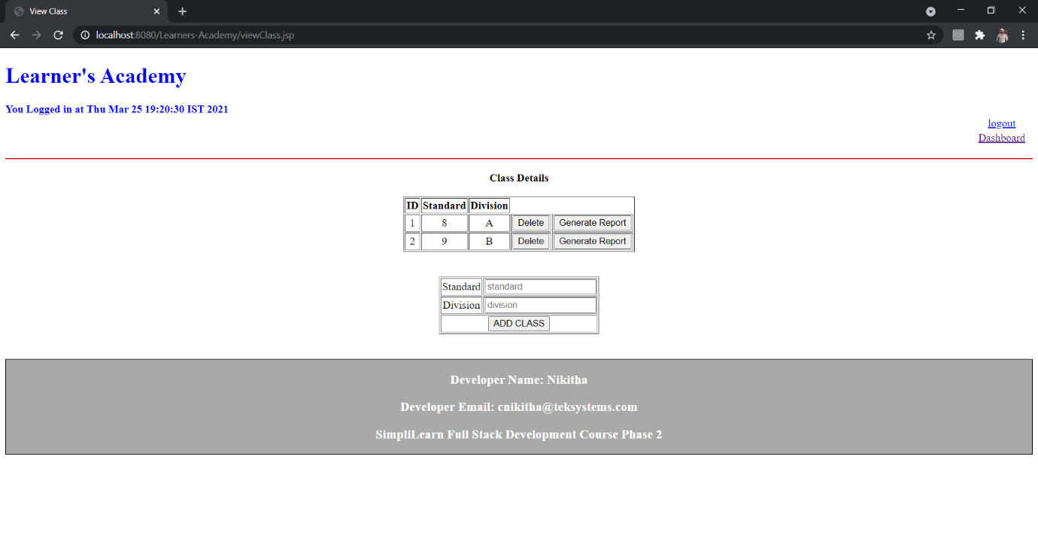

Add class will redirect it to UpdateClasses1.java file and the data gets updated in the database

Step4:

ManageTeacher:

package com.learnersacademy.servlet;

import java.io.IOException;

import java.io.PrintWriter;

import java.util.List;

import javax.servlet.ServletException;

import javax.servlet.http.HttpServlet;

import javax.servlet.http.HttpServletRequest;

import javax.servlet.http.HttpServletResponse;

import javax.servlet.http.HttpSession;

import com.exception.BusinessException;

import com.learnersacademy.bo.LearnersAcadBOImpl;

import com.learnersacademy.model.TeacherObj;

public class ManageTeacher1 extends HttpServlet {

private static final long serialVersionUID = 1L;

public ManageTeacher1() {

super();

// TODO Auto-generated constructor stub

}

protected void doGet(HttpServletRequest request, HttpServletResponse response) throws ServletException, IOException {

response.setContentType("text/html");

HttpSession session=request.getSession(false);

PrintWriter out=response.getWriter();

LearnersAcadBOImpl boObj=new LearnersAcadBOImpl();

if(session!=null) {

try {

List<TeacherObj> teacherList=boObj.listTeacher();

session.setAttribute("teacherList", teacherList);

response.sendRedirect("viewTeacher.jsp");

} catch (BusinessException e) {

session.setAttribute("exception", e.getMessage());

response.sendRedirect( "Dashboard.jsp");}

catch(Exception e1) {

session.setAttribute("exceptionSys", e1.getMessage());

response.sendRedirect( "Dashboard.jsp");

}

}

else {

out.print("<center><h3>Your session has expired.. Navigating you to home page.....</h3></center>");

response.setHeader("refresh", "5;url='/Learners-Academy'");

}

}

protected void doPost(HttpServletRequest request, HttpServletResponse response) throws ServletException, IOException {

response.setContentType("text/html");

HttpSession session=request.getSession(false);

PrintWriter out=response.getWriter();

LearnersAcadBOImpl boObj=new LearnersAcadBOImpl();

if(session!=null) {

try {

Integer teacherId = Integer.parseInt(request.getParameter("teacherId_delete"));

boObj.deleteTeacher(teacherId);

List<TeacherObj> teacherList=boObj.listTeacher();

session.setAttribute("teacherList", teacherList);

response.sendRedirect("viewTeacher.jsp");

} catch (BusinessException e) {

session.setAttribute("exception", e.getMessage());

response.sendRedirect( "teacher");}

catch(Exception e1) {

session.setAttribute("exceptionSys", e1.getMessage());

response.sendRedirect( "teacher");

}

}

else {

out.print("<center><h3>Your session has expired.. Navigating you to home page.....</h3></center>");

response.setHeader("refresh", "5;url='/Learners-Academy'");

}

}

}

ManagecTeacher fetch the data from database with the help of LearnersAacdDAOImpl.java File

Which will redirect it to viewTeacher.jsp file

o/p:

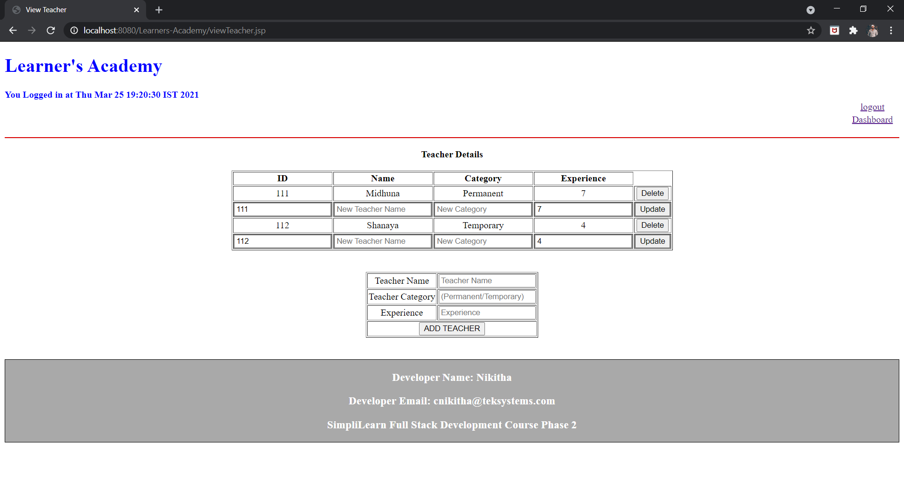

Add Teacher will redirect to UpdateTeacher.java file and gets data gets updated

Step5:

ManageSubjects:

package com.learnersacademy.servlet;

import java.io.IOException;

import java.io.PrintWriter;

import java.util.List;

import javax.servlet.ServletException;

import javax.servlet.http.HttpServlet;

import javax.servlet.http.HttpServletRequest;

import javax.servlet.http.HttpServletResponse;

import javax.servlet.http.HttpSession;

import com.exception.BusinessException;

import com.learnersacademy.bo.LearnersAcadBOImpl;

import com.learnersacademy.model.SubjectObj;

public class ManageSubject1 extends HttpServlet {

private static final long serialVersionUID = 1L;

public ManageSubject1() {

super();

// TODO Auto-generated constructor stub

}

protected void doGet(HttpServletRequest request, HttpServletResponse response) throws ServletException, IOException {

response.setContentType("text/html");

HttpSession session=request.getSession(false);

PrintWriter out=response.getWriter();

LearnersAcadBOImpl boObj=new LearnersAcadBOImpl();

if(session!=null) {

try {

List<SubjectObj> subList=boObj.listSubject();

session.setAttribute("subList", subList);

response.sendRedirect("viewSubject.jsp");

} catch (BusinessException e) {

session.setAttribute("exception", e.getMessage());

response.sendRedirect( "Dashboard.jsp");}

catch(Exception e1) {

session.setAttribute("exceptionSys", e1.getMessage());

response.sendRedirect( "Dashboard.jsp");

}

}

else {

out.print("<center><h3>Your session has expired.. Navigating you to home page.....</h3></center>");

response.setHeader("refresh", "5;url='/Learners-Academy'");

}

}

protected void doPost(HttpServletRequest request, HttpServletResponse response) throws ServletException, IOException {

response.setContentType("text/html");

HttpSession session=request.getSession(false);

PrintWriter out=response.getWriter();

LearnersAcadBOImpl boObj=new LearnersAcadBOImpl();

if(session!=null) {

try {

Integer subjectId = Integer.parseInt(request.getParameter("subjectId_delete"));

boObj.deleteSubject(subjectId);

List<SubjectObj> subList = boObj.listSubject();

session.setAttribute("subList", subList);

response.sendRedirect("viewSubject.jsp");

} catch (BusinessException e) {

session.setAttribute("exception", e.getMessage());

response.sendRedirect( "ManageSubject1");}

catch(Exception e1) {

session.setAttribute("exceptionSys", e1.getMessage());

response.sendRedirect( "ManageSubject1");

}

}

else {

out.print("<center><h3>Your session has expired.. Navigating you to home page.....</h3></center>");

response.setHeader("refresh", "5;url='/Learners-Academy'");

}

}

}

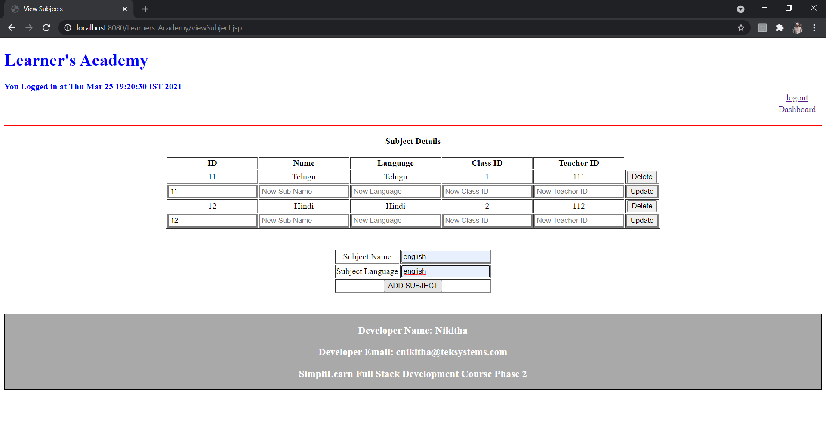

Step6:

Generating class report:

