Order Management System

**N-Views Architecture Representation Document**

|  |  |  |  |
| --- | --- | --- | --- |
|  | **Prepared By / Last Updated By** | **Reviewed By** | **Approved By** |
| **Name** |  |  |  |
| **Role** |  |  |  |
| **Signature** |  |  |  |
| **Date** |  |  |  |

Table of Contents

1.0 Introduction 5

1.1 Purpose of this document 5

1.2 Scope 5

1.3 Structure of the document 6

1.4 Intended Audience 6

2.0 Project Overview 6

2.1 Objectives 6

3.0 Architecture Representation 7

3.1 Architecture Overview 7

3.2 Drivers 9

3.2.1 Business Drivers and Goals 9

3.2.2 Architectural Drivers and Goals 9

3.2.3 Technology Drivers and Goals 10

3.2.4 Non-Functional Requirements 10

3.2.4.1. Logging Requirement 10

3.2.4.2. Audit Requirements 12

3.2.4.3. Security 13

3.2.4.4. Performance 14

3.2.4.5. Scalability 15

3.2.4.6. Reports 15

3.2.4.7. Testing Requirements 17

3.3 Architecture Principles 18

3.4 Key Architecture Decisions 18

3.4.1 Technology Stack Rationalization 18

4.0 Architecture Representational Views 21

4.1 Functional View 21

4.2 Layer View 22

4.3 Solution View 24

4.3.1 Presentation Tier 24

4.3.2 Business Tier 27

4.3.3 Data Access /Integration Layer 28

4.3.4 Reusable Component 29

4.4 User Interface View 30

4.5 Security View 30

4.6 Integration View 31

4.7 Deployment View 34

4.7.1 Tiers 35

4.7.2 Logical Infrastructure 36

4.8 Data View 37

4.8.1 Executive Summary 37

4.8.2 Choice of target Database 37

4.8.3 Master Data Management 37

4.8.4 Data consolidation across data centers 39

4.8.5 Use of DDLs, Primary key and Referential Integrity 39

4.8.6 Database Housekeeping 40

4.8.7 Data Caching 40

4.8.8 Enlarging the length of ID fields 41

4.8.9 Summarized table/DW schema for reporting 42

4.8.10 Database Design Changes 42

4.8.11 Conceptual Data Models for different Subject Areas 46

5.0 Design Consideration 47

5.1 Logging Framework 47

5.2 Audit Trail and Logging 51

5.3 Exception Component 53

5.4 Security Strategy 56

5.4.1 Authentication and Authorization 56

5.4.2 Cross-Site Scripting (XSS) 57

5.4.3 Session Hijacking 57

5.5 Performance Strategy 57

5.5.1 Lazy Loading 57

5.5.2 Pre-Loaded Reference Data 58

5.5.3 Parallel Backend Service Calls 58

5.6 Internationalization 58

5.6.1 Message Resource Bundle 59

5.6.2 Spring Configuration 59

5.6.3 Load Resource Bundle 59

5.6.4 Multiple Unit and Currency format 59

5.7 Reports 60

5.7.1 Online Report 60

5.7.2 Scheduled Report 61

5.7.3 Adhoc Report 61

5.8 Printing 61

5.9 System management and maintainability 62

5.10 Capturing Digital Signature 63

5.11 Voice Picking 63

5.12 Location Tracking 65

5.13 Bar Code and Label Generation 66

6.0 Development Consideration 67

6.1 Build System 67

6.2 Folder Structure 68

6.3 Development environment 70

7.0 Best Practices/Guidelines 71

7.1 Best Practices for Spring 71

7.2 Best Practices for Spring Webflow 71

7.3 Best Practice for Hibernate 71

7.4 Java Coding Standards 71

8.0 Recommendation 72

8.1 Homegrown JPaaS 72

8.2 Homegrown JCAP 72

9.0 Assumptions and Dependencies 72

Appendix A – List of Figures 74

Appendix B – List of Tables 75

Appendix C – Acronyms 75

# Introduction

## Purpose of this document

The purpose of this software architecture is aimed at describing the architecture of the Order Management System based on multiple, concurrent views all of which can be combined to create a holistic view of the system covering both software requirements and non functional requirements. This document also addresses solutions for various functional components like

* Logging
* Exception Component
* Security
* Performance
* Reports
* System management and maintainability

Describe the high-level architecture and high level design of the system.

* Describe precisely the responsibilities, relationships, and interactions of components.
* Document how application/technical parts of the system are related.
* Specify how existing and developed components are related.

## Scope

**In HLD Scope**

The scope of this document includes tools, technologies, patterns and approaches that will be used in the design and development, deployment and support and enhancements (evolution) of the proposed system. The document also brings out the rationale for arriving at a specific technology or tool or framework.

The document describes the application architecture using the N Views architecture model

The application is explained with the following architecture views

1. Functional View
2. Layered View
3. Integration View
4. Security View
5. Data View

**In LLD Scope**

* Low level Design aspects (Class or Sequence Diagrams) of the system.

## Structure of the document

This report is structured in such a manner that it starts with the overall project context detailing the objectives and constraints, key stake holders, key areas of concerns and drivers. The subsequent section details the architectural representation of the envisaged architecture followed by a number of views of the application architecture.

## Intended Audience

The intended audience of this document are Application architect, Application developers , Project Manager.

# Project Overview

## Objectives

The objective of the Order Management System (OMS) Project is to provide target architecture for the

various inventory , order mangement activities . An OMS may interface with a multitude of other technical components.

Order Management System typically offer:

* Inventory management system
* Order creation
* Product catalog
* Inventory Check
* Order management
* Billing and Shippment
* Customer Management

# Architecture Representation

## Architecture Overview

The proposed application architecture is based on the following principles:

* A multi-Tiered, multi-layered architecture that leverages the patterns and open standards
* A well abstracted modular, scalable, flexible and extensible architecture
* Clear separation of roles and responsibilities of various components and sub-systems in the solution
* Enhance creation and dissemination of re-usable assets and their alignment with open industry standards available in this solution space

FUNCTIONAL VIEW

LAYER VIEW

A

Y E R

V

I

E

W

INTEGRATION VIEW

DATA VIEW

SECURITY VIEW

Figure 1: Architecture View

|  |  |
| --- | --- |
| View | Brief Description |
| Functional View | Functional view provides a snap shot of the functional context of the system. Functional view focuses on identifying functional requirements that are important to business. This view identifies the business functions and services that are expected from the solution and its potential users. |
| Layered View | Layered view provides the perspective of how the services, Tiers/layers and components are modeled within the concerned system. This view provides the key Tiers, components and design blocks that are used in order to realize the complete architectural solution. |
| Integration View | Integration view provides the details of the communication mechanisms of the various internal and external interfaces. This view will also detail out the integration patterns and protocols with the each interface. |
| Security View | Security view provides details of the capability of the envisaged system to monitor, manage and maintain security related aspects of the system. This view provides a perspective of the system from access control, authentication and authorization perspectives. It identifies and elaborates the security mechanisms & standards that need to be realized along with identification of tools & technologies, commercial and custom components that will be leveraged to fulfill the security needs of the system. |
| Data View | Data View provides the Entity relationship between different Business Entities and also the Logical Data Model of the system |

Table 1: Architecture Definition Views

## Drivers

### Business Drivers and Goals

The following are the business drivers considered for Order Management System architecture

1. To evaluate new technology to improve efficiency, reduce cost, and provide increased visibility to data within OMS
2. Ease of integrating with third party system .

### Architectural Drivers and Goals

The following are the architectural drivers considered for Order Management System architecture

1. High Availability (HA)
2. Scalability
3. Reliability
4. Performance

### Non-Functional Requirements

### Logging Requirement

The logging for OMS needs to have below mentioned functionality

* Logging Level
* Exception Management
* Report
* Configuration Management

##### Logging Level

The logger is classified into four categories

* Exceptional
* Specific User
* Internal and External system
* Workflow activity

###### Exceptional

Exceptional logger is responsible for capturing the exceptions such as fatal, error and warning to be logged along with certain metadata and passing it to the logging framework for persisting it in log tables / files..

###### Specific User

User & Process logger is responsible for capturing the debug / Information message metadata related to specific user and related process invoked and passing it to the logging framework for persisting it in log tables / files

###### Internal and External system

Process logger is responsible for capturing the debug /Information message metadata and passing it to the logging framework for persisting it in log tables / files

###### Workflow activity

Workflow activity logger is responsible for capturing all the workflow related message metadata and passing it to the logging framework for persisting it in log tables / files

##### Exception Management

The exceptional logger information captured by the logging framework needs to be communicated to support team setup in the configuration table / file. The exceptional application logging warning for communication is classified into three categories such as

###### Fatal

###### Error

###### Warning

###### Fatal

Fatal message have to be send immediately to resources such as IT help desk support team in the system using email options setup in the configuration table.

###### Error

Errors message have to be send immediately to resources such as IT help desk support team in the system using email options setup in the configuration table.

###### Warning

Warning message have to be send immediately to resources such as IT Admin team in the system using email options setup in the configuration table.

##### Configuration Management

The logger framework needs to have configuration parameters for the logging levels. The configuration options are

* Expiry date
* Purging the logging records with below condition
  + Number of days older
  + Records count greater than
  + size

###### Expiry date

###### The expiry date will be default set for the all the logging level categories. This will ensure that the logger is turned after automatically without manual intervention in the all environments. By resetting the expiry date the logger can be turned on again.

###### Purging

The purging of all the logger information needs to be configuration driven. Purging logic will be executed depending upon the configuration parameter in the configuration table

## Architecture Principles

* Architecture must have distinct layers. These layers need to be loosely coupled and accessible through well defined interfaces and should be deployable independent region of the other layers
* The architecture will make use of the technical capability offered by light weight components such as Spring boot in PCF
* Communication interfaces between the layers should be based on open standard interfaces and protocols
* Slf4j framework shall be used for fulfilling the application logging needs.
* Common application server independent security framework (Spring Security) shall be used for Authentication and Authorization purpose.

## Key Architecture Decisions

This section documents the important decisions made to select the right technology stacks for the given Order Management Systemfrom the aspect of the architecture and structure of the system that are given or have been made.

### Technology Stack Rationalization

|  |  |  |  |
| --- | --- | --- | --- |
| **S.No** | **Key Architecture Decision (KAD)** | **Commercial / Open Source** | **Rationale/Driver** |
| KAD1.0 | Spring boot 1.5.4 | Open Source | 1. Spring boot is light weight component having embedded tomcat 2. Enhanced Scope Management 3. Spring Security native support 4. Better Tools support using Spring Tools Suite 5. Spring WebFlow is unit testable |
| KAD 2.0 | MongoDB 3.4.0 | Open Source | 1. NoSql database 2. Maintaing data as a collection in json format 3. Ease of deployment & maintainability |
| KAD 3.0 | RabbitMq 1.4.6 | Open Source | 1. Messaging broker  Decoupling Microservices with Spring AMQP and RabbitMQ  1. RabbitMQ is lightweight and easy to deploy on premises and in the cloud |
| KAD 4.0 | Zuul | Open Source | Zuul is built to enable dynamic routing, monitoring, resiliency and security. |
| KAD 5.0 | Ribbon | Open Source | Inter Process Communication (remote procedure calls) library with built in software load balancer |
| KAD 6.0 | Eureka | Open Source | Service registry for resilient mid-tier load balancing and failover |
| KAD 7.0 | Hystrix | Open Source | Hystrix is a latency and fault tolerance library |
| KAD 8.0 | Redis | Open Source | [Caching](http://en.wikipedia.org/wiki/Cache_%28computing%29) is a way for applications to store data so that future requests |
| KAD 9.0 | Groovy 2.4.5 | Open Source | Writing Unit and Acceptance testcases using Spock framework |
| KAD 10 | Gradle | Open Source | Gradle helps teams build, automate and deliver better software, faster |

Table 2: Technology Stack Rationalization

# Architecture Representational Views

## Functional View

The functional view of Order Management System application is represented in the below pictorial view.Following are the list of the high level functional component of OMS.

* Inventory management system
* Product catalog
* Order management
* Billing and Shippment
* Customer Management



## Layer View

The layering architecture consists of the following layers

* Clients
* Presentation Layer
* Service producer
* Business Layer
* Data Access Layer
* Integration Layer

These layers are designed in accordance with the architecture principle of enabling increased cohesion within the layer and reduced coupling across the layers. This logical separation of the

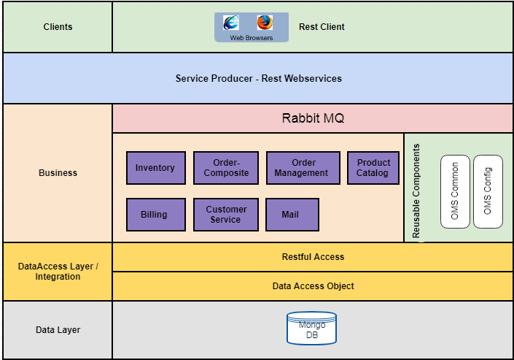

Figure 2: Layered views

architecture enables a clear separation of concerns between the systems thereby partitions the responsibility of the systems more appropriately.

* **Client**

The client layer represents the various modes through which users can access the Order Management Systemapplication. The access to the online application can be done using any latest standard web browsers.

* **Business Layer**

The business service layer comprises of components that realizes a specific business function or services of the Order Management Systemapplication. This layer includes the implementation of application specific business logic and performing business validations in addition to handling the security aspects of the application at this layer. The business layer is responsible for orchestrating with various components or services across the enterprise to realize a specific functionality in Order Management System application.

* **Data Access Layer**

This layer includes the components which are mainly supports for data access operation with underlying database server .It abstracts all the DB operation from the above layer.To improve the DB operation caching functionality also exposed in this layer.

* **Integration Layer**

The responsibility of this layer is to abstract the layers above from the underlying core systems in addition to providing transparent integration. This layer Includes the components which are mainly supports for integrating with other systems. It uses persistence framework to interact with database Mongo Db.

* **Reusable Components**

This vertical column provides common, reusable components that can be used across the various components or services in different layers. The primary responsibility of this layer is to provide stand-alone components that can be plugged into any of the components in the other layers to realize their desired functionalities.

## Integration View

This section specifies the technical interface between micro services. Please note that this section only considers the interfaces of these systems with the OMS

* + Inventory management system
  + Product catalog
  + Order management
  + Billing and Shippment
  + Customer Management

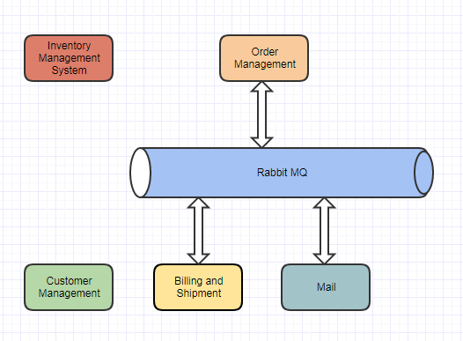

Figure 5: Integration views

**Micro-services**

The following table describes all the micro-services:

|  |  |  |  |
| --- | --- | --- | --- |
| S.No | Micro-service | Protocols | Micro-service Description |
|
| 1 | Inventory management system | HTTP REST Call | Managing the product stock details the in Inventory. |
| 2 | Product catalog | HTTP REST Call | Managing the product details. |
| 3 | Order management | HTTP REST Call | Create/Update/Cancel/Search the order details with selected line items based on the availability of the products in the inventory. |
| 4 | Billing and Shippment | HTTP REST Call | Making the payment on the confirmed order and intimate the customer on the shipment details via an email. |
| 5 | Customer Management | HTTP REST Call | Create/Update/Cancel/Search the customer details. |

## Security Strategy

### Authentication and Authorization

Security in web application refers to Authentication and Authorization. Authentication is the process of establishing a user and authorization pertains to what a user may do in application.

Following figure explains the solution for authentication and authorization in the Order Management System application.



Db

Figure 9: Security Flow

**Authentication**: Authentication will be done for all internal (Customers).

Authentication will be done against Order management system , which stores authentication credentials for internal users.

Authentication will use **spring security** to connect to Mongodb users for authentication

**Authorization**:

Authorization details will be stored in the OMS databases.

Authorization for OMS will use Spring Security for page level and menu level authorizations. Custom classes will be written to fetch the authority level for the users. Annotations driven authorizations will be used for functions.

**URL level authorization** can be configured in the spring security configuration file.

**Method Security**

Method level authorization is achieved by using spring security annotations

## Data View