# 准备工作

## 创建数据库

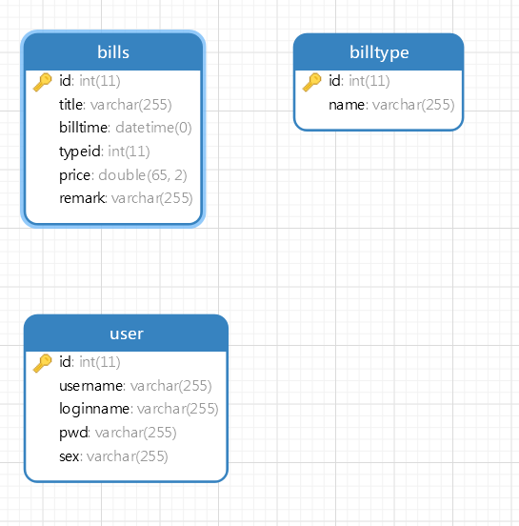

## 创建项目

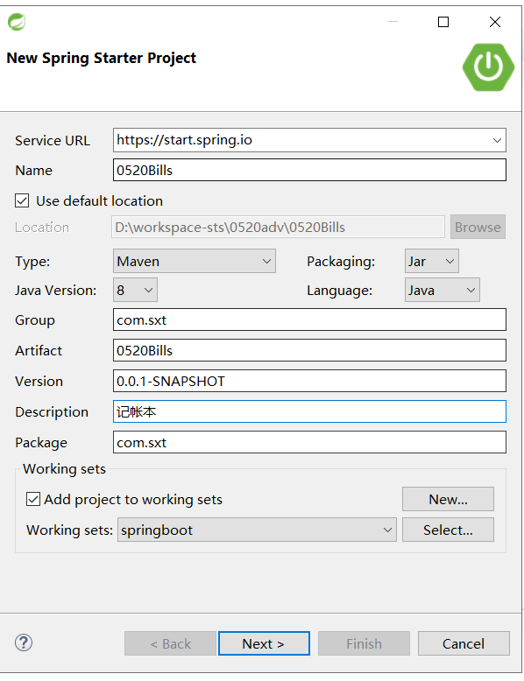

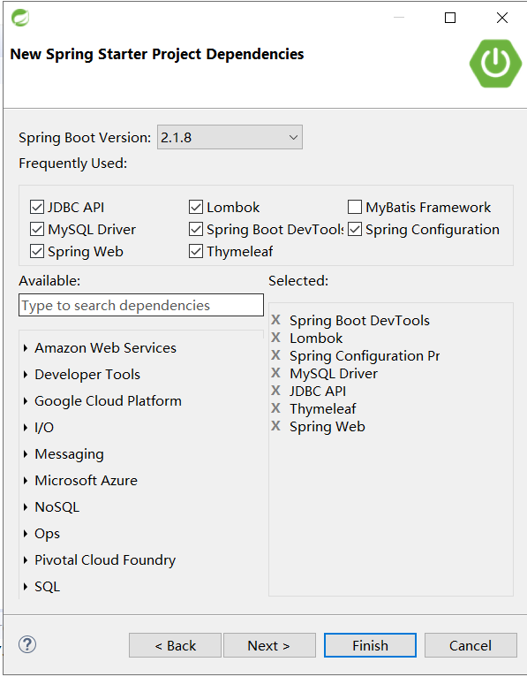

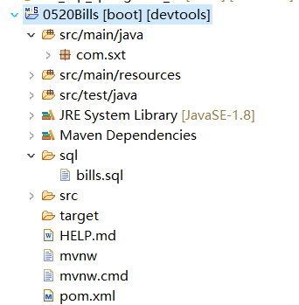

## 修改pom.xml

|  |
| --- |
| <?xml version=*"1.0"* encoding=*"UTF-8"*?>  <project xmlns=*"http://maven.apache.org/POM/4.0.0"*  xmlns:xsi=*"http://www.w3.org/2001/XMLSchema-instance"*  xsi:schemaLocation=*"http://maven.apache.org/POM/4.0.0 https://maven.apache.org/xsd/maven-4.0.0.xsd"*>  <modelVersion>4.0.0</modelVersion>  <parent>  <groupId>org.springframework.boot</groupId>  <artifactId>spring-boot-starter-parent</artifactId>  <version>2.1.8.RELEASE</version>  <relativePath /> <!-- lookup parent from repository -->  </parent>  <groupId>com.sxt</groupId>  <artifactId>0520Bills</artifactId>  <version>0.0.1-SNAPSHOT</version>  <name>0520Bills</name>  <description>记帐本</description>  <properties>  <java.version>1.8</java.version>  <maven-jar-plugin.version>3.1.1</maven-jar-plugin.version>  <mybatisplus.version>3.2.0</mybatisplus.version>  <druid.version>1.1.18</druid.version>  <log4j.version>1.2.17</log4j.version>  <hutool.version>4.6.6</hutool.version>  </properties>  <dependencies>  <dependency>  <groupId>org.springframework.boot</groupId>  <artifactId>spring-boot-starter-jdbc</artifactId>  </dependency>  <dependency>  <groupId>org.springframework.boot</groupId>  <artifactId>spring-boot-starter-thymeleaf</artifactId>  </dependency>  <dependency>  <groupId>org.springframework.boot</groupId>  <artifactId>spring-boot-starter-web</artifactId>  </dependency>  <dependency>  <groupId>org.springframework.boot</groupId>  <artifactId>spring-boot-devtools</artifactId>  <scope>runtime</scope>  <optional>true</optional>  </dependency>  <dependency>  <groupId>mysql</groupId>  <artifactId>mysql-connector-java</artifactId>  <scope>runtime</scope>  </dependency>  <dependency>  <groupId>org.springframework.boot</groupId>  <artifactId>spring-boot-configuration-processor</artifactId>  <optional>true</optional>  </dependency>  <dependency>  <groupId>org.projectlombok</groupId>  <artifactId>lombok</artifactId>  <optional>true</optional>  </dependency>  <dependency>  <groupId>org.springframework.boot</groupId>  <artifactId>spring-boot-starter-test</artifactId>  <scope>test</scope>  </dependency>  <dependency>  <groupId>com.baomidou</groupId>  <artifactId>mybatis-plus-boot-starter</artifactId>  <version>${mybatisplus.version}</version>  </dependency>  <dependency>  <groupId>com.alibaba</groupId>  <artifactId>druid-spring-boot-starter</artifactId>  <version>${druid.version}</version>  </dependency>  <!--log4j -->  <dependency>  <groupId>log4j</groupId>  <artifactId>log4j</artifactId>  <version>${log4j.version}</version>  </dependency>  <!--hutool-all -->  <dependency>  <groupId>cn.hutool</groupId>  <artifactId>hutool-all</artifactId>  <version>${hutool.version}</version>  </dependency>  </dependencies>  <build>  <plugins>  <plugin>  <groupId>org.springframework.boot</groupId>  <artifactId>spring-boot-maven-plugin</artifactId>  </plugin>  </plugins>  </build>  </project> |

## 修改yml

|  |
| --- |
| #配置数据源的属性  spring:  datasource:  druid:  driver-class-name: com.mysql.cj.jdbc.Driver  url: jdbc:mysql://127.0.0.1:3306/bills?useUnicode=true&characterEncoding=utf8&useSSL=true&serverTimezone=UTC  username: root  password: 123456  max-active: 20  max-wait: 5000  initial-size: 1  filters: stat,log4j,wall  validationQuery: SELECT 'x' #验证连接  enable: **true**  #监控配置  stat-view-servlet:  enabled: **true**  login-username: root  login-password: 123456  allow:  deny:  url-pattern: /druid/*  #thymeleaf的配置  thymeleaf:  cache: **false**  enabled: **true**  # web-stat-filter:  # enabled: true  # exclusions: "*.js,*.gif,*.jpg,*.png,*.css,*.ico,/druid/*"  #配置mybatisplus  mybatis-plus:  mapper-locations:  - classpath:mapper/*Mapper.xml  global-config:  db-config:  id-type: auto  banner: **true** |

# 生成代码

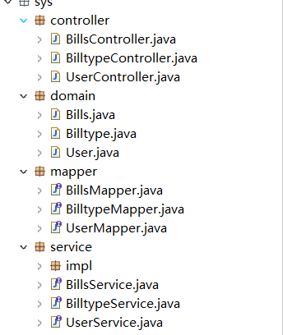

# 导入资源文件

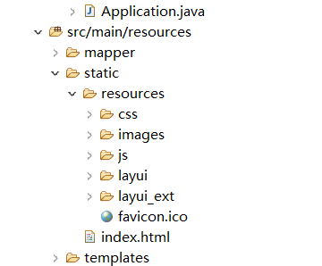

# 完成登陆

## 创建ResultObj

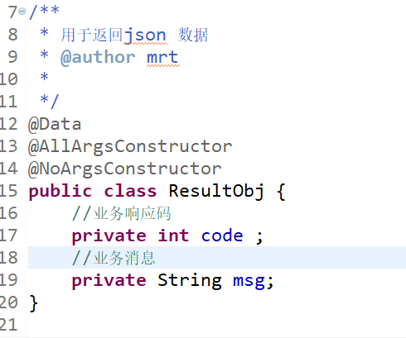

## 创建LoginController

|  |
| --- |
| /**  * <p>  * 前端控制器  * 登陆控制  * </p>  *  * **@author** 老雷  * **@since** 2019-09-20  */  @Controller  @RequestMapping("/login")  **public** **class** LoginController {    @Autowired  **private** UserService userService;    /**  * 跳转到登陆页面  */  @RequestMapping("toLogin")  **public** String toLogin() {  **return** "login";  }    @RequestMapping("login")  @ResponseBody  **public** ResultObj login(String loginname,String pwd,String code,HttpSession session) {  Object codeSession = session.getAttribute("code");  **if**(code!=**null**&&code.equals(codeSession)) {    QueryWrapper<User> queryWrapper=**new** QueryWrapper<>();  queryWrapper.eq("loginname", loginname);  queryWrapper.eq("pwd", pwd);  User user = userService.getOne(queryWrapper);  **if**(**null**!=user) {  session.setAttribute("user", user);  **return** **new** ResultObj(200, "登陆成功");  }**else** {  **return** **new** ResultObj(-1, "用户名或密码不正确");  }  }**else** {  **return** **new** ResultObj(-1, "验证码错误");  }    }    @RequestMapping("getCode")  **public** **void** getCode(HttpServletResponse resp,HttpSession session) **throws** IOException {  CircleCaptcha captcha = CaptchaUtil.*createCircleCaptcha*(116, 36, 4, 5);  //得到code  String code = captcha.getCode();  System.***out***.println(code);  //放到session  session.setAttribute("code", code);  ServletOutputStream outputStream = resp.getOutputStream();  captcha.write(outputStream);  outputStream.close();  }  } |

## 创建static/index.html

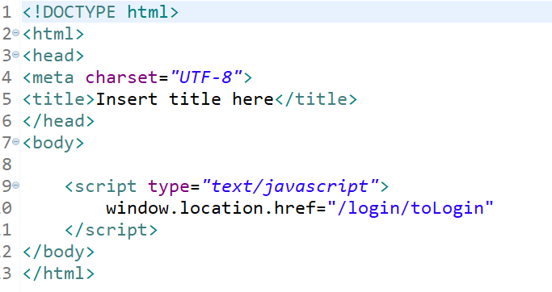

## 创建templates/login.html

|  |
| --- |
| <!DOCTYPE html>  <html class=*"loginHtml"* xmlns:th=*"http://www.thymeleaf.org"* >  <head>  <meta charset=*"utf-8"*>  <title>登录</title>  <meta name=*"renderer"* content=*"webkit"*>  <meta http-equiv=*"X-UA-Compatible"* content=*"IE=edge,chrome=1"*>  <meta name=*"viewport"* content=*"width=device-width, initial-scale=1, maximum-scale=1"*>  <meta name=*"apple-mobile-web-app-status-bar-style"* content=*"black"*>  <meta name=*"apple-mobile-web-app-capable"* content=*"yes"*>  <meta name=*"format-detection"* content=*"telephone=no"*>  <link rel=*"icon"* th:href=*"@{/resources/favicon.ico}"*>  <link rel=*"stylesheet"* th:href=*"@{/resources/layui/css/layui.css}"* media=*"all"* />  <!-- <link rel="stylesheet" href="/resources/layui/css/layui.css" media="all" /> -->  <link rel=*"stylesheet"* th:href=*"@{/resources/css/public.css}"* media=*"all"* />  </head>  <body class=*"loginBody"*>  <form class=*"layui-form"*>  <div class=*"login_face"*><img th:src=*"@{/resources/images/face.jpg}"* class=*"userAvatar"*></div>  <div class=*"layui-form-item input-item"*>  <label for=*"userName"*>用户名</label>  <input type=*"text"* placeholder=*"请输入用户名"* autocomplete=*"off"* name=*"loginname"* class=*"layui-input"* lay-verify=*"required"*>  </div>  <div class=*"layui-form-item input-item"*>  <label for=*"password"*>密码</label>  <input type=*"password"* placeholder=*"请输入密码"* autocomplete=*"off"* name=*"pwd"* class=*"layui-input"* lay-verify=*"required"*>  </div>  <div class=*"layui-form-item input-item"* id=*"imgCode"*>  <label for=*"code"*>验证码</label>  <input type=*"text"* placeholder=*"请输入验证码"* autocomplete=*"off"* name=*"code"* class=*"layui-input"*>  <img src=*"/login/getCode"* onclick="this.src='/login/getCode?'+new Date()">  </div>  <div class=*"layui-form-item"*>  <button class=*"layui-btn layui-block"* lay-filter=*"login"* lay-submit>登录</button>  </div>  </form>  <script type=*"text/javascript"* th:src=*"@{/resources/layui/layui.js}"*></script>  <script>  layui.use(['form','layer','jquery'],**function**(){  **var** form = layui.form,  layer = parent.layer === undefined ? layui.layer : top.layer  $ = layui.jquery;  //登录按钮  form.on("submit(login)",**function**(data){  **var** btn = $(**this**);  //设置登录按钮 为不可点击  btn.text("登录中...").attr("disabled","disabled").addClass("layui-disabled");  $.post("/login/login",data.field,**function**(rs){  //设置登录按钮 恢复可点击 在前端防止 重复点击  btn.text("登录").attr("disabled",**false**).removeClass("layui-disabled");  layer.msg(rs.msg);  **if**(rs.code != 200){  layer.msg(rs.msg);  }**else**{  //跳转到templates/list.html页面  layer.msg(rs.msg);  location.href="/bills/toBillsList";  }  });  **return** **false**;  })  //表单输入效果  $(".loginBody .input-item").click(**function**(e){  e.stopPropagation();  $(**this**).addClass("layui-input-focus").find(".layui-input").focus();  })  $(".loginBody .layui-form-item .layui-input").focus(**function**(){  $(**this**).parent().addClass("layui-input-focus");  })  $(".loginBody .layui-form-item .layui-input").blur(**function**(){  $(**this**).parent().removeClass("layui-input-focus");  **if**($(**this**).val() != ''){  $(**this**).parent().addClass("layui-input-active");  }**else**{  $(**this**).parent().removeClass("layui-input-active");  }  })  })  </script>  </body>  </html> |

## 创建templates/list.html

# 帐单列表

## 创建DataGridView

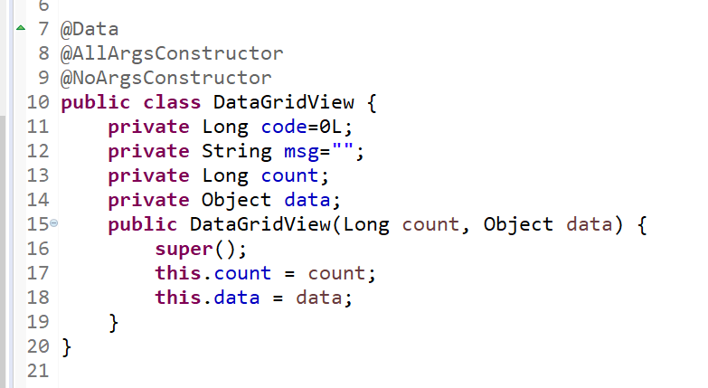

## 创建MyBatisPlusConfig

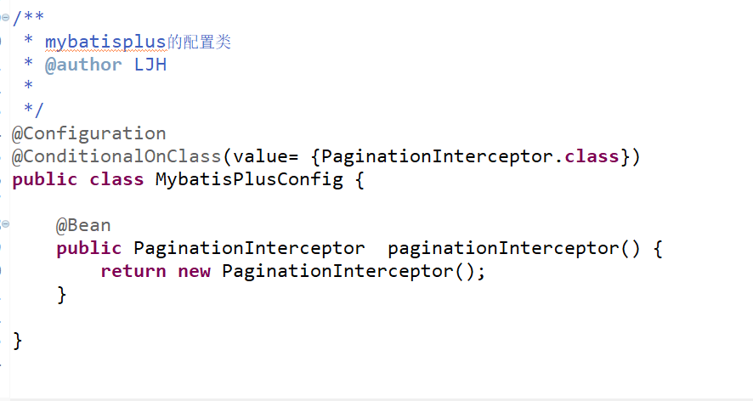

## 创建BillsController

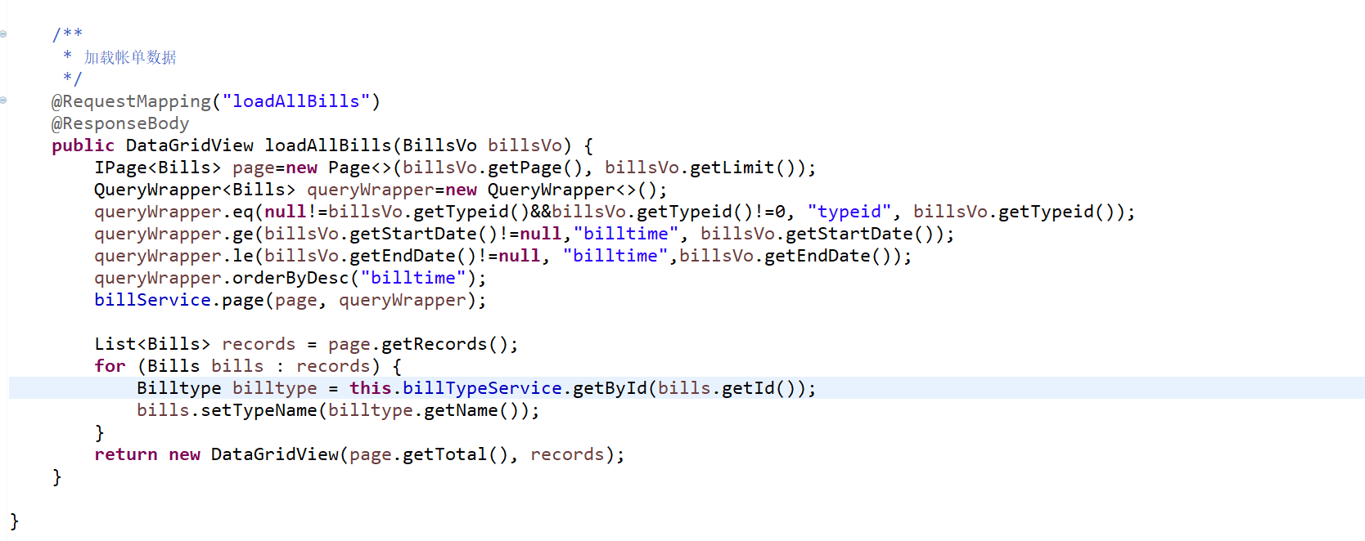

## 修改Bills

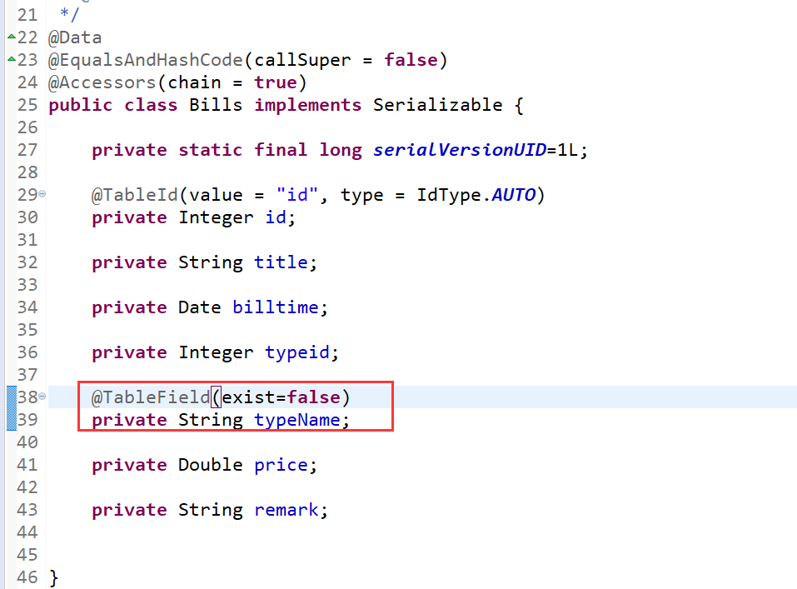

## 修改BillsVo

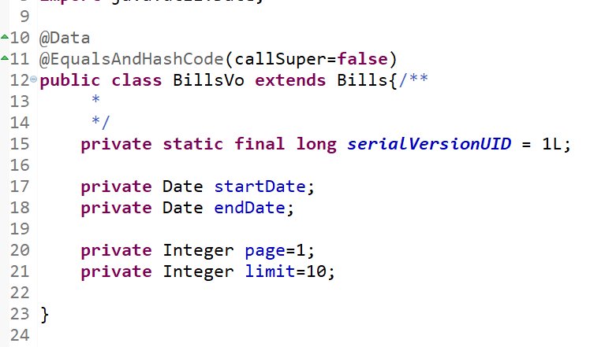

## 创建BillsTypeServiceImpl

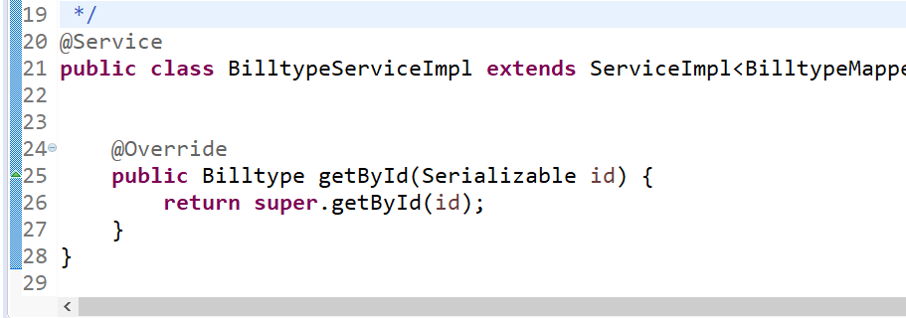

## 创建缓存处理切面类

|  |
| --- |
| @Aspect  @Component  @EnableAspectJAutoProxy  **public** **class** BillTypeCacheAspect {    /**  * 缓存对象  */  **private** Map<String,Object> cache=**new** HashMap<>();    /**  * 缓存前缀  */  **private** **static** **final** String ***BILL_TYPE_CACHE_PREFIX***="billtype:";      @Pointcut("execution(* com.sxt.sys.service.impl.BilltypeServiceImpl.getById(..))")  **public** **void** pc() {    }  @Around(value="pc()")  **public** Object cacheBillType(ProceedingJoinPoint point) **throws** Throwable {  Object[] args = point.getArgs();//得到目标方法的参数  //取出ID  Integer typeId = (Integer) args[0];  //从缓存里面取对象  Object obj = cache.get(***BILL_TYPE_CACHE_PREFIX***+typeId);  **if**(**null**!=obj) {//说明缓存里面有数据  System.***out***.println("缓存里面有数据");  **return** obj;  }**else** {  System.***err***.println("缓存里面有没有数据执行SQL查询");  //说明缓存里面没有 放行执行目标方法 查询数据  Billtype res = (Billtype) point.proceed();  //放入缓存  cache.put(***BILL_TYPE_CACHE_PREFIX***+res.getId(), res);  **return** res;  }        }  } |

## 加入依赖

|  |
| --- |
| <dependency>  <groupId>org.springframework.boot</groupId>  <artifactId>spring-boot-starter-aop</artifactId>  </dependency> |

## 修改BillTypeController

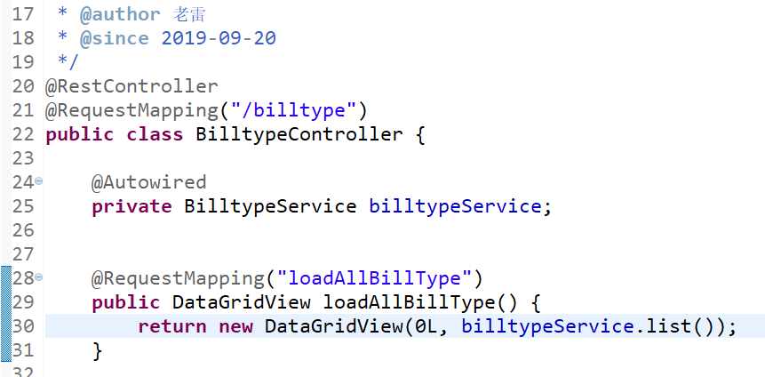

## 创建list.html

|  |
| --- |
| <!DOCTYPE html>  <html xmlns:th=*"http://www.thymeleaf.org"* >  <head>  <meta charset=*"UTF-8"*>  <title>帐单列表</title>  <link rel=*"icon"* th:href=*"@{/resources/favicon.ico}"*>  <link rel=*"stylesheet"* th:href=*"@{/resources/layui/css/layui.css}"* media=*"all"* />  <link rel=*"stylesheet"* th:href=*"@{/resources/css/public.css}"* media=*"all"* />  </head>  <body>  <h1 align=*"center"*>帐单列表</h1>  <!-- 查询条件开始 -->  <div style="text-align: *center*;">  <form id=*"serachFrm"* method=*"post"* class=*"layui-form layui-form-pane"*>  <div class=*"layui-form-item"*>  <div class=*"layui-inline"*>  <label class=*"layui-form-label"*>帐单类型</label>  <div class=*"layui-input-inline"*>  <select name=*"typeid"* id=*"search_typeid"*>  <option value=*"0"*>请选择</option>  </select>  </div>  </div>  <div class=*"layui-inline"*>  <label class=*"layui-form-label"*>开始日期</label>  <div class=*"layui-input-inline"*>  <input type=*"text"* name=*"startDate"* id=*"startDate"* readonly=*"readonly"* placeholder=*"yyyy-MM-dd"* autocomplete=*"off"* class=*"layui-input"*>  </div>  </div>  <div class=*"layui-inline"*>  <label class=*"layui-form-label"*>结束日期</label>  <div class=*"layui-input-inline"*>  <input type=*"tel"* name=*"endDate"* id=*"endDate"* readonly=*"readonly"* placeholder=*"yyyy-MM-dd"* autocomplete=*"off"* class=*"layui-input"*>  </div>  </div>  </div>    <div class=*"layui-form-item"*>  <div class=*"layui-input-block"*>  <button type=*"button"* class=*"layui-btn"* lay-submit=*""* lay-filter=*"doSerach"*>查询</button>  <button type=*"reset"* class=*"layui-btn layui-btn-primary"*>重置</button>  <button type=*"button"* class=*"layui-btn layui-btn-warm"* lay-filter=*"doAdd"*>添加</button>  </div>  </div>  </form>  </div>  <!-- 查询条件结束-->  <!-- 数据表格开始 -->  <div>  <table class=*"layui-hide"* id=*"billTable"* lay-filter=*"billTable"*></table>  </div>  <!-- 数据表格结束 -->  <script type=*"text/javascript"* th:src=*"@{/resources/layui/layui.js}"*></script>  <script type=*"text/javascript"*>  layui.use(['form','jquery','layer','laydate','table'],**function**(){  **var** form=layui.form;  **var** $=layui.jquery;  **var** layer=layui.layer;  **var** laydate=layui.laydate;  **var** table=layui.table;  //渲染时间选择  laydate.render({  elem:'#startDate'  })  laydate.render({  elem:'#endDate'  });    //加载table的数据  **var** tableIns=table.render({  elem: '#billTable'  ,url:'/bills/loadAllBills'  ,toolbar: **true** //开启头部工具栏，并为其绑定左侧模板  ,title: '帐单数据列表'  ,page: **true**  ,cols: [ [  {field:'id', title:'ID', align: 'center'}  ,{field:'title', title:'账单标题', align: 'center'}  ,{field:'billtime', title:'记账时间', align: 'center'}  ,{field:'typeid', title:'类型ID ', align: 'center'}  ,{field:'typeName', title:'类型名称 ', align: 'center'}  ,{field:'price', title:'账单金额', align: 'center'}  ,{field:'remark', title:'账单备注', align: 'center'}  ] ]    });    //初始化查询条件的下拉列表  $.get("/billtype/loadAllBillType",**function**(objs){  **var** types=objs.data;  **var** search_typeid=$("#search_typeid");  $.each(types,**function**(index,item){  search_typeid.append("<option value="+item.id+">"+item.name+"</option>");  });  form.render("select");  })    })  </script>  </body>  </html> |

# 添加帐单

## 修改list.html

|  |
| --- |
| <!DOCTYPE html>  <html xmlns:th=*"http://www.thymeleaf.org"* >  <head>  <meta charset=*"UTF-8"*>  <title>帐单列表</title>  <link rel=*"icon"* th:href=*"@{/resources/favicon.ico}"*>  <link rel=*"stylesheet"* th:href=*"@{/resources/layui/css/layui.css}"* media=*"all"* />  <link rel=*"stylesheet"* th:href=*"@{/resources/css/public.css}"* media=*"all"* />  </head>  <body>  <h1 align=*"center"*>帐单列表</h1>  <!-- 查询条件开始 -->  <div style="text-align: *center*;">  <form id=*"serachFrm"* method=*"post"* class=*"layui-form layui-form-pane"*>  <div class=*"layui-form-item"*>  <div class=*"layui-inline"*>  <label class=*"layui-form-label"*>帐单类型</label>  <div class=*"layui-input-inline"*>  <select name=*"typeid"* id=*"search_typeid"*>  <option value=*"0"*>请选择</option>  </select>  </div>  </div>  <div class=*"layui-inline"*>  <label class=*"layui-form-label"*>开始日期</label>  <div class=*"layui-input-inline"*>  <input type=*"text"* name=*"startDate"* id=*"startDate"* readonly=*"readonly"* placeholder=*"yyyy-MM-dd"* autocomplete=*"off"* class=*"layui-input"*>  </div>  </div>  <div class=*"layui-inline"*>  <label class=*"layui-form-label"*>结束日期</label>  <div class=*"layui-input-inline"*>  <input type=*"tel"* name=*"endDate"* id=*"endDate"* readonly=*"readonly"* placeholder=*"yyyy-MM-dd"* autocomplete=*"off"* class=*"layui-input"*>  </div>  </div>  </div>    <div class=*"layui-form-item"*>  <div class=*"layui-input-block"*>  <button type=*"button"* class=*"layui-btn"* lay-submit=*""* lay-filter=*"doSerach"*>查询</button>  <button type=*"reset"* class=*"layui-btn layui-btn-primary"*>重置</button>  <button type=*"button"* class=*"layui-btn layui-btn-warm"* id=*"doAdd"*>添加</button>  </div>  </div>  </form>  </div>  <!-- 查询条件结束-->  <!-- 数据表格开始 -->  <div>  <table class=*"layui-hide"* id=*"billTable"* lay-filter=*"billTable"*></table>  </div>  <!-- 数据表格结束 -->  <!-- 添加账单的弹出层开始 -->  <div id=*"addBillDiv"* style="display: *none*;margin: *10px*">  <form id=*"dataFrm"* method=*"post"* lay-filter=*"dataFrm"* class=*"layui-form layui-form-pane"*>  <div class=*"layui-form-item"*>  <label class=*"layui-form-label"*>帐单类型</label>  <div class=*"layui-input-block"* id=*"billTypeDiv"*>  </div>  </div>  <div class=*"layui-form-item"*>  <div class=*"layui-inline"*>  <label class=*"layui-form-label"*>帐单标题</label>  <div class=*"layui-input-inline"*>  <input type=*"text"* name=*"title"* placeholder=*"请输入账单标题"* lay-verify=*"required"* autocomplete=*"off"* class=*"layui-input"*>  </div>  </div>  <div class=*"layui-inline"*>  <label class=*"layui-form-label"*>账单时间</label>  <div class=*"layui-input-inline"*>  <input type=*"text"* name=*"billtime"* id=*"billtime"* readonly=*"readonly"* placeholder=*"yyyy-MM-dd"* autocomplete=*"off"* class=*"layui-input"*>  </div>  </div>  </div>  <div class=*"layui-form-item"*>  <div class=*"layui-inline"*>  <label class=*"layui-form-label"*>帐单金额</label>  <div class=*"layui-input-inline"*>  <input type=*"text"* name=*"price"* lay-verify=*"number"* placeholder=*"请输入账单金额"* autocomplete=*"off"* class=*"layui-input"*>  </div>  </div>  </div>  <div class=*"layui-form-item"*>  <label class=*"layui-form-label"*>帐单备注</label>  <div class=*"layui-input-block"*>  <textarea placeholder=*"请输入帐单备注"* name=*"remark"* class=*"layui-textarea"*></textarea>  </div>  </div>  <div class=*"layui-form-item"* style="text-align: *center*;">  <button type=*"button"* class=*"layui-btn"* lay-submit=*""* lay-filter=*"doSubmit"*>提交</button>  <button type=*"reset"* class=*"layui-btn layui-btn-primary"*>重置</button>  </div>  </form>  </div>  <!-- 添加账单的弹出层结束-->  <script type=*"text/javascript"* th:src=*"@{/resources/layui/layui.js}"*></script>  <script type=*"text/javascript"*>  layui.use(['form','jquery','layer','laydate','table'],**function**(){  **var** form=layui.form;  **var** $=layui.jquery;  **var** layer=layui.layer;  **var** laydate=layui.laydate;  **var** table=layui.table;  //渲染时间选择  laydate.render({  elem:'#startDate'  })  laydate.render({  elem:'#endDate'  });  laydate.render({  elem:'#billtime',  type:'datetime'  });    //加载table的数据  **var** tableIns=table.render({  elem: '#billTable'  ,url:'/bills/loadAllBills'  ,toolbar: **true** //开启头部工具栏，并为其绑定左侧模板  ,title: '帐单数据列表'  ,page: **true**  ,cols: [ [  {field:'id', title:'ID', align: 'center'}  ,{field:'title', title:'账单标题', align: 'center'}  ,{field:'billtime', title:'记账时间', align: 'center'}  /* ,{field:'typeid', title:'类型ID ', align: 'center'} */  ,{field:'typeName', title:'类型名称 ', align: 'center'}  ,{field:'price', title:'账单金额', align: 'center'}  ,{field:'remark', title:'账单备注', align: 'center'}  ] ]    });    //初始化查询条件的下拉列表  $.get("/billtype/loadAllBillType",**function**(objs){  **var** types=objs.data;  **var** search_typeid=$("#search_typeid");  $.each(types,**function**(index,item){  search_typeid.append("<option value="+item.id+">"+item.name+"</option>");  });  form.render("select");  });    //模糊查询  form.on("submit(doSerach)",**function**(data){  tableIns.reload({  url:'/bills/loadAllBills',  where:data.field,  page:{  curr:1  }  })  **return** **false**;  });      **var** mainIndex;  //打开添加的弹出层  $("#doAdd").on("click",**function**(){  mainIndex=layer.open({  type:1,  content:$("#addBillDiv"),  area:['800px','600px'],  success:**function**(){  **var** div=$("#billTypeDiv");  $("#dataFrm")[0].reset();//清空表单  div.html("");  $.get("/billtype/loadAllBillType",**function**(objs){  **var** types=objs.data;  $.each(types,**function**(index,item){  **if**(index==0){  div.append('<input type="radio" checked="" name="typeid" value="'+item.id+'" title="'+item.name+'">');  }**else**{  div.append('<input type="radio" name="typeid" value="'+item.id+'" title="'+item.name+'">');  }  });  form.render("radio");  });  initBillDate();  }  });  });    //监控提交事件  form.on("submit(doSubmit)",**function**(data){  $.post("/bills/addBills",data.field,**function**(res){  layer.msg(res.msg);  **if**(res.code==200){  layer.confirm('是否继续录入？', {  btn: ['继续','取消'] //按钮  }, **function**(index){  $("#dataFrm")[0].reset();  layer.close(index);  //设置默认时间  initBillDate();  }, **function**(){  layer.close(mainIndex);  });  }  tableIns.reload();  });  **return** **false**;  });    **function** initBillDate(){  **var** data=**new** Date();  form.val("dataFrm",{billtime:(data.getFullYear()+"-"+(data.getMonth()+1)+"-"+data.getDate()+" "+data.getHours()+":"+data.getMinutes()+":"+data.getSeconds())})  }  })  </script>  </body>  </html> |

## 修改BillsController

