A Cost-, Latency- and Privacy-Aware Router for Multilingual Helpdesk Assistants
Research Paper 1: System Design
Ch.Nripendra | Reg. No. 2520030280 | Department of CSE, KLH
Guide: ASIF SHAIK | 2026
Abstract—Helpdesk assistants that serve multilingual users must balance answer quality, cost and latency, and the protection of personal data. Routing every query to a frontier cloud model maximizes quality but is costly, slow, and exposes sensitive information to third parties. Serving every query from a small local model protects privacy but degrades on complex queries and on low-resource languages. This paper presents the design of a Multilingual Helpdesk Model Router that selects, for each query, one of three model tiers: an on-device small language model, a low-cost cloud model, and a frontier cloud model. The router detects the query language, classifies privacy sensitivity, and then selects a tier. Privacy is enforced as a hard constraint, so critical queries never reach a cloud tier. Among the permitted tiers, the router maximizes a utility function that combines predicted answer quality, normalized cost, and normalized latency, with a per-language correction to the quality estimate. We describe the architecture, the routing policy, and the planned implementation, together with the societal relevance and feasibility of the design. A companion paper specifies the evaluation protocol.
Index Terms—LLM routing, multilingual natural language processing, cost-aware inference, privacy-preserving inference, edge–cloud collaboration, helpdesk systems.

I. INTRODUCTION
Helpdesk assistants are often deployed to users who write in several languages and who sometimes share personal information, such as account numbers, health details, or home addresses. Operators want low per-query cost and fast replies. Users want accurate answers in their own language. Regulations such as the GDPR [1] and HIPAA [2] restrict where certain personal data may be processed, which can rule out some cloud services for some queries.
A single-model deployment forces a choice among these goals. A frontier cloud model gives high accuracy but raises cost, latency, and data exposure. A small local model protects privacy and responds quickly, but it is weaker on complex queries and on lower-resource languages. Choosing a model for each query is a natural middle path. Routing studies such as FrugalGPT [3], Hybrid LLM [4], AutoMix [5], and RouteLLM [6] show that per-query choice can substantially reduce cost. However, they do not treat privacy, latency, and language as joint constraints.
This paper makes three contributions:
- A three-stage routing pipeline consisting of language identification, privacy classification, and utility-based tier selection.
- A routing policy in which privacy is a hard constraint, while cost and latency are soft objectives that the operator can weight.
- A language-aware correction to the quality estimate, which addresses the known weakness of routers on lower-resource languages.
The remainder of the paper is organized as follows. Section II reviews related work. Section III formulates the problem. Sections IV and V describe the architecture and routing policy. Section VI outlines the implementation plan, and Section VII summarizes the evaluation plan. Sections VIII and IX discuss societal relevance and feasibility. Sections X and XI give limitations and conclusions.

II. RELATED WORK

A. Cost–Quality Routing
FrugalGPT [3] uses cascades that escalate to stronger models only when a scoring function judges an answer unreliable. Hybrid LLM [4] trains a quality predictor to decide whether a small model’s answer is sufficient. AutoMix [5] relies on self-verification by the small model. RouteLLM [6] learns routers from human preference data and exposes a cost threshold that sets the quality–cost trade-off. Table I summarizes these methods and the gap they leave open.
TABLE I. RELATED WORK AND THE GAP ADDRESSED BY THIS ROUTER
Line of work | Representative methods | Gap left open
Cost–quality routing | FrugalGPT [3], Hybrid LLM [4], AutoMix [5], RouteLLM [6] | No privacy, latency, or language term
Privacy-aware cloud–edge inference | PRISM [7] | No multi-provider cost term; no language focus
Multilingual cost and quality | Petrov et al. [8], Ahia et al. [9], Shi et al. [10] | Not integrated into a routing policy

B. Multilingual Cost and Quality Disparity
Petrov et al. [8] showed that tokenizers trained mainly on English text produce substantially more tokens for some languages, so the same content costs more to process. Ahia et al. [9] analyzed a commercial API across 22 languages and found that speakers of many supported languages are overcharged while receiving poorer results. Shi et al. [10] showed that multilingual reasoning performance is substantially lower for lower-resource languages. A router that uses only English-derived quality estimates would therefore misjudge these queries.

C. Privacy-Aware Cloud–Edge Inference
PRISM [7] is the closest academic work to this paper. It profiles the sensitivity of each prompt on the edge device and chooses among cloud, edge, or collaborative execution. Its authors report superior privacy–utility trade-offs compared with uniform and selective local differential privacy baselines. PRISM does not consider a cost term across cloud providers and does not address language. Rule-based filters, which block content matching sensitive patterns, are widely used but can miss personal data in unexpected formats or languages.

III. PROBLEM FORMULATION
Let a query be x, with detected language lang(x) and privacy level s(x) ∈ {low, moderate, critical}. The model pool is T = {E, C1, C2}, where E is the on-device tier, C1 is a low-cost cloud tier, and C2 is a frontier cloud tier. For each tier t, the router uses three estimates:
- Q(t | x, lang) ∈ [0, 1], the predicted probability that the answer is judged acceptable;
- c(t, x) ∈ [0, 1], the normalized monetary cost of processing x on t, computed from the token count under the language’s tokenizer;
- L(t) ∈ [0, 1], the normalized expected response time of t, including network delay.
Normalizing cost and latency to [0, 1] makes the weights λ and μ comparable across operators. The admissible set A(x) is determined by privacy:
A(x) = {E} if s(x) = critical; A(x) = {E, C1, C2 (contracted providers only)} if s(x) = moderate; A(x) = T if s(x) = low.
The router selects
t* = argmax over t in A(x) of U(t), where U(t) = Q’(t | x, lang) − λ·c(t, x) − μ·L(t),
and Q’ is the language-corrected quality estimate defined in Section V. The privacy constraint is absolute: for a critical query, no cloud tier may be selected, and if the local tier fails the router returns a fallback response.

IV. SYSTEM ARCHITECTURE
The router has four components, shown in Fig. 1.
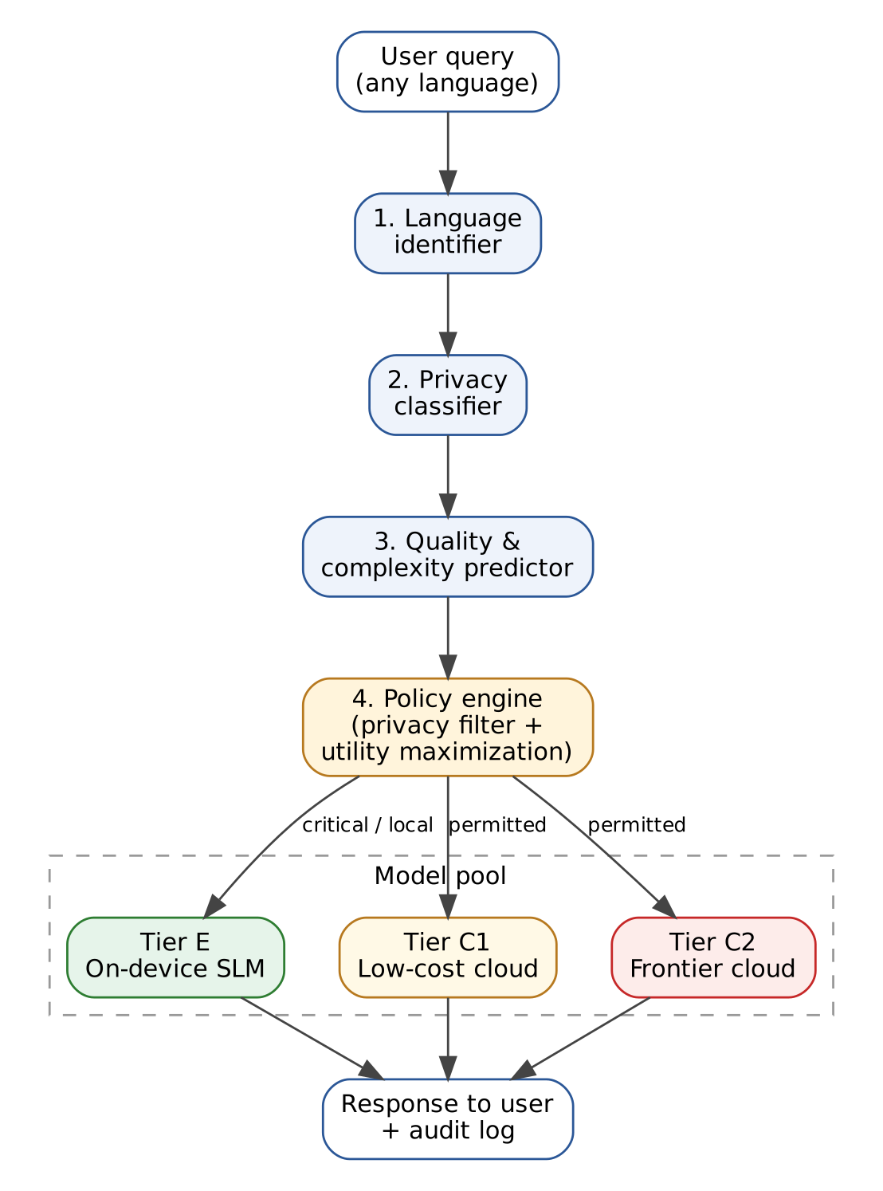
Fig. 1. Architecture of the multilingual helpdesk router. A query passes through language identification, privacy classification, and quality prediction before the policy engine selects a model tier.
- Language identifier. Detects the language and script of the query. Queries that mix languages are tagged with a primary language.
- Privacy classifier. Assigns each query a sensitivity level. Two layers are combined. Deterministic detectors identify structured identifiers, such as phone numbers, e-mail addresses, and account-like numbers. A lightweight multilingual classifier identifies sensitive free-text content, such as health or financial details. When the layers disagree, the higher sensitivity level is used, because a false negative leaks data whereas a false positive only keeps a query local.
- Quality and complexity predictor. Estimates Q(t | x, lang) for each tier. Inputs are a multilingual sentence embedding of the query, the detected language, and query length. The predictor is trained on labeled examples of acceptable and unacceptable answers.
- Policy engine. Applies the privacy filter, computes utility over admissible tiers, and selects the tier.
The model pool has three tiers, summarized in Table II. Specific models and their version identifiers will be fixed during setup and reported with the results.
TABLE II. MODEL TIERS IN THE POOL
Tier | Description | Typical deployment | Data leaves device? | Relative cost | Relative latency
E | Small language model | User device or on-premise server | No | Lowest | Lowest (no network)
C1 | Low-cost hosted model | Third-party cloud | Yes | Low | Medium
C2 | Frontier hosted model | Third-party cloud | Yes | Highest | Highest

V. ROUTING POLICY

A. Privacy Filter
The privacy filter is applied before any utility is computed. Table III gives the admissible tiers for each sensitivity level. If no admissible tier can answer a critical query, the system returns a fallback message and does not escalate to the cloud.
TABLE III. ADMISSIBLE TIERS BY PRIVACY LEVEL
Privacy level | Admissible tiers | Cloud escalation allowed? | Behavior when no admissible tier succeeds
Critical | E only | No | Fallback message; no cloud call
Moderate | E, and C1 or C2 only where a data-processing contract applies | Yes, under contract | Escalate within admissible tiers
Low | E, C1, C2 | Yes | Escalate within admissible tiers

B. Utility Maximization
For each admissible tier, the router computes U(t) as defined in Section III. Table IV defines the symbols. Fig. 2 shows the complete decision flow, and Algorithm 1 gives the procedure in pseudocode.
TABLE IV. SYMBOLS USED IN THE UTILITY FUNCTION
Symbol | Meaning | How it is obtained
x | Incoming query | Input
Q(t | x, lang) | Predicted probability that tier t gives an acceptable answer | Quality predictor
Q’(t | x, lang) | Language-corrected quality estimate | Q minus a per-language penalty
c(t, x) | Normalized monetary cost of x on tier t | Token count multiplied by the per-token price, then normalized
L(t) | Normalized expected response time of tier t | Measured moving average plus network estimate, then normalized
λ, μ | Operator weights on cost and latency | Set by the operator
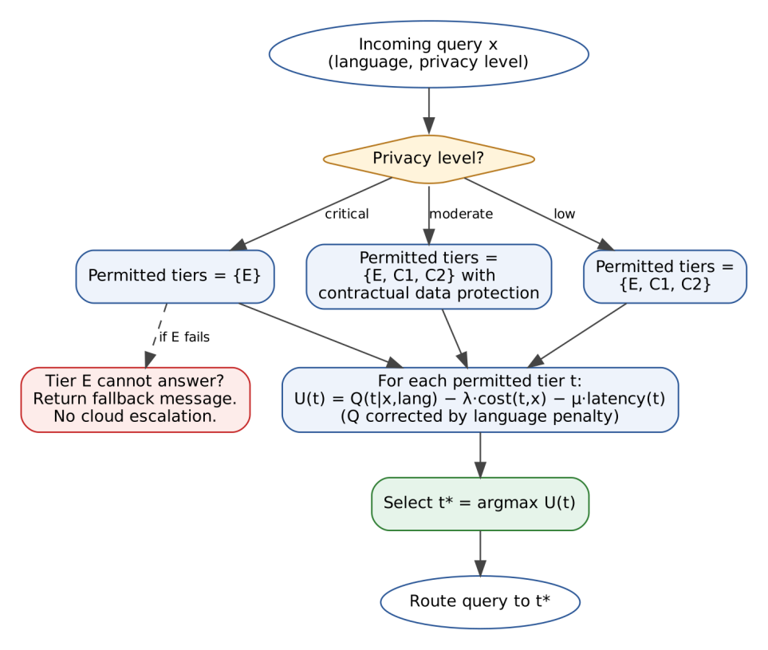
Fig. 2. Routing decision flow. The privacy level determines the admissible tiers, utility is computed over those tiers, and the highest-utility tier is selected.

C. Language-Aware Correction
For a language ℓ on which tier t has low measured quality, the estimate is reduced by a penalty δ(t, lang) learned on a validation set:
Q’(t | x, lang) = max(0, Q(t | x, lang) − δ(t, lang)).
This prevents the policy from sending lower-resource-language queries to a weak tier simply because that tier is cheap. The penalty is estimated per tier and per language, so it does not change the decision for languages where a tier performs well.

D. Algorithm
Algorithm 1: Multilingual routing decision
Input: query x; weights λ, μ; tiers T = {E, C1, C2}
1 lang ← DetectLanguage(x)
2 s ← ClassifyPrivacy(x)
3 A ← AdmissibleTiers(s)
4 for each t in A:
5 Q' ← max(0, Q(t | x, lang) − δ(t, lang))
6 U(t) ← Q' − λ·c(t, x) − μ·L(t)
7 if A is empty or no tier is available:
8 return FallbackMessage
9 t* ← argmax over t in A of U(t)
10 route x to t*
11 log (query id, lang, s, t*, U(t*), cost, latency)

VI. IMPLEMENTATION PLAN
The router will be implemented in Python behind an OpenAI-compatible gateway, so that existing client code can call it as a drop-in replacement. Each routing decision will be logged with its inputs, chosen tier, utility value, estimated cost, and measured latency, which supports auditing. Model versions and pricing will be pinned and recorded with access dates, so that results can be reproduced. The implementation has not yet been completed; this section describes the planned design.

VII. EVALUATION PLAN
The evaluation protocol is specified in the companion paper. In brief, the router is compared with (a) always-edge, (b) always-frontier, (c) a rule-based router that uses only language and keyword rules, and (d) a cost-only learned router similar to RouteLLM [6] without privacy or latency terms. Metrics are cost per resolved query, p50 and p95 latency, privacy violation rate, and the quality gap between high- and lower-resource languages. Table V gives the planned comparison. The values are placeholders to be filled from measurements.
TABLE V. PLANNED COMPARISON (VALUES TO BE FILLED AFTER EXPERIMENTS)
System | Quality (% acceptable) | Cost per resolved query | p95 latency | Privacy violations | Language gap
Always-edge | [ ] | [ ] | [ ] | [ ] | [ ]
Always-frontier | [ ] | [ ] | [ ] | [ ] | [ ]
Rule-based | [ ] | [ ] | [ ] | [ ] | [ ]
Cost-only learned | [ ] | [ ] | [ ] | [ ] | [ ]
Proposed router | [ ] | [ ] | [ ] | 0 (target) | [ ]
We expect the proposed router to retain most of the frontier tier’s quality at a fraction of its cost, with zero privacy violations and a smaller language gap than the cost-only baseline. These are hypotheses to be tested, not findings.

VIII. SOCIETAL RELEVANCE
Automated helpdesk assistants are increasingly used for public services, banking support, healthcare administration, and education, yet the quality of service often depends on the language a person speaks. A router that corrects for language-specific quality helps ensure that users who write in lower-resource languages are not systematically given weaker answers at the same price. The privacy filter supports data minimization: personal information in critical queries stays on the device, which reduces exposure for users whose data is sensitive.
Cost reduction matters for organizations with limited budgets, such as local government offices, community organizations, and small schools, which may otherwise be unable to offer multilingual support at all. Smaller models also generally use less energy per query than frontier models. This benefit is expected but has not yet been measured, and it will be reported with the evaluation.
The design also carries risks. Errors in privacy classification or language identification could affect some users more than others, and a local model may give weaker answers than the frontier model on complex queries. The planned mitigations are conservative privacy thresholds, a fairness metric reported per language, a fallback message that directs users to a human agent, and audit logs that allow errors to be reviewed.

IX. FEASIBILITY

A. Technical Feasibility
Compact open-weight language models can run on a single consumer-grade GPU or on a modern CPU for short queries, so the on-device tier does not require specialized infrastructure. Frontier and low-cost cloud models are available through standard API access. Open-source routing components, including RouteLLM [6], can serve as starting points for the cost-only baseline. Multilingual sentence embedding models cover many of the target languages.

B. Data Feasibility
No public dataset of multilingual helpdesk queries with privacy labels is assumed. The dataset will be built in three steps. First, queries will be generated for each helpdesk category (billing, account access, technical troubleshooting, product information, and complaints). Second, the queries will be translated and checked by native speakers. Third, each query will receive a privacy label from two annotators, with a third resolving disagreements. The target size is [N] queries per language, and the annotation effort will be recorded and reported.

C. Resource Feasibility
The main costs are cloud API usage during evaluation and annotator time. The API budget is [₹ / $ amount], with query counts capped during development so that the budget is not exceeded. Compute requirements for the on-device tier are modest. Annotation effort depends on the number of languages, and the project can begin with fewer languages if needed.

D. Schedule
Table VI gives a proposed schedule. It should be adjusted to the academic calendar.
TABLE VI. PROPOSED SCHEDULE
Phase | Duration (weeks) | Deliverable
1. Literature review and requirements | 2 | Literature survey; requirement list
2. Dataset design and collection | 3 | Query set; privacy labels; translations
3. Tier setup and baseline runs | 2 | Four baselines running; cost logs
4. Router implementation | 3 | Language, privacy, quality, and policy modules
5. Evaluation and ablations | 3 | Metrics; ablation results
6. Analysis and reporting | 2 | Final paper; presentation
Total | 15

E. Risks and Mitigations
TABLE VII. PROJECT RISKS AND MITIGATIONS
Risk | Impact | Mitigation
Too few native-speaker annotators | Weak fairness analysis | Start with fewer languages; report limits
API costs exceed budget | Evaluation incomplete | Cap query counts; use cheap tiers during development
Privacy classifier misses sensitive content | Privacy violations | Conservative thresholds; combined detectors; audit log
Quality predictor overfits | Poor generalization | Split by query template and category
Model versions change | Results cannot be reproduced | Pin versions; record access dates

X. LIMITATIONS
Quality predictions depend on the calibration dataset and may not transfer to new domains or to dialects that are underrepresented in that dataset. Privacy classification can produce false negatives, and the design deliberately favors false positives, which keeps more data local than strictly necessary and reduces quality for some queries. Latency estimates depend on current network conditions and may be inaccurate during outages. The study is limited to the languages selected for the dataset.

XI. CONCLUSION
This paper presented the design of a helpdesk router that treats privacy as a constraint and balances cost, latency, and multilingual quality as objectives. The design appears feasible at the scale of a student project, subject to the resource checks in Section IX, and it addresses a need that existing routing methods leave open. Future work includes learning the utility weights from operator preferences, extending the tier pool to specialized models, and deploying the router with real helpdesk traffic.

REFERENCES
[1] European Parliament and Council of the European Union, “Regulation (EU) 2016/679 (General Data Protection Regulation),” Official Journal of the European Union, 2016.
[2] Health Insurance Portability and Accountability Act of 1996, Pub. L. 104-191, 1996.
[3] L. Chen, M. Zaharia, and J. Zou, “FrugalGPT: How to use large language models while reducing cost and improving performance,” arXiv:2305.05176, 2023.
[4] D. Ding et al., “Hybrid LLM: Cost-efficient and quality-aware query routing,” in Proc. Int. Conf. Learn. Represent. (ICLR), 2024. arXiv:2404.14618.
[5] A. Madaan et al., “AutoMix: Automatically mixing language models,” in Proc. Adv. Neural Inf. Process. Syst. (NeurIPS), 2024. arXiv:2310.12963.
[6] I. Ong et al., “RouteLLM: Learning to route LLMs with preference data,” in Proc. Int. Conf. Learn. Represent. (ICLR), 2025. arXiv:2406.18665.
[7] J. Zhan, H. Shen, Z. Lin, and T. He, “PRISM: Privacy-aware routing for adaptive cloud–edge LLM inference via semantic sketch collaboration,” in Proc. AAAI Conf. Artif. Intell., 2026. arXiv:2511.22788.
[8] A. Petrov, E. La Malfa, P. H. S. Torr, and A. Bibi, “Language model tokenizers introduce unfairness between languages,” in Proc. Adv. Neural Inf. Process. Syst. (NeurIPS), 2023. arXiv:2305.15425.
[9] O. Ahia, S. Kumar, H. Gonen, J. Kasai, D. R. Mortensen, N. A. Smith, and Y. Tsvetkov, “Do all languages cost the same? Tokenization in the era of commercial language models,” in Proc. Conf. Empirical Methods Natural Lang. Process. (EMNLP), 2023. arXiv:2305.13707.
[10] F. Shi et al., “Language models are multilingual chain-of-thought reasoners,” in Proc. Int. Conf. Learn. Represent. (ICLR), 2023. arXiv:2210.03057.

