CPE301 – SPRING 2020

Design Assignment 3A

Student Name: Minsung Cho

Student #: 2001446442

Student Email: chom3@unlv.nevada.edu

Primary Github address: <https://github.com/cho-minsung>

Directory: <https://github.com/cho-minsung/assignment3a>

1. **COMPONENTS LIST AND CONNECTION BLOCK DIAGRAM w/ PINS**

ATMEGA328PB board TeraTerm ATMEL Studio

1. **INITIAL/MODIFIED/DEVELOPED CODE OF TASK 1/A**

#ifndef F_CPU

#define F_CPU 16000000UL

#endif

#ifndef BAUD

#define BAUD 9600

#endif

//#include <stdlib.h>

#include <avr/io.h>

#include <stdio.h>

#include <util/delay.h>

#include <util/setbaud.h>

extern FILE uart_output;

extern FILE uart_input;

//int uart_putchar(char c, FILE *stream);

//int uart_getchar(FILE *stream);

//void uart_init(void);

void uart_init(void) {

UBRR0H = UBRRH_VALUE;

UBRR0L = UBRRL_VALUE;

UCSR0C = _BV(UCSZ01) | _BV(UCSZ00); /* 8-bit data */

UCSR0B = _BV(RXEN0) | _BV(TXEN0); /* Enable RX and TX */

}

int uart_putchar(char c, FILE *stream) {

if (c == '\n') {

uart_putchar('\r', stream);

}

loop_until_bit_is_set(UCSR0A, UDRE0);

UDR0 = c;

return 0;

}

int uart_getchar(FILE *stream) {

loop_until_bit_is_set(UCSR0A, RXC0);

return UDR0;

}

FILE uart_output = FDEV_SETUP_STREAM(uart_putchar, NULL, _FDEV_SETUP_WRITE);

FILE uart_input = FDEV_SETUP_STREAM(NULL, uart_getchar, _FDEV_SETUP_READ);

int main(void) {

uart_init();

stdout = &uart_output;

stdin = &uart_input;

while (1) {

/* Blink led by toggling state of PORTB5 (Arduino digital 13). */

PORTB ^= _BV(PORTB5);

puts("Hello world!");

_delay_ms(500);

}

return 0;

}

Module8A_3.c code given in the Canvas.

1. **DEVELOPED MODIFIED CODE OF TASK 2/A from TASK 1/A**

#ifndef *F_CPU*

#define *F_CPU* 16000000UL

#endif

#ifndef BAUD

#define BAUD 9600

#endif

#include <avr/io.h>

#include <util/delay.h>

#include <util/setbaud.h>

#include <stdio.h>

void USART_init(void);

void USART_tx_string(char *data);

int main(void)

{

USART_init();

int num; //integer that will be randomly generated.

char snum1[8]; //character array that will be converted to string

char snum2[10]; //this one is for floating value.

while (1)

{

num = *rand*(); //gives a random value to the integer.

*itoa*(num, snum1, 5); //converts the integer to string.

float dec = ((*rand*() * 2.2)); //give the floating random value.

*snprintf*(snum2, sizeof(snum2), "%f", dec); //converts the float to string.

USART_tx_string("This is how much I love Embedded Systems: \n");

USART_tx_string(snum1);

USART_tx_string("\n");

USART_tx_string(snum2);

USART_tx_string("\n");

*_delay_ms*(1000); //delay of 1 second.

}

}

/* INIT USART (RS-232) */

void USART_init( void)

{

UBRR0H = *UBRRH_VALUE*;

UBRR0L = *UBRRL_VALUE*;

UCSR0B = (1<<TXEN0); // enable TX & RX interrupt

UCSR0C = (3<<UCSZ00); // asynchronous 8 N 1

}

/* SEND A STRING TO THE RS-232 */

void USART_tx_string(char *data)

{

while((*data != '\0')) // while there's still data

{

while(!(UCSR0A & (1<<UDRE0)));

UDR0 = *data; // data is written into UDR0

data++;

}

}

code 3c.1 printing out random integer with delay function.

#ifndef *F_CPU*

#define *F_CPU* 16000000UL

#endif

#ifndef BAUD

#define BAUD 9600

#endif

#include <avr/io.h>

#include <util/delay.h>

#include <util/setbaud.h>

#include <avr/interrupt.h>

#include <stdio.h>

void USART_init(void);

void USART_tx_string(char *data);

int main(void)

{

USART_init(); //pretty much the same algorithm but this time it uses the timer interrupt.

int num;

char snum1[8];

char snum2[10];

TCCR0A = 0x00;

TCCR0B = 0x05;

TCNT0 = 0;

while (1)

{

num = *rand*();

*itoa*(num, snum1, 5);

float dec = ((*rand*() * 2.2));

*snprintf*(snum2, sizeof(snum2), "%f", dec);

USART_tx_string("This is how much I love Embedded Systems: ");

USART_tx_string(snum1);

USART_tx_string(" ");

USART_tx_string(snum2);

USART_tx_string("\n");

//calculated with the cycle value estimate of 1 second.

for (int i = 0; i <= 61; i++)

{

while (TCNT0 != 255)

{

}

TCNT0 = 0;

}

}

}

/* INIT USART (RS-232) */

void USART_init( void)

{

UBRR0H = *UBRRH_VALUE*;

UBRR0L = *UBRRL_VALUE*;

UCSR0B = (1<<TXEN0); // enable TX & RX interrupt

UCSR0C = (3<<UCSZ00); // asynchronous 8 N 1

}

/* SEND A STRING TO THE RS-232 */

void USART_tx_string(char *data)

{

while((*data != '\0')) // while there's still data

{

while(!(UCSR0A & (1<<UDRE0)));

UDR0 = *data; // data is written into UDR0

data++;

}

}

code with timer interrupt.

1. **SCHEMATICS**

Only connection was between the board and the computer.

1. **SCREENSHOTS OF EACH TASK OUTPUT (ATMEL STUDIO OUTPUT)**

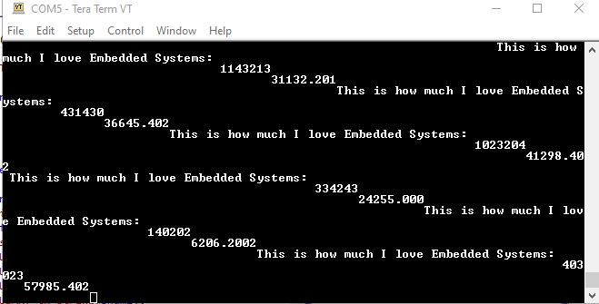

1. **SCREENSHOT OF EACH DEMO (BOARD SETUP)**

the board setup was not necessary because there was nothing done to the board.

1. **VIDEO LINKS OF EACH DEMO**

https://youtu.be/i6Ry8QSXBIY

1. **GITHUB LINK OF THIS DA**

<https://github.com/cho-minsung/assignment3a>

**Student Academic Misconduct Policy**

<http://studentconduct.unlv.edu/misconduct/policy.html>

“This assignment submission is my own, original work”.

Minsung Cho