CPE301 – SPRING 2019

Design Assignment 4A

Student Name: Minsung Cho

Student #:2001446442

Student Email: chom3@unlv.nevada.edu

Primary Github address: <https://github.com/cho-minsung>

Directory: <https://github.com/cho-minsung/assignment4a>

1. **COMPONENTS LIST AND CONNECTION BLOCK DIAGRAM w/ PINS**

ATMEGA328OB

DC Motor

Wires

Arduino shield

Motor Drive

Breadboard

1. **INITIAL/MODIFIED/DEVELOPED CODE OF TASK 1/A**

int main()

{

PORTD |=(1<<7);//enable pull-up

DDRB|=0b00000111;//PB0, PB1, and PB2 as outputs

PORTB&=~(1<<ENABLE);//Enable = 0

PORTB&=~(1<<MTR_1);//MTR_1 = 0

PORTB&=~(1<<MTR_2);//MTR_2 = 0

while(1)

{

PORTB|=(1<<ENABLE);//Enable = 1

if(SW!=0)//if PD7 is high

{

// Clockwise Rotation

_delay_ms(20);

PORTB|=(1<<MTR_1);//MTR_1 = 1

PORTB&=(~(1<<MTR_2));//MTR_2 = 0

}

else

{

// Anti-Clockwise Rotation

_delay_ms(20);

PORTB&=(~(1<<MTR_1));//MTR_1 = 0

PORTB|=(1<<MTR_2);//MTR_2 = 1

}

}

}

Full speed with DIR control

int main()

{

PORTD|=(1<<7);//enable pull-up

DDRB|=0b00000110;//PB0, PB1, and PB2 as outputs

PORTD&=~(1<<ENABLE);//Enable = 0

PORTB&=~(1<<MTR_1);//MTR_1 = 0

PORTB&=~(1<<MTR_2);//MTR_2 = 0

DDRD|=(1<<6);//OC0A as output

OCR0A=50;//Fast PWM, non-inverted

TCCR0A=(1<<COM0A1)|(1<<WGM01)|(1<<

WGM00);

TCCR0B=0x02;//N = 8

while

(1)

{

PORTD|=(1<<ENABLE);//Enable = 1

#include<avr/io.h>

#define ENABLE

#define MTR_1 1

#define MTR_2 2

#define SW(PIND&(1<<7))

if(SW!=0)//if PD7 is high

{

// Clockwise Rotation

_delay_ms(20);

PORTB|=(1<<MTR_1);//MTR_1 = 1

PORTB&=(~(1<<MTR_2));//MTR_2 = 0

}

else

{// Anti-Clockwise Rotation

_delay_ms(20);

PORTB&=(~(1<<MTR_1));//MTR_1 = 0

PORTB|=(1<<MTR_2);//MTR_2 = 1

}

_delay_ms(5000);

if(OCR0A>250)

OCR0A=50;

else

OCR0A=OCR0A+25;

}

}

Variable speed with DIR control

1. **DEVELOPED MODIFIED CODE OF TASK 2/A from TASK 1/A**

#define *F_CPU* 16000000UL

#include <avr/io.h>

#include <avr/interrupt.h>

#include <util/delay.h>

#include <stdio.h>

void adc_init(void);

void read_adc(void);

int main()

{

float poten;

//the ADC setup

ADMUX = (1<<REFS0) | (1<<ADLAR);

/*

Reference selection bits,

AVcc external cap at AREF,

left-adjusted,

ADC5 channel selected*/

ADCSRA=(1<<ADEN)|(1<<ADPS2)|(0<<ADPS1)|(1<<ADPS0);

/*ADC enabled,

auto trigger enabled,

interrupt flag initialized and disabled,

prescaler: 101*/

//the pin setup

DDRC |= ~(1<<3); //PC3 is an input

PORTC |= (1<<3) | (1<<0); //Activate Pull- up resistor PC0 & 3

DDRD |= (1<<DDD6); //PD6 is an output for OCR0A

//the interrupt setup

PCICR = (1<<PCIE1); //Pin change interrupt control register

PCMSK1 = (1<<PCINT11); //Mask register is enabled for for the input

sei (); //the interrupt is enabled.

//the pulse Width Modulation setup

TCCR0A |= (1<<COM0A1)|(0<<COM0A0)|(1<<WGM00)|(0<<WGM01); //Clear OC0A, CPC PWM, phase correct with top as OCR0A

TCCR0B |= (0<<WGM02)|(1<<CS00); //Pre-scaling is 1

OCR0A = 0; //the top value is initialized

while (1)

{

//reading the ADC value

ADCSRA |= (1<<ADSC);

while(ADCSRA & (1<<ADSC));

poten = ADC;

*_delay_ms*(10); //had an error if not included

//16 bit max = 0xFFFF = 65535

//95% is 65535 * 0.95 = 62258.25 = 62258(less than 95%)

if (poten >= 62258)

{

/*the DC cycle calculation

OCR0A = 95% * 0xFF(256) - 1 = 242*/

OCR0A = 242; //top = 242, which is a max

*_delay_ms*(10); //somewhat bearable latency

}

else if ((poten <= 62257) && (poten > 0))

{

//the speed control

OCR0A = 241* (poten / 62257);

*_delay_ms*(10);

}

else

OCR0A = 0;

}

}

ISR(PCINT1_vect)

{

PORTC ^= (1<<0); //switch toggle

}

1. **SCHEMATICS**

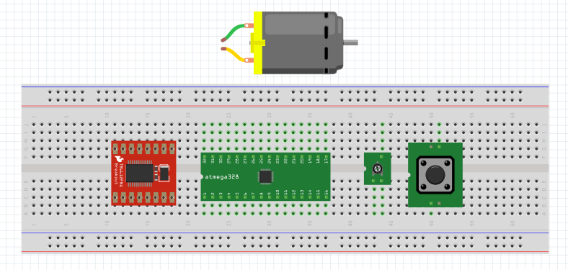

I had an error trying to wire this thing but the connections are as follows:

DC Motor driver:

- GND 1, 2, 3 & Ain2 -> GND of the board

- VMOT, VCC & Ain2 -> VCC of the board

- AO1 & AO2 -> the motor

- STBY -> switch (PC3 of the board)

- PWMA -> PD6 of the board

ATMEGA:

- PC0 -> the potentiometer

1. **SCREENSHOTS OF EACH TASK OUTPUT (ATMEL STUDIO OUTPUT)**

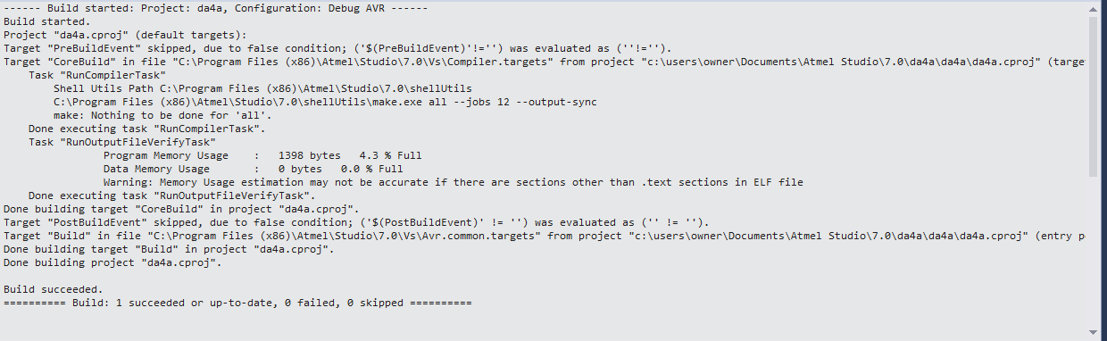

1. **SCREENSHOT OF EACH DEMO (BOARD SETUP)**

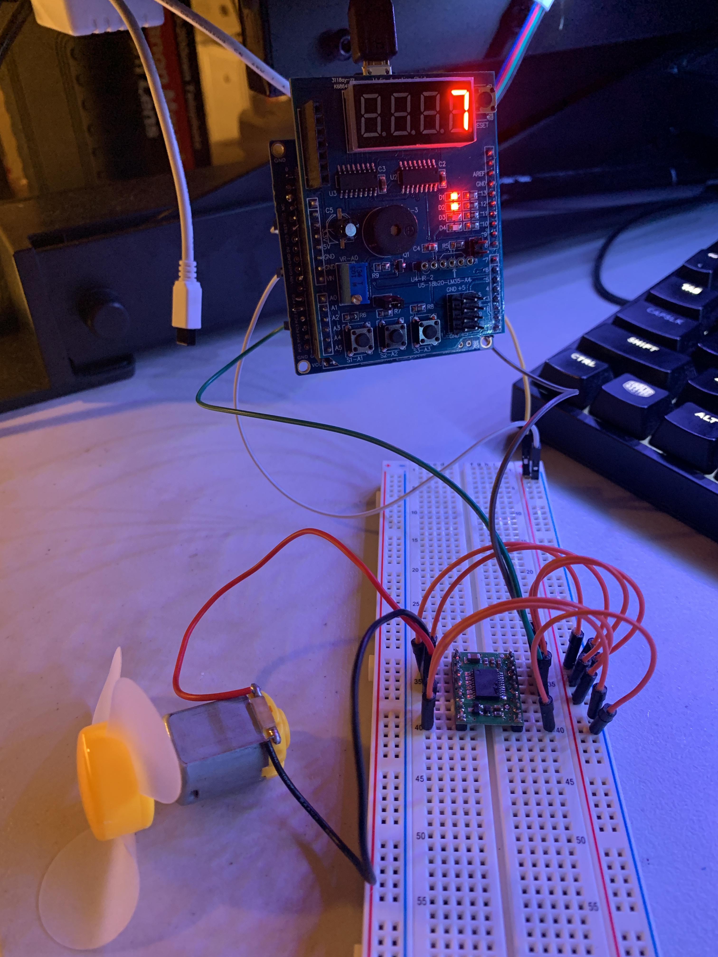

1. **VIDEO LINKS OF EACH DEMO**

<https://www.youtube.com/watch?v=94hKrb4kvf4>

1. **GITHUB LINK OF THIS DA**

<https://github.com/cho-minsung/assignment4a>

**Student Academic Misconduct Policy**

<http://studentconduct.unlv.edu/misconduct/policy.html>

“This assignment submission is my own, original work”.

Minsung Cho