User Interfaces – Case Study

Parker Hegstrom

Robbie Daitzman

1 Main Objectives of the User Interface

2 Profile of the Target Audience

3 Good and Bad Design Practices of Similar Interfaces

3.1 Fandango

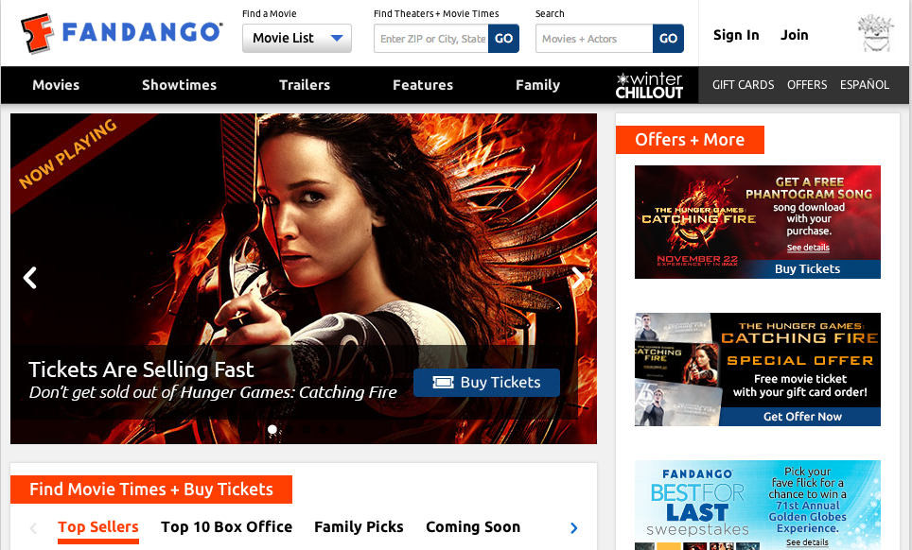

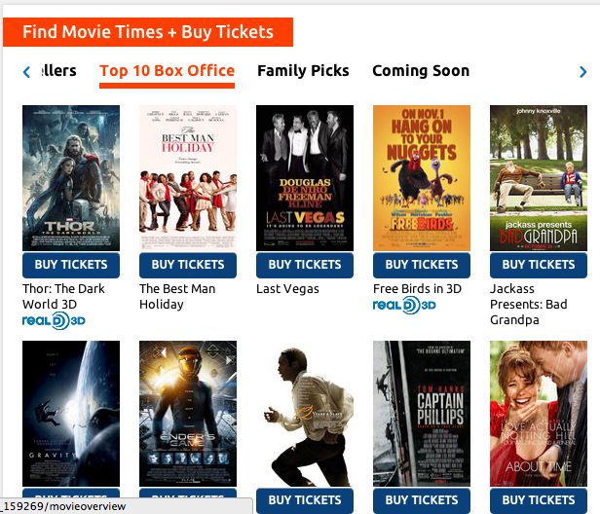

Fandango is an American website dedicated to providing movie fans with a one-stop location to search, review, and purchase movie tickets. One popular aspect of this site is that it allows the user to purchase tickets for almost any movie theater in the country, just by entering in one’s zip code or by using the site’s location services.

As one can see from viewing the homepage of the website in the previous figure, the homepage seems a bit cluttered and perhaps a little confusing as to where one should go to purchase tickets that pertain to his theater. How do you get to a page that displays movie theaters near you? I would like to see the zip code movie finder tool as the centerpiece of this page—not as a small text box at the top of the screen.

Apart from that one negative aspect of the homepage, Fandango does a great job providing a welcoming interface. The site provides quick one-click links to the most popular movies or the most recent movies to have been released. The user can then easily click the “buy tickets” tab under the movie and follow the on screen instructions.

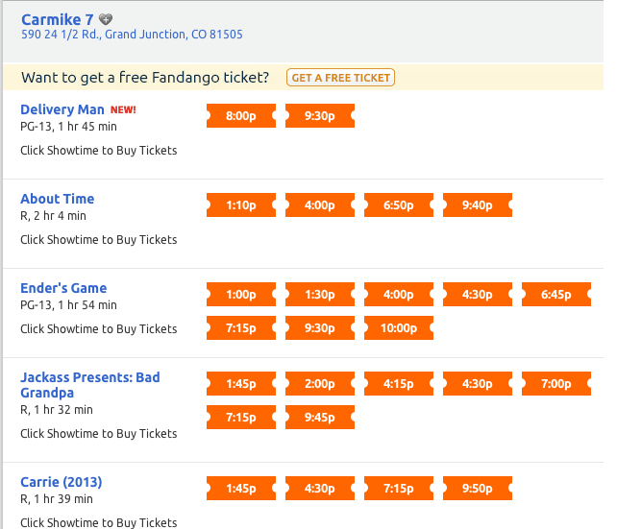

After entering in one’s zip code, Fandango provides an easy to read page that displays all of the surrounding theaters as well as the movies available at those theaters. It is easy to determine which labels correspond to the movie titles and which labels correspond to other features of the movie such as the actual show times or rating.

By reading the simple instructions underneath the movie title, any user will know that, to “Buy Tickets,” all he has to do is click on one of the available show times. Although not shown in this figure, Fandango also removes the possibility of a user buying a ticket for a sold out show time by simply crossing out that specific show time, saving the user from completing the somewhat time consuming process of completing the transaction only to find out that the ticket was not even available in the first place.

Fandango also caters to the undecided user, providing an information page for each of the movies listed. If, for example, I wanted to see more information about “Ender’s Game,” I would be brought to the following screen.

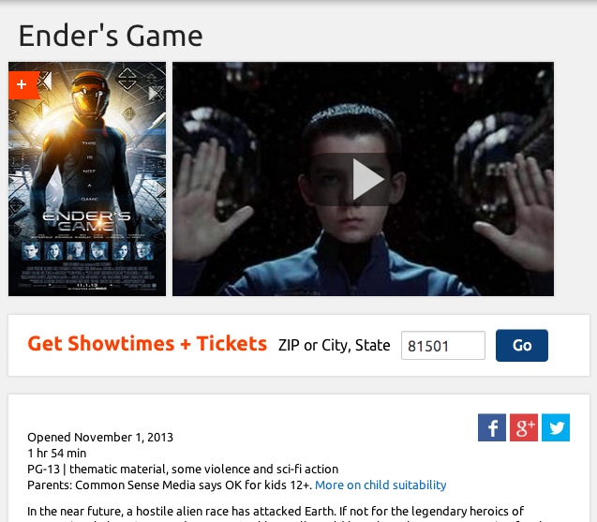

Here one is able to get a synopsis of the film as well as various ratings and the published trailer. Fandango also considers the idea that a user might find himself on this page without having determined his theater. They place an easy to read and see (due to its font weight, color, and size) instructing the user how to display available show times and tickets.

4 Low Level Prototypes

5 Web Design Patterns Used

6 Documentation and Explanation of Source Code