Предлог поена:

Коначно поена:

Интернет језици и алати 1: Предспитни пројекат

Датум:16.12.2022.

Aleksandar Petrovic IT 69/21

**Питања: //** *оставите празну страницу за одговоре*

**Пројекат**

Применом HTML-а и CSS-а креиран је веб сајт на тему: Teretana. Сајт има 4 страница. Респонсиван је

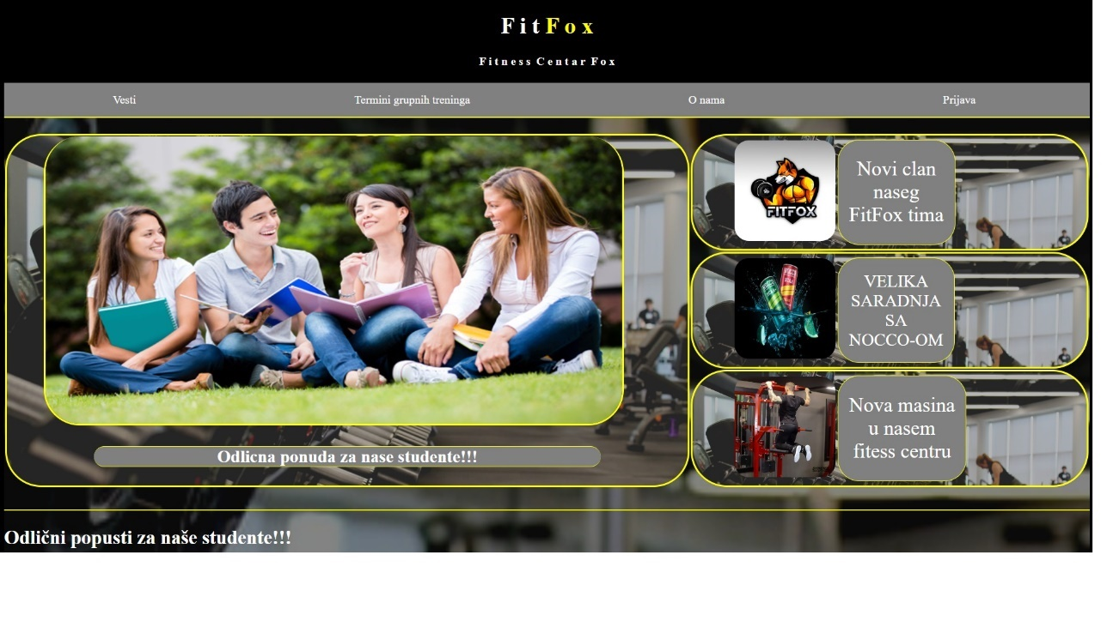

Слика 1: Почетна страница

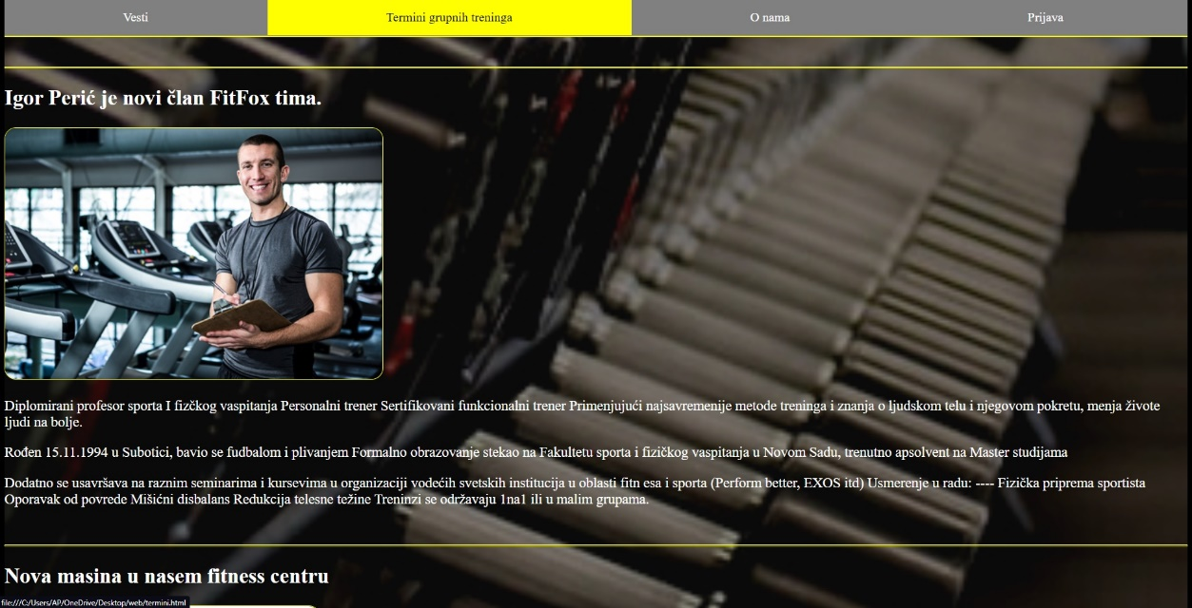

Слика 2: Падајући мени

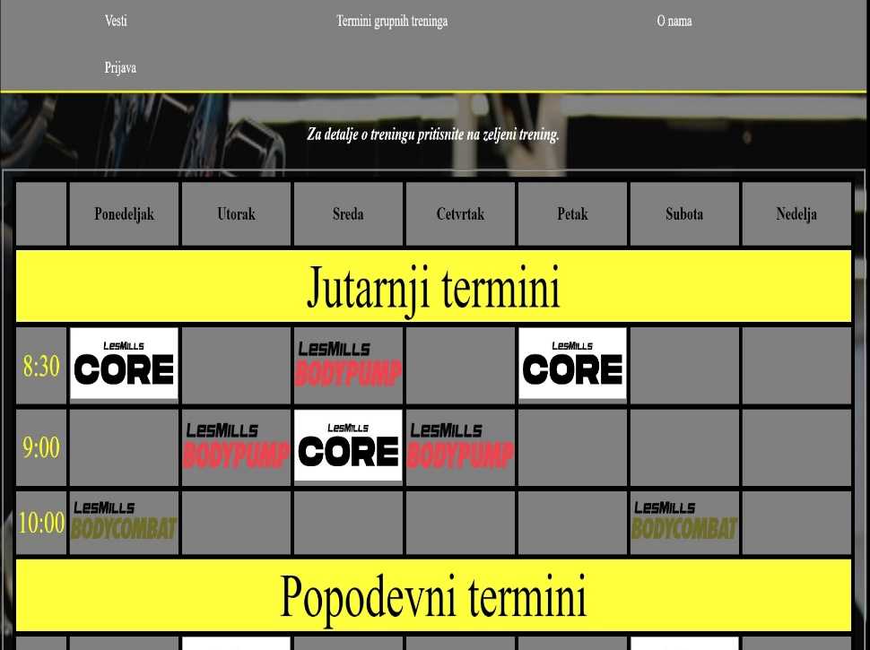

Слика 3: Страница је рспонсивна

Напомена: **слике треба да буду нумерисане, као и странице**

**Код:**

**HTML** (*оставите наслов HTML*)

<!DOCTYPE html>

<html lang="en">

<head>

    <meta charset="UTF-8">

    <meta http-equiv="X-UA-Compatible" content="IE=edge">

    <meta name="viewport" content="width=device-width, initial-scale=1.0">

    <title>FitFox</title>

    <link rel="stylesheet" href="style.css" type="text/css">

</head>

<body>

    <h1>

        F i t<mark id="logo"> F o x </mark>

        <h4>F i t n e s s&nbsp; C e n t a r&nbsp; F o x</h4>

    </h1>

    <div id="naslov">

        <ul id="bar">

            <li class="lin"><a href="pocetka.html" class="link">Vesti</a></li>

            <li class="lin"><a href="termini.html" class="link">Termini grupnih treninga</a></li>

            <li class="lin"><a href="onama.html" class="link">O nama</a></li>

            <li class="lin"><a href="prijava.html" class="link">Prijava</a></li>

        </ul>

    </div>

    <div id="pozadina" style="height: 3000px;">

    <br>

    <table class="vesti">

        <tr class="vesti">

            <td rowspan="3" class="vesti">

                <a href="#student">

                <img src="studenti-raymena.jpg" title="Studenti" id="slika">

                <br>

                <p class="vesti">Odlicna ponuda za nase studente!!!</p>

                </a>

            </td>

            <td class="vesti">

                    <table class="mini">

                        <tr class="mini">

                            <td><a href="#trener"><img src="WhatsApp Image 2022-03-29 at 5.23.52 PM.jpeg" class="minislike"></a></td>

                            <td class="mini"><a href="#trener"><div><p class="mini">Novi clan<br>naseg<br>FitFox tima</p></div></a></td>

                        </tr>

                    </table>

            </td>

        </tr>

        <tr class="vesti">

            <td class="vesti">

                <table class="mini">

                    <tr class="mini">

                        <td><a href="#nocco"><img src="nocco.jpg" class="minislike"></a></td>

                        <td class="mini"><a href="#nocco"><div><p class="mini" style="font-size: 24px;">VELIKA<br>SARADNJA<br>SA<br>NOCCO-OM</p></div></a></td>

                    </tr>

                </table>

            </td>

        </tr>

        <tr class="vesti">

            <td class="vesti">

                <table class="mini">

                    <tr class="mini">

                        <td><a href="#masina"><img src="pull.jpg" class="minislike"></a></td>

                        <td class="mini"><a href="#masina"><div><p class="mini">Nova masina<br>u nasem<br>fitess centru</p></div></a></td>

                    </tr>

                </table>

            </td>

        </tr>

    </table>

    <br id="student">

    <hr>

    <h2 class="student">Odlični popusti za naše studente!!!</h2>

    <img src="https://i1.wp.com/www.centarzaafirmacijuirazvoj.org/wp-content/uploads/2019/12/slika.png?resize=670%2C300&ssl=1" title="Studenti" class="slike">

    <br>

    <p class="student">Za naše studnte ekstra popusti. Za sve članove naše teretane koji su redovni studetni ostvaruju popust na mesečne članarine.<br><strong>Potrebno je priložiti index sa overenim tekućim semestrom</strong>.</p>

    <br id="nocco">

    <hr>

    <h2>Velika saradnja sa NOCCO.</h2>

    <a href="https://nocco.com/"><img src="images.jpg" class="slike"></a>

    <p>U saradnji sa kompanijom <mark style="background-color: yellow;"><i>Nocco</i></mark> uz svaku uplaćenu članarinu dobijate jedno <mark style="background-color: yellow;"><i>Nocco</i></mark> piće po vašem izboru.</p>

    <p>Ukusi koje imamo u ponudi:</p>

    <ul style="color: white;">

        <li>Jabuka</li>

        <li>Kruška</li>

        <li>Breskva</li>

        <li>Pomorandza</li>

    </ul>

    <br id="trener">

    <hr>

    <h2>Igor Perić je novi član FitFox tima.</h2>

    <img src="mh-trainer-2-1533576998.png" title="Trener" class="slike">

    <p>Diplomirani profesor sporta I fizčkog vaspitanja Personalni trener Sertifikovani funkcionalni trener Primenjujući najsavremenije metode treninga i znanja o ljudskom telu i njegovom pokretu, menja živote ljudi na bolje.</p>

    <p>Rođen 15.11.1994 u Subotici, bavio se fudbalom i plivanjem Formalno obrazovanje stekao na Fakultetu sporta i fizičkog vaspitanja u Novom Sadu, trenutno apsolvent na Master studijama</p>

    <p>Dodatno se usavršava na raznim seminarima i kursevima u organizaciji vodećih svetskih institucija u oblasti fitn esa i sporta (Perform better, EXOS itd) Usmerenje u radu: ---- Fizička priprema sportista Oporavak od povrede Mišićni disbalans Redukcija telesne težine Treninzi se održavaju 1na1 ili u malim grupama.</p>

    <br id="masina">

    <hr>

    <h2>Nova masina u nasem fitness centru</h2>

    <img src="pull2.jpg" class="masina">

    <p>

        Usled velike potraznje za ovom sjajnom masinom nas tim je prosto morao da je nabavi.<br>

        Rec je o najmodernijoj masini za izvodjenje zgibova i propadanja uz zeljeno olaksanje.<br>

        Masina radi na principu kontra tega i daje vam pomoc u zavisnosti od kilaze koju stavite,tako da i pocetnici koji ne mogu sa svojom tezinom da izvedu ove vezbe sada ce imati mogucnost da ih rade uz dodatnu pomoc.

    </p>

</body>

</html>

<!DOCTYPE html>

<html lang="en">

<head>

    <meta charset="UTF-8">

    <meta http-equiv="X-UA-Compatible" content="IE=edge">

    <meta name="viewport" content="width=device-width, initial-scale=1.0">

    <title>FitFox</title>

    <link rel="stylesheet" href="style.css" type="text/css">

</head>

<body onload="slideshow()">

    <h1>

        F i t<mark id="logo"> F o x </mark>

        <h4>F i t n e s s&nbsp; C e n t a r&nbsp; F o x</h4>

    </h1>

    <div id="naslov">

        <ul id="bar">

            <li class="lin"><a href="pocetka.html" class="link">Vesti</a></li>

            <li class="lin"><a href="termini.html" class="link">Termini grupnih treninga</a></li>

            <li class="lin"><a href="onama.html" class="link">O nama</a></li>

            <li class="lin"><a href="prijava.html" class="link">Prijava</a></li>

        </ul>

    </div>

    <div id="pozadina" style="height: 1550px;">

    <br>

    <p>Mi smo velika fitnes porodica sa preko 2000 clanova. Nasa teretana se prostire na 500m<sup>2</sup> i ima preko 50 najmorednijih sprava za vezbanje. Pored velikog broja sprava imamo i veliki izbor fitness opreme koja je na raspolaganju svima korisnicima teretane. Za presonalne i grupne treninge su zaduzeni najiskusniji treneri, takodje oni su uvek na raspolaganju za svako vase pitanje.</p>

    <div class="slide">

        <img id="image1">

    </div>

    <br>

    <hr>

    <br>

    <h2 style="text-align: center;">Radno vreme nase teretane</h2>

    <br>

    <table class="radno">

        <tr class="radno">

            <th class="radno">Ponedeljak</th>

            <th class="radno">Utorak</th>

            <th class="radno">Sreda</th>

            <th class="radno">Cetvrtak</th>

            <th class="radno">Petak</th>

            <th class="radno">Subota</th>

            <th class="radno">Nedelja</th>

        </tr>

        <tr class="radno">

            <td class="radno">7:00 - 23:00</td>

            <td class="radno">7:00 - 23:00</td>

            <td class="radno">7:00 - 23:00</td>

            <td class="radno">7:00 - 23:00</td>

            <td class="radno">7:00 - 23:00</td>

            <td class="radno">9:00 - 20:00</td>

            <td class="radno">9:00 - 20:00</td>

        </tr>

    </table>

    <br>

    <hr>

    <br>

    <h2 style="text-align: center;">Kako do nas?</h2>

    <p>Naša lokacija: <i>Bulevar Oslobodjenja 147 ,Novi Sad</i></p>

    <ul>

        <li class="tel"> <i>069-1654-453</i></li>

        <li class="fb"> <a href="https://www.facebook.com/" class="kontakt"><i>FitFox</i></a></li>

        <li class="ig"> <a href="https://www.instagram.com/" class="kontakt"><i>@fitfox.ns</i></a></li>

        <li class="email"> <i>fitfoxns@gmail.com</i></li>

    </ul>

    </div>

</body>

</html>

<!DOCTYPE html>

<html lang="en">

<head>

    <meta charset="UTF-8">

    <meta http-equiv="X-UA-Compatible" content="IE=edge">

    <meta name="viewport" content="width=device-width, initial-scale=1.0">

    <title>FitFox</title>

    <link rel="stylesheet" href="style.css" type="text/css">

</head>

<body>

    <h1>

        F i t<mark id="logo"> F o x </mark>

        <h4>F i t n e s s&nbsp; C e n t a r&nbsp; F o x</h4>

    </h1>

    <div id="naslov">

        <ul id="bar">

            <li class="lin"><a href="pocetka.html" class="link">Vesti</a></li>

            <li class="lin"><a href="termini.html" class="link">Termini grupnih treninga</a></li>

            <li class="lin"><a href="onama.html" class="link">O nama</a></li>

            <li class="lin"><a href="prijava.html" class="link">Prijava</a></li>

        </ul>

    </div>

    <div id="pozadina" style="height: 800px;">

        <br><br>

        <fieldset class="prijava1">

            <legend class="prijava">Probni trening</legend>

            <form onsubmit="provera();" name="formaa">

            <br>Unesite Vase ime: <input type="text" name="ime">

            <br><br>Unesite Vase prezime: <input type="text" name="prezime">

            <br><br>Unesite Vas datum rodjenja: <input type="date" name="rodj" value="2003-01-23">

            <br><br>Unesite Vasu e-mail aredsu: <input type="email" id="email" name="mail">

            <br><br>Unesite Vas kontakt telefon: <input type="tel" id="b" class="telefon" name="brojj">

            <br><br><fieldset class="pol">

                <legend>Vas pol:</legend>

                <input type="radio" name="pol">Musko

                <input type="radio" name="pol">Zensko

            </fieldset>

            <br><br><input type="submit" class="dugme1" name="Posalji prijavu" value="Posalji prijavu">

            </form>

        </fieldset>

        <fieldset class="prijava">

            <legend class="prijava">Prijava za personalni</legend>

            <form>

            <br>Unesite Vase ime: <input type="text" name="ime">

            <br><br>Unesite Vase prezime: <input type="text" name="prezime">

            <br><br>Unesite Vas datum rodjenja: <input type="date" name="rodj" value="2003-01-23">

            <br><br>Unesite Vasu e-mail aredsu: <input type="email" name="mail">

            <br><br>Unesite Vas kontakt telefon: <input type="tel" name="broj">

            <br><br><fieldset class="pol">

                <legend>Vas pol:</legend>

                <input type="radio" name="pol">Musko

                <input type="radio" name="pol">Zensko

            </fieldset>

            <br><br>Unesite Vasu visinu: <input type="number" name="visina" min="100" max="250">

            <br><br>Unesite Vasu kilazu: <input type="number" name="kilaza" min="0">

            <br><br>Status aktivnosti: <select>

                <option name="aktivnost" selected>----------------------</option>

                <option name="aktivnost">Neaktivan</option>

                <option name="aktivnost">Slabo aktivan</option>

                <option name="aktivnost">Umereno aktivan</option>

                <option name="aktivnost">Veoma aktivan</option>

            </select>

            <br><br><input type="submit" class="dugme" name="Posalji prijavu" value="Posalji prijavu">

            </form>

        </fieldset>

    </div>

</body>

</html>

<!DOCTYPE html>

<html lang="en">

<head>

    <meta charset="UTF-8">

    <meta http-equiv="X-UA-Compatible" content="IE=edge">

    <meta name="viewport" content="width=device-width, initial-scale=1.0">

    <title>FitFox</title>

    <link rel="stylesheet" href="style.css" type="text/css">

</head>

<body>

    <h1>

        F i t<mark id="logo"> F o x </mark>

        <h4>F i t n e s s&nbsp; C e n t a r&nbsp; F o x</h4>

    </h1>

    <div id="naslov">

        <ul id="bar">

            <li class="lin"><a href="pocetka.html" class="link">Vesti</a></li>

            <li class="lin"><a href="termini.html" class="link">Termini grupnih treninga</a></li>

            <li class="lin"><a href="onama.html" class="link">O nama</a></li>

            <li class="lin"><a href="prijava.html" class="link">Prijava</a></li>

        </ul>

    </div>

    <div id="pozadina" style="height: 1400px;">

    <br>

    <h4><i>Za detalje o treningu pritisnite na zeljeni trening.</i></h4>

    <fieldset>

    <table id="mytable">

        <tr>

            <th class="celija"></th>

            <th class="celija">Ponedeljak</th>

            <th class="celija">Utorak</th>

            <th class="celija">Sreda</th>

            <th class="celija">Cetvrtak</th>

            <th class="celija">Petak</th>

            <th class="celija">Subota</th>

            <th class="celija">Nedelja</th>

        </tr>

        <tr>

            <td colspan="8" class="dan">Jutarnji termini</td>

        </tr>

        <tr>

            <td class="vreme">8:30</td>

            <td class="celija"><a href="https://www.lesmills.com/workouts/fitness-classes/les-mills-core/"><img src="treninzi/core.jpg" width="155"></a></td>

            <td class="celija"></td>

            <td class="celija"><a href="https://www.lesmills.com/workouts/fitness-classes/bodypump/"><img src="treninzi/58110cc46ccce47c3e3ba7d6_les-mills-bodypump-logo.png" width="155"></a></td>

            <td class="celija"></td>

            <td class="celija"><a href="https://www.lesmills.com/workouts/fitness-classes/les-mills-core/"><img src="treninzi/core.jpg" width="155"></a></td>

            <td class="celija"></td>

            <td class="celija"></td>

        </tr>

        <tr>

            <td class="vreme">9:00</td>

            <td class="celija"></td>

            <td class="celija"><a href="https://www.lesmills.com/workouts/fitness-classes/bodypump/"><img src="treninzi/58110cc46ccce47c3e3ba7d6_les-mills-bodypump-logo.png" width="155"></a></td>

            <td class="celija"><a href="https://www.lesmills.com/workouts/fitness-classes/les-mills-core/"><img src="treninzi/core.jpg" width="155"></a></td>

            <td class="celija"><a href="https://www.lesmills.com/workouts/fitness-classes/bodypump/"><img src="treninzi/58110cc46ccce47c3e3ba7d6_les-mills-bodypump-logo.png" width="155"></a></td>

            <td class="celija"></td>

            <td class="celija"></td>

            <td class="celija"></td>

        </tr>

        <tr>

            <td class="vreme">10:00</td>

            <td class="celija"><a href="https://www.lesmills.com/workouts/fitness-classes/bodycombat/"><img src="treninzi/58110c82a63bf6f76bf718cd_les-mills-bodycombat-logo.png" width="155"></a></td>

            <td class="celija"></td>

            <td class="celija"></td>

            <td class="celija"></td>

            <td class="celija"></td>

            <td class="celija"><a href="https://www.lesmills.com/workouts/fitness-classes/bodycombat/"><img src="treninzi/58110c82a63bf6f76bf718cd_les-mills-bodycombat-logo.png" width="155"></a></td>

            <td class="celija"></td>

        </tr>

        <tr>

            <td colspan="8" class="dan">Popodevni termini</td>

        </tr>

        <tr>

            <td class="vreme">10:30</td>

            <td class="celija"></td>

            <td class="celija"><a href="https://www.lesmills.com/workouts/fitness-classes/les-mills-core/"><img src="treninzi/core.jpg" width="155"></a></td>

            <td class="celija"></td>

            <td class="celija"></td>

            <td class="celija"></td>

            <td class="celija"><a href="https://www.lesmills.com/workouts/fitness-classes/les-mills-core/"><img src="treninzi/core.jpg" width="155"></a></td>

            <td class="celija"><a href="https://www.lesmills.com/workouts/fitness-classes/les-mills-tone/"><img src="treninzi/LM_Tone_black_temp_logo.png" width="120" height="60"></a></td>

        </tr>

        <tr>

            <td class="vreme">11:00</td>

            <td class="celija"></td>

            <td class="celija"></td>

            <td class="celija"><a href="https://www.lesmills.com/workouts/fitness-classes/bodypump/"><img src="treninzi/58110cc46ccce47c3e3ba7d6_les-mills-bodypump-logo.png" width="155"></a></td>

            <td class="celija"><a href="https://www.lesmills.com/workouts/fitness-classes/bodyattack/"><img src="treninzi/58110c7344272e4a1187117b_les-mills-bodyattack-logo.png" width="155"></a></td>

            <td class="celija"><a href="https://www.lesmills.com/workouts/fitness-classes/bodypump/"><img src="treninzi/58110cc46ccce47c3e3ba7d6_les-mills-bodypump-logo.png" width="155"></a></td>

            <td class="celija"></td>

            <td class="celija"></td>

        </tr>

        <tr>

            <td colspan="8" class="dan">Vecernji termini</td>

        </tr>

        <tr>

            <td class="vreme">17:30</td>

            <td class="celija"><a href="https://www.lesmills.com/workouts/fitness-classes/bodypump/"><img src="treninzi/58110cc46ccce47c3e3ba7d6_les-mills-bodypump-logo.png" width="155"></a></td>

            <td class="celija"></td>

            <td class="celija"><a href="https://www.lesmills.com/workouts/fitness-classes/bodypump/"><img src="treninzi/58110cc46ccce47c3e3ba7d6_les-mills-bodypump-logo.png" width="155"></a></td>

            <td class="celija"></td>

            <td class="celija"><a href="https://www.lesmills.com/workouts/fitness-classes/les-mills-core/"><img src="treninzi/core.jpg" width="155"></a></td>

            <td class="celija"></td>

            <td class="celija"></td>

        </tr>

        <tr>

            <td class="vreme">18:00</td>

            <td class="celija"><a href="https://www.lesmills.com/workouts/fitness-classes/les-mills-core/"><img src="treninzi/core.jpg" width="155"></a></td>

            <td class="celija"><a href="https://www.lesmills.com/workouts/fitness-classes/les-mills-tone/"><img src="treninzi/LM_Tone_black_temp_logo.png" width="120" height="60"></a></td>

            <td class="celija"><a href="https://www.lesmills.com/workouts/fitness-classes/les-mills-core/"><img src="treninzi/core.jpg" width="155"></a></td>

            <td class="celija"><a href="https://www.lesmills.com/workouts/fitness-classes/les-mills-tone/"><img src="treninzi/LM_Tone_black_temp_logo.png" width="120" height="60"></a></td>

            <td class="celija"><a href="https://www.lesmills.com/workouts/fitness-classes/bodybalance/"><img src="treninzi/png-transparent-les-mills-international-bodybalance-bodyflow-bodypump-body-balance-pilates-body-fitness-logo-angle-physical-fitness-text.png" width="155" height="65"></a></td>

            <td class="celija"></td>

            <td class="celija"></td>

        </tr>

        <tr>

            <td class="vreme">18:30</td>

            <td class="celija"></td>

            <td class="celija"><a href="https://www.lesmills.com/workouts/fitness-classes/bodyattack/"><img src="treninzi/58110c7344272e4a1187117b_les-mills-bodyattack-logo.png" width="155"></a></td>

            <td class="celija"></td>

            <td class="celija"></td>

            <td class="celija"><a href="https://www.lesmills.com/workouts/fitness-classes/bodycombat/"><img src="treninzi/58110c82a63bf6f76bf718cd_les-mills-bodycombat-logo.png" width="155"></a></td>

            <td class="celija"></td>

            <td class="celija"></td>

        </tr>

        <tr>

            <td class="vreme">18:45</td>

            <td class="celija"><a href="https://www.lesmills.com/workouts/high-intensity-interval-training/les-mills-grit-strength/"><img src="treninzi/les-mills-grit-logo-vector.png" width="155"></a></td>

            <td class="celija"></td>

            <td class="celija"><a href="https://www.lesmills.com/workouts/fitness-classes/bodyattack/"><img src="treninzi/58110c7344272e4a1187117b_les-mills-bodyattack-logo.png" width="155"></a></td>

            <td class="celija"></td>

            <td class="celija"></td>

            <td class="celija"></td>

            <td class="celija"></td>

        </tr>

        <tr>

            <td class="vreme">19:00</td>

            <td class="celija"></td>

            <td class="celija"><a href="https://www.lesmills.com/workouts/fitness-classes/bodypump/"><img src="treninzi/58110cc46ccce47c3e3ba7d6_les-mills-bodypump-logo.png" width="155"></a></td>

            <td class="celija"></td>

            <td class="celija"><a href="https://www.lesmills.com/workouts/fitness-classes/bodycombat/"><img src="treninzi/58110c82a63bf6f76bf718cd_les-mills-bodycombat-logo.png" width="155"></a></td>

            <td class="celija"><a href="https://www.lesmills.com/workouts/fitness-classes/bodypump/"><img src="treninzi/58110cc46ccce47c3e3ba7d6_les-mills-bodypump-logo.png" width="155"></a></td>

            <td class="celija"><a href="https://www.lesmills.com/workouts/high-intensity-interval-training/les-mills-grit-strength/"><img src="treninzi/les-mills-grit-logo-vector.png" width="155"></a></td>

            <td class="celija"><a href="https://www.lesmills.com/workouts/fitness-classes/bodycombat/"><img src="treninzi/58110c82a63bf6f76bf718cd_les-mills-bodycombat-logo.png" width="155"></a></td>

        </tr>

        <tr>

            <td class="vreme">19:30</td>

            <td class="celija"><a href="https://www.lesmills.com/workouts/fitness-classes/bodyattack/"><img src="treninzi/58110c7344272e4a1187117b_les-mills-bodyattack-logo.png" width="155"></a></td>

            <td class="celija"><a href="https://www.lesmills.com/workouts/fitness-classes/bodycombat/"><img src="treninzi/58110c82a63bf6f76bf718cd_les-mills-bodycombat-logo.png" width="155"></a></td>

            <td class="celija"><a href="https://www.lesmills.com/workouts/high-intensity-interval-training/les-mills-grit-strength/"><img src="treninzi/les-mills-grit-logo-vector.png" width="155"></a></td>

            <td class="celija"></td>

            <td class="celija"><a href="https://www.trxtraining.com/trx-suspension"><img src="treninzi/TRX-Training-Logo-wide.png" width="155"></a></td>

            <td class="celija"></td>

            <td class="celija"></td>

        </tr>

        <tr>

            <td class="vreme">20:00</td>

            <td class="celija"><a href="https://www.trxtraining.com/trx-suspension"><img src="treninzi/TRX-Training-Logo-wide.png" width="155"></a></td>

            <td class="celija"><a href="https://www.lesmills.com/workouts/fitness-classes/bodycombat/"><img src="treninzi/58110c82a63bf6f76bf718cd_les-mills-bodycombat-logo.png" width="155"></a></td>

            <td class="celija"><a href="https://www.lesmills.com/workouts/fitness-classes/bodybalance/"><img src="treninzi/png-transparent-les-mills-international-bodybalance-bodyflow-bodypump-body-balance-pilates-body-fitness-logo-angle-physical-fitness-text.png" width="155" height="65"></a></td>

            <td class="celija"><a href="https://www.lesmills.com/workouts/fitness-classes/bodypump/"><img src="treninzi/58110cc46ccce47c3e3ba7d6_les-mills-bodypump-logo.png" width="155"></a></td>

            <td class="celija"></td>

            <td class="celija"><a href="https://www.lesmills.com/workouts/fitness-classes/bodypump/"><img src="treninzi/58110cc46ccce47c3e3ba7d6_les-mills-bodypump-logo.png" width="155"></a></td>

            <td class="celija"><a href="https://www.lesmills.com/workouts/fitness-classes/bodybalance/"><img src="treninzi/png-transparent-les-mills-international-bodybalance-bodyflow-bodypump-body-balance-pilates-body-fitness-logo-angle-physical-fitness-text.png" width="155" height="65"></a></td>

        </tr>

    </table>

    </fieldset>

    </div>

</body>

</html>

**CSS**(*оставите наслов* ***CSS***)

h1{

    text-align: center;

    color: white;

}

p{

    color: white;

}

h4{

    text-align: center;

    color: white;

}

#logo{

    color: yellow;

    background-color: black;

    position: relative;

}

.vreme{

    color: yellow;

    text-align: center;

    font-size: 30px;

    border: 5px solid black;

    border-collapse: collapse;

}

a.slide{

    display: inline;

    color: white;

    margin-left: 30px;

    font-weight: bold;

    margin-right: 10px;

}

a.slide:hover{

    color: yellow;

}

td.radno,th.radno{

    color: white;

    text-align: center;

    border: 1px solid yellow;

    width: 200px;

    height: 70px;

    border-radius: 20px;

    font-size: 20px;

    background-color: rgb(94, 94, 94);

}

li.fb{

    margin-left: 140px;

    padding: 36px 0 36px 54px;

    list-style: none;

    background-image: url("fb.png");

    background-repeat: no-repeat;

    background-position: left center;

    background-size: 40px;

    display: inline-block;

    color: white;

}

li.ig{

    margin-left: 140px;

    padding: 36px 0 36px 54px;

    list-style: none;

    background-image: url("ig.png");

    background-repeat: no-repeat;

    background-position: left center;

    background-size: 40px;

    display: inline-block;

    color: white;

}

li.email{

    margin-left: 140px;

    padding: 36px 0 36px 54px;

    list-style: none;

    background-image: url("email.png");

    background-repeat: no-repeat;

    background-position: left center;

    background-size: 40px;

    display: inline-block;

    color: white;

}

.slide{

    text-align: center;

}

#mytable{

    border: 5px solid black;

    border-collapse: collapse;

    background-color: grey;

}

.celija{

    border: 5px solid black;

    border-collapse: collapse;

    background-color: grey;

    width: 160px;

    height: 60px;

}

#image1{

    left: auto;

    right: auto;

    width: 800;

    height: 400;

    border-radius: 15px;

}

#dugme{

    width: 100px;

    height: 70px;

    margin-left: 600px;

    background-color: gray;

    font-size: large;

}

.ce{

    display: inline-block;

    text-align: center;

    margin-left: 450px;

}

li.tel{

    margin-left: 140px;

    padding: 36px 0 36px 54px;

    list-style: none;

    background-image: url("telefon2.png");

    background-repeat: no-repeat;

    background-position: left center;

    background-size: 40px;

    display: inline-block;

    color: white;

}

a.kontakt{

    color: yellow;

}

.dan{

    background-color: rgb(255, 255, 61);

    text-align: center;

    font-size: 60px;

}

#bar{

    list-style-type: none;

    margin: 0;

    padding: 0;

    overflow: hidden;

    background-color: gray;

    border-bottom: 2px solid yellow;

}

.lin{

    float: left;

}

.link{

    display: block;

    color: white;

    text-align: center;

    padding: 14px 16px;

    text-decoration: none;

    padding-left: 151px;

    padding-right: 152px;

}

.link:hover{

    background-color: yellow;

    color: black;

}

body{

    background-color: black;

}

#pozadina{

    background-image: url("pozadina2.jpg");

    background-repeat: no-repeat;

    background-position: center;

    background-size: cover;

    height: 1200px;

    font-size: 18px;

    background-color: black;

}

#naslov{

    position: sticky;

    top: 0px;

}

fieldset.cene{

    border: 1px solid rgb(255,232,57);

    width: 400px;

    margin: auto;

}

legend.cene{

    background-color: rgb(240, 240, 71);

    text-align: center;

    font-size: 30px;

}

p.cene{

    color: white;

    text-align: center;

}

h3.cene{

    color: yellow;

    text-align: center;

}

img.logo{

    display: inline-block;

    width: 100px;

    height: 100px;

}

.student{

    display: block;

    padding-left: auto;

    padding-right: auto;

}

td.vesti,tr.vesti{

    color: white;

    width: 1300px;

    height: 100px;

    border-radius: 50px;

    background-image: url("pozadina.jpg");

    background-size: cover;

    background-repeat: no-repeat;

    border:solid yellow;

}

.minislike{

    width: 140px;

    height: 140px;

    margin-left: 55px;

    margin-right: 0;

    border-radius: 20px;

}

p.mini{

    font-size: 28px;

    text-align: center;

    margin: auto;

}

td.mini:hover{

    background-color: yellow;

    color: black;

    text-align: center;

}

p.mini:hover{

    color: black;

}

td.mini{

    background-color: grey;

    border-radius: 30px;

    border: 1px solid yellow;

    padding-right: 15px;

    padding-left: 15px;

}

div.mini{

    margin: auto;

    height: 80px;

    width: 500px;

    background-color: grey;

    text-align: center;

    border-radius: 15px;

}

h2{

    color: white;

}

img.slike2{

    width: 100%;

    height: 400px;

    border-radius: 15px;

    border: yellow 1px solid;

}

img.slike{

    border-radius: 15px;

    border: 1px solid yellow;

}

img.masina{

    width: 400px;

    height: 300px;

    border-radius: 15px;

    border: 1px solid yellow;

}

#slika{

    width: 800px;

    height: 400px;

    border-radius: 50px;

    border-right: solid yellow;

    border-bottom: solid yellow;

    border-left: solid yellow;

    margin-left: 50px;

}

h2.student{

    color: white;

}

p.vesti{

    background-color: grey;

    border-top: 1px solid yellow;

    border-bottom: 1px solid yellow;

    border-radius: 15px;

    font-size: 24px;

    font-weight: 800;

    margin-left: 120px;

    margin-right: 120px;

    text-align: center;

}

p.vesti:hover{

    background-color: yellow;

    color: black;

    overflow: hidden;

}

hr{

    border: 1px solid;

    border-color: yellow

}

a{

    text-decoration: none;

}

html{

    scroll-behavior: smooth;

}

h3{

    color: white;

}

fieldset.prijava{

    background-color: rgb(159, 163, 145);

    border-color: yellow;

    border-radius: 15px;

    margin-left: auto;

    margin-right: auto;

    width: 400px;

    height: auto;

    text-align: center;

    display: inline-block;

    margin-left: 200px;

    height: 630px;

}

fieldset.prijava1{

    background-color: rgb(159, 163, 145);

    border-color: yellow;

    border-radius: 15px;

    margin-left: auto;

    margin-right: auto;

    width: 400px;

    height: auto;

    text-align: center;

    display: inline-block;

    margin-left: 120px;

    height: 630px;

}

legend.prijava{

    border-radius: 10px;

    background-color: rgb(247, 247, 100);

    border: 2px solid black;

    text-align: center;

    width: 200px;

    font-size: 26px;

}

fieldset.pol{

    width: 200px;

    text-align: center;

    margin-left: 80px;

}

input.dugme{

    width: 120px;

    height: 80px;

    background-color: rgb(247, 247, 100);

    border-radius: 10px;

    font-size: 12px;

    font-weight: bold;

    margin-top: 5px;

    position: static;

}

input.dugme1{

    margin-right: 15px;

    margin-top: 160px;

    width: 120px;

    height: 80px;

    background-color: rgb(247, 247, 100);

    font-size: 12px;

    font-weight: bold;

    border-radius: 10px;

    position: static;

}