TODO

# Part 1: 1 – Data Structures

1. Lecture Notes
   1. We are going to replace the Lecture notes aka the .docx files with New Notes.
   2. Each New Note is going to be based off of the info on the old Lecture Notes, the Lecture Slides, and the textbooks
   3. New Notes need to be edited, proofread, and partially re-written
   4. Don’t worry about accuracy, I’ll take care of that
   5. Once we’re done with ALL NewNotes, then we’ll get rid of the old Lecture Notes.
   6. IF you find these notes

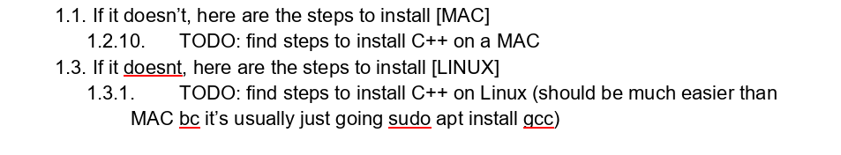

* + 1. If you can do it, go ahead and do so
    2. If you can’t, just skip.

1. Exam Review
   1. Like with Lecture Notes, we are replacing the old notes with New Notes.
   2. There are 3 new New Notes: Midterm1, Midterm2, Final
   3. Each one will be based off of the old slides, the PDF notes
   4. The K_ files aka Quizzes will be deleted so leave those alone and only focus on Midterm1, Midterm2, Final
   5. If there are any missing files, let me know
2. Coding Projects
   1. Leave this folder alone, I’ll take care of it because i need to rewrite a lot of the code in both C++ and Python.

# Part 2: 2 – Algorithms

1. Lecture Notes
   1. There are a LOT of missing notes for this one so we won’t be working on this as much as Data Structures
   2. Just skip this one until later
2. Exam Notes
   1. Just Edit Midterm.docx so that it’s a little more legible. Don’t worry about accuracy, I’ll take care of that.
3. Projects
   1. Again, don’t worry about this, I’ll take care of it since it’s primarily coding.

# Part 3: 3 – Advanced Algorithms

1. Lecture Notes
   1. This one is going to be a lot more complicated so, like Part 1, we are going to replace the old Lecture Notes with New Notes.
   2. Unlike Part 1, I am going to start from scratch and organize by different algorithms mentioned on each lecture slide title.
   3. Since I’ll be rewriting these from scratch, your job is to proofread and edit. Don’t worry about accuracy but, if anything sounds weird such as contradictions, missing information, etc., let me know and add in a note.
2. Exam Notes
   1. Every single separate Quiz doc will be merged into one Quiz document, I will create the new document and you will look over the document for editing, proofreading, and readability.
   2. There will be three new documents, Midterm1, Midterm2, and Final.