UNDERGRADUATE PROJECT PROGRESS REPORT

Project Title | Rapid Development of a Shift-Management System for the Catering Enterprise: Design and Case Study Based on Low-Code Platforms
Student ID | 202218010234
Supervisor Name | Monty Mu
Student Name | Liu Yifei
Student Major | Computer Science

 |  | Date Submitted | 2026-01-07

Table of Contents
Table of Contents II
Chapter 1. Introduction 4
1.1 Background of Study 4
1.2 Project Aim 4
1.3 Project Objectives 4
1.4 Project Overview 5
1.4.1 Scope 5
1.4.2 Audience 5
1.5 Proposed Structure of the Report 6
Chapter 2. Literature Review 7
2.1 Fundamental Theories 7
2.1.1 Shift Management in Service Industry 7
2.1.2 Low-Code Development Platforms (LCDPs) 7
2.2 Background Review 7
2.2.1 Traditional Methods 8
2.2.2 Deep Learning-based Methods 8
2.3 Gaps in the Existing Literature 8
2.3.1 Research Gaps 8
2.3.2 Proposed Solutions 9
2.4 Summary 9
Chapter 3. Technical Progress 10
3.1 Problem Statement 10
3.2 Approach 10
3.3 Technology 15
3.3.1 Hardware and Software Environment 15
3.3.2 Core System Implementation 15
3.4 Testing and Evaluation Plan 16
3.4.1 Data Testing Strategy 16
3.4.2 Model Evaluation Metrics 17
3.4.3 System Usability Testing 17
3.5 Design and Implementation 18
3.5.1 Low-Code System Construction 18
3.5.2 Source Code and Resource Management 19
3.6 Summary 19
Chapter 4. Project Management 20
4.1 Activities 20
4.2 Schedule 20
4.3 Project Version Management Plan 21
4.4 Data Management Plan 21
4.5 Project Deliverables 21
Chapter 5. Professional Issues and Risk 22
5.1 Risk Analysis 22
5.2 Professional Issues 23
5.2.1 Legal and Privacy Issues 23
5.2.2 Ethical and Social Issues 23
5.2.3 Environmental Issues 23
References 24

Chapter 1. Introduction

Background of Study
The catering industry faces significant challenges in managing employee shifts due to high customer demand fluctuations, complex scheduling requirements, and the need for diverse staff skills. Traditional shift management methods, such as manual scheduling using spreadsheets, are inefficient, prone to errors, and lack the flexibility to adapt to changes [5]. These can lead to understaffing during peak hours, resulting in poor service quality and customer dissatisfaction, which unnecessarily increases labor costs [8]. Álvarez et al. [1] showed that overstaffing or understaffing to within 1% of the theoretical minimum can be reduced by simply adding an extra break to each employee and rescheduling shifts. However, it often needs to be achieved through a large number of optimization models. To address these inefficiencies, many industries have turned to digital solutions.
Low-code development platforms have emerged as a powerful tool for rapidly building business applications with minimal hand-coding. These platforms integrate pre-built components and visual development interfaces, enabling users with basic programming skills to create functional systems quickly [2]. For example, Viera-González et al. [10] demonstrated the successful use of Microsoft Power Automate to digitize university class registration processes, reducing manual effort and improving service response times without modifying legacy systems. While low-code platforms have been applied in sectors like education and retail, their potential in catering industry shift management remains underexplored.
This study will explore how to quickly build a shift management system suitable for catering enterprises based on a low-code platform, and verify its feasibility and effectiveness through cases. The low-code development platform is fast to build and easy to change. Therefore, it cuts labour costs, improves schedule accuracy, and lets managers react at once to sudden staff or demand changes.

Project Aim
The aim of this project is to build and implement a operation management system for one catering enterprise, which can be quickly developed using a low-code platform, and by using the rapid application development capabilities of low-code technology, it can be proved that the system can reduce labor costs more effectively than manual methods, while improving scheduling efficiency and flexibility. This project adopts a research-oriented approach to investigate how low-code development platforms can accelerate enterprise information system creation.

Project Objectives
Table 1-1. Progress towards the objectives
Objectives 1 | Analyze current status and challenges of staff scheduling in catering enterprises
Objectives 2 | Design a shift management system architecture for the low-code platform
Objectives 3 | Design prototypes and test core features
Objectives 4 | Compare efficiency and usabilitiy against traditional methods
Objectives 5 | Evaluate user feedback for further improvement

Project Overview
This project aims to enhance shift management in catering enterprises through the development of a system built on a low-code platform. The research will follow a structured process from requirement analysis to prototype implementation, culminating in a case study that validates the system's ability to address practical scheduling challenges effectively.

1.4.1 Scope
This study will focus on small and medium-sized catering enterprises to design and test a shift management system for catering enterprises using a low-code platform, covering core modules such as employee scheduling, shift management, shift transfer application, and notification reminders. The aim is to assess whether this approach can effectively streamline scheduling processes, reduce labor costs, and improve operational flexibility compared to manual methods. The significance of this study is to demonstrate how low-code platforms can quickly create functional management tools to provide practical digital solutions for small and medium-sized catering enterprises without high development costs.

1.4.2 Audience
1. Catering Industry Practitioners: Restaurant managers, operations executives, and business owners will get a fast-deploy tool to improve labor efficiency, reduce scheduling conflicts, and respond quickly to changes in customer demand, while employee satisfaction can be improved through fair and flexible scheduling.
2. Technology and Software Developers: Technical consultants and software developers can learn how low-code platforms can be effectively applied to the service industry, making trade-offs between development speed, system flexibility, and long-term maintainability to quickly build functional systems.
3. Low-Code Platform Providers: Low-code platform providers will benefit from understanding the specific use cases and requirements of the catering enterprises, demonstrating the suitability of their tools. With user feedback on performance and functionality, the platform can better serve this segment.

1.5 Proposed Structure of the Report

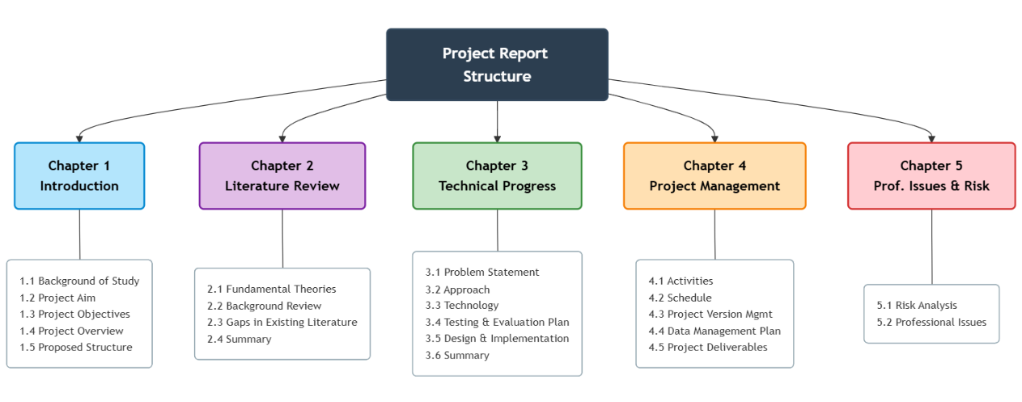
Figure 1-2. Proposed Structure

Chapter 2. Literature Review

Fundamental Theories

2.1.1 Shift Management in Service Industry
Shift management in service industry is a complex optimization problem that involves assigning employees to shifts while considering labor demand, employee availability, skills, preferences, and legal constraints. In the catering industry, labor demand varies significantly by time of day, requiring flexible, real-time scheduling [8]. More recent research expands on this foundation to address human factors, such as skill levels, fairness, and employee satisfaction [5]. Advanced approaches like mixed-integer programming and goal programming [6] balance multiple objectives—labor cost, customer service, and employee welfare. Álvarez et al. [1] and Kiermaier et al. [7] emphasize flexible break assignments and modular scheduling to improve efficiency. These models require substantial data processing, which limits their practical application among small and medium-sized enterprises lacking technology capacity.

2.1.2 Low-Code Development Platforms (LCDPs)
Low-code development platforms (LCDPs) have emerged as a solution that accelerates application development without extensive coding. These platforms support rapid application development by providing pre-built modules, drag-and-drop components, and automated code generation [4]. LCDP is particularly beneficial for non-technical users and is increasingly being used in digital transformation projects due to its speed and ease of integration [2]. Di Ruscio et al. [3] equate low-code principles with model-driven engineering because both rely on abstraction and automation. LCDP integrates workflow automation, database connectivity, and API access, allowing end-users to focus on business logic rather than syntax. Viera-González et al. [10] demonstrate that Microsoft Power Automate can automate administrative tasks in days, showing the agility of low-code solutions for digital transformation. Pinho et al. [9] further emphasize usability as a key success factor, because low-code users often lack formal programming training. These characteristics make LCDPs ideal for small and medium-sized catering enterprises, where technical resources are limited.

Background Review
This section reviews previous work addressing workforce scheduling and low-code implementation across industries. It critically examines the strengths and weaknesses of traditional optimization-based scheduling systems and low-code rapid-development practices.

2.2.1 Traditional Methods
Traditional workforce scheduling relies heavily on mathematical optimization. İşeri et al. [5] proposed a Pareto optimal two-stage integer programming model that combines workers' skills and preferences. The first phase determines staffing levels, while the second phase distributes shifts fairly based on skill levels. This model reduced labor costs for a restaurant chain by 12.3%. Mac-Vicar et al. [8] added a real-time recovery step. When workers are absent, the model reoptimizes plans and reduces lost profits by 18%. Álvarez et al. [1] allow for flexible breaks and overlapping shifts to further improve efficiency. These models work well on paper, but are difficult to use in small restaurants. They need large datasets and expert adjustments. It also takes time to resolve these issues, so managers cannot react quickly to changes. Moreover, those tools are not friendly to non-experts. Due to these limitations, many catering companies still rely on manual scheduling.

2.2.2 Deep Learning-based Methods
The general autoregressive formula for a predictive model can be expressed as:
$$Y_{t}=c+\sum_{i=1}^{p}{ϕ_{i}Y_{t-i}}+\sum_{j=1}^{q}{θ_{j}ϵ_{t-j}}+ϵ_{t}$$ | (2-1)
Deep learning-based recommendation frameworks represent a new generation of intelligent decision-making systems. According to Goodfellow et al. [11], these systems leverage neural networks to automatically learn complex, nonlinear relationships between users, items, and contextual data. Unlike traditional rule-based models, deep learning frameworks enable the extraction of features from large-scale, high-dimensional datasets, enhancing personalization and predictive accuracy. These architectures have achieved state-of-the-art results in areas such as labor demand forecasting.
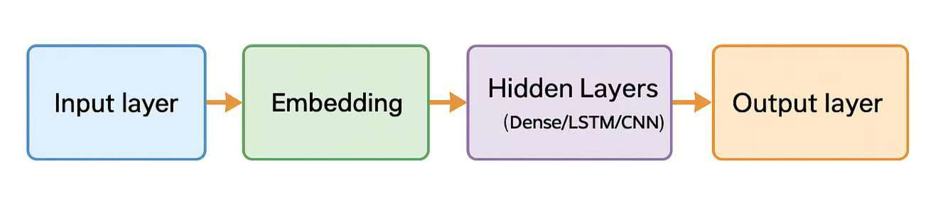
Figure 2-2. General Structure of a Deep Learning-based Recommendation Model

Gaps in the Existing Literature

2.3.1 Research Gaps
1. Inconvenient integration: Optimization models for employee scheduling are not easy for users to use, and low-code systems rarely integrate optimization algorithms effectively.
2. Poor adaptation: Most studies ignore dynamic scheduling and real-time recovery from employee absences or changes in demand.
3. Lack of domain-specific research: Few studies have focused on low-code solutions for the restaurant industry, which has unique time sensitivity and skills-based scheduling needs.
4. Lack of unified evaluation: Previous studies have measured algorithm efficiency and usability separately, but there is a lack of a unified evaluation that combines these two aspects.

2.3.2 Proposed Solutions
1. Optimize low-code development integration: Build a two-stage optimization model (staffing and shift allocation) directly within the low-code platform.
2. Real-time scheduling adjustments: Implement rule-based recovery features to automatically adapt to changes in employees.
3. Balanced evaluation framework: Develop metrics that measure system performance and user experience, such as ease of use.
4. Case studies in the catering industry: Apply and test prototypes in real or simulated catering environments to validate utility and impact.

2.4 Summary
This chapter has shown that while shift-optimisation models can cut catering labour costs, they are too heavy for small and medium-sized catering enterprises, whereas low-code tools are quick to build but still lack smart scheduling features, so the project will merge the two approaches and validate the result in a real catering enterprises case.

Chapter 3. Technical Progress
This chapter presents the technical progress of the project to date. It focuses on the system design, analytical methodology, and the current implementation status of the low-code shift management system for catering enterprises. The chapter describes the adopted development approach, system architecture, data design, and the technologies that have been selected and partially implemented at this stage.

Problem Statement
Small and medium-sized catering enterprises operate in a highly dynamic environment, where customer demand fluctuates with various factors. Accurate shift scheduling is crucial for balancing service quality, employee satisfaction, and labour costs. However, many catering enterprises still rely on manual scheduling using spreadsheets or paper-based methods. These methods are time-consuming, error-prone, and inflexible to handle sudden changes such as employee absence or unexpected demand surges.
Although advanced optimisation-based scheduling systems and intelligent forecasting models have been proposed in academic research, their adoption in small and medium-sized catering enterprises remains limited. The main reasons include high development and maintenance costs, long implementation cycles, and the requirement for specialised technical expertise. On the other hand, low-code platforms enable rapid application development and easy modification but typically lack built-in optimisation and intelligent scheduling capabilities.
Therefore, the core problem addressed in this project is how to rapidly develop a practical shift management system for catering enterprises that combines the speed and usability of a low-code platform to solve the following problems:
(1) forecast short-term labor demand with reasonable accuracy;
(2) support employee skills and preference constraints;
(3) provide real-time recovery mechanisms for unexpected changes;
(4) enable fast development and ease of operation through a low-code platform.

Approach
This project adopts a research-oriented and engineering-driven approach. The system implementation follows a hybrid architecture, using Google Sheets as a relational database backend to ensure data accessibility, and AppSheet as a low-code front-end platform for rapid prototyping of user interfaces and workflows. Meanwhile, the analytical components for demand forecasting and scheduling are designed as external services with this data layer. This approach consists of three main components:
1. Analytical Scheduling Core: The core of the system is a simplified two-stage scheduling process. First, it determines the optimal staffing levels for each shift based on forecasted demand. Second, it automatically assigns employees to these shifts, respecting key constraints such as role suitability, availability, and more. This ensures that the schedule has simple rest handling and skill constraints.
2. Dynamic Adjustment Mechanism: To handle real-time changes, such as staff absence or demand fluctuations, adopting a rule-based adjustment mechanism. Therefore, these rules can automatically suggest and execute adjustments, ensuring operational continuity without recomputing the entire schedule.
3. Low-Code System Integration: The application logic is based on AppSheet. It connects directly to Google Sheets' schema for managing staff, shifts, and assignments, ensuring quick development and easy modification. Automation rules within AppSheet handle notifications and status updates.

3.2.1 Mathematical Basis
At the current stage, these formulations serve as a conceptual analytical foundation for the scheduling logic. The full implementation and evaluation of the optimization process will be completed in the subsequent stage of the project.
1. Staffing Level (period coverage): Decide how many staff are needed in each period to meet demand. Let $r_{t}$ be number of employees required during the forecast period $t$. Objective penalizes understaffing and overstaffing (where $α$ and $β$ are penalty weights, typically $α≫β$ to avoid understaffing) :
$$\min_{x_{t}}{\sum_{t=1}^{T}{\left(α⋅\max\left(0, r_{t}-x_{t}\right)+β⋅\max\left(0, x_{t}-r_{t}\right)\right)}}$$ | (3-1)

2. Staff Assignment (construct shifts): Given staffing needs, assign shifts of employees to start time, end time, and break time. Binary variable $y_{e,s}=1$ if employee $e$ works shift $s$. Objective combines labor cost and fairness penalties:
$$\min_{y_{e,s}}{\sum_{e,s}{c_{e,s}y_{e,s}}+γ\sum_{e}{{\text{pref}\text{_}\text{penalty}}_{e}\left(y\right)}}$$ | (3-2)
3. Demand Forecasting Model: A standard autoregressive model estimates the demand $r_{t}$.
$$Y_{t}=c+\sum_{i=1}^{p}{ϕ_{i}Y_{t-i}}+\sum_{j=1}^{q}{θ_{j}ε_{t-j}}+ε_{t}$$ | (3-3)
4. Real-time recovery heuristic: When an absence or other interruption occurs at period $t$, the system enforces the following rules in turn: (a) try to transfer available staffs from low-priority areas; (b) if a transfer is not feasible, the system automatically offers overtime to qualified on-site employees; (c) if neither possible, reassign breaks or end times to cover critical periods.

3.2.2 Overview of Model Architecture
The system architecture consists of the following logical layers:
(1) Front-end and Logic Layer: Built on AppSheet. It handles user interaction, data validation, and workflow automation.
(2) Database Layer: Google Sheets serves as the relational database. It stores all entity records and provides a structured schema.
(3) Analytical Layer: An external Python-based service processes historical data from the database to generate demand forecasts.
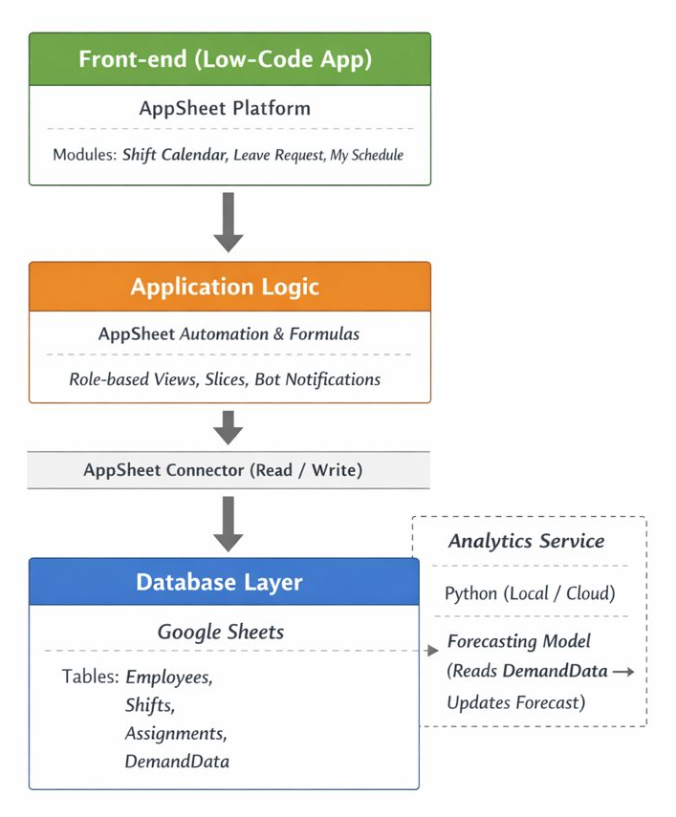
Figure 3-4. High-Level System Architecture

Figure 3-5 illustrates the Entity Relationship (ER) diagram. System architecture relies on a relational data model managed in cloud, these entities are designed to support scheduling constraints and forecasting demand.
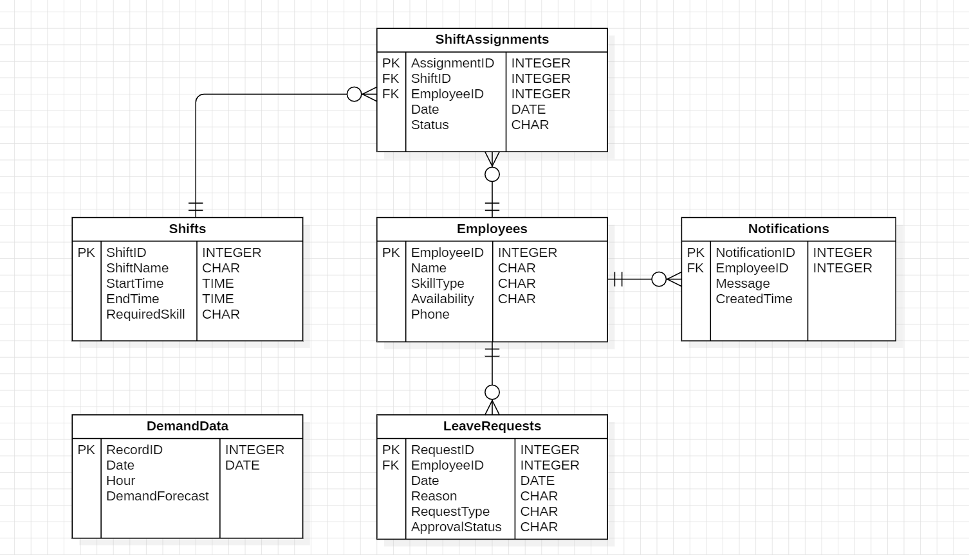
Figure 3-5. Entity Relationship (ER) Diagram

Figure 3-6 illustrates the core workflow. Managers initiate the process by requesting a schedule. The system retrieves data, and if optimization is required, triggers the analytical component. Finally, the manager reviews and publishes the shifts.
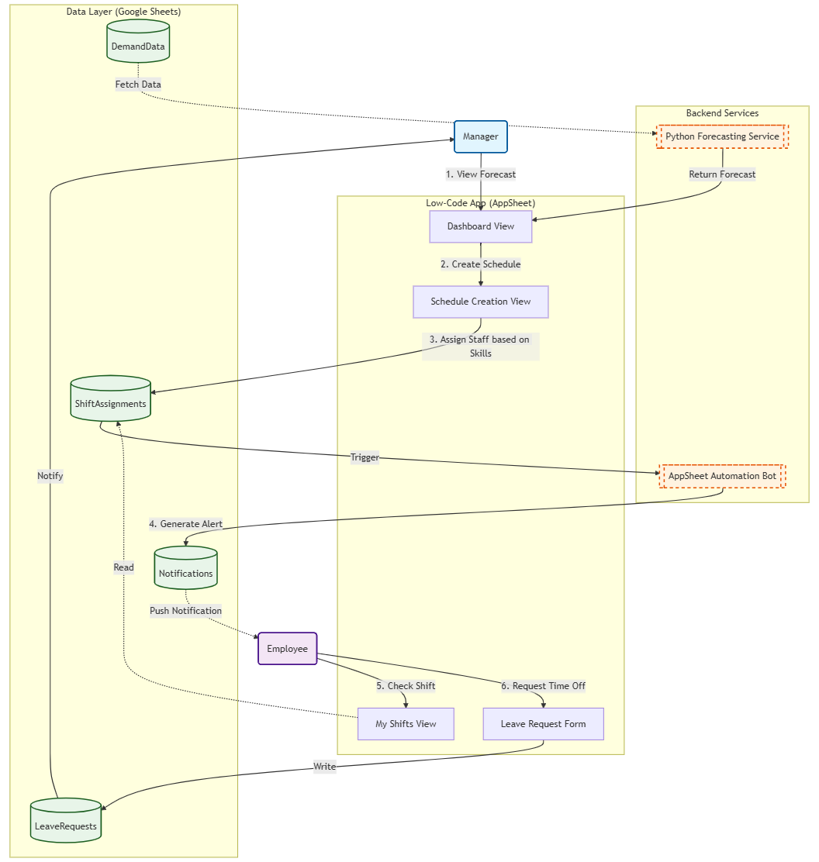
Figure 3-6. User Flow Diagram

3.2.3 Dataset and Data Processing
Table 3-7. Dataset Schema
Table Name | Key Attributes
Employees | EmployeeID (PK), Name, Email, Position, Skills, Availability
Shifts | ShiftID (PK), ShiftName, StartTime, EndTime, Position, RequiredSkill
ShiftAssignments | AssignmentID (PK), ShiftID (FK), EmployeeID (FK), Date, Status
LeaveRequests | RequestID (PK), EmployeeID (FK), Date, RequestType, Reason, ApprovalStatus, SubmittedTime
DemandData | RecordID (PK), Date, Hour, Position, DemandForecast
Notifications | NotificationID (PK), EmployeeID, Message, CreatedTime, IsRead

Table 3-8 shows the preprocessing of raw data collected in the DemandData table before being used in the prediction model.
Table 3-8. Data Processing
Data cleaning | Remove duplicate entries in DemandData table and fill missing DemandForecast values;
Feature engineering | Convert Date and Hour into cyclical time features to capture daily and weekly trends for the machine learning model;
Validation | Ensure ShiftAssignments table follows Employees.Availability constraints during the AppSheet data entry phase.

Technology
This section outlines the specific tools and environment used to implement the system. The project relies on a combination of cloud-based low-code tools and local machine learning environments.

3.3.1 Hardware and Software Environment
Table 3-9. Hardware Environment
Component | Specification
Processor | Intel Core i5 (3.10 GHz)
RAM | 16 GB
Storage | 477 GB
Operating System | Windows 11 (64-bit)
Table 3-10. Software Environment
Category | Platform | Purpose
Low-Code Platform | AppSheet | Build user interface and automatic logic.
Database | Google Sheets | Store relational data.
Language | Python 3.10 | Develop the demand forecasting model.
Library | Pandas | Handle machine learning algorithms.
IDE | Jupyter Notebook | Prototype and test Python code.
Version Control | GitHub | Manage source code and backup.

3.3.2 Core System Implementation
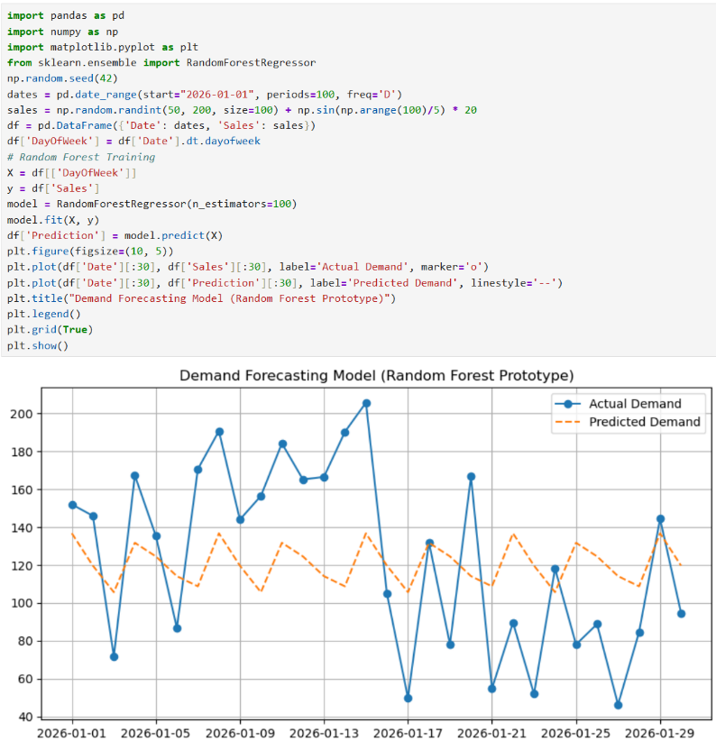
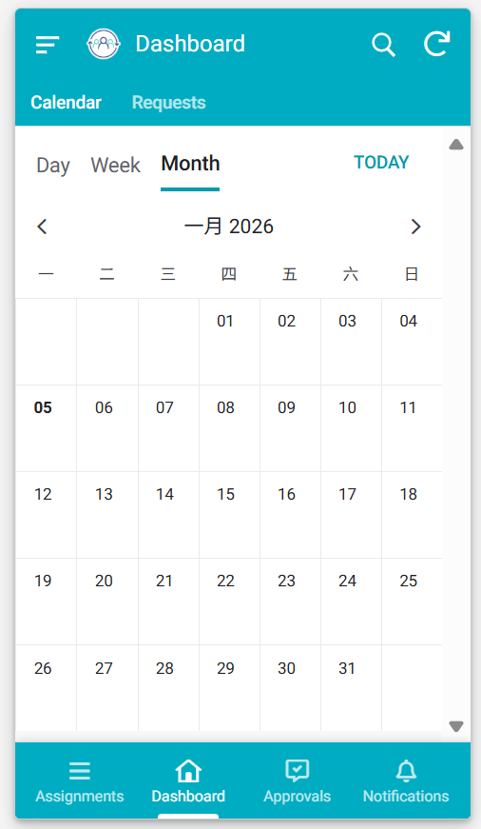
The system implementation relies on the integration of the low-code front end and the machine learning back end, Figure 3-11 illustrates the two core development environments. The left image shows the user interface built rapidly using AppSheet, while the right image displays the Python environment used for training the demand forecasting algorithms. The visual output in the code block shows the demand forecasting logic, and the model plots the predicted labor demand (dotted orange) and actual values (solid blue line).
B.) Random Forest Forecasting Model
A.) AppSheet Dashboard View
Figure 3-11. Low-Code Interface and Analytical Engine

3.4 Testing and Evaluation Plan
The evaluation plan is divided into three layers: data quality testing, machine learning model evaluation, and low-code system functional testing. This ensures that both the forecasting algorithm and the user interface are reliable for catering enterprises.

3.4.1 Data Testing Strategy
The performance of the demand forecasting model depends heavily on the quality of the input data. The DemandData dataset contains time-series records of hourly sales and customer traffic.
1. Data Splitting Method: Unlike standard datasets, time series data cannot be shuffled randomly, which can lead to data leakage. Hence the chronological strategy.
(1) Training Set (80%): The first 80% of the historical data is used to train the Random Forest model. This allows the model to learn past seasonal trends.
(2) Testing Set (20%): The most recent 20% of the data is reserved for testing. This simulates a real-world scenario where the model must predict future unknown demand.

2. Data Quality Checks: Before feeding data into the model, a pipeline of logical checks is executed to ensure integrity.
(a) Completeness: Check if there are any missing hours in the timeline. Missing values are filled using linear interpolation.
(b) Consistency: Verify that the DemandForecast values are non-negative integers.
(c) Format Validation: Ensure the date and time formats in Google Sheets match the input requirements of the Python script.
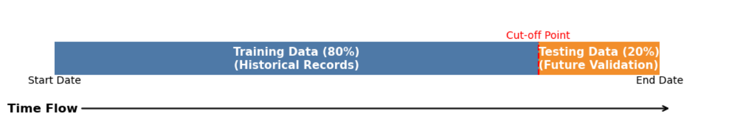
Figure 3-12. Chronological Data Splitting Strategy

3.4.2 Model Evaluation Metrics
The objective of the machine learning component is to minimize the error between the predicted labor demand and the actual business volume.
1. Cross-Validation Technique: Use Time Series Cross-Validation to ensure that the random forest model is robust and does not overfit specific weeks. Compared with simple static splitting, model performance can be evaluated more realistically.
2. Performance Metrics: Standard regression metrics are used to quantify the accuracy of the model. These metrics allow for direct comparison to baseline linear regression models.
Table 3-13. Model Evaluation Metrics
Metric | Purpose
RMSE | Measures the severity of large prediction errors. High RMSE means the model often misses peak hour demand.
MAE | Measures the average gap between predicted and actual staff numbers.
R² | How well the model captures the variance in customer traffic patterns.

3.4.3 System Usability Testing
Beyond the algorithm, the low-code application itself must be tested for usability and logic correctness. This ensures the AppSheet interface functions as intended.
1. Functional Testing: Unit testing individual modules in AppSheet to validate business logic constraints.
(1) Constraint Logic: Attempt to assign a shift to an employee who has marked themselves as "Unavailable". The system must block this action or display a warning.
(2) Automation Logic: Create a new shift assignment and verify that a record is immediately generated in the Notifications table.
(3) Data Integration: Verify that the forecast results generated by the Python script are correctly updated and displayed in the AppSheet dashboard view.
2. User Acceptance Testing: Conduct a comparative test to evaluate and simulate weekly scheduling tasks in two ways:
(a) Manual scheduling using Excel;
(b) Scheduling using the new Low-Code System.
Table 3-14. Functional Test Cases Plan
Module | Test Scenario | Expected Outcome
Shift Assignment | Manager assigns Staff A to a shift during A unavailable time. | System displays an error message: Staff Unavailable.
Forecasting | Python script finishes running. | DemandData table updates with new values.
Notification | A new shift is published. | Notifications table appears a new row: IsRead=False.
Leave Request | Employee submits the leave request. | Manager receives an approval alert in Dashboard.

3.5 Design and Implementation
This section details the implementation process of the shift management system. It covers the logic construction within the low-code platform and the management of source codes and resources.

3.5.1 Low-Code System Construction
The implementation of the AppSheet application involves three key stages: Data Modelling, View Construction, and Automation Logic.
1. Data Connectivity and Column Logic
(1) Reference (Ref): EmployeeID is set in the ShiftAssignments table as the ref type pointing to the Employees table, enabling the app to automatically extract employee names and photos when assigning shifts.
(2) Virtual columns: AppSheet Expressions are used to dynamically compute data without being stored in spreadsheets.
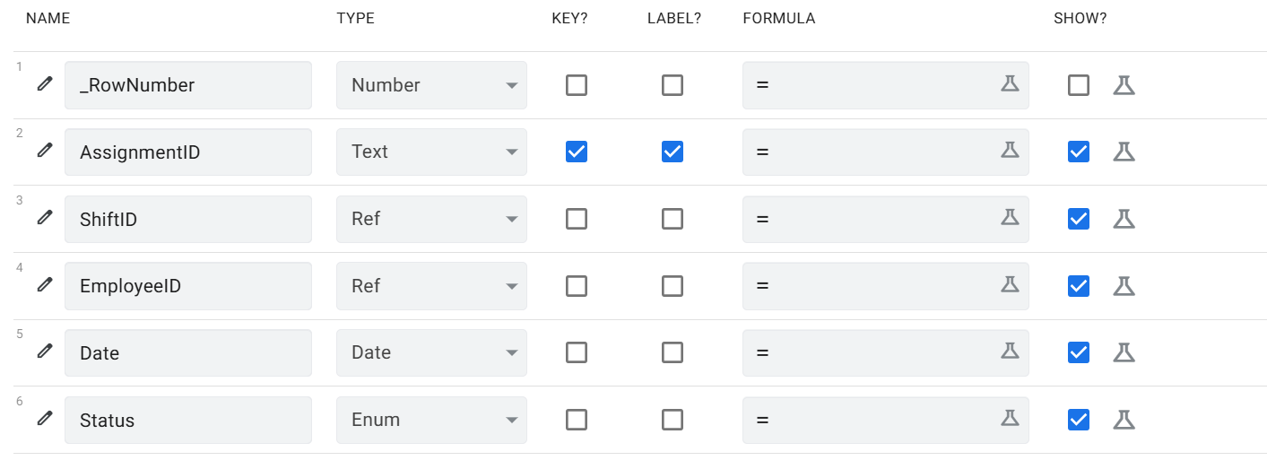
Figure 3-15. Data Column Configuration in AppSheet

2. Automation Bot Implementation: The logic follows an "Event-Process-Task" flow.
(a) Event: A new record is added to the LeaveRequests table.
(b) Process: The system checks if the ApprovalStatus is "Pending".
(c) Task: The system sends a notification to the manager's device and highlights the request in the dashboard.

3.5.2 Source Code and Resource Management
Project adopts GitHub as the main version control and project management platform.
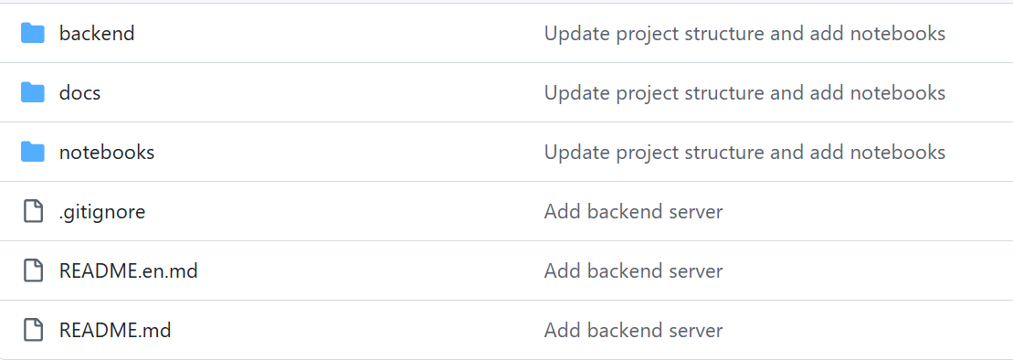
Figure 3-16. GitHub Repository Structure
Every time the Python model is optimized or the dataset is updated, changes are pushed to the remote repository. This ensures that research process is reproducible and all historical versions are traceable.

3.6 Summary
This chapter detailed the technical progress of the project, establishing a hybrid system architecture that integrates AppSheet for the front-end interface and Python for the analytical backend, implementing prototypes for both scheduling interface and demand forecasting model. Furthermore, this section establishes a robust foundation for the subsequent system integration and validation phases.

Chapter 4. Project Management
This chapter outlines the management strategies employed to ensure the successful completion of the shift management system. It details the project activities, the time schedule, and the protocols for version and data management.

4.1 Activities
Table 4-1 Project Activities and Tasks
Activity | Main Task | Deliverable
Requirement Analysis | Identify requirements and system functions. | Requirement List
System Design | Define architecture, workflow, interface layout. | System Design diagram
Data Preparation | Collect historical data and clean it for the forecasting model. | Processed Dataset
Develop Model | Preprocess data and train Random Forest models in Python. | Trained Model
Low-Code Implementation | Build AppSheet views and configure automation bots. | Functional App Prototype
Testing | Verify accuracy and usability of the system. | Test Result Log
Final Report | Summarize and prepare the defense. | Completed Report

4.2 Schedule
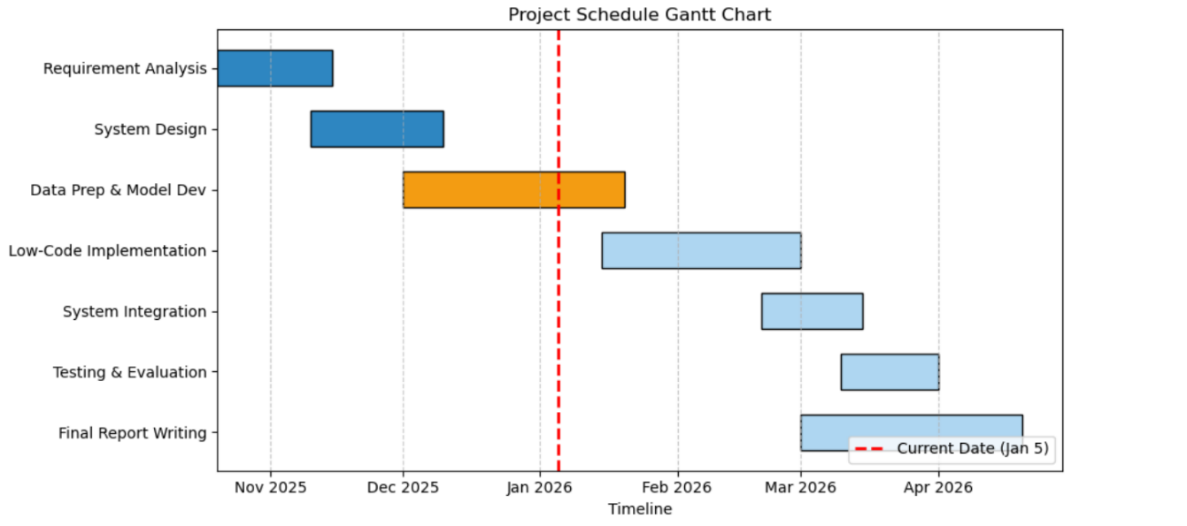
Figure 4-2 visualizes the schedule from the project initiation in October 2025 to the final submission in April 2026.
Figure 4-2. Project Schedule

4.3 Project Version Management Plan
In this project, I use GitHub as the primary version control tool to manage the source code, created a private repository named “Shift-Management-System-LowCode”.
Repository link: https://github.com/chocbagel/Shift-Management-System-LowCode.git
(a) Code Commit: Python model are committed immediately after successful local testing.
(b) Documentation Sync: Weekly progress logs are pushed to the /docs folder.
(c) Tag Versions: Mark stable updates as v1.0, v2.0, and v3.0 to record progress.

4.4 Data Management Plan
Table 4-3 Data Management Strategy
Resource Type | Management Platform | Frequency | Purpose
Project Logs | GitHub | Weekly | Tracking issues, bugs, and notes.
Project Reports | GitHub | Ongoing | Secure storage for reports (backup).
Source Code | GitHub | Daily | Version control and collaboration history.
References | Zotero | Ongoing | Organizing academic citations.

4.5 Project Deliverables
Upon completion of the project, the following materials will be submitted for assessment:
(1) Project Proposal Report (Submitted)
(2) Project Progress Report (Submitted)
(3) Project Final Report
(4) Software Prototype (In Processing)
(5) Source Code (In Processing)
(6) Presentation Slides
(7) Ethics forms (Submitted)

Chapter 5. Professional Issues and Risk
This chapter discusses the potential risks encountered during the project implementation and the professional responsibilities associated with developing an intelligent shift-management system.

5.1 Risk Analysis
The project involves integrating low-code platform with a local machine learning environment. This hybrid architecture introduces specific technical and management risks. Table 5-1 summarizes the risk status, including issues that have been resolved during the technical progress phase and potential future risks.
Table 5-1 Risk Status and Mitigation Strategies
Risk Category | Risk Description | Status | Resolution / Mitigation Stratrgy
Data Quality | Raw catering data often contains missing values or formatting errors, which causes the training model to fail. | Resolved | Implemented a robust preprocessing pipeline, which automatically fills in missing values through linear interpolation [16].
Model Performance | The initial Linear Regression model showed high error rates (RMSE) and failed to capture peak hour trends. | Resolved | Switching to the random forest algorithm [15], this method improves prediction accuracy by better handling nonlinear relationships.
Technical Limit | AppSheet expressions are slow for complex logic. | Resolved | Shifted heavy calculation to Python backend, handling only display tasks to maintain high performance [17].
Integration | API connection between AppSheet and the Python backend may experience delays, causing the app to freeze. | Future | Implement an asynchronous trigger plan. The user clicks a button, and the system notifies them via email when the calculation is finished.
Schedule | Debugging the integration interface took longer than expected, impacting the testing phase. | Monitor | Adjusted the Gantt chart to allocate more time for testing.

5.2 Professional Issues
This project follows the principles outlined by the ACM Code of Ethics [12] and the BCS
Code of Conduct [20], focusing on privacy, fairness, and social responsibility.

5.2.1 Legal and Privacy Issues
The system processes personal data, including employee names, contact details, and work patterns. This falls under data protection regulations such as the GDPR (General Data Protection Regulation) [13].
1. Data Minimization: The system only collects data essential for scheduling. Sensitive information like health records or financial details is excluded.
2. Access Control: To prevent unauthorized access, row-level security is enforced. As noted by Pearson [21], limiting data visibility based on user roles is crucial. Employees can only view their own shifts, while managers have full access.

5.2.2 Ethical and Social Issues
1. Algorithmic Fairness: A major ethical concern is that the scheduling algorithm might unfairly assign unpopular shifts (e.g., late nights) to the same employees repeatedly. Research by Mehrabi et al. [14] highlights that historical data often contains human biases. To address this, the optimization logic includes a "Fairness Penalty" constraint. This ensures that weekend and night shifts are distributed evenly among all staff.
2. Transparency: Employees have the right to understand how their schedules are determined. Following the principle of "Explainable AI" [22], the system provides simple rule-based explanations for shift assignments, rather than using a "black box" approach.

5.2.3 Environmental Issues
1. Green IT: Training large deep learning models consumes significant energy [18]. By selecting the Random Forest algorithm over complex Neural Networks, this project reduces computational cost and energy consumption.
2. Paper Reduction: Moving from manual paper-based scheduling to a digital AppSheet solution helps the catering enterprise reduce paper waste, contributing to environmental sustainability [19].

References
[1] E. Álvarez, J. C. Ferrer, J. C. Muñoz, and C. A. Henao, “Efficient shift scheduling with multiple breaks for full-time employees: A retail industry case”, Computers & Industrial Engineering, vol. 150, 2020. [Online]. Available: https://doi.org/10.1016/j.cie.2020.106884
[2] A. C. Bock and U. Frank, “Low-Code Platform”, Business & Information Systems Engineering, vol. 63, no. 6, pp. 733–740, 2021. [Online]. Available: https://doi.org/10.1007/s12599-021-00726-8
[3] D. Di Ruscio, D. Kolovos, J. de Lara, A. Pierantonio, M. Tisi, and M. Wimmer, “Low-code development and model-driven engineering: Two sides of the same coin?”, Software and Systems Modeling, vol. 21, pp. 437–446, 2022. [Online]. Available: https://doi.org/10.1007/s10270-021-00970-2
[4] M. Hirzel, “Low-Code Programming Models”, Communications of the ACM, vol. 66, no. 10, pp. 76–84, 2023. [Online]. Available: https://doi.org/10.1145/3587691
[5] A. İşeri, H. Güner, and A. R. Güner, “Pareto-optimal workforce scheduling with worker skills and preferences”, Operational Research, vol. 25, p. 27, 2025. [Online]. Available: https://doi.org/10.1007/s12351-025-00903-7
[6] H. E. İnan, “Goal Programming Approach for Service Staff Scheduling Problem in a Restaurant”, Uluslararası Mühendislik Araştırma ve Geliştirme Dergisi, vol. 15, no. 3, pp. 123–132, 2023. [Online]. Available: https://doi.org/10.29137/umagd.1309302
[7] F. Kiermaier, M. Frey, and J. F. Bard, “The flexible break assignment problem for large tour scheduling problems with an application to airport ground handlers”, Journal of Scheduling, vol. 23, no. 2, pp. 177–209, 2020. [Online]. Available: https://doi.org/10.1007/s10951-019-00635-5
[8] M. Mac-Vicar, J. C. Ferrer, J. C. Muñoz, and C. A. Henao, “Real-time recovering strategies on personnel scheduling in the retail industry”, Computers & Industrial Engineering, vol. 113, pp. 589–601, 2017. [Online]. Available: https://doi.org/10.1016/j.cie.2017.09.045
[9] D. Pinho, A. Aguiar, and V. Amaral, “What about the usability in low-code platforms? A systematic literature review”, Journal of Computer Languages, vol. 74, 101185, 2023. [Online]. Available: https://doi.org/10.1016/j.cola.2022.101185
[10] P. M. Viera-González, O. H. González-González, and G. E. Sánchez-Guerrero, “Low-Code Automation for Resolving Incidents During Class Schedule Registration”, Computer, IEEE, vol. 58, no. 3, pp. 41–49, 2025. [Online]. Available: https://doi.org/10.1109/MC.2024.3510463
[11] I. Goodfellow, Y. Bengio, and A. Courville, Deep Learning. Cambridge, MA, USA: MIT Press, 2016. [Online]. Available: https://www.deeplearningbook.org/
[12] ACM, “ACM Code of Ethics and Professional Conduct”, Association for Computing Machinery, New York, NY, USA, 2018. [Online]. Available: https://www.acm.org/code-of-ethics
[13] European Parliament and Council of the European Union, “Regulation (EU) 2016/679 (General Data Protection Regulation)”, Official Journal of the European Union, vol. L119, pp. 1-88, 2016. Available: http://data.europa.eu/eli/reg/2016/679/oj
[14] N. Mehrabi, F. Morstatter, N. Saxena, K. Lerman, and A. Galstyan, “A Survey on Bias and Fairness in Machine Learning”, ACM Computing Surveys, vol. 54, no. 6, pp. 1-35, 2021. Available: https://doi.org/10.1145/3457607
[15] L. Breiman, “Random Forests”, Machine Learning, vol. 45, no. 1, pp. 5-32, 2001. Available: https://doi.org/10.1023/A:1010933404324
[16] R. J. Hyndman and G. Athanasopoulos, Forecasting: principles and practice, 2nd edition, OTexts: Melbourne, Australia, 2018. Available: https://OTexts.com/fpp2
[17] A. S. Khorram, J. M. Mottu, and G. Sunyé, “Challenges and opportunities in low-code evolution: A systematic literature review”, ACM Transactions on Software Engineering and Methodology, vol. 32, no. 4, pp. 1–28, 2023. [Online]. Available: https://doi.org/10.1145/3571857
[18] E. Strubell, A. Ganesh, and A. McCallum, “Energy and Policy Considerations for Deep Learning in NLP,” in Proceedings of the 57th Annual Meeting of the Association for Computational Linguistics, Florence, Italy, 2019, pp. 3645-3650. Available: https://aclanthology.org/P19-1355/
[19] L. Floridi et al., “AI4People - An Ethical Framework for a Good AI Society: Opportunities, Risks, Principles, and Recommendations”, Minds and Machines, vol. 28, no. 4, pp. 689-707, 2018. Available: https://doi.org/10.1007/s11023-018-9482-5
[20] BCS, “Code of Conduct for BCS Members”, British Computer Society, London, UK, 2022. [Online]. Available: https://www.bcs.org/membership-and-registrations/become-a-member/bcs-code-of-conduct/
[21] S. Pearson, “Privacy, security and trust in cloud computing”, in Privacy and Security for Cloud Computing, Springer, 2013, pp. 3–42. [Online]. Available: https://doi.org/10.1007/978-1-4471-4189-1_1
[22] J. Buolamwini and T. Gebru, “Gender shades: Intersectional accuracy disparities in commercial gender classification”, in Conference on Fairness, Accountability and Transparency, 2018, pp. 77–91. [Online]. Available: http://proceedings.mlr.press/v81/buolamwini18a.html

