UNDERGRADUATE PROJECT PROPOSAL

Project Title | Rapid Development of a Shift-Management System for the Catering Enterprise: Design and Case Study Based on Low-Code Platforms
Student ID | 202218010234
Supervisor Name | Monty Mu
Student Name | Liu Yifei
Student Major | Computer Science

 |  | Date Submitted | 2025-10-30

Table of Contents

Table of Contents I
Chapter 1. Introduction 1
1.1 Background of Study 1
1.2 Project Aim 1
1.3 Project Objectives 2
1.4 Project Overview 2
1.4.1 Scope 2
1.4.2 Audience 2
1.5 Proposed Structure of the Report 3
Chapter 2. Literature Review 4
2.1 Fundamental Theories 4
2.1.1 Shift Management in Service Industry 4
2.1.2 Low-Code Development Platforms (LCDPs) 4
2.2 Background Review of Recommendation Systems 4
2.2.1 Traditional Model-based Recommendation Frameworks 5
2.2.2 Deep Learning-based Recommendation Frameworks 5
2.3 Gaps in the Existing Literature 5
2.3.1 Research Gaps 5
2.3.1 Proposed Solutions 6
2.4 Summary 6
Chapter 3. Methodology 7
3.1 Problem Statement 7
3.2 Approach 7
3.2.1 Mathematical Basis 8
3.2.2 Overview of Model Architecture 8
3.2.3 Dataset and Data Processing 9
3.3 Technology 10
3.3.1 Hardware and Software Environment 10
3.3.2 Machine Learning Algorithms for Demand Forecasting 10
3.3.3 Comparative Performance 11
3.4 Project Version Management Plan 11
3.4.1 Gitee Repository 11
3.4.2 Version Tracking and Updates 12
3.4.2 Version Log 12
3.5 Summary 12
Chapter 4. Project Management 13
4.1 Activities 13
4.2 Schedule 13
4.3 Data Management Plan 14
4.4 Project Deliverables 14
References 15

Chapter 1. Introduction

Background of Study
The catering industry faces significant challenges in managing employee shifts due to high customer demand fluctuations, complex scheduling requirements, and the need for diverse staff skills. Traditional shift management methods, such as manual scheduling using spreadsheets, are inefficient, prone to errors, and lack the flexibility to adapt to changes [5]. These can lead to understaffing during peak hours, resulting in poor service quality and customer dissatisfaction, which unnecessarily increases labor costs [8]. Álvarez et al. [1] showed that overstaffing or understaffing to within 1% of the theoretical minimum can be reduced by simply adding an extra break to each employee and rescheduling shifts. However, it often needs to be achieved through a large number of optimization models. To address these inefficiencies, many industries have turned to digital solutions.
Low-code development platforms have emerged as a powerful tool for rapidly building business applications with minimal hand-coding. These platforms integrate pre-built components and visual development interfaces, enabling users with basic programming skills to create functional systems quickly [2]. For example, Viera-González et al. [10] demonstrated the successful use of Microsoft Power Automate to digitize university class registration processes, reducing manual effort and improving service response times without modifying legacy systems. While low-code platforms have been applied in sectors like education and retail, their potential in catering industry shift management remains underexplored.
This study will explore how to quickly build a shift management system suitable for catering enterprises based on a low-code platform, and verify its feasibility and effectiveness through cases. The low-code development platform is fast to build and easy to change. Therefore, it cuts labour costs, improves schedule accuracy, and lets managers react at once to sudden staff or demand changes.

Project Aim
The aim of this project is to build and implement a operation management system for one catering enterprise, which can be quickly developed using a low-code platform, and by using the rapid application development capabilities of low-code technology, it can be proved that the system can reduce labor costs more effectively than manual methods, while improving scheduling efficiency and flexibility. This project adopts a research-oriented approach to investigate how low-code development platforms can accelerate enterprise information system creation.

Project Objectives
- To analyze the current situation and challenge of staff scheduling in catering enterprises.
- To design a system architecture for the shift management system using low-code platform.
- To prototype and test core functions such as shift creation and adjustment.
- To compare efficiency and usabilitiy against traditional methods.
- To evaluate user feedback for further improvement.

Project Overview
This project aims to enhance shift management in catering enterprises through the development of a system built on a low-code platform. The research will follow a structured process from requirement analysis to prototype implementation, culminating in a case study that validates the system's ability to address practical scheduling challenges effectively.

1.4.1 Scope
This study will focus on small and medium-sized catering enterprises to design and test a shift management system for catering enterprises using a low-code platform, covering core modules such as employee scheduling, shift management, shift transfer application, and notification reminders. The aim is to assess whether this approach can effectively streamline scheduling processes, reduce labor costs, and improve operational flexibility compared to manual methods. The significance of this study is to demonstrate how low-code platforms can quickly create functional management tools to provide practical digital solutions for small and medium-sized catering enterprises without high development costs.

1.4.2 Audience
- Catering Industry Practitioners: Restaurant managers, operations executives, and business owners will get a fast-deploy tool to improve labor efficiency, reduce scheduling conflicts, and respond quickly to changes in customer demand, while employee satisfaction can be improved through fair and flexible scheduling.
- Technology and Software Developers: Technical consultants and software developers can learn how low-code platforms can be effectively applied to the service industry, making trade-offs between development speed, system flexibility, and long-term maintainability to quickly build functional systems.
- Low-Code Platform Providers: Low-code platform providers will benefit from understanding the specific use cases and requirements of the catering enterprises, demonstrating the suitability of their tools. With user feedback on performance and functionality, the platform can better serve this segment.

Proposed Structure of the Report

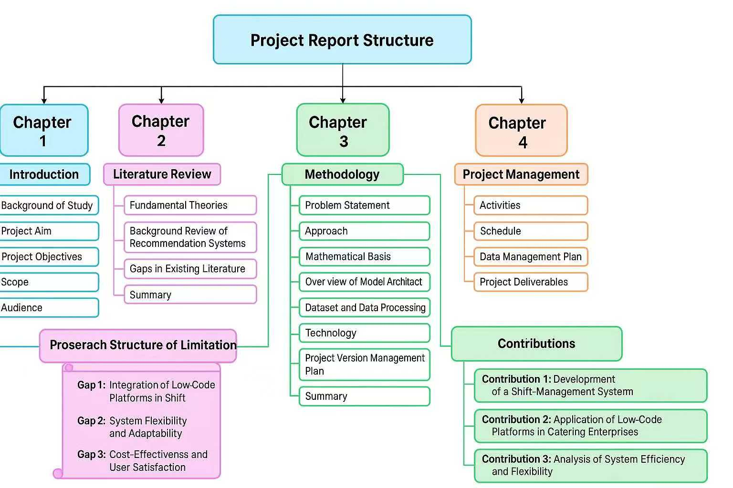
Figure 1-1Project Report Structure

Chapter 2. Literature Review

Fundamental Theories

2.1.1 Shift Management in Service Industry
Shift management in service industry is a complex optimization problem that involves assigning employees to shifts while considering labor demand, employee availability, skills, preferences, and legal constraints. In the catering industry, labor demand varies significantly by time of day, requiring flexible, real-time scheduling [8]. More recent research expands on this foundation to address human factors, such as skill levels, fairness, and employee satisfaction [5]. Advanced approaches like mixed-integer programming and goal programming [6] balance multiple objectives—labor cost, customer service, and employee welfare. Álvarez et al. [1] and Kiermaier et al. [7] emphasize flexible break assignments and modular scheduling to improve efficiency. These models require substantial data processing, which limits their practical application among small and medium-sized enterprises lacking technology capacity.

2.1.2 Low-Code Development Platforms (LCDPs)
Low-code development platforms (LCDPs) have emerged as a solution that accelerates application development without extensive coding. These platforms support rapid application development by providing pre-built modules, drag-and-drop components, and automated code generation [4]. LCDP is particularly beneficial for non-technical users and is increasingly being used in digital transformation projects due to its speed and ease of integration [2]. Di Ruscio et al. [3] equate low-code principles with model-driven engineering because both rely on abstraction and automation. LCDP integrates workflow automation, database connectivity, and API access, allowing end-users to focus on business logic rather than syntax. Viera-González et al. [10] demonstrate that Microsoft Power Automate can automate administrative tasks in days, showing the agility of low-code solutions for digital transformation. Pinho et al. [9] further emphasize usability as a key success factor, because low-code users often lack formal programming training. These characteristics make LCDPs ideal for small and medium-sized catering enterprises, where technical resources are limited.

Background Review of Recommendation Systems
This section reviews previous work addressing workforce scheduling and low-code implementation across industries. It critically examines the strengths and weaknesses of traditional optimization-based scheduling systems and low-code rapid-development practices.

2.2.1 Traditional Model-based Recommendation Frameworks
Traditional workforce scheduling relies heavily on mathematical optimization. İşeri et al. [5] proposed a Pareto optimal two-stage integer programming model that combines workers' skills and preferences. The first phase determines staffing levels, while the second phase distributes shifts fairly based on skill levels. This model reduced labor costs for a restaurant chain by 12.3%. Mac-Vicar et al. [8] added a real-time recovery step. When workers are absent, the model reoptimizes plans and reduces lost profits by 18%. Álvarez et al. [1] allow for flexible breaks and overlapping shifts to further improve efficiency. These models work well on paper, but are difficult to use in small restaurants. They need large datasets and expert adjustments. It also takes time to resolve these issues, so managers cannot react quickly to changes. Moreover, those tools are not friendly to non-experts. Due to these limitations, many catering companies still rely on manual scheduling.

2.2.2 Deep Learning-based Recommendation Frameworks
The general autoregressive formula for a predictive model can be expressed as:
$$\begin{aligned}Y_{t}=c+\sum_{i=1}^{p}{ϕ_{i}Y_{t-i}}+\sum_{j=1}^{q}{θ_{j}ϵ_{t-j}}+ϵ_{t}\#\left(2-1\right)\end{aligned}$$
Deep learning-based recommendation frameworks represent a new generation of intelligent decision-making systems that leverage neural networks to automatically learn complex, nonlinear relationships between users, items, and contextual data (Zhang et al., 2019). Unlike traditional rule-based or matrix decomposition models, deep learning frameworks enable the extraction of features from large-scale, high-dimensional datasets, enhancing personalization and predictive accuracy. These architectures have achieved state-of-the-art results in areas such as labor demand forecasting.
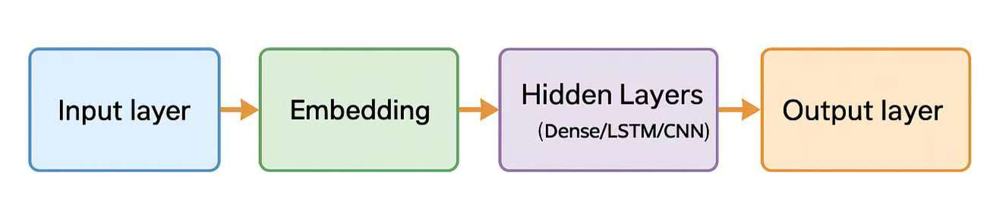
Figure 2-2 General Structure of a Deep Learning-based Recommendation Model

Gaps in the Existing Literature

2.3.1 Research Gaps
- Inconvenient integration: Optimization models for employee scheduling are not easy for users to use, and low-code systems rarely integrate optimization algorithms effectively.
- Poor adaptation: Most studies ignore dynamic scheduling and real-time recovery from employee absences or changes in demand.
- Lack of domain-specific research: Few studies have focused on low-code solutions for the restaurant industry, which has unique time sensitivity and skills-based scheduling needs.
- Lack of unified evaluation: Previous studies have measured algorithm efficiency and usability separately, but there is a lack of a unified evaluation that combines these two aspects.

2.3.1 Proposed Solutions
- Optimize low-code development integration: Build a two-stage optimization model (staffing and shift allocation) directly within the low-code platform.
- Real-time scheduling adjustments: Implement rule-based recovery features to automatically adapt to changes in employees.
- Balanced evaluation framework: Develop metrics that measure system performance and user experience, such as ease of use.
- Case studies in the catering industry: Apply and test prototypes in real or simulated catering environments to validate utility and impact..

Summary
This chapter has shown that while shift-optimisation models can cut catering labour costs, they are too heavy for small and medium-sized catering enterprises, whereas low-code tools are quick to build but still lack smart scheduling features, so the project will merge the two approaches and validate the result in a real catering enterprises case.

Chapter 3. Methodology
This chapter outlines the systematic approach for designing, developing, and validating the shift management system. It details the problem being addressed, the overall development methodology, the system's architectural design, and the plan for implementation and evaluation.

Problem Statement
The catering industry is a highly dynamic environment that requires accurate and flexible shift schedules to meet fluctuating demands while respecting labor rules, employee skills, and preferences. At present, the reliance of small and medium-sized catering enterprises on manual shift management often leads to inefficiency. These methods are time-consuming and prone to human error, often incurring unnecessary labor costs. While advanced optimization models exist, they are often very expensive and require long development cycles. Low-code platforms promise rapid development but rarely include embedded optimization or real-time recovery. Therefore, the project designs and implements a rapidly developed shift management system for catering enterprises based on a low-code platform that will solve:
- Forecast short-term labor demand accurately
- Supports employee skills and preferences
- Provides real-time recovery for changes
- Fast development and simple operation

Approach
The shift-management system is built with a hybrid architecture. Develop using a low-code platform to quickly build user interfaces, workflows, and data models, implementing optimization and predictive logic as externally callable services. This project follows an engineering approach combining three elements:
- Analytical Scheduling Core: The core of the system is a two-stage optimization process. First, it determines the optimal staffing levels for each shift based on forecasted demand. Secondly, it automatically assigns employees to these shifts, respecting key constraints such as role suitability, availability, and more. This ensures that the schedule has simple rest handling and skill constraints.
- Dynamic Adjustment Engine: To handle sudden changes in demand, the system combines lightweight rules with a quick heuristic approach. Therefore, these rules can automatically suggest and execute adjustments, ensuring operational continuity.
- Demand Forecasting: In order to improve scheduling accuracy, optional demand forecasting components can be integrated. It uses simple time series models to predict future customer traffic that informs the scheduling core.

3.2.1 Mathematical Basis
- Staffing Level (period coverage): Decide how many staff are needed in each period to meet demand.
Let periods $t=1,...,T$.
Let $r_{t}$ be number of employees required during the forecast period $t$.
Choose coverage $x_{t}≥0$.
Objective penalizes understaffing and overstaffing (where $α$ and $β$ are penalty weights, typically $α≫β$ to avoid understaffing) :
$$\begin{aligned}\min_{x_{t}}{\sum_{t=1}^{T}{\left(α⋅\max\left(0, r_{t}-x_{t}\right)+β⋅\max\left(0, x_{t}-r_{t}\right)\right)}}\#\left(3-1\right)\end{aligned}$$
- Staff Assignment (construct shifts): Given staffing needs, assign shifts of employees to start time, end time, and break time.
Let employees $e∈E$, shifts $s$.
Binary variable $y_{e,s}=1$ if employee $e$ works shift $s$.
Objective combines labor cost and fairness penalties:
$$\begin{aligned}\min_{y_{e,s}}{\sum_{e,s}{c_{e,s}y_{e,s}}+γ\sum_{e}{{\text{pref}\text{_}\text{penalty}}_{e}\left(y\right)}}\#\left(3-2\right)\end{aligned}$$
- Demand Forecasting Model: A standard autoregressive model or an LSTM can estimate $r_{t}$.
$$\begin{aligned}Y_{t}=c+\sum_{i=1}^{p}{ϕ_{i}Y_{t-i}}+\sum_{j=1}^{q}{θ_{j}ε_{t-j}}+ε_{t}\#\left(3-3\right)\end{aligned}$$
- Real-time recovery heuristic: When an absence or other interruption occurs at period $t$, the system enforces the following rules in turn.
- Try to transfer available staffs from low-priority areas.
- If a transfer is not feasible, the system automatically offers overtime to qualified on-site employees.
- If neither possible, reassign breaks or end times to cover critical periods.

3.2.2 Overview of Model Architecture
High-Level Architecture
- Front-end and workflow: drag and drop UI for shift creation, approval and employee self-service.
- Integration layer: REST APIs that expose optimization, ML and data services.
- Optimization service: computes staffing levels and staff assignments, delivers optimal scheduling solutions.
- Forecasting service: LSTM model packaged as a microservice, provides demand predictions using time-series models.
- Database and support: relational store for core data, and notification service for alerts and reminders.
User Flow
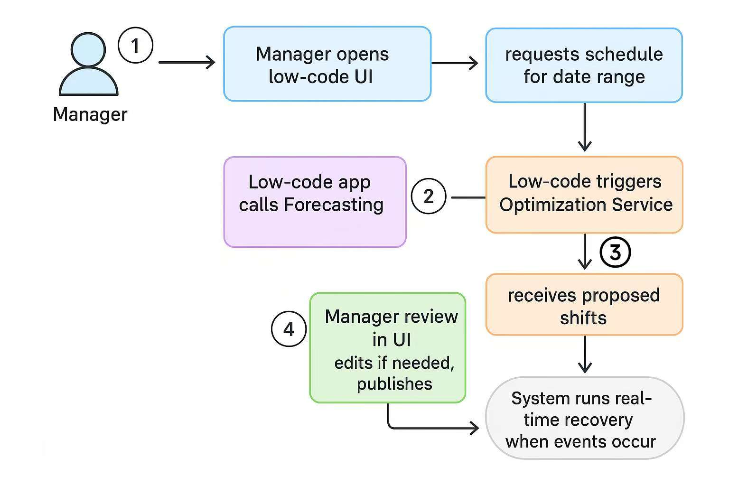
Figure 3-4 User Flow

3.2.3 Dataset and Data Processing
Dataset
- Employee data: includes employee id, skill type, availability periods, maximum working hours per week.
- Business data: hourly customer transaction counts, sales volume.
- Shift data: details of each shift, including start and end times, shift type, staff assignments.
- Performance Metrics: Customer satisfaction, service quality ratings, labor costs.
Data Processing
- Data cleaning: remove duplicates, fix missing items, normalize skill labels.
- Feature engineering: Aggregate POS to hourly demand per outlet, compute rolling averages.
- Model inputs: generate for the planned forecast range.
- Validation: calculate understaffing or overstaffing rates.

Technology
The project combines low-code application design, machine learning models, and optimization algorithms to achieve efficient scheduling and accurate demand prediction. All components were developed and tested using standard software tools and machine learning frameworks.

3.3.1 Hardware and Software Environment
Table 3-5 Hardware Environment
Component | Specification
Processor | Intel Core i5 (3.10 GHz)
RAM | 16 GB
Storage | 477 GB
Operating System | Windows 11 (64-bit)
Table 3-6 Software Environment
Category | Platform | Purpose
Low-code Platform | Microsoft Power Apps | Bulid UI, forms, workflow
Programming Language | Python 3.10 | Machine learning models
Libraries | Scikit-learn, Pandas, Matplotlib | Data preprocessing, model training, visualization
Development Tool | Jupyter Notebook | Interactive development
Data Source | CSV | Demand forecasting input
Version Control | Gitee | Backup and version tracking

3.3.2 Machine Learning Algorithms for Demand Forecasting
To predict hourly staffing demand in catering enterprises, two regression models were applied: Linear Regression as the baseline, and Random Forest as an ensemble learning model. Linear Regression captures basic trends between sales and time, while Random Forest can handle non-linear relationships and interactions between features such as customer volume, time of day, and employee availability. Figure 3-7 compares the distribution of actual and predicted demand values across these two models: Random Forest model demonstrates better alignment with real values, indicating higher forecasting accuracy.
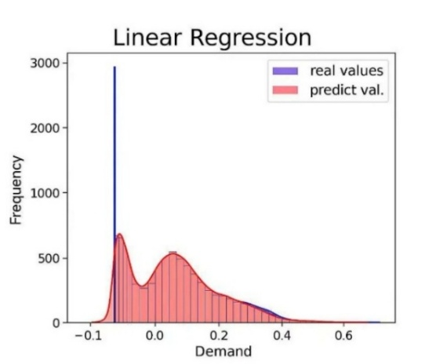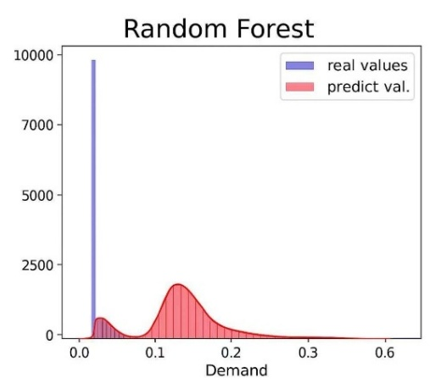
Figure 3-7 Comparison of Predicted and Real Demand Distributions for Two ML Models

3.3.3 Comparative Performance
Linear regression models lacks flexibility in dealing with nonlinear patterns common in demand data. Comparison from Table 3-8 shows that random forests outperform linear regression models due to predictive stability and ease of implementation in Python.
Table 3-8 Model Performance Comparison
K-Fold Validation | RMSE | R² | MSE | MAE
Linear Regression | 0.020 | 0.97 | 0.0004 | 0.006
Random Forest | 0.013 | 0.99 | 0.0002 | 0.004
Average | 0.016 | 0.98 | 0.0003 | 0.005

Project Version Management Plan

3.4.1 Gitee Repository
The project adopts Gitee as the main version control and project management platform. Create a private repository called “Shift-Management-System-LowCode” on Gitee.
Repository Link: https://gitee.com/chocbagel/shift-management-system-low-code.git

Figure 3-9 Repository Structure

3.4.2 Version Tracking and Updates
- Initialize Repository: create the Gitee repository and upload initial files.
- Commit Changes: add and update new modules at each stage of development.
- Tag Versions: mark stable updates as v1.0, v2.0, and v3.0 to record progress.
- Track History: view previous updates and version logs.

3.4.2 Version Log
Table 3-10 Version Log
Version | Date | Description
v1.0 | 2025-10-28 | Initial setup and repository creation
v2.0 | - | Add low-code prototype and model notebook
v3.0 | - | Final testing and optimization

Summary
This chapter outlined the methodology for rapidly developing a shift management system for catering enterprises using low-code technology, establishing a clear, practical framework to support efficient system implementation and validation in the following stages.
It describes the inefficiency of manual scheduling and proposes a combination of low-code development and optimization techniques. The mathematical foundation explains how to model allocation, demand forecasting, the dataset section describes data sources and processing workflows, and the technical section summarizes the tools and machine learning models used for implementation..

Chapter 4. Project Management

Activities
The main activities of this project are designed to achieve the objectives of developing and validating a low-code–based shift management system for catering enterprises.
Table 4-1 Project Activities and Objectives
Activity | Main Task | Objectives
Needs Analysis | Identify requirements and system functions | Requirement list
System Design | Define architecture, workflow, interface layout | System design diagram
Data Preparation | Collect and clean employee and sales data | Processed dataset
Develop Model | Build and test demand forecasting models | Trained model results
Optimization | Apply rules or algorithms for shift assignment | Optimized shift plan
Low-Code Implementation | Create user interface and workflow automation | Functional prototype
Testing | Verify accuracy and usability of the system | Test report
Version Management | Track code and updates through Gitee | Repository version log
Final Report | Summarize and prepare the defense | Completed report

Schedule
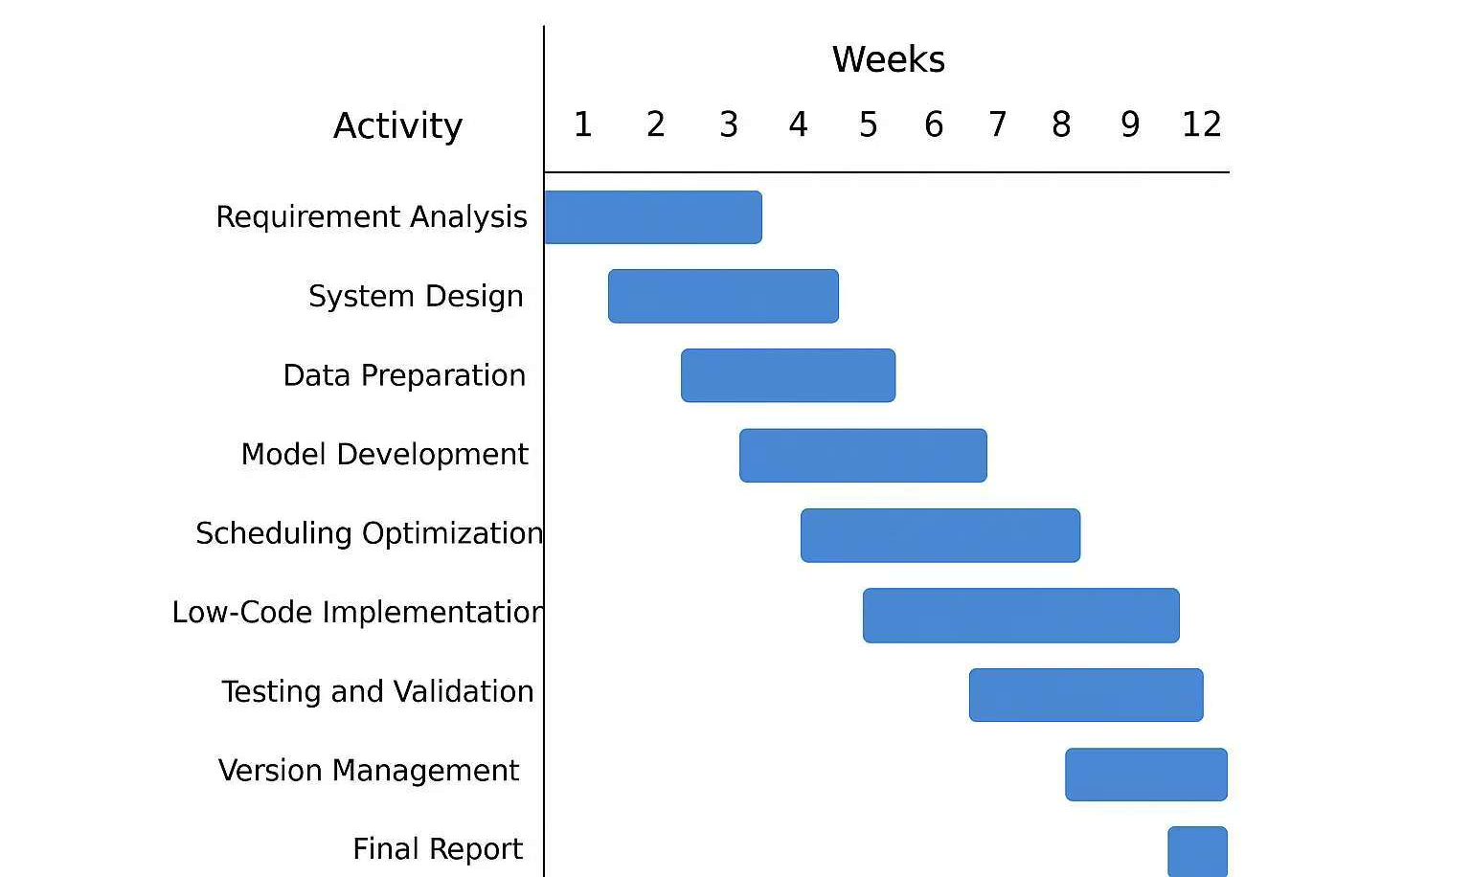
Figure 4-2 Project Schedule

Data Management Plan
To ensure project consistency and security, Gitee is used as the platform for managing all project data and resources.
- All project logs, reports, literature and code files are stored and updated in one private repository named “Shift-Management-System-LowCode”.
- Each update is committed with clear messages and version tags (v1.0, v2.0, v3.0) to record the development progress. The Gitee commit history provides a transparent view of all project changes, ensuring that every file and version can be retrieved when needed.
- Regular backups are performed through cloud storage, and repository access can be shared securely with supervisors for review.

Project Deliverables
After completing project, the following materials will be submitted for assessment:
- Project roposal
- Progress report
- Final report and documents
- Source code
- Low-code prototype
- Presentation slides
- Gitee repository link and version logs

References
[1] E. Álvarez, J. C. Ferrer, J. C. Muñoz, and C. A. Henao, “Efficient shift scheduling with multiple breaks for full-time employees: A retail industry case,” Computers & Industrial Engineering, vol. 150, 2020. [Online]. Available: https://doi.org/10.1016/j.cie.2020.106884
[2] A. C. Bock and U. Frank, “Low-Code Platform,” Business & Information Systems Engineering, vol. 63, no. 6, pp. 733–740, 2021. [Online]. Available: https://doi.org/10.1007/s12599-021-00726-8
[3] D. Di Ruscio, D. Kolovos, J. de Lara, A. Pierantonio, M. Tisi, and M. Wimmer, “Low-code development and model-driven engineering: Two sides of the same coin?,” Software and Systems Modeling, vol. 21, pp. 437–446, 2022. [Online]. Available: https://doi.org/10.1007/s10270-021-00970-2
[4] M. Hirzel, “Low-Code Programming Models,” Communications of the ACM, vol. 66, no. 10, pp. 76–84, 2023. [Online]. Available: https://doi.org/10.1145/3587691
[5] A. İşeri, H. Güner, and A. R. Güner, “Pareto-optimal workforce scheduling with worker skills and preferences,” Operational Research, vol. 25, p. 27, 2025. [Online]. Available: https://doi.org/10.1007/s12351-025-00903-7
[6] H. E. İnan, “Goal Programming Approach for Service Staff Scheduling Problem in a Restaurant,” Uluslararası Mühendislik Araştırma ve Geliştirme Dergisi, vol. 15, no. 3, pp. 123–132, 2023. [Online]. Available: https://doi.org/10.29137/umagd.1309302
[7] F. Kiermaier, M. Frey, and J. F. Bard, “The flexible break assignment problem for large tour scheduling problems with an application to airport ground handlers,” Journal of Scheduling, vol. 23, no. 2, pp. 177–209, 2020. [Online]. Available: https://doi.org/10.1007/s10951-019-00635-5
[8] M. Mac-Vicar, J. C. Ferrer, J. C. Muñoz, and C. A. Henao, “Real-time recovering strategies on personnel scheduling in the retail industry,” Computers & Industrial Engineering, vol. 113, pp. 589–601, 2017. [Online]. Available: https://doi.org/10.1016/j.cie.2017.09.045
[9] D. Pinho, A. Aguiar, and V. Amaral, “What about the usability in low-code platforms? A systematic literature review,” Journal of Computer Languages, vol. 74, 101185, 2023. [Online]. Available: https://doi.org/10.1016/j.cola.2022.101185
[10] P. M. Viera-González, O. H. González-González, and G. E. Sánchez-Guerrero, “Low-Code Automation for Resolving Incidents During Class Schedule Registration,” Computer, IEEE, vol. 58, no. 3, pp. 41–49, 2025. [Online]. Available: https://doi.org/10.1109/MC.2024.3510463

