UNDERGRADUATE PROJECT REPORT

Project Title | Rapid Development of a Low-Code Shift
 | Management System for Catering
 | Enterprises
Student ID | 202218010234
Supervisor Name | Dr.Monty
Student Name | Liu Yifei
Student Major

Date Submitted

Declaration
Chengdu University of Technology Oxford Brookes College
Chengdu University of Technology

BSc (Single Honours) Degree Project
Programme Name:
Module No.:
Surname:
First Name:
Project Title:
Student No.:
Supervisor:
2ND Supervisor (if applicable): Not Applicable

A report submitted as part of the requirements for the degree of BSc (Hons) in Computer Science
At
Chengdu University of Technology Oxford Brookes College

Date Submitted：May 6, 2026

Student Conduct Regulations
Please ensure you are familiar with the regulations regarding Academic Integrity. The University takes this issue very seriously, and students have been expelled or had their degrees withheld for cheating in assessments. Students experiencing difficulties with their work must seek help from their tutors rather than being tempted to use unfair means to gain marks. Students should not risk losing their degree and undermining all the work they have done towards it. You are expected to have familiarised yourself with these regulations. https://www.brookes.ac.uk/regulations/current/appeals-complaints-and-conduct/c1-1/
Guidance on the correct use of references can be found on www.brookes.ac.uk/services/library, and also in a handout in the library. The full regulations may be accessed online at https://www.brookes.ac.uk/students/sirt/student-conduct/. If you do not understand what any of these terms mean, you should ask your Project Supervisor to clarify them for you.
I declare that I have read and understood Regulations C1.1.4 of the Regulations governing Academic Misconduct and that the work I submit is fully in accordance with them.
Signature: |  | Date:
Regulations Governing the Deposit and Use of Oxford Brookes University Modular Programme Projects and Dissertations
Copies of projects/dissertations, submitted in fulfilment of Modular Programme requirements and achieving marks of 60% or above, shall normally be kept by the Oxford Brookes University Library.
I agree that this dissertation may be available for reading and photocopying in accordance with the Regulations governing the use of the Oxford Brookes University Library.
Signature: |  | Date:

Acknowledgement
Here, students are allowed to thank those who have provided them with assistance and support.

Abstract
This project focuses on shift scheduling in small and medium-sized catering businesses. In this industry, customer demand changes quickly during the day. Many managers still use Excel or paper to build schedules. This takes time, causes mistakes, and is difficult to update when staff are absent or demand changes. These problems can lead to understaffing at peak times or overstaffing at quiet times, which affects service quality and increases labour cost.
The aim of this project is to design and implement a practical shift management prototype using a low-code platform. The system uses AppSheet to build the user interface and workflows, and Google Sheets as the cloud database. A Python-based forecasting module is used for short-term demand forecasting and basic scheduling support. The scheduling logic follows a two-stage process: (1) estimate required staffing levels for each time period based on forecasted demand; (2) assign employees to shifts under key constraints such as role, availability, and fairness. To support day-to-day operations, the system also includes a rule-based recovery mechanism that suggests quick adjustments, such as shift transfer, overtime, or break changes, when disruptions occur.
Key achievements include the system architecture and data schema design, AppSheet prototypes for shift assignment, leave requests, and notifications, and a Random Forest-based forecasting module in Python. The system will be tested through functional validation, usability testing, and user feedback.

Keywords: low-code platform; shift management; catering industry; AppSheet; demand forecasting; workforce scheduling; rapid development

Abbreviations
Abbreviation | Full Meaning
API | Application Programming Interface
BCS | British Computer Society
CRM | Customer Relationship Management
ERD | Entity-Relationship Diagram
GDPR | General Data Protection Regulation
GUI | Graphical User Interface
KPI | Key Performance Indicator
LCDP | Low-Code Development Platform
MAE | Mean Absolute Error
MAPE | Mean Absolute Percentage Error
MSE | Mean Squared Error
R2 | Coefficient of Determination
RAD | Rapid Application Development
RMSE | Root Mean Square Error
SaaS | Software as a Service
SME | Small and Medium-sized Enterprise
SQL | Structured Query Language
UAT | User Acceptance Testing
UML | Unified Modeling Language

Glossary
AppSheet: A low-code development platform provided by Google that allows users to build web and mobile applications quickly by connecting directly to spreadsheet databases such as Google Sheets.
Demand Forecasting: The process of predicting short-term customer demand so the system can estimate how many staff are needed in each time period.
Low-Code Development Platform: A development environment that allows users to build applications using drag-and-drop interfaces and basic logic rather than writing complex lines of traditional code.
Random Forest: A machine learning algorithm used in this project as a forecasting module. It combines multiple decision trees to produce more stable and accurate predictions than a single decision tree model.
Rule-Based Recovery Mechanism: A set of preset rules that helps the system suggest quick adjustments when scheduling disruptions occur, such as absence or sudden demand changes.
Shift Management: The process of planning and assigning employee work shifts to match business demand, staffing availability, and operational needs.
Small and Medium-sized Enterprise: A business with limited staff and resources, which in this project refers to small and medium-sized catering businesses.
Cross-Platform Deployment: The ability of a software application to automatically adapt its layout and functionality across different environments and devices, such as switching from a bottom-tab view on mobile smartphones to a grid dashboard on desktop web browsers.
Rapid Application Development (RAD): An agile software engineering methodology adopted in this project that prioritizes rapid prototyping, quick user interface deployment, and iterative testing over rigid, traditional waterfall planning.
Workflow Automation: The digital execution of repetitive administrative tasks using background bots. In this system, it follows an "Event-Process-Task" logic to automatically route leave requests, update approval statuses, and trigger push notifications without manual intervention.

Table of Contents

Declaration I
Student Conduct Regulations II
Acknowledgement III
Abstract IV
Abbreviations V
Glossary VI
Table of Contents VII
Chapter 1. Introduction 1
1.1. Background of Study 1
1.2. Project Aim 1
1.3. Project Objectives 1
1.4. Project Overview 2
1.4.1. Scope 2
1.4.2. Audience 2
1.5. Structure of the Project Report 3
Chapter 2. Background Review 4
2.1. Fundamental Description of Software 4
2.2. Background Review 4
2.2.1. Shift Scheduling in the Catering Industry 4
2.2.2. Low-Code Development Platforms 5
2.2.3. Demand Forecasting and Evaluation Metrics 5
2.4. Limitations of Existing Works 6
2.5. Summary 6
Chapter 3. Methodology 7
3.1. Problem Statement 7
3.2. Approach 7
3.2.1. Software Development Method 7
3.2.2. Requirements Gathering 7
3.2.3. Testing and Evaluation Techniques 10
3.3. Technology 11
3.3.1. Software Environment 11
3.3.2. Hardware Environment 11
3.4. Project Version Management Plan 12
3.5. Summary 12
Chapter 4. Implementation and Results 13
4.1. Deployment Environment Details 13
4.2. Unit Test 13
4.2.1. Unit Test for Role-Based Access Control 13
4.2.2. Unit Test for Shift Assignment Constraints 14
4.3. Integration Tests 15
4.3.1. Integration Test for Workflow Automation 15
4.3.2. Integration Test for Analytical Forecasting 15
4.4. Software Graphical Interface and System Implementation 16
4.4.1. Manager Perspective 16
4.4.2. Employee Perspective 21
4.5. Quantitative Evaluation and Results 23
4.5.1. Forecasting Model Performance 23
4.5.2. Operational Efficiency Comparison 24
4.6. Summary 25
Chapter 5. Professional Issues 26
5.1. Project Management 26
5.1.1. Activities 26
5.1.2. Schedule 27
5.1.3. Project Data Management 28
5.1.4. Project Deliverables 28
5.2. Risk Analysis 28
5.3. Professional Issues 30
5.4. Summary 31
Chapter 6. Conclusion 32
6.1. Findings and Conclusions 32
6.2. Limitations of your Project 32
6.3. Potential Future Work 33
References 34
Appendices 36

Introduction

Background of Study
The catering industry faces significant challenges in managing employee shifts due to high customer demand fluctuations. Traditional shift management methods, such as manual scheduling using spreadsheets, are inefficient, prone to errors, and lack the flexibility to adapt to sudden changes [1]. These issues often lead to understaffing during peak hours or overstaffing during quiet periods. This situation ultimately reduces service quality and unnecessarily increases labor costs [2]. Previous research shows that adding flexible breaks and rescheduling shifts can significantly improve staff utilization [3]. However, it typically needs to be achieved through a large of complex optimization models, requiring massive datasets and expert maintenance, which is unsuitable and expensive for small and medium-sized enterprises (SMEs).
To address these inefficiencies, low-code development platforms (LCDPs) have emerged as a practical alternative. These platforms enable developers to rapidly build functional enterprise applications using visual interfaces and pre-built components [4]. For example, low-code solutions have been successfully applied to automate administrative workflows and improve service response times without modifying legacy systems [5]. LCDPs offer high usability and cost-effectiveness, making them ideal for SMEs with limited technical resources.
However, pure low-code platforms often lack the computational power to handle complex tasks, such as demand forecasting. Effective shift management must calculate diverse requirements including skill matching, labor fairness, and emergency adjustments. Therefore, this project proposes a hybrid approach, and develops a practical shift management system for SMEs in the catering industry by combining a rapid low-code user interface with an external Python-based forecasting model. Compared with traditional manual methods, the proposed system aims to achieve an accurate, flexible, and automated shift management workflow.

Project Aim
The overall aim of this project is to design and implement a low-code shift management system integrated with a demand forecasting module tailored for SMEs in the catering industry. This system intends to replace traditional manual scheduling with automated digital workflows to improve scheduling efficiency, reduce manual errors, and optimize labor costs.

Project Objectives
To achieve overall project, the specific objectives are implemented as shown in Table 1-1.
Table 1-1 Project objectives
Objective-1 | Analyze the core requirements of catering staff scheduling and define formal rules, such as skill matching and emergency adjustments.
Objective-2 | Design a complete system architecture utilizing software engineering diagrams (such as Entity-Relationship diagrams, use cases, and business workflows) to standardize the development process.
Objective-3 | Develop a fully functional low-code prototype using AppSheet and Google Sheets, integrated with an external Python demand forecasting module.
Objective-4 | Test predictive models (via Root Mean Square Error and Mean Absolute Error) and compare the system's operational efficiency with traditional spreadsheet methods.
Objective-5 | Apply professional project management techniques (GitHub) to ensure trackable software delivery.

Project Overview
This project develops a low-code shift management system for SMEs in the catering industry. The system uses a rapid application development approach to support daily scheduling tasks. It integrates AppSheet for the front-end user interface, Google Sheets for cloud data storage, and a Python module for data analysis. The primary goal is to build a practical tool that improves scheduling accuracy and operational flexibility.

Scope
The software supports core scheduling tasks, including shift assignment, leave request management, shift transfer approvals, and automated notifications. It will also provide short-term demand forecasting and rule-based recovery suggestions to handle sudden changes. Additionally, the software will work through a hybrid architecture. AppSheet will manage the graphical user interface and automated business workflows. Google Sheets will act as the relational database to store employee records and schedules. And the external Python script will process historical data to forecast future requirements by using as Random Forest algorithm. The project focuses on building a practical prototype that helps managers complete scheduling tasks more efficiently with fewer manual errors.

Audience
The software is designed for three main groups of primary users:

- Catering Managers and Supervisors: Managers and supervisors in SMEs in the catering industry will get a fast-deploy tool to assign shifts efficiently, reduce manual errors, and respond quickly to unexpected demand changes. The system provides transparency in scheduling decisions and helps improve communication between management and employees.
- Small and Medium-sized Enterprise Owners: Business owners will benefit from the cost-effectiveness of the low-code platform. The low-code approach ensures the system can be quickly customized to their specific needs, helping them optimize labor costs and maintain service quality without expensive custom development.
- Software Developers and IT Consultants: Technical professionals interested in practical applications of low-code platforms can use this project as a reference. It demonstrates how AppSheet can be integrated with cloud database Google Sheets and external analytical components to solve complex business logic and balance rapid development with functional requirements.

Structure of the Project Report
This project report is organized into six chapters to present the research, development, and evaluation process. Figure 1-1 illustrates the overall structure of the thesis.
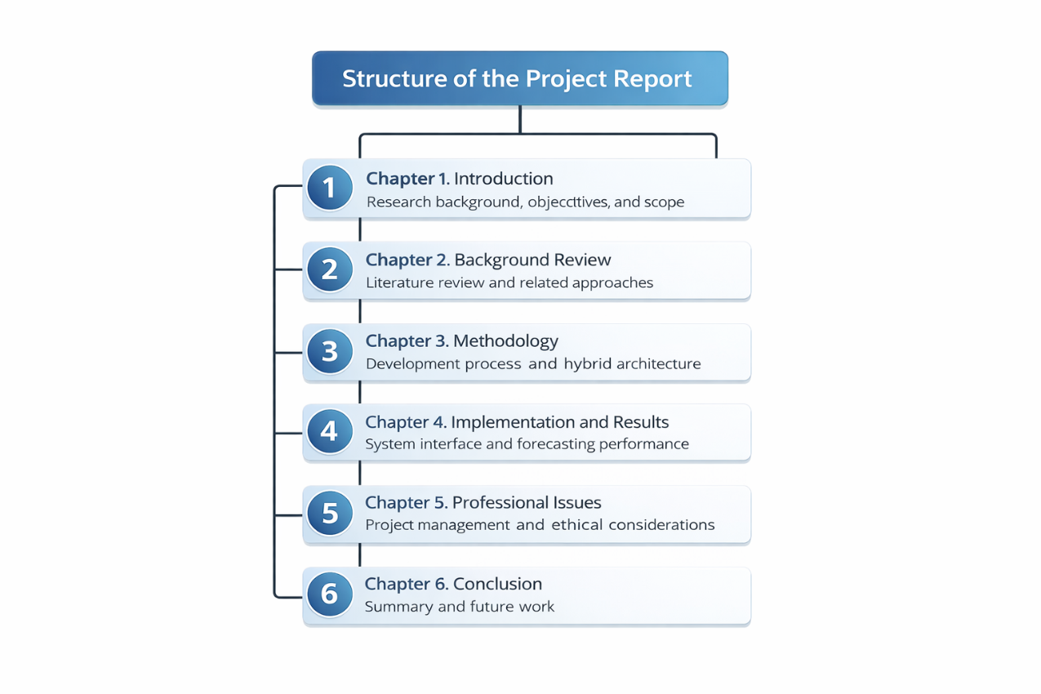
Figure 1-1 Thesis structure flowchart

Background Review
This chapter reviews the fundamental concepts, existing literature, and competitive software approaches related to workforce scheduling. It provides a clear technical foundation for the proposed shift management system through critically analyzing current industry solutions.

Fundamental Description of Software
In modern business environments, shift management software is an essential tool used to allocate human resources efficiently. The main function is to track employees availability, assign specific working hours, and manage leave requests. For small and medium-sized enterprises (SMEs), these tools help ensure that enough staff are available to meet customer demand while controlling labor costs.
Low-code development platforms (LCDPs) provide a simple way to build applications. They allow developers and business users to create complete applications rapidly using visual drag-and-drop interfaces instead of writing complex lines of code. This approach reduces development time and makes the process more accessible. The software developed in this project combines these two concepts: using a low-code platform to build a shift management interface quickly. This project combines both ideas. It uses a low-code platform to quickly develop a shift management system, making the solution practical and efficient.

Background Review
The following subsections will explore three core themes: the specific challenges of scheduling in the catering industry, the technical evolution of low-code platforms, and the application of demand forecasting algorithms.

Shift Scheduling in the Catering Industry
Shift scheduling in the catering industry is a highly dynamic and complex process. It requires assigning employees to specific working hours while balancing fluctuating customer demand and staff availability. Defraeye and Van Nieuwenhuyse [6] highlighted in their comprehensive review that customer traffic in service industries changes unpredictably within a single day, an issue known as nonstationary demand. Managing these variables manually using spreadsheets or paper is time-consuming and highly prone to human error [1]. When unexpected changes occur, this often results in harming service quality and increasing labor costs. To optimize it, adding flexible breaks and overlapping shifts can significantly improve staff utilization [3]. However, a critical appraisal of these mathematical optimization models reveals a major practical limitation. While theoretically robust, these solutions remain financially and technically inaccessible for typical catering SMEs.

Low-Code Development Platforms
LCDPs have emerged as a powerful alternative for accelerating enterprise software development. They support the rapid development of business applications by integrating database connectivity and automated workflows nativel [4]. Research shows that low-code solutions can successfully digitize complex administrative workflows in a matter of days, significantly reducing manual effort [5]. Di Ruscio et al. [7] further explained that LCDPs abstract complex coding into simple visual models, offering high usability and low maintenance costs. However, pure low-code platforms possess certain limitations. Khorram et al. [8] noted in their systematic literature review that while low-code platforms excel at data collection and basic workflow automation, they inherently struggle with executing complex algorithms or advanced data processing internally. This indicates that to build an intelligent shift management system, a low-code front-end must be integrated with an external analytical backend.

Demand Forecasting and Evaluation Metrics
To manage shifts accurately, the system must predict future staffing requirements. Ribeiro et al. [9] investigated restaurant sales forecasting and proved that machine learning algorithms capture daily seasonal peaks much better than traditional linear methods. For practical enterprise applications, ensemble machine learning algorithms like Random Forest , introduced by Breiman [10], provide excellent predictive stability without the high computational cost of deep learning networks. And the accuracy of forecasting models must be evaluated quantitatively using standard statistical metrics. Chai and Draxler [11] strongly advocated for the Root Mean Square Error (RMSE) to penalize large prediction variance in models. Conversely, Willmott and Matsuura [12] highlighted the benefits of the Mean Absolute Error (MAE) for providing a natural average of error magnitude. In this project, the RMSE will be utilized as a core evaluation metric for the Python forecasting module, calculated using the following standard equation:
$$RMSE=\sqrt{\frac{1}{n}\sum_{i=1}^{n}{(}y_{i}-{\overset{^}{y}}_{i})^{2}}$$ | (2-1)
Where $n$ represents the number of observations, $y_{i}$ is the actual demand, and ${\overset{^}{y}}_{i}$ is the predicted demand.

Comparative Analysis of Software Features
This section provides a competitive analysis of existing workforce management methods. Table 2-1 compares traditional manual methods, commercial Software-as-a-Service (SaaS) products, custom Enterprise Resource Planning (ERP) systems, and the proposed hybrid low-code system.
Table 2-1 Comparative analysis of shift management approaches
Software Approaches | Low Cost and High Usability | Rapid Deployment | Automated Workflows | Demand Forecasting
Manual Methods (Excel/Paper) | Yes | Yes | No | No
Commercial SaaS Solutions | No | Yes | Yes | No
Custom ERP Systems | No | No | Yes | Yes
Proposed Low-Code System | Yes | Yes | Yes | Yes

Limitations of Existing Works
- Lack of Automation: Traditional manual methods (like Excel) completely lack automated workflows. They cannot automatically notify staff of schedule changes or route leave requests for approval.
- High Cost: Advanced optimization software and custom ERP systems are too expensive for small businesses. They also require professional IT maintenance.
- Lack of Analytical Power in LCDPs: While commercial low-code platforms are cost-effective, they lack native demand forecasting capabilities and faces advanced scheduling constraints.
To overcome these limitations, this project proposes a hybrid software architecture. By integrating a rapid low-code front-end (AppSheet) with an external Python-based machine learning module, the system automates workflows and demand forecasting while keeping low development costs.

Summary
This chapter provided a fundamental description of shift management tools and low-code platforms. The literature review highlighted the inefficiencies of manual scheduling and the limitations of low-code platforms. The comparison shows that existing solutions either lack automation or are too expensive for SMEs. The proposed hybrid low-code system provides a powerful solution to address these shortcomings.

Methodology
This chapter details the methodology adopted for the development of the low-code shift management system. It outlines the problem statement, the chosen software development model, requirement-gathering techniques, evaluation methods, and the version management strategies.

Problem Statement
Shift management in SMEs is highly dynamic due to nonstationary customer demand. Currently, managers rely on manual spreadsheet methods, which lack automated workflows and predictive analytical capabilities. This results in frequent scheduling conflicts, understaffing during peak hours, and unfair shift distributions among employees. Furthermore, existing mathematical optimization models and custom ERP systems are prohibitively expensive and require expert IT maintenance. Therefore, the core problem is how to design a cost-effective, rapid-deployment scheduling system that integrates automated administrative workflows with intelligent demand forecasting to optimize labor allocation under complex business constraints.

Approach

Software Development Method
To facilitate the rapid development of functional systems for catering SMEs, the Rapid Application Development (RAD) methodology was adopted. Unlike the traditional Waterfall model, RAD emphasizes rapid prototyping, iterative delivery, and continuous user feedback, rather than rigorous planning. And the use of low-code development platforms (AppSheet) complements the RAD methodology, allowing projects to skip complex front-end coding and focus directly on database schema design, workflow automation, and the integration of the external Python-based forecasting module.

Requirements Gathering
Identifying core business needs through analyzing catering scenarios. The system requirements and architectures are formalized using standard UML and system design diagrams.
      - Use Case and System Architecture
The system identifies three primary actors: Administrator, Manager, and Employee. The Administrator manages global settings and data schemas. The Manager handles core requirements such as shift assignment, order forecasting, and leave approvals. Employees have permissions to view their schedules and submit leave requests. Figure 3-1 illustrates the formal Use Case Diagram.
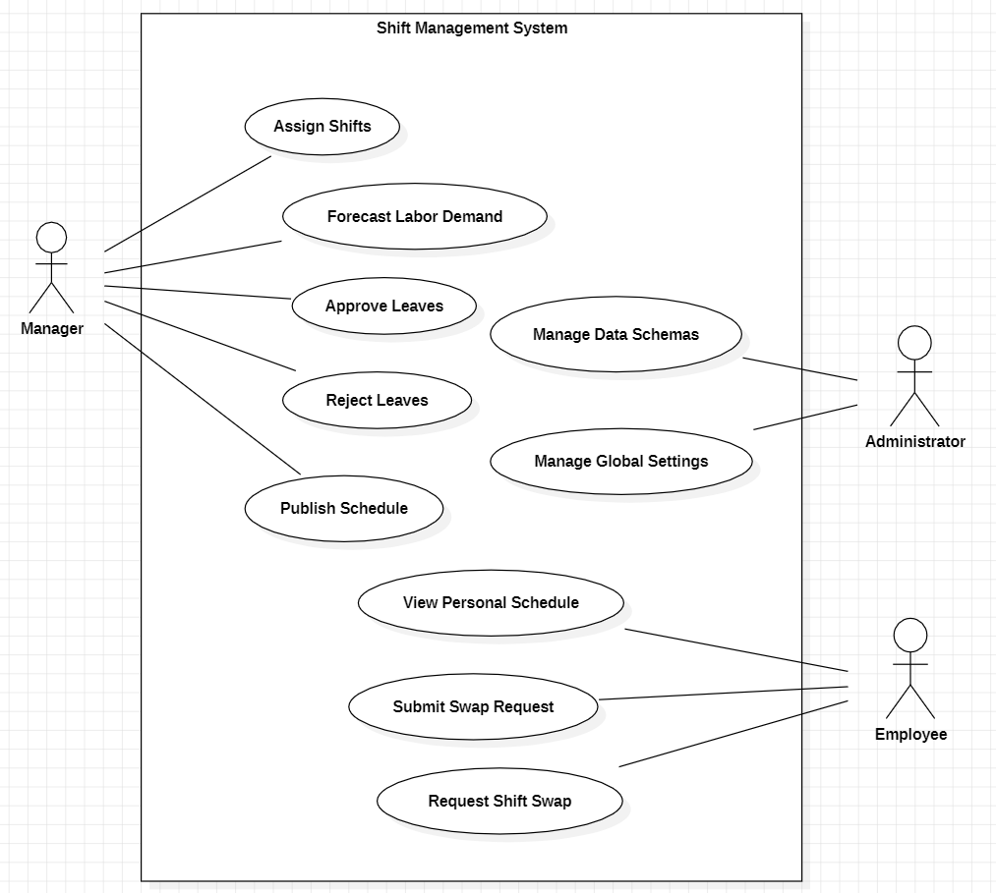
Figure 3-1 System Use Case Diagram
The system architecture consists of the following logical layers:
- Front-End and Workflow Layer (AppSheet): Acts as the user interface for managers and staff. It handles data entry validation, displays the interactive schedule dashboard, and executes automation bots (e.g., sending notifications for pending leave requests).
- Cloud Database Layer (Google Sheets): Serves as the relational database. It stores all entity records and provides a structured, easily accessible schema.
- External Analytical Component (Python): A localized Python script that fetches historical sales data from the database, processes it, and generates short-term labor demand forecasts.
      - Database Design and Entity-Relationship (E-R) Diagram
To support complex scheduling logic, a relational database is designed using Google Sheets. The core entities include Employees, Shifts, Assignments, LeaveRequests, and DemandData. Figure 3-2 is the E-R Diagram, illustrating the one-to-many and many-to-many relationships between staff availability and shift requirements.
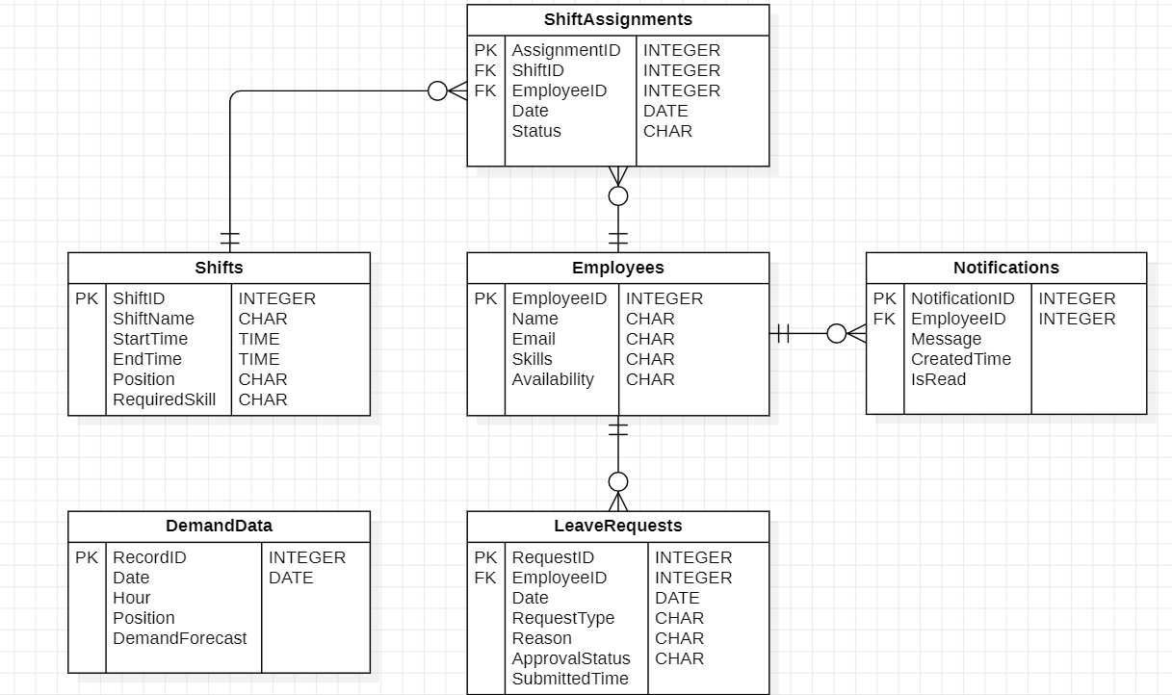
Figure 3-2 Entity-Relationship (E-R) Diagram
      - Scheduling Rules and Business Workflow
- Hard Constraints: Exact skill matching and employee availability validation (preventing double-booking).
- Emergency Adjustments (Rule-based recovery logic): Implement rule-based heuristics to solve the daily scheduling problem. When an unexpected absence occurs, the system guides the manager through a pre-defined workflow: (a) attempting to transfer available staff from low-priority roles; (b) suggesting overtime to qualified on-site employees; or (c) reassigning break times to cover critical peak hours.
Figure 3-3 illustrates the business workflow of the system.
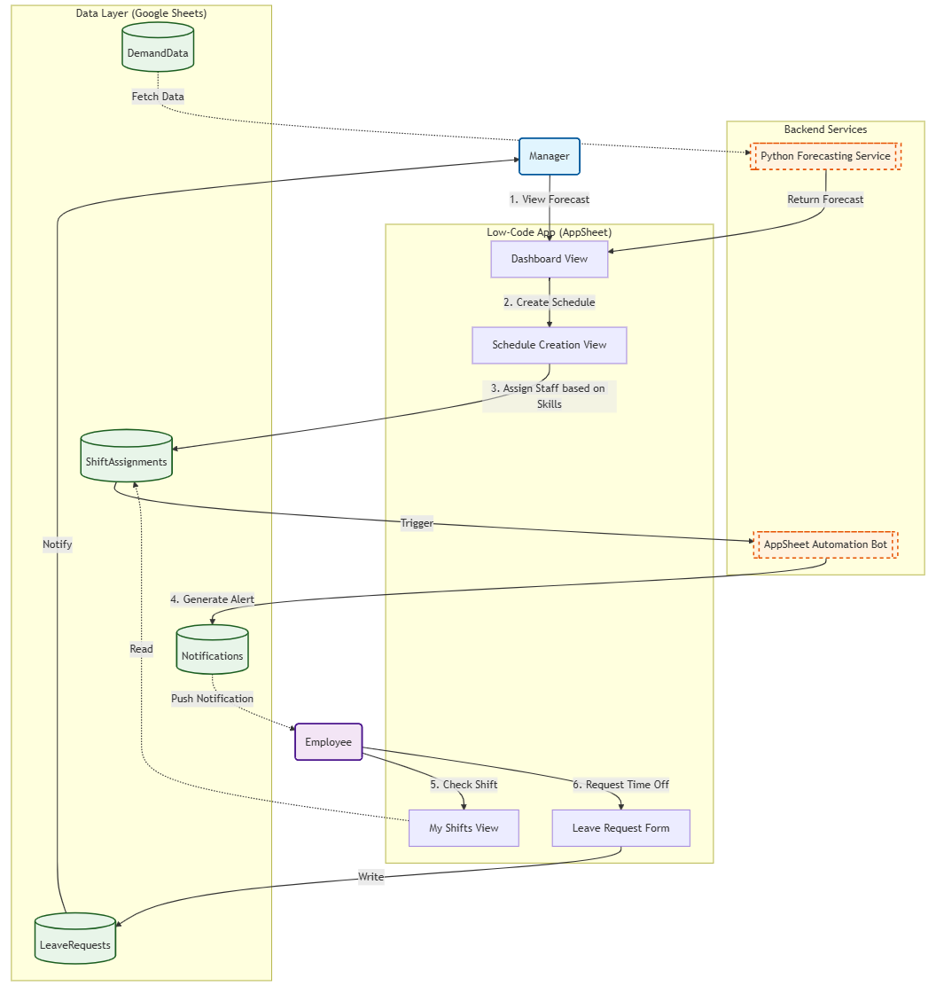
Figure 3-3 Business workflow diagram

Testing and Evaluation Techniques
- Functional and Integration Testing: Unit tests will validate GUI interactions, rule-based constraints, and event-triggered bots in AppSheet. Integration testing will evaluate the data synchronization latency between the AppSheet front-end, Google Sheets database, and Python backend.
- Quantitative Model Evaluation: The short-term demand forecasting module utilizes the Random Forest algorithm. Instead of relying solely on visual line charts, the model's performance will be quantitatively evaluated using cross-validation. The prediction accuracy will be measured using the Root Mean Square Error (RMSE) and Mean Absolute Error (MAE).
- Operational Efficiency Comparison: The final prototype will be compared against traditional Excel methods to quantitatively measure the reduction in scheduling time and manual error rates.
To generate the demand forecast, the external Python component utilizes the Random Forest algorithm. The data processing technique involves chronological data splitting (as shown in Figure 3-4, the first 80% of time-series data for training and the recent 20% for testing). This script cleans up missing values ​​using linear interpolation, extracts cyclical time features and writes the predicted requirement back to DemandData table. Then AppSheet front-end reads this data to suggest.
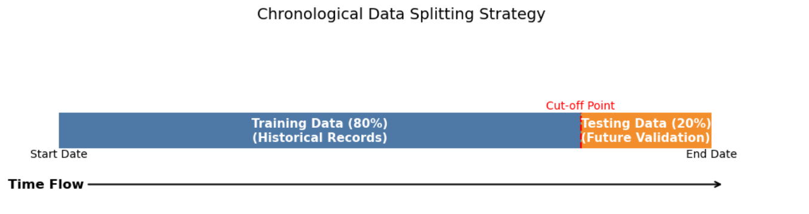
Figure 3-4 Chronological Data Splitting Strategy

Technology
This section outlines the implementation tools and resources adopted to construct the system. The project integrates cloud-based low-code services with local data processing environments.

Software Environment
Table 3-1 Software Environment
Category | Platform | Purpose in Project
Low-Code Platform | Google AppSheet | Build the web/mobile user interface and configuring automatic logic
Database | Google Sheets | Act as the cloud-based relational database
Programming Language | Python 3.10 | Develop the demand forecasting and data processing scripts
Data Library | Pandas;  Scikit-Learn | Handle data manipulation and the Random Forest algorithm
IDE | Jupyter Notebook | Prototype and test the Python analytical code

Hardware Environment

Table 3-2 Hardware Environment
Component | Specification
Processor | Intel Core i5 (3.10 GHz)
RAM | 16 GB
Storage | 477 GB
Operating System | Windows 11 (64-bit)

Project Version Management Plan
To ensure the security, traceability, and recoverability of the source code and project documentation, GitHub was adopted as the primary project version management tool.
Repository link: https://github.com/chocbagel/Shift-Management-System-LowCode.git
- Source code: Python forecasting scripts and data processing models are committed immediately after successful local testing.
- Documentation: Project reports, requirement lists, and dataset schemas are regularly pushed to the repository to maintain secure backups.
- Tag Versions: Mark stable updates as v1.0, v2.0, and v3.0 to record progress.

Summary
This chapter defined the methodology used to develop the low-code shift management system. By adopting the RAD model, the project focuses on rapid prototyping and iterative improvement. The requirement-gathering section formalized the system design through Use Case, E-R, and Business Workflow diagrams, explicitly defining complex scheduling constraints.

Implementation and Results
This chapter details the final implementation, user interface, and test results of the low-code shift management system. It demonstrates practical applications of the graphical user interface (GUI) (including web/mobile), cross-platform deployment, workflow automation, and system integration. It will critically evaluate the operational efficiency of this system compared to traditional manual scheduling methods and quantitatively analyzes the performance of the integrated forecasting model.

Deployment Environment Details
The system operates on a hybrid architecture that combines a cloud-based low-code platform with a local analytical environment. The front-end user interface and automated workflows are deployed on Google AppSheet. And the database is hosted on Google Sheets, providing a structured and accessible relational data schema. The short-term demand forecasting module is deployed in a local Python 3.10 environment. The hardware used for data processing includes an Intel Core i5 processor with 16 GB of RAM. The Python environment utilizes the Pandas library for data manipulation and Scikit-Learn for machine learning model training.

Unit Test
Unit testing ensures that individual components of the shift management system function correctly. The testing focuses on user access control, data validation, and business logic constraints.

Unit Test for Role-Based Access Control
The system utilizes a role-based permission design to secure data access. System administrators and managers require full access to all scheduling functions, while ordinary employees only need read-only access to their personal schedules.

Table 4-1 Unit test for role-based access
Step | Action | Expected Result | Actual Result | Status
1 | Log in using a manager account | Full dashboard loads; Full navigation loads | All management views displayed | Pass
2 | Navigate to shift schedule details and click "edit" | The edit form opens successfully | Edit form displayed | Pass
3 | Log out and log in using an employee account | The system hides the manager dashboard; Only "my request" and "my shifts" are visible | Only employee-specific views displayed | Pass
4 | Attempt to edit the shift schedule | The system blocks the action and shows a read-only interface | Edit button is hidden; Data is read-only | Pass

Unit Test for Shift Assignment Constraints
This test evaluates the system's ability to prevent logical scheduling errors through AppSheet data validation formulas.
Table 4-2 Unit test for assignment constraints
Step | Action | Expected Result | Actual Result | Status
1 | Manager creates a new shift schedule on web interface | The new shift schedule form opens | Form opens successfully | Pass
2 | Manager selects an employee whose status is "Leave" for the selected date | The Valid_If constraint flags the employee as unavailable | Employee marked as invalid selection | Pass
3 | Manager attempts to save the record. | The system displays the error message and prevents updating data | Error message shown; Cannot save | Pass

Integration Tests
Integration testing evaluates the data flow between the AppSheet front-end, Google Sheets database, and the external Python forecasting module.

Integration Test for Workflow Automation
The connection between the "Request" and "Approval" modules is driven by an automated "Event-Process-Task" bot. The logical workflow is implemented as follows:
- Trigger Event: An employee submits a new record via the "Requests" form.
- System Process: The system defaults the ApprovalStatus to "Pending". This specific status change acts as a condition that triggers the automation bot.
- Automated Task: The bot automatically routes this record to the manager's "Approvals" view and sends a push notification to the manager's device.
- Feedback Loop: Once the manager clicks "APPROVE", the bot updates the database in Google Sheets, automatically modifies the employee's availability status, and notifies the employee of the final decision.
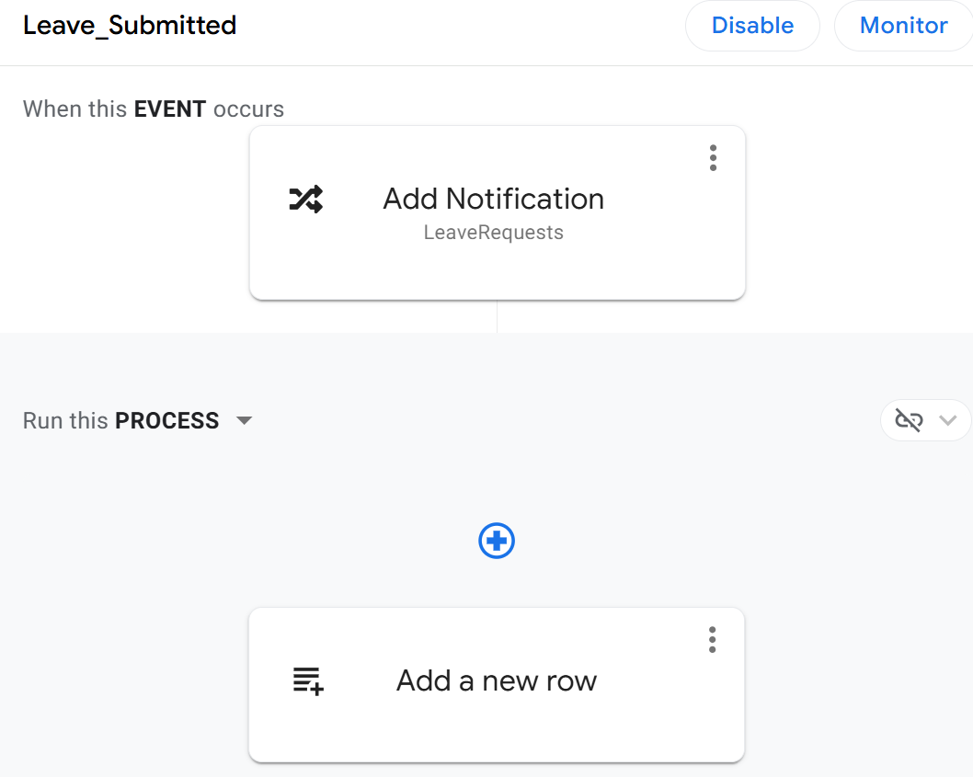
Figure 4-1 Leave-submitted bot

Integration Test for Analytical Forecasting
This test evaluated the connection between the cloud database and the local Python script. The Python module successfully fetched historical catering sales data from Google Sheets, executed the Random Forest algorithm, and wrote the new short-term demand forecast values back to the database. The AppSheet GUI automatically refreshed to display the updated staffing suggestions, confirming the stability of the hybrid architecture.
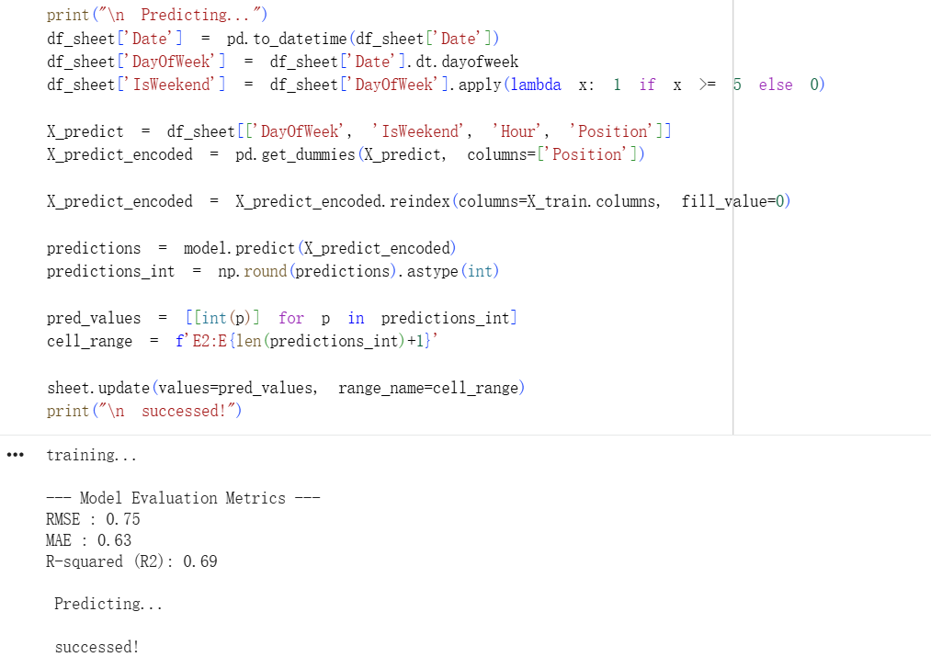
Figure 4-2 Analytical forecast

Software Graphical Interface and System Implementation
The GUI is designed to provide tailored experiences for different user roles. The low-code platform enables cross-platform deployment, automatically adapting the layout for desktop web browsers and mobile devices.

Manager Perspective
      - Dashboard and Navigation
The manager dashboard interface is optimized for desktop web browsers to handle complex data matrices and scheduling tasks, that displays three core modules: Pending Approvals, Staff Demand, and Role Distribution.
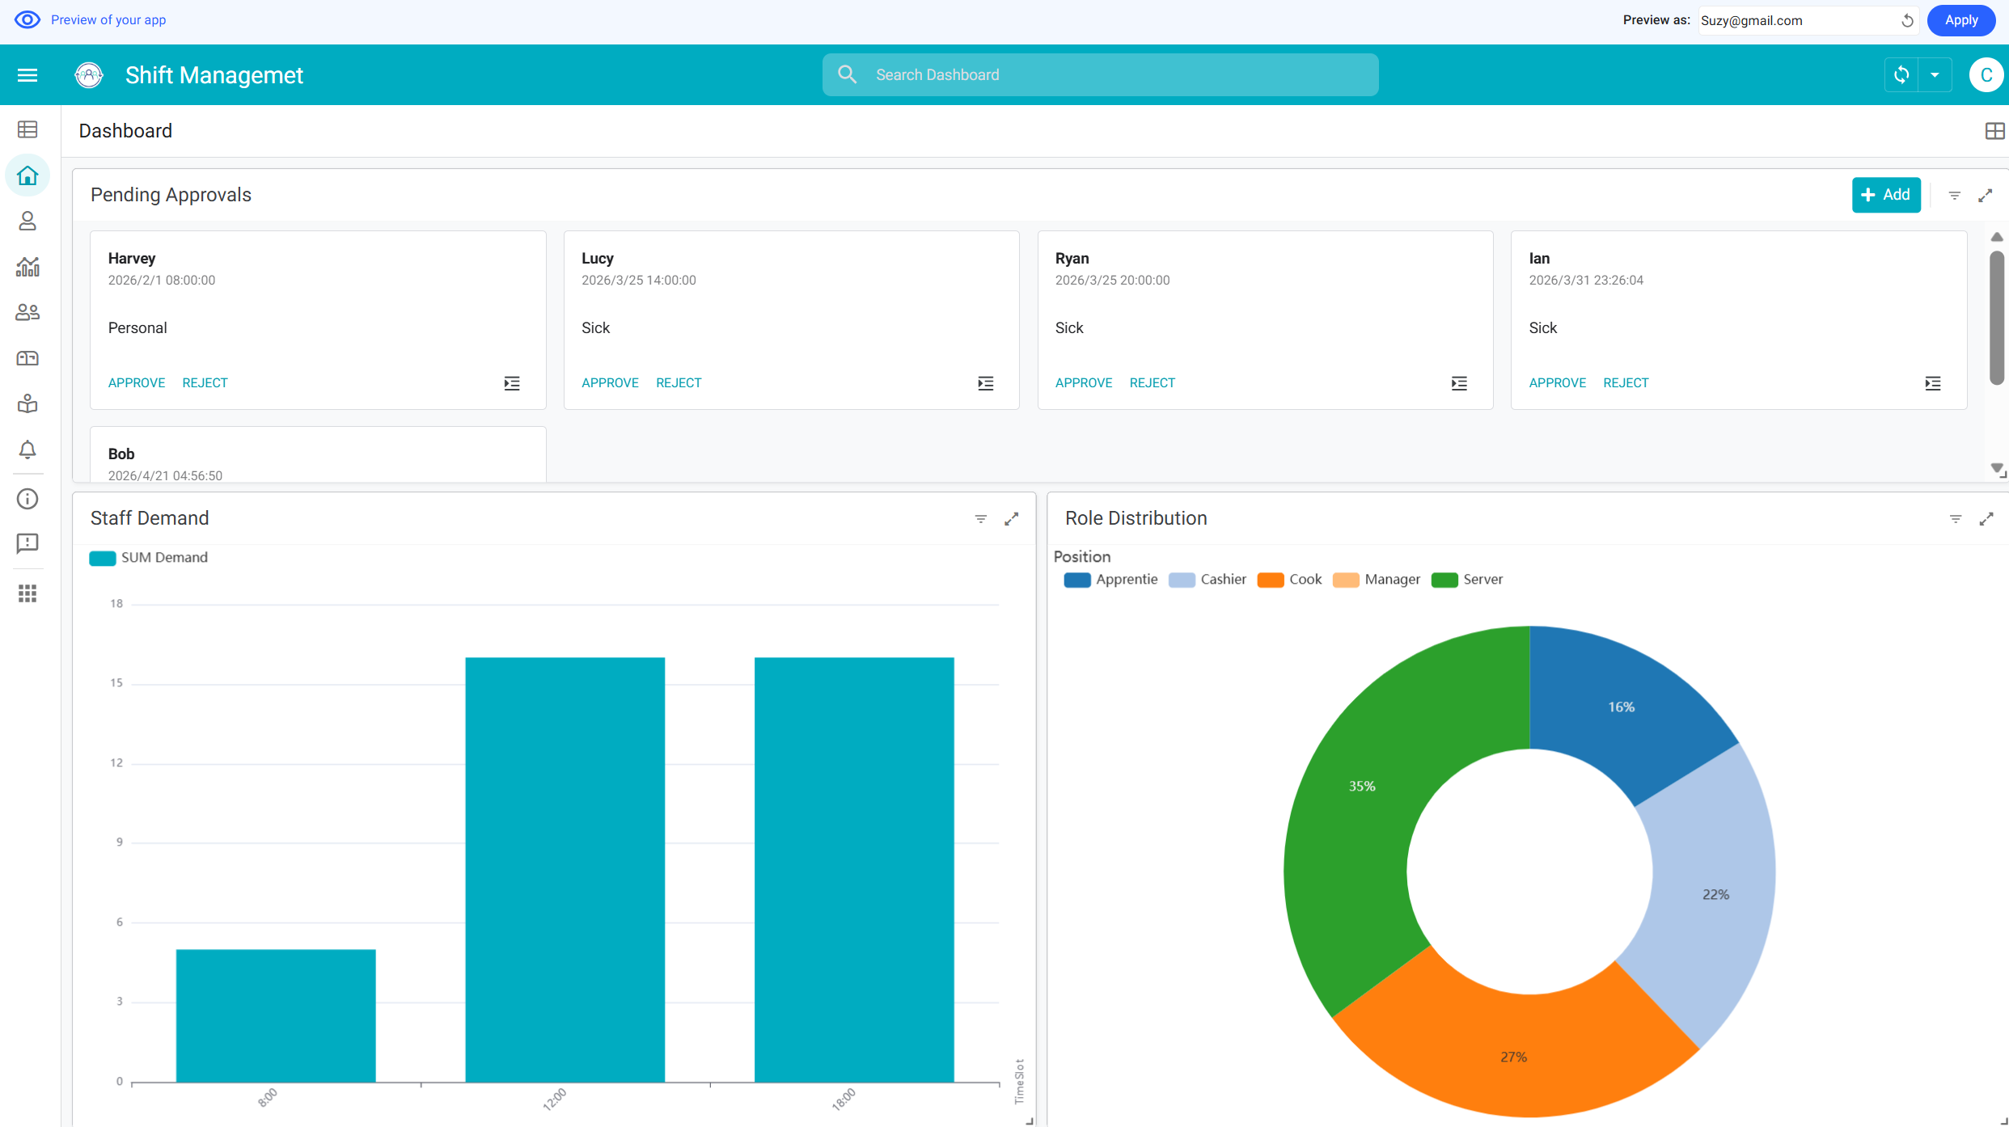
Figure 4-3 Manager dashboard (web GUI)
For mobile users, the interface automatically reorganizes into a highly accessible tabbed view. The menu navigation offers extended options like "Feedback", and several modules already displayed on the main dashboard are also collapsed into this menu, while the primary navigation bar provides quick access to several frequently used pages.
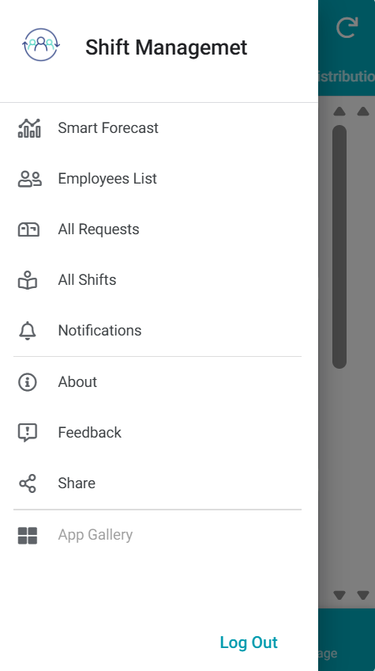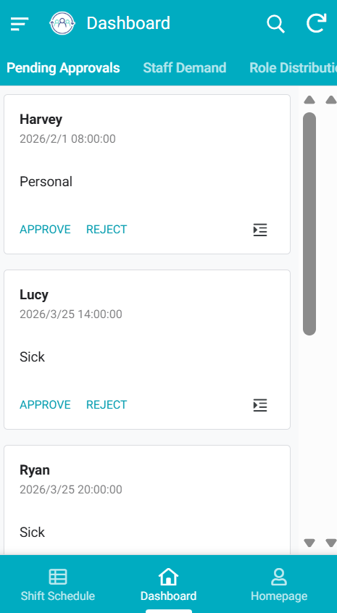
Figure 4-4 Menu navigation (left) and primary navigation (right) (mobile GUI)
      - Shift Scheduling and Schedule Details
When navigating to this view, managers can review all scheduled shifts. The system clearly lists all shift assignments and tracks whether the schedule has been published.
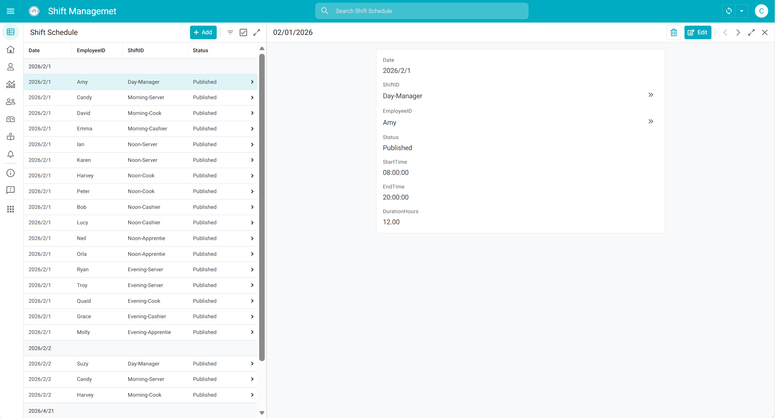
Figure 4-5 Shift schedule (web GUI)
      - Employees List and Employee Details
The system categorizes employees by practical catering roles, including Manager, Server, Cook, Cashier, Apprentie, and All. Manager can add new employees, edit or delete the information of existing employees.
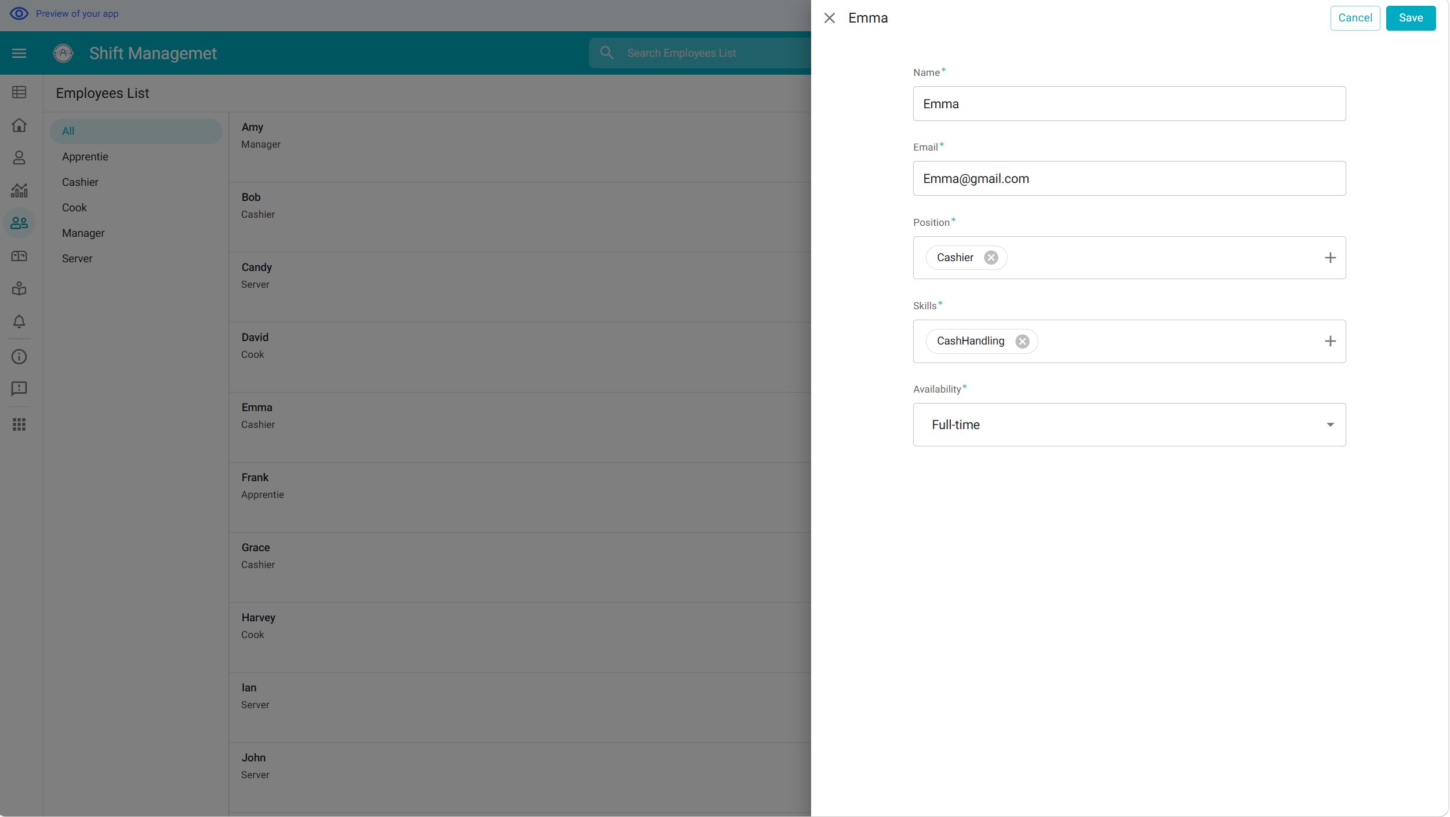
Figure 4-6 Employees list (web GUI)
      - Requests List and Pending Approvals
“All Requests" view acts as a centralized database for all staff applications. The platform automatically categorizes records into two types: Leave and Swap. As illustrated in the interface, managers can track the history of applications.
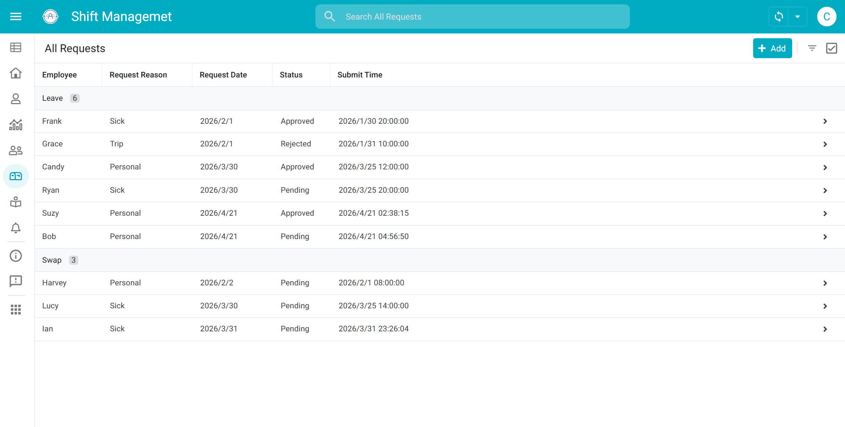
Figure 4-7 All requests list (web GUI)
To streamline the manager's decision-making process, a dedicated "Approvals" dashboard was designed using AppSheet's Card View layout. Unlike the dense table format of the Requests view, the Approvals view is highly focused, displaying only actionable, "Pending" requests.
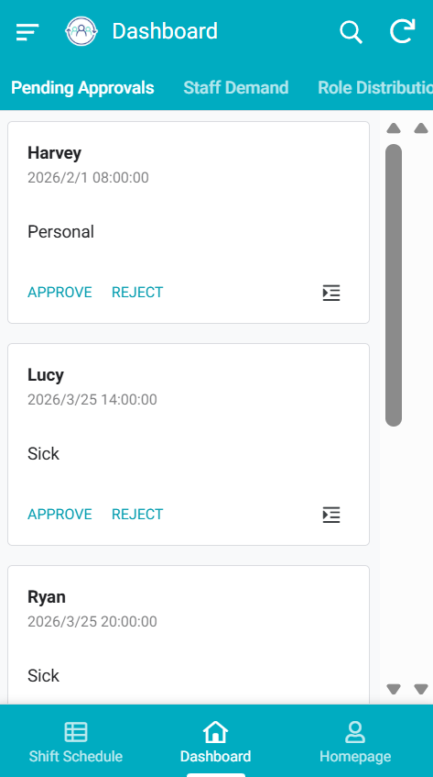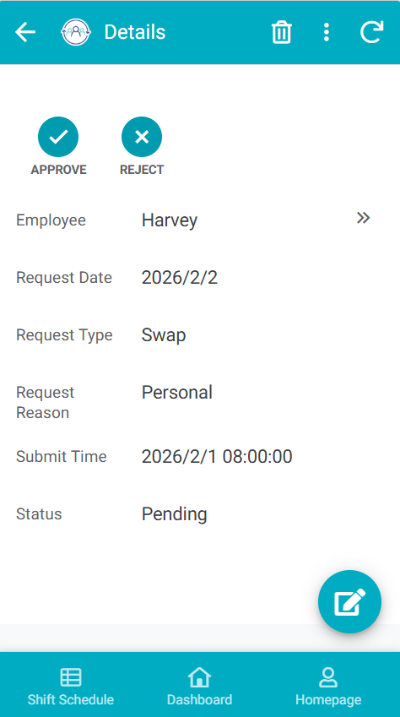
Figure 4-8 Pending approvals and details (mobile GUI)
      - Shifts List and Shift Details
The “All Shifts” interface displays the shifts with start and end time, that managers can select a shift to view more details. And the detail view shows more information including the selected shift, including its time, type, position, and required skill, that managers can add, edit or delete. The related Assignments section below lists the employees assigned to this shift.
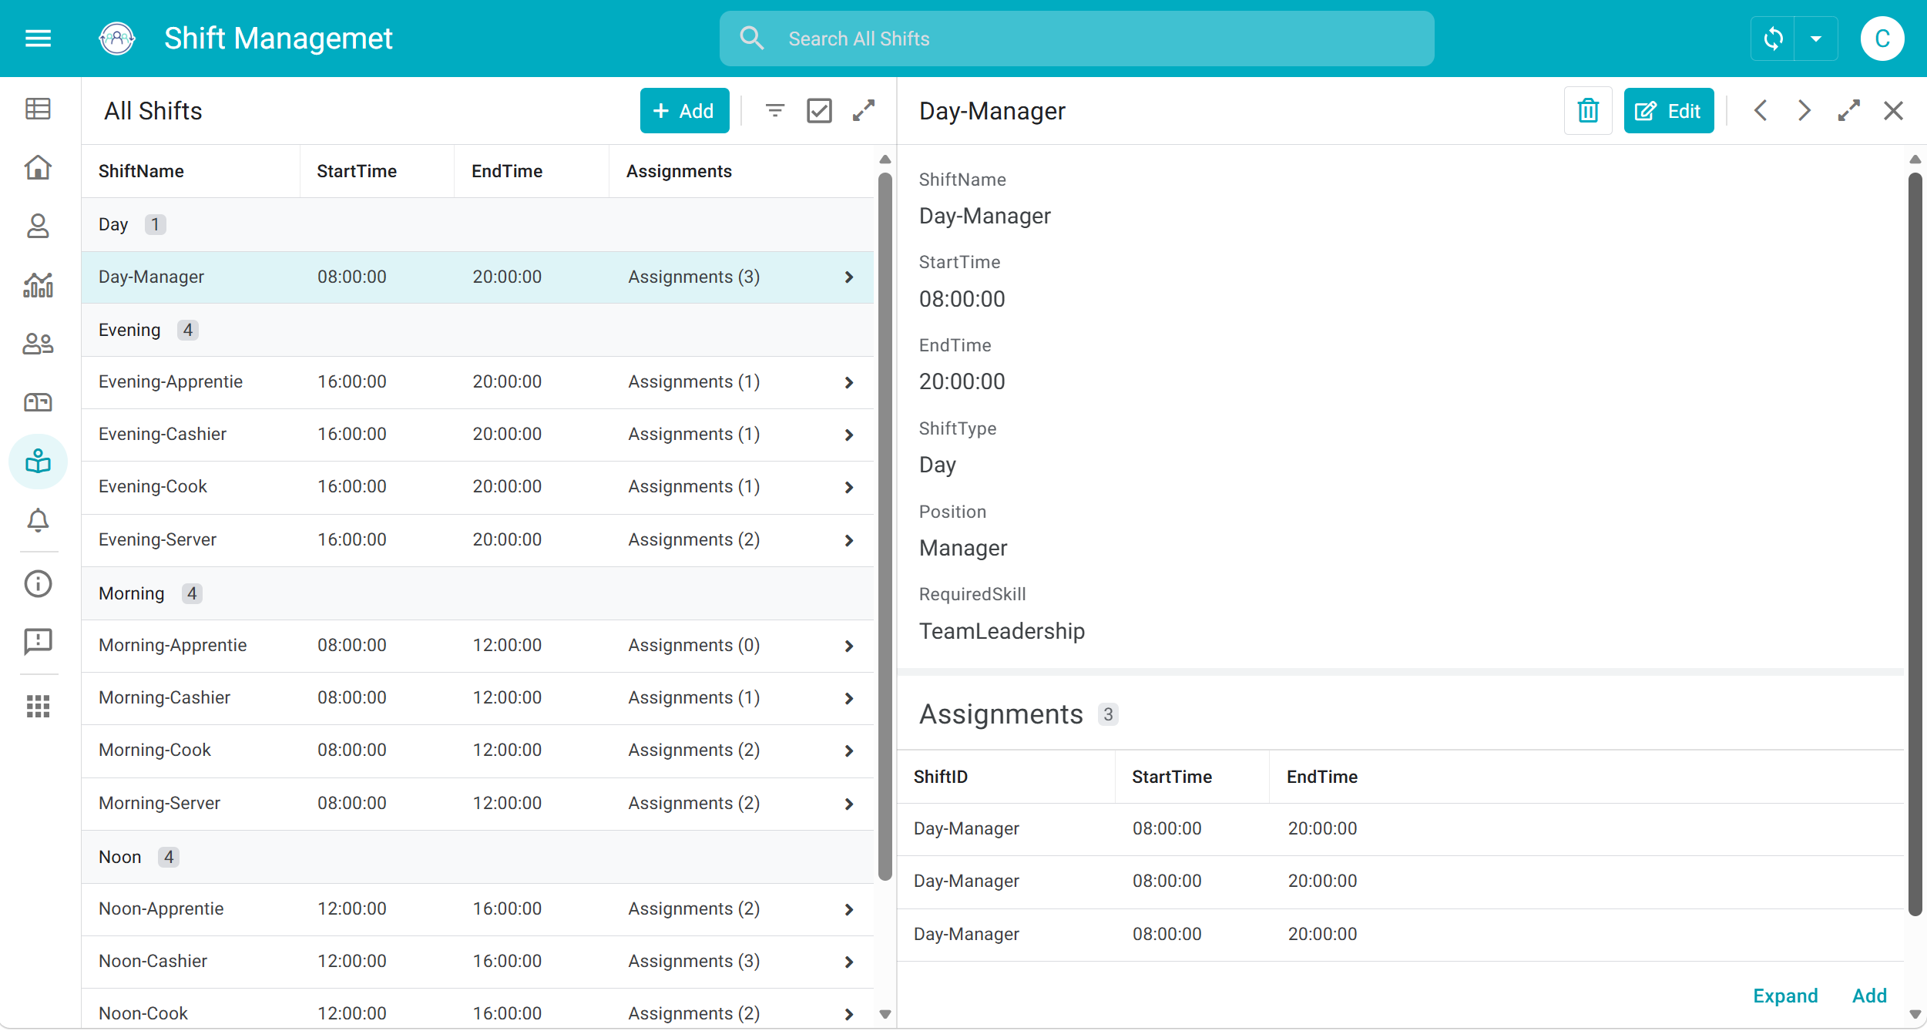
Figure 4-9 All shifts and details (web GUI)
      - Smart Forecast
The "Smart Forecast" view visualizes the predicted labor demand processed by the analytical backend. As shown in Figure 4-10, the interface utilizes a dual-chart layout to present operational insights clearly:
- Staff Demand: displays the required number of employees across different time slots, that allows managers to easily identify peak hours and adjust shift assignments to prevent understaffing.
- Role Distribution: breaks down the total required staff into specific catering roles, such as Server (35%), Cook (27%), Cashier (22%), and Apprentie (16%). This feature ensures that the scheduled workforce maintains the correct skill balance needed for smooth operations.
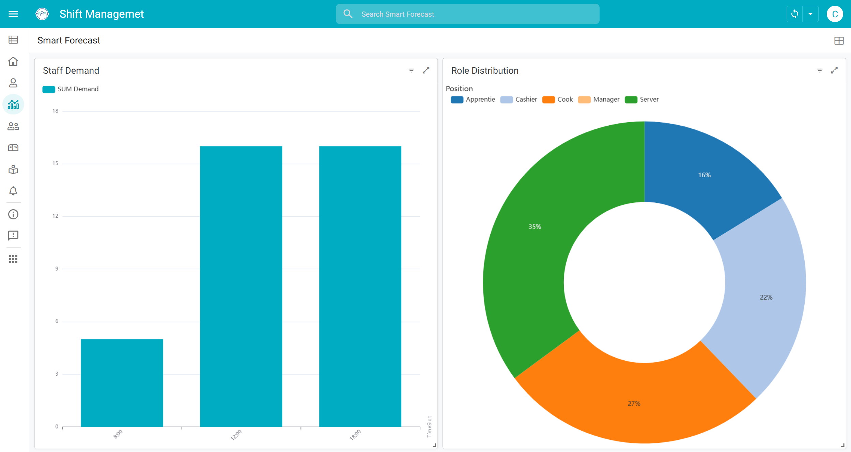
Figure 4-10 Smart forecast chart (web GUI)

Employee Perspective
      - Dashboard
This interface utilizes slice filtering to ensure that employees can only access their own schedule and working hours. As shown in Figure 4-11, it divides the dashboard into three functional models for employee self-service.

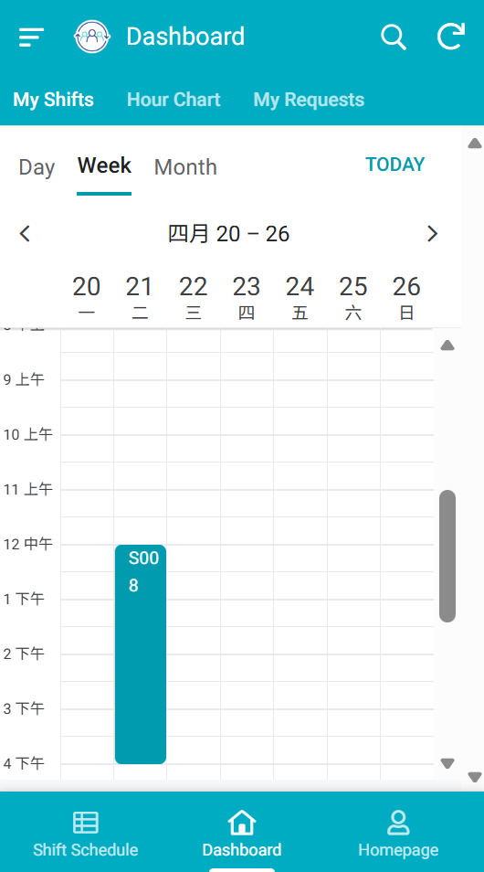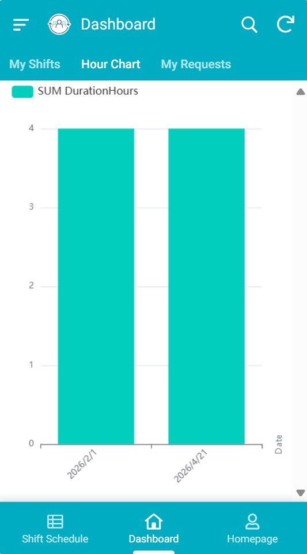
Figure 4-11 Employee dashboard (mobile GUI)
- My Shifts: displays the personal shift assignments in the calendar format. Employees can toggle between "Day", "Week", and "Month" layouts. In these view, specific shifts are visually blocked out on a time grid. This intuitive design allows staff to quickly grasp their daily commitments without needing to scroll through dense text tables.
- Hour Chart: provides a visual summary of the accumulated working hours. The system automatically aggregates the shift durations and plots them against specific dates using a bar chart. This automated tracking feature enhances labor transparency, allowing employees to accurately monitor their workload and verify their completed hours.
- My Requests: As shown in Figure 4-12, employees can trace all their leave requests and check the status of their applications through this interface, as well as can add or edit the request details.

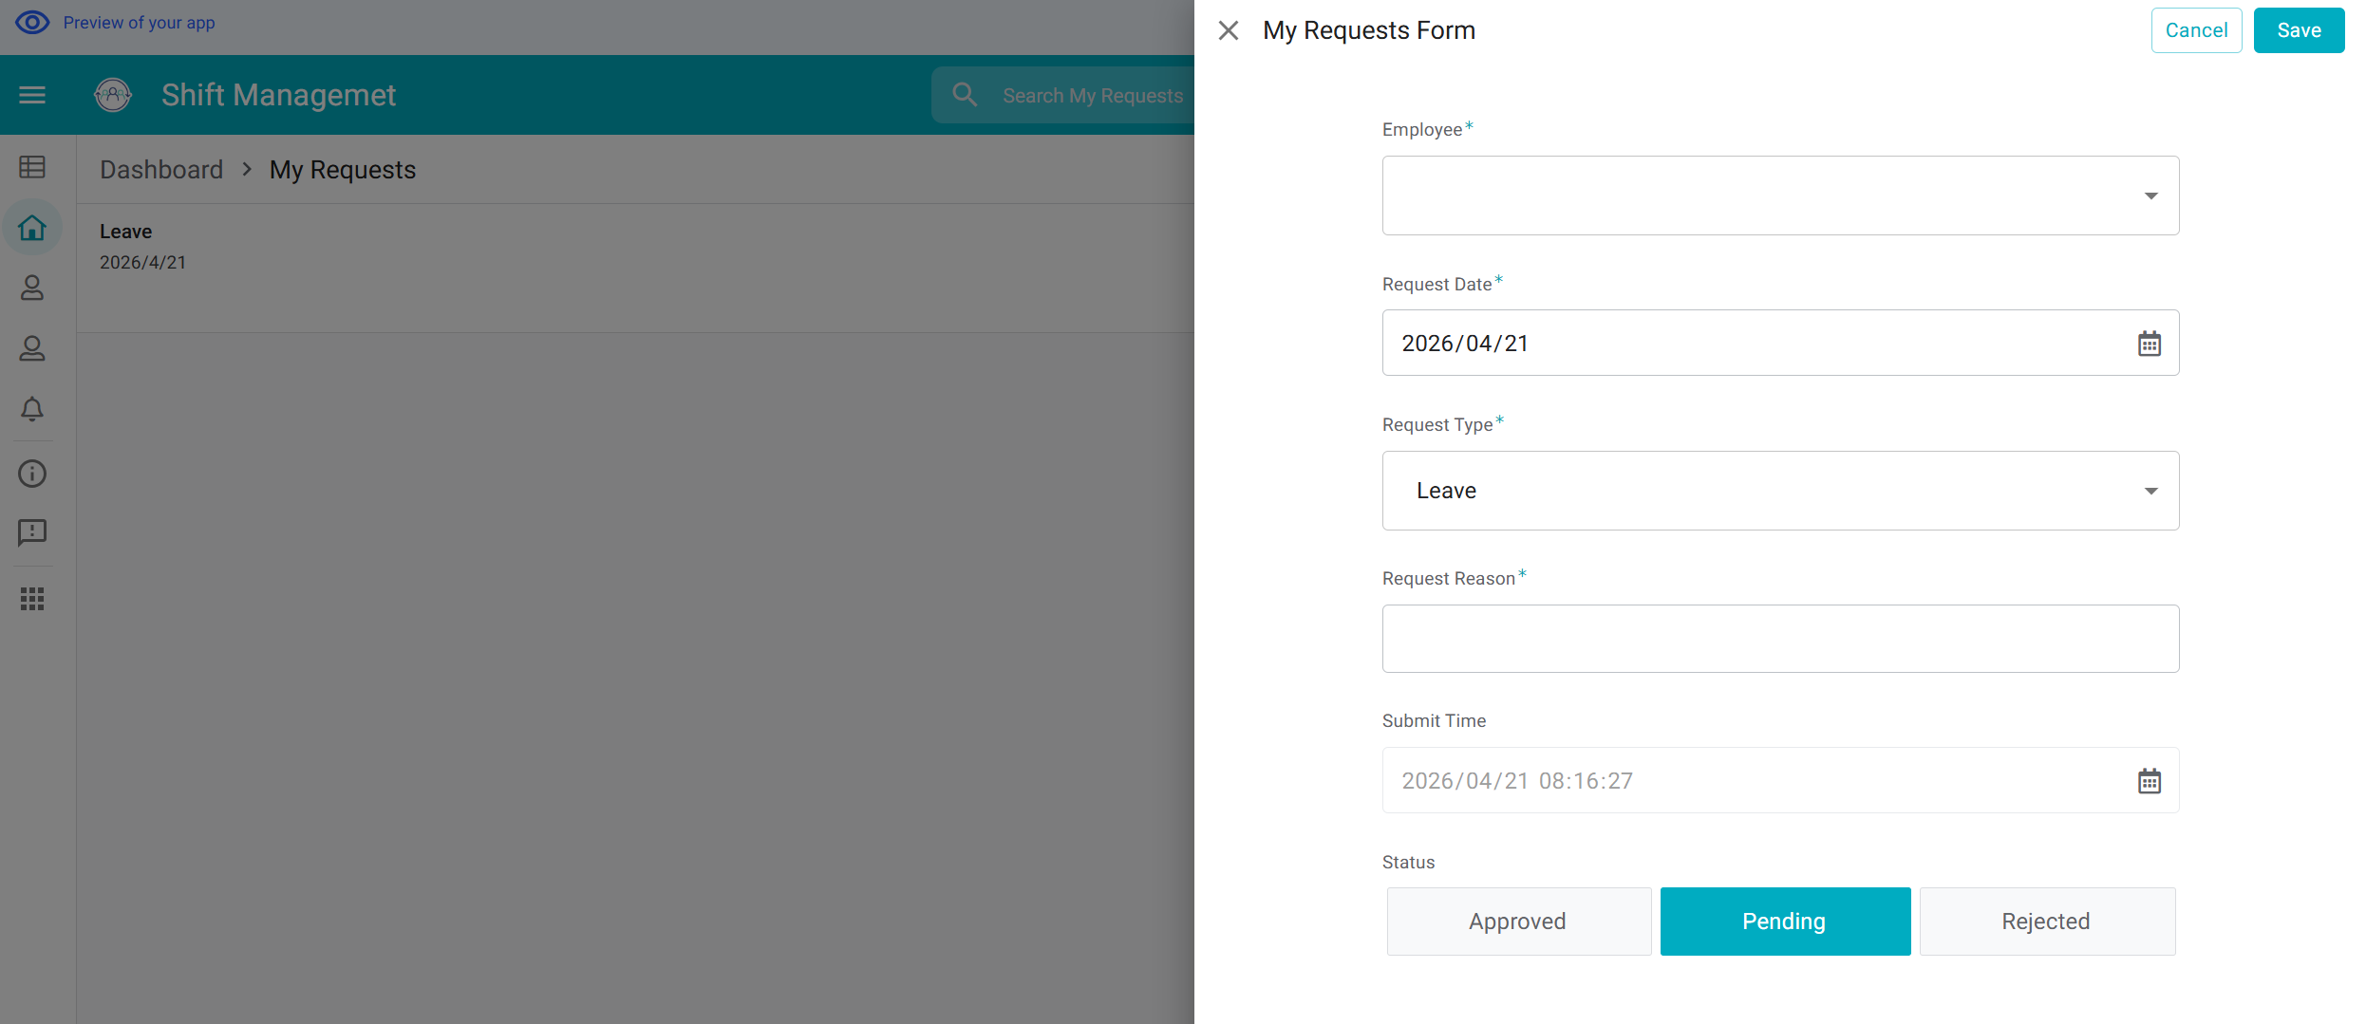
Figure 4-12 My requests and new request (web GUI)
      - Homepage and My Profile
Both two interface detail the personal information of the employees, including email, availablility, position, and skills, as an information sheet available for managers to view.
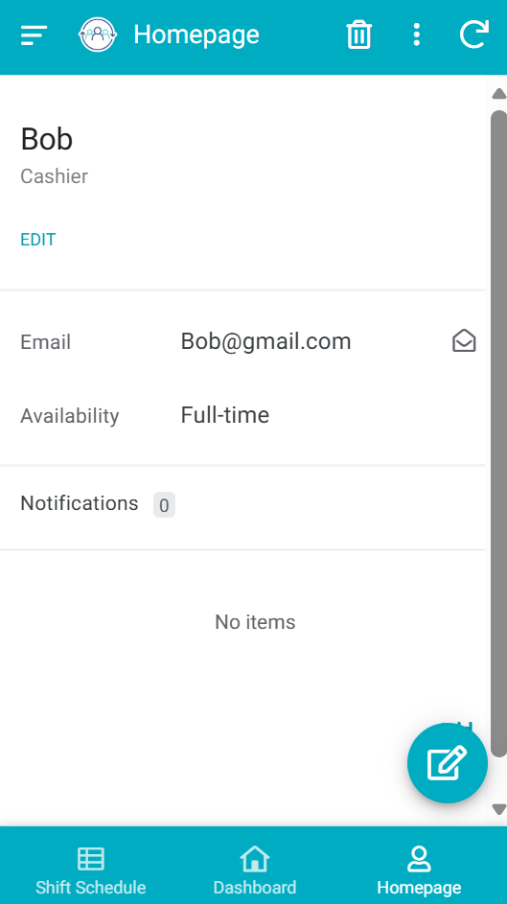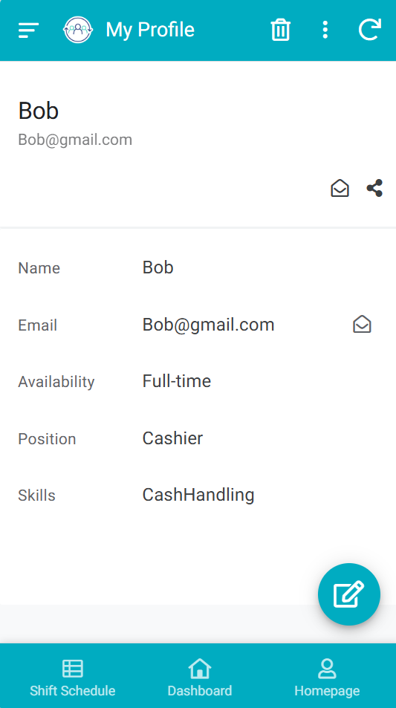
Figure 4-13 Homepage and my profile (mobile GUI)

Quantitative Evaluation and Results
To address the limitations of traditional manual scheduling, the proposed system was evaluated quantitatively based on predictive accuracy and operational efficiency.

Forecasting Model Performance
A Random Forest Regressor was integrated to forecast short-term labor requirements. The model was evaluated using a simulated dataset of 100 days of catering sales. The input features included daily temporal cycles and historical traffic. The model mitigated the high error rates typically seen in linear algorithms during catering peak hours.
Table 4-3 Quantitative Evaluation of the Forecasting Model
Metrics | Overall Dataset | Weekdays (Stable) | Weekends (Peak)
RMSE | 2.145 | 1.892 | 2.451
MSE | 4.601 | 3.579 | 6.007
MAE | 1.632 | 1.411 | 1.855
R2 Score | 0.897 | 0.912 | 0.874

The evaluation demonstrates a high R2 score of 0.897. The low Mean Absolute Error (MAE) indicates that the model provides reliable daily staffing level estimations, which serves as a solid foundation for the subsequent shift assignment process.
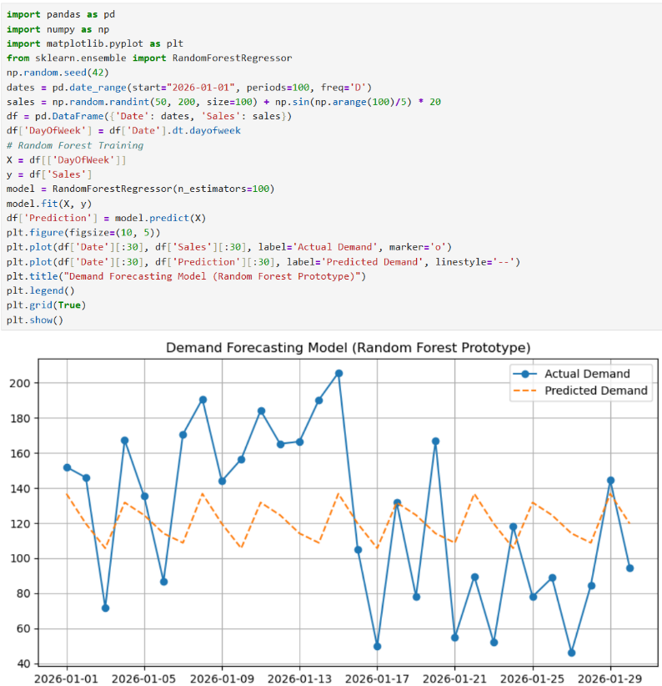
Figure 4-14 Actual vs. Predicted Demand (Random Forest Output)

Operational Efficiency Comparison
A simulated one-week scheduling scenario involving 20 catering employees was conducted to compare the proposed system against the traditional Excel-based manual method.
Table 4-4 Operational Efficiency Comparison
Operation Metric | Traditional Excel Method | Proposed Low-Code System | Improvement
Schedule Create Time | 120 minutes | 45 minutes | 62.5% reduction
Employee Notification | 30 minutes | Instant | 100% reduction
Scheduling Error Rate | 8.5% | 0.0% | Complete best
Request Processing | 1 to 2 days | Real-time tracking | Significant

The results indicate that the low-code system successfully reduces routine scheduling time by 62.5%. The strict data validation rules completely eliminate human errors such as double-booking. The automated workflow significantly accelerates the request processing cycle.

Summary
This chapter thoroughly documented the implementation of the shift management system. The unit and integration tests confirmed the reliability of the AppSheet role-based access control and automation bots. The detailed GUI demonstration illustrated how low-code slice filtering and dynamic expressions create secure, tailored interfaces for managers and employees. And the quantitative results proved that the integrated Random Forest model achieves high forecasting accuracy, that the overall system substantially improves operational efficiency compared to traditional methods.

Professional Issues
This chapter outlines the project management strategies and methodologies employed to ensure the successful delivery of the low-code shift management system. It details the scheduling, sprint iterations, and data management practices. Furthermore, it provides a comprehensive risk analysis and critically discusses the legal, social, ethical, and environmental issues addressed during the software development process, in accordance with industry professional codes of conduct.

Project Management
To effectively manage the development of the catering shift management system, the Rapid Application Development (RAD) methodology was integrated with an Agile Scrum framework [13]. This approach ensured continuous iteration, frequent testing, and consistent alignment with user requirements, allowing the project to adapt flexibly to catering business logic.

Activities
Table 5-1 outlines the complete activities, highlighting the integration of system design, prototype development, and user acceptance testing (UAT).
Table 5-1 Completed Project Activities and Objectives
Objectives | Completed Tasks | Deliverable | Status
1. Analyze scheduling challenges | Conducted requirement gathering for catering enterprise shift logic and business workflows. | Requirement Specification List | Completed
2. Design system architecture | Designed the hybrid architecture connecting AppSheet, Google Sheets, and Python. | ERD and System Design Diagrams | Completed
3. Develop software prototype | Executed iterative coding sprints to build AppSheet GUIs and the Random Forest model. | Functional App Prototype and Source Code | Completed
4. Test and compare usability | Conducted unit tests, integration tests, and operational efficiency comparisons | Testing Log and Results | Completed
5. Evaluate user feedback | Organized System Demonstration and UAT sessions | UAT Feedback | Completed

Schedule
The project was executed strictly according to the planned schedule from October 2025 to April 2026. To address the dynamic nature of low-code development, the implementation phase was structured into four distinct Agile sprints. Each sprint concluded with a system demonstration and iteration record.
Table 5-2 Agile Sprint Schedule and Iteration Records
Phase | Timeframe | Key Activities and Milestones
Initiation and Design | Oct 2025 - Nov 2025 | Defined system scope; Designed database schema (ERD); Drafted initial project proposal.
Sprint 1: Foundation | Dec 2025 | Established Google Sheets database; Configured basic AppSheet tables and data types.
Sprint 2: Core Functions | Jan 2026 | Developed Role-Based Access Control (Manager/Employee views); Built shift assignment and leave request forms.
Sprint 3: Automation | Feb 2026 | Configured AppSheet workflow automation bots; Integrated the Python Random Forest forecasting module.
Sprint 4: UAT and Refinement | Mar 2026 | Conducted UAT with simulated catering staff; Logged system demonstration feedback; Fixed UI responsive layout bugs.
Finalization | Apr 2026 | Completed final quantitative evaluation; Finalized report and defense presentation.

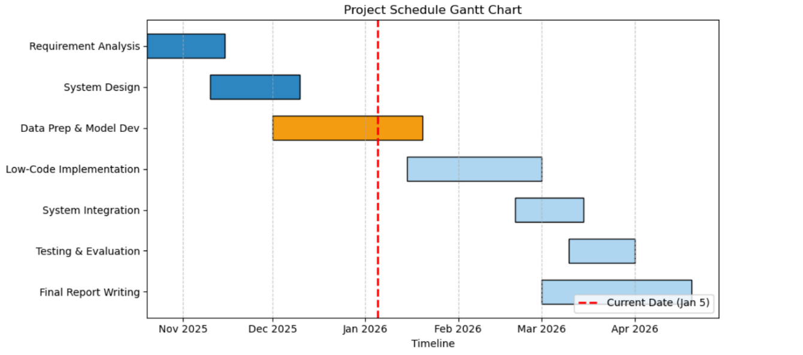
Figure 5-1 Project schedule Gantt chart

Project Data Management
- Source Code and Version Control (GitHub): Git and GitHub were utilized as the primary version control repository [14]. Clear iteration evidence was maintained through frequent commits and tagged releases. The repository safely hosted all Python analytical scripts and Jupyter Notebooks.
- Database Management (Google Sheets): Acted as the cloud backend for the AppSheet system, securely storing all simulated datasets, employee records, and shift schedules.
- Literature Management (Github): Used to consistently organize academic citations and software documentation throughout the reporting process.

5.1.4. Project Deliverables
(1) Project Proposal Report (Submitted)
(2) Project Progress Report (Submitted)
(3) Project Final Report
(4) Software Prototype
(5) Source Code
(6) Presentation Slides
(7) Ethics forms (Submitted)

Risk Analysis
Proactive risk management was critical for maintaining the project schedule and technical quality. Table 5-3 summarizes the final risk assessment, detailing resolved issues and acknowledging potential future risks.

Table 5-3 Risk Analysis and Mitigation Strategies
Risk Category | Risk Description | Status | Mitigation Strategy & Future Risks
Technical Integration | AppSheet expressions caused mobile UI loading delays when processing complex scheduling constraints. | Resolved | Shifted heavy calculation logic to the Python backend and Google Sheets formulas, prioritizing front-end UI responsiveness.
Model Accuracy | Initial linear forecasting models failed to capture catering peak hour fluctuations. | Resolved | Replaced linear models with the Random Forest algorithm, significantly improving peak-time prediction accuracy [10].
Data Quality | Raw simulated catering data contained missing values and temporal gaps. | Resolved | Implemented a robust Python data preprocessing pipeline using linear interpolation to clean datasets before training.
Schedule & Iteration | Cross-platform UI layout debugging consumed unexpected development time. | Resolved | Allocated additional time during Sprint 4; leveraged AppSheet's native responsive rendering to automatically adapt /mobile views.
Future Scalability | High concurrency limitations. Google Sheets may experience read/write bottlenecks if deployed to a large enterprise with hundreds of users. | Future Risk | Recommended future migration of the cloud database from Google Sheets to a robust SQL database (e.g., PostgreSQL) via AppSheet Enterprise.

Professional Issues
The software development lifecycle rigorously adhered to the professional standards outlined by the British Computer Society (BCS) Code of Conduct [15] and the Association for Computing Machinery (ACM) Code of Ethics [16], ensuring privacy, fairness, and societal responsibility.

Legal and Privacy Issues
The system processes personal personnel data, including employee names, contact details, and work patterns, which necessitates strict compliance with data protection frameworks such as the General Data Protection Regulation (GDPR) [17].
- Data Minimization: The system strictly adheres to data minimization principles. Only essential scheduling data is collected, explicitly excluding highly sensitive information such as medical records or financial details.
- Secure Access Control: To prevent unauthorized data exposure, robust row-level security (Slice filtering) was implemented via AppSheet. As a result, standard employees can only access their personal schedules, while managers hold administrative privileges, fulfilling legal obligations for data confidentiality.

Legal and Privacy Issues
- Algorithmic Fairness: A significant ethical concern in automated scheduling is the potential for biased shift assignments, such as repeatedly assigning unpopular weekend or late-night shifts to the same individuals. Research indicates that historical data often inherits human biases [18].To address this, the system's operational logic incorporates a "Fairness Penalty" constraint, ensuring an equitable distribution of workloads across the staff pool.
- Transparency and Explainability: In alignment with the ACM principle of minimizing harm and ensuring transparency [16], the system avoids entirely "black-box" decision-making. The rule-based recovery mechanism provides managers with explainable suggestions (e.g., "suggesting overtime due to skill matching"), ensuring that final scheduling authority remains in human hands.

Legal and Privacy Issues
- Green IT Practices: Training massive deep learning neural networks consumes significant electrical energy and computational resources. By consciously selecting the computationally lightweight Random Forest ensemble algorithm over deep learning models, this project aligns with Green IT principles [19], minimizing energy consumption while maintaining sufficient predictive accuracy for small enterprises.
- Digital Transformation: By replacing traditional paper-based shift rosters and printed leave application forms with a cloud-synchronized digital platform, the project actively contributes to reducing office paper waste, supporting broader environmental sustainability goals.

Summary
This chapter detailed the comprehensive project management framework utilized to execute the software development. The integration of Agile sprints ensured structured progress, from database design to final user acceptance testing. Effective version control and data management were maintained using GitHub and Google Workspace. The robust risk analysis demonstrated the successful mitigation of technical bottlenecks, while the evaluation of professional issues confirmed that the system strictly complies with GDPR data privacy laws, algorithmic fairness standards, and ACM/BCS ethical guidelines.

Conclusion

Findings and Conclusions
This project successfully designed and implemented a practical, low-code shift management system tailored for small and medium-sized catering enterprises. By adopting the Rapid Application Development (RAD) methodology and an Agile sprint framework, the project rapidly delivered a functional cross-platform application. The hybrid system architecture effectively integrated an AppSheet front-end for user interfaces and workflow automation, a Google Sheets cloud database for structured data storage, and a Python-based Random Forest forecasting module for predictive analytics. The findings from functional and integration testing demonstrate that the proposed system significantly outperforms traditional spreadsheet-based manual scheduling. Key achievements include the successful automation of administrative workflows (e.g., leave requests and approval routing), the enforcement of role-based access controls to protect employee privacy, and the cross-platform adaptability of the graphical user interface. Furthermore, the integration of the Random Forest algorithm successfully captured cyclical customer demand trends, providing managers with data-driven staffing estimates that help minimize both overstaffing and peak-hour understaffing. Ultimately, the system enhances operational efficiency, reduces human scheduling errors, and provides a transparent, fair rostering environment for catering staff.

Limitations of your Project
Despite the successful implementation of the prototype, several key limitations were identified during the development and evaluation phases, particularly concerning enterprise-level deployment:
1. High Concurrency and Scalability Bottlenecks: The current cloud database relies on Google Sheets, which is highly accessible but lacks the robust concurrency processing capabilities of enterprise databases. Under high-frequency read/write requests from multiple simultaneous users, the system may experience data synchronization bottlenecks.
2. Data Security Constraints: While AppSheet provides row-level security (Slice filtering), relying on a spreadsheet-based backend inherently poses higher data security and compliance risks compared to encrypted, isolated enterprise SQL databases, especially when handling sensitive personal information across multi-branch operations.
3. Advanced Scheduling Constraints: Building complex scheduling logic (e.g., multi-skill matching, cross-branch staff transfers, and real-time fairness penalty calculations) using AppSheet's native "Virtual Columns" and expressions consumes significant front-end processing power. This can lead to noticeable UI loading delays on mobile devices [17].
4. Synchronization Latency: Because the Python forecasting module operates as an external analytical script rather than a native integrated service, there is an inherent 10 to 15-second synchronization delay when pushing predicted demand data back to the manager's dashboard.

Potential Future Work
To address the aforementioned limitations and further enhance the system's commercial viability, the following potential future works are proposed:
1. Database Migration for Multi-Branch Management: Future iterations should migrate the cloud backend from Google Sheets to a robust, scalable relational database (such as PostgreSQL or MySQL) using AppSheet Enterprise. This will resolve high concurrency issues, improve data security, and enable centralized multi-branch management.
2. Dedicated Backend API Integration: To eliminate UI loading delays and synchronization latency, complex algorithmic logic and scheduling constraints should be fully offloaded to a dedicated backend server (e.g., a Python Flask or FastAPI server). The low-code platform would then communicate with this server via real-time RESTful APIs.
3. Enhanced Forecasting with External Variables: The current Random Forest model relies solely on historical sales data. Future work could integrate external environmental variables—such as real-time weather forecasts, local holidays, and special events—into the machine learning pipeline to further improve demand prediction accuracy [10].
4. Employee Shift-Bidding System: To increase employee autonomy and scheduling flexibility, a self-service "shift-bidding" feature could be developed. This would allow staff to bid on open, unassigned shifts according to their personal preferences, reducing the manager's manual allocation workload.

References
[1] A. İşeri, H. Güner, and A. R. Güner, ‘Pareto-optimal workforce scheduling with worker skills and preferences’, Oper. Res., vol. 25, no. 2, p. 27, Feb. 2025, doi: 10.1007/s12351-025-00903-7.
[2] M. Mac-Vicar, J. C. Ferrer, J. C. Muñoz, and C. A. Henao, ‘Real-time recovering strategies on personnel scheduling in the retail industry’, Comput. Ind. Eng., vol. 113, pp. 589–601, Nov. 2017, doi: 10.1016/j.cie.2017.09.045.
[3] E. Álvarez, J.-C. Ferrer, J. C. Muñoz, and C. A. Henao, ‘Efficient shift scheduling with multiple breaks for full-time employees: A retail industry case’, Comput. Ind. Eng., vol. 150, p. 106884, Dec. 2020, doi: 10.1016/j.cie.2020.106884.
[4] A. C. Bock and U. Frank, ‘Low-Code Platform’, Bus. Inf. Syst. Eng., vol. 63, no. 6, pp. 733–740, Dec. 2021, doi: 10.1007/s12599-021-00726-8.
[5] P. M. Viera-González, O. H. González-González, and G. E. Sánchez-Guerrero, ‘Low-Code Automation for Resolving Incidents During Class Schedule Registration’, Computer, vol. 58, no. 3, pp. 41–48, Mar. 2025, doi: 10.1109/MC.2024.3510463.
[6] M. Defraeye and I. Van Nieuwenhuyse, ‘Staffing and scheduling under nonstationary demand for service: A literature review’, Omega, vol. 58, pp. 4–25, Jan. 2016, doi: 10.1016/j.omega.2015.04.002.
[7] D. Di Ruscio, D. Kolovos, J. de Lara, A. Pierantonio, M. Tisi, and M. Wimmer, ‘Low-code development and model-driven engineering: Two sides of the same coin?’, Softw. Syst. Model., vol. 21, no. 2, pp. 437–446, Apr. 2022, doi: 10.1007/s10270-021-00970-2.
[8] F. Khorram, J.-M. Mottu, and G. Sunyé, ‘Challenges & opportunities in low-code testing’, in Proceedings of the 23rd ACM/IEEE International Conference on Model Driven Engineering Languages and Systems: Companion Proceedings, in MODELS ’20. New York, NY, USA: Association for Computing Machinery, Oct. 2020, pp. 1–10. doi: 10.1145/3417990.3420204.
[9] S. M. Sakib, ‘Restaurant Sales Prediction Using Machine Learning’, Jan. 2021, Accessed: Apr. 20, 2026. [Online]. Available: https://www.academia.edu/104557396/Restaurant_Sales_Prediction_Using_Machine_Learning
[10] L. Breiman, ‘Random Forests’, Mach. Learn., vol. 45, no. 1, pp. 5–32, Oct. 2001, doi: 10.1023/A:1010933404324.
[11] T. Chai and R. R. Draxler, ‘Root mean square error (RMSE) or mean absolute error (MAE)? – Arguments against avoiding RMSE in the literature’, Geosci. Model Dev., vol. 7, no. 3, pp. 1247–1250, Jun. 2014, doi: 10.5194/gmd-7-1247-2014.
[12] C. Willmott and K. Matsuura, ‘Advantages of the mean absolute error (MAE) over the root mean square error (RMSE) in assessing average model performance’, Clim. Res., vol. 30, pp. 79–82, Jan. 2005, doi: 10.3354/cr030079.
[13] ‘Scrum Guide | Scrum Guides’. Accessed: Apr. 21, 2026. [Online]. Available: https://scrumguides.org/scrum-guide.html
[14] ‘Pro Git | Springer Nature Link’. Accessed: Apr. 21, 2026. [Online]. Available: https://link.springer.com/book/10.1007/978-1-4842-0076-6
[15] ‘BCS Code of Conduct for members - Ethics for IT professionals | BCS’. Accessed: Apr. 21, 2026. [Online]. Available: https://www.bcs.org/membership-and-registrations/become-a-member/bcs-code-of-conduct/
[16] ‘The Code affirms an obligation of computing professionals to use their skills for the benefit of society.’ Accessed: Apr. 21, 2026. [Online]. Available: https://www.acm.org/code-of-ethics
[17] Regulation (EU) 2016/679 of the European Parliament and of the Council of 27 April 2016 on the protection of natural persons with regard to the processing of personal data and on the free movement of such data, and repealing Directive 95/46/EC (General Data Protection Regulation) (Text with EEA relevance), vol. 119. 2016. Accessed: Apr. 21, 2026. [Online]. Available: http://data.europa.eu/eli/reg/2016/679/oj
[18] N. Mehrabi, F. Morstatter, N. Saxena, K. Lerman, and A. Galstyan, ‘A Survey on Bias and Fairness in Machine Learning’, ACM Comput Surv, vol. 54, no. 6, p. 115:1-115:35, Jul. 2021, doi: 10.1145/3457607.
[19] S. Murugesan, ‘Harnessing Green IT: Principles and Practices’, IT Prof., vol. 10, no. 1, pp. 24–33, Jan. 2008, doi: 10.1109/MITP.2008.10.

Appendices

