ooeForth, a True Object-Oriented Forth in Java

Xuyang (Shawn) Chen, Brad Nelson, Chochain Lee, and Chen-Hanson Ting.

Chapter 1. Introduction

From the perspective of Forth programming language, Java is interesting because its underlying Java Virtual Machine (JVM) is a Forth Virtual Machine. However, Java went into Object-Oriented paradigm and became so complicated and I (Chen-Hanson Ting) lost any interest in it.

After implementing Forth on JavaScript, I was exposed to object orientation and felt OOP was after all not that bad. Actually, objects greatly simplified the Forth implementation and I was very pleased with jeforth614 which was the smallest and simplest Forth I had ever implemented. That lead me to rethink Java and spent some time learning it. The best way to learn it would be to write a Forth system in it.

Getting deeper into the Java language, I realized that JavaScript was no Java like everybody had said. JavaScript is actually a cScript which makes C language almost interactive. I learned how to make Forth words objects. I read and tried to run several Forth systems written in Java. They were all as complicated as Java itself and I could not understand them, nor could I get them running on my PC. With great help from Shawn Chen and Brad Nelson, I managed to get my Java Forth running. It turned out that Forth even getting simpler than my jeforth614, when Forth words were implemented according to the principles of Object-Oriented Programming.

First Brad helped me write a 4-function calculator with a Forth interpreter. Then Shawn showed me how to write the Forth compiler. Brad and Shawn were using Java techniques too advanced for me, because I had only studied the first 10 Java lessons, and the abstract classes and interfaces were in lesson 15 and beyond. I wrote my objects at the entrance level but got them working, probably not very efficiently. But once I got the Forth interpreter working, all other problems were resolved in due time.

Outer and Inner Interpreters

Forth is an interpretive language. You type a line of Forth words, and Forth interprets or executes them. It is the Forth outer interpreter or text interpreter which parses out individual words, executes them when Forth is in an interpretive mode, or compiles them into word lists when in a compiling mode. The outer interpreter thus evaluates (executes or compiles) a word.

The outer interpreter evaluates a list of words:
word1 word2 word3 …

When the outer interpreter encounters a colon definition:
: name word1 word2 word3 … ;
it compiles the list [ word1 word2 word3 .. ] to an object list, gives it a name, and makes a new word. When this new word is executed, the object list [ word1 word2 word3 .. ] will be executed.

An object list is an internal list of data stored in memory, in a system-dependent form. The internal representation of a word is called a token. The mechanism to execute a token list is called an inner interpreter, generally written in machine code. Therefore, the outer interpreter evaluates word lists in text form, and the inner interpreter executes internal token lists.

I was pleasantly surprised that the Java input method Scanner.in.next()is also a very efficient parser for the Forth outer interpreter. With this ready-made parser, the Forth outer interpreter was reduced to a short loop outerInterpter() in the main() method.

Shawn showed me how to execute object lists with this very tight inner interpreter in Java:
for(var w:words) w.xt();
It is the Forth inner interpreter generally called nest(). You just cannot get any simpler.

Forth Objects

The primitive objects, or the Forth objects executing Java code, have different methods to perform their functions. It is necessary to use different classes for individual objects. One class for one object. Shawn called them necessary evils. I would like to have one class to construct all Forth objects, including colon words. I designed a rather complicated Code class, which anticipates all various attributes required by all different objects. The single method shared by all primitive objects is a giant switch. Each object selects its method by its own name. In a conventional Forth system, each Forth word is represented internally by a token which determines how this word is executed. Here the word itself is the token. How convenient!

The giant switch is the ugliest part of this Java Forth implementation. A word is searched every time it is executed. This giant switch was eventually replaced by a HashMap of lambdas to supply the method needed by each word. Searching speed is not a problem now. The class definition of Code is still bulky. I hope Forth objects do not carry this bulky HashMap around, but only make references to the methods through pointers. Chochain helped me pulling the giant HasMap into a static method which can be called easily by all primitive methods.

I kept on expanding my Code class definition to encompass all these literals and structures. I forced objects to absorb the literals they need. My greatest satisfaction was that all control structures could be absorbed into objects. This way, all object lists in colon words were reduced to linear lists, and Shawn’s simple inner interpreter would work in all circumstances.

Then, on July 4, 2021, I got an email from Chochain Lee, a former student in Taiwan I had yet to meet. He worked at Intel on Pentium for some years, and then went to do business himself on data warehousing, AI, and management consulting, using most of the languages and tools. I immediately asked him to look at ooeForth, and he kindly made suggestions and helped me improve it. He cleaned up the dictionary and pulled the ugly HashMap out of the Code class. I added the Windows interface with java.awt, giving ooeForth the look-and-feel of jeForth614. It is now upgraded to ooeForth204. As Java insists that the java file and top-class have the same name, with a leading capitalized letter, the java file and class name is accordingly Eforth204. At boot, it signs on announcing “ooeForth 2.03”.

The Essence of Forth

The essence of Forth is the colon word, which replaces a list of Forth words by a new word. The new word can be used with other existing words to build other newer words. The nested lists of words generally provide the most efficient solutions to all computable problems.

Years ago I proposed four Laws of Computing:
- Law of Composition: A computable function can be represented by a linear sequence of machine instructions with occasional branching and looping.
- Law of Polymorphism: There are infinite solutions to a computable function.
- Law of Structures: Functions should be constructed in modules and structures.
- Law of Correctness: Correctness of a module can be proven by recursively factoring into smaller modules whose correctness can be proven

Forcing control structures into objects reminded me of the Third Law of Computing which asserts that all computable problems can be reduced to a set of modules and structures. In reducing control structures to objects, I just prove the Third Law of Computing.

When all Forth words, data structures, and control structures are implemented as objects, this Forth is a true object-oriented Forth. I now claim it to be ooeForth: Object-Oriented eForth.

Eforth204

The entire Forth system is implemented in a single file Eforth204.java. Whatever you are accustomed to run Java applications would work with this file. I am using Eclipse IDE from IBM. Create a new project with the name Eforth204 and copy this file into your project. The project should look somewhat like this:

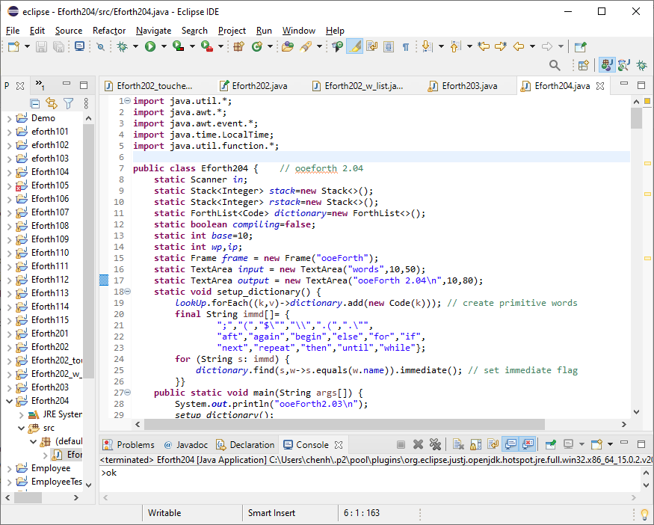

Click the Run button to start Eforth204 and a big window shows up. There are two boxes in the window: To the right is the input box, and to the left is the output box, as shown here:

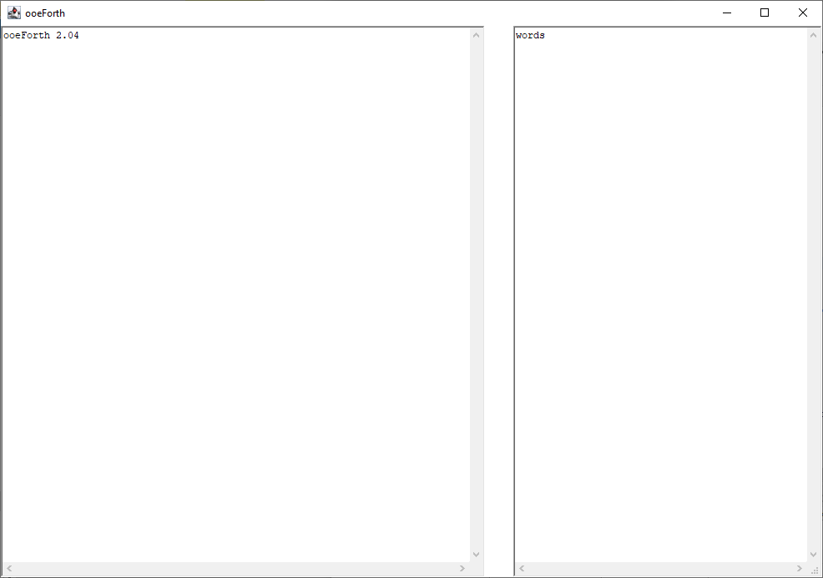

The left output box shows a sign-on message: ‘ooeForth 2.03’. The right input box shows a Forth word ‘words’. Move the mouse cursor over the big window and hit the return key to execute ‘words’. A list of Forth words will appear in the output box, as shown in the next picture:

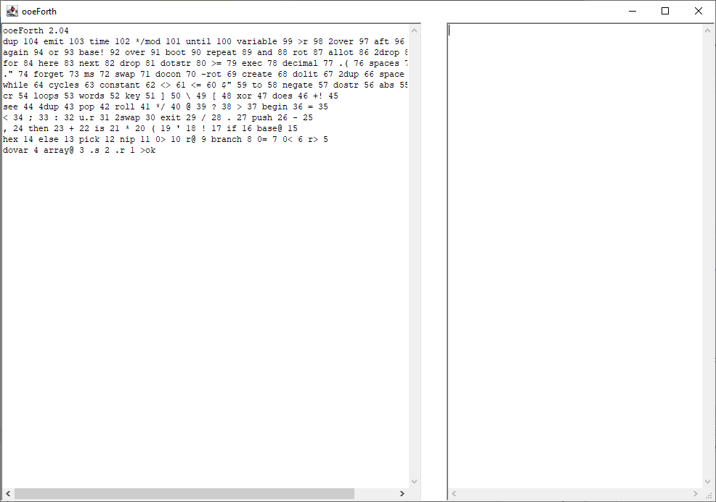

There are 104 words defined in ooeForth204. Each word is followed by a number, which is the token of this word. Tokens are internal representations of Forth words.

A text file Lessons204.txt is also distributed with Eforth204.java. It has 17 tutorial lessons for people who are not familiar with the Forth language to learn how to program in Forth. It is also a very good testbed to verify that ooeForth204 works properly.

Open Lessons204.txt with your favorite text editor. Copy the entire file and paste it into the input box as shown in the next picture:

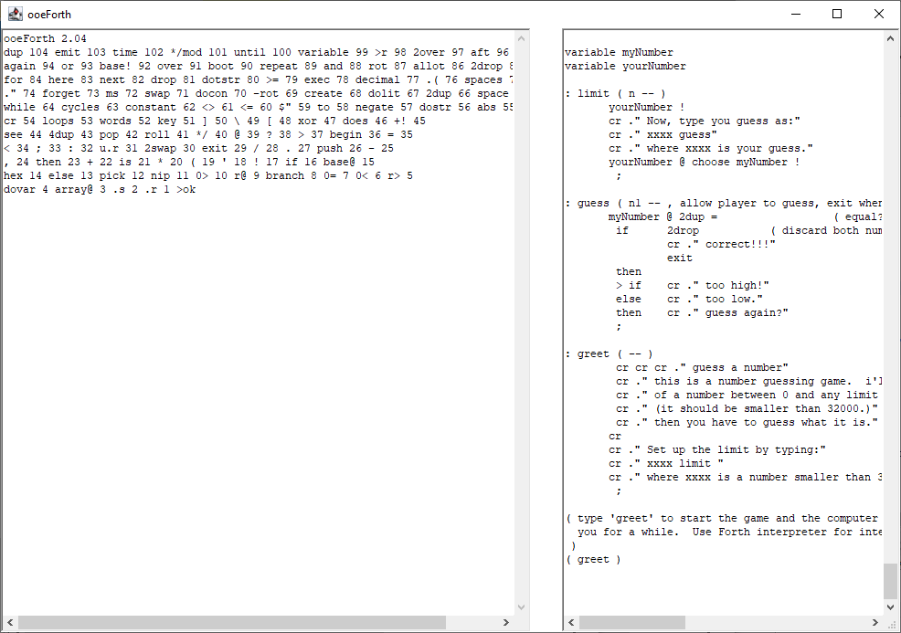

Hit the return key and you have:

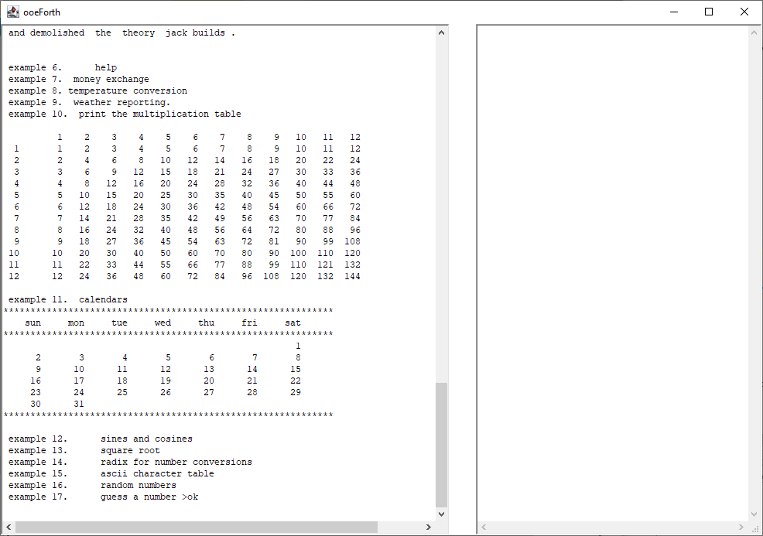

You see only results of the last few tests in the output box, including a multiplication table, and a calendar showing days in May 2021. You can scroll up the box to view all earlier test results.

To see all the words compiles from Lessons202.text, type ‘words’ in the input box and hit the return key. You can see the complete word list as shown here:

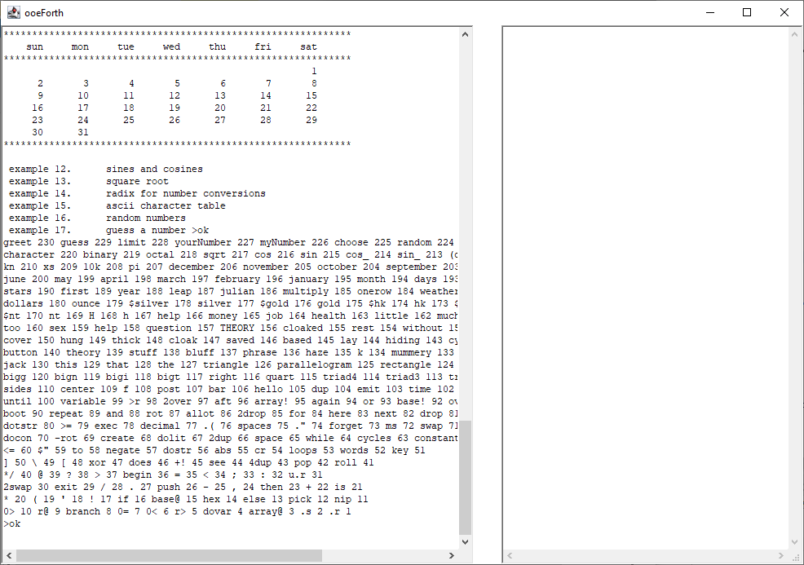

The total word count is now 230.

You can type Forth words into the input box and execute them by hitting the return key. Peferably you will write a large program in a text file. Copy the text file into the input box and hit the return key to run it.

In the early days of Forth, Chuck Moore did not have operating systems and files to manage his source code. He invented the Virtual Memory system to make use of the disks and tapes to store source code and data. He divided mass storage into blocks as Virtual Memory which could be accessed very conveniently by his Forth systems. Blocks of 1024 byte size became standard features of his Forth systems and most Forth systems following his. However, the block is only one of many ways to supply source code to a Forth system, and is not integral part of a Forth system.

eForth assumes only one input device supplying a stream of characters to be evaluated. Any way to supply the character stream is acceptable. In a modern PC, simple text files can supply the character stream. Operating systems allow you manage these files on your PC. You copy the files and feed them to eForth system, which evaluates the character stream you feed it.

ooeForth is a very good model of a Virtual Forth Machine, which accepts text frome an input device, evaluates it, and sends results to an output device. You can type or paste the text into the input device. You can also copy and save the results from the output device to text files. Forth becomes very simple because it does not have to deal with files nor blocks.

Chapter 2. ooeForth Objects

ooeForth is a very simple Forth system, with 104 primitive words, or system commands, on boot up. In comparison, its parent eForth, which used to be the simplest Forth system, had 232 words, with 35 primitive words defined for a Forth Virtual Machine. Half of the words in eForth were required to bring up the Forth outer interpreter, and were rarely used by users or applications. ooeForth does not need these supporting words, because Java provides the services used by the Forth interpreter-compiler.

There are only two types of words in ooeForth: the primitive words as mentioned above, and colon words defined by you the user. The primitive words execute methods written in Java. A colon word contains a word list. A colon word just gives this list a new name, and performs the tasks specified by this word list.

Both primitive words and colon words are objects in ooeForth. ooeForth has a one-size-fits-all constructor that constructs all the primitive objects and colon objects. This unique design makes ooeForth a very simple Forth Virtual Machine, as it takes full advantage of the underlying Java Virtual Machine.

In Java everything belongs to a class. An application is a class that has a main() method. This ooeForth is released in a file Eforth204.java, and the top class has to have the same name Eforth204. Here is a picture showing graphically the contents in this class:

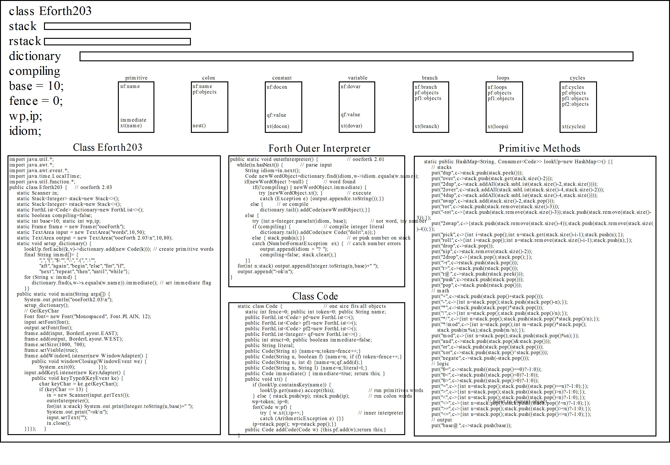In the top left corner is the attributes in this class. There are two stacks, a parameter stack, and a return stack. The dictionary is shown as a long rectangle, containing all the Forth word objects. Under this long rectangle are several small rectangles representing different types of objects in the dictionary. Each type of object has a different set of attributes which we will discuss in great detail later.

In the lower left corner is the main() method of Eforth204 class. It instantiates all primitive objects. It also sets up a Window with an input and an output box. In the center is the Forth outer interpreter called by main() method. Below is the Code class that constructs all Forth objects. The HashMap of the methods used by primitive objects is shown in the lower right corner. Only a small portion of the HashMap is shown here.

Here is a more detailed picture of the literal and control objects in ooeForth:

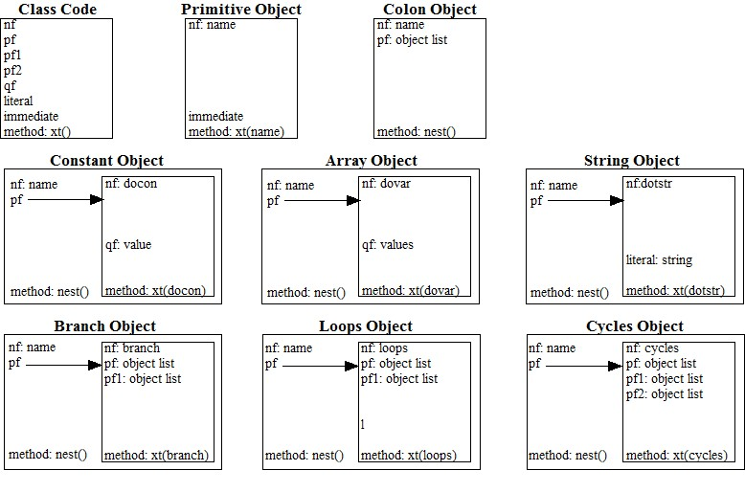
In the top left corner is the Code class with all the attribute templates. The Code class constructs all Forth objects.

In the top center is a primitive object which has a name and immediate attributes, and a method xt(name). To the right is a colon object with a name attribute, a pf attribute containing an object list, and a method nest().

Then there are 6 literal and control objects which appear in the object lists of colon objects. These objects are all colon objects with one literal object embedded in their pf attribute, and they all execute nest() method. The embedded literal objects are shown in their own boxes. The literal objects are primitive objects with unique names and unique methods xt(name). The literal objects have literal values in their respective attributes like qf, pf, pf1, and pf2.

Class Eforth204 Attributes

Here are the class declaration and all the static attributes in this class:

import java.util.*;
import java.awt.*;
import java.awt.event.*;
import java.time.LocalTime;
import java.util.function.*;

public class Eforth204 { // ooeforth 2.03
static Scanner in;
static Stack<Integer> stack=new Stack<>();
static Stack<Integer> rstack=new Stack<>();
static ForthList<Code> dictionary=new ForthList<>();
static boolean compiling=false;
static int base=10;
static int wp,ip;
static Frame frame = new Frame("ooeForth");
static TextArea input = new TextArea("words",10,50);
static TextArea output = new TextArea("ooeForth 2.03\n",10,80);

We have to import java.util.*, java.awt.*, java.awt.event.*, java.time.LocalTime, and java.util.function.Consumer classes to run ooeForth. Statice attributes that will be accessed by all objects are:

Attribute | Properties
in | Object to receive input strings from input box.
stack | Parameter stack to hold parameters passed among objects.
rstack | Return stack to hold pointer wp and ip for accessing local attributes of objects currently executing.
dictionary | ArrayList of all word objects built by ForthList class.
compiling | A flag indication whether Forth is in a compiling or interpreting state.
base | Number base to convert integers between internal and external representations.
fence | The token ID to be assigned to the next new object above the dictionary.
wp | The token of a colon object currently executing.
ip | The position of the object currently executing in the object list of current colon object.
frame | Window frame to hold input and output boxes.
input | TextArea to receive input text.
output | TextArea to display output text.

Setup Dictionary

In the setup_dictionary() method, all primitive objects are instantiated by looking up all the methods in the HashMap array lookUp and adding objects to the dictionary by the method lookUp.forEach().

static void setup_dictionary() {
lookUp.forEach((k,v)->dictionary.add(new Code(k))); // create primitive words
final String immd[]= {
";","(","$\"","\\",".(",".\"",
"aft","again","begin","else","for","if",
"next","repeat","then","until","while"};
for (String s: immd) {
dictionary.find(s,w->s.equals(w.name)).immediate(); // set immediate flag
}}

Immediate words are Forth words which have to be executed when Forth is in the compiling mode. The names of all primitive objects which must be executed immediately by the Forth compiler are in the immd array. Dictionary.find() method look up these objects in the dictionary and add true flags in their immediate attributes.:

setup_dictionary() method will be invoked in main() to setup the Forth dictionary. It greatly simplifies the job to instantiate the primitive objects.

main() Method of Eforth204

In the main() method, new objects are first instantiated by set_dictionary() and added to the dictionary.

public static void main(String args[]) { // ooeforth 2.03
System.out.println("ooeForth2.02\n");
setup_dictionary();

Windows Interface

In the attributes section of Class Eforth204 a Windows interface was set up by frame for a big window, by input for an input box, and by output for an output box:

static Frame frame = new Frame("ooeForth");
static TextArea input = new TextArea("words",10,50);
static TextArea output = new TextArea("ooeForth 2.03\n",10,80);

The the frame and boxes are more precisely specified by the following commands. Now we have a big window frame, 1000 by 700 pixels. The input box is aligned to the EAST (right) side and the output box is aligned to the WEST (left) side.

// GetKeyChar
Font font= new Font("Monospaced", Font.PLAIN, 12);
input.setFont(font);
output.setFont(font);
frame.add(input, BorderLayout.EAST);
frame.add(output, BorderLayout.WEST);
frame.setSize(1000, 700);
frame.setVisible(true);

The window frame comes with three buttons: a ‘-‘ button to hide or reveal, an ‘O’ button to maximize or minimize, and an ‘X’ button to close. When you click the ‘X’ button, the window frame closes and ooeForth terminates..

frame.addWindowListener(new WindowAdapter() {
public void windowClosing(WindowEvent we) {
System.exit(0);
}});

The input and output boxes are TextAreas. They have scrollbars and can hold lots of characters. After you type or paste text into the input box and hit the return key, the text will be sent to the Forth outer interpreter to be evaluated.

Text steam in the input box is received by Scanner(input.getText())method when you hit the return key. They key event will be processed by input.addKeyListener(). The text is then sent to outerInterpreter() to be evaluated. After the text is completely evaluated, an ok> prompt will be sent to the output box with a stack dump.

input.addKeyListener(new KeyAdapter() {
public void keyTyped(KeyEvent ke) {
char keyChar = ke.getKeyChar();
if (keyChar <= 13) {
in = new Scanner(input.getText());
outerInterpreter();
for(int n:stack) System.out.print(Integer.toString(n,base)+" ");
System.out.print(">ok\n");
input.setText("");
in.close();
}
}});
}

I was surprised at the simplicity of this Java Windows interface, even simpler than that of JavaScript, which relies on HTML5 to built web pages. I tried to use the default behaviors of the Windows elements as much as possible, avoiding detailed specifications. Java did a great job in java.awt class to supply the necessary Windows elements.

ooeForth just focused on input and output of text, which were simple tasks in Windows TextAreas. When you wanted to do files or blocks, buttons and menus, things quickly became orders of magnitude more complicated in Windows.

Forth Outer Interpreter

The Forth outer interpreter repeatedly parse out an idiom from the input stream and the evaluate it. Evaluating an idiom involves looking up this idiom in the dictionary. If it is an object, it is executed when not compiling or when the object is immediate, otherwise the object is compiled into the pf attribute in the object currently being compiled.

If the idiom is not an object, it is converted to an integer. This integer is compiled as an integer literal object when compiling. When not compiling, the integer is pushed on the parameter stack. If this idiom cannot be converted to a integer, a NumberFormatException is thrown and the outer interpreter waits for the next idiom from the imput device.

As Java has a very efficient parser in the Scanner.in.next() method. ooeForth just calls in.next() to parse out the next idiom. Evaluating idiom is also very simple to implement in Java as shown in the following outerInterpreter() method.

// outer interpreter
public static void outerInterpreter() { // ooeforth 2.01
while(in.hasNext()) { // parse input
String idiom=in.next();
Code newWordObject=dictionary.find(idiom,w->idiom.equals(w.name));
if(newWordObject !=null) { // word found
if((!compiling) || newWordObject.immediate) {
try {newWordObject.xt(); } // execute
catch (Exception e) {output.append(e.toString());}}
else { // or compile
dictionary.tail().addCode(newWordObject);}}
else {
try {int n=Integer.parseInt(idiom, base); // not word, try number
if (compiling) { // compile integer literal
dictionary.tail().addCode(new Code("dolit",n));}
else { stack.push(n);}} // or push number on stack
catch (NumberFormatException ex) { // catch number errors
output.append(idiom + "? ");
compiling=false; stack.clear();}
}}
for(int n:stack) output.append(Integer.toString(n,base)+" ");
output.append(">ok\n");
}

The Forth outer interpreter is invoked in the main() method, and all primitive Forth words implemented by Class Code execute their methods selected by xt(). Each primitive word object has its own method. If it is a colon object, it executes the inner interpreter nest() that interprets an object list in its pf attribute.
Chapter 3. Class Code

Class Code is a One-Size-Fits-All class that constructs all Forth objects. It is rather complicated because it anticipates all situations Forth objects must cope with. In my reading of Java textbooks and online tutorials, nobody wrote classes like it. I guessed that Java teachers abhorred complicated class definitions like it. However, let me explain why it is done this way. Everything there has a reason to be there.

ooeForth is actually a very simple Forth system. All Forth words are objects constructed by this single Code class, which contains a large set of attributes:

Class ForthList

To simplify manipulating objects stored in dictionary, Chochain defined a new ArrayList called ForthList. Often used dictionary operations like adding a new object, deleting an object, and accessing objects in the middle of the dictionary are new methods defined in this class. With these methods, many Forth words associated with the dictionary are greatly simplified.

static public class ForthList<T> extends ArrayList<T> {
T head() { return get(0); }
T tail() { return get(size() - 1); }
T tail(int offset) { return get(size() - offset); }
T find(String s, Predicate<T> m) {
for (int i=size()-1; i>=0; i--) { // search array from tail to head
T w = get(i);
if (m.test(w)) return w;}
return null;
}
ForthList<T> set_head(T w) { set(0, w); return this; }
ForthList<T> remove_head() { remove(0); return this; }
ForthList<T> remove_tail() { remove(size()-1); return this; }
}

head() | return the first object in a list
tail() | return the last object in a list
tail(offset) | return ab object in the middle of a list
find(s,m) | find an object with name s using predicate m
set_head(w) | set the first object in a list to w
remove_head() | remove the first object in a list
remove_tail() | remove the kast object in a list

Class Code

A Forth word is instantiated as an object in the dictionary[] array. A word object may contain 9 attributes:
- A name attribute, with a name string;
- A token attribute, with a sequential ID;
- An optional attribute pf, with an object list required by a colon object;
- An optional attribute pf1, with an object list used by a control structure object;
- An optional attribute pf2, with an object list used by a control structure object;
- An optional attribute qf, with one or more data values;
- An optional attribute literal, with a literal string;
- An optional immediate attribute, with a true flag to signify an immediate word.
- An optional struct attribute, with an integer determining how a control structure is to be constructed and to be interpreted;

// forth words constructor
static class Code {
static int fence=0;
public int token=0;
public String name;
public ArrayList<Code> pf=new ArrayList<>();
public ArrayList<Code> pf1=new ArrayList<>();
public ArrayList<Code> pf2=new ArrayList<>();
public ArrayList<Integer> qf=new ArrayList<>() ;
public int struct=0;
public boolean immediate=false;
public String literal;

Attribute | Usage
fence | static pointer to top of dictionary
token | ID of word object
name | name of primitive word/object
pf | object list for colon word/object
pf1 | alternate object list
pf2 | alternate object list
qf | data array
struct | type of control structures
immediate | flag for immediacy
literal | string literal

Primitive objects use only the name, token and immediate attributes. Colon objects use the pf attribute to store object lists. Constants, variables, and arraus use the qf attributes to store integer values. Many control structure objects use one to three alternate object lists, and use pf, pf1, and pf2 attributes. For examples:

if {pf} then
if {pf} else {pf1} then
begin {pf} again
begin {pf} until
begin {pf} while {pf1} repeat
for {pf} next
for {pf} aft {pf1} then {pf2} next

All these control structures are compiled to single objects, and are combined with other objects to form linear lists in colon objects. These linear objects can be executed conveniently by the inner interpreter in ooeForth.

Constants and variables need only one data element in qf to store their values. However, ooeForth expects you to use large data arrays, and the data attribute qf can be expanded to hold data arrays. An array object can be initialized to hold an arbitrary number of integer data values.

The immediate flag enables an object to be executed while compiling. Most immediate objects are used to build control structure objects in colon words.

Instances of Forth word objects are collected in a dictionary and their sequential indices in the dictionsry are tokens. In most Forth implementations, tokens are internal representations of Forth words. They can be used to execute a word, and they are compiled into token lists in colon words. In ooeForth, names are used directly to execute words. Objects, not tokens, are compiled into object lists in colon objects. Tokens are not used by primitive objects in ooeForth. Nevertherless, it is required to identify variables and arrays in the dictionary so you can access the qf attributes in these objects.

Constructors

Integer literals and string literals are single objects, with the integer values and string values absorbed into the literal objects. They do not use space in the object lists to store there values. This design simplifies the object list in colon words and helps to linearize the object lists.When we get the control structures compiled to single objects, all object lists become linear and can be execute very conveniently.
We will talk more about the control structure objects later.

Primitive objects are constructed with consecutive tokens from an incrementing variable fence. However, embedded object like integer literals, string literals and control structure literals must not increment variable fence and their tokens. A constructor with a Boolean argument selectively increments fence and tokens.

A method immediate() allows a primitive object to have a true flag in its immediate attribute.

We use four constructors to instantiate five different types of objects:

public Code(String n) {name=n;token=fence++;}
public Code(String n, boolean f) {name=n; if (f) token=fence++;}
public Code(String n, int d) {name=n;qf.add(d);}
public Code(String n, String l) {name=n;literal=l;}

Constructor | Usage
Code(String n) {name=n;} | construct ordinary primitive objects
Code(String n, boolean f) {name=n; if (f) token=fence++;} | construct primitive object with or without increment fence
Code(String n, int d) {name=n;qf.set(0,d);} | construction integer literals
Code(String n, String l) {name=n;literal=l;} | construct string literals

Methods in Class Code

We have two methods in Class Code. The xt() method executes objects, and the addCode() method compiles objects into object lists.

public Code immediate() { immediate=true; return this; }
public void xt() {
if (lookUp.containsKey(name)) {
lookUp.get(name).accept(this); // run primitives words
} else { rstack.push(wp); rstack.push(ip); // run colon words
wp=token; ip=0; // point to current object
for(Code w:pf) {
try { w.xt();ip++;} // inner interpreter
catch (ArithmeticException e) {}}
ip=rstack.pop(); wp=rstack.pop();}}
public Code addCode(Code w) {this.pf.add(w);return this;}
}

immediate() | Add a true flag to immediate attribute
xt() | Execute a method in lookUp table, selected by the name of an object
addCode() | Build an object list in the pf attributes in a colon object.

Each Forth object executes a different method. All these methods are collected in a HashMap named lookUp, with the name of the object as a key and its method as a lambda value. I will show you this HashMap shortly. xt() first use this name of a primitive to search its lambda in the lookUp table. If a key is matched, run the lambda. If the match failed, this word had to be a colon word, and the object list in the pf attribute is executed.

The object list can be executed simply by the commands
for(Code w: pf) w.xt();
It is the Forth inner interpreter for object lists, usually named nest(). It is embedded in a try-catch block which allows an object list to terminate before its completion. In an object list, an exit object throws an ArithmeticException, which is caught in the catch block. This allows an object list to be terminated before reaching its end.

In many occasions we have to know which object is currently executing in order to access its attributes dynamically. We use two pointers wp, ip, and a return stack to kept track of the nested lists. wp has the token of the current colon word, and ip is a pointer into its pf list.

Before execute an object list, current wp:ip pair is pushed on the rstack. wp takes the token of this colon object and ip is initialized to 0. ip will be incremented after an object is executed. After the whole object list is executed, wp:ip pair is popped back off rstack. wp:ip pair is the “Where-am-I?” markers so that an object knowns where to fetch its own attributes.

xt() is the interpreter, executing an object. addCode() is the compiler, building an object list in the pf attributes in a colon object. Each object therefore has an interpreter, xt(), to execute it, and a compiler, addCode(), to compiled itself into an object list, which has to be in a pf attributes of an colon object.

HaskMap LookUp

Now we come to the big HashMap of methods for all the primitive objects.

static public HashMap<String, Consumer<Code>> lookUp=new HashMap<>() {{
// stacks
put("dup",c->stack.push(stack.peek()));
put("over",c->stack.push(stack.get(stack.size()-2)));
put("2dup",c->stack.addAll(stack.subList(stack.size()-2,stack.size())));
put("2over",c->stack.addAll(stack.subList(stack.size()-4,stack.size()-2)));
put("4dup",c->stack.addAll(stack.subList(stack.size()-4,stack.size())));
put("swap",c->stack.add(stack.size()-2,stack.pop()));. . .
. . .

A hash table is declared as a Comsumer HashMap lookUp. Each entry in this hash table has a key which is the name of an object, and a Consumer function written as a lambda. The interpreter of an object xt() first look up an entry in LookUp for this name and then run the lambda. If the name is not found in LookUp, this object has to be a colon word and the object list stored in its pf attribute is executed by the inner interpreter nest()..

In ooeForth, most primitive objects manipulate data stored on a parameter stack stack. Forth Virtual Machine uses a separated return stack rstack to save return addresses in executing nested lists. In ooeForth, nested object lists are executed automatically by JVM using its own calling stack. However, the return stack is preserved for running the for-next loops, and to save numbers on the parameter stack when the parameter stack is too crowded.

ooeForth has these primitive methods:

Stacks

dup | ( a -- a a ) Duplicate tos
over | ( a b -- a b a ) Duplicate 2nd tos item
2dup | ( a b -- a b a b ) Duplicate top 2 items of tos
4dup | ( a b c d -- a b c d a b c d ) Duplicate top quad tos items
swap | ( a b -- b a ) Swap two tos items
rot | ( a b c -- b c a ) Rotata 3rd tos item to top
-rot' | ( a b c -- c a b ) Rotate tos to 3rd position
2swap | ( a b c d -- c d a b ) Swap two pairs of tos items
2over | ( a b c d -- a b c d a b ) Duplicate second pair tos items
pick | ( i -- a ) Copy ith tos item to top
roll | ( i -- a ) Roll ith tos item to top
drop | ( a -- ) Discard tos
nip | ( a b -- a ) Discard 2nd tos item
2drop | ( a b -- ) Discard two tos items
>r | ( a -- ) Push tos to return stack
r> | ( -- a ) Pop return stack to tos
r@ | ( -- a ) Duplicate top of return stack to tos
push | ( a -- ) Push tos to return stack. Same as >r.
pop | ( -- a ) "Pop return stack to tos. Same as r>,"

put("dup",c->stack.push(stack.peek()));
put("over",c->stack.push(stack.get(stack.size()-2)));
put("2dup",c->stack.addAll(stack.subList(stack.size()-2,stack.size())));
put("2over",c->stack.addAll(stack.subList(stack.size()-4,stack.size()-2)));
put("4dup",c->stack.addAll(stack.subList(stack.size()-4,stack.size())));
put("swap",c->stack.add(stack.size()-2,stack.pop()));
put("rot",c->stack.push(stack.remove(stack.size()-3)));
put("-rot",c->{stack.push(stack.remove(stack.size()-3)); stack.push(stack.remove(stack.size()-3));});
put("2swap",c->{stack.push(stack.remove(stack.size()-4)); stack.push(stack.remove(stack.size()-4));});
put("pick",c->{int i=stack.pop();int n=stack.get(stack.size()-i-1);stack.push(n);});
put("roll",c->{int i=stack.pop();int n=stack.remove(stack.size()-i-1);stack.push(n);});
put("drop",c->stack.pop());
put("nip",c->stack.remove(stack.size()-2));
put("2drop",c->{stack.pop();stack.pop();});

The return stack is used by ooeForth inner interpreter xt() to save the current word pointer wp and the current instruction pointer ip. Its operations are mostly hidden from you. However, it is a convenient place to save a few parameters on the parameter stack, when it is too crowded. Remember to pop off all the items you pushed on the return stack before a colon word is finished. Leaving things on the return stack is a very easy way to crash ooeForth system.

The for-next looping mechanism also uses the return stack to store the loop index. In a for-next loop, use r@ to get the current loop index.

>r | ( a -- ) Push tos to return stack
r> | ( -- a ) Pop return stack to tos
r@ | ( -- a ) Duplicate top of return stack to tos
push | ( a -- ) Push tos to return stack. Same as >r.
pop | ( -- a ) "Pop return stack to tos. Same as r>,"

put(">r",c->rstack.push(stack.pop()));
put("r>",c->stack.push(rstack.pop()));
put("r@",c->stack.push(rstack.peek()));
put("push",c->rstack.push(stack.pop()));
put("pop",c->stack.push(rstack.pop()));

Numbers and Math

ooeForth used 32-bit integer numbers exclusively. Logic words and, or, and xor return 32-bit integers after bitwise logic operations.

+ | ( a b -- c ) Add two tos items
- | ( a b -- c ) Subtract tos from 2nd item
* | ( a b -- c ) Multiply two tos items
/ | ( a b -- c ) Divide 2nd item by tos
mod | ( a b -- c ) Modulus 2nd item by tos
and | ( a b -- c ) Bitwise AND of two tos items
or | ( a b -- c ) Bitwise OR of two tos items
xor | ( a b -- c ) Bitwise XOR of two tos items
negate | ( a -- b ) Negate tos

put("+",c->stack.push(stack.pop()+stack.pop()));
put("-",c->{int n=stack.pop();stack.push(stack.pop()-n);});
put("*",c->stack.push(stack.pop()*stack.pop()));
put("/",c->{int n=stack.pop();stack.push(stack.pop()/n);});
put("*/",c->{int n=stack.pop();stack.push(stack.pop()*stack.pop()/n);});
put("*/mod",c->{int n=stack.pop();int m=stack.pop()*stack.pop();
stack.push(m%n);stack.push(m/n);});
put("mod",c->{int n=stack.pop();stack.push(stack.pop()%n);});
put("and",c->stack.push(stack.pop()&stack.pop()));
put("or",c->stack.push(stack.pop()|stack.pop()));
put("xor",c->stack.push(stack.pop()^stack.pop()));
put("negate",c->stack.push(-stack.pop()));

Comparison words generally return -1 for a true flag or 0 for a false flag. When a value is used as a flag, a non-zero value acts like a true flag, and 0 acts as a false flag.

0= | ( a -- f ) Return true if a=0
0< | ( a -- f ) Return true if a<0
0> | ( a -- f ) Return true if a>0
0<> | ( a -- f ) Return true if a is not 0
0<= | ( a -- f ) Return true if a<=0
0>= | ( a -- f ) Return true if a>=0
= | ( a b -- f ) Return true if a=b
> | ( a b -- f ) Return true if a>b
< | ( a b -- f ) Return true if a<b
<> | ( a b -- f ) Return true if a is not equal to b
>= | ( a b -- f ) Return true if a>=b
<= | ( a b -- f ) Return true if a<=b

put("0=",c->stack.push((stack.pop()==0)?-1:0));
put("0<",c->stack.push((stack.pop()<0)?-1:0));
put("0>",c->stack.push((stack.pop()>0)?-1:0));
put("=",c->{int n=stack.pop();stack.push((stack.pop()==n)?-1:0);});
put(">",c->{int n=stack.pop();stack.push((stack.pop()>n)?-1:0);});
put("<",c->{int n=stack.pop();stack.push((stack.pop()<n)?-1:0);});
put("<>",c->{int n=stack.pop();stack.push((stack.pop()!=n)?-1:0);});
put(">=",c->{int n=stack.pop();stack.push((stack.pop()>=n)?-1:0);});
put("<=",c->{int n=stack.pop();stack.push((stack.pop()<=n)?-1:0);});

Number Output

hex and decimal switch number conversion radix to hexadecimal and to decimal, respectively. The radix base is not directly accessible in ooeForth. However, the command base! can change the radix base ranging from 2 to 36. ooeForth inputs and outputs all numbers in current radix.

base@ | ( -- a ) Return current base
base! | ( a -- ) Make a the current base
hex | ( -- ) Change to hexadecimal base
decimal | ( -- ) Change to decimal base
cr | ( -- ) Display a carriage return
. | ( a -- ) Display number a on tos
.r | ( a n -- ) Display a in n columns
key | ( -- a ) Input an ASCII character
emit | ( a -- ) Display an ASCII character
space | ( -- ) Display a space
spaces | ( n -- ) Display n spaces

put("base@",c->stack.push(base));

put("base!",c->base=stack.pop());

put("hex",c->base=16);

put("decimal",c->base=10);

put("cr",c->output.append("\n"));

put(".",c->output.append(Integer.toString(stack.pop(),base)+" "));

put(".r",c->{int n=stack.pop();String s=Integer.toString(stack.pop(),base);

for(int i=0;i+s.length()<n;i++)output.append(" ");

output.append(s+" ");});

put("u.r",c->{int n=stack.pop();String s=Integer.toString(stack.pop()&0x7fffffff,base);

for(int i=0;i+s.length()<n;i++)output.append(" ");

output.append(s+" ");});

put("key",c->stack.push((int) in.next().charAt(0)));

put("emit",c->{char b=(char)(int)stack.pop();output.append(""+b);});

put("space",c->{output.append(" ");});

put("spaces",c->{int n=stack.pop();for(int i=0;i<n;i++)output.append(" ");});

Literals

Character strings are a very important data type for a program to communicate with you. Error messages, appropriate warnings, and suggestions can be displayed dynamically to help you use the system in a friendly way. Character strings are compiled in the colon words as string objects. A string literal is compiled into a string object whose literal attribute contains the character string. It is similar to an integer literal that is a dolit object and has the integer value stored in its qf attribute. This special ooeForth property embedding strings and integers in objects allows you to construct linear object lists in colon words.

This is a good place to mention that an object list only contains objects. We have integer literals and string literals taking care of. Later, we will show you how to take care of control structures, like branching and looping. All control structures are reduced to objects and all object lists in colon words become linear object lists that can be executed easily.

[ | ( -- ) Change to interpreting mode
] | ( -- ) Change to compiling mode
' | ( -- w ) Return token of next idiom outside colon idiom.
(') | ( -- w ) Return token of next idiom inside colon idiom.
['] | ( -- w ) Return token of next compiled string while compiling.
dolit | ( -- ) Push next token on stack
dostr | ( -- w ) Return token of next string
$" | ( -- w ) Compile next idiom as a string literal
dotstr | ( -- ) Display next compiled string
." | ( -- ) Compile next idiom as a string literal for display
( | ( -- ) Comment to the next )
.( | ( -- ) Display next idiom up to next )
\ | ( -- ) Comment to the new line

put("[",c->compiling=false);

put("]",c->compiling=true);

put("'",c->{String s=in.next();

Code w = dictionary.find(s, wx->s.equals(wx.name));

if (w==null) throw new NumberFormatException();

stack.push(w.token);});

put("dolit",c->stack.push(c.qf.head())); // integer literal

put("dostr",c->stack.push(c.token)); // string literal

put("$\"",c->{ // -- w a

var d=in.delimiter();

in.useDelimiter("\"");

String s=in.next();

Code last=dictionary.tail().addCode(new Code("dostr",s)); // literal=s,

in.useDelimiter(d);in.next();

stack.push(last.token);stack.push(last.pf.size()-1);});

put("dotstr",c->{output.append(c.literal);});

put(".\"",c->{

var d=in.delimiter();

in.useDelimiter("\"");

String s=in.next();

dictionary.tail().addCode(new Code("dotstr",s)); // literal=s,

in.useDelimiter(d);in.next();});

put("(",c->{

var d=in.delimiter();

in.useDelimiter("\\)");

String s=in.next();

in.useDelimiter(d);in.next();});

put(".(",c->{

var d=in.delimiter();

in.useDelimiter("\\)");output.append(in.next());

in.useDelimiter(d);in.next();});

put("\\",c->{

var d=in.delimiter();

in.useDelimiter("\n");in.next();

in.useDelimiter(d);in.next();});

Control Structures

When the outer interpreter compiles a colon word, it builds a new object list. Chuck Moore invented a very simple mechanism to build control structures in token lists. He designated a set of words that are executed while compiling. These words are called immediate words. These immediate words build control structures by compiling address literals. The addresses in the address literals are resolved correctly in a single pass, using the parameter stack to hold addresses for forward and backward referencing.

In ooeForth, we went a step further. Each control structure is compiled to an object! In branching and looping structures, there are different paths of execution. We use the attributes pf, pf1 and pf2 to store object lists to be executed selectively in different paths.

Following are all the alternative object lists used in the control structures:

Conditional branch | if {pf} then
 | if {pf} else {pf1} then
Infinite loop | begin {pf} again
Indefinite loop | begin {pf} until
 | begin {pf} while {pf1} repeat
Finite loop | for {pf} next
 | for {pf} aft {pf1} then {pf2} next

We construct three types of objects to take care of all the above control structures:
branch builds an if-then or if-else-then ob ject.
loops builds a begin-until, begin-again, or begin-while-repeat ob ject.
cycles builds a for-next or for-aft-then-next ob ject.

In these control structure objects, they use another attribute struct to decide which path to follow at runtime:
struct=0, execute pf list in if-then, begin-again, or for-next structures.
struct=1, execute pf in begin-until structure.
struct=2, execute pf or pf1 list in if-else-then or begin-while-repeat structure.
struct=3, execute pf, pf1 or pf2 list in for-aft-then-next structure.

branch | Object to hold if-then or if-else-then structure
donext | Loop back to execute pf or pf1 and pf2 lists
if | Instantiate zbran object and start compiling pf list.
else | Terminate pf list and start compiling pf1 list.
then | Terminate pf or pf1 list.
loops | Object to hold begin-until,begin-again, or begin-while-repeat structure
begin | Instantiate loops object and start compiling pf list.
again | Terminate pf list.
until | Terminate pf list.
while | Terminate pf list and start compiling pf1 list.
repeat | Terminate pf1 list.
cycles | Object to hold for-nex or for-aft-then-next structure
for | Instantiate cycles object and start compiling pf list.
next | Terminate pf or pf2 list.
aft | Terminate pf list and start compiling pf1 list.

The following table shows what these immediate words actually do at compile time. In the comments here is for an address to be compiled later into an address literal, and there is a pointer pointing to an address object that needs to be resolved.

put("branch",c->{
if(!(stack.pop()==0)) {for(var w:c.pf) w.xt();}
else {for(var w:c.pf1) w.xt();}});
put("if",c->{
dictionary.tail().addCode(new Code("branch", false));
dictionary.add(new Code("temp", false));});
put("else",c->{
Code last=dictionary.tail(2).pf.tail();
Code temp=dictionary.tail();
last.pf.addAll(temp.pf);
temp.pf.clear();
last.struct=1;});
put("then",c->{
Code last=dictionary.tail(2).pf.tail();
Code temp=dictionary.tail();
if (last.struct==0) {
last.pf.addAll(temp.pf);
dictionary.remove_tail();
} else {
last.pf1.addAll(temp.pf);
if (last.struct==1) { dictionary.remove_tail();}
else temp.pf.clear();}});
// loops
put("loops",c->{
if (c.struct==1) { // again
while(true) {for(var w:c.pf) w.xt();}}
if (c.struct==2) { // while repeat
while (true) {
for(var w:c.pf) w.xt();
if (stack.pop()==0) break;
for(var w:c.pf1) w.xt();}
} else {
while(true) { // until
for(var w:c.pf) w.xt();
if(stack.pop()!=0) break;}
}});
put("begin",c->{
dictionary.tail().addCode(new Code("loops", false));
dictionary.add(new Code("temp", false));});
put("while",c->{
Code last=dictionary.tail(2).pf.tail();
Code temp=dictionary.tail();
last.pf.addAll(temp.pf);
temp.pf.clear();
last.struct=2;});
put("repeat",c->{
Code last=dictionary.tail(2).pf.tail();
Code temp=dictionary.tail();
last.pf1.addAll(temp.pf);
dictionary.remove_tail();});
put("again",c->{
Code last=dictionary.tail(2).pf.tail();
Code temp=dictionary.tail();
last.pf.addAll(temp.pf);
last.struct=1;
dictionary.remove_tail();});
put("until",c->{
Code last=dictionary.tail(2).pf.tail();
Code temp=dictionary.tail();
last.pf.addAll(temp.pf);
dictionary.remove_tail();});
// for next
put("cycles",c->{int i=0;
if (c.struct==0) {
while(true){
for(var w:c.pf) w.xt();
i=rstack.pop();i--;
if (i<0) break;
rstack.push(i);}
} else {
if (c.struct>0) {
for(var w:c.pf) w.xt();
while(true){
for(var w:c.pf2) w.xt();
i=rstack.pop();i--;
if (i<0) break;
rstack.push(i);
for(var w:c.pf1) w.xt();}
}}});
put("for",c->{
dictionary.tail()
.addCode(new Code(">r", false))
.addCode(new Code("cycles", false));
dictionary.add(new Code("temp", false));});
put("aft",c->{
Code last=dictionary.tail(2).pf.tail();
Code temp=dictionary.tail();
last.pf.addAll(temp.pf);
temp.pf.clear();
last.struct=3;});
put("next",c->{
Code last=dictionary.tail(2).pf.tail();
Code temp=dictionary.tail();
if (last.struct==0) last.pf.addAll(temp.pf);
else last.pf2.addAll(temp.pf);
dictionary.remove_tail();});

Defining Words

All Forth words in the boot-up dictionary are primitive words with only the name attribute and the methd xt. All Forth words you define after boot-up are colon words, with an object list in its attribute pf. Constants and variables and arrays have their data stored in the qf attribute. Immediate words that compile control structures have a true flag in their immediate attribute.

This set of words, ‘:’, constant, variable, and create are defining words. They create new objects and add them to the dictionary.

create does not allocate space in its qf attribute. The command ‘,’ (comma) adds one data value to the qf attribute. The command allot allocates a number of data values in the pf attribute, and initializes them all to 0.

exit | Unnest an object list by throwing an ArithmeticException.
exec | ( w -- ) Start executing the colon object at w.
: | (colon) ( -- ; <string> ) creates a new colon word object. It takes the following string in the input stream to be the name of the new word. It sets compiling flag to true so that the pf attribute to receive a new object list,
; | (semi-colon) ( -- ) clear the compiling flag to false and terminate compiling the current object list.
create | ( -- ; <string> ) create a new array without allocating memory. Memory is allocated using allot.
variable | ( -- ; <string> ) create a new variable, and initialize its qf attribute to 0.
constant | ( n -- ; <string> ) create a new constant, and initialize its qf attribute with the value n.
@ | ( w – n ) w is the token of a variable. Return the data stored in its qf attribute.
! | ( n w -- ) stored the data n into the qf attribute of a variable w.
+! | ( n w -- ) add value n to the qf attribute in the variable w.
? | ( w -- ) display the contents in the qf attribute of a variable w.
array@ | ( w i -- ) return the ith object in the qf attribute of an array w defined by create.
array! | ( n w i -- ) Store data n into the ith object in the qf attribute of an array w defined by create.
, | ( n -- ) add n to the qf attribute in the newly created object.
allot | ( n -- ) extends the qf attribute in the newly created object by n integers, and initialize them with the value 0.
does | In a create-does structure, start compiling an object list which will interpret the objects created from this custom defining object..

put("exit",c->{throw new ArithmeticException(); }); // exit interpreter
put("exec",c->{int n=stack.pop();dictionary.get(n).xt();});
put(":",c->{ // colon
String s=in.next();
dictionary.add(new Code(s));
compiling=true;});
put(";",c->compiling=false); // semicolon
put("docon",c->stack.push(c.qf.head())); // integer literal
put("dovar",c->stack.push(c.token)); // string literal
put("create",c->{
String s=in.next();
dictionary.add(new Code(s));
Code last=dictionary.tail().addCode(new Code("dovar",0));
last.pf.head().token=last.token;
last.pf.head().qf.remove_head();});
put("variable",c->{
String s=in.next();
dictionary.add(new Code(s));
Code last=dictionary.tail().addCode(new Code("dovar",0));
last.pf.head().token=last.token;});
put("constant",c->{ // n --
String s=in.next();
dictionary.add(new Code(s));
Code last=dictionary.tail().addCode(new Code("docon",stack.pop()));
last.pf.head().token=last.token;});
put("@",c->{ // w -- n
Code last=dictionary.get(stack.pop());
stack.push(last.pf.head().qf.head());});
put("!",c->{ // n w --
Code last=dictionary.get(stack.pop());
last.pf.head().qf.set_head(stack.pop());});
put("+!",c->{ // n w --
Code last=dictionary.get(stack.pop());
int n=last.pf.head().qf.head(); n+=stack.pop();
last.pf.head().qf.set_head(n);});
put("?",c->{ // w --
Code last=dictionary.get(stack.pop());
output.append(Integer.toString(last.pf.head().qf.head()));});
put("array@",c->{ // w a -- n
int a=stack.pop();
Code last=dictionary.get(stack.pop());
stack.push(last.pf.head().qf.get(a));});
put("array!",c->{ // n w a --
int a=stack.pop();
Code last=dictionary.get(stack.pop());
last.pf.head().qf.set(a,stack.pop());});
put(",",c->{ // n --
Code last=dictionary.tail();
last.pf.head().qf.add(stack.pop());});
put("allot",c->{ // n --
int n=stack.pop();
Code last=dictionary.tail();
for(int i=0;i<n;i++) last.pf.head().qf.head();});
put("does",c->{ // n --
Code last=dictionary.tail();
Code source=dictionary.get(wp);
last.pf.addAll(source.pf.subList(ip+2,source.pf.size()));});
put("to",c->{ // n -- , compile only
Code last=dictionary.get(wp); ip++; // current colon word
last.pf.get(ip++).pf.head().qf.set_head(stack.pop());});// next constant
put("is",c->{ // w -- , execute only
Code source=dictionary.get(stack.pop()); // source word
String s=in.next();
Code w = dictionary.find(s, wx->s.equals(wx.name));
if (w==null) output.append(s+" ?");
else dictionary.get(w.token).pf = source.pf;});

Define a Defining Word

The concept of defining word is a very unique feature of Forth, in that it allows you to define new classes of words that can make specific use of data stored in their data attributes. A new defining word is defined by a create-does construct in a colon word:
: <definingWord>
create <compiler words>
does exit <interpreter words> ;

A defining word is defined just like a regular colon word. It starts with the colon command ‘:’ with a name. Then create (or constant if you use only one data value) creates a new word. The sequences of words in <compiler words> specify how you build the data attribute qf in the new word. The sequences of words <interpreter words> specify how the data in qf attribute are to be interpreted when this new word is later executed. This defining word can be used to create a new class of words that share the same interpreter encoded in <interpreter word> list. You can design your own compiler/interpreter and create a new class of words that solves your problem most efficiently.

An exit command after does is required to stop the compiler to run over the <interpreter words> list while compiling a new word of this type. The <interpreter words> list will be interpreted when the new word thus defined is executed.

put("does",c->{ // n --
Code last=dictionary.get(dictionary.size()-1);
Code source=dictionary.get(wp);
last.pf.addAll(source.pf.subList(ip+2,source.pf.size()));});

New defining words are defined with the create-does construct. An example is ppqn in the jsBach613 music file that defines a set of words that play music chords for different lengths of time:

: ppqn constant does exit 0 array@ fudge @ * play ;
128 ppqn 1/1 64 ppqn 1/2 32 ppqn 1/4 16 ppqn 1/8
8 ppqn 1/16 4 ppqn 1/32 2 ppqn 1/64 1 ppqn 1/128

The object list in their pf attributes is:
0 array@ fudge @ * play

This object list shows up in all new words defined by ppqn:
{name:"1/1",xt:function(){nest();},qf:[128],pf[5,0,121,225,114,35,227,6]}
{name:"1/2",xt:function(){next();},qf:[64]},pf[5,0,121,225,114,35,227,6]}
{name:"1/4",xt:function(){nest();},qf:[32]},pf[5,0,121,225,114,35,227,6]}

Values 128, 64, 32, 16, 8, 4, 2, and 1 are compiled in to their qf attributes.

Tools

All Forth words are objects containing all information needed for their execution. All colon words have their token list in their pf attributes. All variables and all constants have their values in the qf attributes of their corresponding dovar and docon objects.. An array defined by create has the array values stored in the qf attribute of its dovar object. These array objects are addressed by the array token w and an offset. The Forth memory commands @ and ! can only access the first value in qf attributes. Commands array@ and array! must be used to access other array values.

A set of tool words are defined to make it easier for you to write Forth words in ooeForth and to debug them. All Forth words are now objects. These tool words help you to get important information about word objects.

here | Display the index of the next word to be added to the dictionary.
boot | Delete all user defined words.
forget | Search the following word in the dictionary. Delete it and all words defined after it. The system words at boot time are protected and cannot be removed.
words | Display names of all words in the dictionary from the newest to the oldest.
.s | Display all items on the data stack.
see | Look up the following word in the dictionary and decompile its token list.
time | Display the current time.
to | ( n -- ) Change the value of the following constant to n. The constant will return n afterwards.
is | ( w1 w2 -- ) Copy the token list in the pf attribute of w1 to the pf attribute of w2. Make w2 behave like w1.
ms | ( n-- ) Delay n milliseconds..

The colon word decompiler see is also interesting. As mention before, an object list in a colon word contains other objects. The decompiler see simply looks up each object in an object list and display its name. Very simple.

Constants are simple to use. You give its name, and it returns its value on the stack. Variables are more flexible. They return their token, and you use @ to get its current value. You use ! to change its value. It would be nice if we can change the value of a constant. You can do it in ooeForth. You first find the token of a constant by the tick (‘) command. With its token you can store a new value with the ! command. It works well in the interpreting mode. In the compiling mode, use to to change the value of a constant immediately after to.

A colon word has an object list in its pf attribute. An object list can be easily changed to another object list in another colon word. This is generally called vectored execution in Forth parlence. The command is does exactly that. is requires the token of a source colon word and a following target colon word. After is is executed, the target colon word gets the object list of the source colon word, and behaves exactly like the source colon word.

put("here",c->{stack.push(dictionary.tail().token);});
put("boot",c->{for (int i=dictionary.tail().token;i>104;i--) dictionary.remove_tail();});
put("forget",c->{String s=in.next();
Code w = dictionary.find(s, wx->s.equals(wx.name));
if (w==null) throw new NumberFormatException();
for (int i=dictionary.tail().token;i>=Math.max(w.token,104);i--) dictionary.remove_tail();});
put("words",c->{int i=0;for (int j=1;j<=dictionary.tail().token+1;j++) {
var w = dictionary.tail(j);
output.append(w.name+" "+w.token+" ");i++;
if (i>9) {output.append("\n");i=0;}}});
put(".s",c->{for(int n:stack) output.append(Integer.toString(n,base)+" ");});
put("see",c->{String s=in.next();
Code w = dictionary.find(s, wx->s.equals(wx.name));
if (w==null) throw new NumberFormatException();
output.append(w.name+", "+w.token+", "+w.qf.toString());
for(var wx:w.pf) output.append(wx.name+", "+wx.token+", "+wx.qf.toString()+"| ");});
put("time",c->{
LocalTime now=LocalTime.now();
output.append(now.toString());});
put("ms",c->{ // n --
try { Thread.sleep(stack.pop());}
catch (Exception e) { output.append(e.toString());}});
}};
}
Chapter 4. Lessons204.txt

Lessons204.txt file contains 17 tutorials I distributed with earlier eForth systems. They are also my sanity checks. Most of my problems in implementing a new eForth system surfaced when I ran these lessons on my new target machines. The Eclipse Console window can accept a very large amount of text. Instead of typing each lesson by hand, you can copy a lesson and paste it into the console to execute/compile it. When the whole system is debugged, I simply copy the entire file into the console. Everything will be compiled correctly. If you scroll the console up, you will see the results from many lessons. When you read a lesson, you can just type in the final word in that lesson and verify the results.

Lesson 1 | Universal 'Hello World' greeting
Lesson 2 | Use character '*' to build a big F
Lesson 3 | Build more big letters FIG
Lesson 4 | Build parallegrams and other patterns
Lesson 5 | The theory that jack built, a multi-stanza poem
Lesson 6 | Help, use Forth interpreter to carry on dialog
Lesson 7 | Money exchange for different currencies
Lesson 8 | Temperature conversion
Lesson 9 | Weather reporting
Lesson 10 | Print a multiplication table
Lesson 11 | Print monthly calendars, bases on one year=365.256363 days
Lesson 12 | Sines and cosines are JavaScript transcendental functions
Lesson 13 | Square root is a JavaScript functions
Lesson 14 | Radix for number conversions
Lesson 15 | Print an ascii character table
Lesson 16 | Random numberis a JavaScript functions
Lesson 17 | Guess a number game

cr .( example 1. the universal greeting )

decimal

: hello cr ." hello, world!" ;

cr .( example 2. the big f )

: bar cr ." *****" ;
: post cr ." * " ;
: f bar post bar post post post ;

( type 'f' and a return on your keyboard, and you will see a large
f character displayed on the screen )

cr .( example 3. fig, forth interest group )

: center cr ." * " ;
: sides cr ." * *" ;
: triad1 cr ." * * *" ;
: triad2 cr ." ** *" ;
: triad3 cr ." * **" ;
: triad4 cr ." *** " ;
: quart cr ." ** **" ;
: right cr ." * ***" ;
: bigt bar center center center center center center ;
: bigi center center center center center center center ;
: bign sides triad2 triad2 triad1 triad3 triad2 sides ;
: bigg triad4 sides post right triad1 sides triad4 ;
: fig f bigi bigg ;

cr .( example 4. repeated patterns )
(
for [ index -- ] set up loop given the index.
next [ -- ] decrement index by 1. if index<0, exit. if index=limit, exit loop; otherwise
otherwise repeat after for.
r@ [ -- index ] return the current loop index. )

variable width ( number of asterisks to print )

: asterisks ( -- , print n asterisks on the screen, n=width )
width @ ( limit=width, initial index=0 )
for ." *" ( print one asterisk at a time )
next ( repeat n times )
;

: rectangle ( height width -- , print a rectangle of asterisks )
width ! ( initialize width to be printed )
for cr
asterisks ( print a line of asterisks )
next
;

: parallelogram ( height width -- )
width !
for cr r@ spaces ( shift the lines to the right )
asterisks ( print one line )
next
;

: triangle ( width -- , print a triangle area with asterisks )
for cr
r@ width ! ( increase width every line )
asterisks ( print one line )
next
;

( try the following instructions: )

3 10 rectangle
5 18 parallelogram
12 triangle

cr .( example 5. the theory that jack built )
( this example shows you how to build a hiararchical structure in forth)

decimal

: the ." the " ;
: that cr ." that " ;
: this cr ." this is " the ;
: jack ." jack builds" ;
: summary ." summary" ;
: flaw ." flaw" ;
: mummery ." mummery" ;
: k ." constant k" ;
: haze ." krudite verbal haze" ;
: phrase ." turn of a plausible phrase" ;
: bluff ." chaotic confusion and bluff" ;
: stuff ." cybernatics and stuff" ;
: theory ." theory " jack ;
: button ." button to start the machine" ;
: child ." space child with brow serene" ;
: cybernatics ." cybernatics and stuff" ;

: hiding cr ." hiding " the flaw ;
: lay that ." lay in " the theory ;
: based cr ." based on " the mummery ;
: saved that ." saved " the summary ;
: cloak cr ." cloaking " k ;
: thick if that else cr ." and " then
." thickened " the haze ;
: hung that ." hung on " the phrase ;
: cover if that ." covered "
else cr ." to cover "
then bluff ;
: make cr ." to make with " the cybernatics ;
: pushed cr ." who pushed " button ;
: without cr ." without confusion, exposing the bluff" ;
: rest ( pause for user interaction )
." . " ( print a period )
10 spaces ( followed by 10 spaces )
( key drop ( wait the user to press a key )
cr cr ;

(
key [ -- char ] wait for a keystroke, and return the
ascii code of the key pressed.
drop [ n -- ] discard the number.
space [ -- ] display a blank.
spaces [ n -- ] display n blanks.
if [ f -- ] if the flag is 0, skip the following
instructions up to else or then. if
flag is not 0, execute the following
instructions up to else and skip to
then.
else [ -- ] skip the following instructions
up to then.
then [ -- ] terminate an if-else-then structure
or an if-then structure.
)
: cloaked cloak saved based hiding lay rest ;
: THEORY
cr this theory rest
this flaw lay rest
this mummery hiding lay rest
this summary based hiding lay rest
this k saved based hiding lay rest
this haze cloaked
this bluff hung 1 thick cloaked
this stuff 1 cover hung 0 thick cloaked
this button make 0 cover hung 0 thick cloaked
this child pushed
cr ." that made with " cybernatics without hung
cr ." and, shredding " the haze cloak
cr ." wrecked " the summary based hiding
cr ." and demolished " the theory rest
;
THEORY

( type theory to start)

cr .( example 6. help )
( how to use forth interpreter to carry on a dialog )

: question
cr cr ." any more problems you want to solve?"
cr ." what kind ( sex, job, money, health ) ?"
cr
;

: help cr
cr ." hello! my name is creating computer."
cr ." hi there!"
cr ." are you enjoying yourself here?"
key 32 or 121 =
cr
if cr ." i am glad to hear that."
else cr ." i am sorry about that."
cr ." maybe we can brighten your visit a bit."
then
cr ." say!"
cr ." i can solved all kinds of problems except those dealing"
cr ." with greece. "
question
;

: sex cr cr ." is your problem too much or too little?"
cr
;

: too ; ( noop for syntax smoothness )

: much cr cr ." you call that a problem?!! i should have that problem."
cr ." if it reall y bothers you, take a cold shower."
question
;

: little
cr cr ." why are you here!"
cr ." you should be in tokyo or new york of amsterdam or"
cr ." some place with some action."
question
;

: health
cr cr ." my advise to you is:"
cr ." 1. take two tablets of aspirin."
cr ." 2. drink plenty of fluids."
cr ." 3. go to bed (along) ."
question
;

: job cr cr ." i can sympathize with you."
cr ." i have to work very long every day with no pay."
cr ." my advise to you, is to open a rental computer store."
question
;

: money
cr cr ." sorry! i am broke too."
cr ." why don't you sell encyclopedias of marry"
cr ." someone rich or stop eating, so you won't "
cr ." need so much money?"
question
;

: help help ;
: h help ;
: H help ;

( type 'help' to start )

cr .( example 7. money exchange )

( the first example we will use to demonstrate how numbers are
used in forth is a money exchange program, which converts money
represented in different currencies. let's start with the
following currency exchange table:

33.55 nt 1 dollar
7.73 hk 1 dollar
9.47 rmb 1 dollar
1 ounce gold 285 dollars
1 ounce silver 4.95 dollars )

decimal

: nt ( nnt -- $ ) 100 3355 */ ;
: $nt ( $ -- nnt ) 3355 100 */ ;
: rmb ( nrmb -- $ ) 100 947 */ ;
: $rmb ( $ -- njmp ) 947 100 */ ;
: hk ( nhk -- $ ) 100 773 */ ;
: $hk ( $ -- $ ) 773 100 */ ;
: gold ( nounce -- $ ) 285 * ;
: $gold ( $ -- nounce ) 285 / ;
: silver ( nounce -- $ ) 495 100 */ ;
: $silver ( $ -- nounce ) 100 495 */ ;
: ounce ( n -- n, a word to improve syntax ) ;
: dollars ( n -- ) . ;

( with this set of money exchange words, we can do some tests:

5 ounce gold .
10 ounce silver .
100 $nt .
20 $rmb .

if you have many different currency bills in your wallet, you
can add then all up in dollars:

1000 nt 500 hk + .s
320 rmb + .s
dollars ( print out total worth in dollars )

cr .( example 8. temperature conversion )

( converting temperature readings between celcius and farenheit
is also an interesting problem. the difference between temperature
conversion and money exchange is that the two temperature scales
have an offset besides the scaling factor. )

: f>c ( nfarenheit -- ncelcius )
32 -
10 18 */
;

: c>f ( ncelcius -- nfarenheit )
18 10 */
32 +
;

( try these commands

90 f>c . shows the temperature in a hot summer day and
0 c>f . shows the temperature in a cold winter night.

in the above examples, we use the following forth arithmatic
operators:

+ [ n1 n2 -- n1+n2 ] add n1 and n2 and leave sum on stack.
- [ n1 n2 -- n1-n2 ] subtract n2 from n1 and leave differrence
on stack.
* [ n1 n2 -- n1*n2 ] multiply n1 and n2 and leave product
on stack.
/ [ n1 n2 -- n1/n2 ] divide n1 by n2 and leave quotient on
stack.
*/ [ n1 n2 n3 -- n1*n2/n3] multiply n1 and n2, divide the product
by n3 and leave quotient on the stack.
.s [ ... -- ... ] show the topmost 4 numbers on stack.
)

cr .( example 9. weather reporting. )

: weather ( nfarenheit -- )
dup 55 <
if ." too cold!" drop
else 85 <
if ." about right."
else ." too hot!"
then
then
;

( you can type the following instructions and get some responses from the
computer:

90 weather too hot!
70 weather about right.
32 weather too cold.
)

cr .( example 10. print the multiplication table )

: onerow ( nrow -- )
cr
dup 3 .r 3 spaces
1 11
for 2dup *
4 .r
1 +
next
2drop ;

: multiply ( -- )
cr cr 7 spaces
1 11
for dup 4 .r 1 +
next drop
1 11
for dup onerow 1 +
next drop cr
;

( type multiply to print the multiplication table )
multiply

cr .( example 11. calendars )

( print weekly calendars for any month in any year. )
decimal

variable julian ( 0 is 1/1/1950, good until 2050 )
variable leap ( 1 for a leap year, 0 otherwise. )
( 1461 constant 4years ( number of days in 4 years )

: year ( year --, compute julian date and leap year )
dup
1949 - 1461 4 */mod ( days since 1/1/1949 )
365 - julian ! ( 0 for 1/1/1950 )
3 = ( modulus 3 for a leap year )
if 1 else 0 then ( leap year )
leap !
2000 = ( 2000 is not a leap year )
if 0 leap ! then
;

: first ( month -- 1st, 1st of a month from jan. 1 )
dup 1 =
if drop 0
else dup 2 =
if drop 31
else dup 3 =
if drop 59 leap @ +
else
4 - 30624 1000 */
90 + leap @ + ( apr. 1 to dec. 1 )
then ( 59/60 for mar. 1 )
then ( 31 for feb. 1 )
then ( 0 for jan. 1 )
;

: stars 60 for 42 emit next ; ( form the boarder )

: header ( -- ) ( print title bar )
cr stars cr
." sun mon tue wed thu fri sat"
cr stars cr ( print weekdays )
;

: blanks ( month -- ) ( skip days not in this month )
first julian @ + ( julian date of 1st of month )
7 mod 8 * spaces ; ( skip colums if not sunday )

: days ( month -- ) ( print days in a month )
dup first ( days of 1st this month )
swap 1 + first ( days of 1st next month )
over - 1 - ( loop to print the days )
1 swap ( first day count -- )
for 2dup + 1 -
julian @ + 7 mod ( which day in the week? )
if else cr then ( start a new line if sunday )
dup 7 u.r ( print day in 8 column field )
1 +
next
2drop ; ( discard 1st day in this month )

: month ( n -- ) ( print a month calendar )
header dup blanks ( print header )
days cr stars cr ; ( print days )

: january year 1 month ;
: february year 2 month ;
: march year 3 month ;
: april year 4 month ;
: may year 5 month ;
: june year 6 month ;
: july year 7 month ;
: august year 8 month ;
: september year 9 month ;
: october year 10 month ;
: november year 11 month ;
: december year 12 month ;

( to print the calender of april 1999, type: )
2021 may

cr .( example 12. sines and cosines )

( sines and cosines of angles are among the most often encountered
transdential functions, useful in drawing circles and many other
different applications. they are usually computed using floating
numbers for accuracy and dynamic range. however, for graphics
applications in digital systems, single integers in the range from
-32768 to 32767 are sufficient for most purposes. we shall
study the computation of sines and cosines using the single
integers.

the value of sine or cosine of an angle lies between -1.0 and +1.0.
we choose to use the integer 10000 in decimal to represent 1.0
in the computation so that the sines and cosines can be represented
with enough precision for most applications. pi is therefore
31416, and 90 degree angle is represented by 15708. angles
are first reduced in to the range from -90 to +90 degrees,
and then converted to radians in the ranges from -15708 to
+15708. from the radians we compute the values of sine and
cosine.

the sines and cosines thus computed are accurate to 1 part in
10000. this algorithm was first published by john bumgarner
in forth dimensions, volume iv, no. 1, p. 7.

31415 constant pi
10000 constant 10k )
variable xs ( square of scaled angle )

: kn ( n1 n2 -- n3, n3=10000-n1*x*x/n2 where x is the angle )
xs @ swap / ( x*x/n2 )
negate 10000 */ ( -n1*x*x/n2 )
10000 + ( 10000-n1*x*x/n2 )
;

: (sin) ( x -- sine*10k, x in radian*10k )
dup dup 10000 */ ( x*x scaled by 10k )
xs ! ( save it in xs )
10000 72 kn ( last term )
42 kn 20 kn 6 kn ( terms 3, 2, and 1 )
10000 */ ( times x )
;

: (cos) ( x -- cosine*10k, x in radian*10k )
dup 10000 */ xs ! ( compute and save x*x )
10000 56 kn 30 kn 12 kn 2 kn ( serial expansion )
;

: sin_ ( degree -- sine*10k )
pi 180 */ ( convert to radian )
(sin) ( compute sine )
;
: cos_ ( degree -- cosine*10k )
pi 180 */
(cos)
;
: sin ( degree -- sin )
360 mod dup 0< if 360 + then ( mod may be negative )
dup 46 < if sin_ else
dup 136 < if 90 - cos_ else
dup 226 < if 180 - sin_ negate else
dup 316 < if 270 - cos_ negate else
360 - sin_ then then then then ;
: cos 90 + sin ;

( to test the routines, type:

90 sin . 10000
45 sin . 7071
30 sin . 5000
0 sin . 0
90 cos . 0
45 cos . 7071
0 cos . 10000 )

cr .( example 13. square root )

( there are many ways to take the square root of an integer. the
special routine here was first discovered by wil baden. wil
used this routine as a programming challenge while attending
a forml conference in taiwan, 1984.

this algorithm is based on the fact that the square of n+1 is equal
to the sum of the square of n plus 2n+1. you start with an 0 on
the stack and add to it 1, 3, 5, 7, etc., until the sum is greater
than the integer you wished to take the root. that number when
you stopped is the square root.
)

: sqrt ( n -- root )
1600000000 over < ( largest square it can handle)
if drop 40000 exit then ( safety exit )
>r ( save sqaure )
1 1 ( initial square and root )
begin ( set n1 as the limit )
over r@ < ( next square )
while
dup 2 * 1 + ( n*n+2n+1 )
rot + swap
1 + ( n+1 )
repeat
swap drop
r> drop
;

cr .( example 14. radix for number conversions )

decimal

( : decimal 10 base! ; )
( : hex 16 base! ; )
: octal 8 base! ;
: binary 2 base! ;

( try converting numbers among different radices:

decimal 12345 hex .
hex abcd decimal .
decimal 100 binary .
binary 101010101010 decimal .

real programmers impress on novices by carrying a hp calculator
which can convert numbers between decimal and hexadecimal. a
forth computer has this calculator built in, besides other functions.
)

cr .( example 15. ascii character table )

: character ( n -- )
dup emit hex dup 3 .r
octal dup 4 .r
decimal 3 .r
2 spaces
;

: line ( n -- )
cr
5 for dup character
16 +
next
drop ;

: table ( -- )
32
15 for dup line
1 +
next
drop ;

cr .( example 16. random numbers )

( random numbers are often used in computer simulations and computer
games. this random number generator was published in leo brodie's
'starting forth'.
)

variable rnd ( seed )
here rnd ! ( initialize seed )

: random ( -- n, a random number within 0 to 65536 )
rnd @ 31421 * ( rnd*31421 )
6927 + 65535 and ( rnd*31421+6926, mod 65536)
dup rnd ! ( refresh he seed )
;

: choose ( n1 -- n2, a random number within 0 to n1 )
random * ( n1*random to a double product)
65536 / ( discard lower part )
; ( in fact divide by 65536 )

( to test the routine, type

100 choose .
100 choose .
100 choose .

and varify that the results are randomly distributed betweem 0 and
99 . )

cr .( example 17. guess a number )
( example 16 must be loaded.)

variable myNumber
variable yourNumber

: limit ( n -- )
yourNumber !
cr ." Now, type you guess as:"
cr ." xxxx guess"
cr ." where xxxx is your guess."
yourNumber @ choose myNumber !
;

: guess ( n1 -- , allow player to guess, exit when the guess is correct )
myNumber @ 2dup = ( equal? )
if 2drop ( discard both numbers )
cr ." correct!!!"
exit
then
> if cr ." too high!"
else cr ." too low."
then cr ." guess again?"
;

: greet ( -- )
cr cr cr ." guess a number"
cr ." this is a number guessing game. i'll think"
cr ." of a number between 0 and any limit you want."
cr ." (it should be smaller than 32000.)"
cr ." then you have to guess what it is."
cr
cr ." Set up the limit by typing:"
cr ." xxxx limit "
cr ." where xxxx is a number smaller than 32000."
;

( type 'greet' to start the game and the computer will entertain
you for a while. Use Forth interpreter for interaction with you.
)
( greet )

Conclusions

Here we are, I have a Forth system written in Java which is completely Object-Oriented. All Forth words are objects and all colon words have linear object lists which can be nested indefinitely. Integer literals, string literals, and control structures, which used to have address literals, are all compiled to objects. The nested objects are executed by a very simple inner interpreter nest():
for(Code w: pf) w.xt();

In the early days of the Forth Interest Group, figForth was developed to shed the straightjacket of blocks imposed on us by Chuck Moore. figForth thus found many homes in the then evolving microcomputers. eForth continued the figForth tradition while more easily adapted to the newer microcontroller world. Forth survived the on-slaughter of C/C++/C# because the microcontrollers are always limited in their resources that prevent the invasion of mega operating systems. Forth survived on small microcontrollers external to the ubiquitous PC. On PC, gForth and Win32Forth had a very hard time competing against better designed and big company-supported systems like Java, Python and JavaScript. By leveraging built-in functions in Java, perhaps ooeForth can find its place on web-enabled desktop computers.

I always took pride in that eForth was the smallest and simplest Forth system around. The source code of the original 8086eforth was 47Kbytes, with 2094 lines of code. Eforth204.java is only 20Kbytes! It has 398 lines of code. The reason is that Java provided most services I needed in eForth. The fact that all primitive words could be coded in Java testified how good a platform Java is to support an interactive Forth Virtual Machine.

Einstein maintained that: ‘Things should be as simple as possible, but not simpler.’ I think ooeForth is at this ‘not simpler’ state, as I called ‘the irreducible complexity.’

I am sure that ooeForth can be improved as it was my first Java project. I was overwhelmed by its complexity and the enormous number of classes in its libraries. I hope some Java experts will look at it and show me how to do a better job. Chochain Lee did a great job improving it.

Happy journey! Bon voyage! Glückliche Reise! Feliz viaje! 一路順風!

In the Silicon Valley Forth Interest Group (SVFIG), I tried to document the Forth systems developed in this group and by people associated with this group. I wrote tutorials and systems guides for figForth, polyForth, F83, F-PC, and finally Win32Forth. Win32Forth got so big and so complicated and I gave up on documenting it. It was complicated because Windows was complicated. I switched to eForth for my own sanity. Fortunately, Cheahsin Yap in Taiwan FIG gave me an F# system that was eForth with a simpler Windows interface. Even this simpler Windows interface was complicated beyond my understanding. Nevertheless, F# was easy to use, though I did not fully understand its Windows interface.

Jeforth614 was based on HTML5 and JavaScript. HTML generated the graphic webpage to host an eForth system written in JavaScript. The Windows interface was very simple and the webpage code was reduced to about a page. That was the complication I could tolerate. I was very happy to see that in ooeForth, the Windows interface was further reduced to about half a page. Windows might be complicated, but its interface should not.

ooeForth204 is the scond smallest Forth with 398 lines of source code, after jeforth614 with 379 lines. Line count really does not meant much, but it does show that a Forth Virtual Machine can be built easily with very little resources.

Lastly, I would like to point out the seductive effects of the OK prompt to us Forth programmers. I think this is one of the very important inventions Chuck Moore gave us in the Forth language. No other programming languages or operating systems give their users such a comforting and positively uplifting encouragement. We habitually hit the return key just to see the OK message to reassure us of our humanity. When I tried to implement a new Forth system, seeing the OK message assured me that all subsequent problems would be minor, and success was only a matter of time.

In earlier versions of ooeForth I had to sacrifice the OK prompt because I loved the very simple parser in the method in.next() of the Scanner class. With the java.awt class and the TextArea input box, I happily put the OK prompt back. Enjoy it while you can!

Appendix: List of ooeForth Words

dup | ( a -- a a ) Duplicate tos
over | ( a b -- a b a ) Duplicate 2nd tos item
2dup | ( a b -- a b a b ) Duplicate top 2 items of tos
swap | ( a b -- b a ) Swap two tos items
rot | ( a b c -- b c a ) Rotata 3rd tos item to top
-rot' | ( a b c -- c a b ) Rotate tos to 3rd position
2swap | ( a b c d -- c d a b ) Swap two pairs of tos items
2over | ( a b c d -- a b c d a b ) Duplicate second pair tos items
pick | ( i -- a ) Copy ith tos item to top
roll | ( i -- a ) Roll ith tos item to top
drop | ( a -- ) Discard tos
nip | ( a b -- a ) Discard 2nd tos item
2drop | ( a b -- ) Discard two tos items
>r | ( a -- ) Push tos to return stack
r> | ( -- a ) Pop return stack to tos
r@ | ( -- a ) Duplicate top of return stack to tos
push | ( a -- ) Push tos to return stack. Same as >r.
pop | ( -- a ) "Pop return stack to tos. Same as r>,"
+ | ( a b -- c ) Add two tos items
- | ( a b -- c ) Subtract tos from 2nd item
* | ( a b -- c ) Multiply two tos items
/ | ( a b -- c ) Divide 2nd item by tos
mod | ( a b -- c ) Modulus 2nd item by tos
and | ( a b -- c ) Bitwise AND of two tos items
or | ( a b -- c ) Bitwise OR of two tos items
xor | ( a b -- c ) Bitwise XOR of two tos items
negate | ( a -- b ) Negate tos
0= | ( a -- f ) Return true if a=0
0< | ( a -- f ) Return true if a<0
0> | ( a -- f ) Return true if a>0
= | ( a b -- f ) Return true if a=b
> | ( a b -- f ) Return true if a>b
< | ( a b -- f ) Return true if a<b
<> | ( a b -- f ) Return true if a is not equal to b
base@ | ( -- a ) Return current base
base! | ( a -- ) Make a the current base
hex | ( -- ) Change to hexadecimal base
decimal | ( -- ) Change to decimal base
cr | ( -- ) Display a carriage return
. | ( a -- ) Display number a on tos
.r | ( a n -- ) Display a in n columns
emit | ( a -- ) Display an ASCII character
space | ( -- ) Display a space
spaces | ( n -- ) Display n spaces
[ | ( -- ) Change to interpreting mode
] | ( -- ) Change to compiling mode
find | ( -- w ) Return token of next synonym
' | ( -- w ) Return token of next synonym outside colon synonym.
(') | ( -- w ) Return token of next synonym inside colon synonym.
['] | ( -- w ) Return token of next compiled string while compiling.
dolit | ( -- ) Push next token on stack
dostr | ( -- w ) Return token of next string
"s""" | ( -- w ) Compile next synonym as a string literal
dotstr | ( -- ) Display next compiled string
".""" | ( -- ) Compile next synonym as a string literal for display
( | ( -- ) Comment to the next )
.( | ( -- ) Display next synonym up to next )
\ | ( -- ) Comment to the new line
exit | ( -- ) Unnest a list
donext | ( -- ) Loop to the following address
branch | ( -- ) Start a branch object
loops | ( -- ) Start an indefinite loop object
cycles | ( -- ) Start an definite loop object
if | ( f -- ) Skip the next true branch if tos is 0
else | ( -- ) Take the next false branch
then | ( -- ) Terminate an if-else-then branch structure
begin | ( -- ) Start a begin loop structure
again | ( -- ) Repeat the begin loop
until | ( f -- ) Repeat begin loop if tos is 0
while | ( f -- ) Skip the following true branch if tos is 0
repeat | ( -- ) Repeat begin loop
for | ( n -- ) Repeat following loop n+1 times
next | ( -- ) Decrement top of return stack. Exit loop if top of return stack is negative negative.
aft | ( -- ) Skip loop once for the first time
: | ( -- ) Define a new colon word
; | ( -- ) Terminate a colon word
create | ( -- ) Create a new array
variable | ( -- ) Create a new variable with initial value of 0
constant | ( a -- ) Create a new constant with value a
"," | ( n -- ) Compile number n to pf attribute of newest word
@ | ( w -- a ) Return contents of a variable
! | ( n w -- ) Store n in variable at w
+! | ( n w -- ) Add n to the variable at w
? | ( w -- ) Display contents in variable w
array@ | ( w i -- b ) Return contents of the ith item in array w
array! | ( n w i -- ) Store n into ith item of array w
, | ( n -- ) Add n to the current array.
allot | ( n -- ) Allocate n item to the current array. Init values are 0.
does | ( -- ) Assign following token list to the new word just created
here | ( -- w ) Return top of dictionary
boot | ( -- ) Delete all user defined words
forget | ( -- ) Delete following words and all words defined after it.
.s | ( -- ) Display the data stack.
words | ( -- ) Display names of all words in dictionary
see | ( -- ) Disassemble the following synonym
time | ( -- ) Display current time
is | ( w -- ) Force next word to execute w. interpret only.
to | ( n -- ) Change the value of next constant token to n. compile only.
ms | ( n -- ) Delay n milliseconds

