wineforth_502, a Windows Forth in C++

Chochain Lee, and Chen-Hanson Ting.

Wineforth should be pronounced win-e-Forth. You can also pronounce it as wine-Forth

After we successfully built ceforth_403 on C++, two important projects became apparent: porting it to ESP32 kits and building a Windows eForth. Here we report the results in wineforth_502, a Windows eForth written in C++ and compiled on Visual Studio 2019 Community.

The impetus to build an eForth on Windows was to cure my (Ting) long-time illness of Winphobia, a fear of Windows. It was a long story.

My first encounter with Forth was the polyForth from Forth Inc originally founded by Chuck Moore. However, I learned Forth in the Silicon Valley Forth Interest Group (SVFIG). I tried to document the Forth systems developed in this group and by people associated with this group. I wrote tutorials and manuals for figForth, polyForth, F83, F-PC, and finally Win32Forth. That was when I caught Winphobia. The symptoms of Winphobia included indigestion, constipation, stomach aches, and depression. Win32Forth got so big and so complicated and I gave up on documenting it. It was complicated because Windows was complicated. I switched to eForth for my own sanity. Fortunately, Cheahsin Yap in Taiwan FIG gave me an F# system that was eForth with a simple Windows interface. It somehow eased my Winphobia but didn’t cure it. Even this simpler Windows interface was complicated beyond my understanding. Nevertheless, F# was easy to use, though I did not fully understand its Windows interface.

I worked on JavaScript eForth and Java eForth. Then out of the blue, on July 4, 2021, I got an email from Chochain Lee, a former student in Taiwan I had yet to meet. He worked at Intel on Pentium for some years and then went to do business himself on data warehousing, AI, and management consulting, using most of the languages and tools. I immediately asked him to look at my Java eForth and he kindly made suggestions and then greatly improved it. He cleaned up the dictionary and the code class. I added the Windows interface with java.awt to Java eForth, giving it the look-and-feel of the JavaScript eForth I developed earlier. It was upgraded to ooeForth204.

In his very first email, Chochain took issue with my statement that C could not build the Forth dictionary. After we finished ooeforth, I asked him to show me how to build the dictionary in C. He gave me a skeletal Forth system in C++ and showed me how to build Forth word objects and the dictionary. I then ported all Forth primitives from ooeforth to become ceforth_403. It ran on my PC with Visual Studio 2019 Community. Chochain designed a special vector struct that built all the structures we used in ceforth_403, including stacks, dictionary, and object lists in colon objects.

After ceforth_403 was done, I asked Chochain to move it to Windows. I insisted that the Windows interface for ceforth should be as simple as these in jefort614, and in ooeforth. I found an example that opened two EDIT windows and copied text from one window to another. We just had to give the text from an input window to our Forth Virtual Machine and capture the output text into the other window. Chochain obliged and dovetailed ceforth in between the two EDIT windows. It is wineforth_502. He packed the Virtual Forth Machine and its Windows interface into a single wineforth.cpp file that had only 434 lines of code.

My Winphobia is now happily cured.

Forth Virtual Machine

Forth as a programming language is based on a set of words, just like English. Words are objects in the Virtual Forth Machine.

A Forth Virtual Machine has these components:
- A dictionary storing all Forth words as objects,
- An outer interpreter to evaluate lists of Forth words in ASCII character string,
- An inner interpreter to execute lists of Forth objects store in the dictionary,
- A return stack to keep track of objects in nested object lists, and
- A parameter stack to pass parameters among objects.

A complete Forth Virtual Machine can be constructed very efficiently with JavaScript, a Java compiler, or a C++ compiler. All Forth words in the Forth Virtual Machine together with the outer and inner interpreters can be written in these object-oriented languages conveniently. These Forth words are called primitive words.

A very special word ‘:’ (colon) compiles a list of words, gives it a new name, and adds a new colon object to the dictionary. All words thus added to the Virtual Forth Machine are colon words. Deeply nested colon words can be programmed to solve all computable problems.

Forth language using nested object lists often allows you to find and optimize solutions to a wide range of problems in the shortest time and the least amount of code.

Chuck Moore encouraged people to write Forth colon objects in less than 7 words. That’s how your write poems.
Forth programs are poetry compared to lengthy essays by other programming language.

Chapter 1. Running wineforth_502

Install Visual Studio 2019 Community

wineforth_502.cpp was a Visual Studio C++ Windows Application. Visual C++ was a streamlined C compiler running under Windows. To run wineForth, you have to first install Visual Studio IDE. Then you have to copy the wineforth_502 project to it and get it running. Chochain now brought in real C++ and we got wineforth_502

Download Visual Studio 2019 Community from www.microsoft.com and install it on your PC. Open Visual Studio, and you will see its logo:



wineforth_502

The entire Forth system is implemented in a project wineforth_502. Unzip wineforth602.zip into a folder of your choice. Open the project file wineforth.vcxproj in Visual Studio. The project should look somewhat like this:

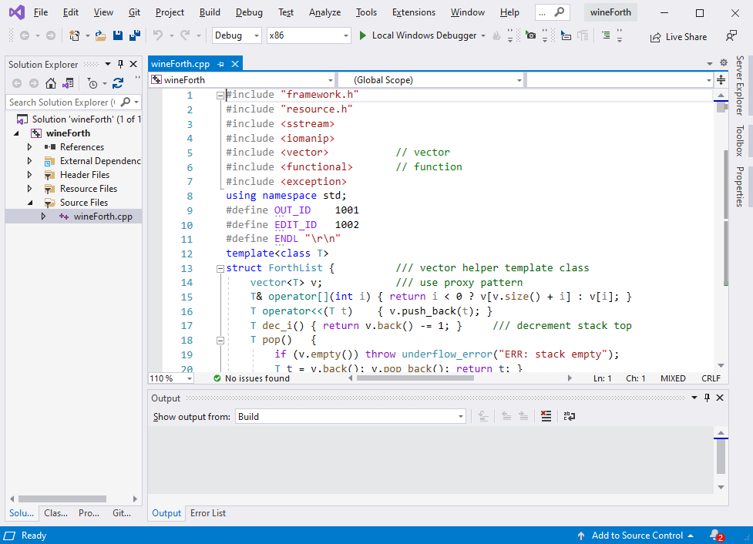

Click Build>Rebuild Solution, and Visual Studio goes to work. After a while, in the Output Panel, it will report a few lines of progress, and end with this message:

===== Rebuild All, 1 succeeded, 0 up-to-date, 0 skipped =====

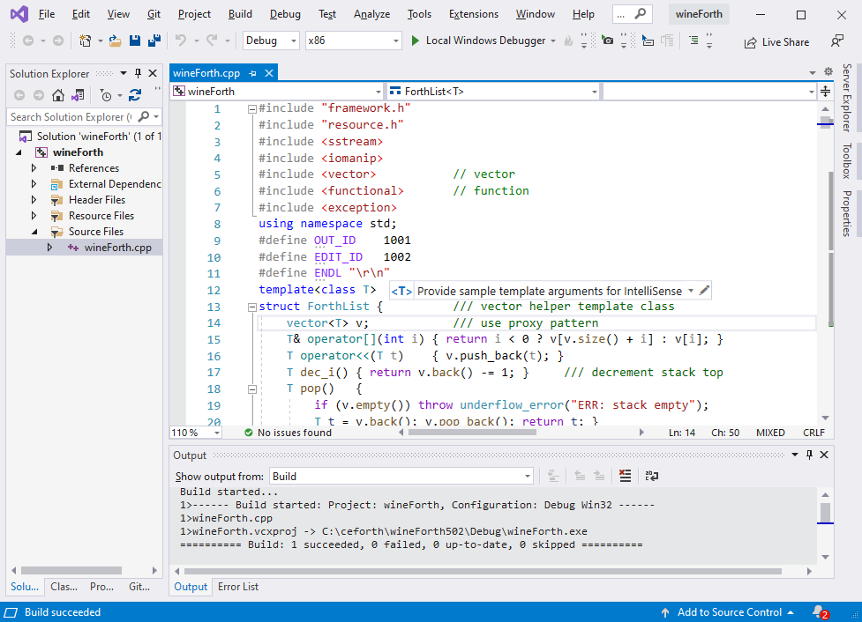

All is well. Ready to test.

Test wineforth_502

Click Debug>Start without debugging. Wait some more. Finally, you will see a Debug window. On top of it, you will have two windows side by side. An output window to the left, and an input window to the right:

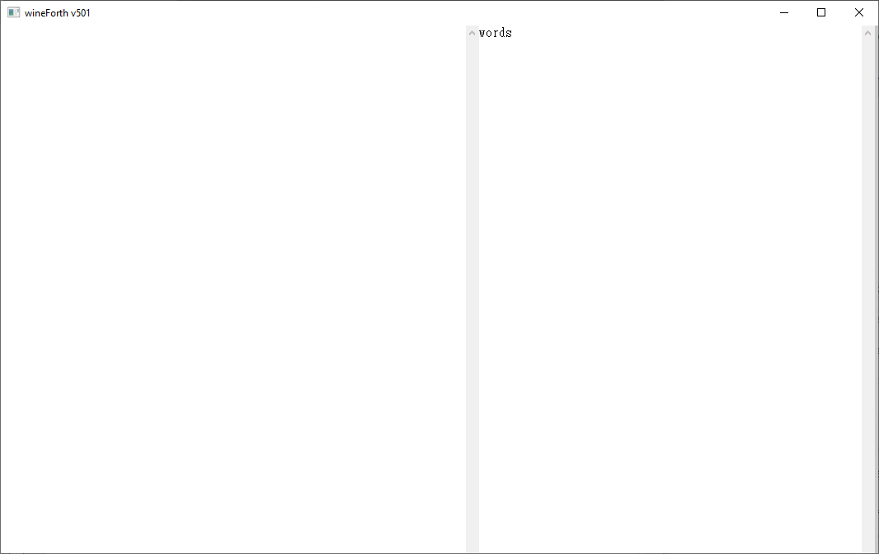

Success! wineForth is running.

Hit the return key to execute WORDS in the input window, and you get a screen of word in the output window:

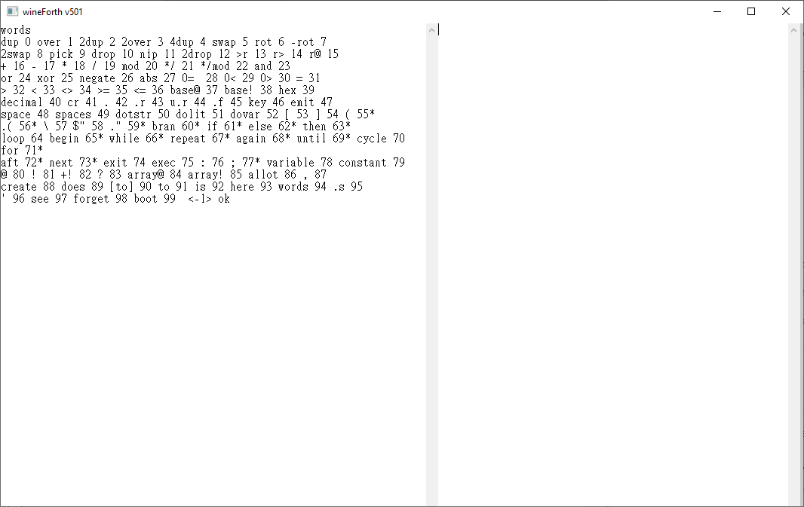

As you can see, there are 100 words implemented in this Forth system. The words are assigned sequential IDs called tokens, running from 0 to 99. A star after the token indicates that this word is an immediate word, which is executed when a new word is being compiled. These immediate words are used by Forth compiler to build branching and looping structures in a colon word.

Lessons502.txt

A text file Lessons502.txt is also distributed with wineforth502. It has 17 tutorial lessons for people who are not familiar with the Forth language to learn how to program in Forth. It is also a very good test bed to verify that wineforth works properly. Open it with your favorite text editor, select the entire file, and copy it into the right input window:

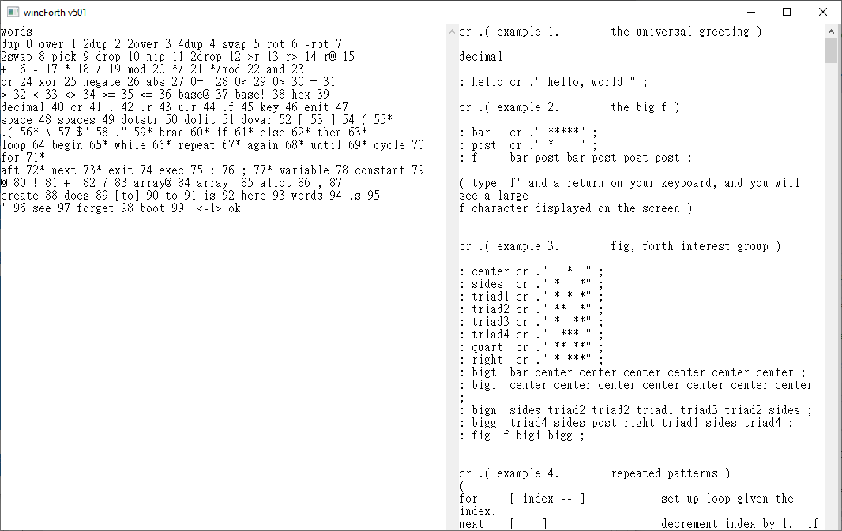
Hit the return key to compile all 17 lessons: You see only the results of the last few lessons in the left output window. You have to scroll up the window to see all earlier test results:

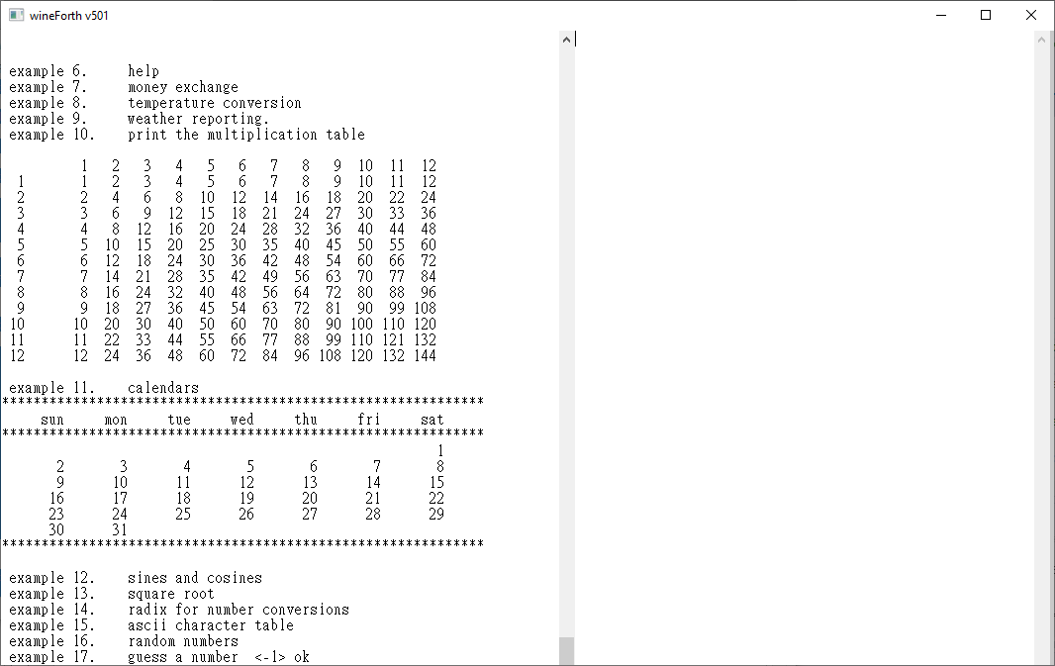

You can type Forth words into the input window and execute them by hitting the return key. Preferably you will write a large program in a text file. Copy the text file into the input window and hit the return key to run it.

In the early days of Forth, Chuck Moore did not have operating systems and files to manage his source code. He only had tape drives and disk drives. So he invented the Virtual Memory system to make use of the disks and tapes to store source code and data. He divided mass storage into blocks as Virtual Memory which could be accessed very conveniently by his Forth system. Blocks of 1024 byte size became standard features of his Forth systems and most Forth systems following his. However, the block is only one of many ways to supply source code to a Forth Virtual Machine, and is not an integral part of a Forth Virtual Machine.

eForth assumes only one input device supplying a stream of characters to be evaluated. Any way to supply the character stream is acceptable. In a modern PC, text files can supply the character stream. Operating systems allow you to manage these files on your PC. You copy the files and feed them to wineforth system, which evaluates the character stream.

Wineforth is a very good model of a Virtual Forth Machine, which accepts text from an input device, evaluates it, and sends results to an output device. You can type or paste the text into the input device. You can also copy and save the results from the output device to text files. Forth becomes very simple because it does not have to deal with files nor blocks, and many other aspects of operating systems.

Chapter 2. wineforth Source Code

wineforth is a very simple Forth system, with only 100 primitive words, or system commands, on boot up. In comparison, its parent eForth, which used to be the simplest Forth system, had 232 words, with 35 primitive words defining a Forth Virtual Machine. Half of the words in eForth were required to bring up the Forth outer interpreter and were rarely used by users or applications. wineforth does not need these supporting words, because C++ provides the services needed by the Forth outer interpreter.

There are only two types of words in wineforth: the primitive words as mentioned above, and colon words defined by you the user. The primitive words execute methods written in C++. A colon word contains an object list. A colon word just gives this list a new name and performs the tasks specified by this object list.

Both primitive words and colon words are objects in wineforth. wineforth has a one-size-fits-all constructor that constructs all the primitive objects and colon objects. This unique design makes wineforth a very simple Forth Virtual Machine, as it takes full advantage of the underlying objective C++ compiler.

ForthList

In wineforth everything belongs to a list. The parameter stack, return stack, dictionary, and object lists in colon words are all lists. To facilitate manipulating these lists, wineforth uses a ForthList struct. To allow lists to grow, ForthList inherits properties from the vector class. A list can grow using the push() method, and it can shrink with the pop() method. Elements in a list can be accessed by the [] and << operator as lists in JavaScript.

To adapt to Windows, the console I/O cin and cout are vectored to io stringstreams, and the input and output windows have unique ID’s as EDIT_ID and OUT_ID.

OUT_ID | ID of output window TextField
EDIT_ID | ID of input window TextBox
ENDL | Shorthand of end of line
ForthList | Struct to construct all lists in wineforth
[] | Operator to access individual element in a list
<< | Operator to add an element to a list
dec_i() | decrement top element in a list
pop() | pop the last element of a list
size() | rfeturn the size of a list
push(T t) | push an element t to a list
clear() | clear a list
merge(T& v2) | merge a list v2 to a list T
erase(int i) | eliminate elements of a list from the ith to end

#include "framework.h"
#include "resource.h"
#include <sstream>
#include <iomanip>
#include <vector> // vector
#include <functional> // function
#include <exception>
using namespace std;
#define OUT_ID 1001
#define EDIT_ID 1002
#define ENDL "\r\n"
template<class T>
struct ForthList { /// vector helper template class
vector<T> v; /// use proxy pattern
T& operator[](int i) { return i < 0 ? v[v.size() + i] : v[i]; }
T operator<<(T t) { v.push_back(t); }
T dec_i() { return v.back() -= 1; } /// decrement stack top
T pop() {
if (v.empty()) throw underflow_error("ERR: stack empty");
T t = v.back(); v.pop_back(); return t; }
int size() { return (int)v.size(); }
void push(T t) { v.push_back(t); }
void clear() { v.clear(); }
void merge(vector<T>& v2) { v.insert(v.end(), v2.begin(), v2.end()); }
void erase(int i) { v.erase(v.begin() + i, v.end()); }
};

Class Code

In wineforth all Forth words are objects. All objects are constructed by Class Code. It is a one-size-fits-all class. All special properties needed by various Forth words are included here and are instantiated when necessary. A set of constructors are used to construct various word objects.

A Forth word is instantiated as an object in the dict[] array. A word object may contain 9 attributes:

Fence | token incremental counter
Name | name string;
token | a sequential ID;
Immd | immediate flag
Stage | branching stage
Fop | primitive function
Literal | string literal
pf | object list required by a colon object;
pf1 | object list used by a control structure object;
pf2 | object list used by a control structure object;
qf | data values;

class Code; /// forward declaration
using fop = function<void(Code*)>; /// Forth operator
class Code {
public:
static int fence, IP; /// token incremental counter
string name; /// name of word
int token = 0; /// dictionary order token
bool immd = false; /// immediate flag
int stage = 0; /// branching stage
fop xt = NULL; /// primitive function
string literal; /// string literal
ForthList<Code*> pf;
ForthList<Code*> pf1;
ForthList<Code*> pf2;
ForthList<int> qf;

Object Constructors

Here are actual object constructors previewed in Class Code. There are 4 constructors for:
- primitive objects,
- colon objects,
- integer literal objects, and
- string literal objects,
respectively.

Code(string n, fop fn, bool im=false) { name = n; token = fence++; xt = fn; immd = im; }
Code(string n, bool f=false) { name = n; if (f) token = fence++; }
Code(Code* c, string s = string()) { name = c->name; xt = c->xt; if (s != string()) literal = s; }
Code(Code *c, int v) { name = c->name; xt = c->xt; qf.push(v); }

Methods

immediate() | Switch the boolean flag immd to true for an immediate word object.
addcode() | Push a new object to the object list in the pf property of the current colon object.
to_s() | Construct a text string with the name and the token of a word object.
see(w) | Decomple an object.
nest() | Inner interpreter of a colon word object. It executes the objects in an object list sequentially. WP points to the current colon word object, and IP points to the object in the object list to be executed. The execution sequence can be terminated by exit() which throws an exception to be caught by the catch branch.

Code *immediate() { immd = true; return this; }
Code *addcode(Code* w) { pf.push(w); return this; }
string to_s() { return name + " " + to_string(token) + (immd ? "*" : ""); }
string see(int dp) {
stringstream cout("");
auto see_pf = [&cout](int dp, string s, vector<Code*> v) { // lambda for indentation and recursive dump
int i = dp; cout << ENDL; while (i--) cout << " "; cout << s;
for (Code* w: v) cout << w->see(dp + 1); };
auto see_qf = [&cout](vector<int> v) { cout << " = "; for (int i : v) cout << i << " "; };
see_pf(dp, "[ " + to_s(), pf.v);
if (pf1.size() > 0) see_pf(dp, "1--", pf1.v);
if (pf2.size() > 0) see_pf(dp, "2--", pf2.v);
if (qf.size() > 0) see_qf(qf.v);
cout << "]";
return cout.str(); }
void nest() {
if (xt) xt(this);
else {
int tmp = IP; IP = 0;
while (IP < pf.size()) { pf[IP]->nest(); IP++; }
IP = tmp;
}
}
};
int Code::fence = 0, Code::IP = 0;

Macros

Macros are used to reduce verbosity. These macros rearrange items on the parameter stack and return stack. Caching the top item on the parameter stack in the top register greatly simplifies C++ code.

CODE | Construct primitive objects allowing methods to be written as finctions.
IMMD | Set the immd flags for immediate primitive objects.
ALU | Construct binary ALU object.
BOOL | Chane Boolean flag to integers.
PUSH | Push object v on parameter stack
POP | Pop an object off parameter stack..

#define CODE(s, g) new Code(string(s), [&](Code *c){ g; })
#define IMMD(s, g) new Code(string(s), [&](Code *c){ g; }, true)
#define ALU(a, OP, b) (static_cast<int>(a) OP static_cast<int>(b))
#define BOOL(f) ((f) ? -1 : 0)

Class ForthVM

ForthVM specifies a class for a Forth Virtual Machine. A Forth Virtual Machine has a parameter stack ss, a return stack rs, and a dictionary dict, which contains all primitive and colon objects. Other variables are used to control the operations in the outer interpreter.

cin | stream input
cout | stream output
rs | return stack
ss | parameter stack
dict | dictionary
compile | compiling flag
base | numeric radix
top | cached top of stack
WP | word pointer
IP | instruction pointers

class ForthVM {
istream &cin; /// stream input
ostream &cout; /// stream output
ForthList<int> rs; /// return stack
ForthList<int> ss; /// parameter stack
ForthList<Code*> dict; /// dictionary
bool compile = false; /// compiling flag
int base = 10; /// numeric radix
int top = -1; /// cached top of stack
int WP = 0, IP=0 ; /// instruction and parameter pointers
inline int POP() { int n = top; top = ss.pop(); return n; }
inline int PUSH(int v) { ss.push(top); return top = v; }

External Functions

These functions will be invoked by primitive objects, in the places of their lambda functions.

find() | Search the dictionary for an object whose name matches a string.
next_idiom() | Parse a string idiom out of the input device. The strings generally separated by spaces or white characters. However, you can specify a different delimiter if you have to.
dot_r() | Print out a number in a specified column. It will be used by .r and u.r.
ss_dump() | Print out a picture of the parameter stack with a “>ok” prompt.
see() | Recursively decompile an object. Nested colon objects are displayed clearly.
words() | Display all words in the dictionary with their tokens. Immediate words are marked with a star.
call(w) | Execute object w.

Code *find(string s) {
for (int i = (int)dict.size() - 1; i >= 0; --i) {
if (s == dict.v[i]->name) return dict.v[i]; }
return NULL; }
string next_idiom(char delim=0) {
string s; delim ? getline(cin, s, delim) : cin >> s; return s; }
void dot_r(int n, int v) { cout << setw(n) << setfill(' ') << v; }
void ss_dump() {
cout << " <"; for (int i : ss.v) { cout << i << " "; }
cout << top << "> ok" << ENDL; }
void words() {
int i = 0;
for (Code* w : dict.v) {
if ((i++ % 8) == 0) cout << ENDL;
cout << w->to_s() << " "; }}
void call(Code* w) {
rs.push(WP); /// * setup call frame
WP = w->token;
try { w->nest(); } /// * run inner interpreter recursively
catch (exception& e) {
string msg = e.what(); /// * capture exception message
if (msg != string()) cout << msg << ENDL;
}
WP = rs.pop();
} /// * restore call frame

Forth Virtual Machine

Here a Forth Virtual Machine is instantiated. It is initiated by the method init() which constructed a dictionary of primitive objects in an array prim. We will then stuff all primitive objects into this array and build the Forth dictionary.

public:
ForthVM(istream& in, ostream& out) : cin(in), cout(out) {}
void init() {
static vector<Code*> prim = { /// singleton, build once only

Stack Operators

A large set of primitive objects are constructed to manipulation items on the parameter and return stack.

dup | ( a -- a a ) Duplicate tos
over | ( a b -- a b a ) Duplicate 2nd tos item
2dup | ( a b -- a b a b ) Duplicate top 2 items of tos
4dup | ( a b c d -- a b c d a b c d ) Duplicate top quad tos items
swap | ( a b -- b a ) Swap two tos items
rot | ( a b c -- b c a ) Rotata 3rd tos item to top
-rot' | ( a b c -- c a b ) Rotate tos to 3rd position
2swap | ( a b c d -- c d a b ) Swap two pairs of tos items
2over | ( a b c d -- a b c d a b ) Duplicate second pair tos items
pick | ( i -- a ) Copy ith tos item to top
roll | ( i -- a ) Roll ith tos item to top
drop | ( a -- ) Discard tos
nip | ( a b -- a ) Discard 2nd tos item
2drop | ( a b -- ) Discard two tos items
>r | ( a -- ) Push tos to return stack
r> | ( -- a ) Pop return stack to tos
r@ | ( -- a ) Duplicate top of return stack to tos
push | ( a -- ) Push tos to return stack. Same as >r.
pop | ( -- a ) "Pop return stack to tos. Same as r>,"

// stack op
CODE("dup", PUSH(top)),
CODE("over", PUSH(ss[-1])),
CODE("2dup", PUSH(ss[-1]); PUSH(ss[-1])),
CODE("2over",PUSH(ss[-3]); PUSH(ss[-3])),
CODE("4dup", PUSH(ss[-3]); PUSH(ss[-3]); PUSH(ss[-3]); PUSH(ss[-3])),
CODE("swap", int n = ss.pop(); PUSH(n)),
CODE("rot", int n = ss.pop(); int m = ss.pop(); ss.push(n); PUSH(m)),
CODE("-rot", int n = ss.pop(); int m = ss.pop(); PUSH(n); PUSH(m)),
CODE("2swap",
int n = ss.pop(); int m = ss.pop(); int l = ss.pop();
ss.push(n); PUSH(l); PUSH(m)),
CODE("pick", int i = top; top = ss[-i]),
// CODE("roll", int i = top; top = ss[-i]),
CODE("drop", top = ss.pop()),
CODE("nip", ss.pop()),
CODE("2drop",ss.pop(); top = ss.pop()),

The return stack is used by wineforth inner interpreter xt() to save the current word pointer WP and the current instruction pointer IP. Its operations are mostly hidden from you. However, it is a convenient place to save a few parameters on the parameter stack, when it is too crowded. Remember to pop off all the items you pushed on the return stack before a colon word is finished. Leaving things on the return stack is a very easy way to crash ooeForth system.

The for-next looping mechanism also uses the return stack to store the loop index. In a for-next loop, use r@ to get the current loop index.

>r | ( a -- ) Push tos to return stack
r> | ( -- a ) Pop return stack to tos
r@ | ( -- a ) Duplicate top of return stack to tos

CODE(">r", rs.push(POP())),
CODE("r>", PUSH(rs.pop())),
CODE("r@", PUSH(rs[-1])),

ALU Objects

Caching the top of the parameter stack in the top register greatly simplified the binary ALU operations, mostly involving only two items on the top of the parameter stack. wineforth used 32-bit integer numbers exclusively. Logic words and, or, and xor return 32-bit integers after bitwise logic operations.

+ | ( a b -- c ) Add two tos items
- | ( a b -- c ) Subtract tos from 2nd item
* | ( a b -- c ) Multiply two tos items
/ | ( a b -- c ) Divide 2nd item by tos
mod | ( a b -- c ) Modulus 2nd item by tos
and | ( a b -- c ) Bitwise AND of two tos items
or | ( a b -- c ) Bitwise OR of two tos items
xor | ( a b -- c ) Bitwise XOR of two tos items
negate | ( a -- b ) Negate tos

// ALU ops
CODE("+", top = ALU(ss.pop(), +, top)),
CODE("-", top = ALU(ss.pop(), -, top)),
CODE("*", top = ALU(ss.pop(), *, top)),
CODE("/", top = ALU(ss.pop(), /, top)),
CODE("mod", top = ALU(ss.pop(), %, top)),
CODE("*/", top = ss.pop() * ss.pop() / top),
CODE("*/mod",
int n = static_cast<int>(ss.pop() * ss.pop());
int t = static_cast<int>(top);
ss.push(n % t); top = (n / t)),
CODE("and", top = ALU(ss.pop(), &, top)),
CODE("or", top = ALU(ss.pop(), |, top)),
CODE("xor", top = ALU(ss.pop(), ^, top)),
CODE("negate", top = -top),
CODE("abs", top = abs(top)),

Compare Objects

Comparison objects generally return -1 for true or 0 for false. When a value is used as a flag, a non-zero value acts like a true flag, and 0 acts as a false flag.

0= | ( a -- f ) Return true if a=0
0< | ( a -- f ) Return true if a<0
0> | ( a -- f ) Return true if a>0
0<> | ( a -- f ) Return true if a is not 0
0<= | ( a -- f ) Return true if a<=0
0>= | ( a -- f ) Return true if a>=0
= | ( a b -- f ) Return true if a=b
> | ( a b -- f ) Return true if a>b
< | ( a b -- f ) Return true if a<b
<> | ( a b -- f ) Return true if a is not equal to b
>= | ( a b -- f ) Return true if a>=b
<= | ( a b -- f ) Return true if a<=b

// logic ops
CODE("0= ", top = BOOL(top == 0)),
CODE("0<", top = BOOL(top < 0)),
CODE("0>", top = BOOL(top > 0)),
CODE("=", top = BOOL(ss.pop() == top)),
CODE(">", top = BOOL(ss.pop() > top)),
CODE("<", top = BOOL(ss.pop() < top)),
CODE("<>", top = BOOL(ss.pop() != top)),
CODE(">=", top = BOOL(ss.pop() >= top)),
CODE("<=", top = BOOL(ss.pop() <= top)),

Number Output

hex and decimal switch number conversion radix to hexadecimal and to decimal, respectively. The radix base is not directly accessible in ooeForth. However, the command base! can change the radix base ranging from 2 to 36. ooeForth inputs and outputs all numbers in current radix.

base@ | ( -- a ) Return current base
base! | ( a -- ) Make a the current base
hex | ( -- ) Change to hexadecimal base
decimal | ( -- ) Change to decimal base
cr | ( -- ) Display a carriage return
. | ( a -- ) Display number a on tos
.r | ( a n -- ) Display a in n columns
key | ( -- a ) Input an ASCII character
emit | ( a -- ) Display an ASCII character
space | ( -- ) Display a space
spaces | ( n -- ) Display n spaces

// output
CODE("base@", PUSH(base)),
CODE("base!", cout << setbase(base = POP())),
CODE("hex", cout << setbase(base = 16)),
CODE("decimal", cout << setbase(base = 10)),
CODE("cr", cout << ENDL),
CODE(".", cout << POP() << " "),
CODE(".r", int n = POP(); dot_r(n, POP())),
CODE("u.r", int n = POP(); dot_r(n, abs(POP()))),
CODE(".f", int n = POP(); cout << setprecision(n) << POP()),
CODE("key", PUSH(next_idiom()[0])),
CODE("emit", char b = (char)POP(); cout << b),
CODE("space", cout << " "),
CODE("spaces", for (int n = POP(), i = 0; i < n; i++) cout << " "),

Literals

Character strings are a very important data type for a program to communicate with you. Error messages, appropriate warnings, and suggestions can be displayed dynamically to help you use the system in a friendly way. Character strings are compiled in the colon words as string objects. A string literal is compiled into a string object whose literal attribute contains the character string. It is similar to an integer literal that is a dolit object and has the integer value stored in its qf attribute. This special wineforth property embedding strings and integers in objects allows you to construct linear object lists in colon words.

This is a good place to mention that an object list only contains objects. We have integer literals and string literals taking care of. Later, we will show you how to take care of control structures, like branching and looping. All control structures are reduced to objects and all object lists in colon words become linear object lists that can be executed easily.

[ | ( -- ) Change to interpreting mode
] | ( -- ) Change to compiling mode
' | ( -- w ) Return token of next idiom outside colon idiom.
(') | ( -- w ) Return token of next idiom inside colon idiom.
['] | ( -- w ) Return token of next compiled string while compiling.
dolit | ( -- ) Push next token on stack
dostr | ( -- w ) Return token of next string
$" | ( -- w ) Compile next idiom as a string literal
dotstr | ( -- ) Display next compiled string
." | ( -- ) Compile next idiom as a string literal for display
( | ( -- ) Comment to the next )
.( | ( -- ) Display next idiom up to next )
\ | ( -- ) Comment to the new line

// literals
CODE("dotstr", cout << c->literal),
CODE("dolit", PUSH(c->qf[0])),
CODE("dovar", PUSH(c->token)),
CODE("[", compile = false),
CODE("]", compile = true),
IMMD("(", next_idiom(')')),
IMMD(".(", cout << next_idiom(')')),
CODE("\\", cout << next_idiom('\n')),
CODE("$\"",
string s = next_idiom('"').substr(1);
dict[-1]->addcode(new Code(find("dovar"), s))),
IMMD(".\"",
string s = next_idiom('"').substr(1);
dict[-1]->addcode(new Code(find("dotstr"), s))),

Control Structures

When the outer interpreter compiles a colon word, it builds a new object list. Chuck Moore invented a very simple mechanism to build control structures in token lists. He designated a set of words that are executed while compiling. These words are called immediate words. These immediate words build control structures by compiling address literals. The addresses in the address literals are resolved correctly in a single pass, using the parameter stack to hold addresses for forward and backward referencing.

In ceforth, we went a step further. Each control structure is compiled into an object! In branching and looping structures, there are different paths of execution. We use the attributes pf, pf1, and pf2 to store object lists to be executed selectively in different paths.

Following are all the alternative object lists used in the control structures:

Conditional branch | if {pf} then
 | if {pf} else {pf1} then
Infinite loop | begin {pf} again
Indefinite loop | begin {pf} until
 | begin {pf} while {pf1} repeat
Finite loop | for {pf} next
 | for {pf} aft {pf1} then {pf2} next

We construct three types of objects to take care of all the above control structures:
branch builds an if-then or if-else-then object.
loops build a begin-until, begin-again, or begin-while-repeat object.
cycles build a for-next or for-aft-then-next object.

In these control structure objects, they use another attribute struct to decide which path to follow at runtime:
stage=0, execute pf list in if-then, begin-again, or for-next structures.
stage=1, execute pf in begin-until structure.
stage=2, execute pf or pf1 list in if-else-then or begin-while-repeat structure.
stage=3, execute pf, pf1 or pf2 list in for-aft-then-next structure.

Branch

branch is an object which has a pf and a pf1 attributes. pf stores a true branch in an if-then or if-else-then object. pf1 stores a false branch in an if-else-then object.

branch | Object to hold if-then or if-else-then structure
if | Instantiate branch object and start compiling pf list.
else | Terminate pf list and start compiling pf1 list.
then | Terminate pf or pf1 list.

// branching - if...then, if...else...then
IMMD("bran",
bool f = POP() != 0; // check flag
for (Code* w : (f ? c->pf.v : c->pf1.v)) call(w)),
IMMD("if",
dict[-1]->addcode(new Code(find("bran")));
dict.push(new Code("temp"))), // use last cell of dictionay as scratch pad
IMMD("else",
Code *temp = dict[-1]; Code *last = dict[-2]->pf[-1];
last->pf.merge(temp->pf.v);
temp->pf.clear();
last->stage = 1),
IMMD("then",
Code *temp = dict[-1]; Code *last = dict[-2]->pf[-1];
if (last->stage == 0) { // if...then
last->pf.merge(temp->pf.v);
dict.pop();
}
else { // if...else...then, or
last->pf1.merge(temp->pf.v); // for...aft...then...next
if (last->stage == 1) dict.pop();
else temp->pf.clear();
}),

Loops

loops is an object which has a pf and a pf1 attributes. The pf stores a repeating branch in a begin-again, begin-until, or begin-while-repeat object. The pf1 stores a true branch in a begin-while-repeat object.

loops | Object to hold begin-until,begin-again, or begin-while-repeat structure
begin | Instantiate loops object and start compiling pf list.
again | Terminate pf list.
until | Terminate pf list.
while | Terminate pf list and start compiling pf1 list.
repeat | Terminate pf1 list.

// loops - begin...again, begin...f until, begin...f while...repeat
CODE("loop",
while (true) {
for (Code* w : c->pf.v) call(w); // begin...
int f = top;
if (c->stage == 0 && (top = ss.pop(), f != 0)) break; // ...until
if (c->stage == 1) continue; // ...again
if (c->stage == 2 && (top = ss.pop(), f == 0)) break; // while...repeat
for (Code* w : c->pf1.v) call(w);
}),
IMMD("begin",
dict[-1]->addcode(new Code(find("loop")));
dict.push(new Code("temp"))),
IMMD("while",
Code *last = dict[-2]->pf[-1]; Code *temp = dict[-1];
last->pf.merge(temp->pf.v);
temp->pf.clear(); last->stage = 2),
IMMD("repeat",
Code *last = dict[-2]->pf[-1]; Code *temp = dict[-1];
last->pf1.merge(temp->pf.v); dict.pop()),
IMMD("again",
Code *last = dict[-2]->pf[-1]; Code *temp = dict[-1];
last->pf.merge(temp->pf.v);
last->stage = 1; dict.pop()),
IMMD("until",
Code *last = dict[-2]->pf[-1]; Code *temp = dict[-1];
last->pf.merge(temp->pf.v); dict.pop()),

Cycles

cycles is an object which has pf , pf1, and pf2 attributes. pf stores a repeating list in a for-next type of object. If the cycles object contains an aft-then clause, 3 pf attributes are used as:
for {pf} aft {pf1} then {pf2} next

cycles | Object to hold for-nex or for-aft-then-next structure
for | Instantiate cycles object and start compiling pf list.
next | Terminate pf or pf2 list.
aft | Terminate pf list and start compiling pf1 list.

// loops - for...next, for...aft...then...next
CODE("cycle",
do { for (Code* w : c->pf.v) call(w); }
while (c->stage == 0 && rs.dec_i() >= 0); // for...next only
while (c->stage > 0) { // aft
for (Code* w : c->pf2.v) call(w); // then...next
if (rs.dec_i() < 0) break;
for (Code* w : c->pf1.v) call(w); } // aft...then
rs.pop()),
IMMD("for",
dict[-1]->addcode(new Code(find(">r")));
dict[-1]->addcode(new Code(find("cycle")));
dict.push(new Code("temp"))),
IMMD("aft",
Code *last = dict[-2]->pf[-1]; Code *temp = dict[-1];
last->pf.merge(temp->pf.v);
temp->pf.clear(); last->stage = 3),
IMMD("next",
Code *last = dict[-2]->pf[-1]; Code *temp = dict[-1];
if (last->stage == 0) last->pf.merge(temp->pf.v);
else last->pf2.merge(temp->pf.v); dict.pop()),

Defining Words

All Forth words in the boot-up dict are primitive words with only the name attributes and the methods xt. All Forth words you define after boot-up are colon words, with an object list in its attribute pf. Constants, variables, and arrays have their data stored in the qf attribute. Immediate words that compile control structures have a true flag in their immd attribute.

This set of words, ‘:’, constant, variable, and create are defining words. They create new objects and add them to the dictionary.

create does not allocate space in its qf attribute. The command ‘,’ (comma) adds one data value to the qf attribute. The command allot allocates a number of data values in the pf attribute and initializes them all to 0.

exit | Unnest an object list by throwing an ArithmeticException.
exec | Start executing the colon object at w.
: | Create a new colon word object. It takes the following string in the input stream to be the name of the new word. It sets compiling flag to true so that the pf attribute to receive a new object list,
; | Clear the compiling flag to false and terminate compiling the current object list.
create | Create a new array without allocating memory. Memory is allocated using allot.
variable | Create a new variable, and initialize its qf attribute to 0.
constant | Create a new constant, and initialize its qf attribute with the value n.
@ | ( w – n ) w is the token of a variable. Return the data stored in its qf attribute.
! | ( n w -- ) Store the data n into the qf attribute of a variable w.
+! | ( n w -- ) Add value n to the qf attribute in the variable w.
? | ( w -- ) Display the contents in the qf attribute of a variable w.
array@ | ( w i -- ) Return the ith object in the qf attribute of an array w defined by create.
array! | ( n w i -- ) Store data n into the ith object in the qf attribute of an array w defined by create.
, | ( n -- ) Sdd n to the qf attribute in the newly created object.
allot | ( n -- ) Extend the qf attribute in the newly created object by n integers, and initialize them with the value 0.

// compiler
CODE("exit", throw domain_error(string())),
CODE("exec", int n = top; call(dict[n])),
CODE(":",
dict.push(new Code(next_idiom(), true)); // create new word
compile = true),
IMMD(";", compile = false),
CODE("variable",
dict.push(new Code(next_idiom(), true));
Code *last = dict[-1]->addcode(new Code(find("dovar"), 0));
last->pf[0]->token = last->token),
CODE("constant",
dict.push(new Code(next_idiom(), true));
Code *last = dict[-1]->addcode(new Code(find("dolit"), POP()));
last->pf[0]->token = last->token),

All Forth words are objects containing all information needed for their execution. All colon words have their token list in their pf attributes. Variables and constants have their values in the qf attributes of their corresponding dovar and dolit objects.. An array defined by create has the array values stored in the qf attribute of its dovar object. These array objects are addressed by the array token w and an offset. The Forth memory commands @ and ! can only access the first value in qf attributes. Commands array@ and array! must be used to access other array values.

CODE("@", int w = POP(); PUSH(dict[w]->pf[0]->qf[0])), // w -- n
CODE("!", int w = POP(); dict[w]->pf[0]->qf[0] = POP()), // n w --
CODE("+!", int w = POP(); dict[w]->pf[0]->qf[0] += POP()), // n w --
CODE("?", int w = POP(); cout << dict[w]->pf[0]->qf[0] << " "),// w --
CODE("array@", int a = POP(); PUSH(dict[POP()]->pf[0]->qf[a])), // w a -- n
CODE("array!", int a = POP(); int w = POP(); dict[w]->pf[0]->qf[a] = POP()), // n w a --
CODE("allot", // n --
for (int n = POP(), i = 0; i < n; i++) dict[-1]->pf[0]->qf.push(0)),
CODE(",", dict[-1]->pf[0]->qf.push(POP())),
CODE("create",
dict.push(new Code(next_idiom(), true)); // create a new word
Code *last = dict[-1]->addcode(new Code(find("dovar"), 0));
last->pf[0]->token = last->token;
last->pf[0]->qf.clear()),

Define a Defining Word

The concept of a defining word is a very unique feature of Forth, in that it allows you to define new classes of words that can make specific use of data stored in their data attributes. A new defining word is defined by a create-does construct in a colon word:
: <definingWord>
create <compiler words>
does <interpreter words> ;

A defining word is defined just like a regular colon word. It starts with the colon command ‘:’ with a name. Then create creates a new word. The sequences of words in <compiler words> specify how you build the data attribute qf in the new word. The sequences of words <interpreter words> specify how the data in qf attribute are to be interpreted when this new word is later executed. This defining word can be used to create a new class of words that share the same interpreter encoded in the <interpreter word> list. You can design your own compiler/interpreter and create a new class of words that solves your problem most efficiently.

Attributes in an object can be changed dynamically like values in a variable and data items in an array object. Here we have a ‘to’ object to change the value of a constant, and an ‘is’ object to change the behavior of a colon object:

Constants are simple to use. You give its name, and it returns its value on the stack. Variables are more flexible. They return their token, and you use @ to get its current value. You use ! to change its value. It would be nice if we can change the value of a constant. You can do it in wineforth. You first find the token of a constant by the tick (‘) command. With this token you can store a new value with the to command. It works well in the interpreting mode. In the compiling mode, use [to] to change the value of a constant immediately after [to].

A colon word has an object list in its pf attribute. An object list can be easily changed to another object list in another colon word. This is generally called vectored execution in Forth parlance. The command is does exactly that. is requires the token of a source colon word and a following target colon word. After is is executed, the target colon word gets the object list of the source colon word and behaves exactly like the source colon word.

does | In a create-does structure, start compiling an object list which will interpret the objects created from this custom defining object..
[to] | ( n -- ) Change the value of the following constant to n. Use in colon words
to | ( n -- ) Change the value of the following constant to n.
is | ( w1 w2 -- ) Copy the token list in the pf attribute of w1 to the pf attribute of w2. Make w2 behave like w1.

CODE("does",
vector<Code*> src = dict[WP]->pf.v; // source word : xx create...does...;
int i = 0; int n = (int)src.size();
while (i < n && src[i]->name != "does") i++; // find the "does"
while (++i < n) dict[-1]->pf.push(src[i]); // copy words after "does" to new the word
throw domain_error(string())), // break out of for { c->exec() } loop

‘to’ object allows you to change the value of a constant at compile time. Constants can now be used as variables but without the extra step of @/.

‘is’ object allows you the change the behavior of a colon object dynamically. To use it, you have to use the “’” (tick) object to find the source colon object. You can stuff its pf attribute to a target colon object. The command sequence is”
‘ source-object is target-object
After that, the target object works exactly like the source object. This is called vectored execution.

CODE("[to]",
vector<Code*> src = dict[WP]->pf.v; // source word : xx create...does...;
src[++Code::IP]->pf[0]->qf[0] = POP()), // change the following constant
CODE("to", // n -- , compile only
Code *tgt = find(next_idiom());
if (tgt) tgt->pf[0]->qf[0] = POP()), // update constant
CODE("is", // w -- , execute only
Code *tgt = find(next_idiom());
if (tgt) {
tgt->pf.clear();
tgt->pf.merge(dict[POP()]->pf.v); }),

Tools

A set of tool words are defined to make it easier for you to write Forth words in ooeForth and to debug them. All Forth words are now objects. These tool words help you to get important information about word objects.

The colon word decompiler see is also interesting. As mention before, an object list in a colon word contains other objects. The decompiler see simply looks up each object in an object list and displays its name. Very simple. Chochain made it even more powerful by recursively diving into nested object lists and decompile them all. Try it to see for yourself.

here | Display the index of the last word in the dictionary.
words | Display names of all words in the dictionary from the newest to the oldest.
.s | Display all items on the parameter stack.
‘ | Find the object of the following name..
see | Look up the following word in the dictionary and decompile it.
forget | Search the following word in the dictionary. Delete it and all words defined after it. The system words at boot time are protected and cannot be removed.
boot | Delete all user defined words.

// tools
CODE("here", PUSH(dict[-1]->token)),
CODE("words", words()),
CODE(".s", ss_dump()),
CODE("'", Code *w = find(next_idiom()); PUSH(w->token)),
CODE("see",
Code *w = find(next_idiom());
if (w) cout << w->see(0) << ENDL),
CODE("forget",
Code *w = find(next_idiom());
if (w == NULL) return;
dict.erase(Code::fence=max(w->token, find("boot")->token + 1))),
CODE("boot", dict.erase(Code::fence=find("boot")->token + 1))
};

Dictionary

Forth dictionary was built as an array in prim. Now this array is used to instantiate the dictionary dict.

dict.merge(prim); } /// * populate dictionary

Outer Interpreter

The outer interpreter is actually Forth itself. The body of code in the original eForth model was to build this outer interpreter. In wineforth, using services provided by the C++ compiler, the outer interpreter becomes very simple.

The outer interpreter outer() repeatedly parse out an idiom from the input stream cin and then evaluate it. Evaluating an idiom involves looking up this idiom in dict. If it is an object, it is executed when not compiling or when the object is immediate; otherwise, the object is compiled into the pf attribute in the object currently being compiled.

If the idiom is not an object, it is converted to an integer by stoi(). This integer is compiled as an integer literal object when compiling. When not compiling, the integer is pushed on the parameter stack. If this idiom cannot be converted to an integer, an exception is thrown and the outer interpreter waits for the next idiom from cin.

As C++ has a very efficient parser in the cin object. wineforth just calls cin to parse out the next idiom. On the other end, the cout object takes whatever you throw at it and shows them on the console.

void outer() {
string idiom;
while (cin >> idiom) {
Code *w = find(idiom); /// * search through dictionary
if (w) { /// * word found?
if (compile && !w->immd) /// * in compile mode?
dict[-1]->addcode(w); /// * add to colon word
else call(w); } /// * execute forth word
else { /// * treat as a numeric?
char *p;
int n = (int)strtol(idiom.c_str(), &p, base);
if (*p != '\0') { /// * not number
cout << idiom << "? " << ENDL; ///> display error prompt
compile = false; ///> reset to interpreter mode
ss.clear(); top=-1; ///> clear stack
getline(cin, idiom, '\n'); } ///> skip the entire line
else if (compile) /// * a number in compile mode?
dict[-1]->addcode(new Code(find("dolit"), n)); ///> add to current word
else PUSH(n); }} ///> or, add value onto data stack
if (!compile) ss_dump(); } /// * dump stack and display ok prompt
};

Windows Interface

In ceforth_403 as a console project, we used cin to read input characters from the keyboard and cout to display characters in the console screen. Here cin is changed to read characters from an input window and cout displays characters in an output window. In wineforth two stringstream objects forth_in and forth_out are declared. They served as input object and output object of the Forth Virtual Machine forth_vm.

std::istringstream forth_in;
std::ostringstream forth_out;
ForthVM* forth_vm = new ForthVM(forth_in, forth_out);
LRESULT CALLBACK WindowProc(HWND, UINT, WPARAM, LPARAM);
TCHAR szClassName[] = _T("wineForth - eForth for Windows");
HWND hwnd, TextBox, TextField;
HACCEL Accel;
HFONT Font = CreateFont(0, 8, 0, 0, 0, 0, 0, 0, 0, 0, 0, 0, 0, _T("MingLiU"));

WinMain

By default Windows executes WinMain routine on boot. In WinMain a Windows class wincl is first instantiated and registered by RegisterClassEx().

int WINAPI WinMain(HINSTANCE hInst, HINSTANCE hPrevInst, LPSTR lpszArg, int nCmdShow) {
MSG msg; /* Here messages to the application are saved */
WNDCLASSEX wincl; /* Data structure for the windowclass */
setlocale(LC_ALL, ".utf8"); // enable Chinese
wincl.hInstance = hInst;
wincl.lpszClassName = szClassName;
wincl.lpfnWndProc = WindowProc; /* This function is called by windows */
wincl.style = CS_DBLCLKS; /* Catch double-clicks */
wincl.cbSize = sizeof(WNDCLASSEX);
wincl.hIcon = LoadIcon(NULL, IDI_APPLICATION);
wincl.hIconSm = LoadIcon(NULL, IDI_APPLICATION);
wincl.hCursor = LoadCursor(NULL, IDC_ARROW);
wincl.lpszMenuName = NULL; /* No menu */
wincl.cbClsExtra = 0; /* No extra bytes after the window class */
wincl.cbWndExtra = 0; /* structure or the window instance */
wincl.hbrBackground = (HBRUSH)COLOR_BACKGROUND;
RegisterClassEx(&wincl);

Main Window

Now we set up the principal window to house our input and output sub-windows. It is a big window and we intentionally leave it at the upper left corner so that the whole window will always be visible. Leaving it to Windows, the bottom of the output window generally gets obscured.

hwnd = CreateWindowEx(
0, /* Extended possibilites for variation */
szClassName, /* Classname */
_T("wineForth v501"),/* Title Text */
WS_OVERLAPPEDWINDOW, /* default window */
0, 0, 1080, 680, /* Put it at upper left corner */
HWND_DESKTOP, /* The window is a child-window to desktop */
NULL, /* No menu */
hInst, /* Program Instance handler */
NULL); /* No Window Creation data */
ShowWindow(hwnd, nCmdShow);

EDIT Windows

Two EDIT windows are set up. The TextBox widown is for input and the TextField window is for output. These windows are very capable text editors. You can do lots of pasting and copying to manage input and output text.

TextField = CreateWindow(_T("EDIT"), _T(""),
WS_CHILD | WS_VISIBLE | WS_VSCROLL | ES_AUTOVSCROLL | ES_MULTILINE,
0, 0, 580, 660,
hwnd, (HMENU)OUT_ID, hInst, NULL);
TextBox = CreateWindow(_T("EDIT"), _T("words"),
WS_CHILD | WS_VISIBLE | WS_VSCROLL | ES_AUTOVSCROLL | ES_MULTILINE,
580, 0, 480, 660,
hwnd, (HMENU)EDIT_ID, hInst, NULL);

Messages

What we want to do is put text in the input window and the hit the return key to send the text to the Forth Virtual Machine to evaluate. EDIT window captures all keystrokes including the return key and masks the return key we need. So we used accelerated keyboard to get the return key. The font for input and output characters are set to a mono-space font to emulate an old-fashion ADM-3 terminal.

Accel = LoadAccelerators(hInst, MAKEINTRESOURCE(IDR_ACCELERATOR1));
SendMessage(TextField, WM_SETFONT, WPARAM(Font), TRUE);
SendMessage(TextBox, WM_SETFONT, WPARAM(Font), TRUE);
forth_vm->init();
while (GetMessage(&msg, NULL, 0, 0)) {
if (!TranslateAccelerator(hwnd, Accel, &msg)) {
TranslateMessage(&msg);
DispatchMessage(&msg); }}
return LOWORD(msg.wParam);
}

Process Messages

Here is the magic Chochain played to work on the text read from the input window, get the Forth Virtual Machine to evaluate the text, and then sends output characters to the output window. Input characters are read from the TextBox input window into a cmd buffer. The character stream is sent to the outerinterpreter outer() to evaluate. Output characters are accumulated in a results buffer and then to the TextField output window.

The TextBox window is cleared and is ready for the next set of input characters.

void ProcessCommand() {
const int len = GetWindowTextLength(TextBox) + 1;
TCHAR* text = new TCHAR[len];
GetWindowText(TextBox, &text[0], len);
char* cmd = (char*)malloc(len*4);
size_t xlen;
wcstombs_s(&xlen, cmd, len*4, text, len*4);
SendMessage(TextField, EM_SETSEL, -1, -1);
SendMessage(TextField, EM_REPLACESEL, 0, (LPARAM)text);
forth_in.clear();
forth_in.str(cmd);
forth_vm->outer();
string out = forth_out.str();
size_t wclen = out.size() + 1;
if (wclen > 1) {
TCHAR* result = new TCHAR[wclen];
mbstowcs_s(&xlen, result, wclen, out.c_str(), wclen);
SendMessage(TextField, EM_SETSEL, -1, -1);
SendMessage(TextField, EM_REPLACESEL, 0, (LPARAM)result);
delete[] result;
forth_out.str(""); }
free(cmd);
delete[] text;
SetWindowText(TextBox, _T(""));
}

WindowProc

The callback processor WindowProc() just sets there waiting for a return key. When a return key is hit, ProcessCommand() is called and the Forth outer interpreter evaluates all the characters in the TextBox input window.

LRESULT CALLBACK WindowProc(HWND hwnd, UINT msg, WPARAM wParam, LPARAM lParam)
{
switch (msg) {
case WM_KEYDOWN: if (wParam == VK_ESCAPE) { ProcessCommand(); } break;
case WM_COMMAND: if (LOWORD(wParam) == IDM_ABOUT) { ProcessCommand(); } break;
case WM_DESTROY: PostQuitMessage(0); break;
default: return DefWindowProc(hwnd, msg, wParam, lParam); }
return 0;
}

Done!

Here we have a Forth Virtual Machine for Windows. Windows is very complicated and people struggled mightily to get it to work in their projects. Existing Forth systems for Windows are as complicated by necessity. There’s got to be an easy way through it and we found one. We open up an input window and an output window. Then we insert a Forth Virtual Machine between them.

The source code in wineforth.cpp is very small, only 434 lines. You can read and understand if readily. Forth is simple yet powerful. I hope that you like it and make good use of it.

Chapter 3. Lessons502.txt

Lessons502.txt file contains 17 tutorials I distributed with earlier eForth systems. They are also my sanity checks. Most of my problems in implementing a new eForth system surfaced when I ran these lessons on my new target machines. The Eclipse Console window can accept a very large amount of text. Instead of typing each lesson by hand, you can copy a lesson and paste it into the console to execute/compile it. When the whole system is debugged, I simply copy the entire file into the console. Everything will be compiled correctly. If you scroll the console up, you will see the results from many lessons. When you read a lesson, you can just type in the final word in that lesson and verify the results.

Lesson 1 | Universal 'Hello World' greeting
Lesson 2 | Use character '*' to build a big F
Lesson 3 | Build more big letters FIG
Lesson 4 | Build parallegrams and other patterns
Lesson 5 | The theory that jack built, a multi-stanza poem
Lesson 6 | Help, use Forth interpreter to carry on dialog
Lesson 7 | Money exchange for different currencies
Lesson 8 | Temperature conversion
Lesson 9 | Weather reporting
Lesson 10 | Print a multiplication table
Lesson 11 | Print monthly calendars, bases on one year=365.256363 days
Lesson 12 | Sines and cosines are JavaScript transcendental functions
Lesson 13 | Square root is a JavaScript functions
Lesson 14 | Radix for number conversions
Lesson 15 | Print an ascii character table
Lesson 16 | Random numberis a JavaScript functions
Lesson 17 | Guess a number game

cr .( example 1. the universal greeting )

decimal

: hello cr ." hello, world!" ;

cr .( example 2. the big f )

: bar cr ." *****" ;
: post cr ." * " ;
: f bar post bar post post post ;

( type 'f' and a return on your keyboard, and you will see a large
f character displayed on the screen )

cr .( example 3. fig, forth interest group )

: center cr ." * " ;
: sides cr ." * *" ;
: triad1 cr ." * * *" ;
: triad2 cr ." ** *" ;
: triad3 cr ." * **" ;
: triad4 cr ." *** " ;
: quart cr ." ** **" ;
: right cr ." * ***" ;
: bigt bar center center center center center center ;
: bigi center center center center center center center ;
: bign sides triad2 triad2 triad1 triad3 triad2 sides ;
: bigg triad4 sides post right triad1 sides triad4 ;
: fig f bigi bigg ;

cr .( example 4. repeated patterns )
(
for [ index -- ] set up loop given the index.
next [ -- ] decrement index by 1. if index<0, exit. if index=limit, exit loop; otherwise
otherwise repeat after for.
r@ [ -- index ] return the current loop index. )

variable width ( number of asterisks to print )

: asterisks ( -- , print n asterisks on the screen, n=width )
width @ ( limit=width, initial index=0 )
for ." *" ( print one asterisk at a time )
next ( repeat n times )
;

: rectangle ( height width -- , print a rectangle of asterisks )
width ! ( initialize width to be printed )
for cr
asterisks ( print a line of asterisks )
next
;

: parallelogram ( height width -- )
width !
for cr r@ spaces ( shift the lines to the right )
asterisks ( print one line )
next
;

: triangle ( width -- , print a triangle area with asterisks )
for cr
r@ width ! ( increase width every line )
asterisks ( print one line )
next
;

( try the following instructions: )

3 10 rectangle
5 18 parallelogram
12 triangle

cr .( example 5. the theory that jack built )
( this example shows you how to build a hiararchical structure in forth)

decimal

: the ." the " ;
: that cr ." that " ;
: this cr ." this is " the ;
: jack ." jack builds" ;
: summary ." summary" ;
: flaw ." flaw" ;
: mummery ." mummery" ;
: k ." constant k" ;
: haze ." krudite verbal haze" ;
: phrase ." turn of a plausible phrase" ;
: bluff ." chaotic confusion and bluff" ;
: stuff ." cybernatics and stuff" ;
: theory ." theory " jack ;
: button ." button to start the machine" ;
: child ." space child with brow serene" ;
: cybernatics ." cybernatics and stuff" ;

: hiding cr ." hiding " the flaw ;
: lay that ." lay in " the theory ;
: based cr ." based on " the mummery ;
: saved that ." saved " the summary ;
: cloak cr ." cloaking " k ;
: thick if that else cr ." and " then
." thickened " the haze ;
: hung that ." hung on " the phrase ;
: cover if that ." covered "
else cr ." to cover "
then bluff ;
: make cr ." to make with " the cybernatics ;
: pushed cr ." who pushed " button ;
: without cr ." without confusion, exposing the bluff" ;
: rest ( pause for user interaction )
." . " ( print a period )
10 spaces ( followed by 10 spaces )
( key drop ( wait the user to press a key )
cr cr ;

(
key [ -- char ] wait for a keystroke, and return the
ascii code of the key pressed.
drop [ n -- ] discard the number.
space [ -- ] display a blank.
spaces [ n -- ] display n blanks.
if [ f -- ] if the flag is 0, skip the following
instructions up to else or then. if
flag is not 0, execute the following
instructions up to else and skip to
then.
else [ -- ] skip the following instructions
up to then.
then [ -- ] terminate an if-else-then structure
or an if-then structure.
)
: cloaked cloak saved based hiding lay rest ;
: THEORY
cr this theory rest
this flaw lay rest
this mummery hiding lay rest
this summary based hiding lay rest
this k saved based hiding lay rest
this haze cloaked
this bluff hung 1 thick cloaked
this stuff 1 cover hung 0 thick cloaked
this button make 0 cover hung 0 thick cloaked
this child pushed
cr ." that made with " cybernatics without hung
cr ." and, shredding " the haze cloak
cr ." wrecked " the summary based hiding
cr ." and demolished " the theory rest
;
THEORY

( type theory to start)

cr .( example 6. help )
( how to use forth interpreter to carry on a dialog )

: question
cr cr ." any more problems you want to solve?"
cr ." what kind ( sex, job, money, health ) ?"
cr
;

: help cr
cr ." hello! my name is creating computer."
cr ." hi there!"
cr ." are you enjoying yourself here?"
key 32 or 121 =
cr
if cr ." i am glad to hear that."
else cr ." i am sorry about that."
cr ." maybe we can brighten your visit a bit."
then
cr ." say!"
cr ." i can solved all kinds of problems except those dealing"
cr ." with greece. "
question
;

: sex cr cr ." is your problem too much or too little?"
cr
;

: too ; ( noop for syntax smoothness )

: much cr cr ." you call that a problem?!! i should have that problem."
cr ." if it reall y bothers you, take a cold shower."
question
;

: little
cr cr ." why are you here!"
cr ." you should be in tokyo or new york of amsterdam or"
cr ." some place with some action."
question
;

: health
cr cr ." my advise to you is:"
cr ." 1. take two tablets of aspirin."
cr ." 2. drink plenty of fluids."
cr ." 3. go to bed (along) ."
question
;

: job cr cr ." i can sympathize with you."
cr ." i have to work very long every day with no pay."
cr ." my advise to you, is to open a rental computer store."
question
;

: money
cr cr ." sorry! i am broke too."
cr ." why don't you sell encyclopedias of marry"
cr ." someone rich or stop eating, so you won't "
cr ." need so much money?"
question
;

: help help ;
: h help ;
: H help ;

( type 'help' to start )

cr .( example 7. money exchange )

( the first example we will use to demonstrate how numbers are
used in forth is a money exchange program, which converts money
represented in different currencies. let's start with the
following currency exchange table:

33.55 nt 1 dollar
7.73 hk 1 dollar
9.47 rmb 1 dollar
1 ounce gold 285 dollars
1 ounce silver 4.95 dollars )

decimal

: nt ( nnt -- $ ) 100 3355 */ ;
: $nt ( $ -- nnt ) 3355 100 */ ;
: rmb ( nrmb -- $ ) 100 947 */ ;
: $rmb ( $ -- njmp ) 947 100 */ ;
: hk ( nhk -- $ ) 100 773 */ ;
: $hk ( $ -- $ ) 773 100 */ ;
: gold ( nounce -- $ ) 285 * ;
: $gold ( $ -- nounce ) 285 / ;
: silver ( nounce -- $ ) 495 100 */ ;
: $silver ( $ -- nounce ) 100 495 */ ;
: ounce ( n -- n, a word to improve syntax ) ;
: dollars ( n -- ) . ;

( with this set of money exchange words, we can do some tests:

5 ounce gold .
10 ounce silver .
100 $nt .
20 $rmb .

if you have many different currency bills in your wallet, you
can add then all up in dollars:

1000 nt 500 hk + .s
320 rmb + .s
dollars ( print out total worth in dollars )

cr .( example 8. temperature conversion )

( converting temperature readings between celcius and farenheit
is also an interesting problem. the difference between temperature
conversion and money exchange is that the two temperature scales
have an offset besides the scaling factor. )

: f>c ( nfarenheit -- ncelcius )
32 -
10 18 */
;

: c>f ( ncelcius -- nfarenheit )
18 10 */
32 +
;

( try these commands

90 f>c . shows the temperature in a hot summer day and
0 c>f . shows the temperature in a cold winter night.

in the above examples, we use the following forth arithmatic
operators:

+ [ n1 n2 -- n1+n2 ] add n1 and n2 and leave sum on stack.
- [ n1 n2 -- n1-n2 ] subtract n2 from n1 and leave differrence
on stack.
* [ n1 n2 -- n1*n2 ] multiply n1 and n2 and leave product
on stack.
/ [ n1 n2 -- n1/n2 ] divide n1 by n2 and leave quotient on
stack.
*/ [ n1 n2 n3 -- n1*n2/n3] multiply n1 and n2, divide the product
by n3 and leave quotient on the stack.
.s [ ... -- ... ] show the topmost 4 numbers on stack.
)

cr .( example 9. weather reporting. )

: weather ( nfarenheit -- )
dup 55 <
if ." too cold!" drop
else 85 <
if ." about right."
else ." too hot!"
then
then
;

( you can type the following instructions and get some responses from the
computer:

90 weather too hot!
70 weather about right.
32 weather too cold.
)

cr .( example 10. print the multiplication table )

: onerow ( nrow -- )
cr
dup 3 .r 4 spaces
1 11
for 2dup *
4 .r
1 +
next
2drop ;

: multiply ( -- )
cr cr 7 spaces
1 11
for dup 4 .r 1 +
next drop
1 11
for dup onerow 1 +
next drop cr
;

( type multiply to print the multiplication table )
multiply

cr .( example 11. calendars )

( print weekly calendars for any month in any year. )
decimal

variable julian ( 0 is 1/1/1950, good until 2050 )
variable leap ( 1 for a leap year, 0 otherwise. )
( 1461 constant 4years ( number of days in 4 years )

: year ( year --, compute julian date and leap year )
dup
1949 - 1461 4 */mod ( days since 1/1/1949 )
365 - julian ! ( 0 for 1/1/1950 )
3 = ( modulus 3 for a leap year )
if 1 else 0 then ( leap year )
leap !
2000 = ( 2000 is not a leap year )
if 0 leap ! then
;

: first ( month -- 1st, 1st of a month from jan. 1 )
dup 1 =
if drop 0
else dup 2 =
if drop 31
else dup 3 =
if drop 59 leap @ +
else
4 - 30624 1000 */
90 + leap @ + ( apr. 1 to dec. 1 )
then ( 59/60 for mar. 1 )
then ( 31 for feb. 1 )
then ( 0 for jan. 1 )
;

: stars 60 for 42 emit next ; ( form the boarder )

: header ( -- ) ( print title bar )
cr stars cr
." sun mon tue wed thu fri sat"
cr stars cr ( print weekdays )
;

: blanks ( month -- ) ( skip days not in this month )
first julian @ + ( julian date of 1st of month )
7 mod 8 * spaces ; ( skip colums if not sunday )

: days ( month -- ) ( print days in a month )
dup first ( days of 1st this month )
swap 1 + first ( days of 1st next month )
over - 1 - ( loop to print the days )
1 swap ( first day count -- )
for 2dup + 1 -
julian @ + 7 mod ( which day in the week? )
if else cr then ( start a new line if sunday )
dup 8 u.r ( print day in 8 column field )
1 +
next
2drop ; ( discard 1st day in this month )

: month ( n -- ) ( print a month calendar )
header dup blanks ( print header )
days cr stars cr ; ( print days )

: january year 1 month ;
: february year 2 month ;
: march year 3 month ;
: april year 4 month ;
: may year 5 month ;
: june year 6 month ;
: july year 7 month ;
: august year 8 month ;
: september year 9 month ;
: october year 10 month ;
: november year 11 month ;
: december year 12 month ;

( to print the calender of may 2021, type: )
2021 may

cr .( example 12. sines and cosines )

( sines and cosines of angles are among the most often encountered
transdential functions, useful in drawing circles and many other
different applications. they are usually computed using floating
numbers for accuracy and dynamic range. however, for graphics
applications in digital systems, single integers in the range from
-32768 to 32767 are sufficient for most purposes. we shall
study the computation of sines and cosines using the single
integers.

the value of sine or cosine of an angle lies between -1.0 and +1.0.
we choose to use the integer 10000 in decimal to represent 1.0
in the computation so that the sines and cosines can be represented
with enough precision for most applications. pi is therefore
31416, and 90 degree angle is represented by 15708. angles
are first reduced in to the range from -90 to +90 degrees,
and then converted to radians in the ranges from -15708 to
+15708. from the radians we compute the values of sine and
cosine.

the sines and cosines thus computed are accurate to 1 part in
10000. this algorithm was first published by john bumgarner
in forth dimensions, volume iv, no. 1, p. 7. )

31416 constant pi
10000 constant 10k
variable xs ( square of scaled angle )

: kn ( n1 n2 -- n3, n3=10000-n1*x*x/n2 where x is the angle )
xs @ swap / ( x*x/n2 )
negate 10k */ ( -n1*x*x/n2 )
10k + ( 10000-n1*x*x/n2 )
;
: (sin) ( x -- sine*10k, x in radian*10k )
dup dup 10k */ ( x*x scaled by 10k )
xs ! ( save it in xs )
10k 72 kn ( last term )
42 kn 20 kn 6 kn ( terms 3, 2, and 1 )
10k */ ( times x )
;
: (cos) ( x -- cosine*10k, x in radian*10k )
dup 10k */ xs ! ( compute and save x*x )
10k 56 kn 30 kn 12 kn 2 kn ( serial expansion )
;
: sin_ ( degree -- sine*10k )
pi 180 */ ( convert to radian )
(sin) ( compute sine )
;
: cos_ ( degree -- cosine*10k )
pi 180 */
(cos)
;
: sin ( degree -- sin )
360 mod dup 0< if 360 + then ( mod may be negative )
dup 46 < if sin_ else
dup 136 < if 90 - cos_ else
dup 226 < if 180 - sin_ negate else
dup 316 < if 270 - cos_ negate else
360 - sin_ then then then then ;
: cos 90 + sin ;

( to test the routines, type:

90 sin . 9999
45 sin . 7070
30 sin . 5000
0 sin . 0
90 cos . 0
45 cos . 7071
0 cos . 10000 )

cr .( example 13. square root )

( there are many ways to take the square root of an integer. the
special routine here was first discovered by wil baden. wil
used this routine as a programming challenge while attending
a forml conference in taiwan, 1984.

this algorithm is based on the fact that the square of n+1 is equal
to the sum of the square of n plus 2n+1. you start with an 0 on
the stack and add to it 1, 3, 5, 7, etc., until the sum is greater
than the integer you wished to take the root. that number when
you stopped is the square root.
)

: sqrt ( n -- root )
1600000000 over < ( largest square it can handle)
if drop 40000 exit then ( safety exit )
>r ( save sqaure )
1 1 ( initial square and root )
begin ( set n1 as the limit )
over r@ < ( next square )
while
dup 2 * 1 + ( n*n+2n+1 )
rot + swap
1 + ( n+1 )
repeat
swap drop
r> drop
;

cr .( example 14. radix for number conversions )

decimal

( : decimal 10 base! ; )
( : hex 16 base! ; )
: octal 8 base! ;
: binary 2 base! ;

( try converting numbers among different radices:

decimal 12345 hex .
hex abcd decimal .
decimal 100 binary .
binary 101010101010 decimal .

real programmers impress on novices by carrying a hp calculator
which can convert numbers between decimal and hexadecimal. a
forth computer has this calculator built in, besides other functions.
)

cr .( example 15. ascii character table )

: character ( n -- )
dup emit hex dup 3 .r
octal dup 4 .r
decimal 3 .r
2 spaces
;

: line ( n -- )
cr
5 for dup character
16 +
next
drop ;

: table ( -- )
32
15 for dup line
1 +
next
drop ;

cr .( example 16. random numbers )

( random numbers are often used in computer simulations and computer
games. this random number generator was published in leo brodie's
'starting forth'.
)

variable rnd ( seed )
here rnd ! ( initialize seed )

: random ( -- n, a random number within 0 to 65536 )
rnd @ 31421 * ( rnd*31421 )
6927 + 65535 and ( rnd*31421+6926, mod 65536)
dup rnd ! ( refresh he seed )
;

: choose ( n1 -- n2, a random number within 0 to n1 )
random * ( n1*random to a double product)
65536 / ( discard lower part )
; ( in fact divide by 65536 )

( to test the routine, type

100 choose .
100 choose .
100 choose .

and varify that the results are randomly distributed betweem 0 and
99 . )

cr .( example 17. guess a number )
( example 16 must be loaded.)

variable myNumber
variable yourNumber

: limit ( n -- )
yourNumber !
cr ." Now, type you guess as:"
cr ." xxxx guess"
cr ." where xxxx is your guess."
yourNumber @ choose myNumber !
;

: guess ( n1 -- , allow player to guess, exit when the guess is correct )
myNumber @ 2dup = ( equal? )
if 2drop ( discard both numbers )
cr ." correct!!!"
exit
then
> if cr ." too high!"
else cr ." too low."
then cr ." guess again?"
;

: greet ( -- )
cr cr cr ." guess a number"
cr ." this is a number guessing game. i'll think"
cr ." of a number between 0 and any limit you want."
cr ." (it should be smaller than 32000.)"
cr ." then you have to guess what it is."
cr
cr ." Set up the limit by typing:"
cr ." xxxx limit "
cr ." where xxxx is a number smaller than 32000."
;

( type 'greet' to start the game and the computer will entertain
you for a while. Use Forth interpreter for interaction with you.
)
( greet )

Conclusion

Here is a nice story I made up from an old Chinese folklore:

“Two quarrelsome frogs lived in a deep well.
They heatedly debated how big the sky was.
With objective observation and accurate measurements,
they finally agreed that the sky was circular and 5 feet in diameter.”

Me and Chochain were these quarrelsome frogs, debating how big the Windows were. With lots of work we proved that the Windows were1080 pixels wide and 680 pixel high.

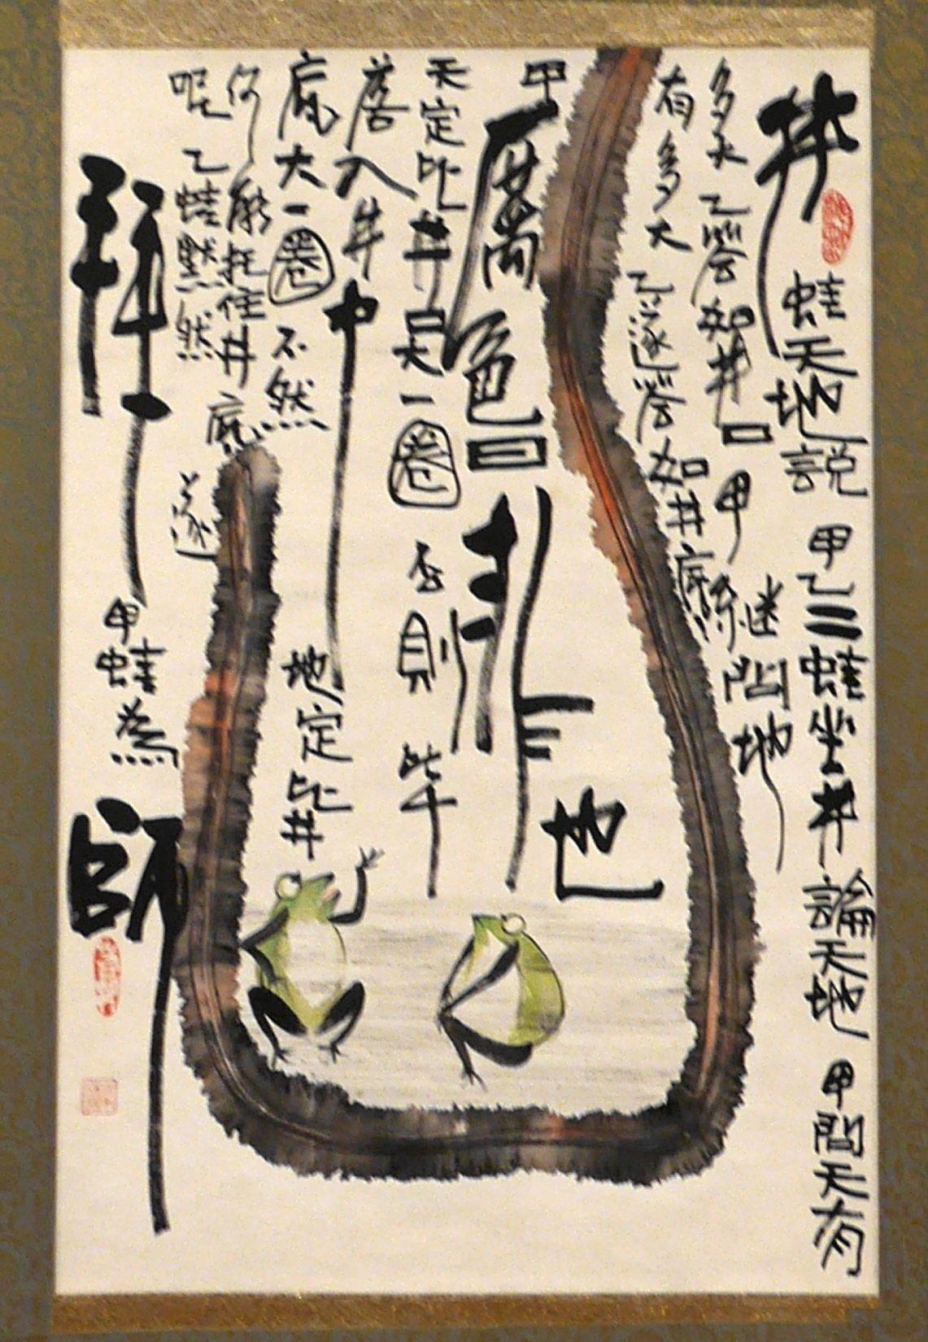
Appendix: List of wineForth Words

dup | ( a -- a a ) Duplicate tos
over | ( a b -- a b a ) Duplicate 2nd tos item
2dup | ( a b -- a b a b ) Duplicate top 2 items of tos
swap | ( a b -- b a ) Swap two tos items
rot | ( a b c -- b c a ) Rotata 3rd tos item to top
-rot' | ( a b c -- c a b ) Rotate tos to 3rd position
2swap | ( a b c d -- c d a b ) Swap two pairs of tos items
2over | ( a b c d -- a b c d a b ) Duplicate second pair tos items
pick | ( i -- a ) Copy ith tos item to top
roll | ( i -- a ) Roll ith tos item to top
drop | ( a -- ) Discard tos
nip | ( a b -- a ) Discard 2nd tos item
2drop | ( a b -- ) Discard two tos items
>r | ( a -- ) Push tos to return stack
r> | ( -- a ) Pop return stack to tos
r@ | ( -- a ) Duplicate top of return stack to tos
push | ( a -- ) Push tos to return stack. Same as >r.
pop | ( -- a ) "Pop return stack to tos. Same as r>,"
+ | ( a b -- c ) Add two tos items
- | ( a b -- c ) Subtract tos from 2nd item
* | ( a b -- c ) Multiply two tos items
/ | ( a b -- c ) Divide 2nd item by tos
mod | ( a b -- c ) Modulus 2nd item by tos
and | ( a b -- c ) Bitwise AND of two tos items
or | ( a b -- c ) Bitwise OR of two tos items
xor | ( a b -- c ) Bitwise XOR of two tos items
negate | ( a -- b ) Negate tos
0= | ( a -- f ) Return true if a=0
0< | ( a -- f ) Return true if a<0
0> | ( a -- f ) Return true if a>0
= | ( a b -- f ) Return true if a=b
> | ( a b -- f ) Return true if a>b
< | ( a b -- f ) Return true if a<b
<> | ( a b -- f ) Return true if a is not equal to b
base@ | ( -- a ) Return current base
base! | ( a -- ) Make a the current base
hex | ( -- ) Change to hexadecimal base
decimal | ( -- ) Change to decimal base
cr | ( -- ) Display a carriage return
. | ( a -- ) Display number a on tos
.r | ( a n -- ) Display a in n columns
emit | ( a -- ) Display an ASCII character
space | ( -- ) Display a space
spaces | ( n -- ) Display n spaces
[ | ( -- ) Change to interpreting mode
] | ( -- ) Change to compiling mode
find | ( -- w ) Return token of next synonym
' | ( -- w ) Return token of next synonym outside colon synonym.
(') | ( -- w ) Return token of next synonym inside colon synonym.
['] | ( -- w ) Return token of next compiled string while compiling.
dolit | ( -- ) Push next token on stack
dostr | ( -- w ) Return token of next string
"s""" | ( -- w ) Compile next synonym as a string literal
dotstr | ( -- ) Display next compiled string
".""" | ( -- ) Compile next synonym as a string literal for display
( | ( -- ) Comment to the next )
.( | ( -- ) Display next synonym up to next )
\ | ( -- ) Comment to the new line
exit | ( -- ) Unnest a list
donext | ( -- ) Loop to the following address
branch | ( -- ) Start a branch object
loops | ( -- ) Start an indefinite loop object
cycles | ( -- ) Start an definite loop object
if | ( f -- ) Skip the next true branch if tos is 0
else | ( -- ) Take the next false branch
then | ( -- ) Terminate an if-else-then branch structure
begin | ( -- ) Start a begin loop structure
again | ( -- ) Repeat the begin loop
until | ( f -- ) Repeat begin loop if tos is 0
while | ( f -- ) Skip the following true branch if tos is 0
repeat | ( -- ) Repeat begin loop
for | ( n -- ) Repeat following loop n+1 times
next | ( -- ) Decrement top of return stack. Exit loop if top of return stack is negative negative.
aft | ( -- ) Skip loop once for the first time
: | ( -- ) Define a new colon word
; | ( -- ) Terminate a colon word
create | ( -- ) Create a new array
variable | ( -- ) Create a new variable with initial value of 0
constant | ( a -- ) Create a new constant with value a
"," | ( n -- ) Compile number n to pf attribute of newest word
@ | ( w -- a ) Return contents of a variable
! | ( n w -- ) Store n in variable at w
+! | ( n w -- ) Add n to the variable at w
? | ( w -- ) Display contents in variable w
array@ | ( w i -- b ) Return contents of the ith item in array w
array! | ( n w i -- ) Store n into ith item of array w
, | ( n -- ) Add n to the current array.
allot | ( n -- ) Allocate n item to the current array. Init values are 0.
does | ( -- ) Assign following token list to the new word just created
here | ( -- w ) Return top of dictionary
boot | ( -- ) Delete all user defined words
forget | ( -- ) Delete following words and all words defined after it.
.s | ( -- ) Display the parameter stack.
words | ( -- ) Display names of all words in dictionary
see | ( -- ) Disassemble the following synonym
time | ( -- ) Display current time
is | ( w -- ) Force next word to execute w. interpret only.
to | ( n -- ) Change the value of next constant token to n. compile only.

