- After Deployment of the war into the tomcat. And successful execution of the DB Scripts in MQSQL Database. Launch the URL https://localhost:8080/admin/login
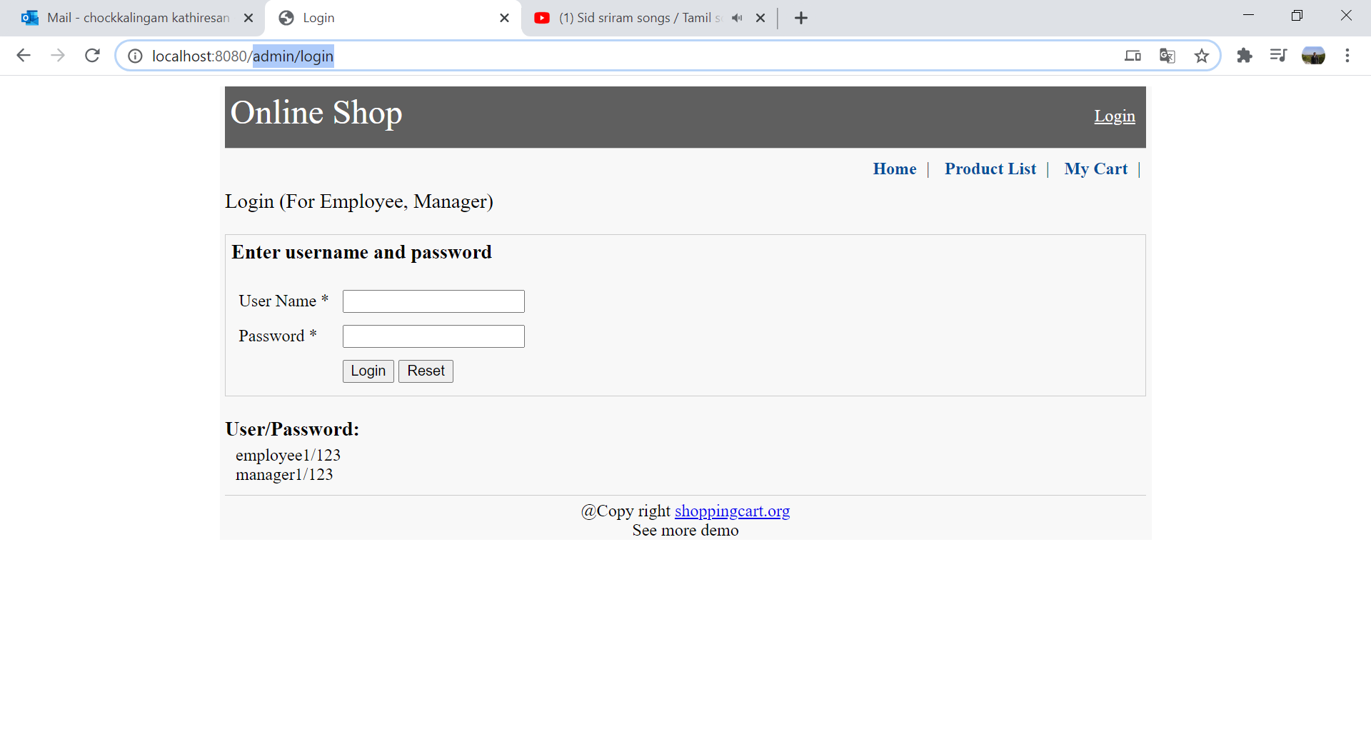
- As instructed, please provide the employee username and password
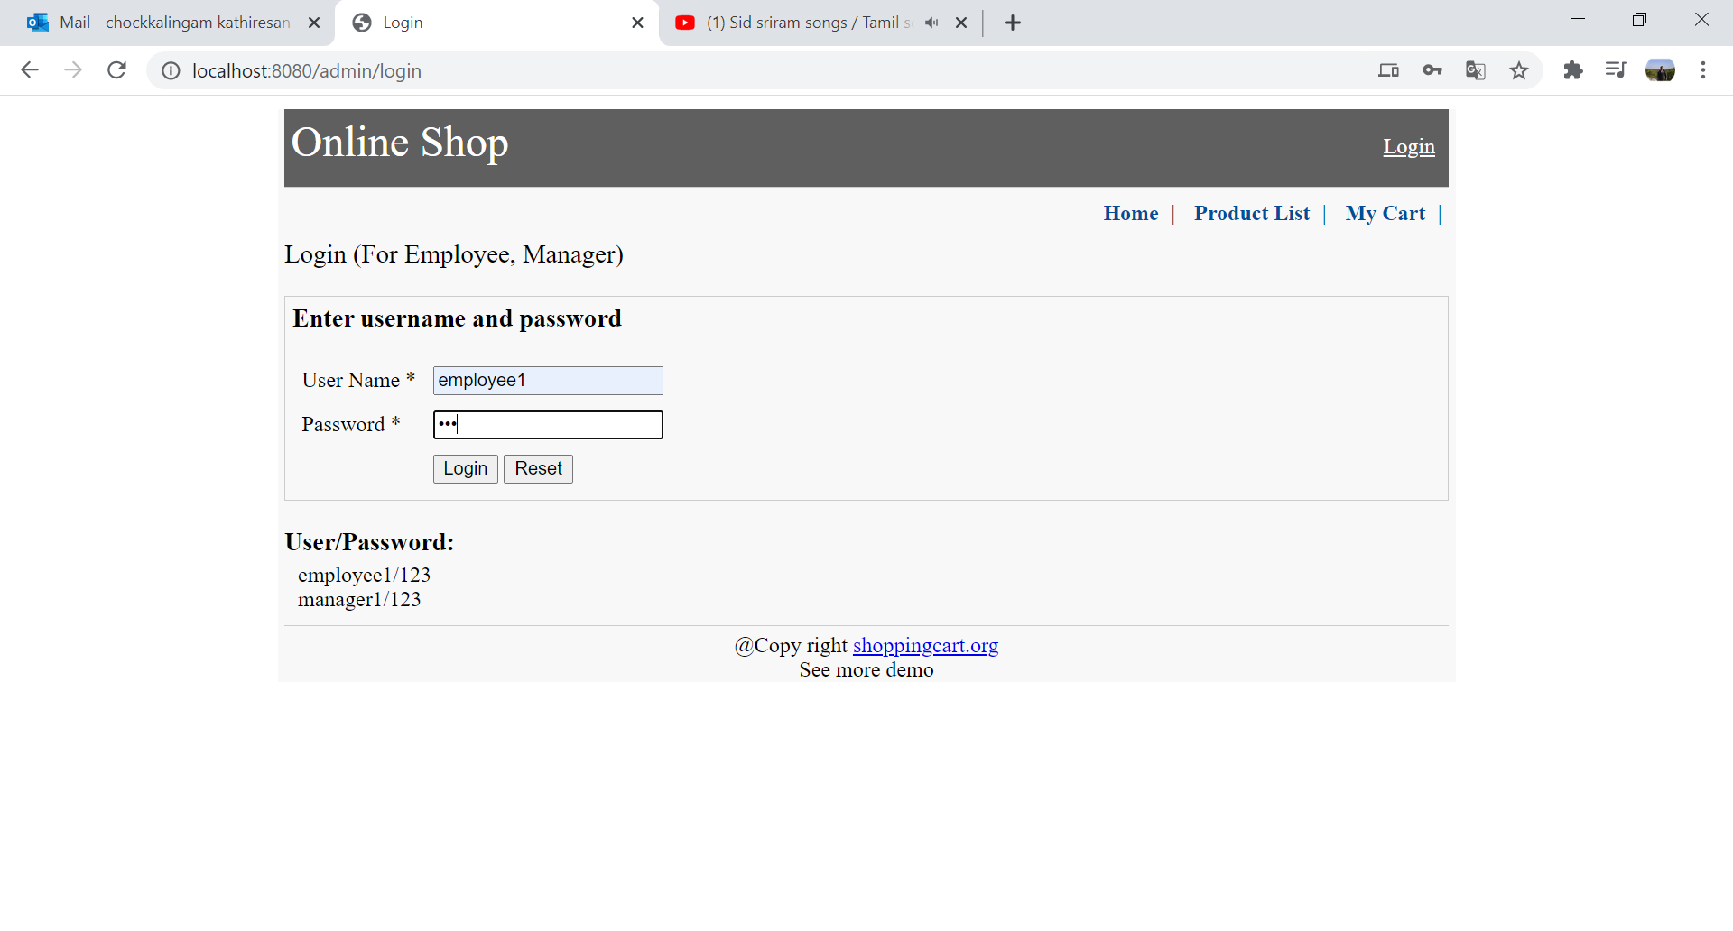

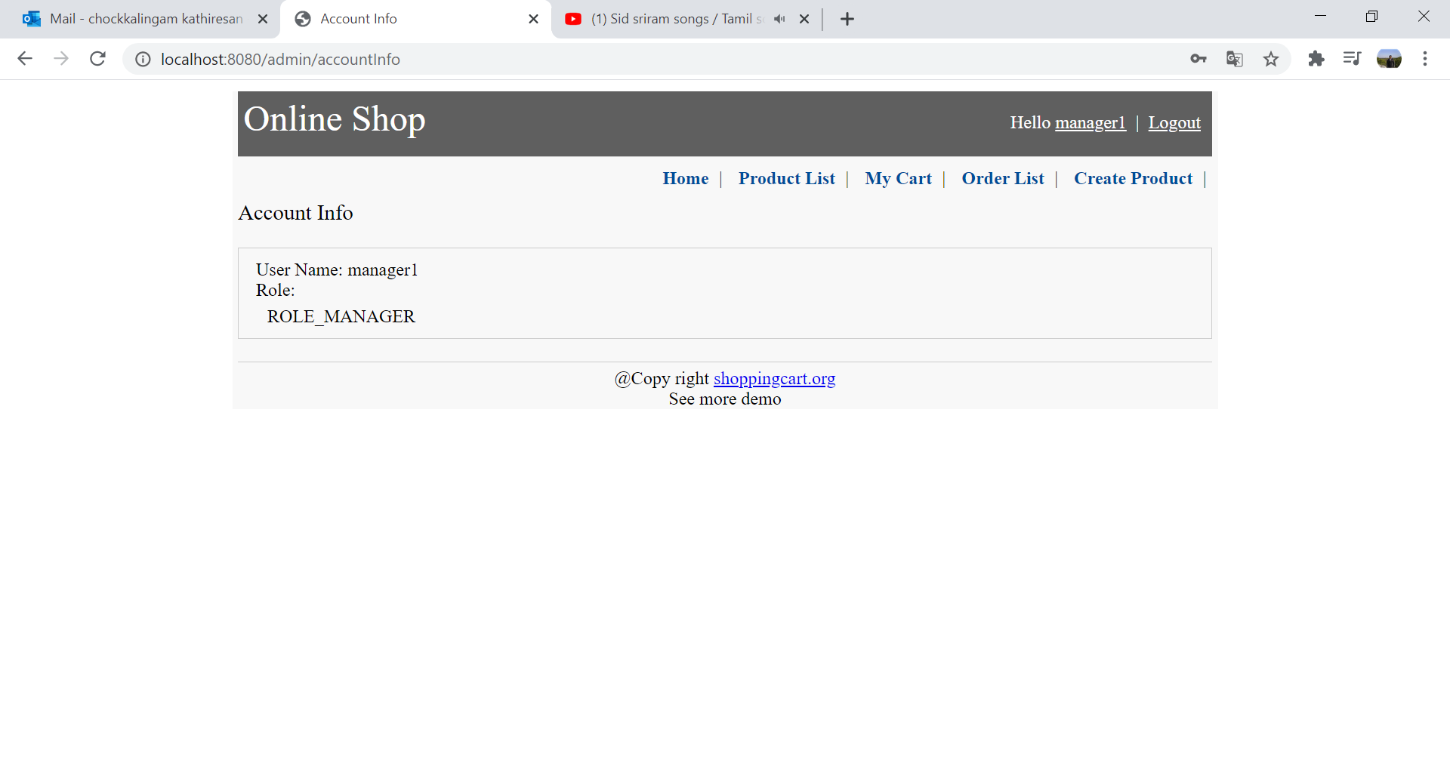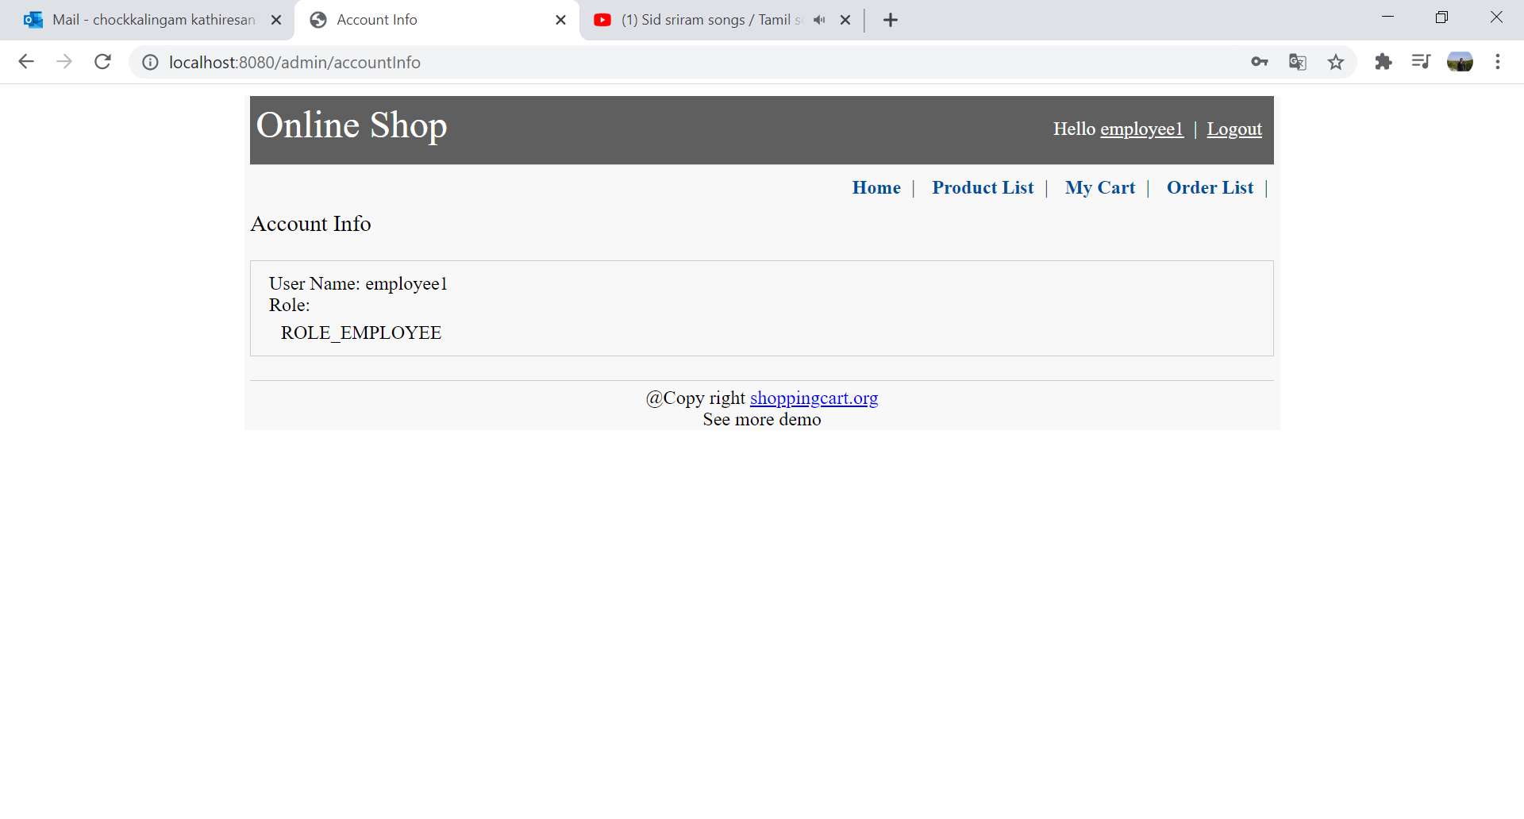
- When we click on the product list the items will be listed down
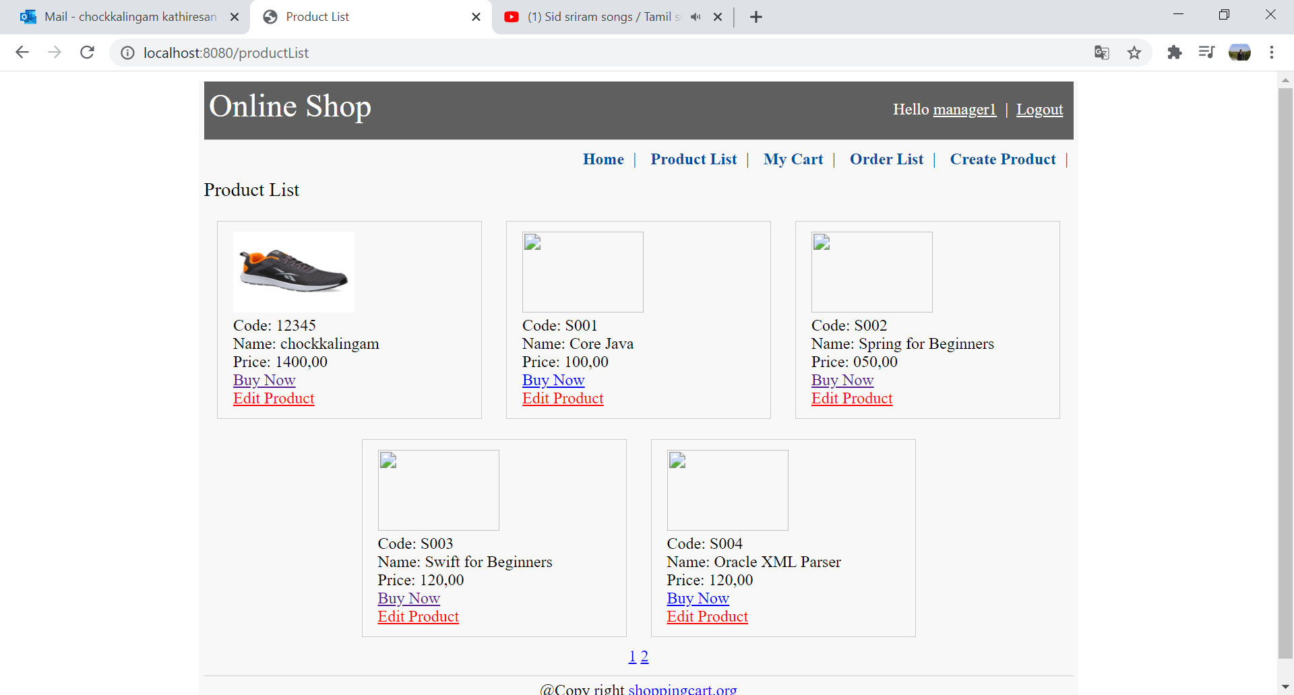

- When you are login as manager you will be able to edit the product
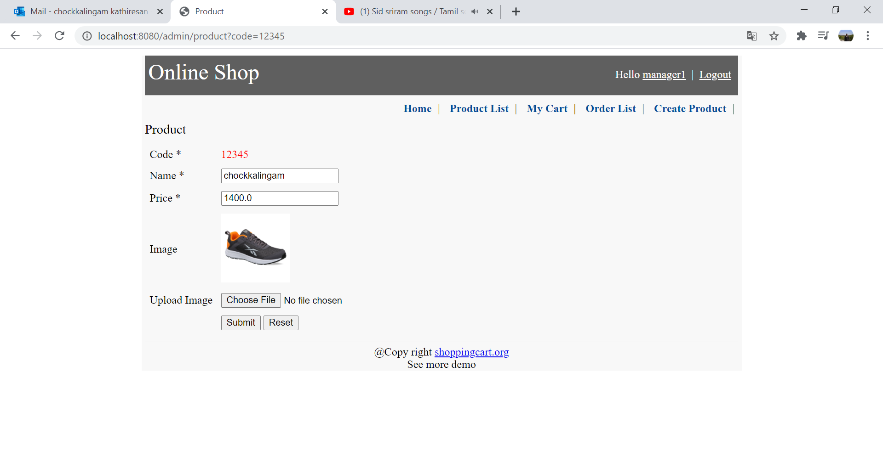
- When we choose the prodcut we will be able to continue with the selection to book the order by moving to the cart. You have customer information

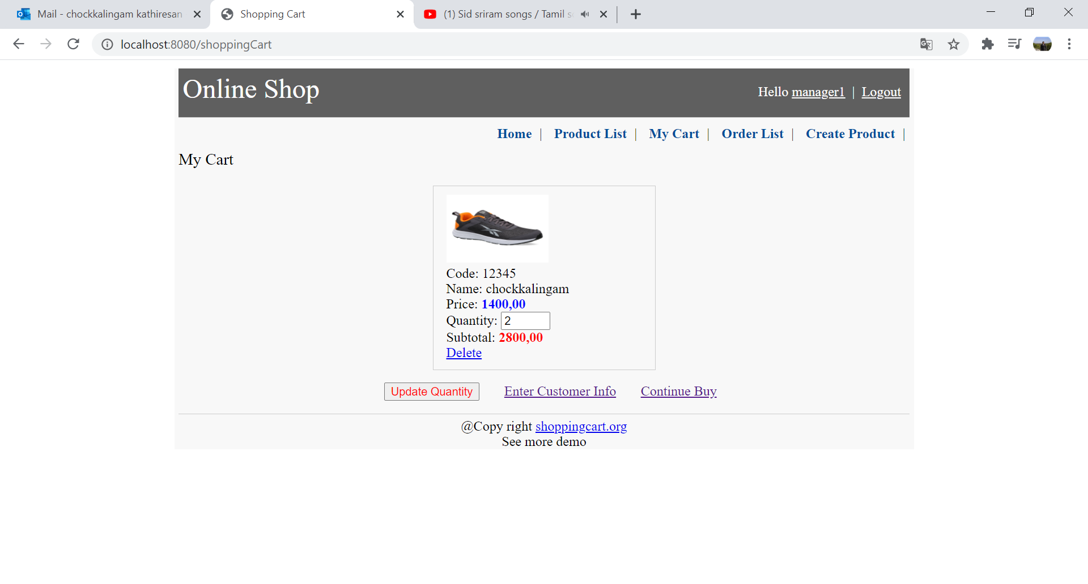
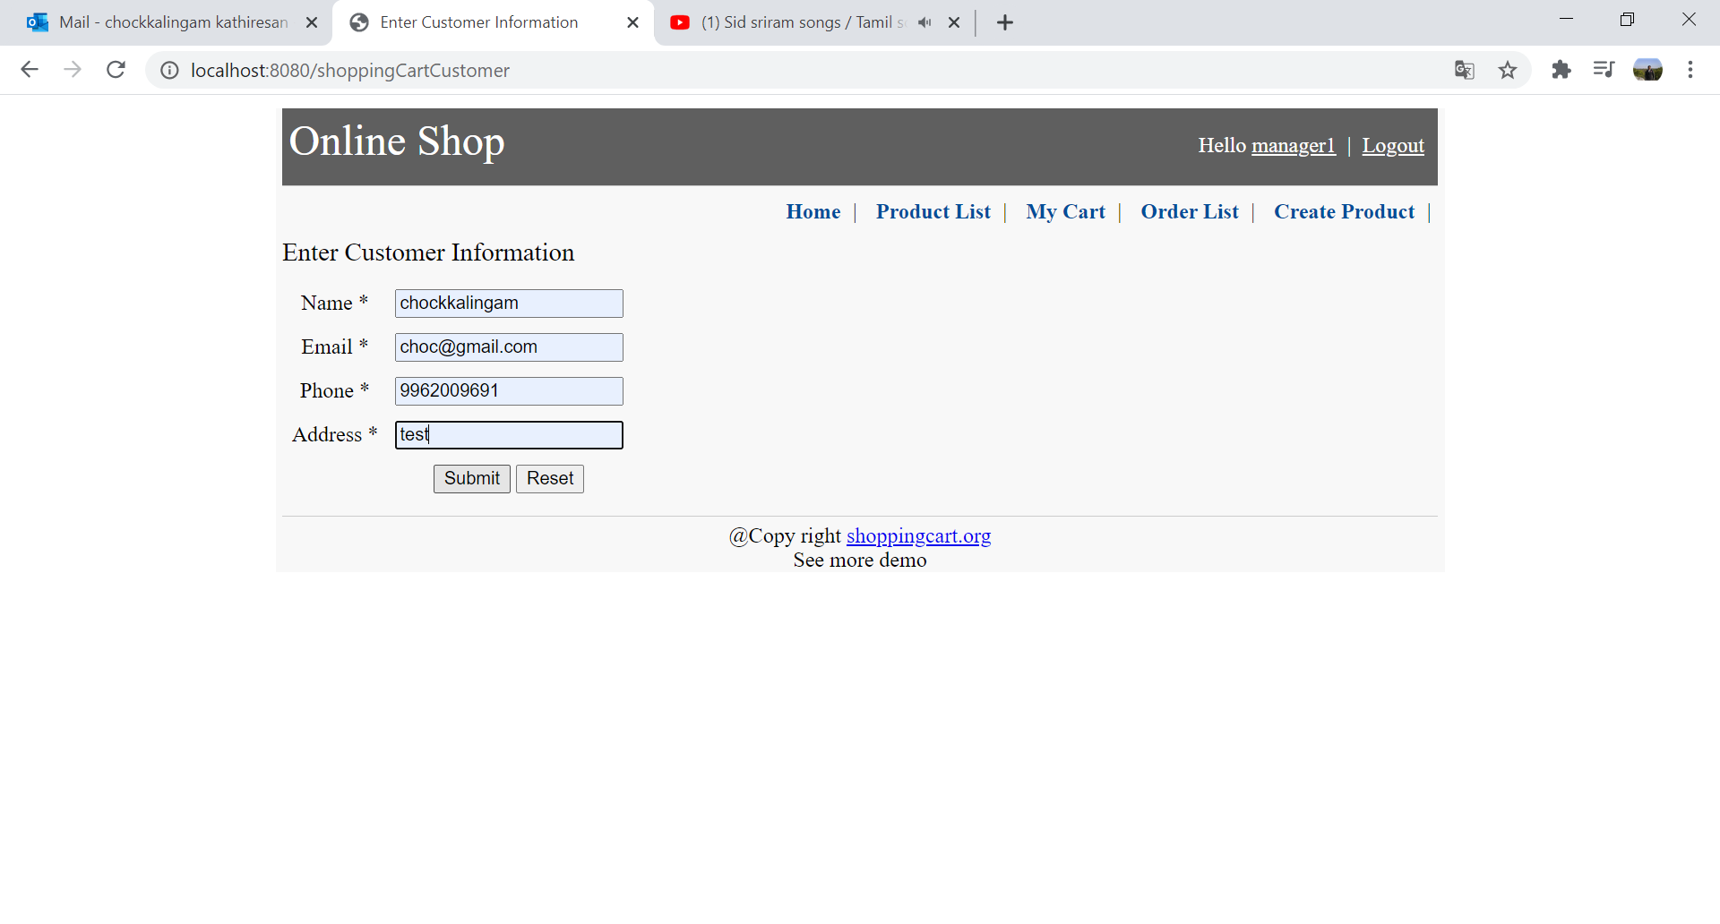
- Successfully submitting the form it will go to the cart information

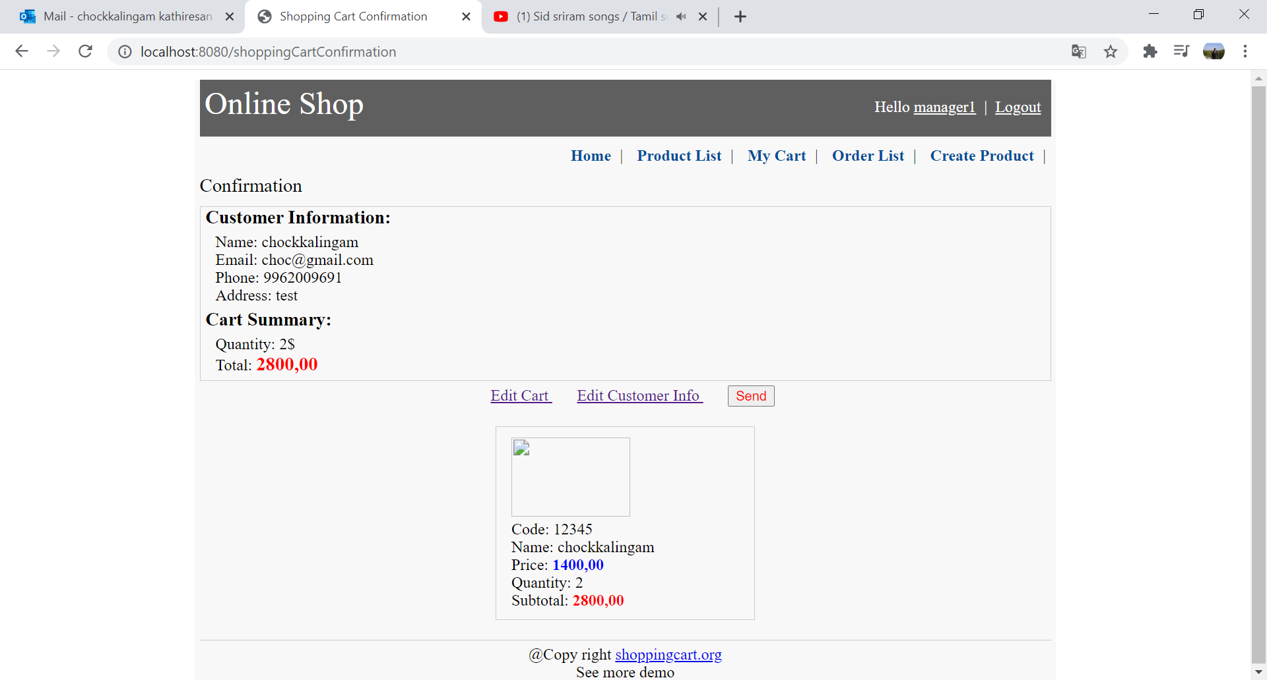
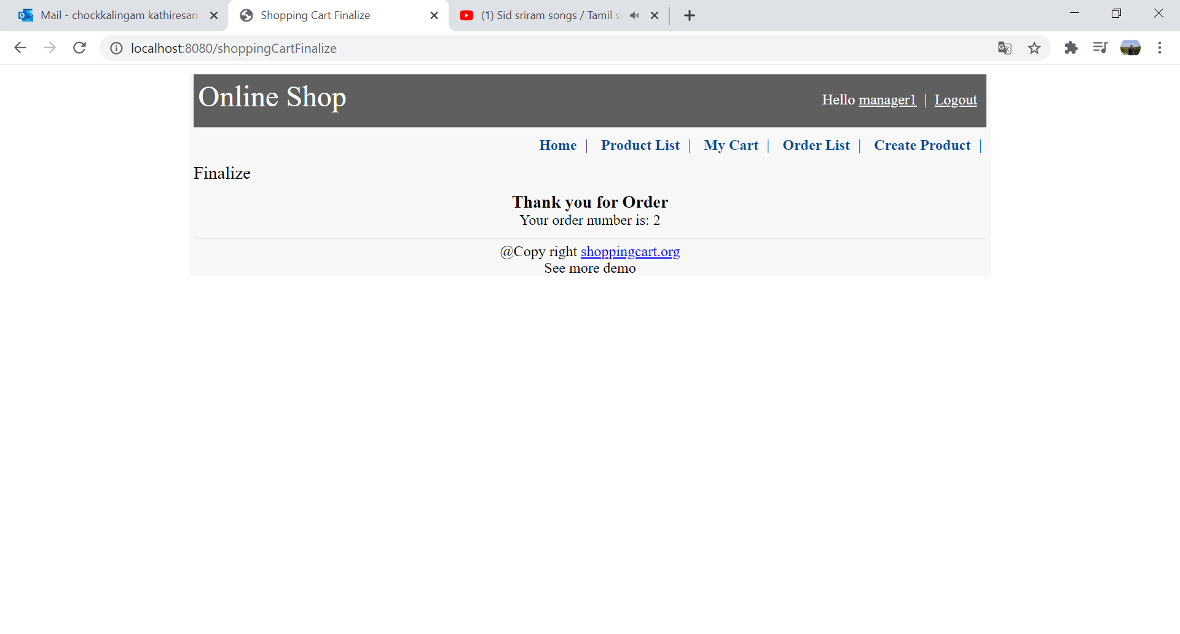
- To view the order list please go and click the orderlist menu
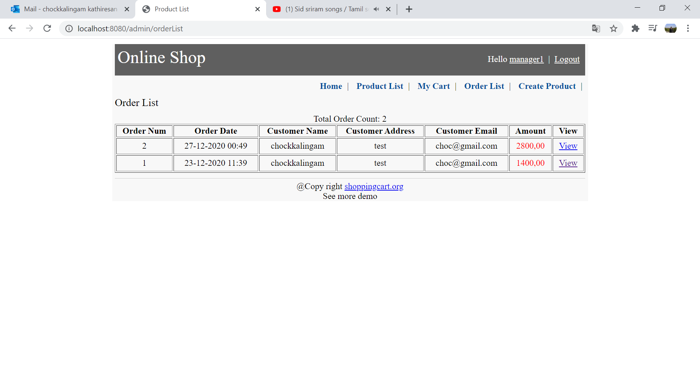
- To createnew product the please provide the information in the product

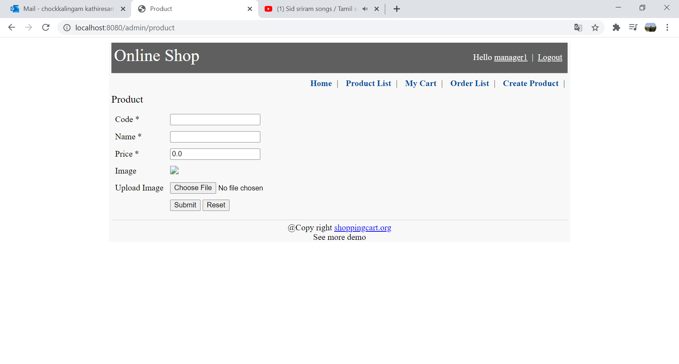
- Click on logout to logout from the application
