- After Deployment of the application into the webserver. And successful startup of the server. Launch the URL https://localhost:4200/
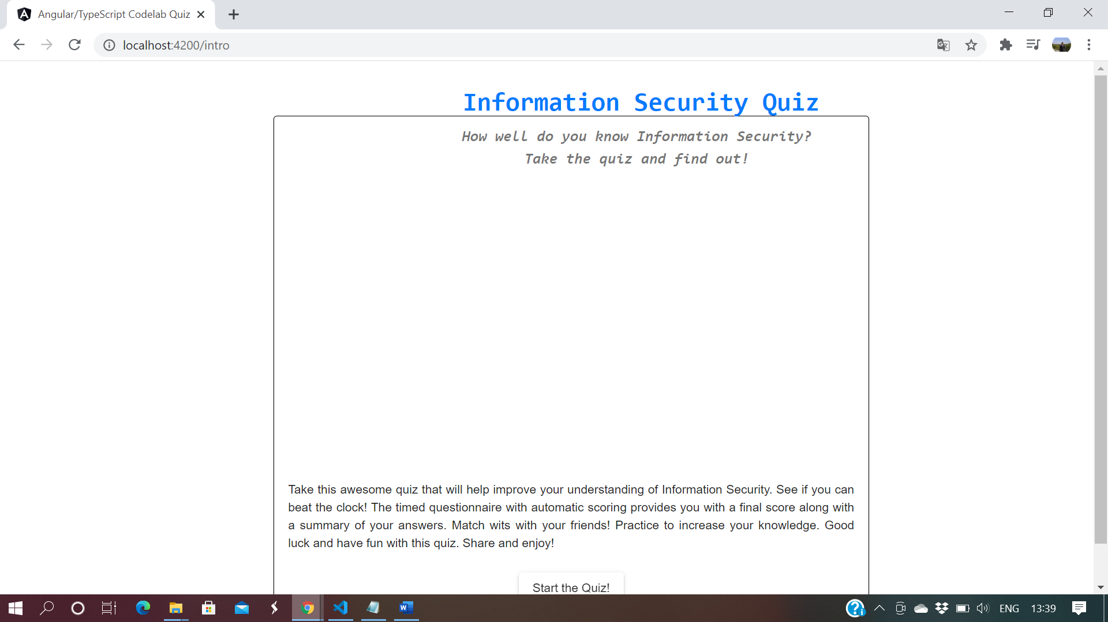
- As instructed, please click on the start-up of the quiz
The below question will be displayed. Please select appropriate the answers
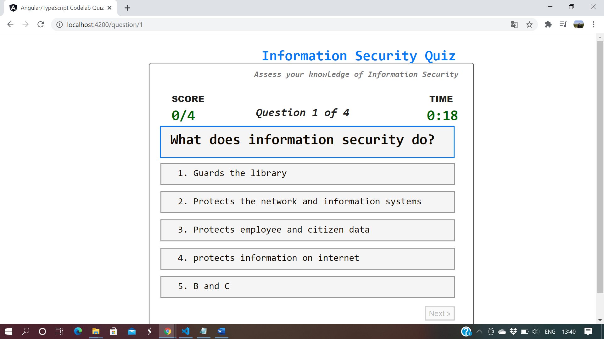
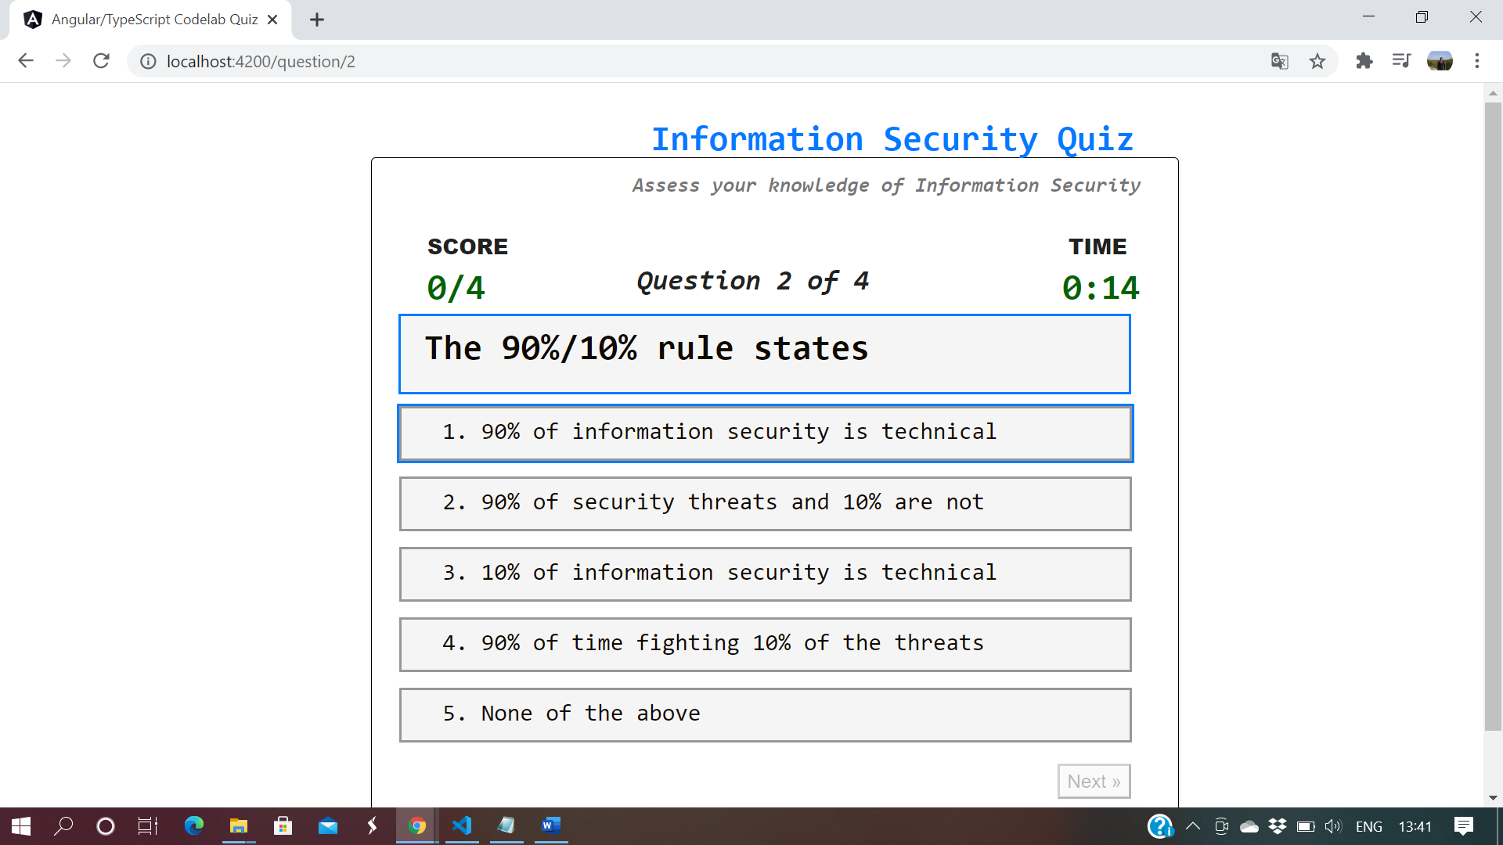
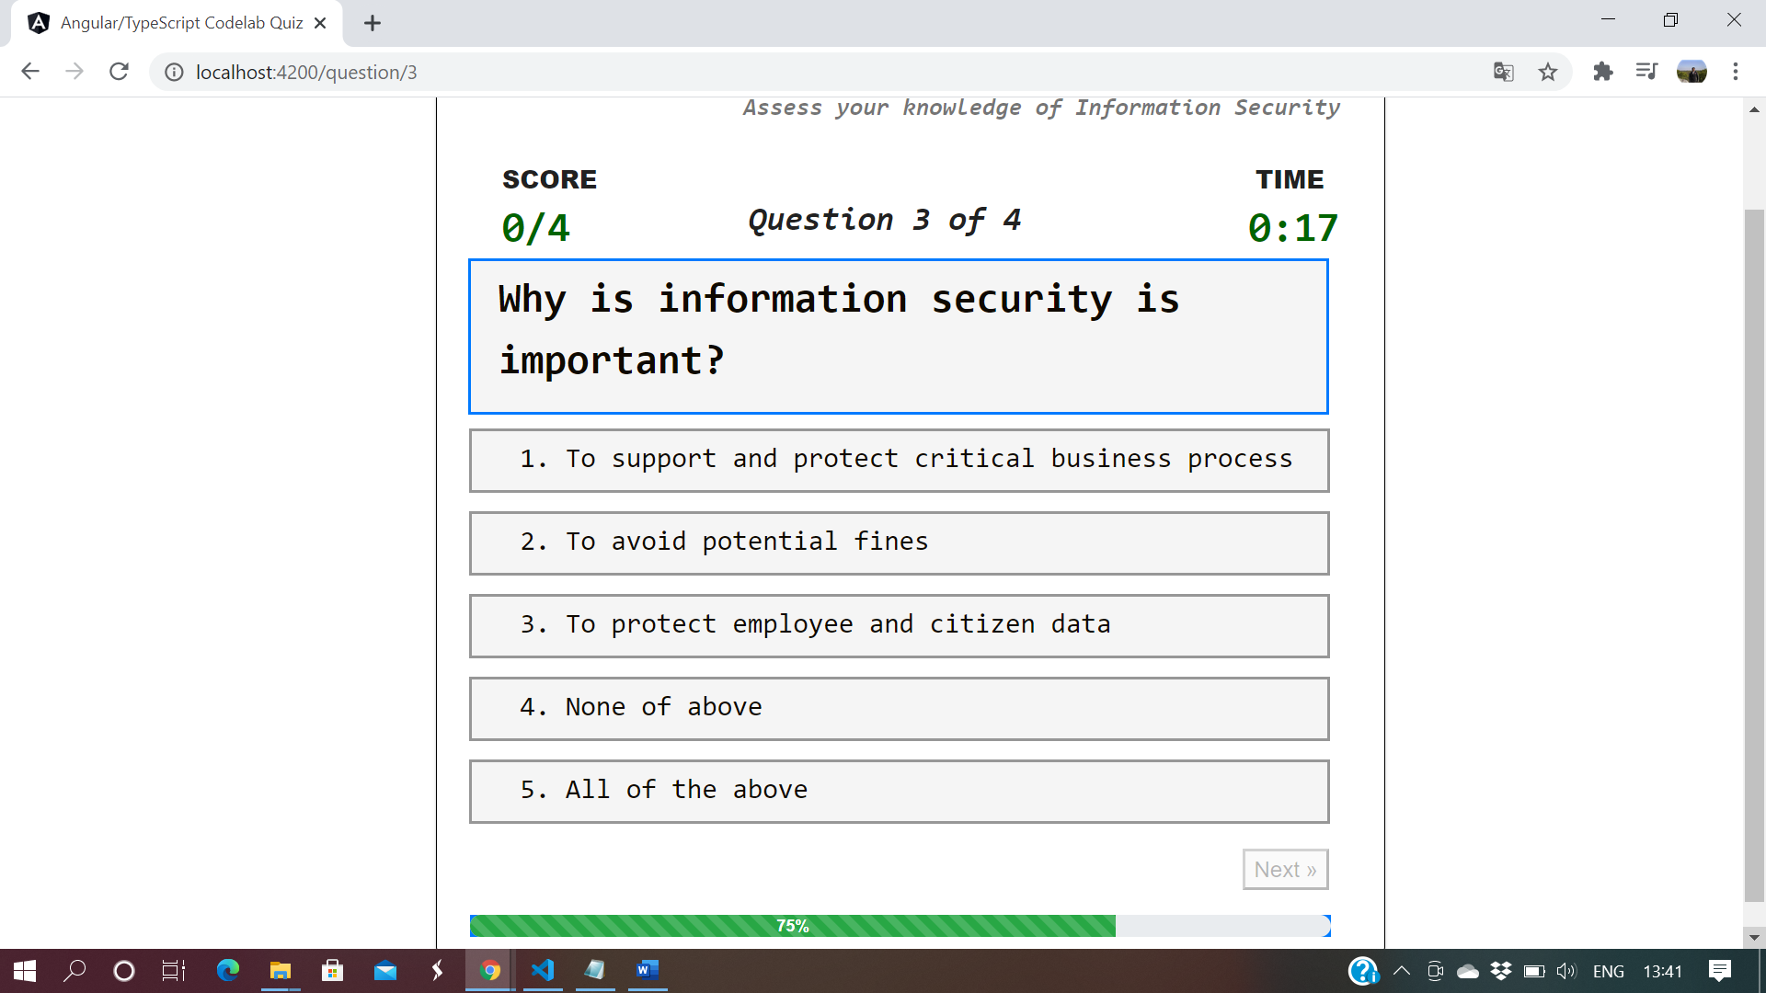
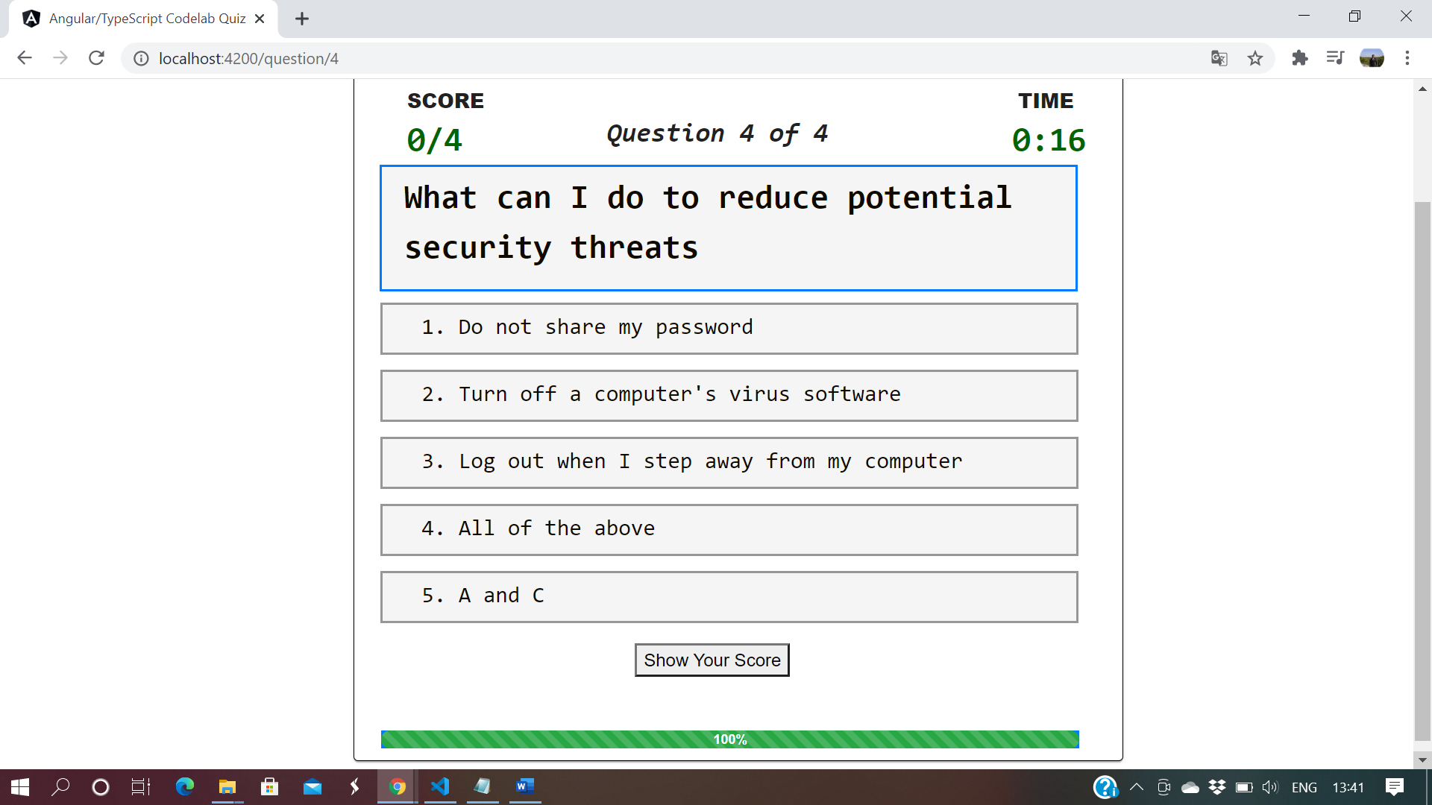
- Based upon the answer if it is correct then below Green selection will be displayed.
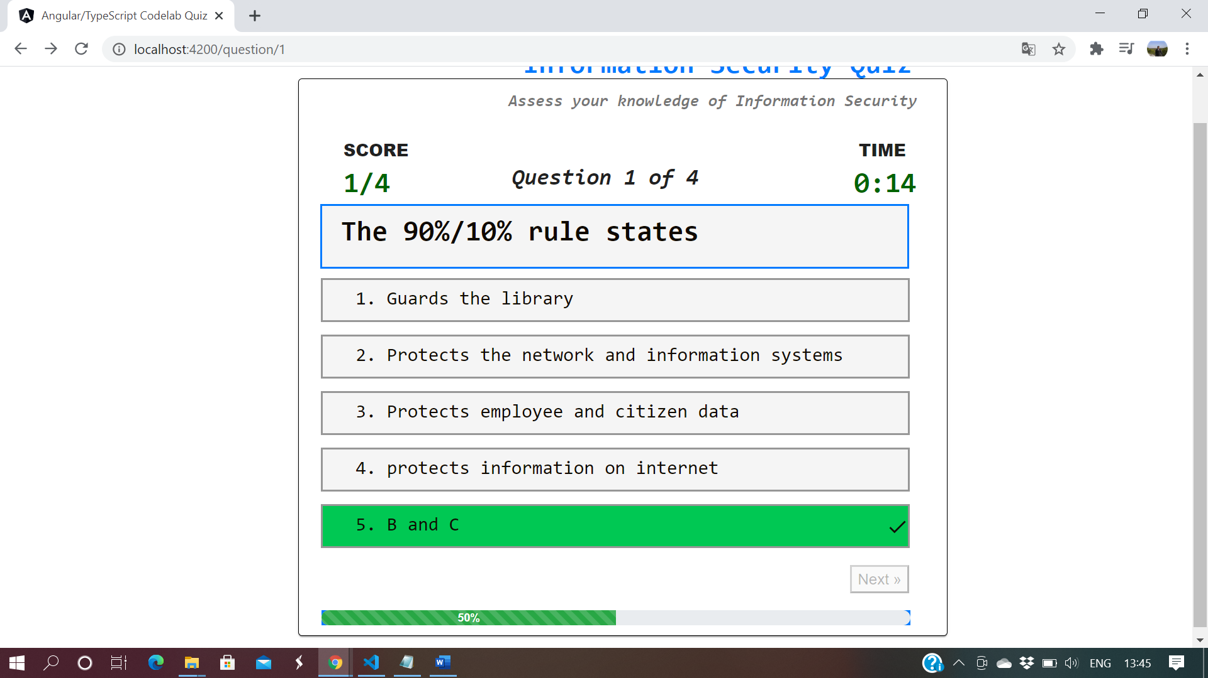
- If the selected answer is wrong then the proper answer would selected and displayed as shown below

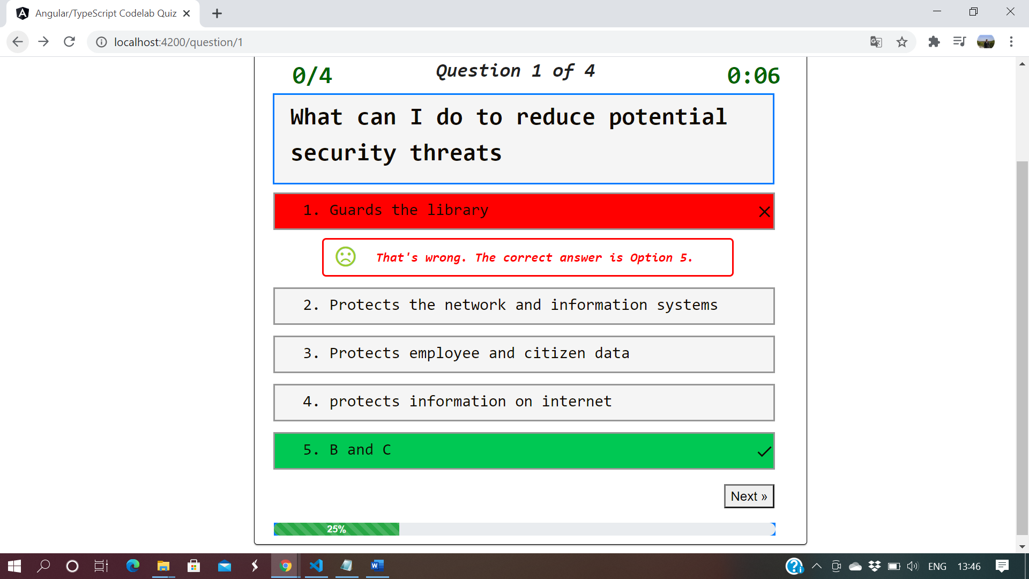
- Timer is also displayed along with the question or if the option selected which ever is greater accordingly screens will move next screen
- Final result is shown screen and a option to restart the quiz
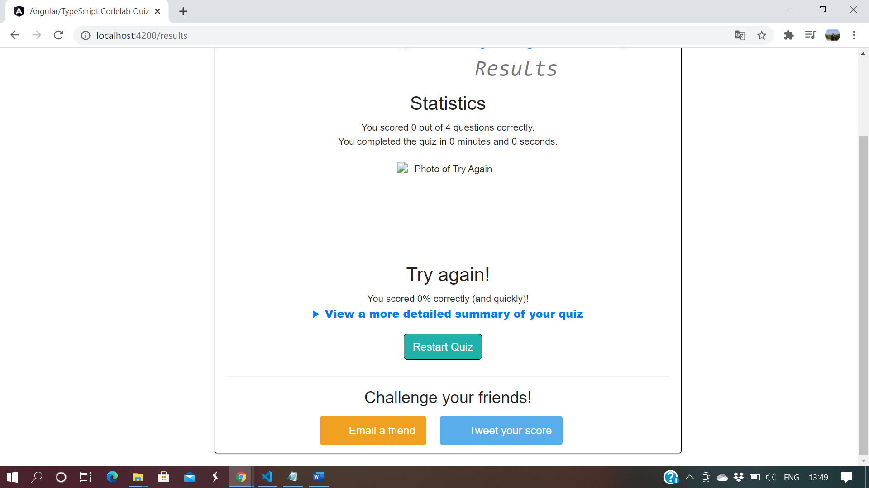
- There is option to display the more detailed summary of your quiz

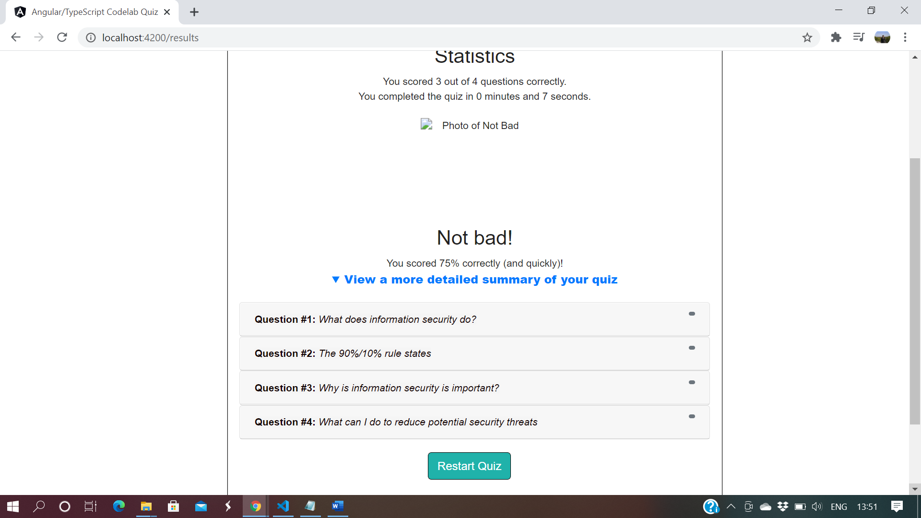
- When on the individual question appropiate question to display along with answer
