Conservation of the Dot/Icm secretion system across Legionella and related bacteria
Chockkshi Devaraj Kalpana | Comparative genomics mini project | October 2026 | Code: github.com/chockkshi/Legionella-DotIcm-Phylogeny
Aim and methods
Aim: to test whether the Dot/Icm type IVB secretion system, which Legionella uses to survive inside host cells, is conserved across the genus and shared with related intracellular bacteria; a small-scale practice run of comparative genomics methods for studying host adaptation.
- Data: 11 RefSeq proteomes (NCBI): eight Legionella species (anisa, bozemanae, feeleii, jordanis, longbeachae, micdadei, oakridgensis, pneumophila), Coxiella burnetii, Francisella tularensis and E. coli K-12 (outgroup).
- Tree: rpoB protein from each proteome, NGPhylogeny.fr One Click workflow (PhyML), rooted on E. coli, drawn in iTOL.
- Gene search: 11 Dot/Icm proteins from L. pneumophila as BLASTP queries; best hit by bitscore; present at ≥30% identity and ≥50% query coverage. DotB hits in E. coli and Francisella were tested by reciprocal best hit.
Results
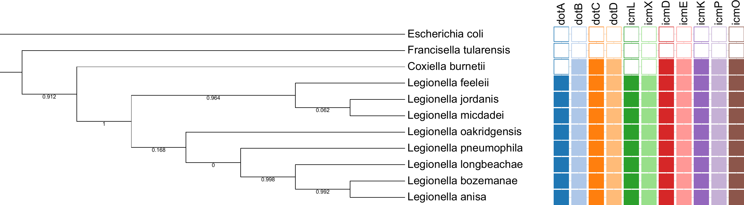
Figure 1. rpoB tree rooted on E. coli (branch lengths not shown; numbers are branch support, 0 to 1) with presence (filled) or absence (empty) of 11 Dot/Icm genes.
Table 1. Dot/Icm genes detected (of 11) at ≥30% identity and ≥50% coverage
Organism | Detected | Not detected
Legionella (8 species) | 11 of 11 | None, in every species
Coxiella burnetii | 8 of 11 | dotA, icmL, icmX (weak or partial similarity)
Francisella tularensis | 0 of 11 | All (DotB-like hit failed reciprocal test)
Escherichia coli K-12 | 0 of 11 | All (DotB-like hit failed reciprocal test)
Table 2. Evidence behind the borderline calls (best hit to L. pneumophila protein)
Comparison | Identity | Coverage | Outcome
DotB: Legionella (8) / Coxiella | 89–94% / 66% | 98–100% / 96% | Reciprocal best hit: true DotB
DotB: E. coli / Francisella | 38% / 32% | 57% / 81% | Not reciprocal: related ATPase, scored absent
Coxiella dotA / icmL / icmX | 32% / 25% / 28% | 32% / 59% / 33% | Below threshold: "not detected"
Key findings
- The Dot/Icm system is complete in all eight Legionella species and mostly present in Coxiella, but not detected in Francisella or E. coli, so it tracks the Legionella–Coxiella lineage.
- Legionella forms one strongly supported group (support 1), with Coxiella as its sister (0.912). Support for the early splits within the genus is low (0 to 0.17) and is not interpreted.
- Francisella lives inside cells without Dot/Icm, so an intracellular lifestyle does not require this system.
Interpretation and limitations
The pattern is consistent with Dot/Icm being a conserved core feature of Legionella, shared with Coxiella and probably present in their common ancestor. Limitations: single-gene tree on 11 genomes, no molecular dating, calls depend on BLAST thresholds (only dotB had a reciprocal check), divergent genes may be missed (a profile HMM search would be more sensitive), gene presence does not show function, small sample. Next steps: many-gene phylogeny with dating, orthogroup-wide host-adaptation gene analysis, and horizontal gene transfer screening.

