简 历

姓 名 | 和 明 | 性 别 | 男 | 出生年月 | 1980年5月
毕业院校 | 南京邮电大学 计算机科学与技术学院 |  |  | 学 历 | 工学硕士
现任职位 | 南京凯敏软件有限公司 软件工程师
电子邮件 | hemi12@163.com |  |  | 电 话 | 138130-96323

求职意向
- 移动平台安全产品开发经理——了解、分析客户的产品需求，讨论、制定产品的技术定位和研发方向（包括产品功能和用户交互等），管理、协调产品开发过程中各模块之间的工作，处理产品在发布前、中、后期的流程性工作。
- 移动平台安全产品研发工程师——在移动智能终端上设计、开发及调试防病毒和防恶意程序的产品，包括Google Android, Apple iOS, Windows Phone (Windows Mobile), J2ME等平台。

工作经历及项目经验
- 2010.4～至今： 在南京凯敏软件有限公司就职，担任软件工程师职务，负责为国外电信运营商Comcast、Cox等定制的、基于Cable的策略控制管理（Policy Control Management）服务器的设计、开发、调试等工作。
期间，与合作伙伴协同开发完成了“基于Android智能终端平台的远程监控、运行权限管理系统”和“智能家居移动控制端”等智能终端应用程序。前者的主要功能包括在安装了“远程监控受控端”的智能手机或平板电脑上，监控运行程序的内容，管理、设定及控制运行程序的权限，获取通话和消息发送记录等功能；后者的主要功能包括在智能手机或者平板电脑上，经由一台指令中转设备，向室内的家电设备发送控制命令，从而实现家居生活的“一机掌控”。详细内容请参考附录A、附录A-1和附录B。

- 2005.5～2010.3： 在摩托罗拉(中国)电子有限公司南京软件中心就职，担任软件技术工程师、项目配置管理员、软件架构设计师等职务。
- 在Google公司发布的Android移动设备平台上，成功地将Motorola公司开发的J2ME版飞信客户端移植到Android平台上，并运行良好；在Android版飞信客户端的基础上，成功地开发了另一款Android应用程序——飞信Contact Link的演示版。该程序可以主动订阅手机通讯录中联系人的飞信状态，并在联系人列表中及时更新其飞信状态。详细内容可参考如下网页或附录E和F：
http://blog.csdn.net/choclover/archive/2008/12/08/3478298.aspx
http://blog.csdn.net/choclover/archive/2008/12/09/3486396.aspx
- 作为主要成员参与“中国移动飞信J2ME客户端”项目，主要负责J2ME飞信引擎和用户界面、数据模型等部分的设计与实现，并将该飞信J2ME客户端移植到不同的Motorola手机平台上。详细内容请参考附录C。
- 为美国电信运营商Sprint iDEN设计开发J2ME SDK，可以用来仿真手机平台上运行的J2ME程序和部分本地程序（如电话簿等）。
- 参与iDEN JAVA平台项目，主要工作是在iDEN嵌入式设备平台上开发Java新功能，调试Java问题以及集成第三方开发的Java功能（Sprint iDEN是一家主要在北美运营的无线网络运营商）。
- 曾在Sprint定制的CDMA手机上的AMS (Application Management System)项目工作，完整的参与了2款CDMA手机产品的开发与测试（请参考附录D中所列网页的内容）。
- 曾独立地研究和原型实现将“语音识别功能（Voice Recognition）”从J2ME平台移植到另一款Motorola手机平台上。
- 曾参与摩托罗拉CMMI Level 5（能力成熟度模型5级）的评估过程，并因此荣获当年“部门年度最佳团队”的荣誉评定。熟悉大型软件企业内部的软件开发流程、项目配置管理以及质量控制规范等规章和制度，具备丰富的项目管理和质量控制经验。
- 曾经在摩托罗拉公司内部的学术会议上发表技术性论文，参考网址如下：
http://blog.csdn.net/choclover/archive/2009/08/30/4500131.aspx
http://blog.csdn.net/choclover/archive/2009/08/30/4500103.aspx

- 2003.10～2005.4：加入南京摩托罗拉软件中心进行全职实习。

工 作 能 力
- 熟悉Android、J2ME开发平台及辅助开发工具，具备丰富的开发和调试经验
- 熟练使用JAVA和C语言来编写和调试程序，熟练使用多种集成开发环境如Eclipse, NetBeans, Visual Studio 2005, Sun WTK等
- 熟悉Java ORM框架MyBatis，主流开源数据库MySQL 5.x，Java NIO（Non-Blocking IO, 非阻塞式）框架MINA等
- 熟练使用Perl、VBA语言来编写自动化脚本以提升重复性工作、自动测试工作的工作效率
- 掌握C++、C#、XML、JavaScript、JSON、汇编等编程语言
- 熟练使用ClearCase、SVN、Accurev、ClearQuest、Mantis、Bugzilla等代码版本控制和错误追踪工具
- 熟悉常用的“设计模式”以及软件开发模型，并能在工作实践中灵活运用

教 育 经 历
- 2002.9～2005.4：南京邮电大学计算机科学技术学院软件理论专业，取得工学硕士学位
- 1998.9～2002.7：石家庄交通大学电子工程系自动化专业，取得工学学士学位

英 语 能 力
- 2007.8～2007.12，2008.3～2008.5，2011.4～2011.6前后多次在美国芝加哥、波士顿市出差，担任驻外联络工程师。负责与客户研究制定产品需求，与外国工程师调试解决技术问题，以及协调国内外同事的工作
- 日常工作使用英文来书写信件、文档等，并使用英语与外国同事进行书面及口头交流
- 通过大学英语六级考试(CET6)
- 通过大学英语口语考试(SET)

个 人 特 点
- 乐观向上，积极进取；踏实肯干，责任心强
- 能够主动学习新的知识；关注行业前沿的发展态势
- 重视团队协作的作用，能够积极地与他人交流、合作
- 刻苦钻研，对技术难题具有天生的敏锐感和征服欲，为解决技术难题甚至能“废寝忘食”

兴 趣 爱 好
音乐，读书，运动

RESUME

Phone Number： | 86 1381-309-6323
Email： | hemi12@163.com

Ming (Given) He (Family)
Gender Male
Birth May, 1980

Major Computer Software & Theory
Degree Master of Engineering
Graduated From: Nanjing University of Posts and Telecommunications

JOB OBJECTIVE
- Mobile Platform Security Products Manager -- Understand and analyze customers' demands for product; discuss and scheme out the product positioning and R&D direction (including product features and user interactions etc.); manage and coordinate the work between different modules during the development phase; handle the process work from pre- to post- release of product.
- Mobile Platform Security Product R&D Engineer -- Design, develop and debug anti-virus and anti-threat products on mobile handsets platforms, including Google Android, Apple iOS, Windows Phone (Windows Mobile), J2ME and etc.
- Online Security Services Developer – Design and develop “Online Security Services” to attract customers to subscribe and consume this service, which is targeting on the new characteristics of 3G wireless network.

WORK HISTORY & PROJECTS EXPERIENCE
- Apr 2010 to present, working in the Nanjing Camiant Software Ltd., taking the position of software engineer, working on the design, development and debug work of Policy Control Management server for telecommunication carriers abroad like Comcast, Cox etc.
Cooperated with partner and completed the Remote Monitoring and Access Control Management System based on Android Smart Terminal Platform, whose features includes monitoring the list of running applications, managing and setting up access control of applications, acquiring history of phone call and messaging records and etc on the smart phone or tablet computers. For more detailed information, please refer to Appendix A and Appendix B.
- May 2005 to Mar 2010, worked in Motorola (China) Electronics Ltd. Nanjing Software Center, taking position of software engineer, project configuration administrator, software architect and etc.
- Have successfully ported the Fetion J2ME client developed by Motorola to the Android mobile device platform which is released by Google. On the basis of the Fetion Android client, I have developed another Android application successfully – Fetion Contact Link. This application can subscribe the Fetion status of the contacts in phone book actively, and update the Fetion status in the contacts list timely. Please refer to the web pages below or Appendix E & F for details:
◎ http://blog.csdn.net/choclover/archive/2008/12/08/3478298.aspx
◎ http://blog.csdn.net/choclover/archive/2008/12/09/3486396.aspx
- Worked in the project of "Fetion J2ME client for China Mobile Corp.” acting as key member, in charge of the design and implementation of J2ME Fetion Engine, User Interface, Data Model parts and etc. (Refer to Appendix C). And porting the Fetion J2ME client to different handset platforms of Motorola.
- Worked in the project of iDEN handset JAVA platform, whose major task is to develop Java features, debug Java issues and integrate 3rd party features on the iDEN embedded device platform using Java and C/C++ language. (Sprint iDEN is a USA wireless network carrier mainly running in North America)
- Worked in the project of AMS (Application Management System) of Sprint CDMA handset. Have attended in the entire software development and testing of two CDMA products (Refer to content of the web pages listed in Appendix D).
- Worked in the project of iDEN J2ME SDK (a 3-tier system architecture of Java-JNI-C), which is a simulator for the J2ME and some native features (e.g. Phone Book) on the Motorola iDEN handsets, for the US telecom carrier Sprint iDEN.
- Researched in and implemented the prototype of porting Voice Recognition feature from J2ME platform to another Motorola mobile handset platform independently.
- Attended in the appraisal process for Motorola CMMI (Capability Maturity Model Integration) Level 5, and won the prize “Annual Best Team” of the department because of this contribution. Familiar with regulations and rules inside large-scale software enterprise, such as software development process, project configuration management, quality control specification and project review process etc.
- Published some technical papers in Motorola China Technology Symposium, reference web pages are listed below.
◎ http://blog.csdn.net/choclover/archive/2009/08/30/4500131.aspx
◎ http://blog.csdn.net/choclover/archive/2009/08/30/4500103.aspx

- Oct 2003 to Apr 2005, was practicing in Motorola Nanjing Software Center as full-time working intern.

WORK CAPABILITY
- Familiar with the Android, J2ME developing platform and possess plentiful developing and debugging experience.
- Proficient in coding and debugging programs using JAVA and C language, also familiar with many IDEs like Eclipse, NetBeans, Visual Studio 2005, Sun WTK and etc.
- Familiar with Java ORM framework MyBatis, open-sourced database MySQL 5.x, Java NIO (Non-Blocking IO) framework MINA.
- Familiar with script languages like Perl and VBA to improve working efficiency for some repeating and automation testing work. Reference web pages are listed below.
◎ http://blog.csdn.net/choclover/archive/2009/11/08/4786926.aspx
◎ http://blog.csdn.net/choclover/archive/2009/11/08/4786920.aspx
- Grasp C++, C#, XML, JavaScript, JSON、Assembly, UML and some other programming languages.
- Proficient in using some code version control and defect tracking tools such as ClearCase, SVN, Accurev, ClearQuest, Mantis, Bugzilla, DDTS and etc.
- Familiar with several common Design Patterns and software developing models, and be capable of utilizing them in practice.
- Familiar with the working processes inside large-scale software enterprise, including project planning, requirement defining, coding & inspection, test planning, bug fixing and etc.
- Have been paying close attention to the business and technology development trend of IT industry for a long time, and wrote several industry investigation and research reports combined with the working experience in carrier enterprise. Reference web pages are listed below.
    - Online Application Store Investigation Report
http://blog.csdn.net/choclover/archive/2009/10/07/4638490.aspx
    - Online Shopping Price Inquiry System
http://blog.csdn.net/choclover/archive/2009/02/18/3904151.aspx

EDUCATION EXPERIENCE
- Sep 2002 to Apr 2005 Master of Engineering in Institute of Computer Science & Technology, Nanjing University of Posts and Telecommunications
- Sep 1998 to Aug 2002 Bachelor of Engineering in Dept. of Automation, Shijiazhuang Communication College

ENGLISH CAPABILITY
- Abroad Working Experience -- Aug 2007 to Dec 2007, Mar 2008 to May 2008, Apr 2011 to June 2011, worked abroad in Chicago and Boston USA as liaison engineer, in charge of working out product requirements with customers, debugging and resolving problems in cooperation with foreign engineers, and coordinating the work among China and US colleagues.
- Good communication skills -- In daily work, I use English to write mails, documents and communicate orally with colleagues at abroad
- Past CET6 (College English Test Level-6) & SET (Spoken English Test) in college period.

CHARACTERISTICS
- Optimistic, Initiative, Independent, Responsible.
- Willing to learn -- Learn new knowledge and technology initiatively, and pay close attention to the developing trend of the leading edge in the industry.
- Team player -- Think highly of team work, be willing to communicate and cooperate with other people actively.
- Hard working -- Study and research intensively, be sensitive and desired to conquer technical problems.

HOBBIES
Music, Reading, Physical Exercise

附录A / Appendix A
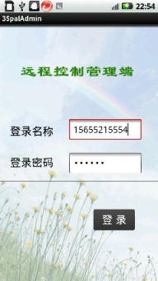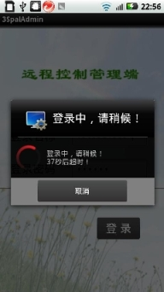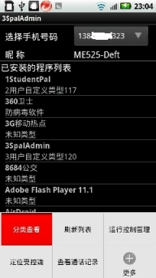
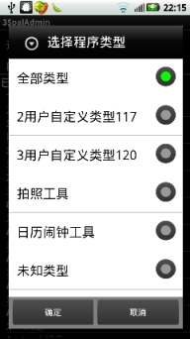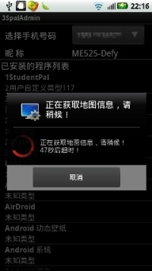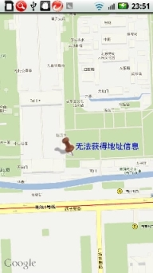
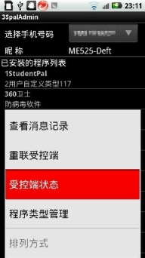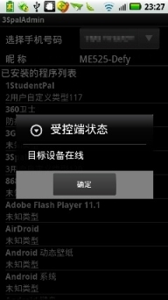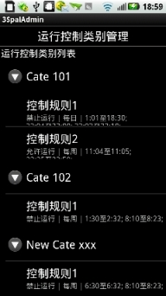
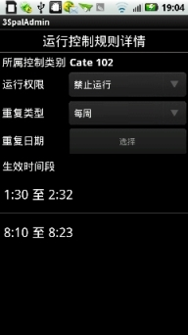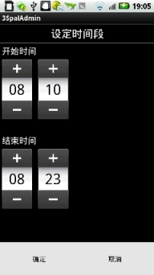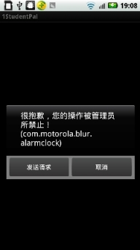
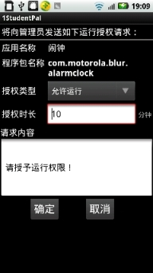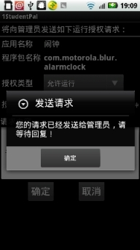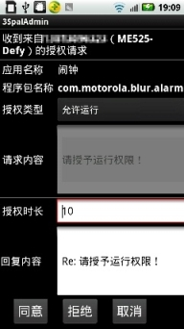
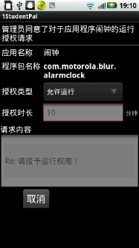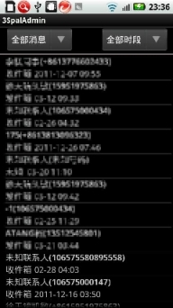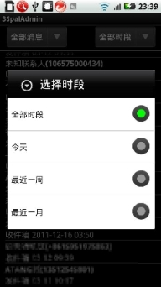
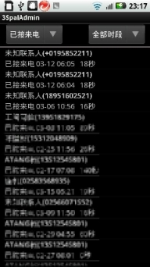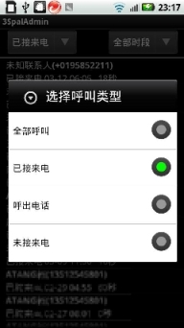

Figure - 远程监控及运行权限管理系统屏幕截图

附录A-1 / Appendix A-1
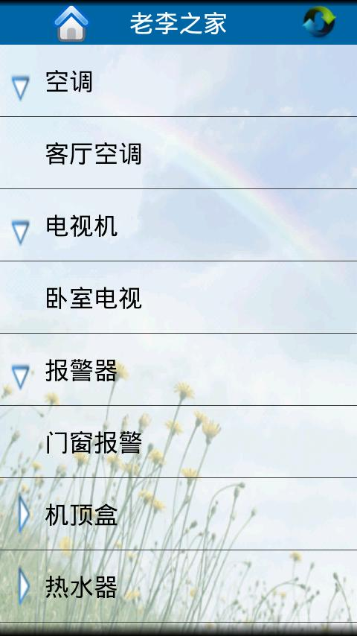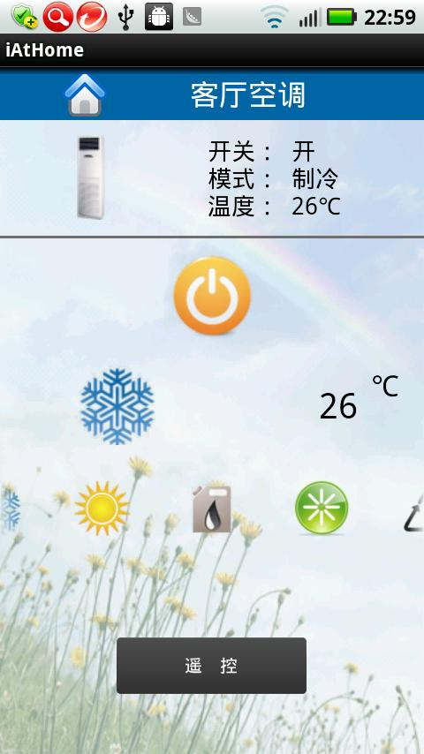
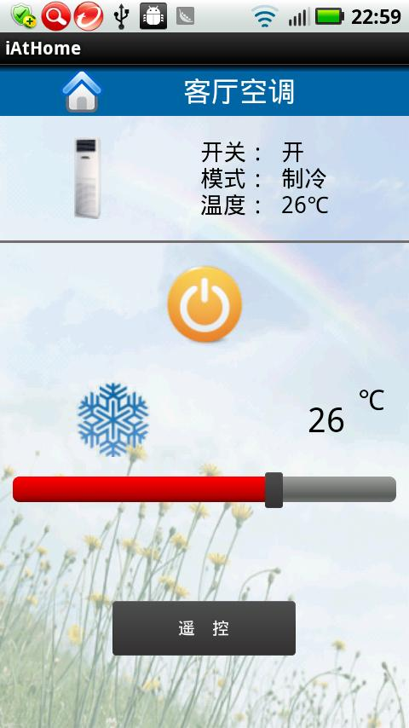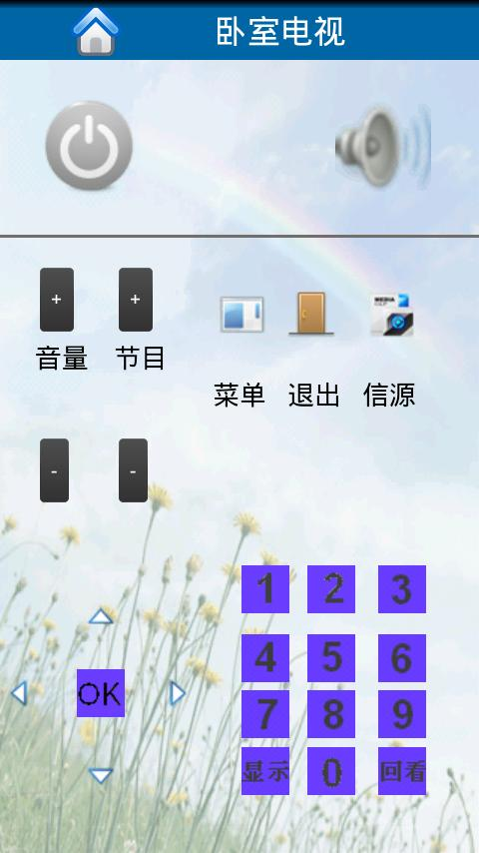


Figure - 智能家居移动控制端运行截图

附录B / Appendix B
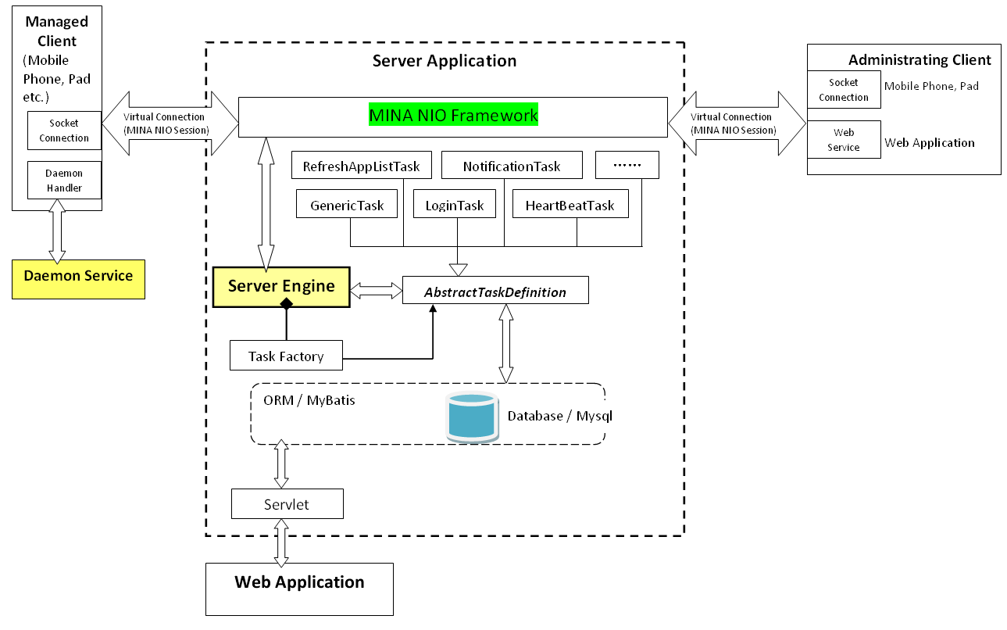
Figure - 远程监控、运行权限管理系统架构图

Main App :: Daemon Handler
Daemon Service
Inner Message Handler
Inner Message Handler
Messenger To MainApp

Service Connection
Messenger To MySelf
Messenger To MySelf
Messenger To Daemon
WatchDog Task / Timeout monitor
WatchDog Task / Timeout monitor
Daemon_WatchDog_Request
Daemon_WatchDog_Response
Client Engine
Start Daemon Service / bindService

Stop/Exit Daemon Service / UnbindService

Remove timeout
Notify timeout
Remove timeout
Notify timeout
Start Main App
Figure - 受控客户端主程序及守护任务程序架构图

Main App stop running ?
N

START
Schedule Daemon WatchDog response timeout action in some time
Send Daemon WatchDog request message to Main App
Cancel current timeout task
Timeout?
Re-launch Main App
Main App sends message of START_DAEMON_TASK
Y

N

N

Y

Y

Received Daemon WatchDog response?
Figure - 受控客户端守护任务程序流程图

附录C / Appendix C
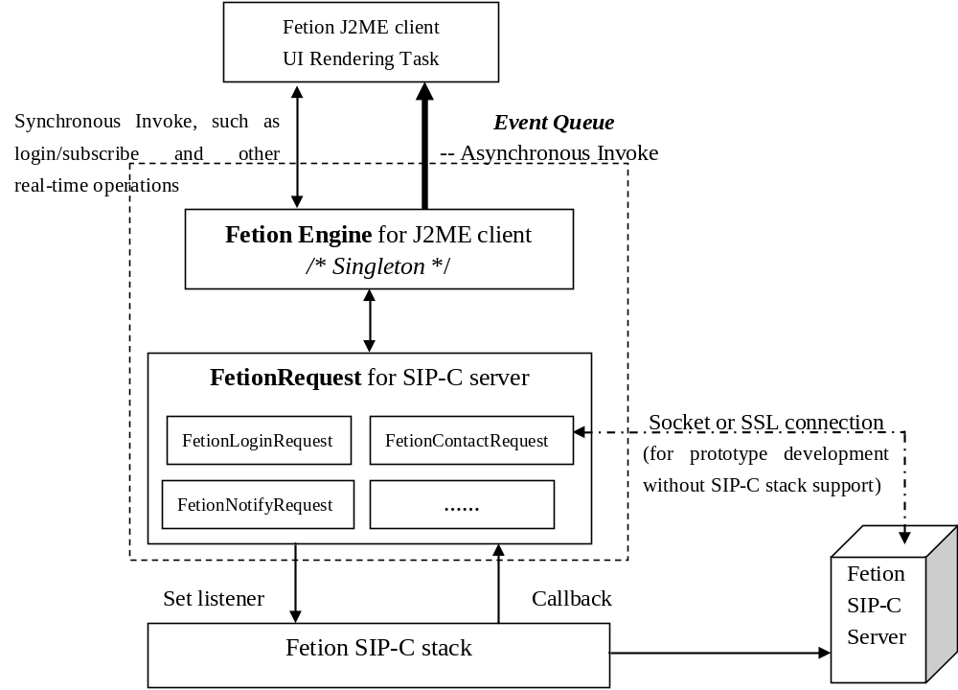
Figure - 飞信J2ME客户端架构图

附录D / Appendix D
- Motorola VE20 CDMA手机:
http://newsreleases.sprint.com/phoenix.zhtml?c=127149&p=irol-newsArticle_newsroom&ID=1187831
- Motorola V950 CDMA手机:
http://support.sprint.com/main.html?selectedDeviceId=10276&manufacturer=Motorola&navtypeid=2&pagetypeid=37&prevPageIndex=34

附录E / Appendix E
Android平台飞信客户端
★ 登录界面：可以点击“取消”登录，并且有登录超时剩余时间显示。
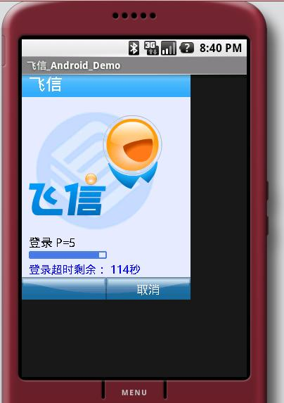

★ 主窗口：显示用户的昵称、在线状态、心情短语等信息。并且用户可以在多种状态间切换。
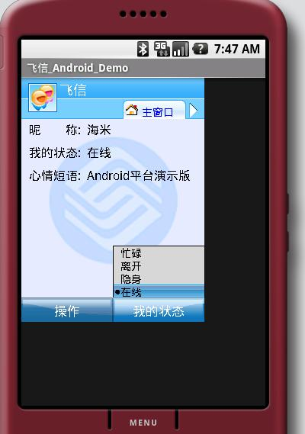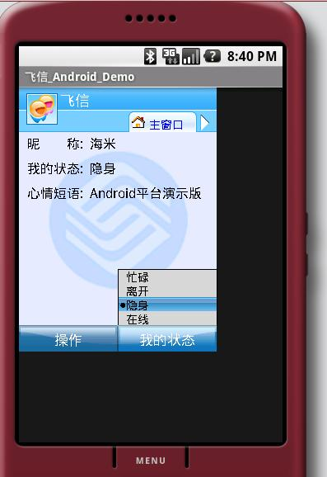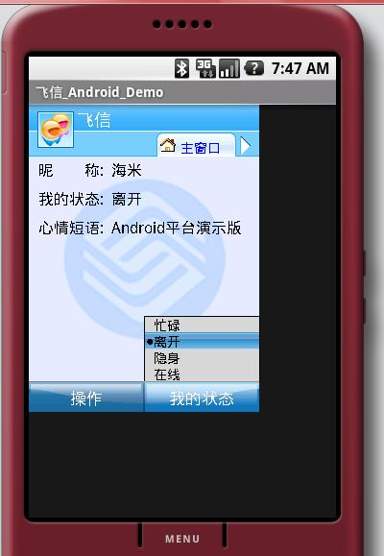

★ 用户可以在主窗口中选择“退出飞信”或者“开/关背景音乐”。
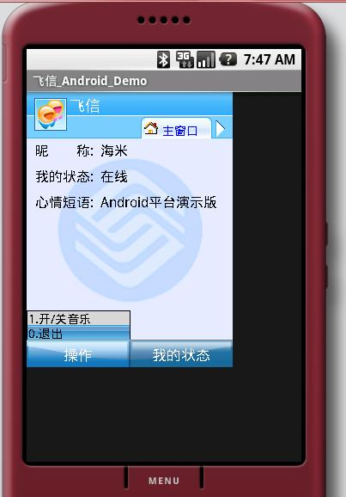

★ 用户列表界面：用户可以向联系人发送飞信消息或者短信消息。
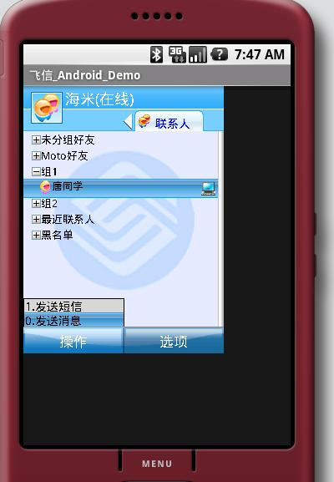

★ 改变联系人分组方式：可以使联系人按照显示名称或者在线状态改变分组方式。
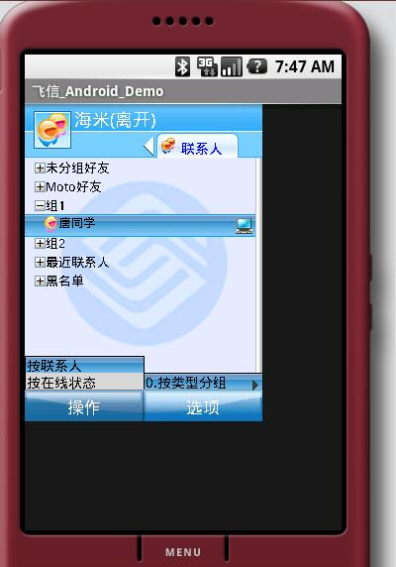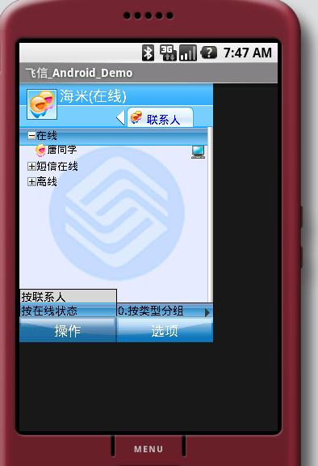

★ 聊天窗口界面：用户可以点击“回复”飞信消息，或者退出聊天窗口。
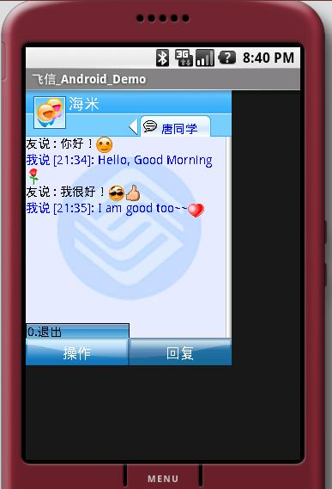

★ 聊天历史记录：聊天窗口关闭后，下次聊天可以看到聊天的历史记录。
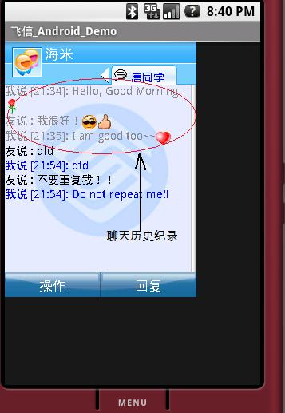

★ 信息输入框以及表情符号选择框
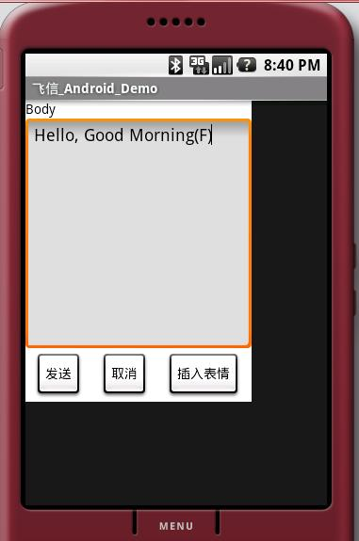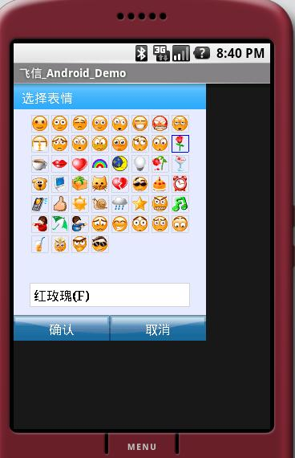

★ 退出飞信界面：
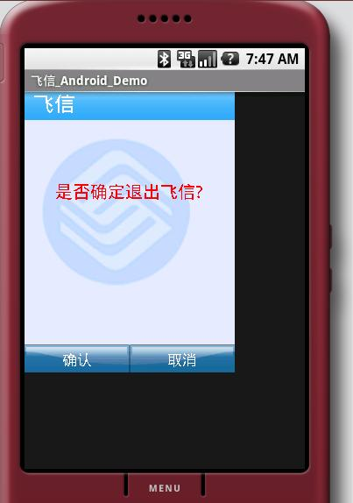

附录F / Appendix F
Android平台Contact Link客户端演示版
★ 需要先在后台启动飞信服务，在状态栏上会显示“飞信服务启动中”的信息，灰色的飞信图标表示Contact Link客户端尚未连接到飞信服务。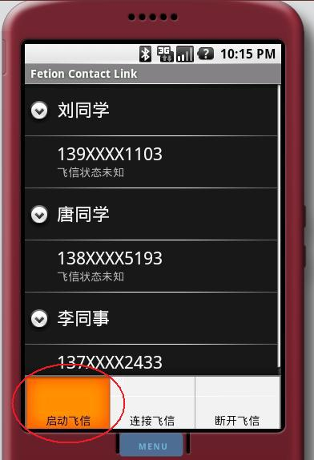 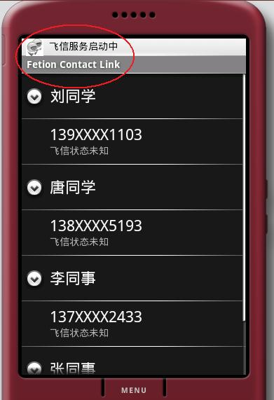

★ 飞信服务在后台启动后，点击“连接飞信”。连接成功后，飞信图标会变成彩色，并且在状态栏显示“已连接到飞信服务”的信息。
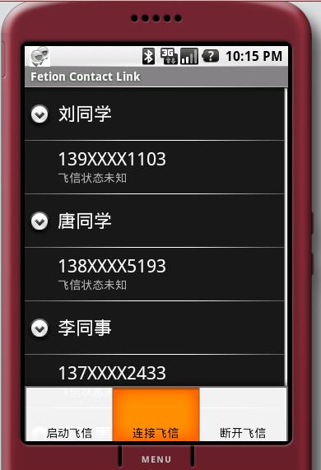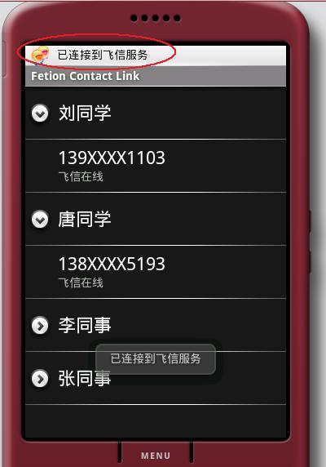

★ 如果联系人改变其飞信状态，Contact Link客户端会及时更新该联系人的飞信状态。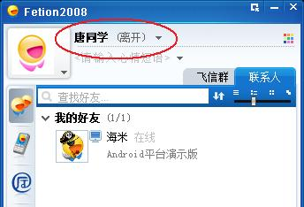 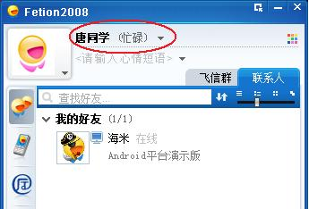
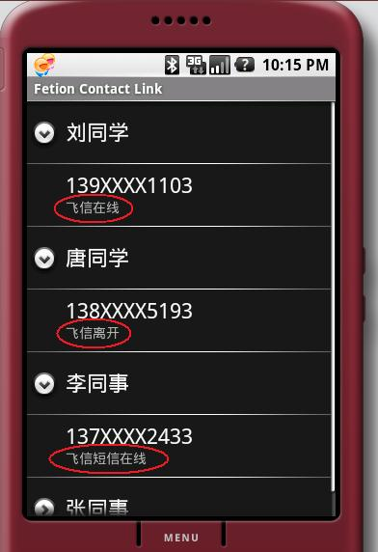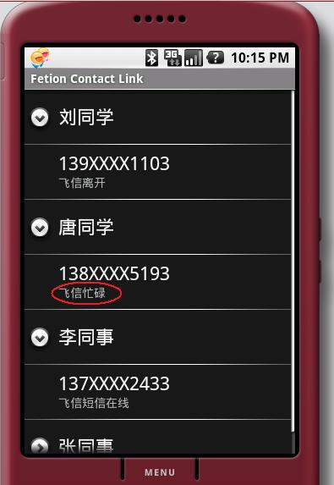
★ 点击“断开飞信”，会在状态栏显示“已从飞信服务断开”的信息，并且飞信图标变为灰色。
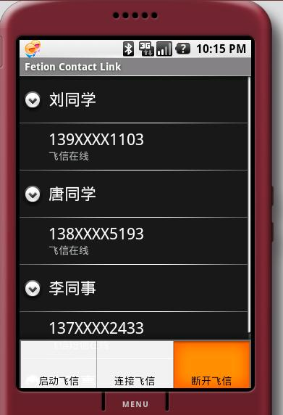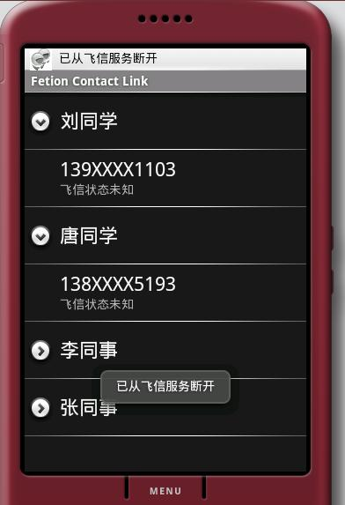

★ 飞信Contact Link客户端演示版的程序流程图：