VPN  
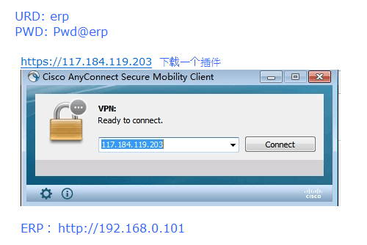  
  
环境  
C:\Users\shuyan\AppData\Local\Temp\%W@GJ$ACOF(TYDYECOKVDYB.pnghttp://192.168.0.101/wtopprd/wa/r/app/gdc_azzi000?Arg=70