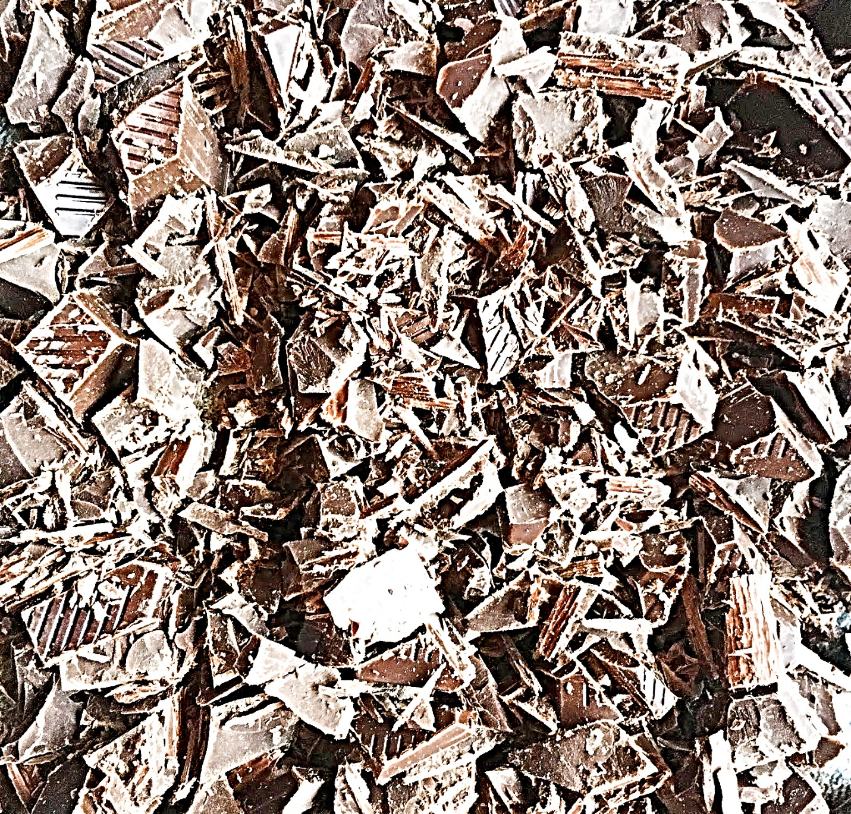

Adawdwadokiwdawd

Wd

Wad

Wad

Wad

Wad

Wad

Wadw

Ad

Wd

wdw