January 31, 2026

ATTY. LIZA C. ALCERA
OIC- Director IV
Licensing and Regulation Bureau (LBR)
DEPARTMENT OF MIGRAT WORKERS
Blas F. Ople Building Ortigas Avenue
EDSA, Mandaluyong City
Subject : Request for Update of Facebook Account Information Due Unauthorized Use

Dear Atty. Alcera;

Good day!

I hope this letter finds you well. I am writing to respectfully request the updating of our registered Facebook account information in the records maintained by the Department of Migrant Workers (DMW).

We are registered Philippine Recruitment Agency (PRA), and we understand that social media details such as Facebook accounts are sometimes used for communication, verification, or outreach purposes.

Unfortunately, our previous Facebook account was compromised and used in a scam without our knowledge or consent. I have since reported the issue to Facebook and permanently deactivated the said account to prevent any further misuse.

For this reason, I am requesting that our records with the Department of Migrant Workers be updated with our new two Facebook account to avoid confusion and ensure secure and accurate communication.
Below are the relevant details for your reference:

BRANCH | USERNAME LINK
SMC MAIN FB PAGE | https://www.facebook.com/smc.main.manila/
SMC SUB PAGE | https://www.facebook.com/smc.manila.sub

We are sincerely hope that this request will be processed promptly to protect our CREDIBILITY, LICENSE and REPUTATION and to maintain accurate records under your office.

Please feel free to contact me should you need additional documents or verification.

Thank you very much for your attention to this matter and for your continued support to overseas Filipino workers
.
Attached herewith is an image of our official SMC Facebook Pages, comprising both the main and sub pages.

Thank you very much,

Respectfully Yours,

ROGELIO M. LANSANG
CEO/ General Manager
SMC Manpower Agency Philippines Company

Furthermore, please be advised that the Facebook account displaying the SMC logo and associated with https://www.facebook.com/smc.main.manila and https://www.facebook.com/smc.manila.sub is our official Facebook account.
Main: https://www.facebook.com/smc.main.manila

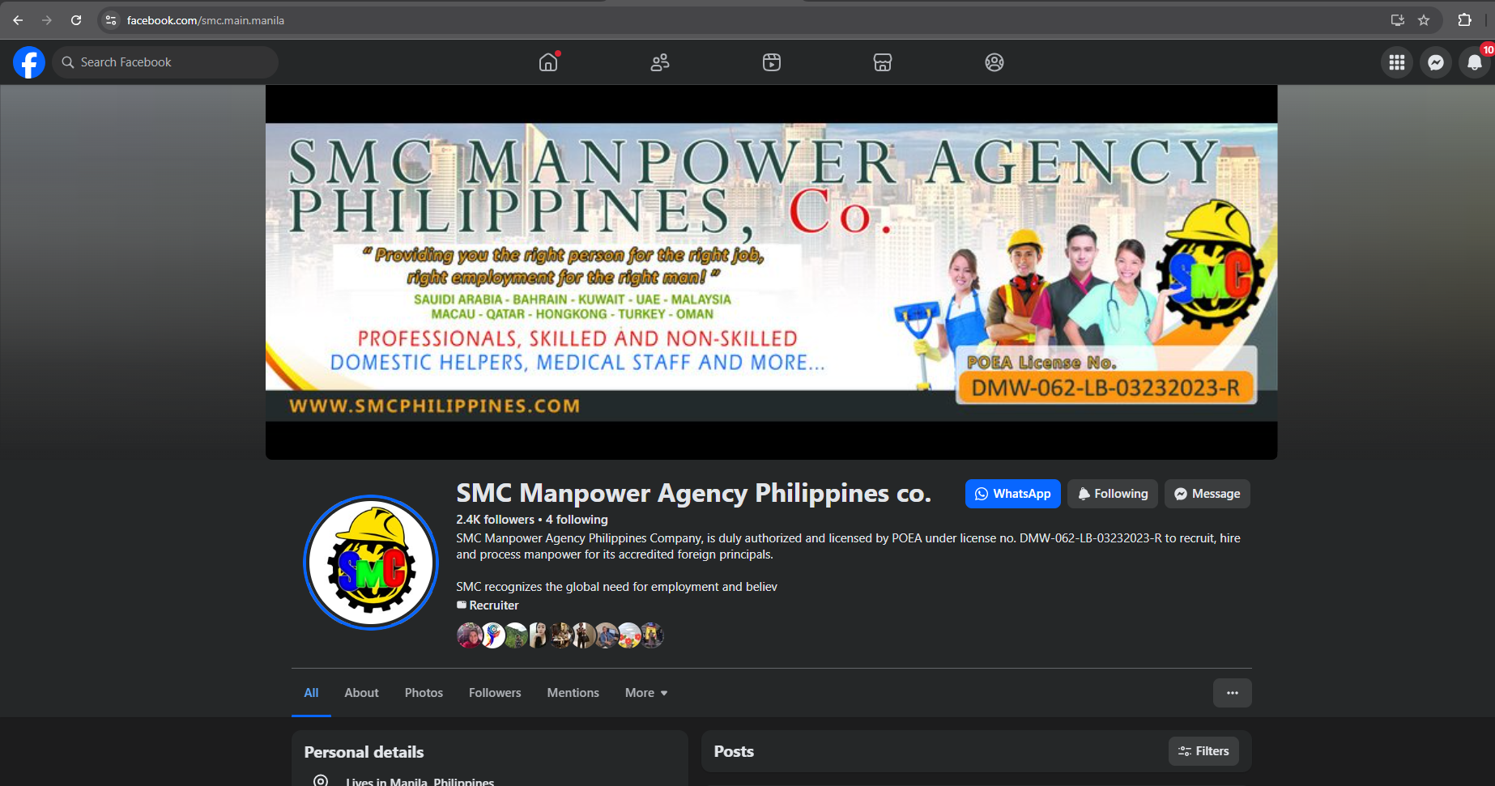

Sub:https://www.facebook.com/smc.main.manila