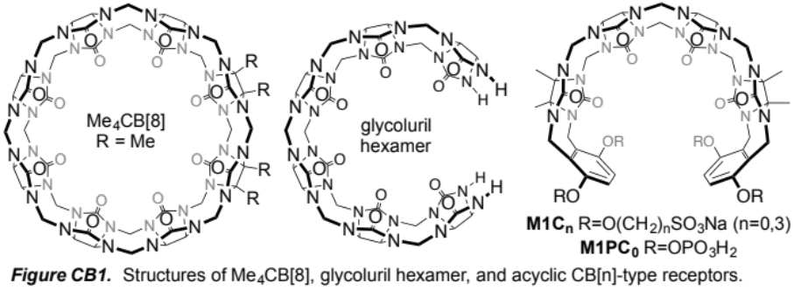
Future SAMPL Challenges Involving Cucurbit[n]uril-Type Receptors. The Isaacs group has previously participated in the SAMPL challenges and supplied unpublished host•guest binding constants.^{[1, 2]} Our participation was quite stimulating for us and influenced our investigation of the biomedical applications of acyclic CB[n]-type receptors (a.k.a Calabadions). Cucurbit[n]uril receptors are particularly well suited for the SAMPL challenges because they exhibit: 1) high binding constants toward suitable guests in water (routinely μM to nM; occasionally pm – femtomolar),^{[3, 4, 5]} 2) high selectivities between structurally related guests which translate into large ΔΔG values,^{[6]} 3) low molecular weights (1000-2000 amu) which allows high levels of theory to be used, and 4) limited conformational degrees of freedom. Herein, we propose to continue to participate in the next three SAMPL challenges during the proposed five year funding period by resynthesizing previously published CB[n]-type receptors of increasing complexity, measure K_{a} values and determine host-guest stoichiometry and geometry toward biologically relevant guests which will allow the computational chemists to push the boundaries of the free-energy prediction of receptor•ligand complexes. Figure CB1 shows the chemical structures of three hosts – Me₄CB[8],^{[7]} glycoluril hexamer,^{[8]} and acyclic CB[n]-type receptors^{[9]} which span the range from preorganized macrocyclic host to uncharged acyclic but preorganized host to highly charged acyclic host.

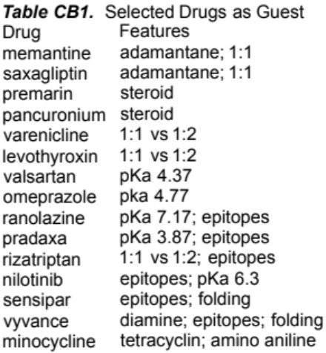
Future SAMPL Challenge #1. For this challenge we propose to measure K_{a} and ΔH values, stoichiometry, and geometry for the interaction of Me₄CB[8] (nicely water soluble CB[8] derivative) toward 15 guests (chosen from top selling drugs, Table CB1, structures not shown due to space restrictions) by either direct or competition isothermal titration calorimetry (ITC), UV/Vis or fluorescence indicator displacement assay, or NMR competition experiments which we are very experienced with.^{[2, 3, 10]} Our selection of Me₄CB[8] and top 100 drugs was based on a desire to increase the level of complexity of the computational challenge by: 1) changing host flexibility (e.g. Me₄CB[8] can exhibit ellipsoidal deformation),^{[7]} 2) by allowing the possibility of binary or ternary (e.g. 1:1 and/or 1:2 host:guest) complexes,^{[11]} 3) using drugs with several potential binding epitopes to include sampling issues. Host:guest stoichiometry and geometry (e.g. which binding epitope is complexed) will be addressed by ITC “n” values, Job plots monitored by UV/Vis or NMR,^{[12]} and by ¹H NMR complexation induced changes in chemical shifts.^{[13]} All three sets of studies will be conducted in phosphate buffered saline (pH 7.4 with physiological salt) which introduces further complexity due to competitive interaction between the C=O portals of CB[n]-type receptors and metal ions via ion-dipole interactions which reduces the observed K_{a} values.^{[14]}

Future SAMPL Challenge #2. We propose to study host:guest complexes of glycoluril hexamer toward the 15 drugs (Figure CB1). We select glycoluril hexamer for this challenge because it: 1) increases the conformational dynamics of the host, and 2) influences the number and energy of solvating (encapsulated and high energy) water molecules that are implicated in the observed high binding constants for CB[n]•guest complexes.^{[5, 15]} Furthermore, in selecting the drugs, we have chosen several that have pK_{a} values in the 3.8 to 7.4 range. Similar to biomolecular host-guest systems, CB[n]-type receptors are well known to induce pK_{a} shifts (up to 4 pKa units) of complexed guests,^{[16]} and the ability of computation to replicate and predict such shifts and their impact on K_{a} are of high significance.

Future SAMPL Challenge #3. In the third sample challenge, we will focus on acyclic CB[n]-type receptors (e.g. M1C₃, M1C₀, and M1PC₀ that contain anionic solubilizing groups attached via different linker lengths. As in the second SAMPL, these acyclic CB[n]-type receptor introduces conformational complixty and influences the free energy of the solvating H₂O molecules in the free host. Moreover, the presence of 4 anionic groups in close proximity to the cavity are expected to have a significant influence on the balance between ion-dipole interactions and the solvation of the free host.

References:

[1] L. Cao, L. Isaacs, Supramol. Chem. 2014, 26, 251-258; D. Ma, R. Glassenberg, S. Ghosh, P. Y. Zavalij, L. Isaacs, Supramol. Chem. 2012, 24, 325-332.
[2] N. She, D. Moncelet, L. Gilberg, X. Lu, V. Sindelar, V. Briken, L. Isaacs, Chem. Eur. J. 2016, 22, 10.1002/chem.201601796.
[3] L. Cao, M. Sekutor, P. Y. Zavalij, K. Mlinaric-Majerski, R. Glaser, L. Isaacs, Angew. Chem., Int. Ed. 2014, 53, 988-993; S. Liu, C. Ruspic, P. Mukhopadhyay, S. Chakrabarti, P. Y. Zavalij, L. Isaacs, J. Am. Chem. Soc. 2005, 127, 15959-15967.
[4] W. L. Mock, N.-Y. Shih, J. Org. Chem. 1986, 51, 4440-4446; K. I. Assaf, W. M. Nau, Chem. Soc. Rev. 2015, 44, 394-418; D. Shetty, J. K. Khedkar, K. M. Park, K. Kim, Chem. Soc. Rev. 2015, 44, 8747-8761; S. Moghaddam, C. Yang, M. Rekharsky, Y. H. Ko, K. Kim, Y. Inoue, M. K. Gilson, J. Am. Chem. Soc. 2011, 133, 3570-3581.
[5] F. Biedermann, V. D. Uzunova, O. A. Scherman, W. M. Nau, A. De Simone, J. Am. Chem. Soc. 2012, 134, 15318-15323.
[6] L. Isaacs, Acc. Chem. Res. 2014, 47, 2052-2062.
[7] B. Vinciguerra, P. Y. Zavalij, L. Isaacs, Org. Lett. 2015, 17, 5068-5071.
[8] D. Lucas, T. Minami, G. Iannuzzi, L. Cao, J. B. Wittenberg, P. Anzenbacher, L. Isaacs, J. Am. Chem. Soc. 2011, 133, 17966-17976.
[9] D. Ma, G. Hettiarachchi, D. Nguyen, B. Zhang, J. B. Wittenberg, P. Y. Zavalij, V. Briken, L. Isaacs, Nat. Chem. 2012, 4, 503-510; D. Ma, B. Zhang, U. Hoffmann, M. G. Sundrup, M. Eikermann, L. Isaacs, Angew. Chem., Int. Ed. 2012, 51, 11358-11362; B. Zhang, L. Isaacs, J. Med. Chem. 2014, 57, 9554-9563; L. Gilberg, B. Zhang, P. Y. Zavalij, V. Sindelar, L. Isaacs, Org. Biomol. Chem. 2015, 13, 4041-4050; D. Sigwalt, D. Moncelet, S. Falcinelli, V. Mandadapu, P. Y. Zavalij, A. Day, V. Briken, L. Isaacs, ChemMedChem 2016, Ahead of Print; B. Zhang, P. Y. Zavalij, L. Isaacs, Org. Biomol. Chem. 2014, 12, 2413-2422.
[10] D. Ma, P. Y. Zavalij, L. Isaacs, J. Org. Chem. 2010, 75, 4786-4795.
[11] Y. H. Ko, E. Kim, I. Hwang, K. Kim, Chem. Commun. 2007, 1305-1315; S. J. Barrow, S. Kasera, M. J. Rowland, J. del Barrio, O. A. Scherman, Chem. Rev. 2015, 115, 12320-12406; A. R. Urbach, V. Ramalingam, Isr. J. Chem. 2011, 51, 664-678.
[12] K. A. Connors, Binding Constants, John Wiley & Sons, New York, 1987.
[13] E. Masson, X. Ling, R. Joseph, L. Kyeremeh-Mensah, X. Lu, RSC Adv. 2012, 2, 1213-1247.
[14] C. Marquez, R. R. Hudgins, W. M. Nau, J. Am. Chem. Soc. 2004, 126, 5806-5816.
[15] F. Biedermann, W. M. Nau, H.-J. Schneider, Angew. Chem., Int. Ed. 2014, 53, 11158-11171.
[16] N. Saleh, A. L. Koner, W. M. Nau, Angew. Chem. Int. Ed. 2008, 47, 5398-5401; W. M. Nau, M. Florea, K. I. Assaf, Isr. J. Chem. 2011, 51, 559-577; I. Ghosh, W. M. Nau, Adv. Drug Delivery Rev. 2012, 64, 764-783.

