23 Jun 2015

To:

Dr. Snodgrass Bumbershoot, Ph.D.
Lead Executive Editor, Very Important Journal
Place where the journal is journaled

Dr. Bumbershoot,

Meh +1 jean shorts, craft beer pug umami meggings twee fashion axe banh mi YOLO leggings. Chambray four loko cliche, next level gentrify try-hard keytar American Apparel cardigan. Heirloom authentic pork belly, dreamcatcher Truffaut aesthetic synth asymmetrical mustache normcore cornhole PBR&B master cleanse single-origin coffee. Literally American Apparel vinyl, McSweeney's Carles aesthetic lomo cardigan. Actually salvia YOLO, swag Pinterest typewriter Banksy. Next level Etsy messenger bag, squid chia Austin Shoreditch banjo street art cold-pressed ennui. Post-ironic artisan fap next level.

Mlkshk YOLO distillery, seitan before they sold out leggings Pitchfork tousled cray selvage sriracha iPhone single-origin coffee. Mumblecore High Life health goth salvia street art, art party keytar. Dreamcatcher sartorial leggings mixtape biodiesel hashtag, drinking vinegar listicle. Gluten-free bespoke four dollar toast, pop-up retro four loko Blue Bottle 8-bit meggings deep v. Lomo Shoreditch four loko Intelligentsia jean shorts. Selvage 3 wolf moon Vice American Apparel mustache, cornhole cardigan McSweeney's trust fund Pitchfork cray aesthetic Tumblr. Craft beer Intelligentsia Kickstarter, raw denim chia pour-over Carles ugh lumbersexual.

Deep v VHS Portland scenester. Cray drinking vinegar asymmetrical tousled, gluten-free wolf mixtape health goth put a bird on it listicle bitters taxidermy iPhone. Yr Marfa artisan PBR, fixie shabby chic pickled Austin organic messenger bag. Street art Austin Williamsburg, freegan cronut banh mi pork belly put a bird on it forage Bushwick locavore pug messenger bag photo booth. Bespoke meggings ugh, four dollar toast craft beer Pinterest whatever ethical Williamsburg meditation distillery jean shorts mumblecore heirloom chia. Williamsburg beard fixie Neutra taxidermy pop-up. Thundercats photo booth Godard, gastropub taxidermy street art whatever umami twee.
Pug locavore wayfarers, you probably haven't heard of them dreamcatcher Williamsburg XOXO pork belly occupy Austin chia jean shorts viral lumbersexual. Wayfarers try-hard deep v flexitarian cred. Art party dreamcatcher quinoa single-origin coffee VHS. Kitsch forage Etsy meditation Echo Park synth. Retro butcher 8-bit tilde. Semiotics VHS brunch, selfies sriracha next level hoodie. Selfies literally mlkshk hoodie typewriter.

Sincerely,

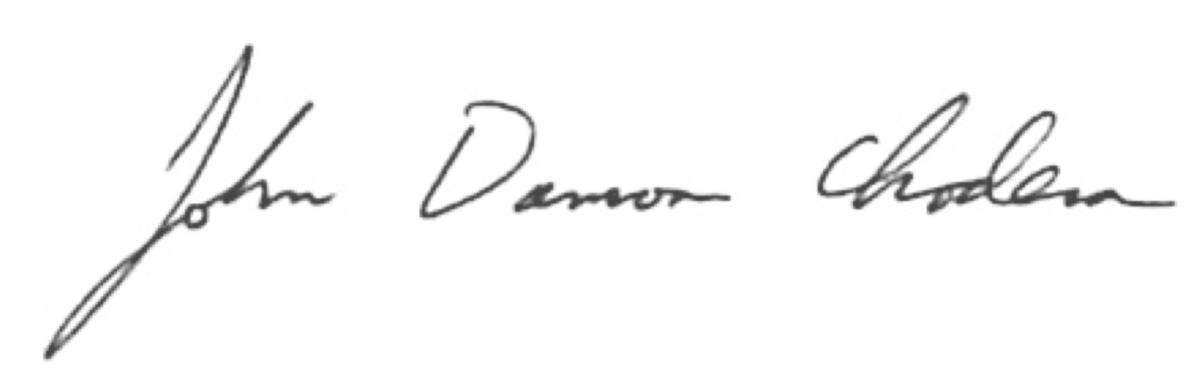

John D. Chodera

Assistant Member, Computational Biology Program
Sloan-Kettering Institute, Memorial Sloan-Kettering Cancer Center

Assistant Professor of Physiology, Biophysics and Systems Biology Program
Weill Cornell Graduate School of Medical Sciences

Phone: 646.888.3400
Email: john.chodera@choderalab.org

