

|  |  |  |  |
| --- | --- | --- | --- |
| **Ligand** | **TWEEN-20** | **kD (uM)** | **kD SD (uM)** |
| **Bosutinib** | no | 0.8564 | 0.2117 |
| **Bosutinib** | yes | 5 | 2.1 |
| **Bosutinib** | no | 3.1 | 9.2 |
| **Bosutinib Isomer** | no | 2.8 | 1.1 |
| **Bosutinib Isomer** | yes | 17.3 | 9 |
| **Bosutinib Isomer** | no | 4.7 | 2.4 |
| **Erlotinib** | no | 9.9 | 6.4 |
| **Erlotinib** | yes | 27.7 | 9.9 |
| **Erlotinib** | no | 37.5 | 67.1 |
| **Gefitinib** | no | 1.9 | 0.5 |
| **Gefitinib** | yes | 6.6 | 1.6 |
| **Gefitinib** | no | 1.2 | 0.3 |

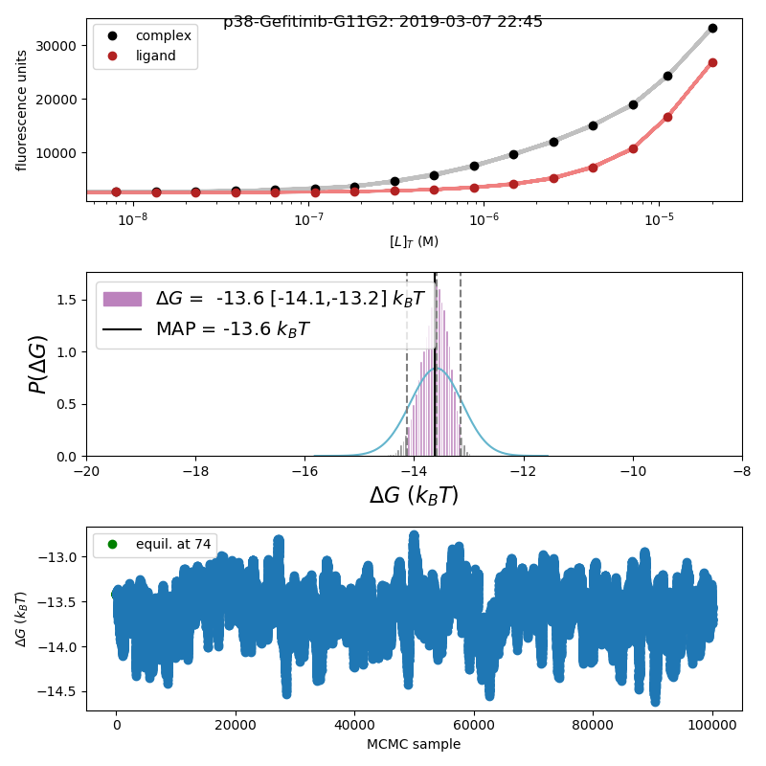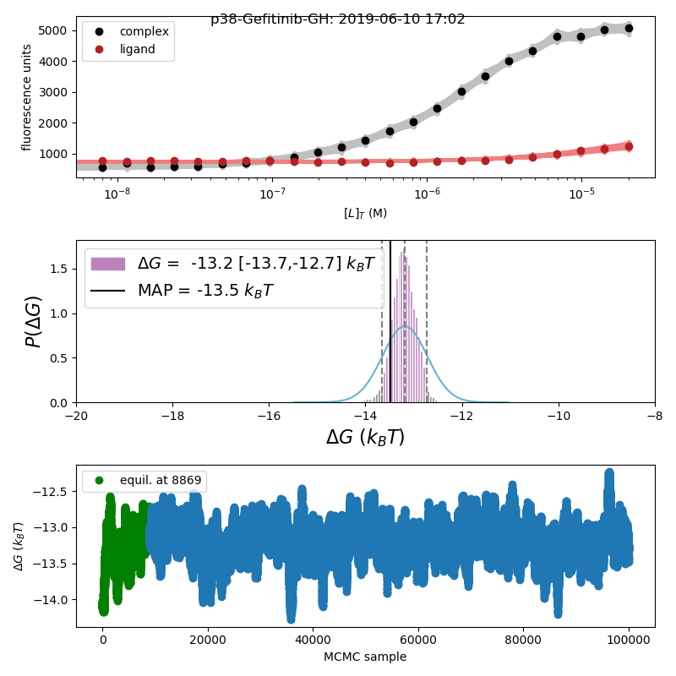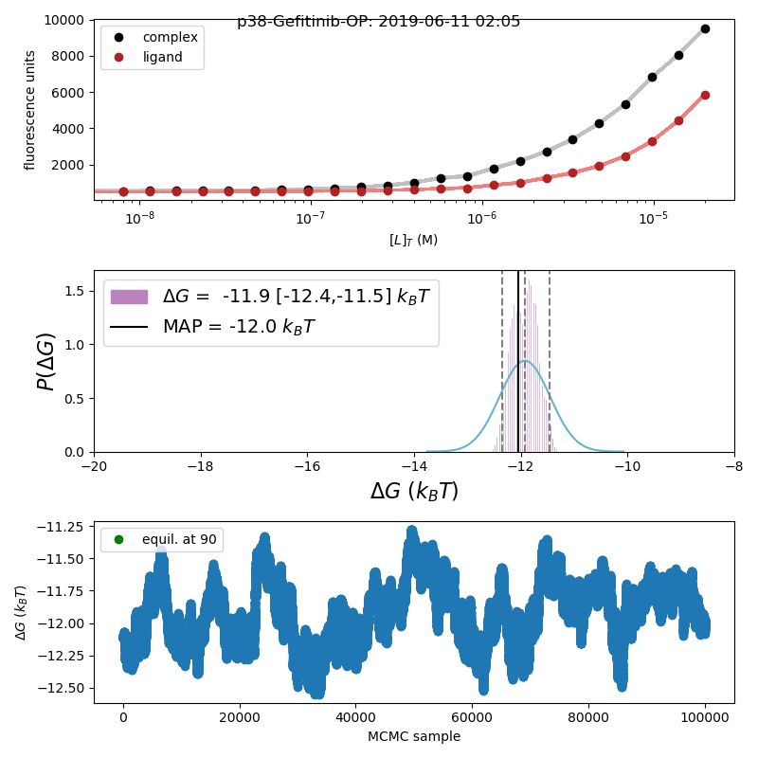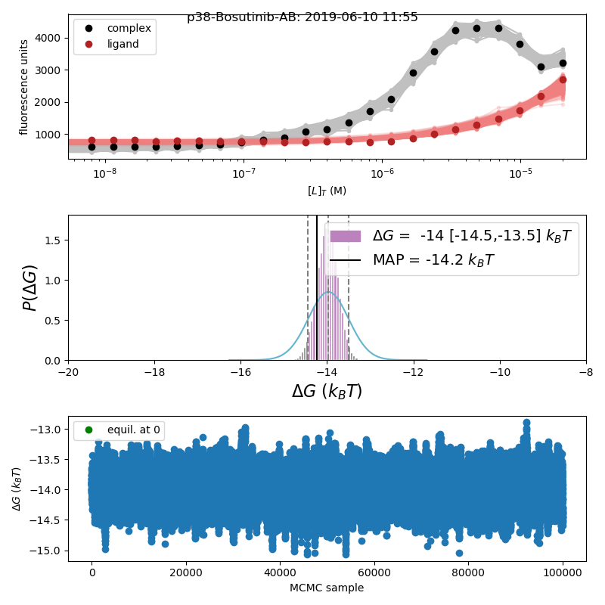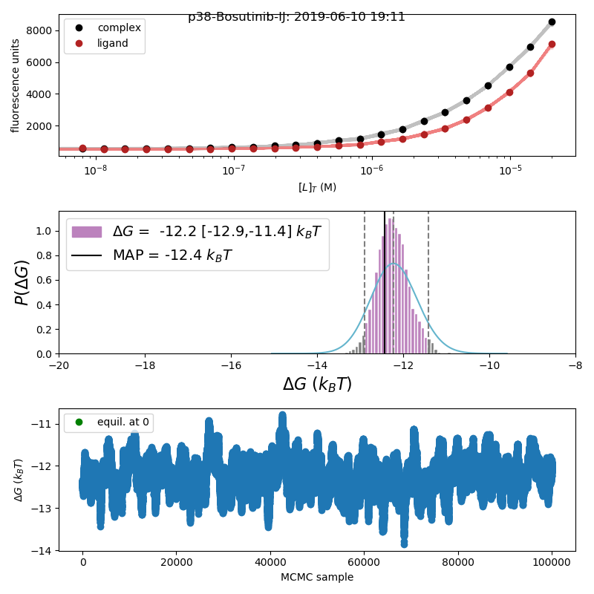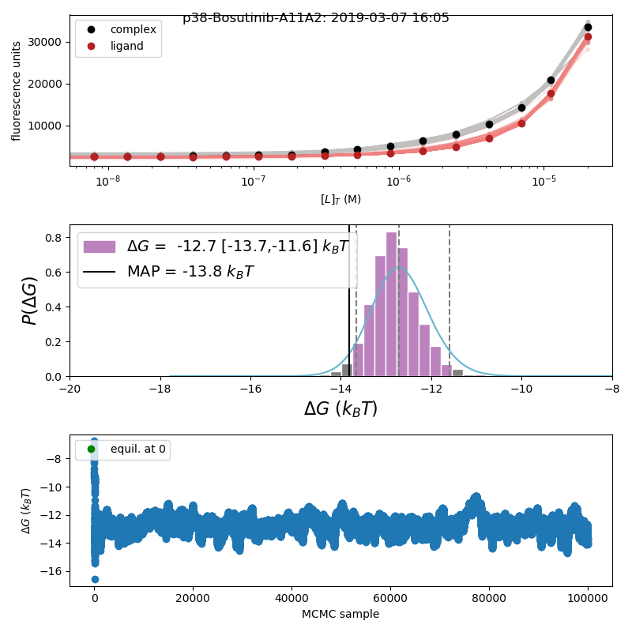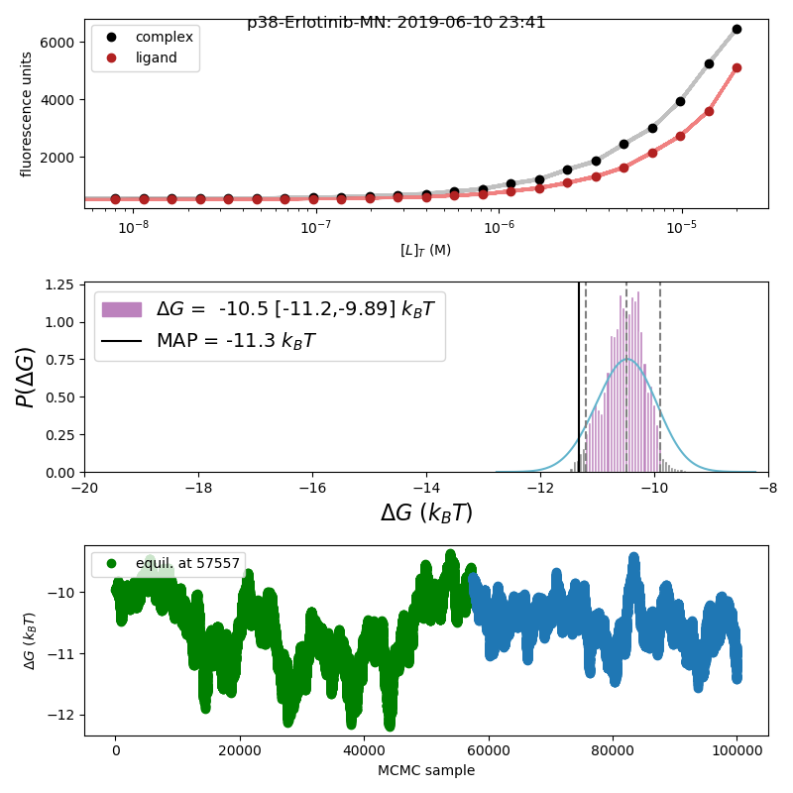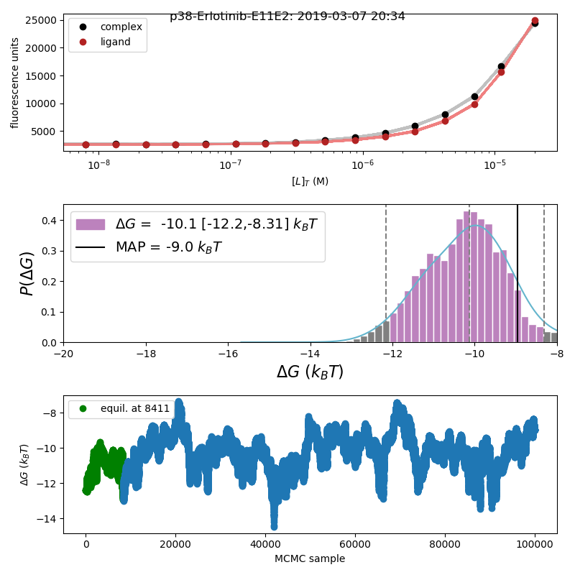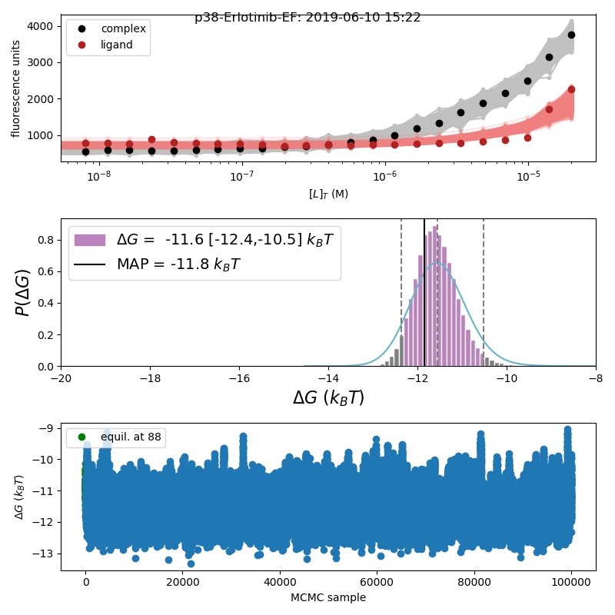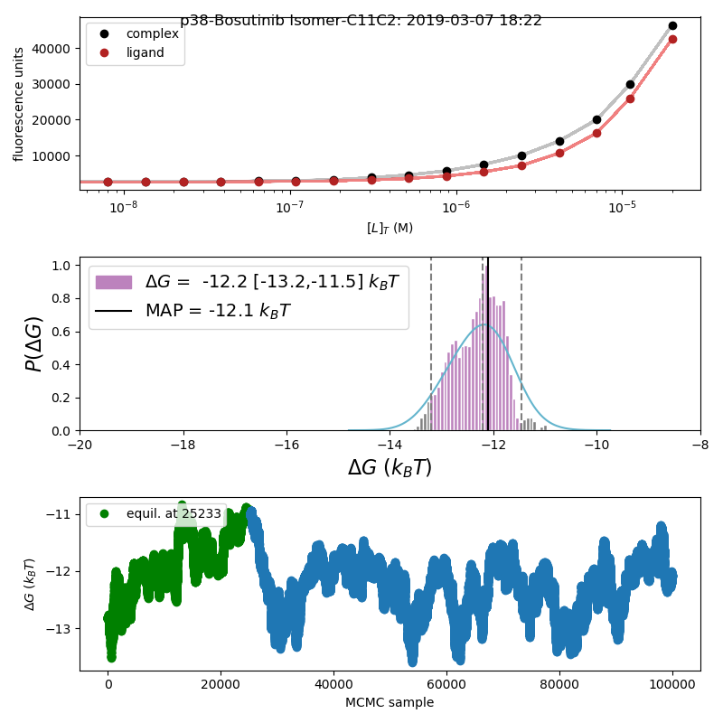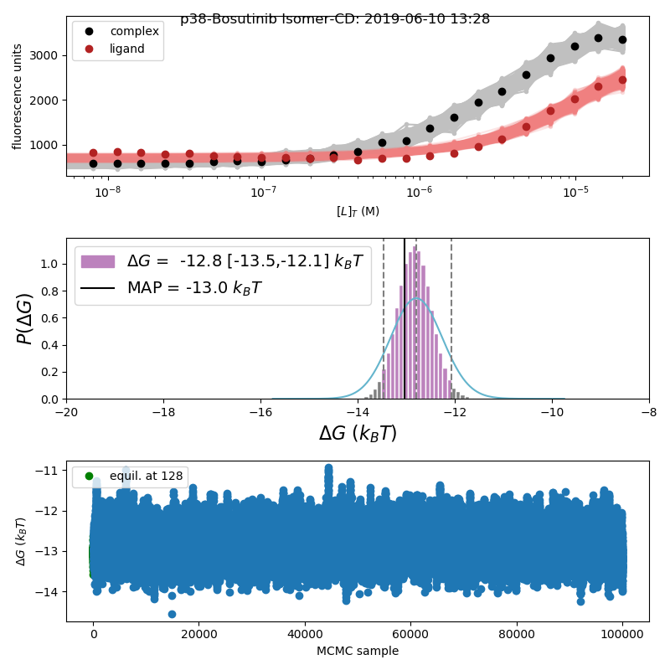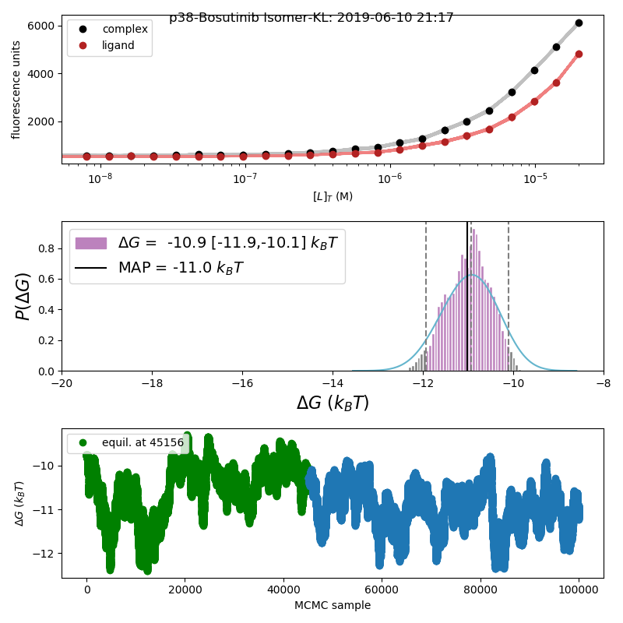

**Gefitinib**

**No tween, 96-well**

**0.05% Tween-20, 384-well**

**No tween, 384-well**

**Bosutinib**

**Erlotinib**

**Bosutinib Isomer**