4 Apr 2016
To:

Editors,
Analytical Chemistry

Re: Technical Note submission

Dear Dr. Niessner,

We thank you for getting back to us quickly about our submission of a Technical Note to be published in Analytical Chemistry:

Avoiding accuracy-limiting pitfalls in the study of protein-ligand interactions with isothermal titration calorimetry.
by Sarah E. Boyce, Joel Tellinghuisen, and John D Chodera.
and apologize for the delay in our returned correspondence due to conference travel.
In our reading of your note and the reviewer comments, there are a few simple misunderstandings that we think can easily be resolved in a manner that we think will make our manuscript highly suitable for publication as a Technical Note with appropriate revisions based on the helpful feedback from the reviews. We wanted to first check with you to make sure you would be amenable to its reconsideration. I’m also happy to answer any questions by phone or email if it would help resolve the misunderstandings notes below.
Pre-publication. You note that the article is fully pre-published on “squarespace”. Squarespace is the provider which hosts our laboratory website [http://choderalab.org], and we have simply provided a link to a preprint of our manuscript on bioRxiv [http://biorxiv.org] that was posted prior to submission to allow our colleagues to give us feedback while the manuscript was under review in order to deliver the strongest final version. When I submitted the manuscript and received the automated notification requesting that we advise the assigned editor if it has been posted to “computer databases of a public nature”, I emailed you on 19 Jan 2016 stating a preprint had been posted to bioRxiv, and no concerns were raised at that time. This was fully consistent with the published Analytical Chemistry Policy Summary on Prior Publication available on the Analytical Chemistry website [http://pubs.acs.org/page/ancham/submission/prior.html], so we think there must have been a simple misunderstanding about this point.
Reviewer comments. Reviewer 2 was clearly very positive about our contribution, noting it in the top 5% in technical quality, asking for only minor revisions, and providing useful suggestions in his review. Reviewer 1 seems to have focused on points that are peripheral to the goal of our manuscript, which was to introduce novice ITC practitioners to clearly illustrated established best practices and get them thinking about how various sources of error and uncertainty can be inadvertently introduced. While Reviewer 1 notes many of these best practices recommendations are not new---which is expected for a Technical Note reviewing best practices---the suggestion that these recommendations are now given by all major instrument manufacturers and have been consistently adopted by practitioners is mistaken. The most notable counterexample of this is the ABRF-MIRG’02 study we reference in our manuscript, in which identical aliquots of material were distributed to 14 core ITC laboratories and highly trained technicians produced measurements with enormous discrepancies in measurements (~20% standard deviation between experiments), up to 1000-fold underreporting of errors, and large methodological variations.
Our goal was to present a clear, concise Technical Note for novice practitioners that will eliminate this kind of variability and error underreporting. Our Technical Note provides a spreadsheet (which Reviewer 1 notes is useful) that will guide practitioners through tracking and propagating error throughout the procedure, ensuring they pay attention to accuracy-limiting steps and allowing them to avoid common mistakes. We believe this is a valuable contribution, and feel strongly that Analytical Chemistry reaches our intended audience.
In light of these misunderstandings, we ask that you allow us to submit a revised manuscript that incorporates the referee feedback. We believe the resulting Note will be widely read by new ITC practitioners and well-cited as a consolidated source of current best practices.

Sincerely,

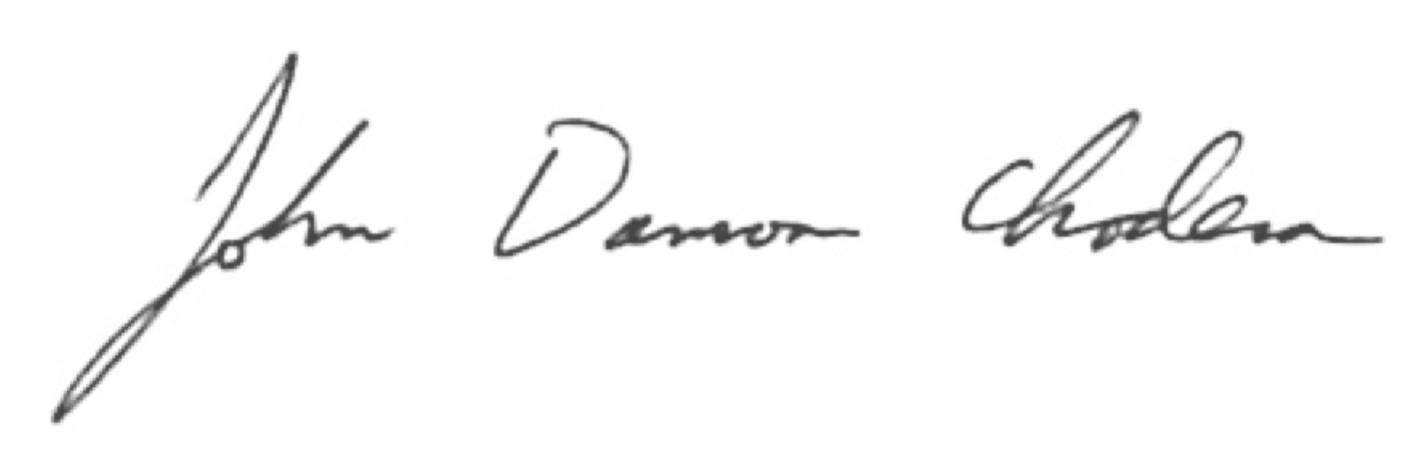

John D. Chodera

Assistant Member, Computational Biology Program
Sloan-Kettering Institute, Memorial Sloan-Kettering Cancer Center

Assistant Professor of Physiology, Biophysics and Systems Biology Program
Weill Cornell Graduate School of Medical Sciences

Phone: 646.888.3400
Email: john.chodera@choderalab.org

