16 Jan 2016
To:

Editors,
Analytical Chemistry

Re: Technical Note submission

Dear Editors:

We wish to submit the following manuscript for your consideration as a Technical Note to be published in Analytical Chemistry:

Avoiding accuracy-limiting pitfalls in the study of protein-ligand interactions with isothermal titration calorimetry.
by Sarah E. Boyce, Joel Tellinghuisen, and John D Chodera.
In the course of our work with isothermal titration calorimetry (ITC) to characterize protein-ligand interactions, we have noted that the dominant source of error and measurement uncertainty in many (if not most) biochemical experiments is the uncertainty in the titrant (usually ligand) concentration, an issue we have written about elsewhere. Modern instrument software fails to provide a simple way to propagate this dominant source of error into the final thermodynamic properties and uncertainties, instead reporting only the error in the nonlinear least-squares fit, which can often be orders of magnitude smaller than the true error one would obtain from fully independent experimental replicates. This often causes practitioners unfamiliar with this issue to believe the resulting thermodynamic parameters---and especially enthalpies----are much more reliable than they actually are.

This manuscript provides a simple way to integrate both the nonlinear fitting error and the titrant concentration error using a tool that most laboratory chemists will already be familiar with---the simple spreadsheet. Using the most famous prototype for a protein-ligand binding affinity measurement---the CAII:CBS binding experiment from the now-infamous ABRF-MIRG’02 benchmark----we walk the practitioner through the various ways in which error might be inadvertently introduced, why the titrant concentration error is often the dominant source of error, and how the contribution from this error can easily be propagated via the provided spreadsheet. The spreadsheet also provides easily achievable uncertainty guidelines that will alert the practitioner to whether something has gone wrong during the course of experimental preparations.

We think that many practitioners of ITC---especially students new to the technique---will find this short Technical Note illuminating and practically useful, and hope you find it suitable for Analytical Chemistry, which already has wide readership amongst our target audience.

Sincerely,

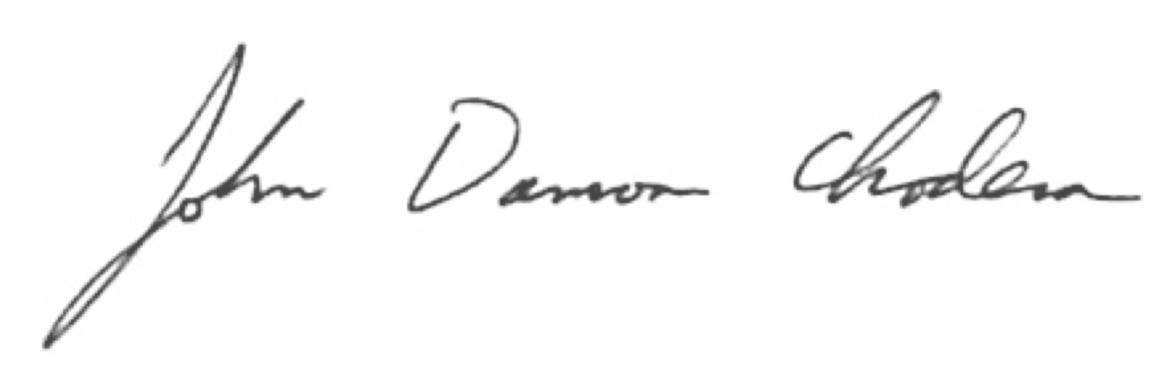

John D. Chodera

Assistant Member, Computational Biology Program
Sloan-Kettering Institute, Memorial Sloan-Kettering Cancer Center

Assistant Professor of Physiology, Biophysics and Systems Biology Program
Weill Cornell Graduate School of Medical Sciences

Phone: 646.888.3400
Email: john.chodera@choderalab.org

