NMR Determination of Microstates of samples SM07 and SM14

In general, the chemical shifts of nuclear species observed in Nuclear Magnetic Resonance (NMR) spectra report on and are very sensitive to the chemical environment. Consequently, small changes in chemical environment, such as the protonation events described in this work, are manifest as changes in the chemical shift(s) of the nuclei. If perturbation occurs at a rate, which is fast on the NMR timescale, an average chemical shift is observed. This phenomena has been exploited and utilized as a probe for determining the order of protonation for molecules with more than one titratable site.1 In some cases, direct observation of the titrated nuclei can be difficult, for example nitrogen and oxygen, due to sample limitations and/or low natural abundance of the NMR active nuclei (0.37% for 15N and 0.038% for 17O) – amongst other factors. In these situations, chemical shifts changes of the so-called “reporter” NMR nuclei – 1H, 31P or 13C nuclei, which are directly attached to or are a few bonds away from the titrated nuclei – have been utilized as the probe for NMR-pH titrations.2-4 This approach is advantageous since the sensitive NMR nuclides (1H and 31P) are observed. In addition, 31P and 13C offers large spectral widths of ~300 ppm and ~200 ppm, respectively, which minimizes peak overlap. However, reporter nuclei chemical shifts provide indirect information subject to interpretation. In complex systems with multiple titratable groups, such analysis will be complicated due to a cumulative effect of these groups on the reporter nuclide due to their close proximity or the resonance observed in aromatic systems. In contrast, direct observation of the titratable nuclide where possible, affords a more straight-forward approach to studying the protonation events. In this study, the chemical shifts of the titratable nitrogen nuclei were observed using the 1H-15N-HMBC (Heteronuclear Multiple-Bond Correlation) experiments – a method that affords the observation of 15N chemical shifts while leveraging the sensitivity accrued from the high abundance the 1H nuclide.

## Experimental

The structures of samples SM07 and SM14 were assigned via a suite of NMR experiments, which included 1H NMR, 13C NMR, homonuclear correlated spectroscopy (1H-1H COSY), heteronuclear single quantum coherence (1H-13C HSQC), 13C heteronuclear multiple-bond correlation (1H-13C-HMBC) and 15N heteronuclear multiple-bond correlation (1H-15N-HMBC) – see SI. All NMR data used in this analysis were acquired on a Bruker 500 MHz spectrometer equipped with a 5 mm TCI CryoProbeTM Prodigy at 298 oC. The poor solubility of the analytes prevented analysis in water and thus water-*d*2/methanol-*d*4 and acetonitrile-*d*3 were used. The basic sites were then determined by titration of the appropriate solutions of the samples with equivalent amounts of deutero-trifluoroacetic acid (TFA-*d*) solution.

**SM07:** 5.8 mg of SM07 was dissolved in 600 µL of methanol-*d*4/water-*d*2 (2:1 ratio). A 9% v/v TFA-*d* solution in water-*d*2 was prepared, such that each 20 µL volume contained approximately 1 equivalent of TFA-*d* with respect to the base. SM07 solution was then titrated with the TFA-*d* solution at 0.5, 1.0, 1.5 and 5.0 equivalents with a 1H-15N HMBC spectra (optimized for 5 Hz) acquired after each TFA addition. A reference 1H-15N HMBC experiment was first acquired on the SM07 solution prior to commencement of the titration.

**SM14:** 5.5 mg of SM14 was dissolved in 600 µL of acetonitrile-*d*3­. A 10% v/v TFA-*d* solution in acetonitrile-*d*3 was prepared, 20 µL of which corresponds to 1 equivalent of TFA-*d* with respect to the base. Further dilution of the TFA-*d* solution in water-*d*2 with 10:90% v/v ratio, respectively, allowed measurement of 0.1 equivalent of TFA-*d* per 20 µL of solution. SM14 solution was then titrated with the TFA-*d* solutions at 0.0, 0.5, 1.0, 1.1, 1.2, 1.3, 1.5, 1.8, 2.0, 2.1, 2.6, 5.1 and 10.1 equivalents. The chemical shift changes were monitored by the acquisition of 1H-15N HMBC spectra (optimized for 5 Hz) after each TFA addition.

## SM07 Results

15N Chemical shifts (ppm, referenced to ammonia at 0 ppm) for N-8, N-10 and N-12 – measured from the 1H-15N HMBC experiments – were plotted against the titrated TFA-*d* equivalents (**Fig. 1**). A large upfield shift of ~ 82 ppm is observed for N-12. The initial linear relationship between chemical shift and TFA equivalents, shown in **Fig.** **1** for N-12, is expected for strong monoprotic bases – as is the case for SM07. The large upfield chemical shift change (82 ppm) is consistent with a charge delocalization as shown in the resonance structures inset of **Fig. 1**. Further evidence for this delocalization is observed for N-8, which shows a downfield chemical shift change of ~ 28 ppm compared to just ~ 1.5 ppm for N-10. Titration of SM07 with more than 1 equivalents of TFA-*d* did not result in further significant chemical shift changes – establishing that SM07 is a monoprotic base.

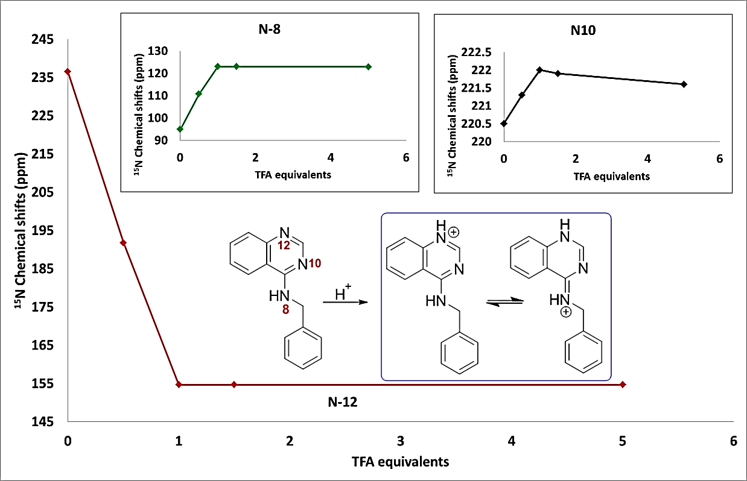

Figure 1: The plot of 15N chemical shifts of N-12 of SM07 vs titrated TFA-*d* equivalents, showing the mono-protonation of N-12 as evidenced by its large upfield chemical shifts change. Insets show the plots for the 15N chemical shifts of N-8 and N-10 of SM07 vs TFA-*d* equivalents (showing electronic effects due to protonation of N-12) and the protonation pathway and resonance structures for the protonated SM07.

## SM14 Results

Determining the protonation sites for SM14, which has pKA values of 2.58 and 5.30 (**Table** **1**), was more challenging due to multiple possible resonance structures in the mono- and di-protonated states. We noticed that water/methanol co-solvent exhibited strong solvent effects, which complicated the data interpretation for SM14. For instance, titration of SM14 in methanol/water (see SI) showed incomplete protonation of N-9 even after 5 equivalents of TFA-*d* were added. Thus the utilization of an aprotic solvent was necessary for unambiguous interpretation of the data.

Acetonitrile-*d*3 was selected as our solvent of choice. Titration of SM14 (5.5 mg) with up to 10 equivalents of TFA-*d* in acetonitrile-*d*3, provided a much clearer picture of its protonation states. N-9, with the large upfield chemical shift change ~ 72 ppm at 1 equivalent of TFA-*d*, clearly is the site of first protonation. At this point, the downfield chemical shift changes observed for N-7 (Δδ ≈ 6.5) and N-16 (Δδ ≈ 5) can be attributed to electronic effects rather than a direct protonation. The large upfield shift for N-9 indicates this to be the site of first protonation; complete protonation was attained at roughly 2.5 equivalents of TFA-*d*, suggesting that SM14 is a weak base under these experimental conditions. Following the protonation of N-9, a second protonation event occurs at N-16 nitrogen as evident by the upfield chemical shift change observed for N-16. However, a continuous change in the chemical shift of N-16 even after addition of 10 equivalents of TFA-*d* indicates that this protonation event is incomplete but provides evidence for N-16 being the second protonation site. This observation is consistent with N-16 being even a weaker base than N-9, which is expected of the aniline-type amines. Other notable observations are the slight downfield chemical shift changes for N-7 and N-9, during the second protonation event. This is attributed to electronic effects from the protonation of N-16.

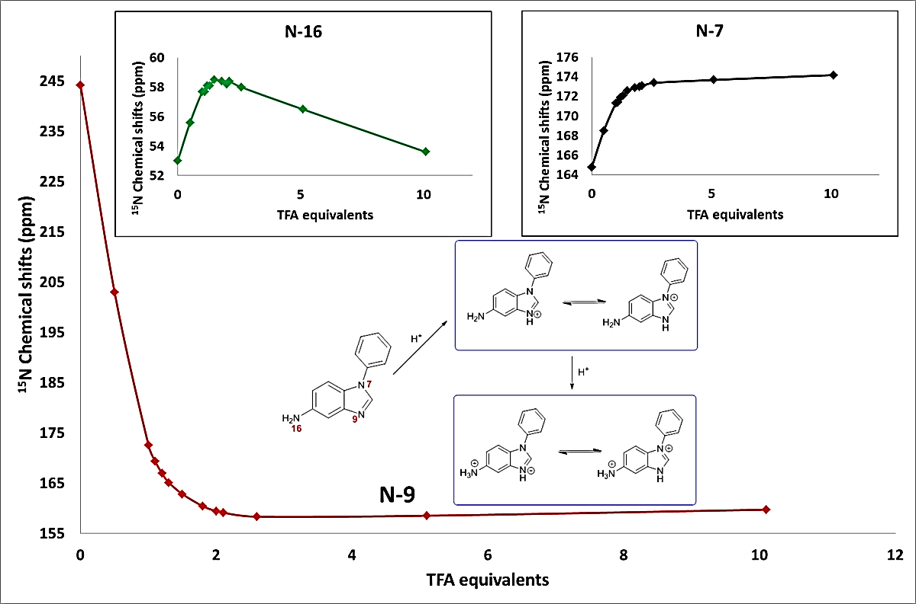

Figure 2: Plot of 15N chemical shifts for the N-9 nuclide of SM14 vs TFA-*d* additions of 0.0, 0.5, 1.0, 1.1, 1.2, 1.3, 1.5, 1.8, 2.0, 2.1, 2.6, 5.1 and 10.1 equivalents, showing the first protonation at N-9 – with a large upfield chemical shifts change of 71.6 ppm between 0 and 1 equivalents of TFA-*d*. Insets show plots of N-7 and N-16 showing the downfield chemical shift, between 0 and 2 equivalents of TFA-*d*, due to electronic effect from the protonation of N-9. N-16 also exhibited a small upfield chemical shift change of 4.4 ppm between 2.5 and 10 equivalents of TFA-*d*, which indicated this to be the second site of protonation. The protonation pathway and subsequent resonance structures for SM14 is shown inset.

## References

1. [Szakács](https://pubs.acs.org/author/Szak%C3%A1cs%2C+Zolt%C3%A1n), Z., [Béni](https://pubs.acs.org/author/B%C3%A9ni%2C+Szabolcs), S., [Varga](https://pubs.acs.org/author/Varga%2C+Zolt%C3%A1n), Z., [Örfi](https://pubs.acs.org/author/%C3%96rfi%2C+L%C3%A1szl%C3%B3), L., [Kéri](https://pubs.acs.org/author/K%C3%A9ri%2C+Gy%C3%B6rgy), G., [Noszál](https://pubs.acs.org/author/Nosz%C3%A1l%2C+B%C3%A9la), B., Acid−Base Profiling of Imatinib (Gleevec) and Its Fragments Journal of Medicinal Chemistry 2005 **48** (1), 249-255 DOI: 10.1021/jm049546c
2. Szakács, Z., Kraszni, M., Noszál, B., Determination of microscopic acid–base parameters from NMR–pH titrations Anal Bioanal Chem (2004) **378**: 1428. https://doi.org/10.1007/s00216-003-2390-3
3. Dozol, H., Blum-Held, C., Gue´dat, P., Maechling, C., Lanners, S., Schlewer, G., Spiess, B., Inframolecular acid–base studies of the tris and tetrakis myo-inositol phosphates including the 1,2,3-trisphosphate motif J. of Molecular Structure **643** (2002) 171–181
4. [Bezençon, J](https://www.ncbi.nlm.nih.gov/pubmed/?term=Bezen%C3%A7on%20J%5BAuthor%5D&cauthor=true&cauthor_uid=24462329)., [Wittwer, M. B](https://www.ncbi.nlm.nih.gov/pubmed/?term=Wittwer%20MB%5BAuthor%5D&cauthor=true&cauthor_uid=24462329)., [Cutting, B](https://www.ncbi.nlm.nih.gov/pubmed/?term=Cutting%20B%5BAuthor%5D&cauthor=true&cauthor_uid=24462329)., [Smieško, M](https://www.ncbi.nlm.nih.gov/pubmed/?term=Smie%C5%A1ko%20M%5BAuthor%5D&cauthor=true&cauthor_uid=24462329)., [Wagner, B](https://www.ncbi.nlm.nih.gov/pubmed/?term=Wagner%20B%5BAuthor%5D&cauthor=true&cauthor_uid=24462329)., [Kansy, M](https://www.ncbi.nlm.nih.gov/pubmed/?term=Kansy%20M%5BAuthor%5D&cauthor=true&cauthor_uid=24462329)., [Ernst, B](https://www.ncbi.nlm.nih.gov/pubmed/?term=Ernst%20B%5BAuthor%5D&cauthor=true&cauthor_uid=24462329)., pKa determination by ¹H NMR spectroscopy - an old methodology revisited [J. Pharm. Biomed. Anal.](https://www.ncbi.nlm.nih.gov/pubmed/24462329) (2014) **93**,147-55. doi: 10.1016/j.jpba.2013.12.014