**pKa measurements for the SAMPL6 prediction challenge for a set of kinase inhibitor-like fragments**

**Mehtap Işık1,2 , Dorothy Levorse3 , Ariën S. Rustenburg1,4 , Ikenna E. Ndukwe5 , Heather Wang6 , Xiao Wang5 , Mikhail Reibarkh5 , Gary E. Martin5 , Alexey A. Makarov6, David L. Mobley7 , Timothy Rhodes3 , John D. Chodera1*,6**

1 Computational and Systems Biology Program, Sloan Kettering Institute, Memorial Sloan Kettering Cancer Center, New York, NY 10065, United States

2 Tri-Institutional PhD Program in Chemical Biology, Weill Cornell Graduate School of Medical Sciences, Cornell University, New York, NY 10065, United States

3 Pharmaceutical Sciences, MRL, Merck & Co., Inc., 126 East Lincoln Avenue, Rahway, New Jersey 07065, United States

4 Graduate Program in Physiology, Biophysics, and Systems Biology, Weill Cornell Medical College, New York, NY 10065, United States

5 Process and Analytical Research and Development, Merck & Co., Inc., Rahway, NJ 07065, United States

6 Analytical Research and Development, Merck & Co., Inc., Rahway, NJ 07065, United States

7 Department of Pharmaceutical Sciences and Department of Chemistry, University of California, Irvine, Irvine, California 92697, United States

*For correspondence:

john.chodera@choderalab.org (JDC)

SUPPLEMENTARY INFORMATION

**Table SI 1.** Procurement details of SAMPL6 pKa challenge compounds

|  |  |  |  |  |  |  |  |  |  |
| --- | --- | --- | --- | --- | --- | --- | --- | --- | --- |
| **SAMPL6 Molecule ID** | **Group** | **Supplier** | **LOT** | **CAT** | **Supplier reported purity** | **CAS** | **eMolecules ID** | **canonical isomeric SMILES** | **Experimental Molecule ID** |
| SM01 | fragment-like | AchemBlock | 11549 | 10222 | 95% | 521937-07-05 | 6679830 | c1cc2c(cc1O)c3c(o2)C(=O)NCCC3 | M01 |
| SM02 | fragment-like | ChemDiv | CM02432403 | 3232-0333 |  |  | 1327907 | c1ccc2c(c1)c(ncn2)Nc3cccc(c3)C(F)(F)F | M02 |
| SM03 | fragment-like | ChemDiv |  | Z27474679 |  |  | 1228629 | c1ccc(cc1)Cc2nnc(s2)NC(=O)c3cccs3 | M03 |
| SM04 | fragment-like | ChemDiv |  | Z126957826 |  |  | 30719859 | c1ccc2c(c1)c(ncn2)NCc3ccc(cc3)Cl | M04 |
| SM05 | fragment-like | ChemDiv |  | Z119335440 |  |  | 18908671 | c1ccc(c(c1)NC(=O)c2ccc(o2)Cl)N3CCCCC3 | M05 |
| SM06 | fragment-like | ChemDiv |  | Z28487401 |  |  | 18893169 | c1cc2cccnc2c(c1)NC(=O)c3cc(cnc3)Br | M06 |
| SM07 | fragment-like | Enamine | 2017-0168841 | Z57161635 | 95% | 100818-54-0 | 1327878 | c1ccc(cc1)CNc2c3ccccc3ncn2 | M07 |
| SM08 | fragment-like | Enamine | 2017-0168838 | Z57157353 | 95% | 65418-08-8 | 1367649 | Cc1ccc2c(c1)c(c(c(=O)[nH]2)CC(=O)O)c3ccccc3 | M08 |
| SM09 | fragment-like | Enamine | 2017-0168839 | Z220564816 | 95% |  | 1865544 | COc1cccc(c1)Nc2c3ccccc3ncn2.Cl | M09 |
| SM10 | fragment-like | Enamine | 2017-0168843 | Z69130143 | 95% | 35056-22-5 | 23354217 | c1ccc(cc1)C(=O)NCC(=O)Nc2nc3ccccc3s2 | M10 |
| SM11 | fragment-like | Maybridge | 142989 | RJC00689SC | 90% | 5334-30-5 | 719540 | c1ccc(cc1)n2c3c(cn2)c(ncn3)N | M11 |
| SM12 | fragment-like | Maybridge | 265423 | DP00818SC |  |  | 1859493 | c1ccc2c(c1)c(ncn2)Nc3cccc(c3)Cl.Cl | M12 |
| SM13 | fragment-like | Maybridge | 248841 | GK03474SC |  |  | 5828805 | Cc1cccc(c1)Nc2c3cc(c(cc3ncn2)OC)OC | M13 |
| SM14 | fragment-like | Enamine |  | Z57290870 |  |  | 31653344 | c1ccc(cc1)n2cnc3c2ccc(c3)N | M15 |
| SM15 | fragment-like | Enamine |  | Z1318268952 |  |  | 37095168 | c1ccc2c(c1)ncn2c3ccc(cc3)O | M16 |
| SM16 | fragment-like | VitaScreen |  | STK098832 |  |  | 1284691 | c1cc(c(c(c1)Cl)C(=O)Nc2ccncc2)Cl | M18 |
| SM17 | fragment-like | VitaScreen |  | STK032731 |  |  | 1444229 | c1ccc(cc1)CSc2nnc(o2)c3ccncc3 | M19 |
| SM18 | drug-like | Enamine |  | Z278071350 |  |  | 18897105 | c1ccc2c(c1)c(=O)[nH]c(n2)CCC(=O)Nc3ncc(s3)Cc4ccc(c(c4)F)F | D01 |
| SM19 | drug-like | Enamine |  | Z30206127 |  |  | 3365457 | CCOc1ccc2c(c1)sc(n2)NC(=O)Cc3ccc(c(c3)Cl)Cl | D02 |
| SM20 | drug-like | VitaScreen |  | STL282831 |  |  | 46568819 | c1cc(cc(c1)OCc2ccc(cc2Cl)Cl)/C=C/3\C(=O)NC(=O)S3 | D05 |
| SM21 | drug-like | VitaScreen |  | STL368658 |  |  | 1574612 | c1cc(cc(c1)Br)Nc2c(cnc(n2)Nc3cccc(c3)Br)F | D06 |
| SM22 | drug-like | VitaScreen |  | STK070581 |  |  | 536848 | c1cc2c(cc(c(c2nc1)O)I)I | D07 |
| SM23 | drug-like | VitaScreen |  | STK097966 |  |  | 4375254 | CCOC(=O)c1ccc(cc1)Nc2cc(nc(n2)Nc3ccc(cc3)C(=O)OCC)C | D08 |
| SM24 | drug-like | VitaScreen |  | STK090644 |  |  | 1415746 | COc1ccc(cc1)c2c3c(ncnc3oc2c4ccc(cc4)OC)NCCO | D09 |

**Table SI 2.** Calculated properties and descriptors of compounds of 28 compounds selected and procured for pKa challenge. pKa measurement experiments were successful 24 molecules labeled SM01-SM24.

|  |  |  |  |  |  |  |  |  |  |  |
| --- | --- | --- | --- | --- | --- | --- | --- | --- | --- | --- |
| **SAMPL6 Molecule ID** | **Experimental Molecule ID** | **group** | **Epik pKas in [3,11] range** | **OpenEye XlogP** | **Molecular Weight (g/mol)** | **eMolecules reported availability (mg)** | **Number of rotatable bonds** | **Number of UV-chr. units** | **eMolecules ID** | **canonical isomeric SMILES** |
| SM01 | M01 | fragment-like | [9.119] | 3.27 | 289.26 | 184 | 0 | 27 | 6679830 | c1cc2c(cc1O)c3c(o2)C(=O)NCCC3 |
| SM02 | M02 | fragment-like | [4.05] | 3.61 | 301.39 | 101 | 3 | 36 | 1327907 | c1ccc2c(c1)c(ncn2)Nc3cccc(c3)C(F)(F)F |
| SM03 | M03 | fragment-like | [7.12] | 3.52 | 269.73 | 379 | 5 | 14 | 1228629 | c1ccc(cc1)Cc2nnc(s2)NC(=O)c3cccs3 |
| SM04 | M04 | fragment-like | [5.564] | 3.79 | 304.77 | 415.5 | 3 | 36 | 30719859 | c1ccc2c(c1)c(ncn2)NCc3ccc(cc3)Cl |
| SM05 | M05 | fragment-like | [5.346] | 2.92 | 328.16 | 424.3 | 4 | 18 | 18908671 | c1ccc(c(c1)NC(=O)c2ccc(o2)Cl)N3CCCCC3 |
| SM06 | M06 | fragment-like | [4.001, 10.328] | 2.91 | 235.28 | 406 | 3 | 37 | 18893169 | c1cc2cccnc2c(c1)NC(=O)c3cc(cnc3)Br |
| SM07 | M07 | fragment-like | [5.564] | 2.80 | 293.32 | 208.7 | 3 | 36 | 1327878 | c1ccc(cc1)CNc2c3ccccc3ncn2 |
| SM08 | M08 | fragment-like | [4.109] | 3.14 | 287.74 | 232.1 | 3 | 59 | 1367649 | Cc1ccc2c(c1)c(c(c(=O)[nH]2)CC(=O)O)c3ccccc3 |
| SM09 | M09 | fragment-like | [4.05] | 2.72 | 311.36 | 119.7 | 3 | 36 | 1865544 | COc1cccc(c1)Nc2c3ccccc3ncn2.Cl |
| SM10 | M10 | fragment-like | [8.672] | 1.50 | 211.22 | 149.1 | 6 | 28 | 23354217 | c1ccc(cc1)C(=O)NCC(=O)Nc2nc3ccccc3s2 |
| SM11 | M11 | fragment-like | [3.869] | 3.90 | 292.16 | 3430 | 1 | 31 | 719540 | c1ccc(cc1)n2c3c(cn2)c(ncn3)N |
| SM12 | M12 | fragment-like | [4.05] | 2.60 | 295.34 | 7366 | 2 | 36 | 1859493 | c1ccc2c(c1)c(ncn2)Nc3cccc(c3)Cl.Cl |
| SM13 | M13 | fragment-like | [4.267] | 2.91 | 235.28 | 1864 | 4 | 36 | 5828805 | Cc1cccc(c1)Nc2c3cc(c(cc3ncn2)OC)OC |
| - | M14 | fragment-like | [5.564] | 2.33 | 209.25 | 208.7 | 3 | 36 | 1327878 | c1ccc(cc1)CNc2c3ccccc3ncn2 |
| SM14 | M15 | fragment-like | [6.348] | 2.22 | 210.23 | 50213 | 1 | 40 | 31653344 | c1ccc(cc1)n2cnc3c2ccc(c3)N |
| SM15 | M16 | fragment-like | [5.82, 8.709] | 4.23 | 263.33 | 21650.2 | 1 | 40 | 37095168 | c1ccc2c(c1)ncn2c3ccc(cc3)O |
| - | M17 | fragment-like | [3.158] | 2.93 | 267.11 | 283.7 | 2 | 24 | 45809595 | CC(C)c1ccc(cc1)/C=C\2/c3ccccc3NC2=O |
| SM16 | M18 | fragment-like | [4.714, 9.847] | 3.31 | 269.32 | 385 | 3 | 20 | 1284691 | c1cc(c(c(c1)Cl)C(=O)Nc2ccncc2)Cl |
| SM17 | M19 | fragment-like | [4.902] | 3.34 | 426.44 | 170 | 4 | 30 | 1444229 | c1ccc(cc1)CSc2nnc(o2)c3ccncc3 |
| SM18 | D01 | drug-like | [9.381, 10.773] | 5.17 | 381.28 | 247.7 | 7 | 37 | 18897105 | c1ccc2c(c1)c(=O)[nH]c(n2)CCC(=O)Nc3ncc(s3)Cc4ccc(c(c4)F)F |
| SM19 | D02 | drug-like | [9.167] | 5.78 | 403.31 | 489.9 | 6 | 28 | 3365457 | CCOc1ccc2c(c1)sc(n2)NC(=O)Cc3ccc(c(c3)Cl)Cl |
| - | D03 | drug-like | [4.113] | 4.72 | 401.48 | 324.5 | 6 | 35 | 10794751 | CC(C)(C)c1cc(n(n1)c2ccccc2)NC(=O)Nc3cccc(c3Cl)Cl |
| - | D04 | drug-like | [3.199] | 5.24 | 380.25 | 636.9 | 5 | 34 | 3064762 | c1ccc(cc1)C(=O)Nc2ccc(cc2)Oc3c4c5c(sc4ncn3)CCCC5 |
| SM20 | D05 | drug-like | [8.05] | 4.14 | 438.09 | 154 | 4 | 24 | 46568819 | c1cc(cc(c1)OCc2ccc(cc2Cl)Cl)/C=C/3\C(=O)NC(=O)S3 |
| SM21 | D06 | drug-like | [3.892] | 3.37 | 396.95 | 222 | 4 | 28 | 1574612 | c1cc(cc(c1)Br)Nc2c(cnc(n2)Nc3cccc(c3)Br)F |
| SM22 | D07 | drug-like | [3.511, 6.794] | 2.94 | 420.46 | 239 | 0 | 29 | 536848 | c1cc2c(cc(c(c2nc1)O)I)I |
| SM23 | D08 | drug-like | [6.336] | 2.79 | 391.42 | 319 | 10 | 28 | 4375254 | CCOC(=O)c1ccc(cc1)Nc2cc(nc(n2)Nc3ccc(cc3)C(=O)OCC)C |
| SM24 | D09 | drug-like | [4.829] | 3.27 | 289.26 | 398 | 7 | 71 | 1415746 | COc1ccc(cc1)c2c3c(ncnc3oc2c4ccc(cc4)OC)NCCO |

**Table SI 3**. pKa results of replicate UV-metric pKa measurements. "UV-metric pKa" assay indicates spectrophotometric pKa measurements done with Sirius T3 in ISA water. "UV-metric pKa with cosolvent" assay refers to pKa determination by Yasuda-Shedlovsky extrapolation from psKa measurements in various ratios of ISA methanol:water mixtures. Triplicate measurements were performed at 25 ± 0.5°C and in the presence of approximately 150 mM KCl to adjust ionic strength.

|  |  |  |  |  |  |  |
| --- | --- | --- | --- | --- | --- | --- |
| **Molecule**  **ID** | **pKa1** | **pKa2** | **pKa3** | **Assay Type** | **Experiment ID** | **Experiment Report** |
| SM01 | 9.54 |  |  | UV-metric pKa | 17I-15024 | SM01_17I-15024_M01_UV-metric pKa_report.pdf |
| SM01 | 9.53 |  |  | UV-metric pKa | 17I-15025 | SM01_17I-15025_M01_UV-metric pKa_report.pdf |
| SM01 | 9.53 |  |  | UV-metric pKa | 17I-16001 | SM01_17I-16001_M01_UV-metric pKa_report.pdf |
| SM02 | 5.04 |  |  | UV-metric pKa with cosolvent | 17I-22022 | SM02_17I-22022_M02_UV-metric psKa_report.pdf |
| SM02 | 5.04 |  |  | UV-metric pKa with cosolvent | 17I-22023 | SM02_17I-22023_M02_UV-metric psKa_report.pdf |
| SM02 | 5.02 |  |  | UV-metric pKa with cosolvent | 17I-22024 | SM02_17I-22024_M02_UV-metric psKa_report.pdf |
| SM03 | 7.01 |  |  | UV-metric pKa with cosolvent | 17I-19004 | SM03_17I-19004_M03_UV-metric psKa_report.pdf |
| SM03 | 7.01 |  |  | UV-metric pKa with cosolvent | 17I-19005 | SM03_17I-19005_M03_UV-metric psKa_report.pdf |
| SM03 | 7.03 |  |  | UV-metric pKa with cosolvent | 17I-19006 | SM03_17I-19006_M03_UV-metric psKa_report.pdf |
| SM04 | 6.03 |  |  | UV-metric pKa | 17I-18018 | SM04_17I-18018_M04_UV-metric pKa_report.pdf |
| SM04 | 6.02 |  |  | UV-metric pKa | 17I-18019 | SM04_17I-18019_M04_UV-metric pKa_report.pdf |
| SM04 | 6.02 |  |  | UV-metric pKa | 17I-18020 | SM04_17I-18020_M04_UV-metric pKa_report.pdf |
| SM05 | 4.57 |  |  | UV-metric pKa with cosolvent | 17I-19007 | SM05_17I-19007_M05_UV-metric psKa_report.pdf |
| SM05 | 4.6 |  |  | UV-metric pKa with cosolvent | 17I-19008 | SM05_17I-19008_M05_UV-metric psKa_report.pdf |
| SM05 | 4.6 |  |  | UV-metric pKa with cosolvent | 17I-19009 | SM05_17I-19009_M05_UV-metric psKa_report.pdf |
| SM06 | 2.96 | 11.76 |  | UV-metric pKa | 17I-18021 | SM06_17I-18021_M06_UV-metric pKa_report.pdf |
| SM06 | 3.11 | 11.74 |  | UV-metric pKa | 17I-18022 | SM06_17I-18022_M06_UV-metric pKa_report.pdf |
| SM06 | 3.02 | 11.71 |  | UV-metric pKa | 17I-18023 | SM06_17I-18023_M06_UV-metric pKa_report.pdf |
| SM07 | 6.07 |  |  | UV-metric pKa | 17I-16002 | SM07_17I-16002_M07_UV-metric pKa_report.pdf |
| SM07 | 6.07 |  |  | UV-metric pKa | 17I-16004 | SM07_17I-16004_M07_UV-metric pKa_report.pdf |
| SM07 | 6.09 |  |  | UV-metric pKa | 17I-20001 | SM07_17I-20001_M07_UV-metric pKa_report.pdf |
| SM08 | 4.23 |  |  | UV-metric pKa | 17I-19001 | SM08_17I-19001_M08_UV-metric pKa_report.pdf |
| SM08 | 4.2 |  |  | UV-metric pKa | 17I-19002 | SM08_17I-19002_M08_UV-metric pKa_report.pdf |
| SM08 | 4.22 |  |  | UV-metric pKa | 17I-19003 | SM08_17I-19003_M08_UV-metric pKa_report.pdf |
| SM09 | 5.37 |  |  | UV-metric pKa with cosolvent | 17I-16014 | SM09_17I-16014_M09_UV-metric psKa_report.pdf |
| SM09 | 5.35 |  |  | UV-metric pKa with cosolvent | 17I-16015 | SM09_17I-16015_M09_UV-metric psKa_report.pdf |
| SM09 | 5.4 |  |  | UV-metric pKa with cosolvent | 17I-16016 | SM09_17I-16016_M09_UV-metric psKa_report.pdf |
| SM10 | 9.01 |  |  | UV-metric pKa with cosolvent | 17I-20020 | SM10_17I-20020_M10_UV-metric psKa_report.pdf |
| SM10 | 9.02 |  |  | UV-metric pKa with cosolvent | 17I-20021 | SM10_17I-20021_M10_UV-metric psKa_report.pdf |
| SM10 | 9.02 |  |  | UV-metric pKa with cosolvent | 17I-20022 | SM10_17I-20022_M10_UV-metric psKa_report.pdf |
| SM11 | 3.89 |  |  | UV-metric pKa | 17I-16005 | SM11_17I-16005_M11_UV-metric pKa_report.pdf |
| SM11 | 3.89 |  |  | UV-metric pKa | 17I-16006 | SM11_17I-16006_M11_UV-metric pKa_report.pdf |
| SM11 | 3.89 |  |  | UV-metric pKa | 17I-16007 | SM11_17I-16007_M11_UV-metric pKa_report.pdf |
| SM12 | 5.28 |  |  | UV-metric pKa | 17I-21002 | SM12_17I-21002_M12_UV-metric pKa_report.pdf |
| SM12 | 5.28 |  |  | UV-metric pKa | 17I-21003 | SM12_17I-21003_M12_UV-metric pKa_report.pdf |
| SM12 | 5.27 |  |  | UV-metric pKa | 17I-21004 | SM12_17I-21004_M12_UV-metric pKa_report.pdf |
| SM13 | 5.79 |  |  | UV-metric pKa | 17I-16011 | SM13_17I-16011_M13_UV-metric pKa_report.pdf |
| SM13 | 5.76 |  |  | UV-metric pKa | 17I-16012 | SM13_17I-16012_M13_UV-metric pKa_report.pdf |
| SM13 | 5.76 |  |  | UV-metric pKa | 17I-16013 | SM13_17I-16013_M13_UV-metric pKa_report.pdf |

**Table SI 3**. Continued.

|  |  |  |  |  |  |  |
| --- | --- | --- | --- | --- | --- | --- |
| Molecule ID | pKa1 | pKa2 | pKa3 | Assay Type | Experiment ID | Experiment Report |
| SM14 | 2.59 | 5.31 |  | UV-metric pKa | 17I-29002 | SM14_17I-29002_M15_UV-metric pKa_report.pdf |
| SM14 | 2.57 | 5.29 |  | UV-metric pKa | 17I-29003 | SM14_17I-29003_M15_UV-metric pKa_report.pdf |
| SM14 | 2.57 | 5.29 |  | UV-metric pKa | 17I-29004 | SM14_17I-29004_M15_UV-metric pKa_report.pdf |
| SM15 | 4.71 | 8.96 |  | UV-metric pKa | 17K-10009 | SM15_17K-10009_M16_UV-metric pKa_report.pdf |
| SM15 | 4.7 | 8.94 |  | UV-metric pKa | 17K-10010 | SM15_17K-10010_M16_UV-metric pKa_report.pdf |
| SM15 | 4.69 | 8.92 |  | UV-metric pKa | 17K-10011 | SM15_17K-10011_M16_UV-metric pKa_report.pdf |
| SM16 | 5.37 | 10.64 |  | UV-metric pKa | 17J-03025 | SM16_17J-03025_M18_UV-metric pKa_report.pdf |
| SM16 | 5.37 | 10.65 |  | UV-metric pKa | 17J-03026 | SM16_17J-03026_M18_UV-metric pKa_report.pdf |
| SM16 | 5.38 | 10.65 |  | UV-metric pKa | 17J-03027 | SM16_17J-03027_M18_UV-metric pKa_report.pdf |
| SM17 | 3.15 |  |  | UV-metric pKa | 17J-02024 | SM17_17J-02024_M19_UV-metric pKa_report.pdf |
| SM17 | 3.16 |  |  | UV-metric pKa | 17J-02025 | SM17_17J-02025_M19_UV-metric pKa_report.pdf |
| SM17 | 3.17 |  |  | UV-metric pKa | 17J-02026 | SM17_17J-02026_M19_UV-metric pKa_report.pdf |
| SM18 | 2.1 | 9.51 | 10.93 | UV-metric pKa with cosolvent | 17I-28001 | SM18_17I-28001_D01_UV-metric psKa_report.pdf |
| SM18 | 2.15 | 9.59 | 11.03 | UV-metric pKa with cosolvent | 17I-28002 | SM18_17I-28002_D01_UV-metric psKa_report.pdf |
| SM18 | 2.19 | 9.63 | 11.11 | UV-metric pKa with cosolvent | 17I-28003 | SM18_17I-28003_D01_UV-metric psKa_report.pdf |
| SM19 | 9.59 |  |  | UV-metric pKa with cosolvent | 17I-28004 | SM19_17I-28004_D02_UV-metric psKa_report.pdf |
| SM19 | 9.58 |  |  | UV-metric pKa with cosolvent | 17I-28005 | SM19_17I-28005_D02_UV-metric psKa_report.pdf |
| SM19 | 9.52 |  |  | UV-metric pKa with cosolvent | 17I-28006 | SM19_17I-28006_D02_UV-metric psKa_report.pdf |
| SM20 | 5.72 |  |  | UV-metric pKa with cosolvent | 17J-12002 | SM20_17J-12002_D05_UV-metric psKa_report.pdf |
| SM20 | 5.75 |  |  | UV-metric pKa with cosolvent | 17J-12003 | SM20_17J-12003_D05_UV-metric psKa_report.pdf |
| SM20 | 5.64 |  |  | UV-metric pKa with cosolvent | 17K-16013 | SM20_17K-16013_D05_UV-metric psKa_report.pdf |
| SM21 | 4.11 |  |  | UV-metric pKa with cosolvent | 17J-06002 | SM21_17J-06002_D06_UV-metric psKa_report.pdf |
| SM21 | 4.09 |  |  | UV-metric pKa with cosolvent | 17J-06003 | SM21_17J-06003_D06_UV-metric psKa_report.pdf |
| SM21 | 4.09 |  |  | UV-metric pKa with cosolvent | 17J-06004 | SM21_17J-06004_D06_UV-metric psKa_report.pdf |
| SM22 | 2.45 | 7.42 |  | UV-metric pKa with cosolvent | 17J-07003 | SM22_17J-07003_D07_UV-metric psKa_report.pdf |
| SM22 | 2.37 | 7.45 |  | UV-metric pKa with cosolvent | 17J-07004 | SM22_17J-07004_D07_UV-metric psKa_report.pdf |
| SM22 | 2.37 | 7.41 |  | UV-metric pKa with cosolvent | 17J-07005 | SM22_17J-07005_D07_UV-metric psKa_report.pdf |
| SM23 | 5.45 |  |  | UV-metric pKa with cosolvent | 17J-07006 | SM23_17J-07006_D08_UV-metric psKa_report.pdf |
| SM23 | 5.44 |  |  | UV-metric pKa with cosolvent | 17J-07007 | SM23_17J-07007_D08_UV-metric psKa_report.pdf |
| SM23 | 5.45 |  |  | UV-metric pKa with cosolvent | 17J-07008 | SM23_17J-07008_D08_UV-metric psKa_report.pdf |
| SM24 | 2.61 |  |  | UV-metric pKa with cosolvent | 17J-06007 | SM24_17J-06007_D09_UV-metric psKa_report.pdf |
| SM24 | 2.58 |  |  | UV-metric pKa with cosolvent | 17J-06008 | SM24_17J-06008_D09_UV-metric psKa_report.pdf |
| SM24 | 2.6 |  |  | UV-metric pKa with cosolvent | 17J-06009 | SM24_17J-06009_D09_UV-metric psKa_report.pdf |

**Table SI 4**. UV-metric pKa measurements with and without cosolvent for 12 pKa challenge compounds with higher aqueous solubility and pyridoxine HCl. pKa values were measured with both methods to test if cosolvent method introduces bias.

|  |  |  |  |  |  |  |
| --- | --- | --- | --- | --- | --- | --- |
| **Molecule ID** | **pKa1** | **pKa2** | **pKa3** | **Assay Type** | **Experiment ID** | **Experiment Report** |
| SM01 | 9.54 |  |  | UV-metric pKa | 17I-15024 | SM01_17I-15024_M01_UV-metric pKa_report.pdf |
| SM01 | 9.53 |  |  | UV-metric pKa | 17I-15025 | SM01_17I-15025_M01_UV-metric pKa_report.pdf |
| SM01 | 9.53 |  |  | UV-metric pKa | 17I-16001 | SM01_17I-16001_M01_UV-metric pKa_report.pdf |
| SM01* | 9.71 |  |  | UV-metric pKa with cosolvent | 17J-06011 | SM01_17J-06011_M01_UV-metric psKa_report.pdf |
| SM04 | 6.03 |  |  | UV-metric pKa | 17I-18018 | SM04_17I-18018_M04_UV-metric pKa_report.pdf |
| SM04 | 6.02 |  |  | UV-metric pKa | 17I-18019 | SM04_17I-18019_M04_UV-metric pKa_report.pdf |
| SM04 | 6.02 |  |  | UV-metric pKa | 17I-18020 | SM04_17I-18020_M04_UV-metric pKa_report.pdf |
| SM04* | 5.97 |  |  | UV-metric pKa with cosolvent | 17K-09020 | SM04_17K-09020_M04_UV-metric psKa_report.pdf |
| SM06 | 2.96 | 11.76 |  | UV-metric pKa | 17I-18021 | SM06_17I-18021_M06_UV-metric pKa_report.pdf |
| SM06 | 3.11 | 11.74 |  | UV-metric pKa | 17I-18022 | SM06_17I-18022_M06_UV-metric pKa_report.pdf |
| SM06 | 3.02 | 11.71 |  | UV-metric pKa | 17I-18023 | SM06_17I-18023_M06_UV-metric pKa_report.pdf |
| SM06* | 3.46 | >12 |  | UV-metric pKa with cosolvent | 17K-09021 | SM06_17K-09021_M06_UV-metric psKa_report.pdf |
| SM06* | 3.4 | >12 |  | UV-metric pKa with cosolvent | 17K-10008 | SM06_17K-10008_M06_UV-metric psKa_report.pdf |
| SM06* | 3.45 | >12 |  | UV-metric pKa with cosolvent | 17K-16011 | SM06_17K-16011_M06_UV-metric psKa_report.pdf |
| SM07 | 6.07 |  |  | UV-metric pKa | 17I-16002 | SM07_17I-16002_M07_UV-metric pKa_report.pdf |
| SM07 | 6.07 |  |  | UV-metric pKa | 17I-16004 | SM07_17I-16004_M07_UV-metric pKa_report.pdf |
| SM07 | 6.09 |  |  | UV-metric pKa | 17I-20001 | SM07_17I-20001_M07_UV-metric pKa_report.pdf |
| SM07* | 5.96 |  |  | UV-metric pKa with cosolvent | 17J-12006 | SM07_17J-12006_M07_UV-metric psKa_report.pdf |
| SM08 | 4.23 |  |  | UV-metric pKa | 17I-19001 | SM08_17I-19001_M08_UV-metric pKa_report.pdf |
| SM08 | 4.2 |  |  | UV-metric pKa | 17I-19002 | SM08_17I-19002_M08_UV-metric pKa_report.pdf |
| SM08 | 4.22 |  |  | UV-metric pKa | 17I-19003 | SM08_17I-19003_M08_UV-metric pKa_report.pdf |
| SM08* | 4.47 |  |  | UV-metric pKa with cosolvent | 17J-12007 | SM08_17J-12007_M08_UV-metric psKa_report.pdf |
| SM11 | 3.89 |  |  | UV-metric pKa | 17I-16005 | SM11_17I-16005_M11_UV-metric pKa_report.pdf |
| SM11 | 3.89 |  |  | UV-metric pKa | 17I-16006 | SM11_17I-16006_M11_UV-metric pKa_report.pdf |
| SM11 | 3.89 |  |  | UV-metric pKa | 17I-16007 | SM11_17I-16007_M11_UV-metric pKa_report.pdf |
| SM11* | 3.74 |  |  | UV-metric pKa with cosolvent | 17J-04003 | SM11_17J-04003_M11_UV-metric psKa_report.pdf |
| SM12 | 5.28 |  |  | UV-metric pKa | 17I-21002 | SM12_17I-21002_M12_UV-metric pKa_report.pdf |
| SM12 | 5.28 |  |  | UV-metric pKa | 17I-21003 | SM12_17I-21003_M12_UV-metric pKa_report.pdf |
| SM12 | 5.27 |  |  | UV-metric pKa | 17I-21004 | SM12_17I-21004_M12_UV-metric pKa_report.pdf |
| SM12* | 5.16 |  |  | UV-metric pKa with cosolvent | 17J-11014 | SM12_17J-11014_M12_UV-metric psKa_report.pdf |
| SM13 | 5.79 |  |  | UV-metric pKa | 17I-16011 | SM13_17I-16011_M13_UV-metric pKa_report.pdf |
| SM13 | 5.76 |  |  | UV-metric pKa | 17I-16012 | SM13_17I-16012_M13_UV-metric pKa_report.pdf |
| SM13 | 5.76 |  |  | UV-metric pKa | 17I-16013 | SM13_17I-16013_M13_UV-metric pKa_report.pdf |
| SM13* | 5.68 |  |  | UV-metric pKa with cosolvent | 17J-04005 | SM13_17J-04005_M13_UV-metric psKa_report.pdf |
| SM14 | 2.59 | 5.31 |  | UV-metric pKa | 17I-29002 | SM14_17I-29002_M15_UV-metric pKa_report.pdf |
| SM14 | 2.57 | 5.29 |  | UV-metric pKa | 17I-29003 | SM14_17I-29003_M15_UV-metric pKa_report.pdf |
| SM14 | 2.57 | 5.29 |  | UV-metric pKa | 17I-29004 | SM14_17I-29004_M15_UV-metric pKa_report.pdf |
| SM14* | 2.56 | 5.29 |  | UV-metric pKa with cosolvent | 17J-12008 | SM14_17J-12008_M15_UV-metric psKa_report.pdf |

* These UV-metric pKa measurement with cosolvent were not used in the calculation of pKa mean and SEM in the experimental data reported for

SAMPL6 pKa challenge because replicate water based experiments also existed for these molecules.

**Table SI 4**. Continued.

|  |  |  |  |  |  |  |
| --- | --- | --- | --- | --- | --- | --- |
| **Molecule ID** | **pKa1** | **pKa2** | **pKa3** | **Assay Type** | **Experiment ID** | **Experiment Report** |
| SM15 | 4.71 | 8.96 |  | UV-metric pKa | 17K-10009 | SM15_17K-10009_M16_UV-metric pKa_report.pdf |
| SM15 | 4.7 | 8.94 |  | UV-metric pKa | 17K-10010 | SM15_17K-10010_M16_UV-metric pKa_report.pdf |
| SM15 | 4.69 | 8.92 |  | UV-metric pKa | 17K-10011 | SM15_17K-10011_M16_UV-metric pKa_report.pdf |
| SM15* | 4.67 | 9.01 |  | UV-metric pKa with cosolvent | 17J-12009 | SM15_17J-12009_M16_UV-metric psKa_report.pdf |
| SM16 | 5.37 | 10.64 |  | UV-metric pKa | 17J-03025 | SM16_17J-03025_M18_UV-metric pKa_report.pdf |
| SM16 | 5.37 | 10.65 |  | UV-metric pKa | 17J-03026 | SM16_17J-03026_M18_UV-metric pKa_report.pdf |
| SM16 | 5.38 | 10.65 |  | UV-metric pKa | 17J-03027 | SM16_17J-03027_M18_UV-metric pKa_report.pdf |
| SM16* | 5.35 | 11.01 |  | UV-metric pKa with cosolvent | 17J-12010 | SM16_17J-12010_M18_UV-metric psKa_report.pdf |
| SM17 | 3.15 |  |  | UV-metric pKa | 17J-02024 | SM17_17J-02024_M19_UV-metric pKa_report.pdf |
| SM17 | 3.16 |  |  | UV-metric pKa | 17J-02025 | SM17_17J-02025_M19_UV-metric pKa_report.pdf |
| SM17 | 3.17 |  |  | UV-metric pKa | 17J-02026 | SM17_17J-02026_M19_UV-metric pKa_report.pdf |
| SM17* | 3.2 |  |  | UV-metric pKa with cosolvent | 17J-12011 | SM17_17J-12011_M19_UV-metric psKa_report.pdf |
| Pyridoxine HCl | 4.81 | 8.85 |  | UV-metric pKa | 18E-22003 | 18E-22003_Pyridoxine HCl_UV-metric pKa_0417936-0002.pdf |
| Pyridoxine HCl | 4.83 | 8.87 |  | UV-metric pKa | 18E-22004 | 18E-22004_Pyridoxine HCl_UV-metric pKa_0417936-0002.pdf |
| Pyridoxine HCl | 4.84 | 8.86 |  | UV-metric pKa | 18E-22010 | 18E-22010_Pyridoxine HCl_UV-metric pKa_0417936-0002.pdf |
| Pyridoxine HCl | 4.85 | 8.79 |  | UV-metric pKa with cosolvent | 18E-22011 | 18E-22011_Pyridoxine HCl_UV-metric psKa_0417936-0002.pdf |
| Pyridoxine HCl | 4.85 | 8.79 |  | UV-metric pKa with cosolvent | 18E-22012 | 18E-22012_Pyridoxine HCl_UV-metric psKa_0417936-0002.pdf |
| Pyridoxine HCl | 4.86 | 8.77 |  | UV-metric pKa with cosolvent | 18E-22013 | 18E-22013_Pyridoxine HCl_UV-metric psKa_0417936-0002.pdf |

* These UV-metric pKa measurement with cosolvent were not used in the calculation of pKa mean and SEM in the experimental data reported for SAMPL6 pKa challenge because replicate water based experiments also existed for these molecules.

**Table SI 5.** pKa mean and SEM results of with (cosolvent) and without cosolvent (water) replicate experiment. pKa values without SEM reported were measured with 1 replicate. pKa values reported with SEM were measured in triplicates.

|  |  |  |  |  |  |
| --- | --- | --- | --- | --- | --- |
| **Molecule ID** | **pKa ID** | **pKa mean water** | **pKa SEM water** | **pKa mean cosolvent** | **pKa SEM cosolvent** |
| SM01 | SM01_pKa1 | 9.53 | 0.01 | 9.71 |  |
| SM04 | SM04_pKa1 | 6.02 | 0.01 | 5.97 |  |
| SM06 | SM06_pKa1 | 3.03 | 0.04 | 3.44 | 0.02 |
| SM07 | SM07_pKa1 | 6.08 | 0.01 | 5.96 |  |
| SM08 | SM08_pKa1 | 4.22 | 0.01 | 4.47 |  |
| SM11 | SM11_pKa1 | 3.89 | 0.01 | 3.74 |  |
| SM12 | SM12_pKa1 | 5.28 | 0.01 | 5.16 |  |
| SM13 | SM13_pKa1 | 5.77 | 0.01 | 5.68 |  |
| SM14 | SM14_pKa1 | 2.58 | 0.01 | 2.56 |  |
| SM14 | SM14_pKa2 | 5.3 | 0.01 | 5.29 |  |
| SM15 | SM15_pKa1 | 4.7 | 0.01 | 4.67 |  |
| SM15 | SM15_pKa2 | 8.94 | 0.01 | 9.01 |  |
| SM16 | SM16_pKa1 | 5.37 | 0.01 | 5.35 |  |
| SM16 | SM16_pKa2 | 10.65 | 0.01 | 11.01 |  |
| SM17 | SM17_pKa1 | 3.16 | 0.01 | 3.2 |  |
| Pyridoxine HCl | Pyridoxine HCl_pKa1 | 4.83 | 0.01 | 4.85 | 0.01 |
| Pyridoxine HCl | Pyridoxine HCl_pKa2 | 8.86 | 0.01 | 8.78 | 0.01 |

**Table SI 6.** Summary of LC-MS purity results of SAMPL6 pKa challenge compounds. LC-MS purity was calculated as percentage of area under the curve relative to all the peaks observed.

|  |  |  |  |  |  |  |
| --- | --- | --- | --- | --- | --- | --- |
| **SAMPL6 molecule ID** | **Supplier reported purity (%)** | **LC-MS purity (Area%)** | **Supplier reported molecular weight (g/mol)** | **eMolecules reported molecular weight (g/mol)** | **LC/MS molecular weight (g/mol)** | **eMolecules ID** |
| SM01 | 95 | 98.516 | 217.23 | 217.221 | 217.221 | 6679830 |
| SM02 |  | 97.62 |  | 289.255 | 289.255 | 1327907 |
| SM03 |  | 90.798 |  | 301.387 | 301.387 | 1228629 |
| SM04 |  | 99.884 |  | 269.729 | 269.729 | 30719859 |
| SM05 |  | 98.749 |  | 304.771 | 304.771 | 18908671 |
| SM06 |  | 98.913 |  | 328.163 | 328.163 | 18893169 |
| SM07 | 95 | 99.384 | 235.284 | 235.284 | 235.284 | 1327878 |
| SM08 | 95 | 99.242 | 293.317 | 293.317 | 293.317 | 1367649 |
| SM09 | 95 | 98.969 | 287.744 | 287.744 | 287.744 | 1865544 |
| SM10 | 95 | 96.98 | 311.357 | 311.358 | 311.358 | 23354217 |
| SM11 | 90 | 98.022 |  | 211.223 | 211.233 | 719540 |
| SM12 |  | 98.134 |  | 292.163 | 292.163 | 1859493 |
| SM13 |  | 97.512 |  | 295.336 | 295.336 | 5828805 |
| SM14 |  | 96.484 |  | 209.247 | 209.247 | 31653344 |
| SM15 |  | 98.698 |  | 210.231 | 210.231 | 37095168 |
| SM16 |  | 97.733 | 267.114 | 267.111 | 267.111 | 1284691 |
| SM17 |  | 96.994 |  | 269.322 | 269.322 | 1444229 |
| SM18 |  | 92.601 |  | 426.439 | 426.439 | 18897105 |
| SM19 |  | 94.464 |  | 381.276 | 381.276 | 3365457 |
| SM20 |  | 97.176 | 380.25 | 380.245 | 380.245 | 46568819 |
| SM21 |  | 96.791 | 438.1 | 438.092 | 438.092 | 1574612 |
| SM22 |  | 86.975 | 396.95 | 396.951 | 396.951 | 536848 |
| SM23 |  | 96.011 | 420.47 | 420.461 | 420.461 | 4375254 |
| SM24 |  | 99.331 | 391.43 | 391.42 | 391.42 | 1415746 |

**A**

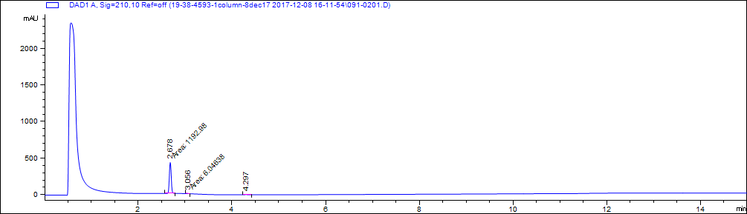

|  |  |  |  |
| --- | --- | --- | --- |
| # | Retention time (minutes) | Area | Area% |
| 1 | 2.7 | 1193 | 98.5 |
| 2 | 3.1 | 6 | 0.5 |
| 3 | 4.3 | 11.9 | 1.0 |

**B**



M+1

2M+Na

**Figure SI 1.** LC-MS chromatogram and mass spectrum for SM01. Molecular weight is 217.221 g/mol. (A) LC chromatogram and table of peak properties. %Area describes relative area under the curve of selected peaks and interpreted as an estimate of purity. (B)Mass spectrum

**A**

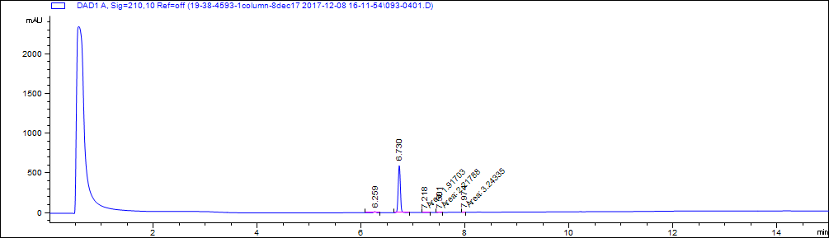

|  |  |  |  |
| --- | --- | --- | --- |
| # | Retention time (minutes) | Area | Area% |
| 1 | 6.3 | 34.9 | 2.0 |
| 2 | 6.7 | 1733.8 | 97.6 |
| 3 | 7.2 | 1.9 | 0.1 |
| 4 | 7.5 | 2.2 | 0.1 |
| 5 | 8.0 | 3.2 | 0.2 |

**B**

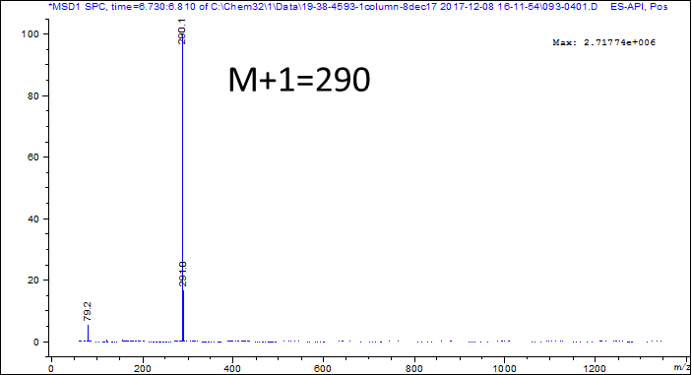

**Figure SI 2.** LC-MS chromatogram and mass spectrum for SM02. Molecular weight is 289.255 g/mol. (A) LC chromatogram and table of peak properties. %Area describes relative area under the curve of selected peaks and interpreted as an estimate of purity. (B) Mass spectrum

**A**

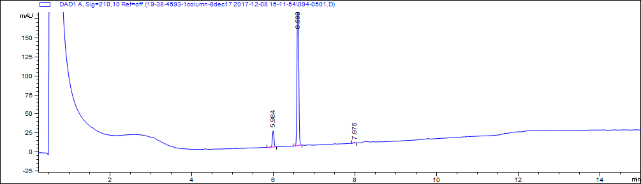

|  |  |  |  |
| --- | --- | --- | --- |
| # | Retention time (minutes) | Area | Area% |
| 1 | 6.0 | 58.2 | 8.7 |
| 2 | 6.6 | 606.7 | 90.8 |
| 3 | 8.0 | 3.3 | 0.5 |

**B**

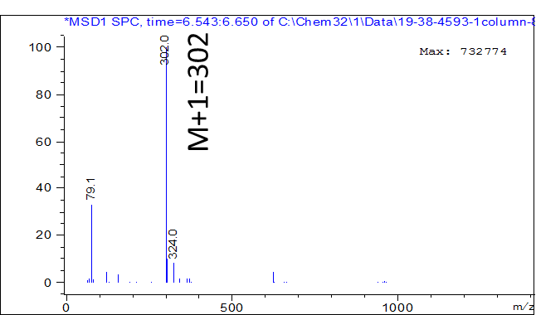

**Figure SI 3.** LC-MS chromatogram and mass spectrum for SM03. Molecular weight is 301.387 g/mol. (A) LC chromatogram and table of peak properties. %Area describes relative area under the curve of selected peaks and interpreted as an estimate of purity. (B) Mass spectrum

**A**

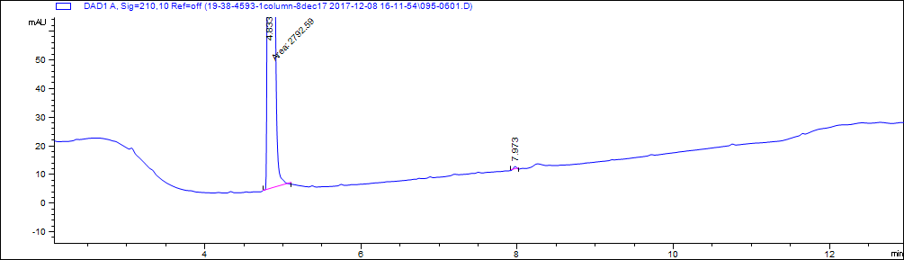

|  |  |  |  |
| --- | --- | --- | --- |
| # | Retention time (minutes) | Area | Area% |
| 1 | 4.8 | 2792.6 | 99.9 |
| 2 | 8.0 | 3.2 | 0.1 |

**B**

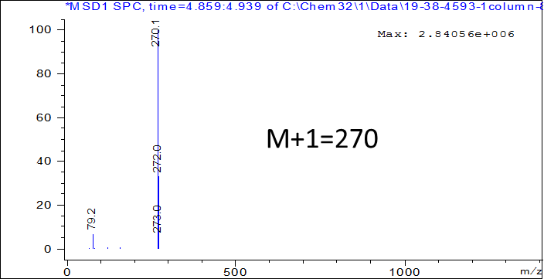

**Figure SI 4.** LC-MS chromatogram and mass spectrum for SM04. Molecular weight is 269.729 g/mol. (A) LC chromatogram and table of peak properties. %Area describes relative area under the curve of selected peaks and interpreted as an estimate of purity. (B) Mass spectrum

**A**

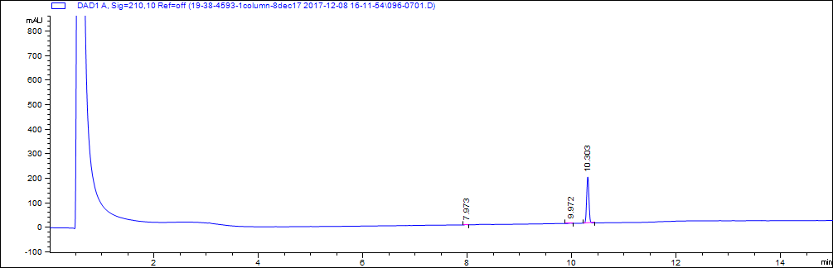

|  |  |  |  |
| --- | --- | --- | --- |
| # | Retention time (minutes) | Area | Area% |
| 1 | 8.0 | 3.3 | 0.6 |
| 2 | 10.0 | 4 | 0.7 |
| 3 | 10.3 | 569.7 | 98.7 |

**B**

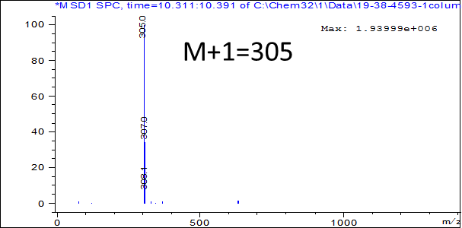

**Figure SI 5.** LC-MS chromatogram and mass spectrum for SM05. Molecular weight is 304.771 g/mol. (A) LC chromatogram and table of peak properties. %Area describes relative area under the curve of selected peaks and interpreted as an estimate of purity. (B) Mass spectrum

**A**

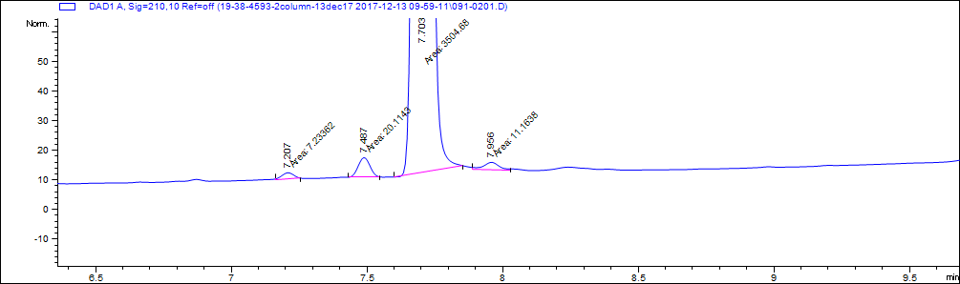

|  |  |  |  |
| --- | --- | --- | --- |
| # | Retention time (minutes) | Area | Area% |
| 1 | 7.2 | 7.2 | 0.2 |
| 2 | 7.5 | 20.1 | 0.6 |
| 3 | 7.7 | 3504.7 | 98.9 |
| 4 | 8.0 | 11.2 | 0.3 |

**B**

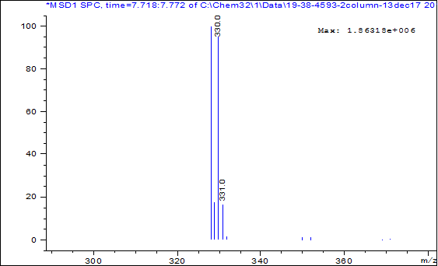

M/Z=328 and 330

**Figure SI 6.** LC-MS chromatogram and mass spectrum for SM06. Molecular weight is 328.163 g/mol. (A) LC chromatogram and table of peak properties. %Area describes relative area under the curve of selected peaks and interpreted as an estimate of purity. (B) Mass spectrum

**A**

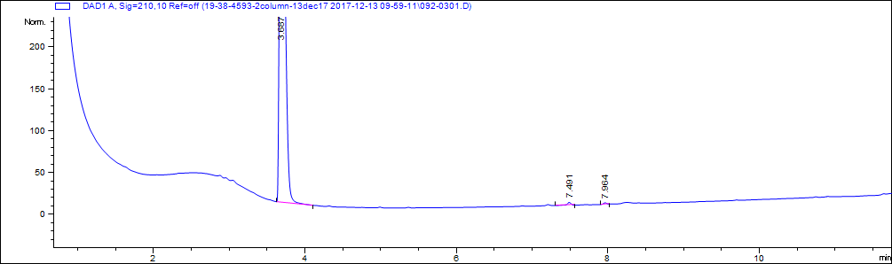

|  |  |  |  |
| --- | --- | --- | --- |
| # | Retention time (minutes) | Area | Area% |
| 1 | 3.7 | 2822.4 | 99.4 |
| 2 | 7.5 | 11.3 | 0.4 |
| 3 | 8.0 | 6.2 | 0.2 |

**B**



M+1=236

**Figure SI 7.** LC-MS chromatogram and mass spectrum for SM07. Molecular weight is 235.284 g/mol. (A) LC chromatogram and table of peak properties. %Area describes relative area under the curve of selected peaks and interpreted as an estimate of purity. (B) Mass spectrum

**A**

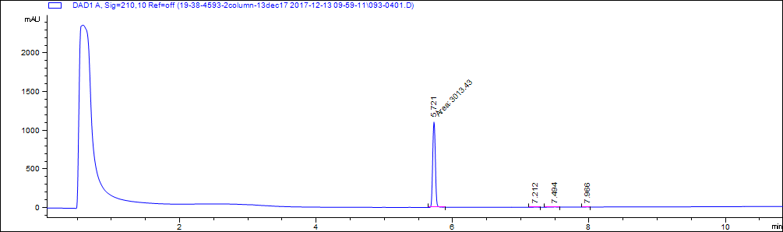

|  |  |  |  |
| --- | --- | --- | --- |
| # | Retention time (minutes) | Area | Area% |
| 1 | 5.7 | 3013.4 | 99.2 |
| 2 | 7.2 | 5 | 0.2 |
| 3 | 7.5 | 11.1 | 0.4 |
| 4 | 8.0 | 6.9 | 0.2 |

**B**

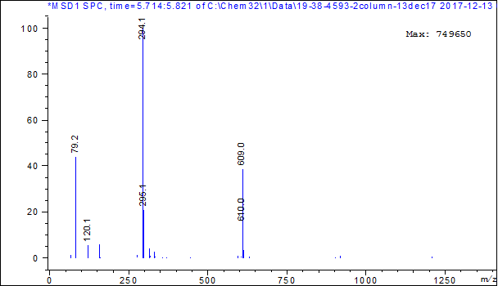

M+1=294

**Figure SI 8.** LC-MS chromatogram and mass spectrum for SM08. Molecular weight estimated from mass spectrometry is 293.317 g/mol. (A) LC chromatogram and table of peak properties. %Area describes relative area under the curve of selected peaks and interpreted as an estimate of purity. (B) Mass spectrum

**A**

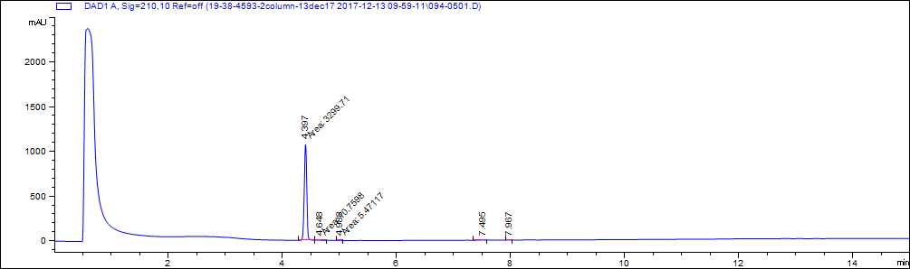

|  |  |  |  |
| --- | --- | --- | --- |
| # | Retention time (minutes) | Area | Area% |
| 1 | 4.4 | 3299.7 | 99.0 |
| 2 | 4.6 | 10.8 | 0.3 |
| 3 | 5.0 | 5.5 | 0.2 |
| 4 | 7.5 | 12.6 | 0.4 |
| 5 | 8.0 | 5.7 | 0.2 |

**B**

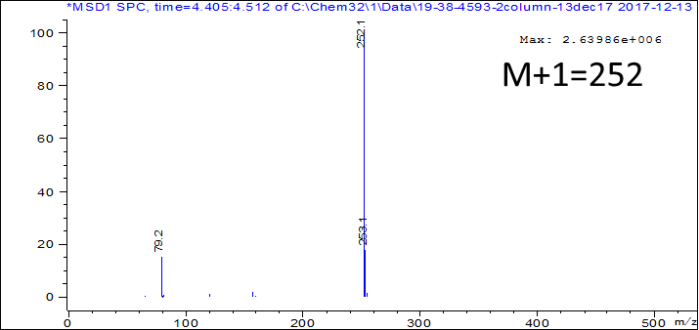

**Figure SI 9.** LC-MS chromatogram and mass spectrum for SM09. Molecular weight estimated from mass spectrometry is 287.744 g/mol (m/z = 251.244). (A) LC chromatogram and table of peak properties. %Area describes relative area under the curve of selected peaks and interpreted as an estimate of purity. (B) Mass spectrum

**A**

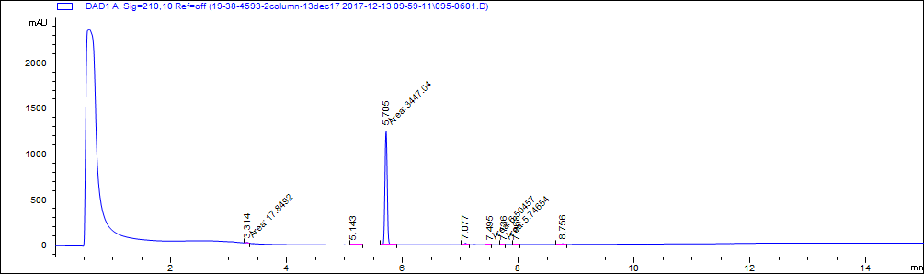

|  |  |  |  |
| --- | --- | --- | --- |
| # | Retention time (minutes) | Area | Area% |
| 2 | 5.1 | 5.2 | 0.1 |
| 3 | 5.7 | 3447 | 97.0 |
| 4 | 7.1 | 43.7 | 1.2 |
| 5 | 7.5 | 6.5 | 0.2 |
| 6 | 7.7 | 5.7 | 0.2 |
| 7 | 8.0 | 6.8 | 0.2 |
| 8 | 8.8 | 21.5 | 0.6 |

**B**



M+1=312

**Figure SI 10.** LC-MS chromatogram and mass spectrum for SM10. Molecular weight is 311.358 g/mol. (A) LC chromatogram and table of peak properties. %Area describes relative area under the curve of selected peaks and interpreted as an estimate of purity. (B) Mass spectrum

**A**

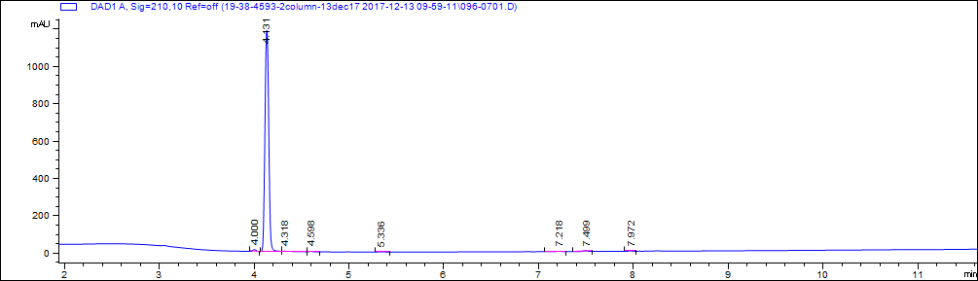

|  |  |  |  |
| --- | --- | --- | --- |
| # | Retention time (minutes) | Area | Area% |
| 1 | 4 | 25.1 | 0.8 |
| 2 | 4.1 | 3281.8 | 98.0 |
| 3 | 4.6 | 5.6 | 0.2 |
| 4 | 5.3 | 6.5 | 0.2 |
| 5 | 7.2 | 7.1 | 0.2 |
| 6 | 7.5 | 15.2 | 0.5 |
| 7 | 8.0 | 6.8 | 0.2 |

**B**



M+1=212

**Figure SI 11.** LC-MS chromatogram and mass spectrum for SM11. Molecular weight is 211.233 g/mol. (A) LC chromatogram and table of peak properties. %Area describes relative area under the curve of selected peaks and interpreted as an estimate of purity. (B) Mass spectrum

**A**

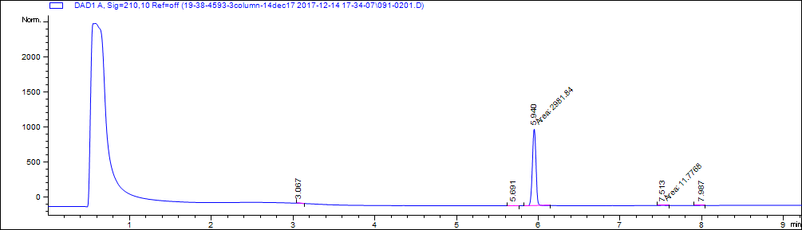

|  |  |  |  |
| --- | --- | --- | --- |
| # | Retention time (minutes) | Area | Area% |
| 1 | 3.1 | 5.1 | 0.2 |
| 2 | 5.7 | 7.3 | 0.2 |
| 3 | 5.9 | 2981.8 | 98.1 |
| 4 | 7.5 | 11.8 | 0.4 |
| 5 | 8.0 | 6.7 | 0.2 |
| 6 | 12.3 | 25.7 | 0.8 |

**B**



M-1=254

M+1=256

**Figure SI 12.** LC-MS chromatogram and mass spectrum for SM12. Molecular weight is 292.163 g/mol (m/z = 255). (A) LC chromatogram and table of peak properties. %Area describes relative area under the curve of selected peaks and interpreted as an estimate of purity. (B) Mass spectrum

**A**

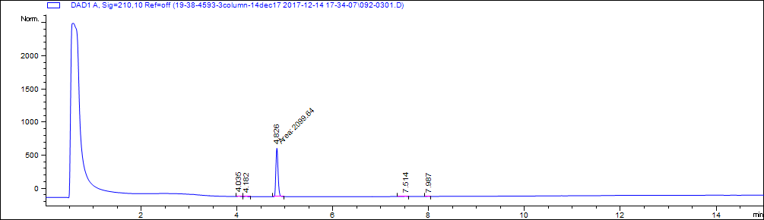

|  |  |  |  |
| --- | --- | --- | --- |
| # | Retention time (minutes) | Area | Area% |
| 1 | 4.0 | 18.1 | 0.8 |
| 2 | 4.2 | 15.4 | 0.7 |
| 3 | 4.8 | 2099.6 | 97.5 |
| 4 | 7.5 | 13.5 | 0.6 |
| 5 | 8.0 | 6.5 | 0.3 |

**B**



M+1=296

**Figure SI 13.** LC-MS chromatogram and mass spectrum for SM13. Molecular weight is 295.336 g/mol. (A) LC chromatogram and table of peak properties. %Area describes relative area under the curve of selected peaks and interpreted as an estimate of purity. (B) Mass spectrum

**A**

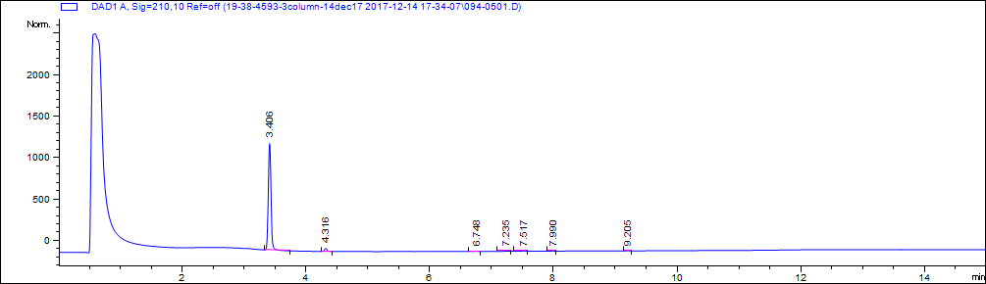

|  |  |  |  |
| --- | --- | --- | --- |
| # | Retention time (minutes) | Area | Area% |
| 1 | 3.4 | 3561.5 | 96.5 |
| 2 | 4.3 | 90.1 | 2.4 |
| 3 | 6.7 | 7.5 | 0.2 |
| 4 | 7.2 | 5.9 | 0.2 |
| 5 | 7.5 | 14.3 | 0.4 |
| 6 | 8.0 | 6.6 | 0.2 |
| 7 | 9.2 | 5.3 | 0.1 |

**B**



M+1=210

**Figure SI 14.** LC-MS chromatogram and mass spectrum for SM14. Molecular weight is 209.247 g/mol. (A) LC chromatogram and table of peak properties. %Area describes relative area under the curve of selected peaks and interpreted as an estimate of purity. (B) Mass spectrum

**A**



|  |  |  |  |
| --- | --- | --- | --- |
| # | Retention time (minutes) | Area | Area% |
| 1 | 4.4 | 2822.7 | 98.7 |
| 2 | 5.5 | 15.6 | 0.5 |
| 3 | 5.8 | 5.5 | 0.9 |
| 4 | 7.5 | 9.4 | 1.2 |
| 5 | 8.0 | 6.7 | 1.0 |

**B**



**Figure SI 15.** LC-MS chromatogram and mass spectrum for SM15. Molecular weight is 210.231 g/mol. (A) LC chromatogram and table of peak properties. %Area describes relative area under the curve of selected peaks and interpreted as an estimate of purity. (B) Mass spectrum

**A**

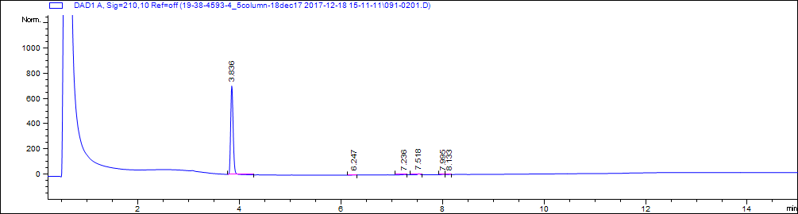

|  |  |  |  |
| --- | --- | --- | --- |
| # | Retention time (minutes) | Area | Area% |
| 1 | 3.8 | 2375.8 | 97.7 |
| 2 | 6.2 | 5.3 | 0.2 |
| 3 | 7.2 | 9.6 | 0.4 |
| 4 | 7.5 | 23.9 | 1.0 |
| 5 | 8.0 | 10.2 | 0.4 |
| 6 | 8.1 | 6.1 | 0.3 |

**B**



M/Z=267,269

**Figure SI 16.** LC-MS chromatogram and mass spectrum for SM16. Molecular weight is 267.111 g/mol. (A) LC chromatogram and table of peak properties. %Area describes relative area under the curve of selected peaks and interpreted as an estimate of purity. (B) Mass spectrum

**A**

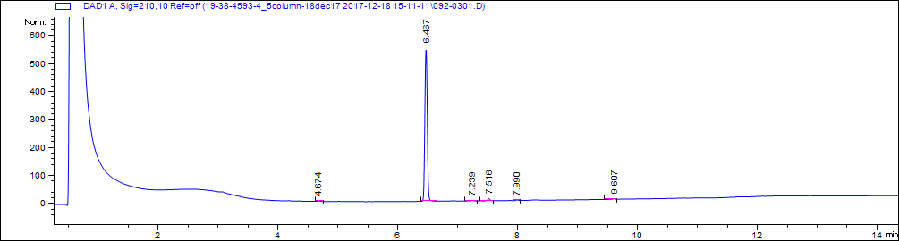

|  |  |  |  |
| --- | --- | --- | --- |
| # | Retention time (minutes) | Area | Area% |
| 1 | 4.7 | 5.3 | 0.3 |
| 2 | 6.5 | 1541.6 | 97.0 |
| 3 | 7.2 | 7.3 | 0.5 |
| 4 | 7.5 | 22.5 | 1.4 |
| 5 | 8.0 | 6.4 | 0.4 |
| 6 | 9.6 | 6.3 | 0.4 |

**B**



M+1=270

**Figure SI 17.** LC-MS chromatogram and mass spectrum for SM17. Molecular weight is 269.322 g/mol. (A) LC chromatogram and table of peak properties. %Area describes relative area under the curve of selected peaks and interpreted as an estimate of purity. (B) Mass spectrum

**A**

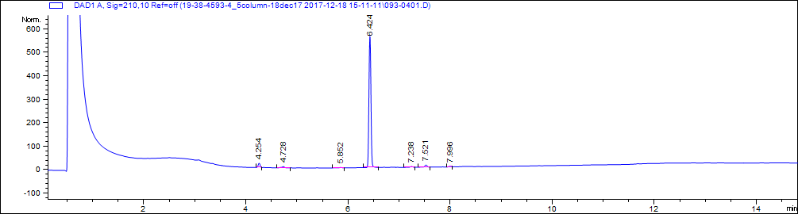

|  |  |  |  |
| --- | --- | --- | --- |
| # | Retention time (minutes) | Area | Area% |
| 1 | 4.3 | 47.8 | 2.9 |
| 2 | 4.7 | 22.5 | 1.4 |
| 3 | 5.9 | 5.7 | 0.3 |
| 4 | 6.4 | 1538.3 | 92.6 |
| 5 | 7.2 | 10.7 | 0.6 |
| 6 | 7.5 | 28.5 | 1.7 |
| 7 | 8.0 | 7.8 | 0.5 |

**B**



M+1=427

**Figure SI 18.** LC-MS chromatogram and mass spectrum for SM18. Molecular weight is 426.439 g/mol. (A) LC chromatogram and table of peak properties. %Area describes relative area under the curve of selected peaks and interpreted as an estimate of purity. (B) Mass spectrum

**A**

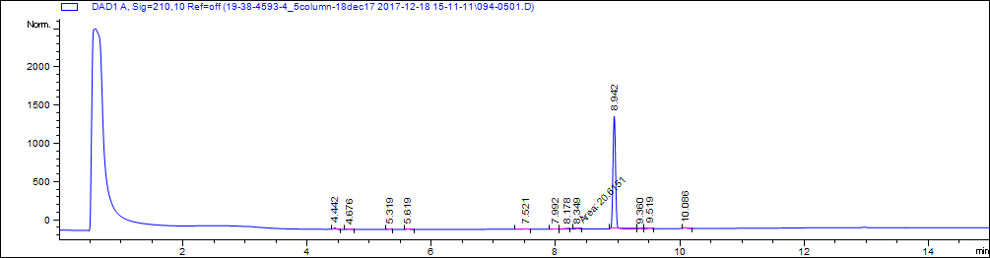

|  |  |  |  |
| --- | --- | --- | --- |
| # | Retention time (minutes) | Area | Area% |
| 1 | 4.4 | 51.6 | 1.3 |
| 2 | 4.7 | 5.7 | 0.1 |
| 3 | 5.3 | 14.3 | 0.3 |
| 4 | 5.6 | 17.8 | 0.4 |
| 5 | 7.5 | 17.4 | 0.4 |
| 6 | 8.0 | 8.2 | 0.2 |
| 7 | 8.2 | 14.1 | 0.3 |
| 8 | 8.3 | 20.6 | 0.5 |
| 9 | 8.9 | 3893.8 | 94.5 |
| 10 | 9.4 | 15.4 | 0.4 |
| 11 | 9.5 | 26.1 | 0.6 |
| 12 | 10.1 | 37.1 | 0.9 |

**B**



M/Z=381 and 383

**Figure SI 19.** LC-MS chromatogram and mass spectrum for SM19. Molecular weight is 381.276 g/mol. (A) LC chromatogram and table of peak properties. %Area describes relative area under the curve of selected peaks and interpreted as an estimate of purity. (B) Mass spectrum

**A**

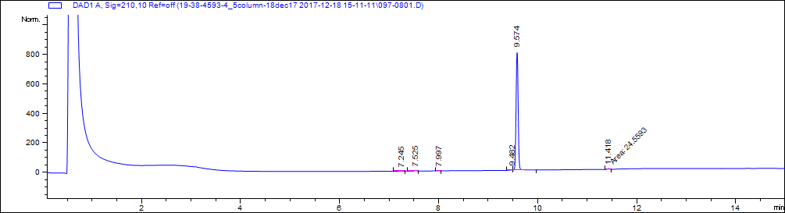

|  |  |  |  |
| --- | --- | --- | --- |
| # | Retention time (minutes) | Area | Area% |
| 1 | 7.2 | 5.6 | 0.2 |
| 2 | 7.5 | 16.4 | 0.7 |
| 3 | 8.0 | 7.0 | 0.3 |
| 4 | 9.5 | 15.4 | 0.6 |
| 5 | 9.6 | 2376.4 | 97.2 |
| 6 | 11.4 | 24.6 | 1.0 |

**B**

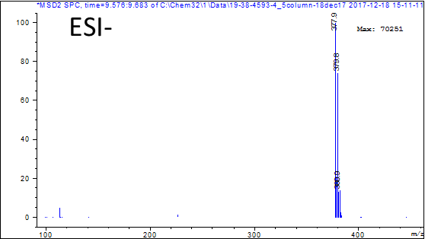

M/Z=378 and 380

**Figure SI 20.** LC-MS chromatogram mass spectrum for SM20. Molecular weight is 380.245 g/mol. (A) LC chromatogram and table of peak properties. %Area describes relative area under the curve of selected peaks and interpreted as an estimate of purity. (B) Mass spectrum

**A**

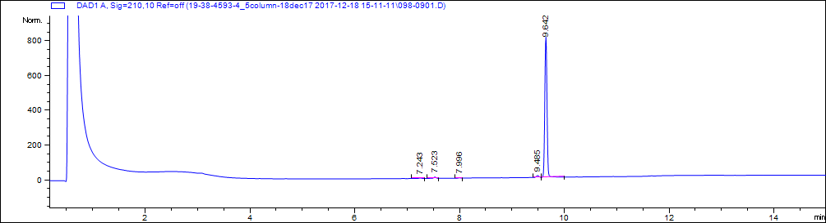

|  |  |  |  |
| --- | --- | --- | --- |
| # | Retention time (minutes) | Area | Area% |
| 1 | 7.2 | 9.1 | 0.4 |
| 2 | 7.5 | 23.6 | 1.0 |
| 3 | 8.0 | 6.4 | 0.2 |
| 4 | 9.5 | 39.9 | 1.6 |
| 5 | 9.6 | 2381.2 | 96.8 |

**B**



M+1=439

**Figure SI 21.** LC-MS chromatogram and mass spectrum for SM21. Molecular weight is 438.092 g/mol. (A) LC chromatogram and table of peak properties. %Area describes relative area under the curve of selected peaks and interpreted as an estimate of purity. (B) Mass spectrum

**A**

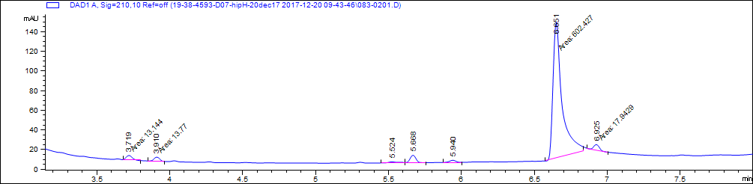

|  |  |  |  |
| --- | --- | --- | --- |
| # | Retention time (minutes) | Area | Area% |
| 1 | 3.7 | 13.1 | 1.9 |
| 2 | 3.9 | 13.8 | 2.0 |
| 3 | 5.5 | 8.0 | 1.2 |
| 4 | 5.7 | 24.9 | 3.6 |
| 5 | 5.9 | 12.4 | 1.8 |
| 6 | 6.7 | 602.4 | 87.0 |
| 7 | 6.9 | 17.9 | 2.6 |

**B**



M+1=398

**Figure SI 22.** LC-MS chromatogram and mass spectrum for SM22. Molecular weight is 396.951 g/mol. (A) LC chromatogram and table of peak properties. %Area describes relative area under the curve of selected peaks and interpreted as an estimate of purity. (B) Mass spectrum

**A**

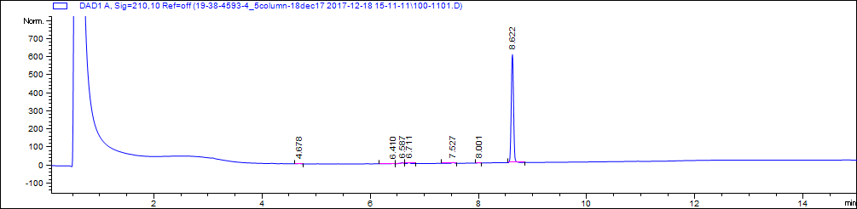

|  |  |  |  |
| --- | --- | --- | --- |
| # | Retention time (minutes) | Area | Area% |
| 1 | 4.7 | 5.4 | 0.3 |
| 2 | 6.4 | 5.6 | 0.3 |
| 3 | 6.6 | 22.7 | 1.2 |
| 4 | 6.7 | 18.1 | 1.0 |
| 5 | 7.5 | 16.1 | 0.9 |
| 6 | 8.0 | 5.6 | 0.3 |
| 7 | 8.6 | 1770.7 | 96.0 |

**B**



M+1=421

**Figure SI 23.** LC-MS chromatogram and mass spectrum for SM23. Molecular weight is 420.461 g/mol. (A) LC chromatogram and table of peak properties. %Area describes relative area under the curve of selected peaks and interpreted as an estimate of purity. (B) Mass spectrum

**A**

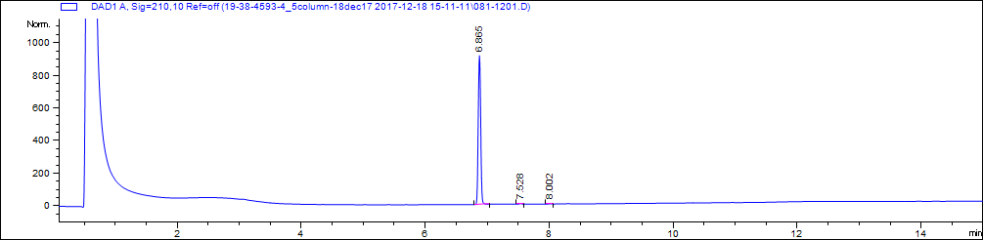

|  |  |  |  |
| --- | --- | --- | --- |
| # | Retention time (minutes) | Area | Area% |
| 1 | 6.9 | 2511.1 | 99.3 |
| 2 | 7.5 | 11.0 | 0.4 |
| 3 | 8.0 | 5.9 | 0.2 |

**B**



M+1=392

**Figure SI 24.** LC-MS chromatogram and mass spectrum for SM24. Molecular weight is 391.42 g/mol. (A) LC chromatogram and table of peak properties. %Area describes relative area under the curve of selected peaks and interpreted as an estimate of purity. (B) Mass spectrum