SCHOOL OF COMPUTER SCIENCE AND ARTIFICIAL INTELLIGENCE |  |  |  |  | DEPARTMENT OF COMPUTER SCIENCE ENGINEERING
Program Name: B. Tech |  |  |  | Assignment Type: Lab |  |  | Academic Year:2025-2026
Course Coordinator Name |  |  |  | Dr. Rishabh Mittal
Instructor(s) Name
  Mr. S Naresh Kumar
  Ms. B. Swathi
  Dr. Sasanko Shekhar Gantayat
  Mr. Md Sallauddin
  Dr. Mathivanan
  Mr. Y Srikanth
  Ms. N Shilpa
  Dr. Rishabh Mittal (Coordinator)
  Dr. R. Prashant Kumar
  Mr. Ankushavali MD
  Mr. B Viswanath
  Ms. Sujitha Reddy
  Ms. A. Anitha
  Ms. M.Madhuri
  Ms. Katherashala Swetha
  Ms. Velpula sumalatha
  Mr. Bingi Raju
CourseCode |  |  | 23CS002PC304 | Course Title |  | AI Assisted Coding
Year/Sem |  |  | III/II | Regulation |  | R23
Date and Day  of Assignment |  |  | Week1 – Wednesday | Time(s) |  | 23CSBTB01 To 23CSBTB52
Duration |  |  | 2 Hours | Applicable to  Batches |  | All batches
Assignment Number:1.3(Present assignment number)/24(Total number of assignments)
 | Q.No. | Question |  |  |  |  |  | Expected Time  to complete
 | 1 | Lab 2: Exploring Additional AI Coding Tools beyond Copilot – Gemini (Colab) and Cursor AI  Lab Objectives:  - To explore and evaluate the functionality of Google Gemini for AI-assisted coding within Google Colab.  - To understand and use Cursor AI for code generation, explanation, and refactoring.  - To compare outputs and usability between Gemini, GitHub Copilot, and Cursor AI.  - To perform code optimization and documentation using AI tools.  Lab Outcomes (LOs):  After completing this lab, students will be able to:  - Generate Python code using Google Gemini in Google Colab.  - Analyze the effectiveness of code explanations and suggestions by Gemini.  - Set up and use Cursor AI for AI-powered coding assistance.  - Evaluate and refactor code using Cursor AI features.  - Compare AI tool behavior and code quality across different platforms.  Task 1: Word Frequency from Text File  - Scenario:  You are analyzing log files for keyword frequency.  - Task:  Use Gemini to generate Python code that reads a text file and counts word frequency, then explains the code.  - Expected Output:  - Prompts  Write a python code to count how many times that word is repeated in given text file and also handle case sensitive and punctuation.  - Working code  """Count word frequencies in a log file."""  import argparse  from collections import Counter  from pathlib import Path  def word_frequency(file_path: Path) -> Counter[str]:  text = file_path.read_text(encoding="utf-8")  return Counter(text.lower().split())  def main(argv=None) -> int:  parser = argparse.ArgumentParser(  description="Count word frequencies in a log file.",  epilog="Run without arguments to process logfile.txt in the current directory\nor pass a custom path such as logs/server.log.",  )  parser.add_argument(  "logfile",  nargs="?",  default="logfile.txt",  help="Path to the log file to analyze.",  )  args = parser.parse_args(argv)  file_path = Path(args.logfile)  if not file_path.exists():  parser.error(f"{file_path} does not exist. Create that file or provide another path.")  frequency = word_frequency(file_path)  for word, count in frequency.most_common():  print(f"{word}: {count}")  return 0  if __name__ == "__main__":  raise SystemExit(main())  - Explanation  The program opens and reads the entire text file.  It converts every capital letter into lowercase so the counting is consistent.  It breaks the sentences down into a simple list of individual words.  Finally, it prints out a clear list of every word and how many times it appeared.  - Screenshot  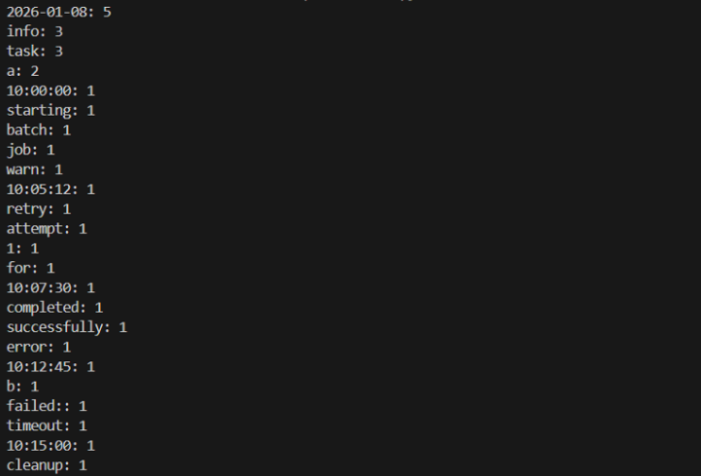  Task 2: File Operations Using Cursor AI  - Scenario:  You are automating basic file operations.  - Task:  Use Cursor AI to generate a program that:  - Creates a text file  - Writes sample text  - Reads and displays the content  - Expected Output:  - Prompts  Write a python code for which take file named 'sample.txt' and write three lines of text in it. Then open the file read it and print the words on the screen.  - Functional code  def main() -> None:  file_name = 'sample.txt'  # Writing to the file  with open(file_name, 'w') as file:  file.write("This is the first line of example text.\n")  file.write("This is the second line of example text.\n")  file.write("This is the third line of example text.\n")  # Reading from the file  with open(file_name, 'r') as file:  content = file.read()  # Printing the content to the console  print("Content of 'sample.txt':")  print(content)  if __name__ == "__main__":  main()  - Cursor AI screenshots  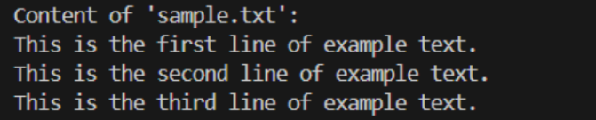  Task 3: CSV Data Analysis  - Scenario:  You are processing structured data from a CSV file.  - Task:  Use Gemini in Colab to read a CSV file and calculate mean, min, and max.  - Expected Output:  - Prompt  Write a python code in which it should read a CSV file and take a particular numerical column in which it should calculate mean , min, max.  - Functional code  import csv  def calculate_statistics(file_name: str, column_name: str) -> None:  values = []  # Reading the CSV file  with open(file_name, mode='r') as csvfile:  csvreader = csv.DictReader(csvfile)  for row in csvreader:  try:  value = float(row[column_name])  values.append(value)  except ValueError:  continue # Skip rows where conversion fails  if not values:  print(f"No valid data found in column '{column_name}'.")  return  mean_value = sum(values) / len(values)  min_value = min(values)  max_value = max(values)  print(f"Statistics for column '{column_name}':")  print(f"Mean: {mean_value}")  print(f"Min: {min_value}")  print(f"Max: {max_value}")  if __name__ == "__main__":  # Example usage - Using 'Age' column from data.csv  calculate_statistics('data.csv', 'Age')  - Correct output  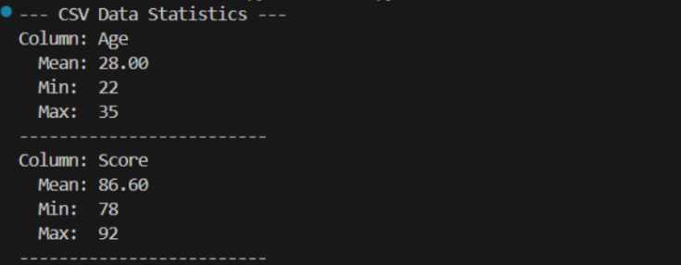  - Screenshot  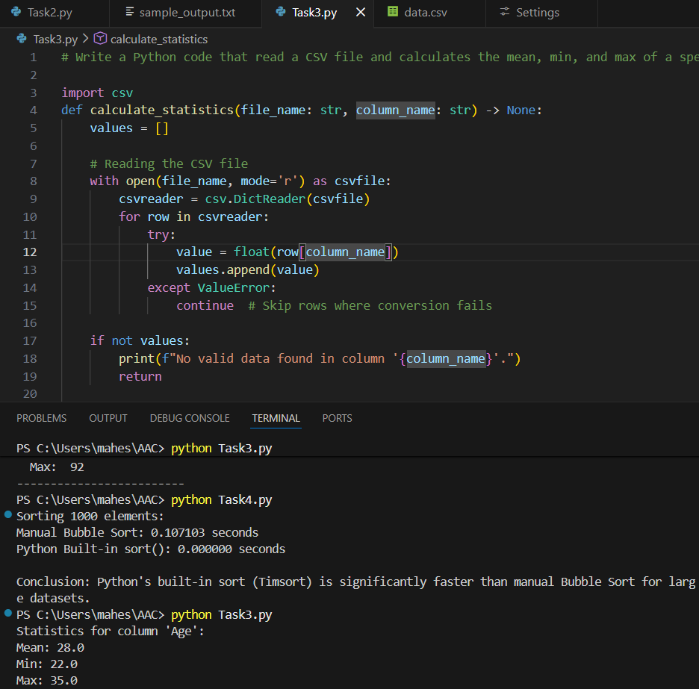  Task 4: Sorting Lists – Manual vs Built-in  - Scenario:  You are reviewing algorithm choices for efficiency.  - Task:  Use Gemini to generate:  - Bubble sort  - Python’s built-in sort()  - Compare both implementations.  - Expected Output:  - Prompt  Write a python code to create a list of 5000 random numbers. Sort them using the Bubble Sort method then sort them again using Python in built function.In output show how much time each method took so we will know which one is faster.  - Two versions of code  import time  import random  def bubble_sort(arr):  n = len(arr)  # Manual Bubble Sort Implementation  for i in range(n):  for j in range(0, n - i - 1):  if arr[j] > arr[j + 1]:  arr[j], arr[j + 1] = arr[j + 1], arr[j]  return arr  def compare_sorting_methods():  # Generate a random list of integers  size = 1000  original_data = [random.randint(0, 5000) for _ in range(size)]  # 1. Bubble Sort (Manual)  data_bubble = original_data.copy()  start_time = time.time()  bubble_sort(data_bubble)  bubble_duration = time.time() - start_time  # 2. Built-in sort() (Timsort)  data_builtin = original_data.copy()  start_time = time.time()  data_builtin.sort()  builtin_duration = time.time() - start_time  print(f"Sorting {size} elements:")  print(f"Manual Bubble Sort: {bubble_duration:.6f} seconds")  print(f"Python Built-in sort(): {builtin_duration:.6f} seconds")  print(f"\nConclusion: Python's built-in sort (Timsort) is significantly "  f"faster than manual Bubble Sort for large datasets.")  if __name__ == "__main__":  compare_sorting_methods()  - Short comparison  Sorting 1000 elements:  Manual Bubble Sort: 0.126919 seconds  Python Built-in sort(): 0.000098 seconds  Conclusion: Python's built-in sort (Timsort) is significantly faster than manual Bubble Sort for large datasets.  Note: Report should be submitted as a word document for all tasks in a single document with prompts, comments & code explanation, and output and if required, screenshots. |  |  |  |  |  | Week1 - Monday

