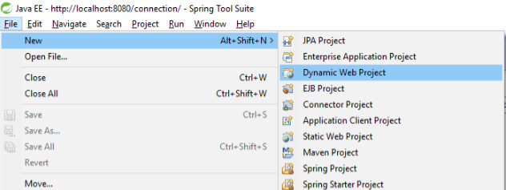

1. Creating dynamic web project

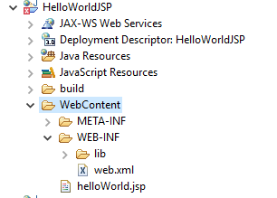

1. In web content folder write your JSP code

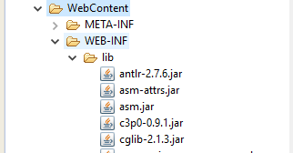

1. In web-inf copy all jar files in lib folder and give required server libraries if need

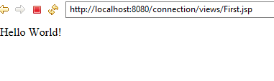

1. Now execute us jsp file on server we will get output.

**Redirection**

1. After getting Hello world working now getting Hello World through redirection

Things need for redirection is **Controller class** and JSP files

**Controller class**

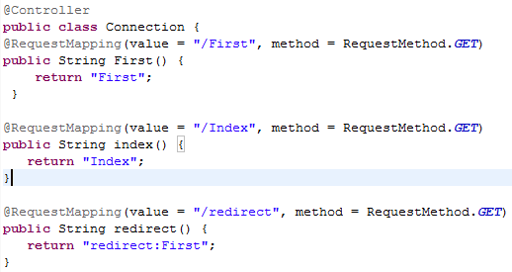

In the snippet

The **@Controller** annotation is used to mark any java class as a controller class.

The **@RequestMapping** annotation is used to map the web request "/First" to the Controller class.

As shown in the snippet to redirect from one page to another page

* Redirect is given as value in the view function (request mapping) and return has the address of destination view function.
* To redirect correctly return has “**redirect: (redirect view name)**”

Creating View files using JSP

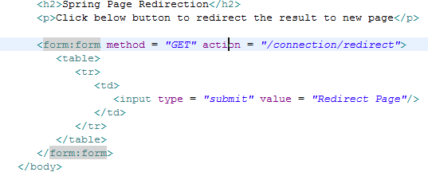

In the snippet button is provided to enable redirect

In action **/connection/redirect** is provide in controller class from there @RequestMapping is used to redirect from one page to another.

