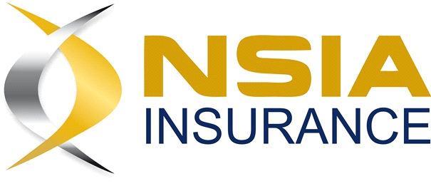
2023 ANNUAL GENERAL MEETING – PROXY FORM

I/We ………………………………………………………………………………………………………
Of ………………………………………………………………………………………………
being shareholder(s) of NSIA Insurance Company Limited, hereby appoint
………………………………………………………………………………………………………
(or failing him/her the duly appointed Chairman of the meeting) as my/our proxy to vote for me/us at the Annual General Meeting to be held on Tuesday, 6th May, 2025 at 0900h GMT+0 by Zoom and at every adjournment thereof):

Please indicate with an X in the spaces below how you wish your votes to be cast.

RESOLUTION | FOR | AGAINST
To waive the notice period required for this meeting
To receive and consider the financial statements of the company and the reports of the directors and auditors for the year ended 31st December 2023.
To receive the directors’ statement on dividend for the year ended 31st December 2023.
To ratify the remuneration of the auditors for the year 2023.
To ratify the appointment of Mrs. Monica Amissah as a director of the company, subject to the approval of the National Insurance Commission
To ratify the remuneration of the non-executive directors
To approve the payment of end-of-service benefits to the non-executive directors

Signed this …………….. day of ……………………………. 2025.

*Shareholder’s signature …………………………………………….

*If executed by a company, the proxy form should be signed by a director of the company.

PLEASE SEND THE COMPLETED PROXY FORM TO akuaa@oxfordconusltantsgh.com by 2nd May 2025.

