[사전준비]

•CentOS 7 64 bit with 4GB of RAM - elk-master

•CentOS 7 64 bit with 1 GB of RAM - client1

•Ubuntu 16 64 bit with 1GB of RAM - client2

* setenforce 0

[kibana설치]

* wget https://artifacts.elastic.co/downloads/kibana/kibana-5.1.1-x86_64.rpm
* rpm -ivh kibana-5.1.1-x86_64.rpm
* vi /etc/kibana/kibana.yml

server.port: 5601

server.host: "localhost"

elasticsearch.url: "http://localhost:9200"

* sudo systemctl enable kibana
* sudo systemctl start kibana
* [root@q-nimi-os02 ~]# netstat -anlp | grep 5601
* tcp 0 0 127.0.0.1:5601 0.0.0.0:* LISTEN 32317/node

키바나 설치후 <http://ip:5601> 포트로 접근해도 됨

[nginx설치]

* yum -y install epel-release
* yum -y install nginx httpd-tools
* cd /etc/nginx/
* vi nginx.conf에서 server {}을 제거
* vi /etc/nginx/conf.d/kibana.conf

server {

listen 80;

server_name elk-stack.co;

auth_basic "Restricted Access";

auth_basic_user_file /etc/nginx/.kibana-user;

location / {

proxy_pass http://localhost:5601;

proxy_http_version 1.1;

proxy_set_header Upgrade $http_upgrade;

proxy_set_header Connection 'upgrade';

proxy_set_header Host $host;

proxy_cache_bypass $http_upgrade;

}

}

* sudo htpasswd -c /etc/nginx/.kibana-user admin
* TYPE YOUR PASSWORD -> admin 계정에 대한 패스워드 설정
* [root@q-nimi-os02 ~]# nginx -t

nginx: the configuration file /etc/nginx/nginx.conf syntax is ok

nginx: configuration file /etc/nginx/nginx.conf test is successful

* systemctl enable nginx
* systemctl start nginx
* curl -XDELETE <http://localhost:9200/basketball>
* curl -XGET <http://localhost:9200/basketball>
* curl -XPUT 'http://localhost:9200/basketball/record/_mapping' -d @basketball_mapping.json
* curl -XGET <http://localhost:9200/basketball?pretty>
* curl -XPUT 'localhost:9200/_bulk' --data-binary @bulk_basketball.json
* http:/ip로 접속

[ Management] -> Index Patterns -> index 패턴(basketball) -> 제출

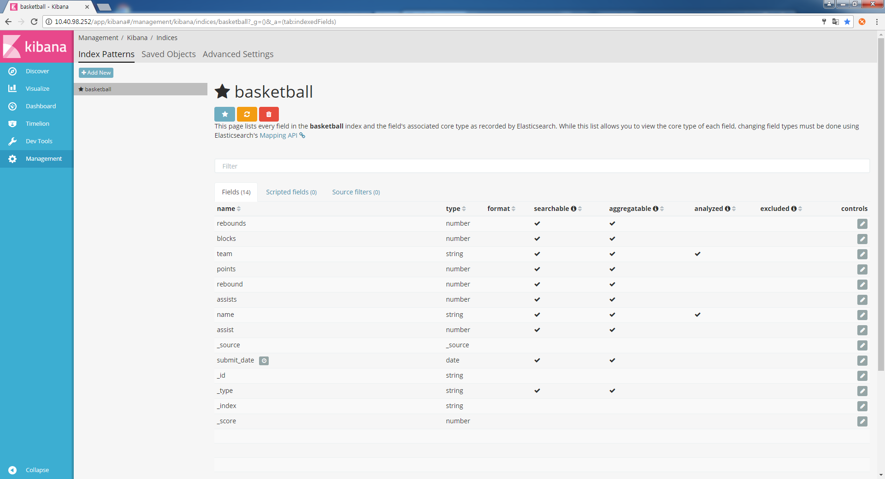

[ Discover ] -> Index Patterns -> index 패턴(basketball) -> 제출

* time Rage (입력된 데이타를 기준시간으로)

Quck, Relative, Absolute로 조절가능

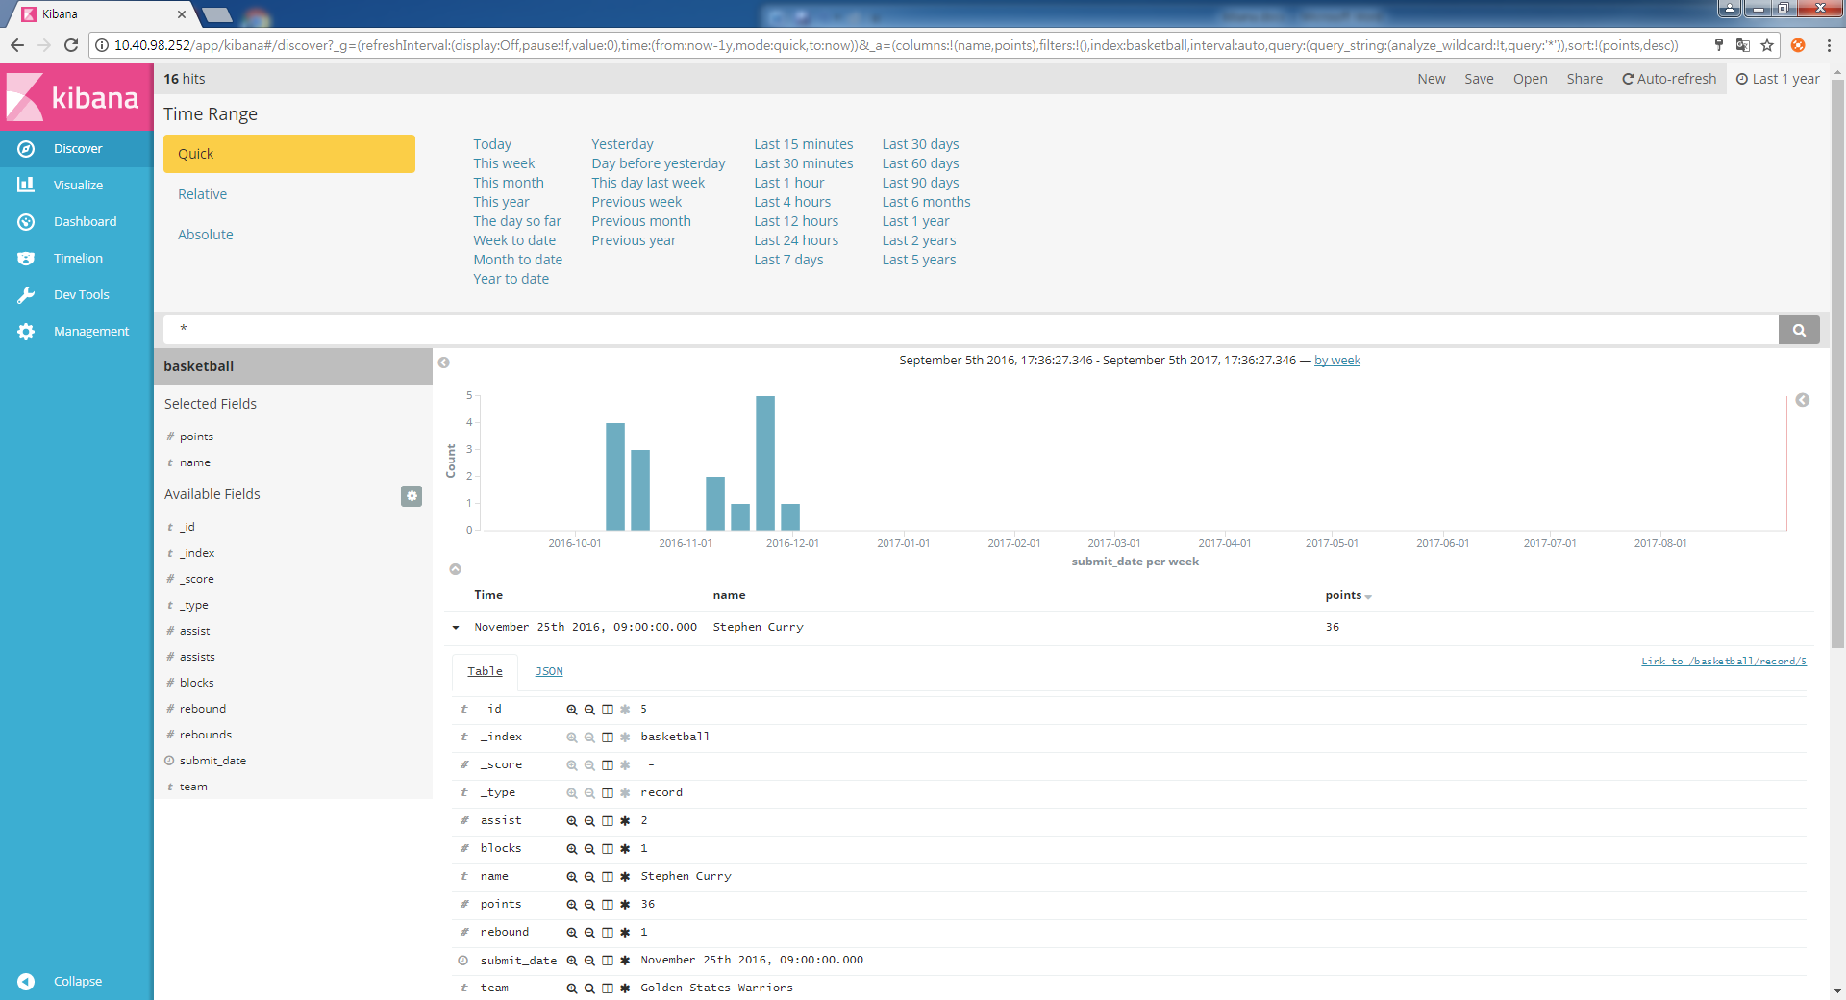

플러스 돋보기: 해당 value로 필터

마이너스 돋보기: 해당 valuer 밖으로 필터

창문: 테이블 칼럼에 대한 토글

지울때: 필터된 항목에서 휴지통 선택

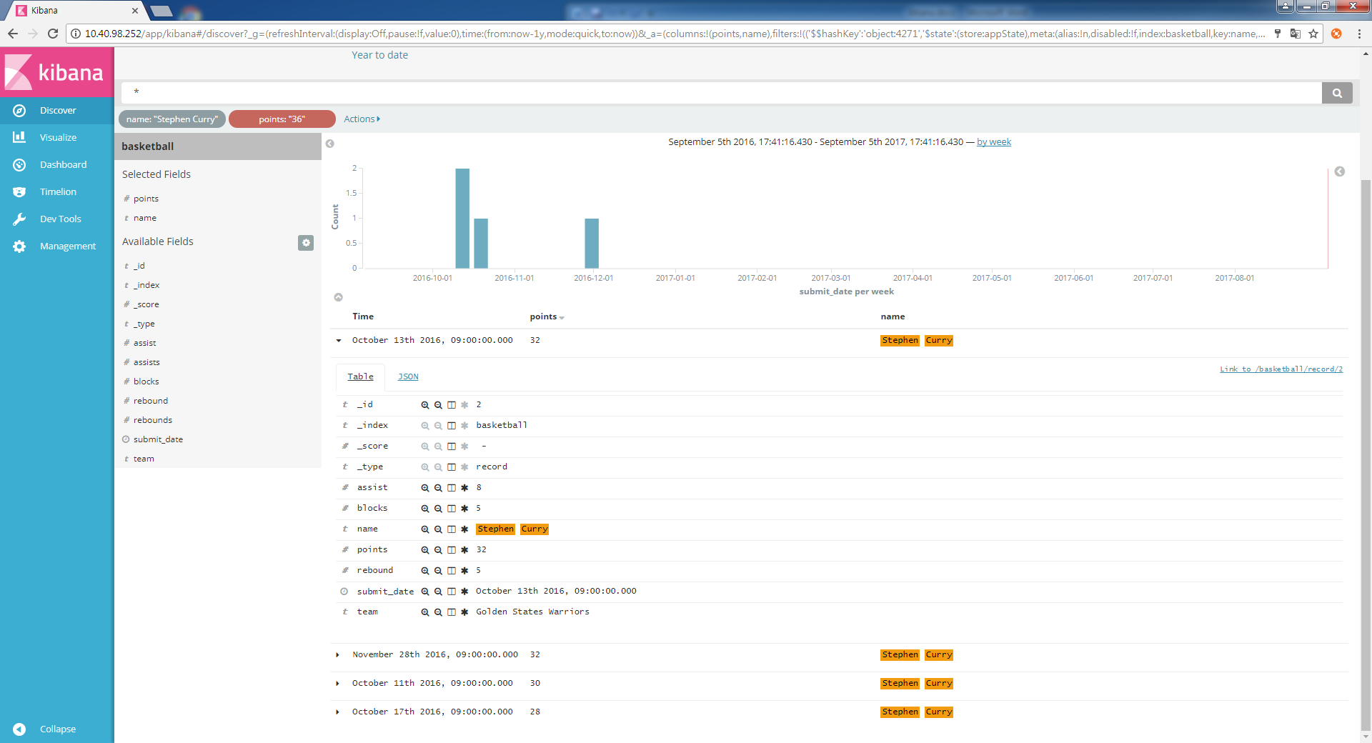

[ Visualize ] Visualize에서 차트에 대하여 save하여야함

Bar차트-> Y축선택 -> X축선택

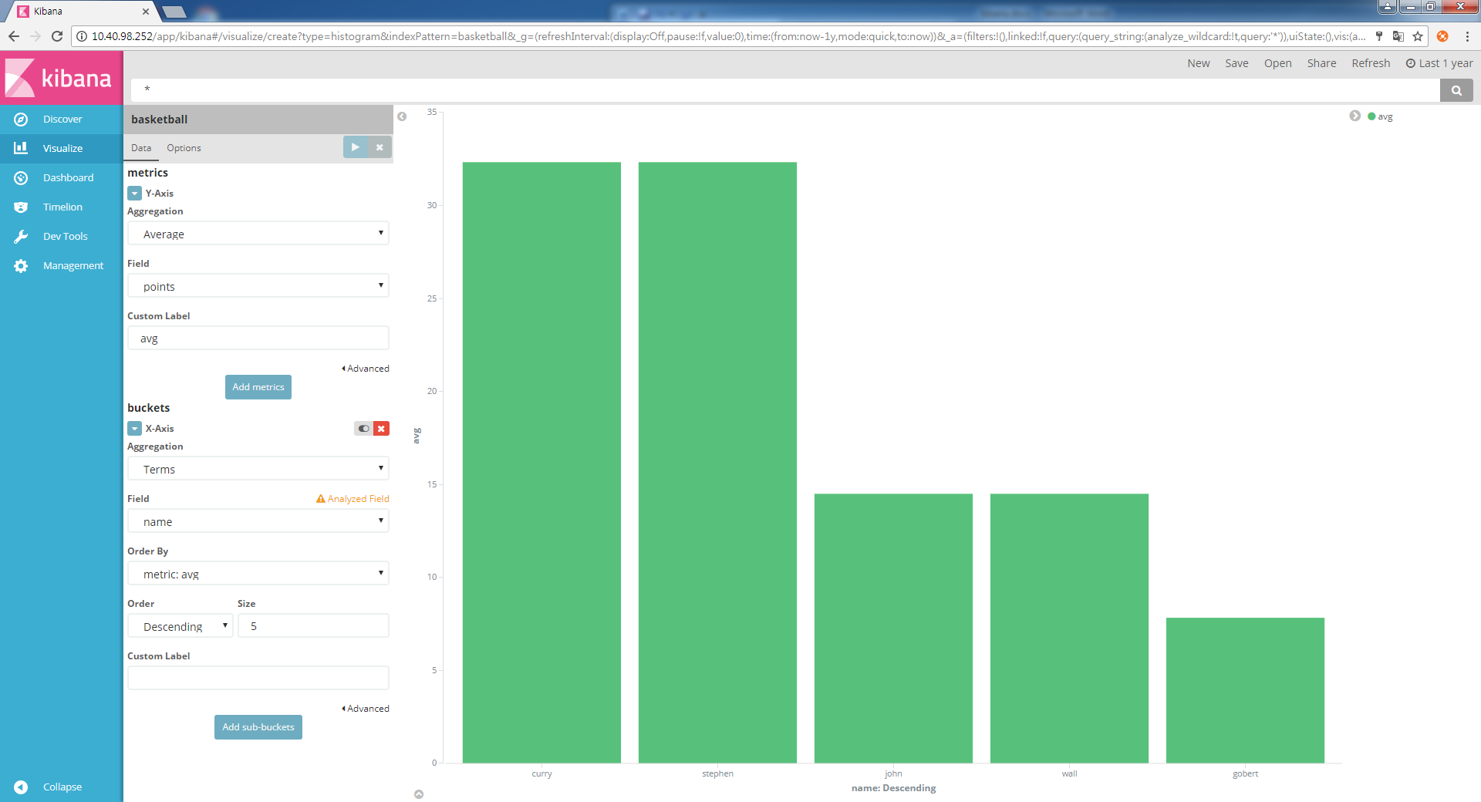

[ Visualize ]Pie차트-> split size -> split slice축선택

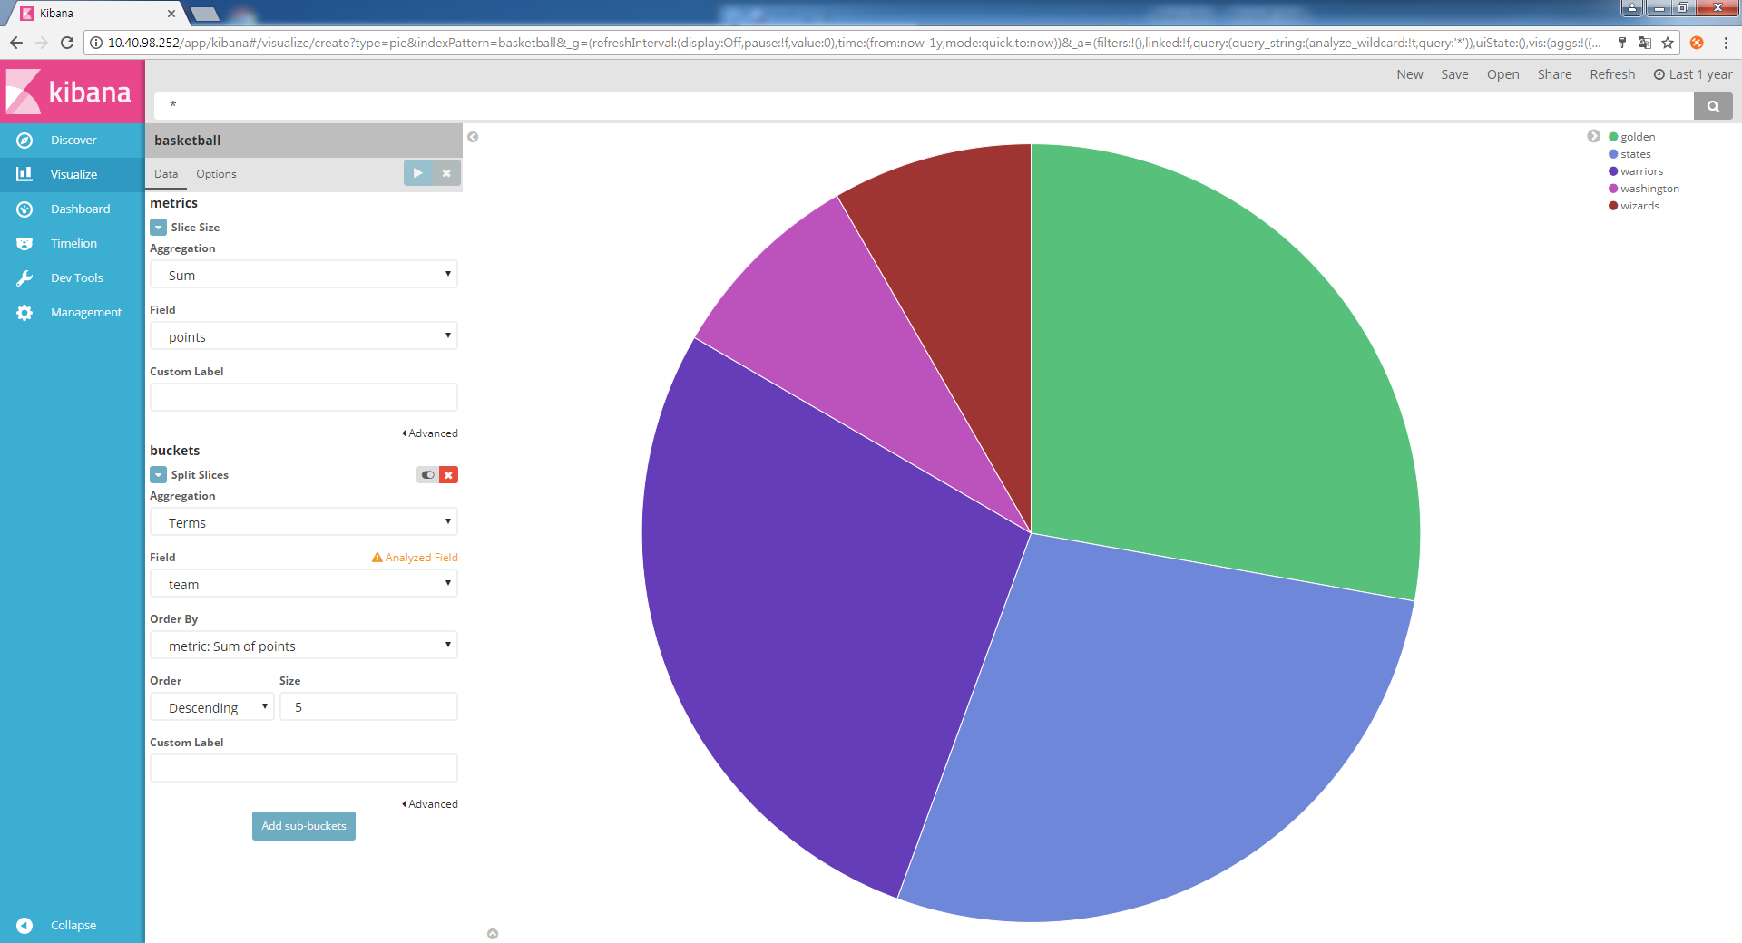

* curl -XDELETE http://localhost:9200/classes
* curl -XGET <http://localhost:9200/classes>
* curl -XPUT 'http://localhost:9200/classes/class/_mapping' -d @classesRating_mapping.json
* curl -XGET <http://localhost:9200/classes?pretty>
* curl -XPUT http://localhost:9200/classs/_bulk?pretty --data-binary @classes.json

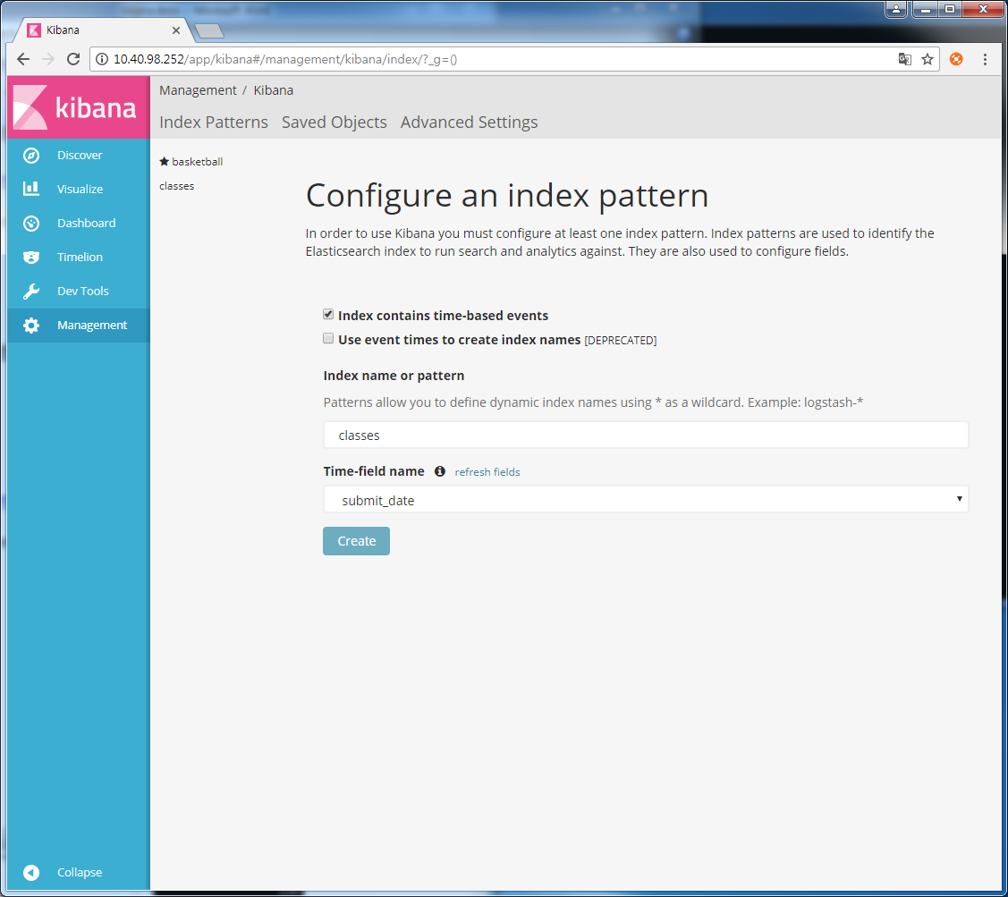

[ Visualize ] MAP차트-> Geohash -> school_location 선택

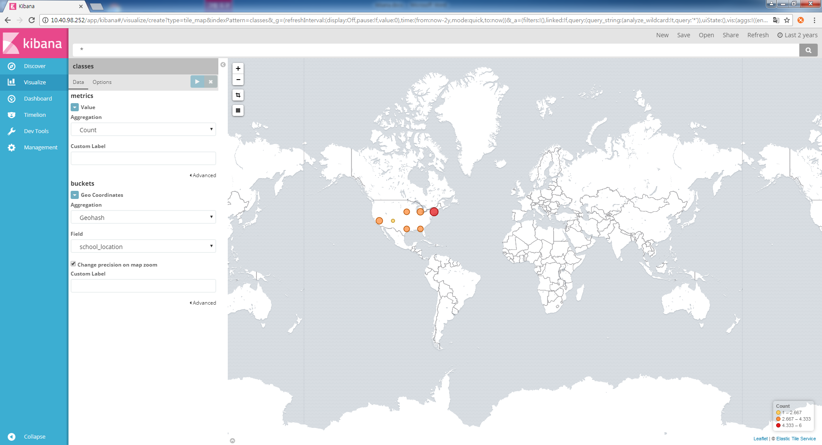

[Dashboard] add->Visualize에서 만든 차트선택후 save버튼 -> 불러낼때는 open

